World Notes

M-Player: Tupper  
Race : Half-Orc

Class : Barb/Cleric

HP : ___ / ___

STR | DEX | CON

10 | 16 | 12

INT | WIS | CHA

15 | 14 | 8

Pass Percpetion: _**13**_

A-Player: Tupper  
Race : Satyr/Human

Class : Monk

HP : ___ / ___

STR | DEX | CON

16 | 20 | 15

INT | WIS | CHA

12 | 15 | 5

Pass Percpetion: _**12**_

|  |  |
| --- | --- |
| ***D8*** | ***Encounter*** |
| **1** | *TBD – Matteo* |
| **2** | *Thorn – Isaiah* |
| **3** | *Storm Chaser – Jason* |
| **4** | *Sanira – Alicia* |
| **5** | *Sana Family – C’Stine* |
| **6** | *Adv. Guild* |
| **7** | *Attack Encounter* |
| **8** | *University / GOSPEL* |

M-Player: Sparky  
Race : Aasimar

Class : Sorcerer

HP : ___ / ___

STR | DEX | CON

13 | 15 | 12

INT | WIS | CHA

11 | 13 | 15

Pass Percpetion: _**13**_

C-Player: Indigo  
Race : Gnome

Class : Druid

HP : ___ / ___

STR | DEX | CON

10 | 16 | 12

INT | WIS | CHA

15 | 14 | 8

Pass Percpetion: _**12**_

M-Player: Dandellion  
Race : Half-Elf (Eld’n)

Class : Barb

HP : ___ / ___

STR | DEX | CON

9 | 17 | 10

INT | WIS | CHA

13 | 10 | 15

Pass Percpetion: _**12**_

X-Player:   
Race :

Class :

HP : ___ / ___

STR | DEX | CON

| |

INT | WIS | CHA

| |

Pass Percpetion: ____

World Notes,   
Part 1

M-Player: Tupper  
Race : Half-Orc

Class : Barb/Cleric

HP : ___ / ___

STR | DEX | CON

10 | 16 | 12

INT | WIS | CHA

15 | 14 | 8

Pass Percpetion: _**13**_

A-Player: Tupper  
Race : Satyr/Human

Class : Monk

HP : ___ / ___

STR | DEX | CON

16 | 20 | 15

INT | WIS | CHA

12 | 15 | 5

Pass Percpetion: _**12**_

|  |  |
| --- | --- |
| ***D8*** | ***Encounter*** |
| **1** | *TBD – Matteo* |
| **2** | *Thorn – Isaiah* |
| **3** | *Storm Chaser – Jason* |
| **4** | *Sanira – Alicia* |
| **5** | *Sana Family – C’Stine* |
| **6** | *Adv. Guild* |
| **7** | *Attack Encounter* |
| **8** | *University / GOSPEL* |

M-Player: Sparky  
Race : Aasimar

Class : Sorcerer

HP : ___ / ___

STR | DEX | CON

13 | 15 | 12

INT | WIS | CHA

11 | 13 | 15

Pass Percpetion: _**13**_

C-Player: Indigo  
Race : Gnome

Class : Druid

HP : ___ / ___

STR | DEX | CON

10 | 16 | 12

INT | WIS | CHA

15 | 14 | 8

Pass Percpetion: _**12**_

M-Player: Dandellion  
Race : Half-Elf (Eld’n)

Class : Barb

HP : ___ / ___

STR | DEX | CON

9 | 17 | 10

INT | WIS | CHA

13 | 10 | 15

Pass Percpetion: _**12**_

X-Player:   
Race :

Class :

HP : ___ / ___

STR | DEX | CON

| |

INT | WIS | CHA

| |

Pass Percpetion: ____

# Party Item Tracking

**Isaiah**

**Robe of Useful things**

*That who dons it will note that it is adorned with small cloth patches of various shapes. Only the wearer of the robe can see, recognize, and detach these patches. One patch can be detached each round. Detaching a patch causes it to become an actual item, as indicated below.*

*A robe of useful items always begins with two each of the following patches:*

* *Two Daggers*
* *Two lanterns (full of oil, lit)*
* *Two Mirrors (Large)*
* *Two 10' poles*
* *Two coils of silk rope (50')*
* *Two Grappling hooks*
* *Two large Sacks.*

*Additionally, you find 17 patches that you recognize their contents after 1 hour of study.*

*1 A sack of 100gp*

*2 2x orbs that seem to be barking quietly (summonable mastiffs)*

*3 A bottled tree that plants and roots itself to offer nice shade. 30ft tall*

*4 A Blank Marriage Certificate*

*5 4x Potion of Healing*

*6 A Disposable magic longsword, +1 for 10 attacks, then disintegrates*

*7 A jar of peanut butter*

*8 A magnifying glass*

*9 A Set of wind chimes*

*10 A loaded crossbow*

*11 A set Shakers of Salt and Pepper*

*12 A herb-scented bar of soap*

*13 A disposable magic key - opens one lock then disappears*

*14 A lawn ornament in the form of a gnome*

*15 A clean set of nice clothing*

*16 A set of thieves tools*

*17 A frothy mug of ale*

**Isaiah (2)**

**Cloak of Billowing**

**Alicia**

**Acorn of Far Travel – Backstory Item**

While attuned to this acorn, you are treated as withing forested region for regional abilities. (Favored terrain)h1

**Jason**

**Dark Orange Potion – Potion of Darkvision**

**Silver, glittery potion – Potion of Silver Tongue**

Next hour, advantage on Pursuasion, Intimidation and Deception Maximum of 1d6 uses. (wears off while talking)

***Ring of rope*** *Requires attunement. This rusted,* ***copper*** *ring has a tiny yellow topaz in the center. It carries 4 charges. When activated (bonus action), this ring shoots out up to 30ft of rope from its gem. The rope can be commanded to latch onto the target, at GM's discretion. It cannot latch on to creatures or anything alive. Regain 1d4 charges at dawn.*

**Christine**

Plant – **Hyperia** (Love Fungus)

*Brew into tea. INT DC 18 to fall in love with next person seen.*

*Adv on CHA checks (Charmed)*

4x **Goodberries**

Plant – **Falsifal**

*Mash to pulp, heal 1d8 fire damage if taken within 1d4 rounds*

**Matteo**

**Kegotomes Ointment**

*5 uses – 250gp – roll 1d20/day, on 20, refresh a use.*

Heall 2d8 + 2 hit points, end poison, and cured of disease.

**Bedazzled Glove**

*0 uses –3,000 gp*

***GROUP***

***Allchemy Jug***

***Ring of tracking*** *Requires attunement. A simple* ***brass*** *ring, when attuned to a user, the user always knows the location of the ring, up to 5 miles away. Often used to keep track of people or goods. If the ring exceeds the 5-mile distance, you know the general direction the ring is, up to 50 miles.*

***Ring of returning*** *Requires attunement. This simple* ***silver*** *ring, whenever removed or discarded, will return to the pocket of the player in 30 seconds.*

***Ring of minor prestidigitation*** *Requires attunement. This* ***wooden*** *ring can cast a limited version of prestidigitation. With it, you can:  
- Create an Instantaneous, harmless sensory Effect, such as a shower of sparks, a puff of wind, faint musical notes, or an odd odor.*

*- Create a nonmagical trinket or an illusory image that can fit in your hand and that lasts until the end of your next turn.****Ring of the Claw*** *Requires attunement. This* ***steel*** *ring has the ability to sprout a 4in curved claw-like blade from it, so long as the ring is worn. The claw is likened to a beast’s claw, and strikes make with this claw deal 1d6 + STR or DEX slashing damage.*

***Dust of Sneezing and Choking***

*When you use an action to throw a handful of the dust into the air, you and each creature that needs to breathe within 30 feet of you must succeed on a* ***DC 15 Constitution saving throw*** *or become unable to breathe, while sneezing uncontrollably. A creature affected in this way is* ***incapacitated*** *and* ***suffocating****.*

*As long as it is conscious, a creature can repeat the saving throw at the end of each of its turns, ending the effect on it on a success. The lesser restoration spell can also end the effect on a creature.*

***3rd Level Spell Scroll***

***Folding Keelboat***

*The second command word causes the box to unfold into a ship 50 feet long, 20 feet wide; and 8 feet deep.*

*The ship has a deck, rowing seats, five sets of oars, a steering oar, an anchor, a deck cabin, and a mast with a square sail. The ship can hold fifteen Medium creatures comfortably.*

*When the box becomes a vessel, its weight becomes that of a normal vessel its size, and anything that was stored in the box remains in the boat.*

***Eyes / Charming***

*These crystal lenses fit over the eyes. They have 3 charges. While wearing them, you can expend 1 charge as an action to cast the* ***charm person spell*** *(****save DC 13****) on a humanoid within 30 feet of you, provided that you and the target can see each other. The lenses regain all expended charges daily at dawn.*

***Bag of Tricks, Tan***

*You can use an action to pull the fuzzy object from the bag and throw it up to 20 feet. When the object lands, it transforms into a creature you determine by rolling a d8 and consulting the table that corresponds to the bag's color.*

*The creature is friendly to you and your companions, and it acts on your turn. You can use a bonus action to command how the creature moves and what action it takes on its next turn, or to give it general orders, such as to attack your enemies. In the absence of such orders, the creature acts in a fashion appropriate to its nature.*

*Once three fuzzy objects have been pulled from the bag, the bag can't be used again until the next dawn.*

***+1 Brass Knuckles***

*A knuckleduster deals damage equal to your unarmed damage + 1. This is normally 2 bludgeoning damage. Care should be taken if you allow this variant with monks as it will ultimately deal more damage than other monk weapons.*

*Brass knuckles only occupy the fingers and palms of the wielder. You may perform the somatic components of spells while you are wielding brass knuckles.*

***+1 Shortstaff (Quarterstaff)***

***Bejeweled Glove – 3000gp***

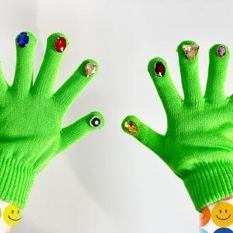

# DM

***Setting a Scene with EASE***

**Environment**.   
Describe the plants, structures, lighting, and weather. This information may be a bit generic at times, but helps set give a base "template" to layer other description on top of.  
 **Atmosphere**.   
This is less about what is seen and more about what is felt. It is the emotion that is evoked by being in the setting. Be careful here not to tell the players how they feel, but rather focus on how most people would likely feel if they were here.  
  
**Senses**.  
Use your description to engage all the senses. Sight is easiest, but use a bit of flowery language to evoke the players' sense of smell, hearing, touch, and even taste (as applicable). This will help to get them engaged in the story and setting more viscerally.  
  
**Events**.   
Now that the stage is set, you can talk about what is happening now. Here you will describe creatures, NPCs, or general goings-on. If nothing of note is currently unfolding, talk about what may have happened recently. This is an especially great time to engage your hunter/tracker character, who may pick up on bits of info others may have missed.  
  
**Here's an example of the method:**  
You step out of the dense woods into a small clearing. A soft rain falls, and the clouds block out what remains of the setting sun. There is a stillness in the clearing that is almost too quiet to be serene; white noise seems almost entirely absent. The smell of the wet grass fills your noses, but the air has a sourness to it when you take a deeper breath. Something feels just off. A keen eye (Passive Perception 17+) notices all the blades a grass seems to point towards the center of the clearing, with many laying nearly parallel to the ground.

## Questions before a session

1. What the Encounter is (cross a river, survive a storm, recover an artifact from a tomb)
2. What are you conveying to the players (hardship of a storm, dangers on a trade road)
3. Will this be a simple encounter or complex (is the solution obvious and definitive?)
4. Why will this encounter be enjoyable to the players? (what brings tension)
5. Are the players active or reactive (who will be prompting the encounter)
6. How long/significant will the Encounter be (real life game time spent)

Does failure stop the game and if not what does failure look like?

## Other Ideas

#### Encounters

#### The Night Market.

Known in other lands as the Bazaar, The Fey Fete, The Enchanted Emporium and many more names, The Night Market is a place of enchantment and wonder, one that opens every full moon night on the edges of the Feywild. Compacts are made, bargains are struck and mighty magic is traded, bought and sold.

The Faerie run the market, but traders come from all over the planes- Genie and Efreeti, Pixies and Devils all trade at the Night Market. Mortals are not unheard of, but those who do not take sufficient care will find the market a dangerous place. Many traders will not accept anything as humdrum as gold, but will only trade for other items of magic, information and the completion of favours and tasks.

The market has five laws:

* No blood may be shed within the Night Market
* No spells may be cast that affects another within the Night Market
* No lies may be told within the Night Market, whilst agreeing a contract
* All contracts within the Night Market are final and binding
* Anything and anyone still within the market boundaries at midnight’s toll becomes the property of the hosting Faerie Lord

Any breach of the law will find quick intervention from the Mistguard. Each squad (Known as a ‘Hand’) consists of 5 Warlocks of the Archfey (CR 4, Volos guide, page 219). The penalty for any transgression within the

market is 24 hours incarceration within the dungeon vault of the Sinspire.

------------------------------------------------------------------------------------

##### Feywild Encounters

###### Terrible Toadstools

A group of vegepygmies lie in wait around a ring of magical mushrooms (not that kind of magic mushroom).

This one is best combined with something making the players enter the ring, for instance it could be the only route through an area of thick undergrowth or be in a narrow gorge so there is no easy route around. Alternatively put some bait inside the circle.

Read or paraphrase:

You come across a large ring of purple-coloured mushrooms.

Casting detect magic will reveal the mushrooms have a strong transmutation aura.

Anyone who enters the ring must immediately make a Con save (DC 18) or shrink as if hit by an enlarge/reduce spell. Vegepygmies will then emerge from hiding and attack. In total the encounter I ran had 5 thornies, 3 vegepygmies, and 2 vegepgmy chiefs (page 146 of Volo’s Guide to Monsters). (Alternate from the basic rules would be awakened trees and twig blights reflavoured to be more fungal).

The vegepygmies are looking for easy prey and so will retreat if more than half of them are killed.

Leaving the ring removes the reduce curse.

###### On one of the random islands off

Storm near Brightharbour Reef only, and roll a 3 or lower on a d20

There's an island with a forest that covers the entirity of the island, and is filled with just about every animal one would find in a forest.

Long ago, some Druid came to this island to stay away from civilization, but got really lonely and wanted a companion. So, he casts awaken on a tree in the forest. However, this tree was a quaking aspen, which is a type of real life tree that is literally a forest of a single tree whose roots are all one. As such, when he casts awaken the entire forest came to life.

With the large amount he could percieve, the forest grew quickly in intelligence as it learned more and more from its surroundings, meanwhile with the druid teaching him along the way. He even eventually learned some druidic magic of his own, as time went on. Eventually, the druid died and he was left alone, unable to move or leave. So, he eventually figured out how to awaken, and awoke all the animals within him.

People eventually came to the island, and at first were welcomed as their only experiences with people were great. Eventually, however, they were betrayed, and now any human to enter the island is stalked upon, eventually captured, and questioned.

Again, its on a random island in the archipelago off the sword coast, so the odds of them going to that island specifically are slim to none.

------------------------------------------------------------------------------------

###### A Faerie Battlefield

Read or paraphrase:

This area has been subject to a lot of disturbance and destruction. Trees have been uprooted and tossed upon the ground like twigs. Arrows and discarded weapons litter the forest floor. Most disturbing of all, in the centre of the clearing is a pile of bodies. Sitting around the pile are four small creatures in iron boots. Each of the creatures holds a strange, red rag which they are soaking in the wounds of the corpses.

The creatures are 4 redcaps (VGtM pg. 188) which will put on their hats and attack upon seeing the characters. (Can use 4-5 ogres instead if you want).

If your players are macabre and search the pile of corpses they find a variety of Fey creatures in armour or carrying weapons (satyrs, sprites, darklings and eladrin are all possibilities). There are 50 electrum pieces in various pockets of the corpses. Looking around the area DC 15 arcana or investigation will reveal that there was a large battle here involving powerful magic.

###### Pixie Court

A group of mischievous fey get bored and decide to have some fun with the passing party.

This one is very much a roleplay-based encounter and so is quite lengthily written and requires some thought from the DM and buy-in from the players to really work well.

As the party walk through the forest read or paraphrase this:

Suddenly all around you are sounds of laughter. Around you colourful lights burst into the air swirling and spinning in a complex dance accompanied by the heady scent of spring flowers. Suddenly the lights flit towards you and resolve into five tiny women with fluttering dragonfly wings. One of the women moves forwards and opens a tiny scroll before reading “You have breached the laws of the pixie council. You are under arrest. We will take you to court.”

If the characters, try and argue the pixies will promise that they will have a chance to have their say in court. The pixies are non-threatening and will just keep asking the party to come with them. If the players attack the pixies, they will flee immediately and turn invisible. The pixies will avoid direct confrontation with the players but will cause them problems in revenge (roll or pick 2 complications from the list further down and double the effect of each complication).

If the players agree to travel with the pixies they will be led to a clearing nearby where a makeshift court has been set up including benches with a pixie jury, a raised area with a satyr judge dressed in a powdered wig holding a huge hammer and two pixies prosecution lawyers in suits made of leaves with files full of paper.

The key to this encounter is roleplaying it. Basically, the pixies have heard of human courts but don’t really understand them. They act like children playing a game where they pretend to be lawyers. The prosecution has a case about how the players have made the land uglier by walking across it and should have flown to avoid damaging the grass. How the encounter goes from here is up to the players.

If they try and seriously argue the case then go with that and have the pixies try and argue against them. If you would prefer you can give the player minor tasks (find a pretty flower, dress up as a lawyer etc.) to be found not guilty. A great way to get players who are normally quitter involved is to cross-examine them (in a friendly way) that way they are given a moment in the spotlight. Try and reward creative arguments (good opportunity to give out inspiration if you want) and buy-in not just dice rolls although obviously charismatic characters should be given some advantages if they chose to argue it out.

At the end of the encounter (basically go until it starts getting boring or one side or the other makes a great point) find the players guilty or innocent depending on how well they did. The players don’t necessarily have to win the argument, just being entertaining to the pixies and/or flattering the satyr enough will get them found innocent.

If the characters are found innocent the pixies will give them a Grey Bag of Tricks (DMG pg. 154).

If they are found guilty roll or chose one complication from the complications below for each character.

Complications

1. The DM rolls a d6. The character’s age is reduced by that number of years. They can become no younger than ten from this effect. Drinking milk increases the curses individuals age by one month per glass up to the age they started as.
2. The target gets 3 unbearable itches on their body. Every time an itch is scratched, it vanishes briefly before reappearing somewhere else. The target suffers -5 to Wisdom checks and suffers disadvantage on rolls to maintain concentration. This effect lasts for 1 day.
3. Half of a character's money (precious metals, promissory notes, etc) turn into worthless glitter. Gemstones are immune to this effect.
4. The target gains some feature of an animal e.g. cat’s ears, horns, fur. This change lasts until it is removed by remove curse, greater restoration etc.
5. Insects adore the target and will follow them around for a day. The cloud of insects causes the character’s view to be lightly obscured.
6. All plants and animals dislike the player and will avoid being within 10 ft of the player where possible. Animals will flee, plants will bend away as much as they can.

###### Games in the evening

A skilful gambler offers the party a chance to make some money.

Read or paraphrase:

In the grass ahead of you is a beautiful, smiling man sat behind a table. Around the table are several (one for each member of the party) wooden chairs with a set of intricate bone dice in front of each seat. “Welcome travellers, please join me at my table.” the man says, “You never know, you may win something you truly need, or perhaps not.”

The man goes on to explain that he is a bored gambler looking for some entertainment. He offers to play liars dice (adapt it to a game of your choice if you want) for a buy in of 50 gold per opponent. The man is a fey with a passive insight of 16 and a passive deception of 18.

Rules of Liars Dice (I may have got these wrong, it has been a while since I’ve played)

1. Each player rolls 5 d6s (or 1d6 5 times and note down the rolls). They do not show the rolls to the other players (or to the dm).
2. The first player states a face value and the number they believe to be present (e.g., player 1 says there are 4 threes present in the game), this is called the bid.
3. The next player clockwise can either bid a higher quantity of any face (e.g., 6 ones), or the same quantity of a higher face (e.g., 4 fours). Alternatively, they can say the previous player lied about the number present, challenging the bid.
4. This repeats with each player raising the bid until someone challenges a bid.
5. Once a bid is challenged all dice are revealed, if the current bid is correct (there are at least the stated number of that face present) the challenger loses. If not the player who made the bid loses. The loser discards one die and everyone rolls their remaining dice and move onto the next round.
6. The game ends when only one person has dice left.

Special modifications for DnD:

1. Take everyone’s passive deception and passive insight. If someone’s passive insight beats another players passive deception by 2 or more, they get to know one of that players dice. If they beat the deception by more than 5 they get to know 2 of the dice.
2. Any character with proficiency in dice can change the value of one of their die each round. This can be done at any time during the round but can only be done once per round. It can’t be done on a die which another player knows the value of.

Whoever wins the contest receives 50 gp from each person who participated. if the fey loses he will be very impressed and will give the winner a set of lucky dice (outlined below).

Lucky dice

A set of 5 bone d6s. If you ask a die a question with six numbered answers (or 2 answers and number them 1-3 and 4-6 etc) then roll the die will display the most factually correct of the 6 options. Each die can only be used once before becoming an ordinary d6.

###### The Lonely Naiad

A naiad living in a river driven slightly mad by isolation looking to make (kidnap) a new friend.

This should be placed in a situation where the players would want to cross the river.

Read or paraphrase:

The air is filled with the gentle burbling of a river and you find yourselves on the bank of a river. The clear water flows over a bed of small stones with green weeds gently waving in the current. The river is fast flowing and deep in parts but probably could be forded.

Any character who enters the water must make a wisdom saving throw (DC 16). On a failed save they see a glimpse of a golden ring, glowing with magical power, amongst the reeds in the deepest part of the river. If they try to point out the ring to anyone else, it will be covered by weeds before anyone else can look.

Reaching the ring will require the character to swim through the deepest part of the river, this area is too deep to stand up in so the character will be underwater. Any character who swims down to the location of the ring must make a Dexterity or Strength saving throw or be grappled (DC 16 in either case). If they are in heavy armour this check has disadvantage. Any creature held by the weeds is considered grappled and can’t attack the weeds. They can repeat the save every turn but each time they fail the DC increases by 1. Remember that you can hold your breath for 1+CON minutes (1 minute = 10 rounds).

Anyone who is not held by the weeds can spend a round cutting another character free of the weeds.

While underwater characters hear the voice of a naiad asking them to stay with her and keep her company. If a character runs out of breath but is pulled out of the water before drowning, they gain a level of exhaustion.

If the players escape the water with the ring, they will see the “gold” ring is in fact a plain copper ring. Placing any copper item in the river will make it appear gold until it is removed.

###### A Tangle of Thorns

A powerful druid has cursed this area to punish those who abandon their allies.

This should be placed when the party is following some kind of path or trail.

Read or paraphrase:

On each side of the path thick tangles of blackthorn grow up from the ground, the thorns are long and wickedly pointed making leaving the path practically impossible. The plants reach high and curve over the path creating a tunnel of thorns.

Give the group a chance to look around and test the thorns if they want. The most obvious features they will notice are:

1. Forcing their way through the thorns would be difficult and would cause them to take damage.
2. After 30 ft the light in the tunnel is dim, after 60 ft the tunnel is in darkness. These effects are magical so darkvision doesn’t allow you to see through them, assume it is 5th level for the purposes of trying to dispel it. Anyone who gets a perception roll above 13 can make out shapes moving in the darkness.
3. Every time the characters go within 30 ft of the dim light ahead of them the edge of the dim light moves backwards, will always remain 30 ft or more away from the closest character.
4. As soon as they start walking the area behind them will begin to go dark at a speed slightly faster than the fastest person moved (so if everyone moves 30 ft it will advance about 35 ft, if everyone dashes and goes 60 ft it would move about 65 ft, if everyone goes 30 ft but the rogue decides to sprint and goes 90 ft then the darkness advances 95 ft, darkness starts out 30 ft behind the group)

The speed the party moves a t is actually irrelevant, so I recommend not giving specific speeds, just ask the players how fast they are going then roll some dice and nod ominously. The person at the front of the group will always escape the tunnel just before the darkness catches them. Obviously if someone can’t keep up they will get caught.

Anyone who is caught blacks out immediately. Once someone escapes the tunnel they will find the people caught by the blackness are waiting for them.

If everyone escaped

The next time the party takes a long rest they will wake up to find that they each have a potion of invisibility (DMG pg. 188).

If at least one person was captured

The next time the party takes a long rest the people who escaped the blackness age 1d10 years (a creature can’t be killed by this aging). Those who were caught by the blackness suffer no ill-effect.

##### Hooks to Adventure

Top of Form

* Blood letting a captured Unicorn to make discount Potions of Healing. Potions don't work as well, prompting investigation from the players

###### Movie Inspired

1. **Raiders of the Lost Ark**. Find the thing before an evil larger force finds it first.
2. **Seven Samurai / Magnificent Seven**. Defend a town from an overwhelming force.
3. **Jaws**. Hunt down a powerful beast.
4. **The Hobbit**. Rout a villain and restore a location to its rightful owner.
5. **The Good, the Bad, and the Ugly**. You and two other groups seek the same treasure.
6. **Yojimbo**. Defend a town from two different competing factions.
7. **Oceans 11 / Inception**. Break into a vault and steal something.
8. **Apocalypse Now**. Hunt down a former hero who became a cult fanatic.
9. **Aliens**. Find out what happened to a location that stopped responding.
10. **The Thing**. Uncover enemies among us.
11. **Mad Max Fury Road**. Rescue people from tyrannical villains.
12. **Kill Bill**. Hunt down a squad of master assassins.
13. **Escape From New York**. Rescue someone from a prison ruled by the inmates.
14. **The Princess Bride**. Save someone from a fixed marraige and bring them to their true love.
15. **Saving Private Ryan**. Recover a soldier behind enemy lines during a war.
16. **Jurassic Park.** Escape a park of monsters gone wild.
17. **Star Wars / Rogue One**. Acquire secret information and get it into the right hands.
18. **Children of Men / Willow**. Save a child from a world trying to destroy it.
19. **Die Hard / Dredd**. Escape from a building overtaken by villains.
20. **The Warriors**. Villains and heroes alike hunt you for a crime you didn't commit.

###### Oceans

1. **An Ocean Giant** has claimed this part of the sea, and demands a stiff tribute from all vessels that pass through, over, or under it.
2. **A Sea Druid** has declared these waters off-limits to land-dwellers, and has taken great pains to make the area appear haunted, and will harass any trespassers.
3. **A clan of Sirens** lays in wait among some rocky islands that offer the chance for vessels to replenish their water supplies. Many wrecks litter the sea floor here.
4. **A Kraken** **is asleep**, and floating on the ocean surface. It has been asleep for many centuries, and groups of humanoids have constructed buildings on its surface. They worship it as a god, and regularly sacrifice lives to it.
5. **A hulking wreck** from a massive warship serves as the lair for a vicious pack of Lacedon, who will attempt to pick off lone watchmen, or swimmers, or small vessels and drag them down to serve as food.
6. **A banshee** haunts a rocky island, attempting to destroy any vessels that wander too close and feed on the drowning victims.
7. **Armada** - a floating city of lashed-together vessels, has sent out a flotilla of scout and warships to take over foreign vessels, press-gang the passengers and crew, and add the ships to the whole of Armada. No one has ever escaped from Armada, and it holds a terrifying secret.
8. **A pair of Ocean Striders** shows up while the party is plundering a shipwreck and becomes angry at the party’s greed. The Striders will attempt to retrieve the treasure and return it “to its rightful place”.
9. **A desert island**, with a bountiful oasis, serves as a peaceful place to rest and refresh supplies. Those who sleep here find their wounds healing faster than normal.
10. **Something has enchanted the water**, stopping all living creatures from breaking the surface. People can walk across the surface of the water, and while it feels as hard iron, though it still moves like the ocean.
11. **A volcano is creating a new chain of islands**, and hordes of Mephits can be seen scampering about on the still-smoking lands.
12. **The ocean turns to ice, frozen solid from top to bottom**. Wildlife perishes and ships become stuck.
13. **Cargo ships are going missing** before reaching their destinations. Their sails are washing up on shore. Some cargo is found floating (some of it very valuable), but no signs of the crews.
14. **A shooting star roars over the ship**, landing in the ocean a few leagues off with a booming concussion. The area within a mile of the impact is now a wild magic zone (random effects, spells either don't work, are magnified or diminished, or their effects are changed).
15. **A storm-wracked ship**, stripped of sails and masts, floats into view from over the horizon. There is no crew and the only thing aboard is a crystal throne, with a shriveled corpse of a robed and armored figure strapped tightly to it.
16. **A flock of seabirds** is seen flying in perfect, overlapping, geometric patterns over an otherwise unremarkable patch of ocean. Their wings do not flap, and they do not call out.
17. **Iceberg!** The party's ship is near the equator, however, and this iceberg appears to be unaffected by the tropical waters.
18. **The food is running out** twice as fast as it should. Is there a stowaway?
19. **The ship runs aground**, in deep waters miles from any shore. A new island begins to surface around the crew, mountains and beaches. A perceptive or inquisitive member of the party notes that the island is not just rising, but moving, as if swimming in a single direction. The party has found an **ancient Zaratan**, one of the last of its kind.
20. **Kraken!** But it's not just attacking the ship(s). It's fleeing something...**and it is afraid**.

Bottom of Form

##### Dwarf Bar Song / Game

**Dwarven Yardwork**

A raucous and energized song fills your ears as you make your way through the beerhall. It's bellowed by the dozens of half-drunk, slovenly dwarves still coated in the dust and grit from the day's labor. Swaying as if in unison, they pat you on the back as you move to the front of 'The Yard'. Taking a step up you grasp your ale in one hand, grab the hammer in the other, and stare down your opponent as the crowd sings around you

*To the tune of "Get Along" by Kenny Chesney*

Get along, and down your drink,

There’s no time for you to think

Smash the stones, see them fly

Kill an elf before you die

Chug an ale, smash a stone, slay an elf,

Chug an ale, smash a stone, slay an elf,

Chug an ale, smash a stone, slay an elf,

Chug an ale, smash a stone, slay an elf

**Mechanics**

Players enter a three-walled room of the tavern. Bits of crushed stone and rubble litter the floor. A waist-high wall runs down the middle, separating the players. On the waist-high wall, are four filled ale mugs, a bucket of darts, and a hammer per player. On the walls opposite the waist high wall are four elven shaped targets. In front of the players are four pedestals, on which are four stones.

Each round the players must:

Chug an ale (**CON save**)

Smash a stone (**STR attack**) with the hammer

Slay an elf (**DEX attack**) against the target with a dart

The first player to complete all four rounds is the winner. This is determined by adding up all of their rolls and seeing who has the higher number.

#### NPC's

##### NPC - Rankle the Prankster

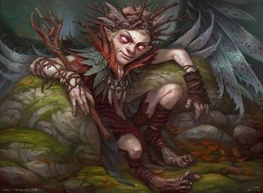

Appearance Look up

Personality Relaxed, excitable and chaotic.

Goals Trick and kill anyone he encounters, then rob them.

Notes Not very persuasive. Easy to surpass.

##### NPC - Thieves Guild Enforcer

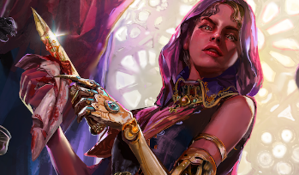

Appearance Look up

Personality Calm and powerful. Expects respect and does job.

Goals Maintain order in the thieves guild under Hexa.

Notes Lives in Mistvalley Keep and teleports when needed.

##### NPC - Merfolk Robber

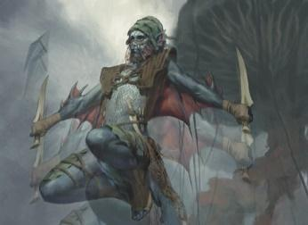

Appearance Look up

Personality Wild and unpredictable. Will flee before death.

Goals Rob unsuspecting PC's for loot and leave them hurt.

Notes Only if deviating from the regular trade routes.

##### NPC - Zareth San, the trickster

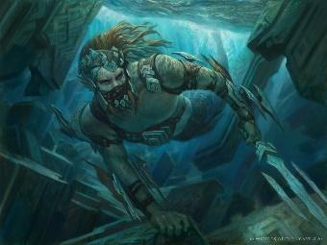

Appearance

Personality

Goals

Notes

##### Location - Dismal Blackwater

Appearance

Personality

Goals

Notes

##### Location - Temple of Deceit

Appearance

Personality

Goals

Notes Home to the Thieves Guild in Mist valley Keep.

#### Items

##### Bolt of Silence

Weapon (bolt), common

This magic bolt is much-prized by those seeking to move about unheard. Tipped with a glyph-graven head, when fired the bolt creates a bubble of magical silence within a 20-foot-radius sphere where the bolt strikes. Any creature or object entirely inside the sphere is immune to thunder damage, and creatures are deafened while entirely inside it. Casting a spell that includes a verbal component is impossible there. This effect lasts for 1 minute.

##### The Book of the Void

Wondrous item, very rare

This translation of a Librarian text tells of the outer reaches of the cosmos and the unplumbed dimensions of invisible space that suffuse all reality – a tale of cosmic outside and cosmic inside. Anyone reading the book must pass a Charisma saving throw of DC 20 to avoid becoming depressed and disturbed by the nihilistic implications of the tome’s multi-layered and profoundly pointless ontology, gaining a level of exhaustion and permanently losing a point of Charisma. Those who fail by more than 5 also suffer 14 (4d6) force damage as small voids blossom across their bodies, leaving clean, painless holes; these holes can only be closed through magic and the damage cannot be healed magically. Those who succeed on the save may use the text to glean knowledge of its spells, which can be copied into a wizard’s book or absorbed into a sorcerer’s mind: Antilife Shell, Blink, Confusion, Feeblemind, Mind Blank, True Seeing. If the reader spends 48 hours over a period of 6 days or fewer studying the book, their Wisdom score increases by 2, as does their maximum for that score, but they permanently lose 2 points of Constitution as their dreams become preoccupied with thoughts of oblivion, planets plunging into vortices of absolute night, countless lives being extinguished over the slow march of aeons, and weird, polyp-like beings invisibly drifting through the air, just out of sight.

##### Bottled Darkness

Wondrous item, common

This carefully conjured and stored magical darkness can be released from its bottle as per the spell darkness, though it dissipates after 1 minute. Even creatures with darkvision cannot see through the darkness, and nonmagical light can’t illuminate it. The bottle can also be thrown to release its darkness upon shattering. The darkness cannot be re-bottled.

##### Bottled Ocean

Wondrous item, legendary

This small bottle looks at first to be nothing more than a bottle of water, but on closer inspection, one can see within it not just water but tides, clouds, rain, and even tiny islands suspended on the surface. The bottle contains an entire ocean; if opened and poured, it functions similarly to a Decanter of Endless Water, but always as a salt-water geyser. It also continues in this fashion until stoppered, which requires a DC 20 Strength check. Various aquatic animals emerge from the bottle (1% chance each turn), and there is an entire archipelago of small islands which eventually emerge as well, growing in size as they exit the bottle (roughly 1/day for the 7 days it takes to produce the entire ocean).

##### Catoblepas Hide Vest

Wondrous item, uncommon

This vest of toughened catoblepas hide acts as a suit of +1 hide armour which also grants its wearer advantage on saving throws against petrification.

##### Censer of Peace

Wondrous item, rare

When incense is burned in this censer, no direct violence can be performed by all those who smell the incense, within a 3o-foot radius of the censer. This effect lasts for 1 minute and cannot be used again until the next dawn.

##### Charlatan’s Coin

Wondrous item, common

Though to be made by the same wizard who created the Cheater’s Purse, the Charlatan’s Coin has a simple ability – although a perfectly balanced coin, if tossed, it always lands in the favour of its owner.

##### Cheater’s Purse

Wondrous item, uncommon

This simple purse has a buckle etched with the Sylvan symbol for wealth. The purse always contains 50 gold pieces whenever opened – the same 50 gold pieces. If used to pay someone, the gold remains with them until the purse is opened again, at which point the coins vanish and reappear in the purse.

##### The Eternal Page-Turner

Wondrous item, legendary

The cursed tome known as The Eternal Page-Turner is an incredibly compelling novel that continues forever, seemingly generating new pages as they are turned without ever growing thicker. Anyone who begins reading the book must pass a DC 20 Wisdom saving throw or become addicted to it. They must now read the book for 1 hour per day for every point they failed by, with a new save every day. If they fail to complete their reading, they begin suffering from exhaustion as if they were beginning to die of thirst, which can only be relieved by reading the proscribed amount. Once a character is “hooked,” only three successful saves in a row or Remove Curse will cure them. The Eternal Page-Turner has a rich and compelling story, and reading it is not without reward. It tells the tale of a hero being reborn again and again throughout time and space, battling cosmic evil in each lifetime. The book has no formal title and seems to begin in media res. For every 24 hours of the book completed, a reader gains 100 XP, to a maximum of 10,000 XP.

##### Doppelgänger Poppet

Wondrous item, rare

The Doppelgänger Poppet appears as totally featureless until a drop of someone’s blood is “fed” into its mouth. At this point, it assumes the shape of the person whose blood it was fed, and speaks, moves (walking in place), and otherwise acts precisely as that person currently is. If wounded with a knife or otherwise damaged, drowned, etc, the person who the Poppet is mimicking receives a Wisdom saving throw to avoid 1d4 necrotic damage to the afflicted area and the poisoned condition for 1 hour; if the attacker has Sneak Attack, they also deal additional damage accordingly. If the target passes their save, the link is broken, and the Poppet can no longer assume their form, even if more of their blood is fed to the doll.

##### Fangs of Retching

Wondrous item, uncommon

This necklace consists of thirteen rat’s teeth on a simple cord. If swallowed, one of the teeth deals 1d4 damage to the swallower, but also allows the swallower to vomit forth a swarm of rats that obeys the swallower’s commands until destroyed.

##### Footpad’s Cowl

Wondrous item, rare (requires attunement)

While you wear this cloak with its hood up, Wisdom (Perception) checks made to see you have disadvantage, and you have advantage on Dexterity (Stealth) checks made to hide. Pulling the hood up or down requires an action. In addition, someone who spots you when wearing the footpad’s cowl will forget that they saw you if you pass out of their sight for 1 minute.

##### Gargoyle Lamp

Wondrous Item, rare

When lit and used to illuminate a statue that statue becomes temporarily lively enough to answer simple questions posed to it about what it may have seen over the years (provided the statue has a mouth). Statues enlivened in this way can lie if they wish – they are not compelled to answer truthfully. Each use of the Lamp rapidly burns a pint of lamp oil.

##### Gloves of Thief’s Sight

Wondrous item, rare (requires attunement)

When worn and pressed against a solid surface, these gloves see through this surface. The vision can penetrate 1 foot of stone, 1 inch of common metal, or up to 3 feet of wood or dirt. Thicker substances block the vision, as does a thin sheet of lead. The gloves do not provide Darkvision. If used continuously for more than 1 minute, the gloves require a DC 15 Constitution saving throw to avoid a level of exhaustion.

##### Gnomish Sliver mine

Clockwork, uncommon

These fiendish clockwork devices are built by unscrupulous gnomes in Mainspring and elsewhere. Armed slivermines are triggered if touched or even if a loud noise or something disturbs their delicate mechanism. They release a whirl of wicked little blades that embed themselves in those nearby. Each creature within 5 feet of a discharged slivermine must succeed on a DC 12 Dexterity saving throw or take 3d6 piercing damage, or half that on a successful save. Slivermines can also be rigged with a timer to be thrown like grenades using an action, at a target within 60 feet. Once the mine is used, it cannot be reset.

##### Gorgon Bomb

Wondrous item, uncommon

When thrown, this small grenade bursts open and releases a concentrated blast of petrifying vapour. Anyone within a 15-foot-radius sphere must succeed on a DC 13 Constitution saving throw. On a failed save, they begin to turn to stone and are restrained. Restrained targets must repeat the saving throw at the end of their next turn. On a success, the effect ends on the target. On a failure, the target is petrified until freed by the Greater Restoration spell or other magic.

##### Hand of Glory

Wondrous item, uncommon

This pickled left hand was taken from the wrist of a hanged man. It clutches in its cadaverous grip a tallow candle made from the fat of a condemned criminal. These sinister hands are often made illegally by Reanimators in Shambleside. Burglars favour them, since when the candle is lighted those bathed in its glow can be stricken immobile, making them an excellent means of pacifying angry guards or police. The Hand of Glory, when lit, requires all those not carrying it within 30 feet of the light (including allies) to make a Wisdom saving throw of DC 12 or be paralyzed for 1 turn for each point they failed. Those with eye protection will have advantage on the roll and those immune to being blinded need not save. Using the Hand of Glory in this way burns through the magic in the candle, but a new candle can be purchased for 100 gp.

##### The Head of Granny Midnight

Wondrous item, legendary

This shrunken head has long, black hair and bluish flesh. If a name is whispered into the hag’s ear, the witch attunes to them, and speaks whenever they speak. While so synched, the target suffers from nightmare haunting, with dreadful visions, reducing its hit point maximum by 5 (1d10) and preventing restful sleep. If this effect reduces the target’s hit points to 0, it dies. The head can be reattuned as desired.

##### The History of Hex

Wondrous item, rare

This heavy brown book appears to be a history of Hex. However, even cursory reading of the text reveals a very different history than that familiar to inhabitants of this reality. The text describes the opening of the Gate of Horn and Ivory in the Dreamer’s Quarter and an invasion of nightmares, captained by a brutal entity called Phobetor and its army of “Oneiroi,” daemons of terror and madness. A series of hideous wars – the Phantasm War, the War of Slumber, the Somnambulist’s War – fundamentally transform the city, which eventually becomes split into two halves – one controlled by Phobetor, and one by the magi of Hex.

This book can have a strange effect on the reader. As they read, they must pass a DC 10 Constitution saving throw and a DC 10 Wisdom saving throw. If they fail the Constitution saving throw, their body begins to change, becoming the body of their equivalent in the reality described in the tome: scars appear, strange magical tattoos blossom under skin, and they gain +2 Constitution. If the saving throw was failed by 5 or more, the creature sustains 14 (4d6) force damage as wounds inflicted by nightmare-creatures manifest. If they fail their Wisdom saving throw, they gain memories and experiences that grant them +2 Wisdom; if they fail by 5 or more, their mind becomes entirely that of their equivalent in the reality described in the tome. Constitution and Wisdom score maximums also increase by 2. Readers may voluntarily fail these saves.

##### Lawbreaker’s Mask -Hexa

Wondrous item, legendary

This twisted, colourful mask is sacred to cults worshipping the Antinomian, trickster-god of primordial chaos. When worn by a non-Chaotic creature, the creature must pass a DC 15 Wisdom saving throw to immediately remove the mask or else become Chaotic in alignment while the mask is worn. The character will not willingly remove the mask once the save is failed. A Chaotic creature can wear the mask with no ill effect. In addition to the alignment-switching properties the mask makes it difficult for someone to describe the individual. Anyone attempting to recall specifics of the individual’s dress, build, posture, voice, etcetera must pass a DC 20 Wisdom saving throw to be able to do so. Otherwise, they can offer only vague, meaningless descriptions.

##### Libro-Cupiditas

Wondrous item, legendary

The Libro-Cupiditas is heavy; its gaudy cover is made from gold dragon-scales, its title spelled out with rubies, its pages have gilded edges, and its letters glitter, the ink itself containing tiny diamonds. The book is an exhaustive set of instructions for the making, keeping, and enlarging of wealth, but also elucidates a series of mystic rites for wealth-generation. Anyone who reads it will find themselves not only more financially literate but possessed of fabulous luck when it comes to matters pecuniary. For a period of one year, they have advantage on any skill check directly related to money-making, including gambling; if they re-read the Libro, this good fortune is renewed.

The rites of wealth-generation are complex, take 48 hours to complete, and include the following:

* Swallow a gemstone worth at least 1,000 pp
* Bathe in the blood of the poor
* Drink a tincture with powdered platinum worth 500 gp, along with the hair of the wealthiest person in a 1000-mile radius
* Flay off the face of an aristocrat and wear it as a mask
* Make a paste from the bones of a banker and smear it on your skin

If these instructions are carried out and the celebrant passes a DC 10 Intelligence (Arcana) check to recite the correct incantations, their good fortune becomes truly astonishing. For one year, they gain a +1 bonus on ability checks and saving throws, and when they roll a 1 on the d20 for an Attack roll, ability check, or saving throw, they can reroll the die (though they must use the new roll). In addition, through some combination of random coincidence, fortuitous investment, savvy business decisions, sudden inheritance, or similar happenstance, they will acquire 2,000 gp per week for one year. If someone who completed the rite is imprisoned or something similar, they will literally vomit up golden coins and gemstones. The ritual can be repeated annually.

##### Massacre Flute

Wondrous item, rare

This flute is carved from a human femur and bears unusual, abstract etchings. When played it grants advantage on Performance checks, gracing its player with natural skill. However, anyone listening to the music created by the flute must succeed on a Wisdom saving throw of DC equal to the Performance check. If they fail, they fly into a murderous ecstasy and begin maniacally engaging in acts of unspeakable violence against all those near. Crowds can become truly horrifying under the flute’s influence. This effect lasts until the performance stops.

##### Music Box of Animation

Wondrous item, rare

The Music Box of Animation plays a spirited little tune when wound. Upon playing, the box brings to life all inanimate objects fashioned by intelligent beings within 50 feet while the song plays similarly to the spell Animate Objects. Such objects are not controlled by the owner of the Music Box and may act erratically, according to the nature their form suggests. Tools may become resentful of their masters, weapons enraged and aggressive; clothes may constrict or fly off; torches may flare or gutter; coins struggle mightily in purses to return to the earth, their mother. This can cause utter calamity in cities or other spaces with large numbers of inanimate objects. Shutting the music box does not immediately end the effect, which continues for 1 turn. The box has a minute’s worth of music per day, after which time it refuses to open till a day has passed.

##### Perfect Portrait

Wondrous item, rare

The Perfect Portrait appears to be an idealized portrait of whoever is observing it. No two observers see the same portrait. The style of the portrait varies with the aesthetic tastes of the observer. Studying the portrait boosts the confidence of any observer. Studying the portrait for at least 10 minutes privately grants a character advantage on all Charisma checks for 24 hours, but also requires them to make a Wisdom saving throw of DC 10. On a failure, the individual is switched with the version of themselves trapped in the painting, a version identical to them but with 20 Charisma and an Evil alignment. In the moment of transfer the Perfect Portrait ceases to function as such and instead becomes a portrait of the trapped character. The idealized version can still be played by the character but will always attempt to hide the Perfect Portrait to conceal their ruse; if the Perfect Portrait is destroyed, the idealized version will die, and the trapped character will be restored.

##### Persuasive Polemic

Wondrous item, rare

The Persuasive Polemic, a slender crimson volume, contains several pages of handwriting in different hands, followed by a series of blank pages. The written pages include eloquent philosophical arguments in favour of the divine right of kings and radical communitarianism, and a religious text effusively espousing the virtues of worshipping the Magistra, goddess of order, magic, and reason. Several other pages have clearly been removed. The Polemic’s magical functions become evident when someone writes in its pages. The text acts to reconfigure the words being written, actually moving the hand holding a quill or pen, such that the writer expresses their ideas not just as clearly as possible but as persuasively as possible. Logical fallacies are impossible to commit to paper, and problems with an argument are artfully evaded, obscured, or minimized. The result is an incredibly erudite and compelling case for whatever position is being argued. If someone is attempting to change someone’s mind using arguments pre-written in the Polemic, they have advantage on any Persuasion checks.

##### Pocket-watch of Time Dilation

Wondrous item, very rare

This ornate pocket-watch can be wound two ways. The clockwise function causes the winder to disappear from time and reappear up to minute in the future. The counter-clockwise function allows the winder to shift back up to 1 minute in time; only the winder retains any memory of the time deleted in this way. The pocket-watch can be used once per day safely. If used more than once per day, roll 1d12. On a 1, the pocket-watch breaks. It can be repaired but only at great cost (1000 gp) at the hands of an experienced artificer. In addition, anyone who uses the pocket-watch more than once per day must pass a DC 20 Constitution saving throw or suffer from a temporal side-effect, which disappears after a successful long rest:

Roll (1d6) Temporal Side Effect

1. Degeneration: The character begins to “regress” into a previous evolutionary state – so, humans become more ape-like, Lengians more arachnoid, waspkin more insectile, ghouls more canine, etc. While precise adjustments may vary this typically engenders an adjustment of -1 to Intelligence and Charisma and +1 to Strength and Constitution. Each day the character must save again or regress further down the evolutionary tree. A successful save halts the process.
2. Bodily Deterioration: The character begins to exhibit unwholesome physical changes: fingernails suddenly growing or falling out, extra teeth growing or developing caries, bald patches, uneven accelerated aging, nosebleeds, and similar symptoms. The character suffers -1 to all physical ability scores.
3. Mental Deterioration: The characters’ experience has unhinged them subtly. The character begins suffering from terrible headaches, disturbed sleep, and even hallucinations. The character has disadvantage on all mental ability scores for 24 hours, after which they can save again to reverse the effects. If this save fails, the character develops some form of indefinite madness.
4. Visions of the Past: The character has become slightly unstuck in time and now perceives brief glimmers of the past wherever they go, resulting in a blur of translucent, flickering bodies and objects. While this “ability” allows the character a brief peek into the past, it is also incredibly disorienting. The character has disadvantage on any roll relying on sight, such as attack rolls, and can no longer effectively take the dodge action.
5. Nightmares of the Future: The character suffers from hideous visions of an awful, nightmarish future – a world of apocalyptic landscapes, mass starvation, horrific crimes, and tenebrous beings devouring or absorbing all those they encounter. The character can no longer benefit from a long rest unless they pass a Wisdom saving throw (DC 20).
6. Mindswap: The character’s mind has been seized by an alien entity from a different time. Their alignment changes to true neutral, their mental ability scores change to 18, they lose all existing class levels, and they gain 1d20 wizard levels. The player may continue playing the character if desired but should be encouraged to alter their behaviour to reflect their new consciousness, gathering information on their “new” time period.

##### Poems for the Apocalypse

Wondrous item, very rare

This slim, unorthodox spellbook has incantations disguised as poems describing a series of cataclysmic events, titled “The Sundering,” “They Wept Crimson Tears,” “And Then the Heavens Parted,” “Fire Games,” “Chitinous Desolation,” “From the Outer Void,” “Hatred of the Sky,” and “The Sea, Our Devouring Mother.” The book contains the following spells, rendered in such a way that a wizard may copy them into their spellbook: Earthquake, Contagion, Control Weather, Fire Storm, Insect Plague, Meteor Swarm, Storm of Vengeance, Tsunami. In addition, the spells can be recited out loud by a trained bard, requiring a Performance check with a DC of 10 + the spell level. On a success, the spell is cast, but the poem disappears from the text. On a failure, roll on the scroll mishap table; the poem is also destroyed in this instance.

##### Robe of the Python

Wondrous item, rare (requires attunement)

This loose robe is fashioned from snakeskin. While wearing the robe you may speak with snakes as per the spell Speak with Animals. You also gain +1 natural armour. Once per day you can also use the cloak to cast Polymorph on yourself and transform into a constrictor; you retain your Intelligence, Wisdom, and Charisma scores. If as a constrictor you eat any creature, you must pass a DC 5 Charisma saving throw or be trapped in snake-form permanently, until someone uses remove curse or similar magic to reverse the spell.

##### Robe of Rats

Wondrous item, very rare

This ugly, rat-eaten brown robe looks like a monk’s garb. Although it appears to offer magical defense against unholy magic, in fact the item is cursed. Upon being donned the wearer becomes intensely attractive to rats. All rats within a 500-foot radius converge on the wearer, swarming up into the robe. Functionally, this conjures a swarm of rats every 1 minute until the DM deems the local rat population depleted or until the wearer is devoured by the rats. Clever robe-wearers will realize that they can lead rat-swarms around using the robe, potentially even forcing them into deadly situations. If someone wearing a holy symbol of Mordiggia dons the robe, then it instead grants them the ability to speak with rats, who will no longer be hostile to the wearer but who will consider them holy figures, worthy of reverence and even obedience with a little persuasion.

##### Sanguineous Stone

Wondrous item, legendary

This large, reddish-black stone permanently transmutes any liquid it touches to blood. This includes poisons and potions, although magical liquids have a 50% chance of resisting transmutation. Transmutation occurs rapidly, beginning with 5 cubic feet of liquid but expanding quickly. If immersed in an ocean or river an entire waterway can be contaminated over a period of times – days or weeks for a river, months for an ocean. If the Sanguineous Stone is removed the transformation halts but does not revert.

##### Shadow Oil

Potion, rare

This tenebrous oil is harvested from atramentals, the same strange shadow elementals whose milk is used to create the drug known as shadowmilk. The oil can cover a Medium or smaller creature, along with the equipment it’s wearing and carrying (one additional vial is required for each size category above Medium). Applying the oil takes 10 minutes. The affected creature then gains the effect of the Etherealness spell for 1 hour.

##### Skeleton Idol

Wondrous item, uncommon

This idol depicts a macabre Angel of Death, complete with bony wings and a horrific grin upon a gaunt, near-fleshless visage. This idol, if prayed to by a cleric and anointed with fresh blood, allows the cleric to temporarily replace one of their usual domains with the Death domain. This ability lasts until the cleric prays to their usual deity. If they pray to the Skeleton Idol more than three times in a row, their previous deity forsakes them and they become a cleric of the Angel of Death – they will be visited by a vision of the Angel in a nightmare, who will inform them of their new allegiance. In addition to these effects, anyone who simply carries the idol on their person gains advantage on death saving throws.

##### Sword of Judgment

Weapon, rare (requires attunement by a Lawful creature)

The sword is useless against all Lawful creatures and will not hew their flesh, while againstChaotic creatures it acts as a +2 greatsword. Any creature who wields the sword cannot tell lies and gains disadvantage on Deception checks. Chaotic creatures wielding the sword suffer 1 fire damage per turn as it burns them.

##### Tongue of Dead Speech

Wondrous item, rare

This embalmed human tongue, when placed in the mouth of a corpse in place of the corpse’s tongue, endows the corpse with the capacity to speak as per the spell Speak with Dead. While a corpse so-implanted may answer any number of questions rather than those usually afforded by the spell, it may also be highly reluctant to give up the Tongue. Unless a corpse is carefully negotiated-with, anyone attempting to remove the Tongue of Deadspeech with their hands will be subject to an attack roll with +2 to hit dealing 1d4 damage; unless the remover is wearing a gauntlet or similar armour, one of their fingers will be removed for every point of damage dealt. Destroying a head containing the Tongue of Deadspeech usually destroys the Tongue as well.

##### The Ultimate Tragedy

Wondrous item, legendary

This book has a dour cover in the least favourite colour of the one who looks upon it. Within is written a tragic play, but each reader will perceive different characters and a different plot, seemingly calculated to make them as sad as possible. One reader may discover an intense religious play, a meditation on suffering, sin, and damnation; another may find a taut domestic drama climaxing in brutal patricide (or matricide, or infanticide, or whatever other form of death the reader finds saddest); another an epic about the horror and meaninglessness of war; or any other number of variations.

If anyone reads their version of *The Ultimate Tragedy* from start to finish (a process taking 3 hours) they must pass a DC 10 Wisdom saving throw or be plunged into existential despair and acquiring a form of indefinite madness. If they succeed on this save, however, the catharsis they experience is sufficient to grant them a level of experience. They also become somewhat numbed to mundane examples of suffering.

If someone copies out their version of the play and mounts a production, the resulting performance will not change in the way the book version changes, though audience members will remember subtly different lines that will seem especially sad – if they even live to survive the play, as all audience members watching a performance of any version of *The Ultimate Tragedy* must pass a DC 10 Wisdom saving throw or else be overcome with horror and sadness, committing suicide by any means possible after the play ends. Alternatively, for campaigns that wish to avoid depictions of suicide, the audience may lapse into a state of depressed catatonia for 1d100 days.

Those who succeed on the saving throw gain a level and 1 point of Wisdom as their souls are ennobled by the experience. Audience-members who survive such a performance will often become tight-knit, recognizing in one another a shared trauma. They will often be inspired to perform acts of charity.

##### Vermin Drums

Wondrous item, uncommon

This pair of drums is made from two bisected human skulls whose open tops are covered in flayed human skin. When beaten, the drums cause worms and creeping vermin of all kinds to writhe forth from bare earth, or else from manhole covers, holes in a wall, or some other place where bugs might nest. This summons a swarm of insects (drummer’s choice) under the drummer’s control. The ability can be used once per day.

##### Zombie Paddles

Wondrous item, rare

These glyph-engraved wooden crosses, created by the renegade reanimator known as the Marionettist, can be used to cast the spell Command at will but is only effective against zombies. Once per day, it can be used to cast the spell Animate Dead to produce zombies, and also grants control over an additional two zombies.

#### 8 magic items and Metals

_______________________________________

**Elemental Plane of Air - Aerialite**

Over the aeons, beings of great power have clouded the purity of the infinite Elemental Plane of Air with their own palaces, meteorite-sized chunks of earth, or clouds thick enough to support buildings, that hold their followers or even entire civilizations. These solid materials have gradually been influenced by the plane’s magics, causing them to aerate, and a new, unique material to be formed, aerialite. An excessively light, but still workable material, aerialite is a sky blue metal with powerful magic flowing through it, making its properties quite unique.

***Aerialite Dagger***

Weapon(dagger), uncommon

This extremely light, but very sharp dagger is made of a light blue metal known as aerialite. This metal lets the weapon cut through the air far faster, and for far longer, than knives of any other type. The throwing range for this weapon is increased to 150/600, and you get a +1 bonus to attack and damage rolls made when throwing this magic weapon.

***Wings of Supreme Flight***

Wondrous item, very rare (requires attunement)

This sky blue cloak is decorated with thousands of small, intricately carved feathers of aerialite, infused with magic that allows the wearer to have mastery over aerial movement and acrobatics.

While wearing this cloak, you can use an action to speak its Command Word. This turns the cloak into a pair of beautiful bird wings on your back for 1 hour or until you repeat the Command Word as a bonus action. The wings give you a flying speed of 60 feet.

Additionally, while you are flying using this cloak, you have advantage on acrobatics checks, cannot be grappled, and cannot be moved against your will. When they disappear, you can't use them again for 1d20 hours.

***Sword of Cutting Gales***

Weapon (longsword), very rare (requires attunement)

This sword's pale blue blade is capable of cutting with unmatched precision and speed, allowing the user to strike down opponents with deadly efficiency. You gain a +1 bonus to attack and damage rolls made with this magic weapon. Additionally, this weapon gains the finesse and light properties.

Gale Strikes. This sword has 3 charges. As an action, you can expend a charge to slice this sword in wide arcs, cutting the wind itself and sending sharp blades of compressed air out in a 20 foot cone. All creatures of your choice in this area must make a DC 13 Dexterity Saving Throw or take 4d6 slashing damage. This weapon regains all charges daily at dawn.

_______________________________________

**Ethereal Plane - Etherplasm**

Adventurers, wizards and wanderers are often familiar with the odd realm of the Ethereal Plane. A plane of existence that directly borders the physical world, but where one can manifest as a mysterious, invisible, and incorporeal figure, free to travel and move in any way they please.

However, travelers who have strayed too far into the mists of the Border Ethereal know that there is a darker, much less traveled interior of the plane. The Deep Ethereal is home to objects, energy, and even beings, that are almost entirely enigmatic. Dense ethereal energy, against all odds, forms a material with weight, mass, and physical properties. All objects and beings in the Deep Ethereal are made of this substance, Etherplasm, much to the dismay of those who may have assumed themselves safe from physical harm in this plane.

Etherplasm is a unique, gelatinous, translucent gray solid, that constantly undergoes sublimation while outside of the Deep Ethereal plane. Within seconds, small samples of Etherplasm will wisp into nothingness, and within minutes, the same will happen to any amount of the material. Care must be taken to seal the material properly within a container, and to use it as fast as possible when it is exposed.

Etherplasm can be worked into any malleable substance, giving the material a faint blue glow after the process is complete. When used in a weapon, the weapon can be used to damage creatures and objects that are currently located within the Ethereal plane, and when used in armor, the user gains the ability to physically interact with, but not damage, the same creatures and objects.

Etherplasm can also be used in potions and magical items that allow travel to the ethereal plane, or the summoning of creatures native to it, making the processes much easier and cutting costs considerably.

***Rift***

Weapon (rapier), very rare (requires attunement)

This exquisitely crafted and remarkably thin rapier glows with a faint blue light. The magic infused into this item is powerful enough to pierce through dimensions, but requires careful precision to be used properly.

This rapier has a +1 bonus to attack and damage rolls. Additionally, the intense magical energy from this rapier can be focused into it’s tip, allowing the user to pierce holes through reality with single thrusts.

This weapon has 1 charge. As an action, you may expend this charge and spend movement to make a wormhole strike. Charges regain each dawn.

When you make a wormhole strike, you may make an attack on a creature within a range of however many feet of movement you spent. Your arm as well as the sword pierce through a small tear in reality and stab the target out of nowhere.

For every 10 feet of movement you spend making a wormhole strike, you can deal an extra 1d8 piercing damage to the target on a hit, to a maximum of 3d8 extra damage.

For all intents and purposes, all attacks with this rapier are still considered melee attacks. This weapon regains all expended charges daily at dawn.

***Cloak of Incorporeality***

Wondrous item (cloak), legendary (requires attunement)

This unassuming black cloak holds the unique magical properties of the Ethereal Plane within it, allowing the user to transcend the limitations of the Material Plane without the need to exit it.

This cloak has 3 charges. As an action while wearing the cloak, you can spend a charge to become completely incorporeal for up to 10 minutes, or until you end the effect (no action required). While you are under this effect, you gain the following benefits:

- You cannot be physically harmed or affected by any creature, object, or spell.

- You cannot physically interact with, or cast magic which affects any creature (besides yourself), object (besides those on your person), or spell (besides spells you have casted after you activated this effect). You can still hear and speak to others while under this effect.

- You can move in any direction through space, including up and down, through objects, and through magical barriers, as if you were walking normally.

- Any object you drop will be suspended in space and remain incorporeal until you end the effect.

If you re-materialize within an occupied space, you are shunted to the nearest unoccupied space and take 5d10 force damage. This item regains all expended charges daily at dawn.

​

***Hades - Daemon Iron***

The realm of Hades is a plane that is entirely devoid of emotion, life, or spirit. The magics of Hades actively drain mortals of each of these qualities, reducing them to soulless husks willing to commit themselves to an afterlife of aimless wandering, without qualm or resistance. While this may make curious mortals easy targets for local fiends, it is not an environment that fosters the creation of impressive magical materials.

Although no metals are native to Hades, the Yugoloths wished not to build their fortresses and strongholds of torture with cobblestone and dead wood. So, iron was imported into the plane through the magic of Arcanaloths. This iron, like all things on Hades, was slowly influenced by the magic of the lower planes, and began to take on the characteristics of Hades itself, becoming daemon iron.

The magic infused within this material saps all emotion and identity out of those who are near it. Daemon weapons can cause powerful amnesia effects on individuals that they strike, while daemon armor can make the wearer immune to several kinds of mind-altering magic. However, these enchantments slowly affect the user as well, and over time they lose the ability to feel emotions as strongly, or at all.

***Gauntlets of Cleansing***

Armor (gauntlets), uncommon (requires attunement)

These pale gray gauntlets allow the user to cure ailments of the mind, calming the fearful and steeling the enchanted against their seducers. As an action while you are wearing the Gauntlets of Cleansing, you can touch a creature and end a magical effect that is causing them to be frightened or charmed. Additionally, while you are holding these gauntlets over your ears, other creatures cannot communicate with you telepathically.

***Blade of Mind Drain***

Weapon (longsword), very rare (requires attunement)

This unassuming iron sword has an almost sentient hunger for the memories and emotions of its victims, destroying their minds as efficiently as their bodies. You have a +1 bonus to attack and damage rolls made with this magic weapon.

This weapon has 3 charges. As an action while you wield this blade, you may force a creature within 60 feet to make a DC 15 Wisdom Saving Throw or suffer extreme amnesia for 1 minute. The creature forgets where it is, who it is, and cowers away from perceived threats and abnormal situations. The creature is incapacitated, will use its full movement to run from anything that threatens it, and may re-roll the saving throw if it takes damage, or if an ally uses their action to attempt to snap them out of it.

This item regains all charges daily at dusk.

***Helm of Nothingness***

Helm, legendary (requires attunement)

This pitch black iron helm provides the user a barrier to even the strongest of psychic assaults and mental malaise.

While wearing this helm, you are always under the effects of the mind blank spell, except you are immune to the frightened condition in addition to its other effects.

#### Ideas

##### Fun - Session 1

murder via rug of smothering

##### General - Moerth arch mages

In large cities, and a group description for the church.  
  
GMR River bridge- old Stonebridge  
  
Alchemy book - Celum Tinture

##### General - DESERT CULTURES OVERVIEW

Diet -   
Salt+Meat and root vegetables. Sweets are delicacy  
Curry and bread is a pretty common desert staple.  
Thing-on-a-stick (lizards, rodents, bugs, dune mice).   
Cactus fruit/flower/just eating a cactus. Humans can eat cactus  
Each other. Make it a freaky cannibal society on the down-low.   
  
Heirarchy  
Cheifs/Kings?  
  
Ideas -  
Beetle-headed merchants?  
Desert Chasers of the Great Storm?  
Ring worm attacks  
  
  
Alicia's characters lover will be found in a fighting ring or at the hand of a bbeg, not knowing who she is.

##### NPC - Jerrik the human.

Definitely a doppelganger

##### NPC - Sir Pent-Arrow

A man of renown that owns his stature and reputation. Sir Pent is well known to all and is a man of legend, with some believing he is a disguised dragon.

##### NPC - Lady Tianne Ashwood

(Matteo's aunt ig) is an influential noble. Lives in Port rockstar and is currently campaigning for a post of lord representative.

##### Plot - Three sons, princes, were all born on the same Day:

Elijah, of Kotharel  
Gregg , of Shartan  
Goora, of Spirality Forest  
All go MISSING on the same day with a letter left

##### Plot - Hexa has agents

in the merchants Guild, bard college and even the university. Feeds her information

##### Plot - Plots

Undead- visit university for answers  
  
Pirates - speak to military in Meera or a town mayor  
  
Political - talk to lawful reps.  
  
  
Aquatas merfolk are actively repelling sea monsters from gaining influence in the world. This is my the Lurker wants to defeat them, and claim the area as his domain.  
  
From this, I want to add a man washing up on a shore all frazzled on a broken rowboat, going on about a mythical fight with mermaids and some tentacle monster that his ship got caught in the middle of. Only he managed to escape on the boat while his crewmates were used as a throwable weapon by the monster.  
  
The guys name will be ________ maybe an old sea captain or first mate?

##### Plot - Why does a bugbear need silver?

DM brain activates  
On your way to town, you pass a merchant cart. The owner, looking shaken and confused but unharmed, says he was robbed by goblins and they only took his silver pieces leaving the gold and copper.  
In town you discover the local bank was robbed. Again, only silver pieces were taken.  
Following the tracks/clues, you discover a tribe of treetop dwelling goblins who are attacked monthly by werewolves. They've stolen the silver pieces and are attempting to melt them down and coat their weapons. Will you help them defeat the werewolves? Will you kill the goblins and take the silver back? What do you do?

##### Plot – Ending Session 1

Dim orange haze begins to show over the south-western horizon. Grows over the first week until panik or uncertainty sets in with locals. Find out that there has been a phase shift in the Nightgrove forest, which slowly passes over the region, unleashing otherworldly beings in the area that begin to grow their reach.

##### Plot - Conflict in support of the old King

The old King was removed with usurpers and divine intervention, but loyalists will have kept secrets and traditions in alignment with his rule. Good catalyst for the revolt, and allows leaders/bbep into the conflict in each town.  
  
Should assign which towns have heavier loyalist presences/which openly oppose Kings rule.  
  
Add pirate attack on OAR ship to news in next town. Happened at far water. Call for sailor soldiers.

##### Item - Gauntlet of the Aether

- Mooncake Artifact.

##### Item - The Storm Quiver

Quiver that holds 10 arrows and imbues them with a d10 thunder damage or something.

##### Location -Town of Tide-Swallow

is a town set in a valley below sea level, and if flooded every month before draining through a volcanic geyser that effectively pumps the water back to the ocean. All buildings build on thick stilts.

##### Location - Evershard mines

**Player Notes**

## Backstories

#### Matteo – Half-Orc Barb/Cleric

**PASSIVE PERCEPTION 13**

**OCCASSIONALLLY RAGES INVOLUNTARILY. FIGURE THAT OUT**

**BACKSTORY**

**I**

Ten months of the year, rain battered the clifftop temple called Stormhall. Built of unhewen stone and salt-eaten wood, the temple stood as a tribute to the Storm God. Acolytes served not through prayer, but by feeding the temple's massive flame, a beacon that guided sailors safely to shore.

It was here, twenty years ago at the **edge of the world**, that a baby washed up on the rocky shore. As Arch Priest **Mellian** pulled the infant from the icy water, he noted the child's grey skin. Pulling back the infant's bottom lip revealed two small tusks that confirmed his suspicion. The child had orc blood.

It wasn't hard for Mellian to piece together a narrative. This far from any orc settlement, the child was likely born a bastard. A human mother and an orc father. It didn't take much of an imagination to understand what possessed the poor girl to abandon the baby. Mellian's heart ached for her.

But despite all that, the child was chosen. Born of two worlds, wanted by neither, the storm god delivered him to Mellian.

As he began the ascent back to the temple, Mellian held the baby close.

**II**

The child, born to no mother or father, was soon being raised in the temple by the family that found him. Twenty-eight priests doted on the boy, scolded him and taught him how to make trouble. They saw him take his first steps and speak his first words. They read him their history and prepared him for a life of priesthood. Tupper was the name they gave him, after the mythological builder who is said to have crafted the temple with his bare hands.

Along with raising the young orc and showing him their ways, the priests also protected the boy. They knew what could happen to him if anyone were to find out about his existence. So he was kept within the confines of the temple grounds.

In many ways the temple was the perfect place for the boy to grow up. It was far from any settlement and never entertained visitors. The grounds were vast, with caves to explore and creeks for swimming. But most of all, it was where his brothers were. As Tupper aged into adulthood, like his brothers before, he chose the path of an acolyte.

When he came of age, Tupper was baptized in the storm. Cast out into the very same icy waves that brought him to the temple shores twenty years ago, Tupper emerged anew. He was no longer a bastard abandoned at birth but a chosen priest of Stormhall. A **brother of the rain, wind, and salt.**

**III**

The **celebration** of Tupper's annointment did **not** **last**. That same **evening**, a brother **returned** with a troubling **message**. The **island** had been **invaded**. By whom it was **not known**, but news had spread that the army was on its way.

Mellian did **not** **fear** the changing of **rulers**. Power shifted like the tides and the **temple** had **no** **business** playing **politics**. The temple's business was being a **beacon** for **seafairers**, a duty it performed regardless of who sat on a throne. But something was different this time. The temple usually recieved a formal greeting from the new ruler, or even a simple letter of introduction. But no such communication had been established.

**On** a peculiarly **stormy** **evening**, after a **week** of **silence**, the **temple** **got** its **answer**. A force of **twenty** **men**, cloaked in **black** and **armed** with **daggers** ascended the steps **to** **Stormhall**. Like shadows they **moved** **through** the **temple**, killing priests in their **beds**. **Mellian** had time enough to **hide** the half-**orc** **under** the **floor** boards before he was **strung** from the banister and **slaughtered** like an animal.

**Mellian hides Tupper and is killed brutally by WHO?**

*The* ***Night Cloaks*** *atemped to snuff the light of Stormhall in the OAR. Their hirers did not Identify themselves, but they would be a group that wanted to sew chaos into the republic and raise old powers in the sea.*

Tupper didn't remember anything after that. The fear and andrenaline had held him frozen, stole the breath from his lungs. A tunnel closed around him and everything went black.

**Denial and fear. Passed out**

When Tupper woke he was in the courtyard, kneeling naked in the rain. His heartbeat was slowing from a rabid pace and he could feel the ache and sting of a dozen blade wounds all over his body. At his feet lay eight bodies. Dismembered, gutted, and broken. Limping through the temple, the scene was much the same. Bodies of brothers and enemies littered the grounds.

**Blind rage. Naked and lots of murder**

The course of his life once again turned toward darkness. His family had been killed and his home desecrated. Fearing more would come, Tupper knew he had to leave. Taking a piece of the **temple's flame** in a lantern, Tupper turned his back on Stormhall forever.

**Leaves forever fearing life is over**

People:

Mellian

27 other priests – Followers of Torrent

20 killers, all killed. WHO THOUGH

Items:

Broken Trident (Unident) & Temple necklace,

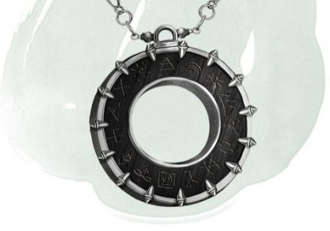

Cracked pendant

#### Matteo#2- Ol’Tek Twilight Cleric

Like many boys, Ol'tek dreamt that he would be a great hero. However, in the ruins of Rasa, there were few opportunities to be such. Much against his parent's wishes, he joined the Order of the Twilight at the age of ten.

Followed hero dreams, join clerics at age 10

In keeping with the traditions of the order, Ol'tek had two mentors -- the first not being of the Twilight Order at all. His name was Janus, a priest of Lumas who happened to be travelling through Rasa and took a liking to the boy. Janus was a warm man from the East with a kindly sense of humour, lacking entirely the harshness of the desert. Janus taught Ol'tek how to call upon the power of the sun to light the way and heal with magic.

Two mentors. First Janus, priest of Lumas. Good man

His second mentor was a Silver Priest of the Order called Sel'jak. She took the boy on as an apprentice not at her own will, but at the humble request of Janus. She was a tough teacher, cold and lacking any humour -- a perfect representation of the very desert in which they lived. She instilled in the Ol'tek the ways of the night, teaching him how to pass through shadow unseen and kill all manner of creatures. Together they walked in death, shepherding souls to the other realms.

Second is Silver Priest Sel’Jak. Tough, cold, one of shadow

After his education was complete, Ol'tek donned the black cloak and swore an oath under a twilight sky.

Swore oath as twillight priest

It didn't take long for Ol'tek to become well respected in the order. He protected a number of high profile travellers and even earned himself a decent living on tips (something not strictly forbidden by the Order). However, he didn't properly feel the satisfaction of adventure until he met

***Aldwulf Kadrehl***

**Aldwulf** and his party were meaning to cross the entire desert without stopping to re-supply in any settlement. They were to move quickly, inconspicuously, and, as expected of Dwarven nobility, were willing to pay handsomely. Being still young and inexperienced, Ol'tek took the job without so much as a second thought.

***Aldwulf was in a hurry to return home after news of his ailing father, hurt in a cave-in and sick with fever***

*Taking group fast through desert for good money.* ***Dwarves***

On the second day, **Aldwulf** was bit by a venomous viper (A Cilviper, lol), but Ol'tek neutralized the poison and healed him. On the third day, they diverted course so as not to disturb a **blue dragon's lair**. (*The dragon’s lair appears as a lush oasis, in which the dragon’s illusion tricks people to drinking sand until they’re unable to hack it up, and die of disease or mass in your stomach)*On the fourth day, they encountered a desert troll. Ol'tek led the creature far away from the party using himself as bait. He returned later that evening, bloodied and bruised.

Four days of near peril. The fifth saw disaster

On the fifth day the sandstorm rolled in. There was no shield that could stop it, no magic to quell its fury. It was a true force of nature and it tore through their camp in the early hours of morning. Ol'tek had only seconds to shout a warning before his voice was drowned out. His visibility went to zero. Casting a minor spell, he could see the general location of his party members, scattered about, seeking shelter where there was none. He tried to move towards the nearest of them but lost the battle against the wind. They would not survive in the open desert. Already, he was buried up to his knees.

Sandstorm. Group lost without magic, and lost still.

Then he saw it, uncovered by the shifting sands, a stone slab covered in ancient runes. With great effort, he threw the slab aside, revealing a room buried beneath the sand -- ruins offering shelter from the storm. He fell down into a heap of decaying artefacts: crumbling pots and unidentifiable threadbare cloth. Something in the heap reflected the light pouring in from the hole in the ceiling.

Find shelfter in old, runed crypt. Open slab and dive in.

Ol'tek sifted through the debris, pulling forth a polished silver lantern. Despite being buried, it showed no signs of age, but the lid seemed fuzed shut. Using a spell of unbreaking, Ol'tek separated the two pieces and black smoke came curling out.

Find silver lantern, fused shut. Break and open.. Smoke

The smoke assumed a rough humanoid shape and Ol'tek's fear quickly turned to relief. He fell to his knees before the Djinn, pleading for it to grant him just one wish. The Djinn said no words, only stared at the Priest through glowing purple eyes. Then Ol'tek voiced his wish, "I wish for the power to end this storm and save my friends."

Purple eye Djinn. Ol’tek asks for help and power

Ol'tek felt a surge of power flow from his heart into his left arm. Removing his glove he saw his veins glowed purple with power. He looked to the Djinn for an explanation but the humanoid form had dissipated and the black cloud slipped out through the entrance Ol'tek had made. Ol'tek followed, emerging back into the storm. There was no sign of the Djinn. No sign of the dwarves. In desperation, Ol'tek raised his hand to the sky and... all went silent. The wind ceased and the sand caught in the storm stayed suspended in the air.

Get power, smoke leaves, and the storm stills in the air.

Ol'tek scoured the dunes, pulling dwarves from the sand like ripe carrots. All were accounted for. To show his thanks, **Aldwulf** gifted Ol'tek his warhammer.

**Finds the dwarves, gets warhammer known as Daybreaker**

As the party continued onward, Ol'tek felt a tinge of pain in his left hand. Pulling his glove free revealed blackened veins and dying skin. He bore the Djinn's curse.

Continue quest, gain a curse onbenownst to the dwarves

*Upon seeking out ailments for this curse, Ol’Tek learned of a healer in Retria by the name of* ***Cardaro Macasse.*** *An accomplished man, and old friend of Janus. Cardaro Macasse earned his fame in knowing the hidden secrets of the world. Should anyone know of the curse you have, and it’s ailment, it’s likely him. Not to mention, the strength and power of the church is in full swing in the OAR.*

*Cardaro is nearing the age of that which most pass on, as far as Ol’tek is told. Time is now of the essence. So Ol’tek chances the waystones, an old relic often warned against, to save the many-month journey. Beyond the doubt of even the priests, the relic powered to life and transported Ol’tek to his destination.*

*Take the waystone from* ***Vermillis*** *or* ***Wake Field?***

***RETRIA****, home to Lord Osval and 4 OAR Representatives*

*Ol’tek knows only this of Retria. It’s a city the size of a region, taking a day and a night to cross. And that’s if you know your way. Most stick to their homed neighbourhoods, main roads, or key arteries throughout the city. Beyond that, vagabonds, merchants, whores, and nobles (amongst many factions) occupy the vast city to make it beat strong and true.*

***Retria finds wealth in trade, mining and bountiful woodlands.***

**THE SILVER PRIESTS**

The Silver Priests begin their worship when the shroud of night folds over the Tarsal desert's unending sky.

Theirs is not one of old chants or stuffy prayers, the desert has no patience for that. The priests serve

their matron, Lunas, as wardens of the twilight, keeping watch over the bright settlements and dark sweeping

dunes of the desert.

The role of a Silver Priest is not unlike that of a shepherd, guiding travellers between settlements in the

open desert or leading creatures of shadow away from harm. But on occasion a rogue force manifests, prompting

swift and final action. For this reason, Silver Priests are some of the most adept warriors in the Tarsal,

instrumental in the protection of Rasa, the Tarsal's largest settlement.

Silver Priests are nomadic, travelling between settlements performing acts of medicine and magic. They are

bringers of life -- aids to mothers in labour -- and a comfort in death -- walking with dying souls into

the afterlife.

**Ally - The College of GOND**Finorder of craftsmen that work with the Silver Priests to adequately arm them to face their foes and rise to their challenges. Operate out of Vermillis, with Close ties to the Dwarven Craftsmen of Vel-Gendar

Helped Aldwulf Kadrehl, the last lord of the Clan before it fell to the World Serpent. Ol’tek(?) helped Aldwulf earlier in life and earned the prestigious gift of a Dwarven warhammer by the name of

Hammer names:

* Daybreak

Reason to leave?

The order itself is becoming villainized, and for some reason a new so and so is in power.

#### Isaiah – Eld’n Elf, Bard-Eloquence Age 28

**PASSIVE PERCEPTION**

The ballad of Dandelion Everbloom

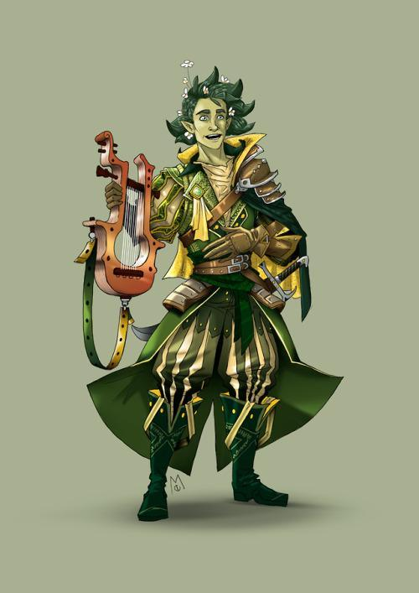

Starting as all Eladrin do Dandelion was **born in the fey wild**s and with him was born his **bloodied twin Thorn**. As with all Eladrin, **Thorns mission** is to **kill** his unbloodied **twin** and start the cycle over again nothing will stop Thorn from his mission. In fact, on their very first day Thorn as a baby attempted to take a rock and bash dandelions head in but failed his is task. **Dandelion** has **always** been **running** from his twin as to **evade** certain **death** **but** what **makes** this **difficult** is that all **Eladrin** are **linked** **mentally** and **spiritually**, this means what ever Dandelion knows and thinks Thorn also knows and vice versa they can also mentally communicate using this link.

***RET-CON the RED so it’s deep-seated and limited to family + Primal fey and past lives, not ALL Eladrin so directly.***

Dandelion was ever the **problematic** **child**, always **pulling** **pranks** and **telling** wild **stories** to **entertain** and **delight** his **friends** and family. But there was a **secret** **reasoning** behind this as Dandelion was **purposefully** naming things wrong and **convince** **himself** of these in correct names to **throw** **Thorn** **off** his **trail**. Dandelion was **never** **truly** a **follower** of the **gods** as he always **found** **them** to be **interfering** and **annoying** but he **does** **follow** and **give** light **praise** **to** the **Twin** **gods** of the **chase** beseeching them to keep him safe and keep ahead of his evil twin. One thing **Thorn** **hates** almost as much as Dandelion is **puns**, **music** and **fables**, thus **Dandelion** to **erk** his **twin** as much as possible **became** a **bard** and **joined** the **Lyres for hire** become a part of something grander in his mind. **While working** with the LFH (Lyre for Hire) **Dandelion collected** many **stories** and heard **rumour** of even more **legendary** tales he wished to collect and **spin** in his **own narrative** to let all the people know Dandelion Everbloom can tell the best rendition of the story and make his own story’s with a group of legendary adventurers.

**Throughout** his many **adventures** Dandelion has **had** *cough* “**relations**” *cough* **with** **countesses**, **duchesses** and even one **queen** **although** that **particular** **story** did **not** **end** **well** and to this day there **remains** a **bounty** on **Dandelions** **head** if he is **ever** to **return** to that **country**.

Ever charismatic **Dandelion** truly **wishes** those **around** **him** to have a **genuine** and **fun** **time** while also **assisting** them to **follow** along in his **grand** **schemes** and plans, **while** he is **not** **evil** **if** there is a **noble** to **rob** or a **dragon** to **seduce** you can **count** on **Dandelion** Everbloom to **be** **there** doing his thing to make his next and greatest idea to come into fruition.

Fond **memories** were **created** when **Dandelion** **attended** the **bard** **college** of Eloquence, in this time he **made** a true **name** **for** **himself** (in his mind) and **learned** the **craft** and art of **Story** **telling** (You do NOT want to hear him sing…..) and **learned** the “**Game of houses**” a **political** manipulation **game** **played by many** if not all of the nobles across the world, as it turns out **Dandelion** was a **natural** at this **game** and **often** would **influence** important **political** **decisions** **without** even **realizing** he had been playing.

In particular there Is on Duchess who claims due to his influence she got cheated of her chance of becoming queen, though Dandelion claims this as a lie and states that if she hadn’t been addicted to sniffing perfume she would have won the crown, how this story got out he does not know or so he claims.

Due to his evil twin hell bent on killing him Dandelion never stays in one place for very long and often doesn’t even know where he is or how he got there and ends up spinning some elaborate tale to how he got there (often very untrue but true in his mind) this confuses and enrages his twin Thorn who cleverly has become part of a paladin group who are on the hunt to purge evil. Thorn has convinced this group that Dandelion is a evil sorcerer seducing the masses into his schemes and must be killed at all costs and those with him purged from the world of the living. Through his charismatic attitude he has influenced many of the lands and tried to spread his favourite catch phrase “ If they don’t find you handy they should at least find you Dandy”.

Eager to tell legendary tales and build his reputation Dandelion has begun looking for a adventuring group to build their and his story to make a tale to be known across the world. **Hears of tales to the East in the mighty oceans, and decides to test the reach of his brothers influence. Charters a boat and heads to Usterduum.**

**Characters**

Dandellion Everbloom - Isaiah Char, ElfMonk

Thorn Everbloom - Isaiah Brother

Queen Andalle - Queen of Stories

Sir Delmonn - Noble knight of E.P.  
 (*Elysian Protectorate)*

**Items**

**Locations**

Realms of Xandor Birthplace

Lyric Bard college attendance

Somarden Queen’s Tale origin location

Much of the Central part Time spend fleeing and evading

of the western

subcontinent

#### Alicia – Satyr Monk-Asc’t Drg, Age 96

**Astraea of Sylven**

**(Satyr Female/ Way of the Ascendant Dragon Monk/ 96 yrs/ Strawberry Blonde/ Green eyes/ 4’11”)**

Astraea had no memories of her biological parents. From as young as she could remember she was nurtured by a dryad of a great willow tree. **Sylven** was a kind but fiercely protective mother to the forest and a mother to a young just as fierce satyr. Her days were simple living in the forest, as she grew older she grew to know the forest like the back of her hand. No matter how far she strayed she always found her way home. The animals and other creatures had a reverence for her, even the predators bowed their heads as her tiny hooves hit the forest floor knowing her to be under the care of their protector. The only creature that did not turn to her was her mother.

**Satyr raised by Dryad, was well respected in the forest**

Like most mothers Sylven would scold her for coming back to the grove late, not bringing a shall when it rained, and being reckless and getting hurt. When Astraea wasn't being scolded by her mother, her mother was singing to her teaching her how to forage, telling tales of travellers from the outside world and most importantly teaching her how to respect the forest and maintain the balance.

**Held back and taught by mother dryad**

One night Astraea rested in the bows of her mother's tree sleeping soundly, she was woken to the distant sounds of marching, She looked to her mother who was already standing on high alert. Minutes felt like hours as they saw torches through the trees, the forest fell silent aside from the footfall. Astraea tried desperately to count the torches in the distance, it was not a large party but still, more than she had ever seen. Her mother had said on occasion humanoids from outside the forest would come and seek her out, though those people were often druidic or at the very least had a respect for the fey. This felt different though, a pit opened in Astraea's gut.

**Rising Action – Human intervention.**

A small party of men, human men led by a tall **elvish** man, finally broke into the clearing donned in leather and metal. A smell of soot and alcohol hung in the air. Sylven gestured to Astraea to stay hidden in the bows of the tree, but she climbed high up and peaked down onto the gathering. Her mother emerged, her slender figure somehow still seemed to tower over the men.

**Introduction of bad man**

The man in the middle who Astraea identified as the **leader** due the way the other men looked to him for direction and validation they were where they needed to be. He, in stark comparison to his flunkies, had a young face but an air of wisdom about him that indicated he was **much older than he looked** to be. His long **silver-blonde hair** reached the small of his back. He had a grin on his face of sick **satisfaction** having **found** the **home** of the **fabled “Mother of the Forest**”. The elvish man identified himself as **Lunan Willowsong**, a man of lofty wealth and he came to the forest seeking his bride that matches his namesake.

**Nobleman finds hidden grove.**

He took in her form slowly like how a mountain lion would stalk its prey. He made promises of saving her from this boring life stuck in the forest. She would be the jewel to his crown, and together they’d command power and earn a spot amongst royalty. Finally, he presented her with a **bracelet**, attached was an **acorn** **of** **far** **travel** which would allow her to travel from her tree. Astraea’s hair stood on end, she was no stranger to magic her mother taught her of her ways. She could feel a spell placed upon the bracelet, a spell that would bind her mother to Lunan. She looked to her mother, she was also aware of the trick placed upon the trinket.

**Fake offer of grace via bracelet. Mom knows**

Disgusted, Sylven attacked Lunan’s party brutally. Striking them down easily, leaving Lunan alive to watch his men fall. She strode up to him gracefully and towered over him commanding him to leave her forest at once and if he or any of his people were to return she would see them all dead. Months following that incident Sylven became uneasy, rarely relaxing, causing the pit in Astraeas stomach to grow.

**Mom kills men, threatens bad man**

Astraea woke up one night to the sounds of marching once again, but this time the footfalls were heavy and accompanied by the sound of dragging. Before she could react she felt her mother lift her into her arms, holding her to her warm wooden chest. She could feel her mother slightly trembling but despite that, her mother looked down at her face tears welling in her eyes but a soft smile on her face. Sylven pressed a **small gold embossed leaf** into her daughters hand and **nudged** her **towards** the **edge** of the **grove**. The marching drew close and she could hear shouts and the snapping of branches and the fall of trees.

**Many coming, mom ushers girl to leave**

As the **sounds** drew near they began to see the **fire** in between the trees, and the smell of **smoke** filled the air. **Sylven’s** face changed to **panic**, she looked down to her daughter and **urged** her **to leave** the forest quickly, trusting her daughter would know the swiftest and most untraveled path. Without giving much thought and frightened by her mother's sudden panic **Astraea** **ran** turning around one last time at the edge of the grove she looked at her mother one last time. Sylven straightened up and looked at her daughter they exchanged a loving glance, and she looked away as **Lunan** **burst** through **into** the **clearing**.

**Last glance, mom then face of enemy**

Astraea ran through the forest as fast as she could, her body on auto pilot luckily she knew every path of this forest with ease. She ran until morning and she finally came to the edge of the forest. She kept running over the rocky terrain, afraid that if she stopped running then reality would set in, realizing the likelihood that her mother was gone. She finally stopped on a hillside, looking down onto the forest she once called home now engulfed in flames and spreading quickly.She walked for days, exhausted and sapped of all energy she finally collapsed. Assuming it to be the end she felt wash of relief over herself and she let herself slip away.

**Ran away, out of forest into hillside/mountains**

She did **awake**, in the wee **hours** **of** the **morning** a layer of dew covered her body. The fur on her haunches caked with mud and blood from where she scraped across jagged rocks. It took all of her strength to lift herself from the ground. She dared not turn around for she would then truly have to take in the reality of her new life ahead of her, but the scent of bnurning wood hung heavy in the air. To **stop** herself from **thinking** further she **started** **walking**, she was unsteady on her feet but she **trudged** **forward**.

**Wake up, carry on and avoid past**

She **walked** until she **saw buildings**, down in the **basin of a valley**, her mother told her of far off villages and the people that dwelled there, though she didnt recall them all in a favourable light. Astraea finally **collected** the **courage** to **approach** the small **town**, it was easy to **avoid** the few **guards** they had. She **hid** in the **darkest** areas she could find, **surviving** off anything she could find.

**Enters town, stays hidden**

Just when she was **realizing** she **wasnt** going to be **able** to **live** like this forever, while she was **collecting** **water** from the dripping gutter hanging off the local tavern she was spotted. A large **man** came **barreling** **towards** her **shouting** for any **guards** near to **come** at once. He **grabbed** Astraea by the **bicep** easily lifting her up, he **wreaked** of **liquor** and sweat. She **tried** desperately to **wriggle o**ut of the mans grasp but it was to **no avail**. She was **brought** into the **square** which before had been dark and empty now **full** of **people** clamouring to the square to see the commotion all lit with torches.

**Captured by man, brought to square**

Once she was in plain **view** of **everyone** she was **passed** to the **guards** and **brought** **infront** a man in much **fancier** clothes than anyone else she had seen in the town. The crowd grew dead **silent** as she was **thrown** **at** his **feet**, he turned her to look at him with his leather boot and she **met** his disgusted gaze**.** He gave her a **death** **sentence**, she didnt understand why all she knew was that she was **set** **to** **hang** come morning. The **crowd** erupted with **cheers**, she prayed to hear at least some protest but the only sign she saw of that was hanging in the door of what looked to be a blacksmith. She stood next to a stout human man but she was tall and well built, her skin green and two small tusks protrude from her lower jaw. Before she could look closer she was knocked unconscious.

**Death sentence. See orc, and knocked out**

She went through the motions once she came too, no fight left in her **completely** **surrendering** to her sentence. She **didnt** **understand** why she was set to die but she **didn’t** **care** she had **nothing** **left** to keep **living** for. Just when she **heard** the **bell** toll, a **disturbance** could be heard **down** the **hall**, her instincts told her to stand up and ready herself. She heard **footsteps** approaching her cell and **unlocking** her **door** but she couldnt see who it was, just then the door swung open, it was the **tall** **green** skinned **woman** she saw the knight before. She wore the same pained **sad** **expression** and without saying a word Astraea knew to **follow** her. As she **escaped** the **barracks** she **saw** **bodies** hewn here and there in halls.

**Orc kills many to help escape in darkest hour**

**Astraea** **escaped** with the woman she came to know was a **half-orc** named **Sanira**. She **brought** her to the **tribe** where her mother lived, while the **people** were at first **wary** of such a creature as Astraea once they **heard** of what she **suffered** in the town their **attitudes** **changed**. They werent loving or nurturing but **willing** to **attempt** to give **Astraea** the tools she needed to **survive**.

**New home with orcs, new opportunities**

They **knew** that her **satyr** features were always going to be a **cause** for **trouble** so they **shaved** her **horns** down and when she left the tribe grounds she would **bind** her **hooves** in leather and where **baggy** **pants** to **hide** her **haunches**. Astraeas **relationship** with Sanira grew into **loving** one, Sanira kept Astraea safe and in return Astraea would tell her of the forest and sing her the songs her mother taught her.

**Disguised satyr, loving relationship begins**

Sanira also **brought** Astraea into the **temple** of **Eigengrau**, **trained** her to be a **monk** in the way of the **ascendant** **dragon**. She **excelled** in this **practice** her small frame and **agile** **nature** allowed her to take to the **training** quite **easily**. **Sanira** was already a **master** of the martial arts and she grew more and more **proud** as **Astraea’s** power grew. Sanira’s **mother** **didnt** take **kindly** to **seeing** her **daughter** grow **weak** **over** a small impish creature such as **Astraea**.

**Trained as monk, mother not happy**

They **woke** **Astraea** up one **night** under the **guise** of more **training**, **bringing** up to the **highest** part of their **tower**, there she **meditated** for **hours**. **Unbeknownst** to her, **Sanira** was across the camp being **knocked** out and taken out of camp to be **exiled** in an **unknown** **location**. **Once** Astraea **heard** of this she **unleashed** all of her **might** onto **Sanira’s** **mother**, **nearly** **killing** her. Astraea **wandered** the **badlands** for days in **search** of **Sanira,** now she **wanders** the **world** **looking** for **her**.

**Mother betray, Sanira Banished, Mother attacked, look for Sanira**

**Characters**

Astraea/Shem (Orc) - Alicia, Satyr Monk

Sanira - Half-orc love interest

Sylven - Alicia Dryad mother

Lunan Willowsong - BBEG, bad noble of nearby area (Grogg)

**Items**

small gold embossed leaf

Acorn of Far Travel

**Locations**

basin of a valley town

Dragon orc village

Orc Tower

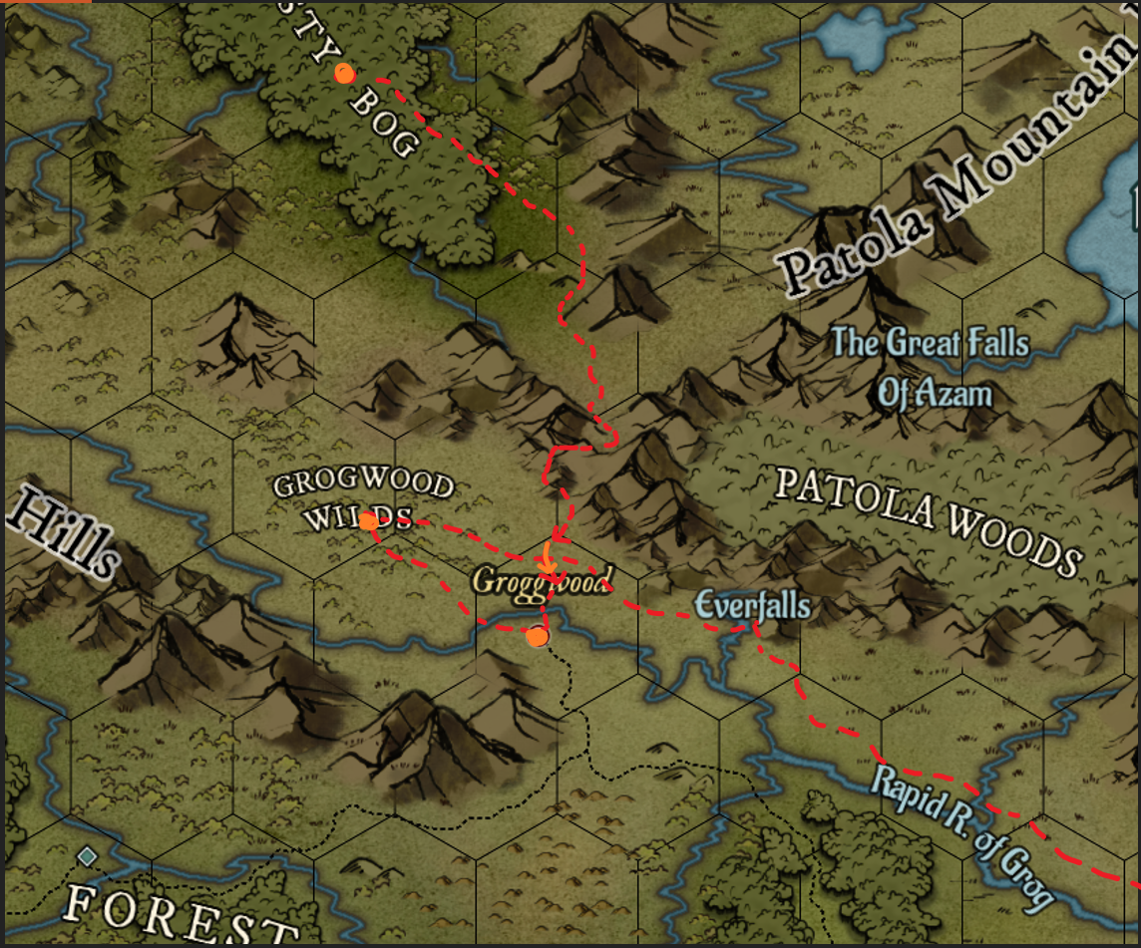

**Story in world**

From Misty Bog, known as the ***Banyon Grove*** to inhabitants

Noble of town trekks to hunt for renown, finds them

Mother banishes them, he comes back

Astraea runs, mother left behind

Go south over patola mountains

Go to Groggwood

Sentenced to death

Broken out by half orc

Escape with to Groggwood wilds, orc settlement

Learn monk ways (Eigengrau, way of Ascendant Dragon)

Bad mom of Sanira (**Name**?)

Sanira banished

Astraea leaves to find her

<TIME PASSES>

Eventually makes way to Usterduum to on a lead of a woman half orc champion being set out on a quest to clear through multiple temples and crypts, searching for… something.

#### Chr’tn – Forest Gnome Druid Age 200

**PASSIVE PERCEPTION 12**

Indigo Ursus Arctos

**BACKSTORY**

At **200 years old**, Indigo had **taught** the **Sana**

**family** the **medicine** they practice for **7 generations**.

Her **career** with them **ended** when she **discovered**

that the 7th **son** she taught, **Raik** Sana, was

**intending** to **use** her **teachings** for **evil**.

She could **not let** him **continue** to gain power and

knowledge and **murdered him** to **prevent** the

fruition of his **intentions**. She **reported** to the **family**

that they **encountered** a **bear during a lesson** in

the **forest** and she was **unable to save him**.

**No** **one** **assumed** a tiny **gnome** could have **bested**

their strong **beloved** **son**. The **family** was **unaware**

of her **druidic** **nature**. She was **never** **considered** a

**suspect**. **Killing** Raik **broke** her **heart**, she had

**known** him **since** he was a **child** and was of course

**close** with his **family**.

She **couldn't** **bear** to **stay** and **watch** the **family**

**grieve**. She felt **sorrow** and **guilt** but **not** **regret**.

She now **feels** **lost**, after **losing** the **job** she had

held and **enjoyed** **for so long**.

She also **feels** **ashamed** and **angered** that **Raik**

had **used** her **teachings** to **commit** inhumane

**crimes**. She **came** from a **long line** of **teachers** and

**knows** **no** other **trade**, aside from what she

teaches (which is medicine). She **doesn't** **think** she

**could** **ever** **trust** enough to **teach** **again**.

She has **no** **goal** or **destination**, this was a setback

she would never have anticipated, **but** she is **not**

**aimless**. A **spark** is **alight** **in** her **soul**, **motivating**

her to **end** **anyone** who **commits** **crimes** **against**

**nature**.

**Approach by Grove Striders**

**Ask:**

**What kind of town/location/background do you want?**

**How did you leave your home?**

**What kind of evil was the student learning? Biological?  
 *Idea – Pulling essence from people to grow his own.***

--

Fun fact: Ursus Arctos is brown bear in latin.

**TRAITS**

*Before you get to know her, Indigo can come off as a nosey know-it-all who has "been around longer than you".*

*She has some new-found trust issues and can be guarded and elusive.*

*If you make it through her defenses and she makes a great friend, caring and always happy to help.*

*When she asks a question, you get a sense that she is gleaning more from the conversation than just the answer. She is learning about the person from the way they speak, thier posture and energy.*

*She is good at reading moods but doesn't care enough to be sensitive to them.*

*She quite enjoys the company of anything with feathers of fur.*

*She is curious about the odd things or the seemingly minor details, less so what might seem a big deal to others.*

*She is mysterious, full of magic and cunning, but not very interesting to her aquaintences who tend to amount her up to her size.*

#### Jason – Aasimar Storm Sorcerer, 27

**APPEARANCE**

**Sparky** is a 27-Year-old male. He stands 5’9, slim, wiry build from years of sailing/pirating, skirmishes, the occasional shipwreck on a deserted island.

**His skin** is tanned dark from being out in the open sea all day long. The hair on his body is an almost translucent, bright white. His short hair is cut roughly and perpetually messy like he had just stepped out of a wind storm.

**He** **used to be self-conscious** about his white hair until his mom and friends spread the story that Sparky had so much of the Everstorm lighting magic in him that it turned his hair white. Kids stopped making fun of him as much afterwards.

**His eyes** are usually a sky blue unless his emotions get the best of him and, in which case, they start glowing a bright, hot white with occasional tiny bolts of lighting crackling outward from them. It’s assumed by Sparky and those around him that his eyes glow because he is a young and hot-blooded sorcerer who has poor control over his lightning-based powers.

**He wears** a long, dark gray oilskin cloak with a large cowl and an eclectic mix of traveler, pirate, and military garb all a bit worn and threadbare in places from adventuring and constant seaspray.

**PERSONALITY**

Sparkticus is a **trigger**-**happy** **thrillseeker** with a fierce **rebellious** streak. He can **never** **sit** **still** in one **place** for too **long**. He’s a **simple** man who **loves** his **adventure**, his **loot**, and his **gold** above all else. Or at least, that’s **what** he’ll **tell** **you**. **However**, he will **never** **hesitate** to **rid** a town of raiding **marauders** and **slavers** or quietly slip his **entire** life **savings** into the **pocket** of a **starving** **mother** on the street so she could **feed** her **children**. If you try to confront him about it though, he will feign ignorance or dismiss the conversation  with a casual lie or joke.

His biggest **hubris** is his **recklessness**. At its most **extreme**, it’s almost as if he has a **complete** **disregard** for his own **life.** Despite his antics though, he’s **not** **daft**. He has a **sharp** **mind** and **approaches** **problems** with a **tactical** and exacting eye. This is **mirrored** in his **speech** as he often **prefers** **directness** over tact and he finds **no** **value** in **formalities**, ceremony, or most societal laws–having literally been on both sides of the law.

For the most part, he is easy-going enough and will happily go along with anything as long as it might give him the sweet adrenaline rush he so craves. Those who seek to harm the innocent

**BACKSTORY**

Sparky and his mother, Zyra, lived in the city of **Retria** where he grew up. **Zyra** was the **daughter** of the Storm Chasers’ **Storm** **Lord** and a **Sea** **Master** within her clan. Sparky is the only male heir of the current Storm Lord, his grandfather. They spent their lives between city and storms for many happy, chaotic years

**Origin. Retria. Zyra mother, grandpa is Storm Load. Sparky male heir**

He is **unaware** of his **lineage** on his **father’s** side, much less his divinity. His **mother** only **told** him that his **father** was a **passing** foreign **traveler** that appeared one day on the shores of Retria and **left** **before** Sparky was **born**. His mother and **Sparky** were **ostracized** because she had a relationship and a **child** out of **wedlock** that was **not** **approved** by the **Stormlord** and Sparky was marked as a “**demon** **spawn**” when he **started** **exhibiting** **powers** as a baby. **IN REGULAR CITY LIFE, THE ISSUES WERE LESS-SO, RESULTING IN SPARKY BEING COMFORTABLE IN MODERN SETTLEMENTS**  
**Doesn’t know about aasimar. Father is someone else, but shunned to others cuz of powers.**

Zyra raised him on her own without her clan's support. But she made a hard but modest living from putting her exemplary naval skills up for hire. She never let Sparky feel ashamed of who he was and taught him everything she knew about sailing/her love of the sea and to embrace his abilities. Sparky was extremely proud of his mom and wanted to grow up to be just like her.

**Raised by single mom raised. Raised well and proud. Loves his mom**

When he was little, he found out his mom’s name meant “dawn/Eastern Brightness” and thought that the actual dawn and his mom were the same thing/interchangeable words because she was the one who would always wake him up to start a new day. As he got older, it became an ongoing joke/term of endearment because his mom would always be the one to get him out of bed no matter how bleak or depressing the day seemed. Ex. “Oh wow, it’s Zyra already, where did the time go?” “I have to wake up before Zyra or she’ll shake me out of bed again.”

**Side Joke about mom’s name meaning Dawn, Eastern Brightness**

Sparky signed up for the Storm Chasers as soon as he was old enough. Before that point, there were also several failed attempts to enlist before he was of age (Ex. Lied about his age unsuccessfully, disguises/impersonations, multiple attempts to crash entry exams, etc.) He was heavily bullied during training but befriended two fellow rebellious spirits, Rai (F) and Dorrin. They became fast friends and would often get into trouble together, especially with the local authorities.

**Joined Storm chasers after much failed attmpes. Bullied but firneds with Rai and Dorrin. *Trio!***

One day, his new friends and mother came up with the idea to spread the rumor that there was a piece of the Everstorm in Sparky which explained his appearance and magical abilities. The bullying abated after that as people were either curious, in awe, or frightened of him. Sparky harboured feelings for Dorrin, but he kept them secret as he knew Rai had feelings for Sparky and he knew telling the truth could potentially break apart the trio.

**Sparky + Friends change perception of powers, got renown. Also feelings for Dorrin (M)**

By working hard together and raw talent, Sparky and his friends rose up to the ranks of Tide Surge by the age of 16. But Tragedy struck when Zyra was hired on a large expedition sponsored by wealthy patrons to breach the Everstorm, **supposedly using some new artifact to guide them**. The small fortune this expedition would pay would mean Zyra and Sparky would no longer have to live day by day. But she never returned and it was assumed the ship was wrecked at sea as there were no survivors or traces of expedition ships.

**Opportunity to breach storm with riches possible. Zyra left but never returned (11 years ago).**

PER SPARKY VISION, IT WORKED. SHE’S IN ANOTHER LAND WITH ODD BEINGS.

Sparky was convinced his mother was still alive and did everything to convince the Storm Chasers to rescue her, including getting into an argument with the Storm Lord himself where he accused his grandfather of being a coward and abandoning his daughter. His anger got the best of him and his powers were unleashed, setting fire to the Storm Chaser’s guild hall and almost striking down the Storm Lord with lightning. Sparky was immediately confined to the dungeons.

**Denial. Argues with Storm Lord, unleashes power. Thrown in dungeons**

The moment he got out, several weeks after his fight with the Storm Lord, he concocted a plan with Dorrin and Rai to steal the Storm Breaker. The plan was to convince a small and discreet group of fellow Tide Surges to man the ship and prove their worth by breaching the Everstorm and earning instant promotions to Sea Masters–but the real purpose was to search for Zyra and save any remaining survivors of the expedition. Out of sheer luck and a bit of magic, they succeeded in stealing the Storm Breaker and setting sail towards the Everstorm.

**Makes plan with firneds after released. Steal Storm Breaker, set sail**

Unluckily, one of the biggest and most violent storms in the Storm Chaser’s history blew in on the night of Sparky’s plan. Sparky and his friends sailed well despite the extreme conditions and managed to get incredibly close to the Everstorm but their ship was suddenly struck by a freak bolt of lightning and the Storm Breaker was ultimately shipwrecked. The last thing Sparky saw before being swept away in the storm and losing consciousness was Dorrin and Rai climbing safely onto a safety raft.

**Big, BAD storm. Got close but lightning strike & shipwrecked. Sparky passes out seeing friends**

When he awoke, he found himself stranded on the shores of one of the Meerilian Islands. He spent many **WEEKS** alone on the island and surviving the elements before the pirate crew of the Golden Rose found him. Too ashamed and knowing returning to Retria would mean instant banishment or a life sentence, he convinced the Captain of the Golden Rose to let him join their pirate crew.

**Wakes up, Beached. Found and taken in by Pirates of the Golden Rose**

After many swashbuckling adventures and years of a questionable but thrilling life as a pirate, Sparky was starting to question their way of life and their disregard for those they hurt along the way.

**Enjoys pirate life, but only for a while. Too much hurt**

The Golden Rose was finally chased down by the Meera Trading Company after a raid on one of their ships and their pirate crew was captured. During the fight, Captain Helen Cromwell was impressed by Sparky’s naval finesse and fighting ability. He was able to take down nearly half of her crew of skilled officers and crew people without actually killing anyone.

**Pirate crew hunted, fought, and Sea Lord Captain impressed**

She gave Sparky an ultimatum, join her crew as a probationary officer of the lowest rank and reduced privilege as he was an outlaw and work his criminal sentence off or rot in a Republic jail cell for the rest of his life.

**Ultimatum: Join Navy or Join Jail.**

Sparky was trained and became an officer of the Meera Trading company, as a naval sailor, storm navigator/specialist, and occasional battlemage. His skills as a Storm Chaser, magical abilities as a storm sorcerer, and natural talent made him an invaluable shipmate and he soon gained the trust and respect of his officers.

**Developed career and became integral to the crew. Used bad skills for good**

EVENTUALLY SPARKY HAD WORKED OFF HIS SENTENCE, AND DECIDED TO LEAVE THE PATH OF THE NAVY BEHIND HIM. SEEKING A PATH BACK TO THE STORM AND ANSWERS ABOUT HIS MOM AND DAD, SPARKY FOUND HIS WAY TO USTERDUUM, WHERE HE COULD START ANEW.

**Characters**

Sparkitus (Sparky)

**Zyra**

Sparky’s mother –

Fiercely kind, strong, fearless, and outspoken. A force of nature in her own right.

**Rai Surewind**

female best friend –

Sassy, quick-minded, but reliable to Sparky. Her family have been Storm Chasers for many generations.

**Dorrin**

Sparky’s male best friend –

Two years older than him. A fellow outsider but talented and passionate sailor with a gentle demeanor.

**Storm Lord**

Grandfather –

Captain Mercer Mace and the pirate crew of the Golden Rose

**Captain Helen Cromwell (F)**

Meera Trading Company –

His commanding officer of a ship in Huron’s Fleet

**Items**

**Locations**

Retria, early life

Pirates Sanctum post-everstorm tragedy

Everstorm – tragedy

Usterduum – Current position

Rebecca – Dahlia

**Name** - Dahlia **Race -** Human **Class -** Cleric Level 5, Life domain

**Alignment** - Neutral Good **Patron -** Maat

**Patron** - Maat, the Judge (Servant of Lumas, God of Sun and Life)

**He is an intermediate deity, the second most-powerful type of deity – below a greater deity but above lesser deities, demigods, and the like. Fey originating, all-serving. Focused on endurance, compassion, and justice.**

Raised in the church and has been considered a devout worshiper turned cleric who cannot bear to see others in pain, who has received personal instruction from the pope (?) of the church. She considers this to be a high honor. Currently on a quest to relieve suffering and heal others while journeying across the continent.

Raised as an **orphaned** acolyte in church of **Retria**, Dahlia proved herself devout and committed enough to take up cleric hood. Dahlia was taken under the tutelage of **Low Sentinel Maria Blackwood** who spoke in favor of her devotion to helping those who suffer undue pain. Dahlia was given free passage to travel the republic (and world, if necessary) to follow her passion in the name and image of the church.

Dahlia has worked many deeds in recent years. Most recently, she/you worked with **Cardaro Macasse** and the local adventurer’s guild to ‘purify’ the path of despair, south of town. In these weeks, months, years of service, she found quiet places to meditate and reflect. Upon one of these reflections, **she blinked, and a month had passed**. She came home to find the church and guild sick with worry, and **Cardaro missing.** Last she heard; he ventured down the path on a regular cleanse.

Unsure of recent events, Dahlia went to an old friend, **Lady Shaunna**, seeking patronage advice and support before she headed out to find **Cardaro**.

Cardaro Macasse – An accomplished man, and old friend of much nobility. Cardaro Macasse earned his fame in knowing the hidden secrets of the world and committing great deeds in the name of his family.

Maria Blackwood – Delightful natured, wealthy beyond means and wise beyond her years. Maria is a gnome paladin that lives in the Halfling district and works in/with the church. She takes her low sentinel duties seriously, and looks after the lowest of people in the city as best she can.

Lady Shaunna Humek – Human nobility, kind and respected. Lady Shaunna is heavily invested in much of the town, namely the Dwarves district shops and the Market District.

Retria – A bustling city of retirees, military families, and old heroes. The people of Retria live with abundant renown, and act like it. If you don't fit in, you'll be told so.

Retria is formally regarded as a city-state, although the area it directly controls is large and the area it indirectly influences is huge. The surrounding countryside out to around 50 miles in all directions is heavily patrolled by Retrian guards and militia and the city frequently employs mercenaries and adventurers to further secure its borders out three times as far.

Made of **districts** named for races and funtions. Dwarves, Market, Halfling, Tiefling, etc.

**Possible side quest/ working towards?**

However the pope of the church is masquerading as a life domain paladin while in actuality is a Neutral Evil grave domain paladin who is providing cursed items to lower leveled members who cannot tell the difference. - Her amulet is one of these cursed items.

The church is governed by a circle of High Sentinels that travel regularly and meet often, as needed. Each year a spokesperson is chosen among the Sentinels to speak for the church.

One of the High Sentinels is **Tyrell Berlavi**, who **Dahlia** met once upon the ceremony in which she was given her freedom. He gifted her an “Amulet of Balance”, in the shape of a sharp crescent that hangs down.

His purpose is to sacrifice the opposing churches to build an empire for the god Bane (<https://forgottenrealms.fandom.com/wiki/Bane>). Looking to summon this god, ascend to being a demigod and rule with Bane as his right hand on this plane.

**Tyrell is a devout servant of Aenthi and is attempting to destroy the church from within while also collecting secrets known to banish demons. Tryell has been promised immortal power and freedom in the end.**

Possible End game / if this character comes back - party finds her strapped to a sacrificial Altar dead / dying while the pope ascends to a demigod?

**Note Packet**

### Letter to the Players

Welcome players!

Welcome to my world. **Your** world of **Morthia (Mo-earth).** Welcome to lands divided by Race, religion, and political conflict. This world, open to explore, will serve as a realm of stories to be made and legends to be unfurled.

The regions of this world are described later in this document. Valleys, oceans, forests and mountain ranges dominate the land, serving as natural divides between kingdoms. Among the topography are more than 100 major locations over 9 Nations, some new and many old. Each location has their own special histories and secrets, culminating into a world so large that no one man could explore it all. And in this new world age, nothing stands for certain.

Long-standing effects of ages past have led to a world without extensive divine intervention. The 829-year-new 'Age of the Haps' began with the fall of the **Mad King** in Morheim and the divide of his kingdom. This, plus a flurry of other events, have shown the gods that mankind needs no longer rely on their direct engagement. Lesser gods still wander the world, but the prime deities have receded to their place in the astral plane, only to impose their will on the domains in which they claim. The nations are still adapting, as the world finds it way once more. But with all these changes, so too came the chaos.

**Pirates, Dragons, Undead and War** riddle the world. Evil lurks in the shadows and is slowly growing to a point where it can no longer be tolerated or ignored. Widespread calls to heroes are heard and taken up. Now, the call is for you to take! Choose your role in this world and find the evils that lurk in your story. Or… choose to join the evil and see how far it goes.

The choice is yours. The story is ours.

Let’s see what happens!

*IF THERE IS AN ASPECT OF YOUR CHARACTER TO BE ADDED, LET ME KNOW AND I'LL WORK WITH YOU*

### Your World (Map)

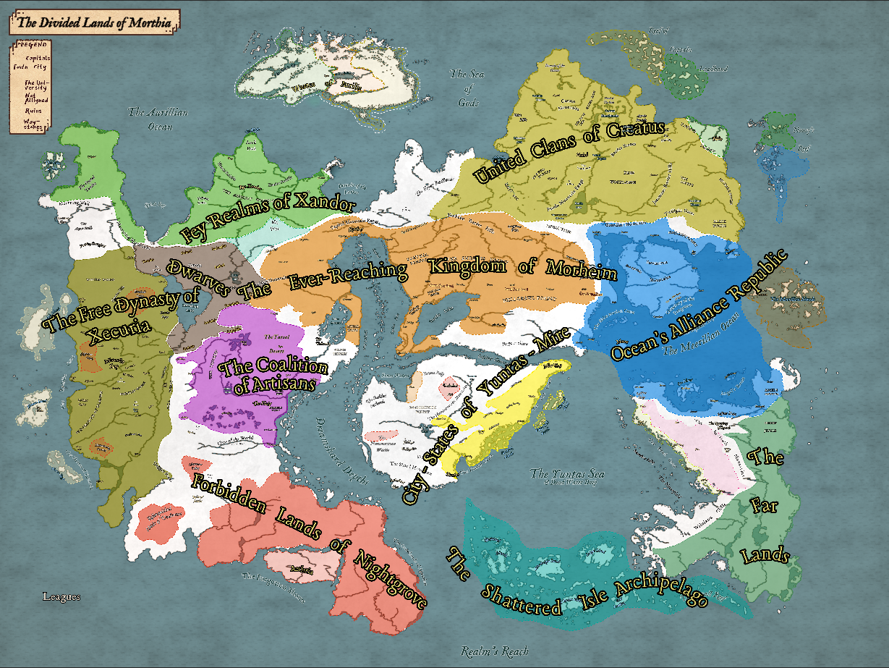

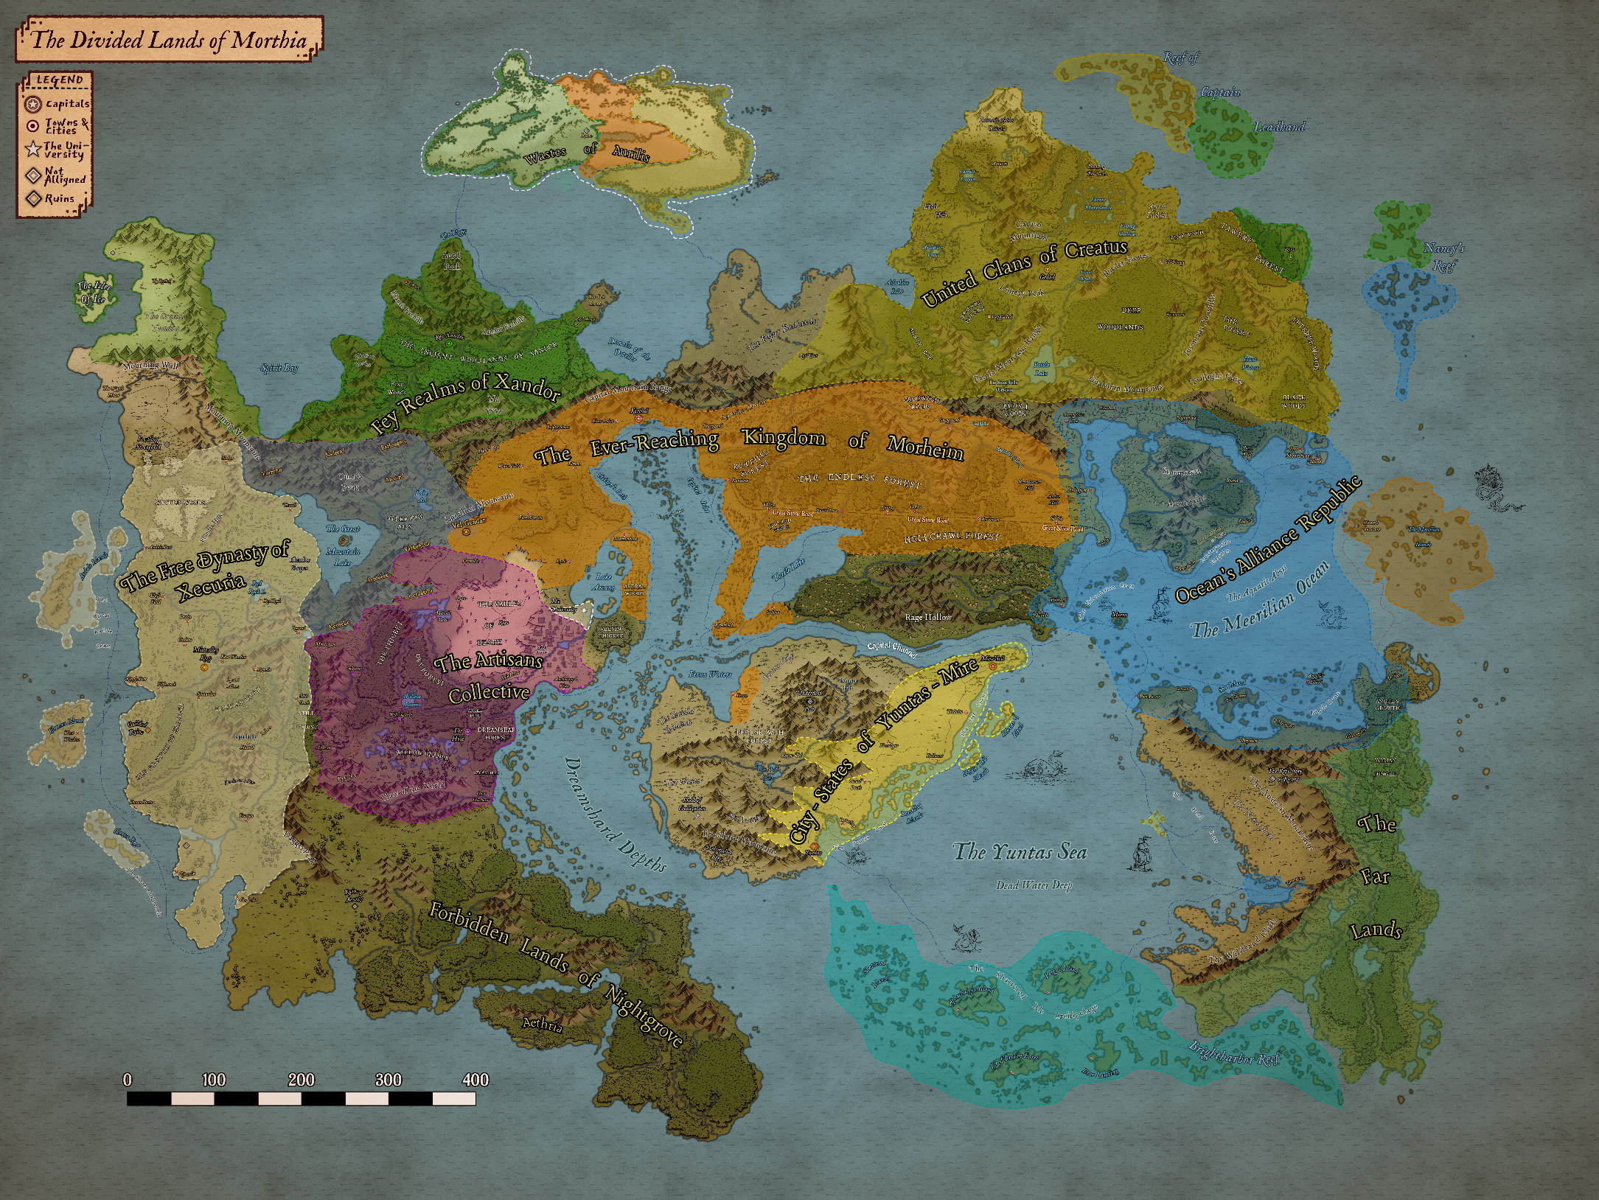

### Homebrew Mechanic

#### Soul bonds

Soul bonds are uncommon for regular folk but well known to all religious leaders. A long and complicated ritual can link two souls, and they will share most effects and thoughts while bonded. Soul bonds are not taken lightly, and trust is of the essence when creating one.

They are believed to be applied directly by Lumas & Maat, and channelled through the priest and/or ritual caster.

It Requires:

* Willing souls
* Offering of something important each person is willing to lose. Appendage or piece of extreme value and importance to the player
* A promise, to stay unbroken.

Effects:

* Share all afflictions, dreams, and blessings/curses, less physically transmitted curses (lycanthropy).
* Can communicate basic thoughts and emotions to each other.
* If one partner is killed, the bonded partner becomes permanently comatose, and their souls are corrupted.

Can be broken by:

* **Spells**: Mind Blank or Wish, plus other DM ruled alternatives if found.
* **Common agreement** to dissolve the bond.
* **Breaking the promise** (corrupts the souls)
* Fulfillment of the promises of the bond.

### Brief World History

Religious leaders and historians commonly teach of **5 ages** in this world. They are summarized as follows:

The Age of Chaos

At the beginning, there was the void. The astral sea was filled with entities of chaos, dominated the no-lands, fighting aimlessly for survival and power amongst primordial gods.

Then came the **First**, as it's known. The First knows no name, but was the only entity in existence to not thrive in the darkness. The First radiated untold power, and birthed the primal realms.

The realms existed in intertwined **elemental chaos**, but were immensely rich in substance. From this chaos over time came a magic that bound together, further solidifying **order in the universe**. Over much time, the energy formed and molded itself into the planes of existence known today.

The Age of Celestials

Through the ashen skies of Creation Primordial, the new and formless energy of Lumas emerged to claim the new realm as his own.

Lumas formed Geeba, then Lunas and Lastly Nereus. They formed the basis of all life on Morthia, but Geeba swayed in alignment.

Geeba, god of the earth, feared the potential of life, and shook violently to kill it all. Lumas brought forth the **Shine** that radiated over the world for an eon. The shine imbued the world with magic and attracted an ancient void god, name unknown.

The Age of Creation

Ancient times of primitive races like Troglodytes and early humanoids. Soon came what would be known as modern humanoid races. In this age, most deities are born and made into legend, affirming their place in the world.

The Age of creation includes the rise of ancient civilizations, long-lost powers, and the emergence of the demon lord, **Azerim**. Azerim ravaged the world for centuries before one hero, **Hammer Ranjfold** faced them alone and, with the help of the gods, decimated the demon hoard before sacrificing himself to banish Azerim into oblivion.

The Age of Man

A new age is celebrated following the banishment of a demon lord, **Azerim**, and defined by the explosion of humanoid development in the world, with the influence and help of the gods.

This age follows a **Cultural Exodus** to far, unknown lands in the east. It historically ends with large political, gruesome-fought wars, and fables conflicts in the pantheon(s). The western nations soon receded back to their lands after heavy losses, and a large storm begins to rage between the lands. The **Everstorm** begins, becoming an impenetrable wall of tempestuous force. The history of what's beyond is mostly lost to time, but legends remain.

Established in this age is the **Ocean's Alliance Republic**, and the **Yuntas-Mire** city-state nation.

The age is officially ended with the beheading of a mad king, at which time the gods recede from human involvement to allow for the world to follow it’s own path. They left to the astral plane and established an entryway known as the **Diverging gate**, for those who wish to physically traverse the planes indefinitely.

The Haps

Marked by the receding of the gods to a lesser role, and the demise of Morheim's mad king **Arteron,** 829 years ago. At this time, the province of **Xecuria** found a new leader and broke off, forming it's own **dynasty**. Quickly after came The Collective**,** a group of like-minded trade cities and cultures that chose not to be led.

We now explore the time known as The Haps.

The world is currently finding it's purpose and path in an age that no longer relies so heavily on the gods. With wars, conflicts, and uncertainty in the air, it's hard to say what will come next..

### Races (Brief Summary)

Permitted as a Player:

Dragonborn Rare, but found in small communities everywhere. Both feared and respected.

Dwarves Homes are the mountains/Forests and hills. Largely extinct, save some areas.

Elves Almost exclusively in the north. Being with humans is internally frowned upon

Gnomes Mixed in with the world. Some communities lives in the wild but are respected.

Half-Elves Wary to humans, shunned by Elves. Half-Elves have it hard in this world.

Halflings Tolkien's Hobbits. Just think that.

Half-Orcs Rare but like the half elves, find it difficult to find a home. Fight for respect.

Humans The most abundant race. Vary largely in culture and most other aspects of life.

Tieflings Greeted with stares and whispers, they suffer violence and insult & mistrust.

Aarokocra **Very** rare, and not native to this continent. But they are accepted when found.

Aasimar Seen as children or champions of gods. Feared, respected & looked upon warily.

Lizardfolk Found in deserts. Largely left to their own but live freely with humans in Yuntas

Changeling Seldom recognized for what they are, they live with humans in secret.

War-Forged Remnants of ages past. Warforged are believed to be soulless constructs. Rare

Non-Permitted, but may still be in the world (not part of civilizations) Negotiable given reasoning.

Loxodon Only in fairy tales are they known. If found, they'd be hunted or Revered

Kobold Goblin-like Lizardfolk. Vicious, greedy, and reclusive, praying on those they find.

Genasi Not welcome in many areas, they are seen as to chaotic and closed-minded.

Triton Fabled to reside in underwater nations, the triton are hunted like a white whale.

Leonin Again, fairy tale. No one's seen one, but history books say they lived to the East.

Satyr Deep in the forests of unknown lands, Satyrs are told to live and hunt.

Tortle VERY Rare and believed to be an abomination, until spoken with.

Shifter Lycanthropy or beast-changing without magic is largely feared & untrusted.

### Nations

The nations of Morthia are diverse and unique to each other in many ways. They share battles, secrets, alliances and powers hither to unknown.

#### Morheim Kingdom

Nestled in the north center of the continent, Morheim is ruled under a kind and fair rule by King Ferguson Divinitus.

Currently, they're riddled with bandits beasts along major trade routes that are cause for significant alarm.

**Capital: Korthal**

#### Xecuria Dynasty

The ruler to the west is Queen Andale Xecuria, a powerful mage and elected heir to the recently liberated region of Moreth.

The people of this nation are still adjusting to their severance from the kingdom, and are finding their path. All they know for sure is they've entered a new era for their people

**Capital: Mistvalley Keep**

#### The Collective Alliance

The lands of The Collective are ruled by the code of the guilds. Tradespeople, merchants, and citizens alike hold respect and order above all else.

They have achieved peace through the pursuit of development. The council of the 9 Guild leaders acts as a representative government for international business.

**Capital:** **The Hold** The Hd

#### Ocean's Al. Repub.

The People of OAR are a homogeneous, sea-faring nation who live by ocean trade.

They sail along the coast as the deep waters are ridden with pirates and sea beasts. The Everstorm rages to the east, past the pirates reach.

**Capital: Trader's Outpost Meera**

#### Xandor & Creatus Clans

The Kingdom of Creatus is nestled in mystery, north of all other nations. It’s a place of conflict.   
There is an ongoing war between Orcs and Elves, which has been at a stalemate for generations.

**Capital: Rea Xandor & Gag Gedad**

#### States of Yuntas-Mire

Yuntas-Mire is a coastal collection of largely independent city states, governed by two leaders from Yuntas and Mire'Seil. Their desert lands lie on the dead continent, and their culture shows an elegant resilience to both their environment and the nations around them.

**Capital: Yuntas & Mire'Seil**

#### The Far Lands

Nothing is known about The Far Lands, hence it’s name. At best are tales of lands where beasts rule in ivory castles and the people are at perfect balance with nature. But that's a tale as old as time. The only reason it's marked on the map is to provide a sense of knowing.

**Capital:** **Unknown**

#### Dwarven Kingdoms

Once mighty and revered, the dwarven Kingdom (No official name) has fallen to ruin and its secrets largely lost to history. The last keep is east of Morheim. They keep their history and level of resources a closely guarded secret, so very few know the full extent of their peoples abilities.

**Capital: Vel Gendar**

#### Shattered Isle Archplg.

The Shattered Isles are a collection of five or so large islands and hundreds of smaller bits of land that know no ruler. Various communities, people and secrets inhabit each one, with Laogai Island holding the only well-known town of note. The town, Laogai, sits at the base of a volcanic mountain

**Capital: Laogai (Unofficial)**

Religion

Religion and churches around the world are complex and full of preference. Most nations or areas will focus a particular god or set of gods. Small towns may favor a lesser god that speaks to them often. Large nations or regions may worship or shun certain groups of gods based on their history and beliefs.

For example:

**Morheim** worships the original pantheon. The eight gods that birthed the world and led mankind to the age they're in now. They consider outside worship as taboo and lesser deities as stains in the spotlight of the "true gods"

**Xecuria** favors the gods that aid them. This does not pertain specifically to the original gods, but includes deities such as The Face in the Tree, The Huntress and Gond.

**The Collective** allows free worship of any and all deities, so long as they are keepers of peace and don't serve to harm The Collective or it's citizens. "To each their own" they say.

**Dwarves** Devoutly worship gods such as Craghand Silverbeard, Gond, and even Hammer. Their histories tell of other, lesser known dwarven gods such as Mortamoor Dun, god of wanderers and dwarves that leave their clans. Many of these types of gods are seldom heard of outside of

**Creatus** have special religions between the races of orcs and elves. The **elves** have their own small pantheon, including fey gods and a mix of original and lesser gods. The **orcs** worship only orc deities or claim themselves to be gods, but never acknowledge the influence of the original gods.

**Individuals (you)**are open to choose your own beliefs. Perhaps you'll find a patron that caters to your needs, and never encounter another god in your life. While that doesn't change the fact that they exist, it will change the way in which you live your life, and how your story plays out.

Either way, blessings upon you. Choose wisely, or be wisely chosen.

### Commonly Known Deities

|  |  |  |  |  |
| --- | --- | --- | --- | --- |
| Category | Name | Alignment | Domains | Symbol |
| Prime | Lumas | LN | Life, Light | Sun |
| Prime | Geeba | N | Earth, Wealth | Red Diamond |
| Prime | Lunas | LG | Light, Grave | Crescent Moon |
| Prime | Nereus | CN | Tempest | Wave |
|  |  |  |  |  |
| Human-Prime | Torrent | CN | Tempest | Thunderbolt |
| Human-Prime | Kiel | LN | Knowledge, War | Open-paged book |
| Human-Prime | Flip | CE | Death, Trickery | Dagger |
| Human-Prime | Till | LN | Life, Nature | Heart |
|  |  |  |  |  |
| Void |  | CE | Death | Hand Clutching a Heart |
|  |  |  |  |  |
| Fey | Oberon | LG | Nature, Order | Stag |
| Fey | Hyrsam | CN | Trickery, Nature | Dice |
| Fey | Auril | CE | Tempest, Nature | Snowflake |
| Fey | Titania | NG | Friendship, Magic | White diamond with blue star |
|  |  |  |  |  |
| Lesser | Maat, The Judge | LN | Order, Light | Scale |
| Lesser | The Face in the Tree | N | Knowledge, Nature, Peace | Tree of Life |
| Lesser | Gond | LN | Forge, Knowledge | Flagon |
| Lesser | Craghand Silverbeard | CN | Grave, Forge | Anvil |
| Lesser | The Huntress | N | Nature, War | Bow |
| Lesser | Hammer | LG | War, Peace | Hammer |
| Lesser | Ruathym | CN | Tempest, Trickery | Ship Sail |
| Lesser | Azerim | CE | Death, War | Horn |
| Lesser | Amzy/Yzma | CG | Trickery, Twilight | Lever |
| Lesser | The Painted Lady | LG | Peace, Order | White hand, glowing |
| Lesser | The World Serpent | NE | Grave, Arcana | Coil |
| Lesser | Marduk, The Lurker | CE | Grave, Tempest | Trident |
| Lesser | Mortamoor Dun | N | Nature, Forge, Tempest | Cart Wheel |
|  |  |  |  |  |
| Dragon | Asamantheus | LG | Order, Peace | White Dragon Fang |
| Dragon | Makon | N | Order | Blue Dragon Fang |
| Dragon | Eigengrau | CG | Order, Tempest | Black Dragon Fang |

#### Prime Deities

Lumas LN

Father of Light, creator of the world and the realms of Morthia.

Geeba N

Father Earth, god in the ground and bringer of riches.

Lunas LG

Lady of the moon, guide to the afterlife.

Nereus CN

Master of the deep, reaper of the drowned.

#### Human-Prime Deities

Torrent CN

Bringer of storms, guide to travellers.

Kiel LN

Keeper of knowledge, master of war.

Flip CE

God of shadows thieves and crime. Folly of men.

Till LN

Mother nature, lady of Love.

#### The Void

The God of No Name CE

An unnamed, unknown but believed in god/entity of the void, death, and destruction.

#### Fey Deities

Oberon LG

King Oberon, Lord of Beasts, god of animals.

Hyrsam CN

Prince of Fools, the Satyr trickster.

Auril CE

The Frost maiden, a fickle, vain deity.

Titania NG

Summer Queen of the Fey wild.

#### Lesser Deities

Hammer LG

Hero-made-god. Banisher of evil and patron of mankind.

The Painted Lady LG

Lady of lakes, healer of the sick and defender of nature.

Gond LN

The Lord of All Smiths and makers, protector of roads.

Maat, The Judge N

The personification of truth, justice, and the cosmic order.

The Face in the Tree N

God of forests and bearer of sage advice.

The Huntress N

In nature, she is the patron of hunting. Her archery is well-known to be the best by all.

The World Turtle N

Stone soldier, keeper of time.

The World Serpent NE

The earthworm, bringer of death and leveler of nations.

Amzy/Yzma CG

Ladies of choices, twin goddesses of transmogrification and fate.

Craghand Silverbeard CN

The Ascended dwarf, and astral forge master.

Ruathym CN

Protector of the shallow shores and easer of tides.

Azerim CE

Demon lord and master of hell. The Banished god.

Marduk, The Lurker CE

Keeper of the deep and bane of sailors.

Mortamoor Dun CE

Dwarven god of wanderers and home-leavers/adventurers.

#### Dragon Deities

Asamantheus LG

Dragon god of justice and a subservient deity to Lumas.

Makon N

Dragon god of magic, and keeper of peace.

Eigengrau CN

Dragon god of death and undeath. The Reaver, and the Guardian of the Lost.

# Campaign Notes - Sessions

**Encounter Ideas**

* Map and chart an unexplored archipelago. Possibly it was recently accessible because a monster was slain, or storms there mysteriously ceased.
* You are pirates out to get your fortune at someone else's expense.
* You have a treasure map that leads to wealth or an ancient lost artifact.
* You are sanctioned privateers and bounty hunters. Bring criminals to justice and keep the trade routes safe!
* War is threatening to destroy everything you love, and you have been dragged into it.
* You seek a lost legend! Something like the fabled city of gold, or the legendary fountain of eternal youth.
* You need to steal an artifact from the treasure vault of a notorious crime lord. And get away with it.
* You are an exploration team tasked with mapping an unexplored island that your patron now owns.
* The D&D towards Morthia
* There is news on an ancient, fabled treasure

**Matteo**

We are brothers of the storm. Raised in rain, salt and thunder. Bathed in the seas and born to serve the way of the light. We live now in divided, seeking the warm comfort of our home and hearth. Our home was taken by a group we believe to be tied to unknown, dark powers. They will stop at nothing until the way of the gods is dead.

**Overarching Story**

Establish the main conflict. **Dark happenings, hostile wilds. Azerim is returning.**

*Pure fey creatures are being taken from their domain and sacrificed to an unknown entity through a new and unkwown collective. This calling speaks to more undeveloped creatures, including orcs and goliaths, as well as creatures of limited intilect. In forests, beasts and creatures answer the calling and begin the hunt, bringing all that is good to ancient locations of worship. Perhaps an old evil is returning.*

*Azerim is an ancient demon lord who once raised to power by taking the discarded creations of the gods and reforming them into his own army. He conquered much of the mortal realm and sewed havoc across the world. That is, until the famous god-hero Hammer Ranjfold crossed him. With the help of the gods, Azerim was defeated and banished back to where he came. After the battle, the gods feared the effect of their intervention, and retreated (mostly) back to their ethereal domains.*

*Azerim has patiently waited until the age of man has passed and sought a new means to his power. He has contacted the God of the void, Deusorum.*

*Deusorum is older than Lumas, originating from the greater universe. He is often thought to be the direct counterpart of Lumas, so few people will dare utter his name, and he has been left off of all religious coins except very few of old ages. Those who pray to him are known to have a terrible life and bring misfortune to all around them. Uttering his name to certain people or in certain areas is a punishable crime. This god is known to collect acolytes, and beasts of the underworld to do his bidding. So far, Deusorum has resurrected a great dragon of Evil, in an effort to rid the world of life and peace.*

*Azerim is looking to collect enough life force to breach his prison in the depths of*

## Misc Ideas

* ~~Tomb on the path of despair - Leads to the doors of denial.~~
* Northern reaches - Fallen to necromancy and frost
* Nir-Uhlin Sol. Place of stolen souls
* Anvil of stone - broad expanse of bare rock, pools of rainwater, and jagged entrances to caves
* Dragons
  + Dragon – Eldrid
  + Dragon - Horeilion – Bad
* Captain Enright, a navy captain of circumstance rather than skill.
* The Storm Quiver - Quiver that holds 10 arrows and imbues them with a d10 thunder damage or something.
* Moerth arch mages in large cities, and a group description for the church.
* GMR River bridge - old Stonebridge
* Alchemy book - Celum Tinture
* Character named Jerrik the human. Definitely a doppelganger
* Three sons, princes, were all born on the same Day:
  + Elijah, of Kotharel
  + Gregg , of Shartan
  + Goora, of Spirality Forest
  + All go MISSING on the same day with a letter left
* Plot;
  + Undead- visit university for answers
  + Pirates - speak to military in Meera or a town mayor
  + Political - talk to lawful reps.
* Gauntlet of the Aether - Mooncake Artifact.
* "The weak will perish" bbeg quote
* Location: ever shard mines
* "Why does a bugbear need silver?"  
    
  On your way to town, you pass a merchant cart. The owner, looking shaken and confused but unharmed, says he was robbed by goblins and they only took his silver pieces leaving the gold and copper.  
    
  In town you discover the local bank was robbed. Again, only silver pieces were taken.  
  Following the tracks/clues, you discover a tribe of treetop dwelling goblins who are attacked monthly by werewolves. They've stolen the silver pieces and are attempting to melt them down and coat their weapons. Will you help them defeat the werewolves? Will you kill the goblins and take the silver back? What do you do?
* DESERT CULTURES OVERVIEW  
  Diet - Salt+Meat and root vegetables. Sweets are delicacy. Curry and bread is a pretty common desert staple. Thing-on-a-stick (lizards, rodents, bugs, dune mice). Cactus fruit/flower/just eating a cactus. Humans can eat each other. Make it a freaky cannibal society on the down-low.
  + Hierarchy
    - Cheifs/Kings?
  + Ideas
    - Beetle-headed merchants?
    - Desert Storm chasers?
    - Ring worm attacks
* Alicia's characters lover will be found in a fighting ring or at the hand of a bbeg, not knowing who she is.
* Hexa has agents in the merchants Guild, bard college and even the university. Feeds her information
* Sir Pent-Arrow  
  A man of renown that owns his stature and reputation. Sir Pent is well known to all and is a man of legend, with some believing he is a disguised dragon.
* The lost clan. Group of warriors of varying backgrounds
* CHARACTERS
  + Baelin
  + Saya
  + Vaellin
  + Rennet
  + Chole
  + Beni
  + Taro
  + Dentos
  + Nortah
  + Frentis - Modern Timmy
* Poison - Hunters Arrow
* Sedorah Sil - mysterious group of outlanders that hold an unnatural connection with the lands of their ancestors
* Chancellor is heading to Ruslet to speak with the people concerning the news of Usterduum being destroyed
* You are a group of adventurers resting in Still Creek. You are on the way to the town of Heath and the Esper falls, where an old treasure is rumored to be held. While replenishing stocks around Still Creek, you hear multiple conversations mentioning sightings of a large beast flying overhead. You then hear from the town crier that a mountain outpost was destroyed in fire, and people are getting worried. A job board posts about the issue, saying anyone who investigates and solves the issue will receive a generous reward from the lord of the town.
* MAGIC ITEMS
  + Miner's Gold Ring
    - Accessory, low power, 44.0 gp
    - While wearing this gold ring and you are underground, you know the direction of the nearest path to the surface, if any such path exists.  
      ************
  + Studded Leather Armor of the Thespian
    - Armor, low power, 75.0 gp  
      While wearing this studded leather armor, you can change the color and style of your hair and makeup at will.  
      --Common clothing of OAR Performer's Guild  
      ************
  + Amphibious Scarf
    - Accessory, medium power, 124.1 gp  
      While wearing this scarf, you can breathe in both air and water.  
      --Ocean green, with sparse design of scales  
      ************
  + Shield of the Alpha
    - Armor, low power, 158.0 gp  
      While wearing this shield, you can understand and be understood by wolves and dogs.  
      ************
* QUESTS
  + Sea adventurer gathering a group to help him scrounge   
    the cemetery for lost treasures and loot, with a map he has.
  + The mines outside of town have been reporting odd murmurs from a recent cave they broke into.  
      
    no miners are willing to work until it's explored and expunged.
  + Another BBEG swoops in after treasure is found and steals it from the group  
      
    - Sanira is looking for a man
* THE TWELVE SISTERS  
  chain of islands near the meerilian islands or the shattered isles

## Session 0

Name Character Race Class Pass Per. Color & Hex

Charles DM God All of Them **∞ Red/Black 000000/FF0000**

Jason Sparky Aasimar Sorcerer 13 Blue 006FFF

Isaiah Dandelion Elf Bard 12 Purple CF00FF

Mateo Tupper Half-orc Cleric 13 Yellow FFF500

Christine Indigo Gnome Druid 12 Green 09B000

Alicia Astrea Satyr Monk 12 Orange FF8A00

Starting Notes and Campaign tools for players 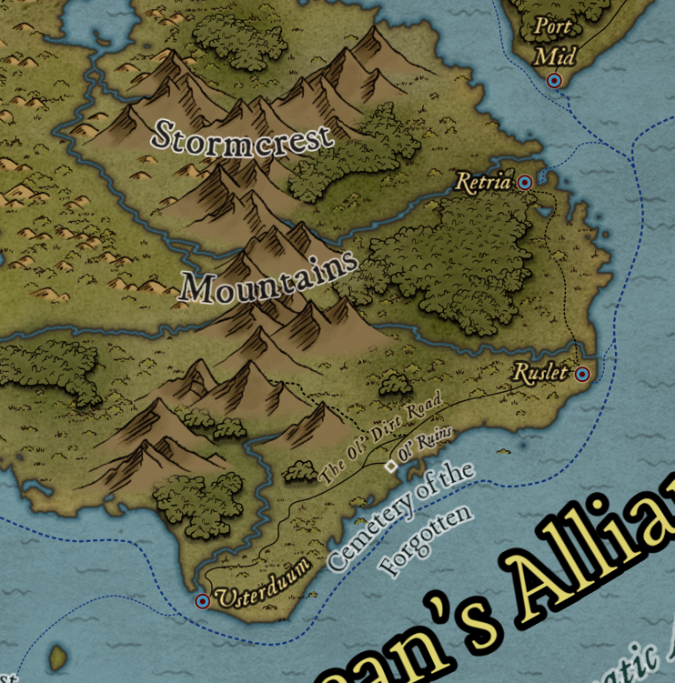

**'I know a guy'.** Each character can create a contact from their past that might be able to help the party. One 'guy' per charisma mod per campaign (minimum of 1). Player must tell the dm the name of the contact, basic info on how they can help, how the player knows them, and where they can be found.

**Every long rest** the players have an opportunity to RP for an inspiration point. They can talk about current (in game) events, tell a story from their past, or ask a question of another character. Anyone who meaningfully participates in the conversation gets an inspiration point. (D6)

**If players want to assist each other**, they have to roll their own d20 (10 and above) to see if they actually usefully help.

You can use strength or charisma for intimidation checks. (Thank you Matteo)

**Flanking** in combat gives +1 to attack rolls. **NOT Advantage.**

**Drinking Potions** Costs a bonus action, not action

## Session 1 – A Drake & a Door

East Past the forbidden lands of pirates lies a magnificent, stagnant storm known only as the Everstorm. Age 800 years

West Ever-reaching Kingdom of moreheim, and farher is the liberated dynasty of Xecuria as well as the Coalition of Artisans

North Wide, brutal lands of the Creatus Orc clans, warring constantly with the elves of the land in sprawling, dynamic landscapes

South Arid lands of Yuntas-Mire, and the Far Lands. Farther south the climate breaks to tropical breezes in the Shat.Isl. Archipelago

**Coast & City**

Along the coast of the cemetery of the forgotten. The city is part of the OAR and has worked for the past decades to establish themselves as a prominent city in the region. They rose quickly to a notable city that's beginning to attract notice in the republic.

**Vibe**

Notice a sense of unease throughout the town. News spread quickly to you of a group of miners that stumbled into a cave along the river up north. They went back the next day with more gear to explore, but never came home. The city sent out soldiers yesterday morning, but they never returned. It's now almost evening and people are becoming concerned.

#### First Encounter – The Tavern

***Simple village tavern****. Open* ***tall ceilings*** *extend to the second floor, and a balcony-walkway above that leads to the upstairs rooms. Stairs on either end of the tavern take you up. The bar sits on the opposite end of the settlement as a small stage does, with scattered tables strewn about the place.* ***Dandelion plays a tune for the crowd (20sp on good performance)***

*Several groups are settled about- seemingly more than you would imagine at mid day. Gnomes gambling, humans scattered, and one dark hooded figure settled in the corner, alone.*

*A tall silky lady,* ***Gene****, tend to the bar and is in conversation with a middle-aged male patron.*

* Meet the characters around you.
* A stout, sturdy looking **man** comes **into** the **tavern** and begin to **walk** **around** the tavern.
* Openly **berates** some **dirtier** looking **men** for **drinking** **midday** when there’s **work** **to be** **done**.
* **Calls** on the **crowd** to **consider** the **needs** of the **town** in the **midst** of these.. **troubling** **times**
* Barkeep can mention the issue of the missing miners, and suggest you **check out the job board**

#### Locations

**TOWN IN GENERAL**

For the most part, business as usual. Feeling the uncertainty of the disappearance of the miners, and some feel more recently uneasy about the surrounding areas in general. Animals acting out, pets getting loose and running to the woods, etc.

**Inn - Genie's Tavern**

Simple village tavern. Open tall ceilings extend to the second floor, and a balcony-walkway above that leads to the upstairs rooms. Stairs on either end of the tavern take you up. The bar sits on the opposite end of the settlement as a small stage does, with scattered tables strewn about the place.

A lady, Gene, tend to the bar and is in conversation with a middle-aged male patron.

**Smith - The Fancy Forge**

The open-air establishment is still damp from the rain of last night. Smoke billows from one corner of the property and you hear the clang, clang, clangof metal being hammered on the anvil. Following the noise you find a man hard at work, back faced to you.

**Shop - Odds and Ends**

This relatively well-sized shop sits in a wood and stone two-story building. Goods are arranged neatly on racks and shelves, much like you'd expect at any reputable shop. You do notice that there are no display cases, and no particular items of exorbitant value aside from regular adventuring items. The one exception lays behind the counter, where you see some sort of uniform and spyglass carefully displayed behind glass.

The shopkeeper stands expectantly at the counter, eyeing you curiously but friendly enough.

**Guild House**

A low and long building bears double-wooden doors at the entrance. The inside lays largely barren, but is outlines much like you'd imagine a whiskey lounge. Several leather chairs are strewn neatly about, and in the corner of the one room you see a tall man attempting to put up a board by himself, with some trouble..

**Farm**

It's a farmhouse and a field. And also private property

**Lords House**

The largest building in down. The only 3-story building in town too. It's built much like a miniature white house, with an entrance in the middle and two distinct wings to either side. It's topped by interwoven domes, one of which tops the two below it.

**Church/Temple**

A large building under construction to the north. No one is permitted entry at this time

**Waystones**

Upon leading town, the group comes across a large rectangular stone with a large hollow circular base. Inside the hole (10ft dia) are runes etched all over the walls. The group feels a strange pulling on them in several directions, which they instinctually resist. They’ve heard bad omens and tales of death from giving in to the pull.

_______________

Description

_______________

Description

_______________

Description

#### Around Usterduum

**The Forest to the North**

The Forest to the north is a largely regular forest, but it is regarded with general caution due to old stories of fey monsters and spirits that haunt the woods. It's mainly comprised of Cedar (tall) and Yew (Wide and branched out)

**The Long Coast North (Cemetery of the Forgotten)**

The LCN is recently made and not perfectly maintained/established. The town relies primarily on the ports for their trade, but is working to connect themselves to the larger city of Ruslet. As such, they've been working on the road. Some citizens prefer the road because they don't trust sailors, or prefer the scenic route of the road, or get seasick.

**The Caves**

Several caves can be found in the forests and surrounding mountains/hills. They could be home to:

(1) nothing,   
(2-7) (owl/brown)bears,   
(8-13) large spiders,   
(14-19) other monsters, or   
(20) something more dangerous. Perhaps a sleeping dragon wyrmling?

**The River**

The river is in similar size to the Fraser as it runs along cultus lake. Approximately 40m across and 15m deep with fast-running current. Other that limited bridges, it's a STR 18 DC to swim across without being swept down-river 1d6 kilometers.

(1-4) nothing, (5-9) flying fish, (10-15) Bandit Captain ambush, (16-19) Ghast x2 (20) Green Dragon Wyrmling. Perhaps a sleeping dragon?

**The Fields to the East**

The fields to the east are used for several reasons. Some of the fields are good for farming, while others have rolling hills, sparse

**Harvesting:**

**Panaeolo** Magical herb whose leaves tastes like leather and function as an ingested drug with no initial effect. Can be rolled and smoked. Low addiction, **100 gp/Kilo**

**Ripplebark** Shelf-like fungus that looks like rotting flesh but is perfectly edible, although it tastes better if cooked properly. **10cp**

**Densewood** AC16. It doubles the weight of any wooden item and costs twice as much. **4gp/kilo raw**

**Green Air** Fast-growing creping vine that sprouts green berries.

**Bramble** Can grow in most inhospitable climates and only needs to be in moist soil for 6 hours per week. Exposure to poison quickly kills the plant, wrinkling leaves, and berries. **80 sp**

**Wish** Small, petalled bulb plan with glowing gold spheres

**Blossom** in the center. Nature NAT 20 to harvest or the bulbs dim and the plant dies. Three bulbs in a drink grant the user one wish, which (DM discretion) comes true after a nights sleep. **Priceless.**

**Sunberry** Found deep in dark forests, sunberries are small, round yellow berries with a faint glow. They taste sweet as honey with a mild sour afterbite. They can be distilled into a golden whisky known as sunshine which sheds light with half the intensity of a torch indefinitely. It is very expensive and tends to be served in crystal goblets that can catch and refract the light into magnificent displays. **50gp/bushel**

#### NPC's

**Republic Representative** Lord-Rep Chris Servaant, 65

S speed L pitch and Nasal. Usually happy.

Can be seen wandering the streets in his regular clothing

Worried about surrounding areas not observed in new town

**Low judge** Justice Hyatt Keen, 109

S speed L pitch and Relaxed. Grey hair and blue eyes.

Is haunted by the ghost of someone he killed.

**Lord** Lord Ulysses Xiloria, 36

M speed H pitch and Strained. Usually CAREFREE.

Tall and slender. Very well presented, and always smiling.

Often drinks and socializes at Genies, and is open to all.

Plays off confidence, but was thrust into the role and feels lost

**Priestess** Bede Daneori, 70

Bede is a well-known, golly old lady who devoutly worships Gond.   
She values the kindness of strangers and believes in the best of people.

She's a little too kind and welcoming to new people. It's weird.

**Gld. Member** Mr. Wesley Burns

Quiet and reserved, and regularly speaks up for business.

Well dressed, but common clothes. Sole member of adventures guild.

Completely out of his league. Looking for help to cleanse the forest

**Smith** Burton Bradford, 39

S speed L pitch and Throaty.

Broad, hunched shoulders and focused on work.

Enjoys a quiet life in which he can work on his craft.

Wants to travel to The Collective one day

**Shopkeeper** Barney Sautner, 58

S speed L pitch and Throaty. Usually GLOOMY.

Friendly but reclusive shop owner

Keeps essentials but doesn't dabble with magic

Has a troubled past with magic, being rejected from University. Hoarder

**Innkeeper** Gene Grae, 85

Oldest native member to this town.

Tries to keep things as-is, but worries about the development

Was responsible for the old lords death, who's plans were too extreme

**Bard** Bardy McFly, 5

Relaxed, great singing Aarokocra. Friendly to the party. Talks like Chetney from Critical Role and always seems to have insight into the groups current needs. Ie. ID of monster, location of NPCs, etc

Secretly a worker of the BBEG, and keeps open eyes out.

**Farmer** Darius Clayton, 75

Lives on the outskirts of town

Doesn't care for trespassers

Let his pet drake go a couple of years when it got too big

**IT Officer** Valentine, 48

Lives on the outskirts of town

Doesn't care for trespassers

Let his pet drake go a couple of years when it got too big, before the IT found out.

**Nobility** Olga Smither, 40

**Nobility** Geoffrey Windchester, 27

**Farmer** Porter Blossombard, 43

**Killer** Harlan Fishcher, 35

M speed H pitch and Throaty. Usually DISAGREEABLE. When calm WEAK-WILLED. When stressed DETERMINED.

Never killed anyone still looking for their first contract.

Friends with Sidar Ashwood the "Nickname"

Identifying trait

#### Encounters:

**Find the missing miners**

5gp for information. 50gp per alive miner (Total 5 known missing) or 10gp/dead one

*A week ago, a crew of prospective miners under lead of nobleman* ***Geoffrey Windchester*** *broke into an ore-rich cavern along the river to the east. They joyously announced their findings to their boss and families, and went back the next day with more gear. But they never came home. The city sent out soldiers yesterday morning, but they too never returned. It's now almost evening and people are becoming concerned.*

Following the river in the the forest, the group will come across the miners tracks and eventually find the cave. In the cave will be a drake. It will be devouring a guards body while others lay lying motionless with dissolved skin.

**Guard a caravan heading by road to Ruslet**

20gp success, + 70gp if there's successful defense during combat.

*Hired by Burton Riley. Having finest wares sent to Ruslet for appraisal by their Smith, Jack Tuner. He'd go but his wife is pregnant and needs him home. It's a 10-day trip at regular pace by carriage and departure is scheduled for 3 days from now. The Carriage is driven by Carrel with 4 horses, and guards are expected to be stationed in the back.* ***Cannot take seas and carrying precious cargo not to be lost at sea.***

*The roads are still (relatively) new and uncertain.*

Can learn that the traveller, Carrel, is an old friend of Jack's and frequents this route often. He also claims to have gone farther into the forest, where he encountered fey creatures **AND LIVED** (his shock.)

**Traveller (Rag'ne)** with a broken cart is on the road. Asks for any help to give. Help and warns about ambush. Rob and breaks cart. Help and feed + give $, gives amulet of feather fall to you. **Broken,** 1d6 uses left before dud.

Will either way leave a note by the area saying, "It's always wise to help a fellow traveller."

**Ambush** as the weather turns to heavy rain. Along the road, the left closes to forest and mountains, while the right is open fields.

Bandit Captain + 3 bandits with bows, at a distance.

Bandits been made aware of the cargo, and be looking to seize it. By Jack Turners friend, Beau Kellar, 76 of Port Sheerstone.

**Ol’ Ruins - Captive Unicorn** as the group travells along the road, they will come across a hoard of goblins near old ruins with a very weak-looking unicorn in a steel cage. Strong anti-magic field on the cage, but the unicorn looks to the players and says “Help me”  
Goblins taking unicorn to a cultlist hideout for a ritual involving the sacrifice of a pure creature to appease an unknown force.

**Wanted ad for a criminal, looks old.**

250gp Alive, 150 Dead. Couple of years old now.

The criminal is named Harlan. He has a birthmark on his right ankle and is wanted for killing the old Lord of the town, Ronan. Motive unknown.

Description is fair-faced man with long blonde-white hair and storm-grey eyes. Believed to be a possible religious heretic or pirate, but he disappeared without a trace. Witness is Low Judge Hyatt Keen, who was able to watch but not apprehend due to his age. He was a well-known citizen of the town, and the attack was a shock.

The criminal is someone they'll find in later sessions. He'll be the worker to the BBEG.

"Harlan was a good lad. He studied in the winter each year in Ruslet with Ogmund the Alchemist in Ruslet as his apprentice, then came home to work the farmlands with his family. To see him do something like this, it's a loss to me."- **Hyatt**

**Find a Sunberries in the forest for Gene**

25gp/Bushel

Sunberries are used to make a fine whiskey that shines beautifully in sunlight. They're little orange bulbs found on white wood trees in dense forests. The whiskey the berries make takes years of care and attention, but are worth thousands of gold. The Sunberries are very rare though. There's a poster at the general outpost calling for retrieval, but urging adventurers only.

The berries are usually enjoyed and cultivated by sprites, and also stolen by woodland creatures. Makes good social/combat time..

**If the party travels in the woods, the keenest ears will hear something following or watching them. Perception check to see a small, cloaked figure with white eyes watching them before running off. Keen perception will show that as this character runs off, his features seem to morph into animal-like traits, such as hooves or wings.**

**Will be hexa child living in the woods watching for people they think can help them. Nonbinary. Will watch group while they're on this subcontinent.**

##### Miners

Save any miners?

Kill beast?

Notes:

**Loot:** Guard Armor (Leather), miner pickaxes, and 4 Ostridge-sized eggs, Sewer drake acid gland (Nature)

Caravan

Help the fellow traveller?

Notes:

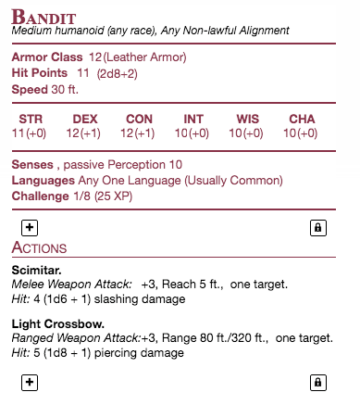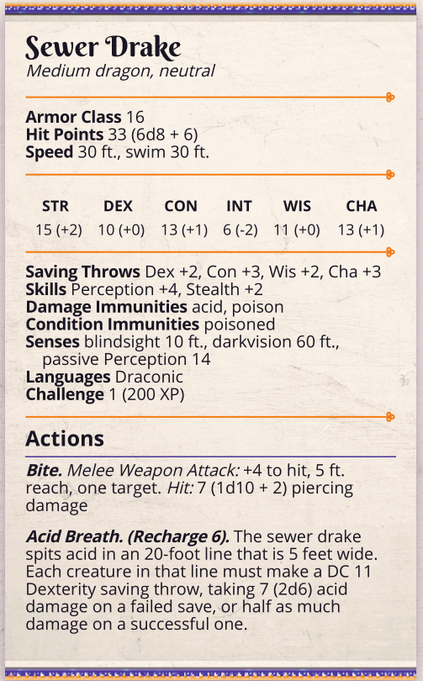

##### Criminal

Notes:

##### Sunberries

Notes:

Pixies will fly around the tree and attack people who approach the Tree. They'll then scatter as a bush in the middle of the trees begins to morph, and out folds a tree spirit. A fog quickly rushes in around you, and you hear a voice. "The face in the tree doesn't look kindly upon thieves. Be gone, or be destroyed!"

Ending Session 1

Miners

* Make sure there's a lingering goal
* Note from the **secret patron**  
  "If you break into the cave, look for the idol. Meet me in the The Grumpy Bird when you do. Message me before you do anything! After that's sorted, feel free to extract the ore and sell it to Burton. He's a good man." -JS

Caravan

* Bandit will drop a letter of intent from his patron
* Have it signed J.S.

Criminal

Sunberries

Preferred ending - The captain.

### Session 1 REECAP

People in this session:

* Marillac Mysterious Miner.
* Gene Genie’s Tavern owner
* Valentine Garrison Leader (Iron Temple)
* Rennes Stablehand/Ride
* Harlan Supposed Killer
* Barney Dugir Shopkeeper Odd’s and Ends
* Burton Bradford Smith, The Fancy Forge

1. Began with an intro of the characters and the town they were staying in.
2. c. Did ok and got 14 silver, then did a flip off the stage to garner attention. Guys got silly with Gene the server but kept good spirits
3. Garrison Leader Valentine came in and berated workers for slacking duing time of uncertainty. Shooed them all out of tavern and back to work. Openly challenged the group to make themselves worthwhile by helping with the miners job. Also put **the Berry, shipment and wanted poster jobs on the tale. Party aware of all levels.**
4. Group took the Miner’s job. Hired a cart from Rennes the stablehand to pick them up in 2 and/or three days. Rennes agrees for 11 silver. Along the walk to the forest, there was Indigo and Sparky RP for inspiration.
   1. As they headed north the weather got worse, and lightning struck from above. Seemingly, it was deflected by something..
5. Group manages 24h trek to the cave (overnight watch omitted) and finds the cave littered with corpses. One man left alive. Healed with goodberry. Delve deeper into the cave.
   1. Near the end of the cave far inside was a Drake, who was protecting his/it’s eggs. Attacked the group and avoided worthwhile communication with Ingigo. Acid Drake.
6. Group killed drake with amazing fight and began to collect bodies, loot soldiers, harvest drake heart, acid gland and claw.
   1. Also discovered another cave corridor in the cave of a cleaner cut, leading to a 30w x 60h stone door. **No investigation** but a NAT 20 to attempt to open (23). It budged a little. The rumbling area says something gargantuan is inside it…
   2. Matteo took the revived man back to the cart and got a note from the guy, reading as follows:  
        
        
      The guy refused to divulge who JS (signed) was on the note, and wanted a quiet life from then-on out. Name of **Man** was **Marillac.**
7. Collected 11 dead minors and 22 dead guards. Town follows them to the guard house where Valentine looks over them, and publicly apologizes for his **racist** remarks.
8. Around town, speaks to Merrilac again for a bit and he gives up little information, so group goes to the Smith Burton. Finds a complete unit of a human that’s as obtuse as can be, and they leave him shortly as well.
9. Walking through town near the docks, someone bumps Sparky’s shoulder and it’s Harlan! Chase ensues, grapples and thunderous blasts, until Isaiah casts vicious mockery and he falls to the ground laughing.  
   “You have no idea what you’re doing”
10. Ships at dock all simultaneously explode, except one ship beloinging to a Storm Chaser. Group bounds Harlan while this happens and drags him into an alley. Session Ends

Notes

People in this session:

* Marillac Mysterious Miner.
* Gene Genie’s Tavern owner
* Valentine Garrison Leader (Iron Temple)
* Rennes Stablehand/Ride
* Harlan Supposed Killer
* Barney Dugir Shopkeeper Odd’s and Ends
* Burton Bradford Smith, The Fancy Forge
* The group thinks that Harlan is a wrongly convicted man by the nobles. **Have not looked for witnesses or explored the story of the murder**
* They may want to examine further beyond the stone door, where they heard loud rumbling.
* They want to find Sir Windchester for questions
* They need to find out who JS is, likely in Flurham
* There is an idol that needs to be found and identified.
* There is an unexplained explosion in port with only the storm chaser vessel intact.
  + In the port is a Large Sailing ship/Cargo
  + 2 yachts
  + 1 rowboat
  + A Storm-chaser vessle “Boa-boa”.

**The Idol in question** is an ancient relic lost from the temple of an old-dwelling spirit of the sea of a magnificent **serpent**. Restoring this idol to it’s true home and completing a ritual will allow the spirit to re-awaken and “guard the seas once more”

**Marillac** was hired by the **Relic Alliance** to find and secure this **idol** as his last mission before retirement. He was hired by a **gnome** by the name of **Seebo**, a **druid** in the organization. He scouted the area and came across unusual markings on the cave that indicated old magics. Seebo broke the arcane locks but was severely injured in return and was unable to continue. He’s now **cursed**

**Harlann** – A disgraced storm chaser of recent times, known to be the bastard offspring of a devil (really a god, **Nereus**) and is looking to redeem himself and set his story straight. His murder of the old Lord **Ronan** was an accident during an argument, but he knew the price of murder- Death.

Harlann is hoping to prove his story before he’s tried, and is operating under the promise of opportunity from an underground dwarf agent named **Ulfgar**, who’s in the area on business of the submersers. He’s searching for some lost relic that’s important to his organization.

**DOCK EXPLOSION**

was planned and carried out by Ulfgar to cover Harlann’s escape from the area, and it was supposed to be so he could steal the Storm Chaser ship and have it deemed lost in the explosion. Harlann is keen on travelling to **Pikeville** to meet with the Guild of Hammer **(Sung Dawnweaver)** so they can answer questions he has. Now he’s stuck with the group until he’s caught, killed, or finds a new path.

There was also the benefit of having a chance to destroy at least 3 boats belonging to wealthy merchants, in turn sewing chaos in the city.

*The stormchaser boat will now be confinscated and the Storm Chasers inevestigated. Sparky may be caught out. Nearest port now is Ol' Ruins or Ruslet.*

**THE IDOL CAVE**

If broken into the brick room, the party will feel an internal shift in their location as they’re flung into another plane. In this new plane the sit on a Stone platform with the door behind them, and in front a large walled lake of sorts. The walls are perfectly straight, smooth and about 1 mile in diameter. In the center of the lake, approximately 500ft away, sits a small rocky island with a glowing gold stone sitting atop it. The island is no more than 50ft wide and 30ft high.

## Session 2 – Dock Explosion & Harlann

**Immediate Actions**

* Party goes to alleyway with Harlann
* Valentine arrives and guides guards to wreckage
* Secures the Storm chasers boat.
* Harlann is STILL laughing.

**Next Day / That evening**

* The Storm Harper will dock at Usterduum
  + A magnificent ship, 4 masted and too big to dock at port.
  + A smaller ship will bring the Sea Lord to dock to establish order in the town.

**HELPING HARLANN?**

Begin with the fire raging, and a crowd of manic people frantically trying to douse the boats. The guards will also come over (including Valentine) and ask about who did this act, to which the crowd will point in the direction they went.

*DIS stealth for the hideous laughter.*

Harlann desperately pleads with the group to hide him, claiming he can help them in return by offering riches and renown in more important ways. Interntionally holds back information until he’s helped.

**IF HELPED**

Hide him away in a nearby house

(I know a guy(?)) and can

talk about his motivation.

Lose some reputation with Valentine.

Will talk about Ulfgar and his circumstance, and give the players a choice to help him.

**IF NOT HELPED**

Can call Valentine over and keep him restrained, gaining renown with the town but no questions answered. Will receive the reward for his capture, but he’ll escape later that evening or next couple of days.

Ulfgar will also approach the group at night and try to convince them to help him instead.

**Harlann:**

* A disgraced storm chaser of recent times, known to be the bastard offspring of a devil (really a god, **Nereus**)   
   *As such, he’s particularly well-adjusted to navigation and oceans. He also has water and thunder abilities, including Thunderwave and Shape Water. Better skilled then Sparky.*
* looking to redeem himself and set his story straight.
* His murder of the old Lord **Ronan** was an accident during an argument,
  + He knew the price of murder- Death.
* Harlann is hoping to prove his story
* Operating under the promise of opportunity from an underground dwarf agent named **Ulfgar**,   
  + In the area on business of the **Submersers**.
  + He’s searching for some lost relic that’s important to his organization.
  + Ulfgar claims to know a way to clear his name in the town and make him a free man.
  + Being desperate and caught, H agrees.

**Ulfgar**:

* A dwarf fighter, member of the submersers. From Lyric initially but was fed up with the kingdom and the way of dwarves.
* Found the submersers in SMIT and made his way to Usterduum on a special assignment after proving himself.
* Knows Harlann hold special powers and tried to recruit him for this task of idol retrieving.

**Slimee Abyss**: (Slim-Aybess)

* A calm and collected woman of many resources
* Her team of assistants keep eyes and ears open across the coast for people of interest to the republic.

Knows Harlann hold special powers and tried to recruit him for this task of idol retrieving.\

***THE IDOL***

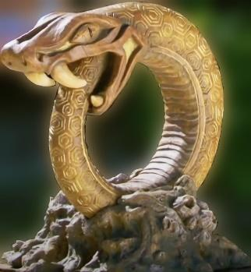

Akin to the World Serpent, a colossal monster birthed of Geeba as a being that may raze his surface under his bidding. Can only be activated or summoned under anothers power through a complex, costly and powerful ritual involving several ancient artifacts. This is one of four.

**THE IDOL CAVE**

If broken into the brick door, the party see a large suspended sphere of water behind it. If the group touches the water that will immediately rush out and grab them, pulling them in.

They will feel an internal shift in their location as they’re flung into another plane. In this new plane the sit on a Stone platform with the door behind them, and in front a large walled lake of sorts. The walls are perfectly straight, smooth and about 1 mile in diameter. In the center Is an island approximately 50ft wide and 30ft tall, the top holding this Idol in stone.

If the idol is removed, the island will collapse and a sea serpent will be woken up, and begin to attack the group. It they’re able to make it back to the entrance, the water will push them out and

Characters:

Harlann

Ulfgar

**The Idol Cave**

If broken into the brick door, the party see a large suspended wall of water behind it, that will immediately rush out and grab them, pulling them in.

They will feel an internal shift in their location as they’re flung into another plane. In this new plane the sit on a Stone platform with the door behind them, and in front a large walled lake of sorts. The walls are perfectly straight, smooth and about 1 mile in diameter. In the center Is an island approximately 50ft wide and 30ft tall, the top holding this Idol in stone.

If the idol is removed, the island will collapse and a sea serpent will be woken up, and begin to attack the

**The Ol’ Road – ‘TRAVELLER’ or ‘AMBUSH’ encounter**

* **TRAVELLER - Rag'ne** (Old gnome man alone) with a broken cart is on the road. Asks for any help to give. Help and warns about ambush. Rob and breaks cart.
* **AMBUSH -** Bandit Captain + 3 bandits with bows, at a distance. Bandits been made aware of the cargo, and be looking to seize it. By Jack Turners friend, Beau Kellar, 76 of Port Sheerstone.

**On the Seas – NAVY or PIRATE SHIP**

* Steal storm chaser ship, illegal
  + Becomes wanted after 1d6 days
* Seaside encounter en route to goal.

**Into The Forest - UNICORN**

* as the group travels through the forest, they will come across a hoard of goblins near old ruins with a very weak-looking unicorn in a steel cage. Strong anti-magic field on the cage, but the unicorn looks to the players and says “Help me”
* Goblins taking unicorn to a cultlist hideout for a ritual involving the sacrifice of a pure creature to appease an unknown force. Leads to a map a

**Windchester’s Estate**

* Use the Vineyard estate as a setup. To the south west is the Ol’ Ruins

**The Ol’ Ruins**

**The Waystones**

### Session 2 REECAP

1. Dock explosion
2. Matteo rushes into crowd, saves dwarf from drowning

|  |  |
| --- | --- |
| **NPC Generator:** | **Dwarf: Kathra** |
| ***Friendliness*** | ***1%*** |
| ***Allign- Goodness*** | ***34%*** |
| ***Wealth*** | ***0 Gp, 1 Sp, 4 Cp*** |
| ***Beauty*** | ***95%*** |
| ***Job*** | ***Model*** |

1. Goes to Storm Chaser ship. INV finds ownership papers to a **Lee Hopkins** of Tebiton
2. Christine turns into seal and saves 3 people from drowning in the sea. Hops on top of storm chaser ship
3. Matteo confronted by 4 guards, taken in and questioned with no answers for **Valentine**. Guard makes nice with Matteo and **Dandy** when he joins. **Astrea** in the jail too.
4. **Christine** joins with us at the jail as well, but chills. Is told to go north and follow **Harlann** who was escaped and went north (**deception** not believed)
5. Christine goes north and finds a hallucinogenic herb named Northlinch. Used lots by orcs for spirit journeys.
6. Harlann brought to inn with Isaiah and Jason, interrogated
   1. Conceides that he killed lord by accident and is on the run. Disgraced storm chaser and went to Ulfgar for help in the underground. Helping to find an idol to harness his powers for Ulfgar, who will then help him find peace with the law.
7. Guard has a friend named **Gorn** who’s a caretaker in the Shattered Isles.
8. Isaiah makes song – Gold penis from the sky.
9. Astrea takes the horse from the guards and goes back to the inn. – Milk the horse
10. In the inn, Matteo gives the trident to Harlann to prove his godlike association, and he lights up the lantern and trident.   
    *The trident glows around the pole and energy spikes create the two missing prongs, buzzing and cracklying.*  
    Harlann Wants to go to the waystones for some reason.
11. Harlann recognizes Sparky as an aasimar too, and tells him to try praying sometime.
12. **Stuff..** Mainly filler and stuff.
13. Matteo is not convinced to help harlann. Thinks is too much trouble for what it’s worth.
    1. Fights Harlann when not letting him go and defeated him, then is taken to Valentine. Is arrested and will be subject to the law.
14. Level up to 3

## Session 3 – Gifts, Lions and the Forest King

Group finished the last session by helping the crowd through the chaos of the dock explosion. Matteo investigated the Storm Chaser ship and found it to be owned by Lee Harper of Tebioton. Then confronted by guards and taken to jail and questioned by Valentine then is released.

Harlann interrogation finds he actually killed the lord by accident due to very low quality of life argument and is on the run. found Ulfgar to help him but was tasked with finding some idol. Group decides too much trouble to help harlann and fights him, then turns him in. Finsih the session at level 3, and 300gp reward for harlann.

Dandelion sees his reputation precedes him.

**This session:**

**Current Goals**

* Berry quest for Gene
* Take the boat from Harlann.
* Guard a Caravan to Ruslet. Weapon shipment.
* Investigating the dock explosion.
* Find Windchester regarding the cave idol quest.

**Introducing:**

* The Circus
* The Bard college quest
* Astrea’s woman interest, at the circus OR on boat.. (Sanira)
* Fallmoer boat is coming in with a shipment of Mire’Seil-ian freshwater.

**What do I want out of this session**

Establish the main conflict. **Dark happenings, hostile wilds. Azerim is returning.**

Pure fey creatures are being taken from their domain and sacrificed to an unknown entity through a new and unkwown collective. This calling speaks to more undeveloped creatures, including orcs and goliaths, as well as creatures of limited intilect. In forests, beasts and creatures answer the calling and begin the hunt, bringing all that is good to ancient locations of worship. Perhaps an old evil is returning.

Azerim is an ancient demon lord who once raised to power by taking the discarded creations of the gods and reforming them into his own army. He conquered much of the mortal realm and sewed havoc across the world. That is, until the famous god-hero Hammer Ranjfold crossed him. With the help of the gods, Azerim was defeated and banished back to where he came. After the battle, the gods feared the effect of their intervention, and retreated (mostly) back to their ethereal domains.

Azerim has patiently waited until the age of man has passed and sought a new means to his power. He has contacted the God of the void, Deusorum.

*Deusorum is older than Lumas, originating from the greater universe. He is often thought to be the direct counterpart of Lumas, so few people will dare utter his name, and he has been left off of all religious coins except very few of old ages. Those who pray to him are known to have a terrible life and bring misfortune to all around them. Uttering his name to certain people or in certain areas is a punishable crime. This god is known to collect acolytes, and beasts of the underworld to do his bidding. So far, Deusorum has resurrected a great dragon of Evil, in an effort to rid the world of life and peace.*

**Starting session**

We begin this session on the next day since last, the party having rested up and given free accommodations for their actions on the evening prior. Gene calls you down for breakfast in the morning at the tavern. The following events occur in the first hour of the morning, before the crows disperses for the workday:

**CIRCUS**

As the group fumbles through town, a young boy will approach the group and give them a flyer for a circus that’s coming to Ruslet in one week, and will be there for two weeks to come.

The name is the Magnificent Show of Feywild Oddities. Find the waystone and you find us!

**LETTER FOR DANDELION**

*Orc fighting, shows of magic, and rumors of a fabled unicorn on display!*

Additionally, Valentine will approach the group annoyingly and hand a letter to **Dandelion**. This is a letter from the Lyric Bard College, branch of Eloquence.

*Dear Dandelion Everbloom, lover of nobility and wanderer of Morthia. Legendary conqueror of women and captivator of crowds.*

*Your tales of adventuring and roundabout shenanigans have garnered both fame and infamy across the many kingdoms. While your reputation as Queen-layer holds significant weight in the Collective and abroad, it’s time to assess your position in the Guild.*

*Given recent tales of your escapes with guards, drakes, and murders (Yes, news travels fast), we have found the title of journeyman is no longer appropriate for you. You are no longer authorized to operate under that title. Instead, we gladly offer a promotion in our ranks to an official agent of Lyres for Hire, Eloquence branch.*

*But with this gilded position comes the request and expectation of dutiful service. Our strings are heard strongly throughout Morheim, but the college holds no songs in the Republic.* ***We ask you to seek out the musician’s guild of the OAR and search for their secrets.*** *The OAR is rumored to hold secret songs of the feywild that enchant their performers abilities. We ask you to seek out their magics and report back to the guild with any findings and means of their acquisition.*

*For the sake of aiding in your journey, the guild has agreed to bestow upon you, and your party, the following gifts.*

*For out newest Agent, we send you this specialized robe of many useful things. Study it’s pockets wisely, as you never know what needs may arise to suit you. And for your party, we gift the following set of rings for their choosing. A word to the wise, appearances isn’t always everything.* ***You receive the following rings: Brass, Silver, Wood, Copper, Steel.***

*Melloran Belarus, Director of Lyres for Hire.*

**TUPPER (Matteo), while sitting in thought at breakfast or bed at night.**

*Be drawn to the light of your fire. In the flame, as it batters against the lantern housing, you feel as though you hear a voice speaking through what sounds like harse winds. Soon after you are drawn into a trace-like state, and hear a deep, ethereal voice call out to you.*

*My child,*

*You are one of many brothers of the storm. Raised in rain, salt, and thunder. Bathed in the seas and born to serve the way of the light.*

*You live now divided. Your home was taken from dark, corrupt powers that will stop at nothing until the way of the Storm’s Light is extinguished. I call on you now, alongside your surviving brothers, to fight. At all costs.*

*Hold your flame with pride, child. Hold close to the light, and your path will show the way. Beware Azerim [Ah-Zehr-emm]*

…Your flame with intensity in brightness and encompass the surrounding area. A comforting warmth will be felt by all around you, sparking a moment of awe from commoners...

**Lantern of Stormlight**, on the **Trident of Waves (Requires Attunement)**

Combined. Spellcasting Focus, +1

When this lantern is placed on the broken fork of the Trident, the combined equipment gains the following attributes:

* This now contains the properties of the Flail and Trident. Either 1d8 bludgeoning or 1d6 piercing.
* Channelling divine evergy allows the wielder to cast one spell of the following, regaining each dawn.
  + Light
  + Guidance
  + Word of Radiance
* The lantern is magically linked to the lantern and may only be removed by command of the attuned wielder.

**Indigo**

After pondering on the decay and death on the outskirts of town, you begin to feel a stronger sense of natural unease in the region. The air feels heavier, the wind blows more oppressively, and the birds no longer sing in the mornings. Something essential to this region is fundamentally **wrong**.

**Introduce Jaiveer and Erin**

**Jaiveer**

Tall, proud gold Dragonborn, donned in a warrior’s adornment of studded leather armor and large glaive on his back.

He arrives in town/the tavern to much confusion, alongside an elegant elf. The two look very well-dressed and hold high stature. The crowd shifts uncomfortably out of their way, with many gasps and even one scream.

**Erin**

A high elf whos presence causes confusion but muffles hostile emotions from simple commoners. She carries a large wooden staff, and ornate looking cap on her hear and long elegant robes that stop short of her lower shin. She meet sthe height of the dragonborn she travels with. A large book hangs by her side by leather clasp

**Jaiveer and Erin** are part of the Guild of hammer, a group of vetted heroes that wander the realms and seek out trouble. They’ve been sent by the guild elder Kara (old human female. Wise, strict and knowledgeable) to help the region however they can. You (Jaiveer and Erin) find make your way to the only other adventuring group you see.

*GIFTS*

***Ring of tracking*** *Requires attunement. A simple* ***brass*** *ring, when attuned to a user, the user always knows the location of the ring, up to 5 miles away. Often used to keep track of people or goods. If the ring exceeds the 5-mile distance, you know the general direction the ring is, up to 50 miles.****Ring of returning*** *Requires attunement. This simple* ***silver*** *ring, whenever removed or discarded, will return to the pocket of the player in 30 seconds.****Ring of minor prestidigitation*** *Requires attunement. This* ***wooden*** *ring can cast a limited version of prestidigitation. With it, you can:  
  
- Create an Instantaneous, harmless sensory Effect, such as a shower of sparks, a puff of wind, faint musical notes, or an odd odor.   
- Create a nonmagical trinket or an illusory image that can fit in your hand and that lasts until the end of your next turn.****Ring of rope*** *Requires attunement. This rusted,* ***copper*** *ring has a tiny yellow topaz in the center. It carries 4 charges. When activated (bonus action), this ring shoots out up to 30ft of rope from its gem. The rope can be commanded to latch onto the target, at GM's discretion. It cannot latch on to creatures or anything alive. Regain 1d4 charges at dawn.****Ring of the Claw*** *Requires attunement. This* ***steel*** *ring has the ability to sprout a 4in curved claw-like blade from it, so long as the ring is worn. The claw is likened to a beast’s claw, and strikes make with this claw deal 1d6 + STR or DEX slashing damage.*

**Robe of Useful things**

*That who dons it will note that it is adorned with small cloth patches of various shapes. Only the wearer of the robe can see, recognize, and detach these patches. One patch can be detached each round. Detaching a patch causes it to become an actual item, as indicated below.*

*A robe of useful items always begins with two each of the following patches:*

*Two Daggers*

*Two lanterns (full of oil, lit)*

*Two Mirrors (Large)*

*Two 10' poles*

*Two coils of silk rope (50')*

*Two Grappling hooks*

*Two large Sacks.*

*Additionally, you find 17 patches that you recognize their contents after 1 hour of study.*

*1 A sack of 100gp*

*2 2x orbs that seem to be barking quietly (summonable mastiffs)*

*3 A bottled tree that plants and roots itself to offer nice shade. 30ft tall*

*4 A Blank Marriage Certificate*

*5 4x Potion of Healing*

*6 A Disposable magic longsword, +1 for 10 attacks, then disintegrates*

*7 A jar of peanut butter*

*8 A magnifying glass*

*9 A Set of wind chimes*

*10 A loaded crossbow*

*11 A set Shakers of Salt and Pepper*

*12 A herb-scented bar of soap*

*13 A disposable magic key - opens one lock then disappears*

*14 A lawn ornament in the form of a gnome*

*15 A clean set of nice clothing*

*16 A set of thieves tools*

*17 A frothy mug of ale*

### Encounters

#### BERRY - Find a Sunberries in the forest for Gene

25gp/Bushel

Sunberries are used to make a fine whiskey that shines beautifully in sunlight. They're little orange bulbs found on white wood trees in dense forests. The whiskey the berries make takes years of care and attention but are worth thousands of gp.

The Sunberries are very rare though. There's a poster at the general outpost calling for retrieval but urging adventurers only.

The berries are usually enjoyed and cultivated by sprites, and stolen by woodland creatures. Makes good social/combat time.

Sprites

Woodland creatures

Dryad Guardian: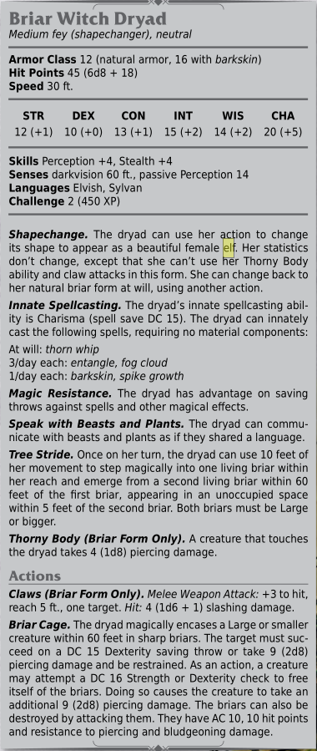

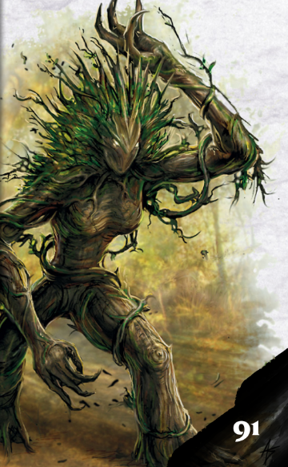

**The dryad’s name is, in sylvan, Seshana. It’s her domain and her berries. She’ll allow the group to take them if they recover the forest king, a missing unicorn who**

**If the party travels in the woods, the keenest ears will hear something following or watching them. Perception check to see a small, cloaked figure with white eyes watching them before running off. Keen perception will show that as this character runs off, his features seem to morph into animal-like traits, such as hooves or wings.**

**Will be hexa child living in the woods watching for people they think can help them. Nonbinary. Will watch group while they're on this subcontinent.**

#### BOAT - Taking the Storm Chaser

Taking the ship will require **stealth and diplomacy**.

The ship will be guarded day and night by **two soldiers**, with periodic checks from **Valentine**.

*The ship will be held for one night until the navy claims it to return to the Storm Chasers, who are notified and waiting.*

The group will see **a hooden figure** in robes speaking with the guards and shaking hands. He’ll then continue back through town and out the north road.

This is **Jesm**, the dragonborn GOSPEL member from Nightshale. He’s a reclusive mage that looks over the OAR lands for threats and is called oin occasion to help with magical means.

Jesm added an **alarm** spell to the boat for anyone trying to enter or move it. Can be identified and disarmed with a DC check like a trap. Higher DC than a normal trap though (15?)

Once the boat is found to be missing, the group will be wanted in the OAR for arrest under suspicion of collaboration in the Usterduum dock explosion.

If the players make it to the open sea, they will have a seaside encounter with a **feral sea lion**.

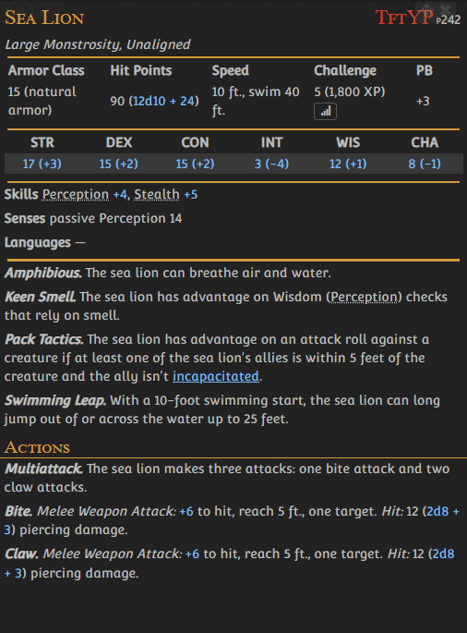

#### GUARD - Guard a caravan heading by road to Ruslet – CHANGE TO BOAT IF NEEDED

20gp success, + 70gp if there's successful defense during combat.

*Hired by Burton Riley. Having finest wares sent to Ruslet for appraisal by their Smith, Jack Tuner. He'd go but his wife is pregnant and needs him home. It's a 10-day trip at regular pace by carriage and departure is scheduled for 3 days from now. The Carriage is driven by Carrel with 4 horses, and guards are expected to be stationed in the back.* ***Cannot take seas and carrying precious cargo not to be lost at sea.***

*The roads are still (relatively) new and uncertain.*

Can learn that the traveller, Carrel, is an old friend of Jack's and frequents this route often. He also claims to have gone farther into the forest, where he encountered fey creatures **AND LIVED** (his shock.)

**Traveller (Rag'ne)** with a broken cart is on the road. Asks for any help to give. Help and warns about ambush. Rob and breaks cart. Help and feed + give $, gives amulet of feather fall to you. **Broken,** 1d6 uses left before dud.

Will either way leave a note by the area saying, "It's always wise to help a fellow traveller."

**Ambush** as the weather turns to heavy rain. Along the road, the left closes to forest and mountains, while the right is open fields.

Bandit Captain + 3 bandits with bows, at a distance.

Bandits been made aware of the cargo, and be looking to seize it for Jack Turners friend, Beau Kellar, 76 of Port Sheerstone.

**4x Bandits and 1x Bandit Captain**

**4x 1x**

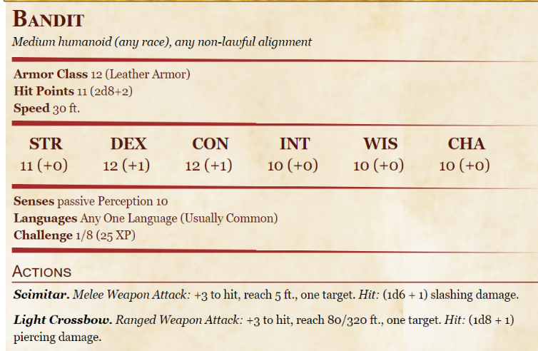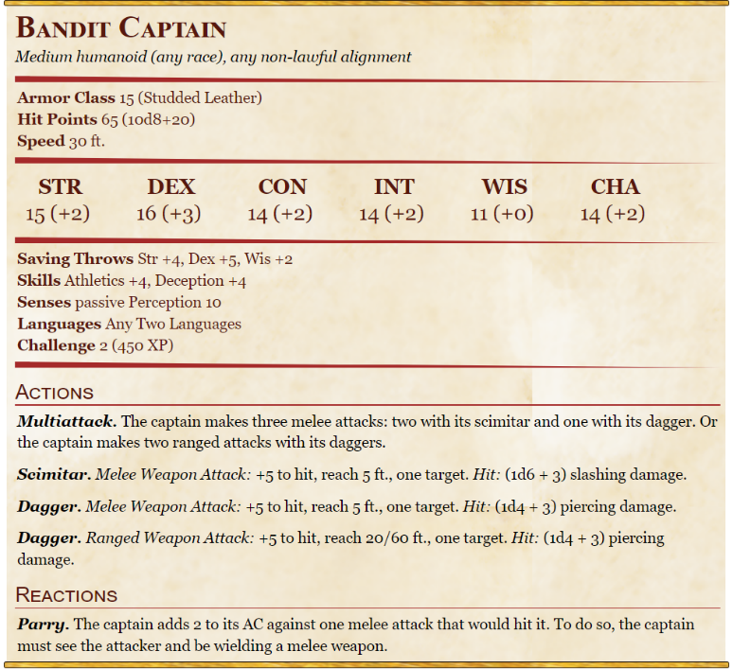

**Grove-Striders**

as the group travells along the road, they will come across a group of nature-oriented druids. An elf, a human, and a dwarf. They will claim to be investigating the disappearance of a powerful entity in the forest, and will appreciate any help you can offer. May offer Christine a position as **Springwarded.** This is the rank a character receives when first joining and pledging service to a faction. Perks include:

**2x Druids**

Permanent items. i) a faction insignia (Grove Striders metal leaf clasp) and

ii) a faction loot satchel, as well as access to Grove Strider locations.

**Ol’ Ruins - Captive Unicorn**

as the group travells along the road, they will come across a hoard of goblins near old ruins with a very weak-looking unicorn in a steel cage. Strong anti-magic field on the cage, but the unicorn looks to the players and says “Help me”  
Goblins taking unicorn to a cultlist hideout for a ritual involving the sacrifice of a pure creature to appease an unknown force.

On the road:

2 stops, and the ruins

Stop 1 (South)

Stop 2 (South)

Ruins

#### DOCK - Dock Explosion

The dock explosion is still unexplained.

Further investigation reveals the following

* The surfaces of the ships only were damaged. None sank
* The tops of the ships are burned and batterd. Sails are gone and masts severely damaged. The interior and hull of the ships are left untouched (largely)
* Asking around reveals:  
  + Someone was paying off the dock master to load unknown cargo onto the ships in a supposed smuggling venture  
      
    **Two Day’s later:**
  + The dockmaster, **Porter Blossombard**, has been brought into the jail the day following the explosion. He’s facing charges of bribery, accessory to terrorism, and conspiracy. The republic brought in the Capital guard to oversee the case, due to the severity of the incident.
* The townsfolk are banding together to salvage what they can from the ships. The large cargo ship has (Passive perception 15) a chest, larger than the others, being offloaded and taken through the crowd. **Ends up at Odds and Ends, with Barney Saunter.**
  + Inside the chest, if you get that far, are several illicit magical goods, such as eversmoking bottles, imovable rods, and dusts of disappearances.

### Session 3 Recap

* Start tavern
  + letter from bard college
* Meet Hydra
* isaiah did performance. Was bad. People left
* People leaving mentioned incoming trade ship from Mire-Seil.
* Decided wanted to take the ship
* saw a hooded figure shaking hands with Valentine
* Little boy, Perci, announced a circus coming to Ruslet.
* Went to Valentine. Asked if group could have the ship to return to Storm Chasers.
* Valentine said no, plans were to pick up.
* Asked to take for a day to finish a goal. Valentine made a call to someone in the Chasers
* agreed to lend ship for one day. Storm Chasers coming in 2 days to retrieve
* Circus:
* Freak show
* Orc fighting Forest King
* Fortune Teller
* Games
* dozen-dozen animals
* Took the ship to the forest, was attacked by a pack of some kind of rabid sea lions on the way
* only one made it to the ship becuase of a rope thrown to it.
* killed after a big fight, and smoke came out of it. Weird, hissing steaming black gas.
* Docked and long-rested in the boat. Matteo prayed on the light of the lantern to see if he
* could find twin lanterns. No luck
* Christine found and befriended a mouse. Either Oat or Shithole
* Isaiah wrote a song called Lion of the Sea.
* Jaiveer found treasure hidden in the boat, behind a wooden board.
* Bag of holding,
* Potion of Animal Friendship,
* Elemental Gem, Fire
* Chrisitne found a love fungus. Brew into team. DC 18 to fall in love with next person they see. Name: **HYPERIA**
* Came across a small encampment with a large steel cage in it.
* Items inside the cage would have magic dissipate, and become invisible.
* Scared away goblin encampment due to loud sparky matteo orc and firey dragon Jaiveer.
* Kept one goblin. Druel. Wanted to leave. Kept as slave.
* Key was shaken out of the goblin.
* Unicorn Lord of the Forest released. Was very grateful. Was convinced not to kill goblin.
* Sprouted glowberries for us as thanks.
* **Unicorns presence and freedom brought light and life back to the forest as well as surrounding area.**
* Mentioend the possible rising of an ancient one known as Azerim. The fey of you may know the tale.
* 20 bushels
* drag druel out of forest at very least
* Rope tied around chest like baby character..
* plant 6 berries, harvest 19 bushels and leave one behind.
* Upon leaving the forest and back on the boat. A man standing in the middle of the ocean spoke to the group, and Dandelion specifically. He thanked him and the group for their recent deeds, and warned him that Thorne was coming.
* Ended with rain coming down as they returned from their journey via boat, to Usterduum.

## Session 4 – The Circus.

### BASIC LAYOUT

* Find out what to do with Druel, the Goblin
* Town destroyed,
  + Harlann loose. Valentine missing
  + Genie still at the Tavern, hiding in cellar. Will still buy
* Circus in full swing up north. Missing Unicorn so Green Ape is center of show.
* Mire’Seil ship has not arrived yet.
* Circus will capture crowd of bystanders, and force them through the waystone to a secret base.
  + Rousseau wanted a unicorn but outweighs with large group. Is attempting to appease his boss, who needs souls for some nefarious reason.
* END – Kill/deafeat Rousseau (Rogue/Bard) and ideally free the crowd. Writer will share news with Ruslet and gain the group (TO BE NAMED) some renown in the region.

### Encounters

#### Town Start - Attack

**DRUEL**

**TOWN**

*Arrive in the dark cover of rain, only to find through the thick veil the remains of a desecrated town.*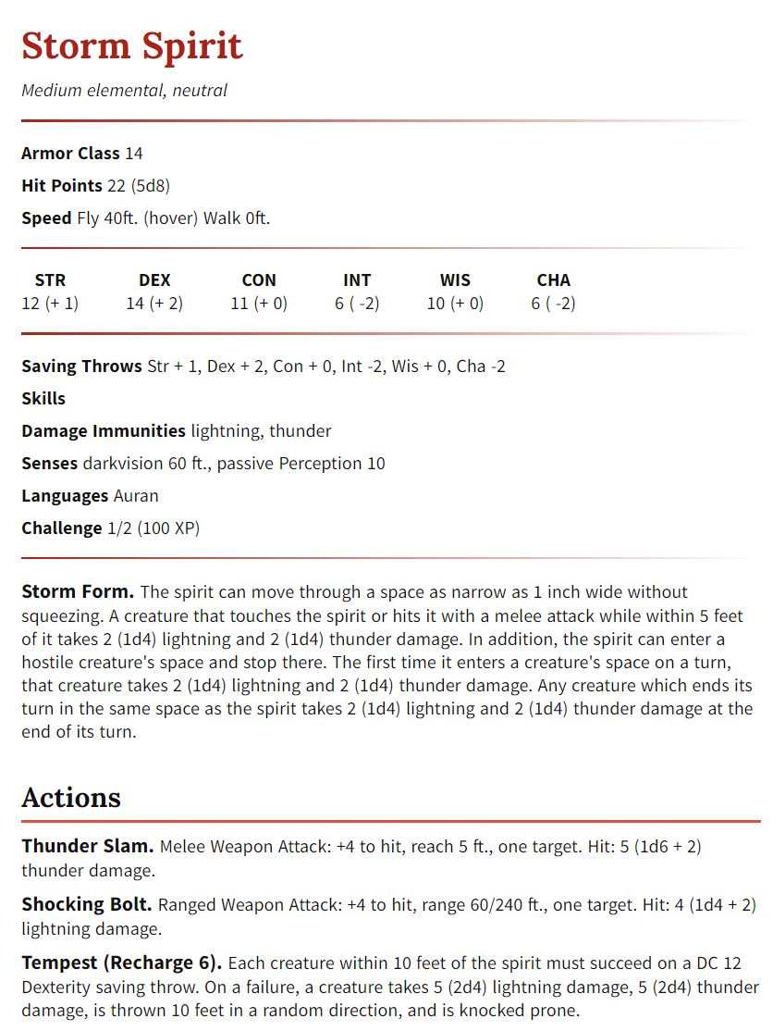

***Town***

Bodies lay astrew in the roads. Most smaller buildings lie in smoldering shambles of what they once were. Windows are broken everywhere, and the smell of death and ozone lingers in the air. All the boats in the harbor lie in various states of disarray, all of them accounted for and at least partially sunken. In the barracks, Harlann is gone.

***Valentine***

The door is wide open, and Valentine lies against the ground, on the edge of death. (**Death save). Harlann seems to have suffered electric burns on his skin, and his metal armor is burned through.**

*“It’s Harlann. His eyes.. they went, WHITE and glowed! His body burned from flesh to bone, right in front of me. Something… something emerged from him. A shadow I think… I don’t know. It expelled these* ***things*** *that attacked me. I don’t know why it didn’t finish me off... Thank you heros, for saving me. How is the town?*

***Genie***

You find Genie hiding in the cellar of her inn, after she carefully calls out to hearing you enter the inn. *“Thank the gods you’re back. They came so quickly. I heard the bell and hid. Then the screams… Oh god, the screams. Wait.. I hear it again!”*

***Fight***

Crackling can be heard all around the town. The crackling holds no pattern and happens all over. After speaking with the NPC’s, it gets louder and louder around town, until they find it’s illuminating right in front of them.

***Battle of storm spirits x8. SET HP TO 15 NOT 22***

**SILAQUI**

During your travels, meet Silaqui, Springwarden member of the Grove Striders

*A widespread group of wilderness survivalists who preserve natural order while rooting out unnatural threats.*

#### Windchester - Windchester Mine – Idol?

Math of dates for making the meeting with JS:

First session, 2 days since mining accident

Day of travel, 1

Day of travel, 1

Day bringing bodies back. 1

2+1+1+1 = **5**

JS man won’t wait more than a week in Ruslet.

**No way to travel 330 miles via regular means**.   
Will likely miss opportunity, unless they find the waystone option. Otherwise looking for new opportunities.

Bigger encounter. Burton Windchester won’t be available or want to chat with a group of adventurers he doesn’t know.

* Perhaps meeting the queen-fucker would make enough attention to garner a meeting, if given a good reason.
* Will be unlikely to share personal information. Knows about the idol and works with JS but believes he’s not above assassination for divulging that information “SHHH.. They’re always listening. I’m certain at least some of my staff work for them, so this isn’t the time OR the place. Just know that those in the know gain many perks for this kind of work. Those who aren’t.. well, they don’t.”

#### Circus - Magnificent Show of Feywild Oddities

Owned/Operated by: Rousseau Rouge, a fancy charismatic human.

Performers: Madame Zironi, Destain the goblin, Twins Alda and Geti, and Rubien the cook.  
  
**NPC Gobln: Destain Gnome: Shamil Madam Zironi Cook: Rubien**

Friend 60% 44% 98% 30%

Allign 50% 77% 50% 43%

Wealth 6 Gp, 7 Sp, 4 Cp 0 Gp, 0 Sp, 4 Cp 6 Gp, 8 Sp, 6 Cp 0 Gp, 0 Sp, 4 Cp

Beauty 15% 91% 80% 62%

Job Freak Tattooist Warlock Cook   
-----------------------------------------------------------------------------------------  
**NPC Alda Geti Culai Keri (Keery)**

Friendliness 39% 88% 75% 92%

Allign- 45% 50% 80% 40%

Wealth 1 Gp, 2 Sp, 1 Cp 12 Gp, 1 Sp, 6 Cp 0 Gp, 120 Sp, 6 Cp 530 Gp, 200 Sp, 1010 Cp

Beauty 88% 43% 73% 72%

**Job Trapese Trapese Drakologist Enchanter/Curio Shop  
-----------------------------------------------------------------------------------------  
NPC Rousseau Vane Rosa Anastrianna**

Friendliness 69% 0% 60% 30%

Allign- 5% 0% 70% 70%

Wealth 100 Gp, 2 Sp, 1 Cp 1 Gp, 1 Sp, 1 Cp 1 Gp, 12 Sp, 1 Cp 1 Gp, 50 Sp, 1 Cp

Beauty 88% 0% 57 % 89 %

**Job Owner/Smuggler Writer/Journalist Visitor Visitor**

**Goal**: Act as a front for the transport of illegal goods. Roussea Rouge is a smuggler that uses the circus  
 to sell illicit goods to his partners. Works for Submersers.

Help Story? Capture all spectators and take them through the hidden waystone at the center of the tent. Arrive at sacrificial chamber where souls are harvested

What/Where The circus is setup about a mile outside of Ruslet, to the west. It’s a large valley with several large tents and one massive pavilion-style building in the center. Arranged in a rectangle.

**Schedule**

Late Morning Games, food, music

Afternoon Tent attractions, food, music, and games

Evening Tents close, main show begins. Music, then Trapese, then Animal Show (No unicorn as advertised)

THEN Half-orc fighter will challenge anyone to a non-lethal fight with wooden weapons.

**Main Show** Unicorn   
1gp Propoganda of wild beast on the loose. Fight between orc and beast called off, challenge to fight green ape is open to the public. Crowd is displeased.

Half-orc (Sanira) Wearing an old, roman-esque helmet that completely covers the face. Glowing red eyes, that controls her. [Helm of madness]

**Tents**

*Fortune teller* 10sp Have fortune read. d100. +50 divination, adv on check of choice in next week.

*Freakshow* 2cp to view Malformed goblin in a cage, that twists and contorts itself with a pained smile  
 Given name is Destain. Surgically malformed after being captured from a **nearby den.**

*Trapese artists* 20cp to visit Show in the main tent. Performance checks, or they fail. DC 5 (+2)

*Food stand* 5cp for meal. CON DC 5 or food poisoned, Dis on ability checks for next 1d4 hours. 5 to recover

*Oddity Shop* Varies

**Games corner**

Apple bobbing

Rules: CON check. DC 5, 1d4; DC 10, 1d6; DC 15 1d8; DC 20, 1d10. Roll 5 times, and see result.

Pize: 0-5: Nothing; 6-10: Candy Apple; 11-20: carved wooden toy; 30+: common magic item.

Dagger throwing – Throw unbalanced daggers at hanging sacks from a tree branch. Win whatever slips out of the bag.

Rules: DEX dis. Even = hit, Odd = Miss

Pize: 10+ = Win (Drops very common magical item) <10 = Lose (Spills sand)

Eating contest Join the eating contest at midday, right before the main show in the big tent.

Rules: CON save. <10, lose and puke; 10-15, Lose; 16+ Win!

Pize: Voucher for free entry to the main event!

Wheel spin Spin the wheel

Rules: Roll d100

Pize: Refer to the table

1-5 - Small stone with a smile painted on it.

6-10 - Small straw doll

11-15 - Toffee apple

16-20 - Huge lollipop

21-30 - Clown nose

31-40 - Copper ring with a polished grey stone

41-50 - Clacking teeth on a wind-up key

51-60 - Woolen gloves

61-70 - Small wooden carved Animal (Horse, 7in long)

71-80 - Voucher for free meal/ale at the circus

81-95 - Pair of shiny silver bells (25sp)

96-100 - “Magic Wand” [Sends sparks out on command for up to 1 minute. Cast 3x/day]

#### Astrea – Sanira

The Green Ape : Berserker  
Female Half Orc, any alignment

Green in skin, clad in iron armor. The identity and face is completely obscured from the public, but it’s an orc no doubt.

**Armor Class:**16 (Worn Plate shirt)

**Hit Points:**30 (4d8 +12)

**Speed:**30ft

**Proficiency:**+1

**STR** 17 (+3)  
**DEX** 14 (+2)  
**CON** 17 (+3)  
**INT** 10 (+0)  
**WIS** 12 (+1)  
**CHA** 8 ( -1)

Actions

**Greatclub.** *Melee Weapon Attack* +4 to hit, reach 5 ft, one target. Hit: 7 (1d8 +3 ) slashing damage.

*Properties: Heavy, Two-handed,*

**Javelin.** *Melee Weapon Attack* +7 to hit, range 30/120ft, one target. Hit: 8 (1d6 +5 ) piercing damage.

*Properties: Thrown: range 30/120ft,*

**Skills:***Intimidation* +2 *Athletics* +7 *Animal Handling* +3 *Survival* +3 *Intimidation* +2

**Saving Throws:***Strength*+7 *Constitution*+5

**Challenge:** 1 (200 XP)

Special Abilities

**Indomitable:**The berserker has advantage on saving throws against being frightened.  
**You are comming with me:**When the berserker drops to 0 hit points he can try to make one melee weapon attack as a reaction to one enemy at 5ft of him.

Racial Features

**Ability Modifiers**: +2 Str, +1 Con

**Menacing**: You have proficiency in the intimidate skill.

**Darkvision**: 60ft (18m / 12sqr)

**Relentless Endurance**: When you are reduced to 0 hit points but not killed outright, you can drop to 1 hit point instead. You can’t use this feature again until you finish a long rest.

**Savage Attack**: When you score a critical hit with a melee weapon attack, you can roll one of the weapons’s damage dice one additional time and add it to the extra damage of the critical hit.

**Languages**: speaks Common and Orc. Commanded not to engage verbally with it’s opponents.

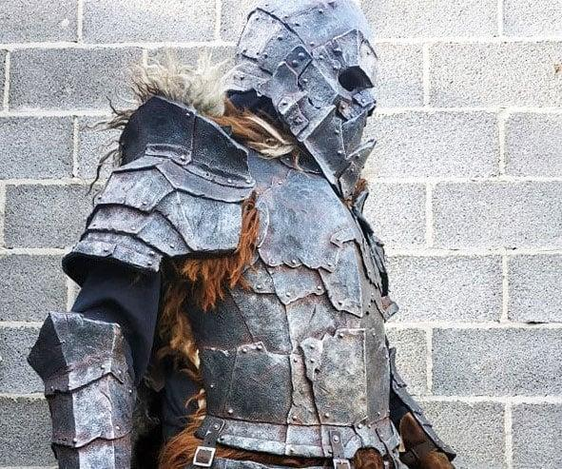

Sanira was stolen from Smuggler’s Cove, after wandering the Patola Woods and searching for a clan to begin a new life with. Her Captor has held her for many years before finding mastery over her, and using the crown of madness to control her.

“I first went to the great falls of Azam. I hoped for a vision, and it came to me. I saw the mountains, then dense dark woods, a large bay of ships, then darkness. And then I saw you… So I followed as best I can, and here you are 😊”  
  
I’m happy I found you, but I can’t stay. A group approached me,

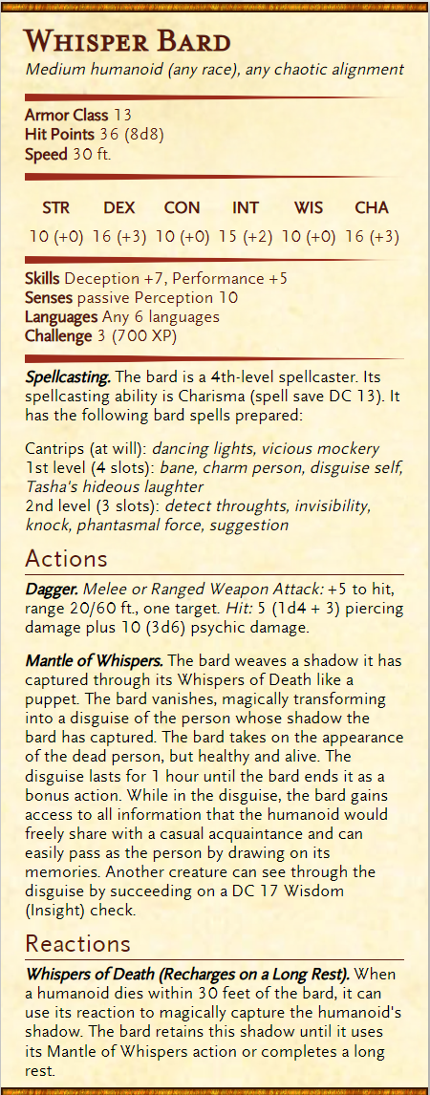

#### Isaiah – Quest

At the circus, the writer will quietly report the news to the Bards College via sending stone.

### Session 4 Recap

* Begin on the way to Usterduum, where Isaiah is hidden away
* Thorne is coming, XINE asks about it. Isaiah reveals his backstory
* Enter the town, full of destruction. Rain and thunder intensifies
* Find Gene, and get reward of berries received **GET AMOUNT**
* Defeat spirits and last one questioned. Said he serves a dark lord, Aenthi
  + Wished to be released to the storm. Promised no harn, and released
  + Some spirits **Escape**
  + **Story of Aenthi is breifly described, including the hero of HAMMER**
* **Something about the Order of the Golden Cloves**
* Received a one-use esending stone by Gene?
* One of the spirits comfirms aenthi is back
* The gorup HATES this town and leaves very quickly soon after. Druel takes them to the waystone
* Group messes with Druel a little, while on the cliff where they spot him leaving their presence.
* Dandellion writes a new song. “Druel in Folly”, a somber tone of wasted passion
* Druel
* Head for the circus.
* Matteo scouts ahead, comes across a bear sleeping, a den-like hole in the ground, and several small pieces of interst(?)
* Mice(OAT) comes back with Bear and cubs. Bear name Kiri. Asks of their aid later on, sewing chaos when they release the animals later. Kiri and co oblige
* Christine finds goodberries and encounters a a Fairy named Thia,
* Also finds **Falsifal**
* **The group finds the circus to be largely fraudulent and disappointing. (MAKE IT BETTER NEXT TIME) but also a** lesson in realistic expectations
* Isaiah continues to the back posed as a performer. Uses name and gets one guard to go with it via charming.
  + Finds his way to Rousseau, NAILS the audition performance, and goes to his tent. Steals all 7 keys to the cages, along with interesting looking papers. Weird sex song.
* In sneaking, around the circus, come across an orc being donned on armor. Sanira. Fight Alicia fights way through and helps Sanira break her spell/curse.
* Help out animals, Jason sets tent on fire. Pandamonium but all survive. Circus destroyed as they excape
* Too chaotic. Tupper leaves as they settle back by the waystone, and leaves. Drops money at Astreas feet.

## Session 5 – Ol’Tek, Sanira, and Thorne

1. What the Encounter is The city they visit hosting a holiday festival
   1. Head into Retria, or at least on the way there. **Matteo**
   2. Find out how Sanira got her helmet. **Alicia**
   3. Sparky wants to pray. **Jason**
   4. Give a letter to Dandellion **Isiaiah**
   5. Grove Striders are actively seeking help for a disturbance in the forestwant to talk to **Indigo**
2. What are you conveying to the players (hardship of a storm, dangers on a trade road)
   1. **Matteo** will help facilitate the need to get there so he can meet his contact, a skilled worldly healer.
      1. Have his curse instigate a damaging event to the party to show **urgency**
   2. **Alicia** will speak with Sanira privately.
      1. Mentions she sought a new beginning in the OAR. Got mixed up with the wrong people in a hidden seaside port. She made mistakes, and built up a debt to pay. When she couldn’t, they trapped her and sold her as hired muscle. She only knows the name of the one person she dealt with. **Woodrow Wind.** She was part of something called **The Nightcloaks(?)**
   3. **Jason** will go to a church.
      1. **Small one:**
      2. **Medium one:** Ruslet. As mentioned,. Calm will come across him while around those who go with a wild wind picks up.   
         **Large one:**
   4. **Isaiah** Can seek out the musician’s guild who’s looking for a hero to tell tales of. Every adventure he reports gains glamor and prestige amongst the guild
   5. **Christine** Can join the grove striders and become an official protector of the forest.
3. Will this be a simple encounter or complex (is the solution obvious and definitive?)
4. Why will this encounter be enjoyable to the players? (what brings tension)
5. Are the players active or reactive (who will be prompting the encounter)
6. How long/significant will the Encounter be (real life game time spent)

Does failure stop the game and if not what does failure look like?

**Tupper**

-Leave through the woods. Group search and search but find no trace, w

**Ol’tek**

-Enter through the waystone, clutching his hand. **Give reason to go to Retria or the University, where he seeks help to rid a foul curse upon him.**

**Thorne**

In storm and rushing waves, Thorn is battling monsters and seas to make his way to Thorne.  
sends a letter to a contact in Retria to give the following letter to Dandellion

*“Dear brother,*

*I hope you’re unwell. While against custom and nature, I felt it necessary to send you word of my adventures. I see you have at long last found use of the waystone. You grow wise, but know this. I will find you, and I WILL kill you. I may now have to readjust course to Retria, but I will be there in a meer span of days. The group I travel with has certain… skills. What a man does in a week, we do in an hour. In their aid, our fateful meet draws nearer. I look forward to sending fire and lightning into your heart, and watching you sink to the deepest depths of the ocean. Then we may begin anew.*

*With love and terrible ire,*

*Thorne & Co.”*

**Sanira’s Story and now-goal**

After leaving her clan, Sanira searched for meaning for many years.

She found her way to the University, and learned great secrets of the world. Old histories and magics, and some new. In her time she learned to master her

**MORE**

Mentions she sought a new beginning in the OAR. Got mixed up with the wrong people in a hidden seaside port. She made mistakes, and built up a debt to pay. When she couldn’t, they trapped her and sold her as hired muscle. She only knows the name of the one person she dealt with. **Woodrow Wind.** She was part of something called **The Nightcloaks(?)**

**The Golden Clove and the Other survival guild**

The Golden clove originated as a group that watched a swift, warm wind carry a murmuration of gold leaves across the land, glittering and shining in the still air. They followed the glove and watched, for every place one landed saw unbridled fertility. With immense haste, they rushed forwards and tried to collect them. Every time they came near, the wind blew them on and on, ever out of reach.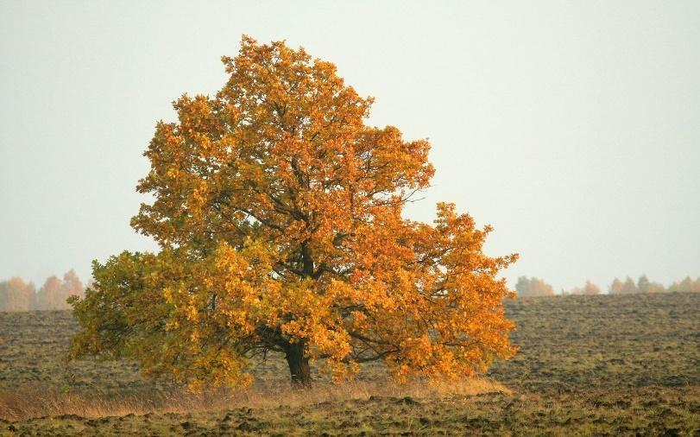

One girl amonst the group stopped in her tracks and began to rather enjoy the life brought to the land. She sang a happy song, and the wind suddenly changed to her calling. In her lands laid three golden leaves, while the rest danced around before carrying on. The three leaves sunk into her skin and from her feet grew roots, that stuck into the ground. Her skin turned to bark, and she sang through it all happily. Within moments she was transformed into a magnificent oak tree with a face marked into it. From her new-found branches sprouted a million golden flowers.

The story is fresh in their mind as it only happened a season back. They claim it was witnessed in the valley west of Groggwood. **Just sounds of the groggwood wilds, and misty bog.**

The Golden clove all took a branch of the tree and fashioned them into several tools. A wand, a staff, a club, and the handle of a hammer.

Retria

***RETRIA****, home to Lord Osval and 4 OAR Representatives*

*Ol’tek knows only this of Retria. It’s a city the size of a region, taking a day and a night to cross. And that’s if you know your way. Most stick to their homed neighbourhoods, main roads, or key arteries throughout the city. Beyond that, vagabonds, merchants, whores, and nobles (amongst many factions) occupy the vast city to make it beat strong and true.*

***Retria finds wealth in trade, mining and bountiful woodlands.***

Here you find:

**CHURCH**

**IRON TEMPLE**

**MEERA TRADING COMPANY**

**STORM CHASERS**

**UNIVERSITY BRANCH**

**HUNTING GROUNDS**

**DOCKBUCKS DOMAINE**

Ruslet

Lord Roland **Berkeley**, 108

Priestess Kaley Alhock, 23

Here you find: 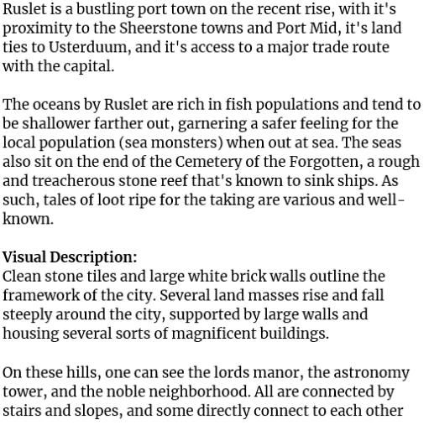

* **Waystone**

Found outside of town, where the group rests. Forest, Cliff and grassy valley. Forest: Bear, Cliff: Gnome, Valley: Bear & Kobold/Goblin den

* **Church**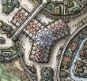

Medium-sized, run by Priestess Allok (Kayley)

In midtown, near the port and under a bridge of the hills. Cental viewport, two wings, and a main worship area

**Allok fears people are losing faith.**

* **Iron Temple**

**-**Work out of the Church. Patrol the town for evil-doers, and a genuine group of fighters with good intentions.

**-** led by Legate Elsenri Evans. Other are Curteys and Heriet.

**Heard rumor of a beast attacking sailors on the open waters. Ran scouting missions and found a dragon has taken hold in a nearby seaside cliff cave. Doesn’t quite add up though..**

* **Musician’s Guild**

Performer “Mr. Duchamps” is siniging in the Grumpy Bird.

**Will talk about the guild a little. Quiet and scarce information, but mentions (if nice) that his boss is seeking new talent. Auditions taking place in a week or so at the church. Dress up nice, and don’t make more of a scene that a professional would make.**

* **Grove Striders**
* Recruiting in the streets, trying to gain reputation. Passerby (Brock,46,Nightcloaks) spills beer on the man (Jack Turner) and teases their “pointless crusade to save what’s already dead”
* **Nightcloaks**  
  Brock and Sully, holding up the hideout while others are away on **secret business**
* **Astronomy Tower**Large building that watches the skies. Run by Reti, a rude, exceptionally ugly half elf. Skilled in Intelligence, and mans astronomy tower. Old friend of the lord Roland Burkeley
* **The Siren’s Bell**A small island in the center of the port houses a gazebo. Inside it is the statue of a siren sitting on a bench, mid-song. Her history is lost and most just know of it's existence.
* **Great treasures of the Cemetery**

Quite the colleciton of ocean-sunk treasures. On show are several colorful amulets, capes, and a red&silver sword with a jeweled hilt.

Cannot purchase without renown, lots of gold, or a personal meeting. Will be sized up at the door, by a man who is known as **Gizbo**.

### Recap – A tiring session lol

* Begin at waystone, Tupper is gone
* Through waystone comes Oltek, the twillight priest. **Looking for aquaintance in Retria**
  + **Offers to pay group 200gp each to help absolve curse**
* Another man comes through soon after – Adran – Wife and kids but hired to stab Dandellion. From Usterduum
* Leave the waystone, go to Ruslet for shopping and exploring
* X
* Kid messenger – Isaiah uses him (2gp) to spread news about Thorne and mercenaries coming to kill everyone. To guards
* Dandellion to Inn – Plays against Duchamppes, an elven bard.
* Christine and Alicia to astonomy tower – closed lol
  + Meet the grove striders calling for people to join
    - Name is **Innil**
* Matteo and Jason to Church – Jason vision
  + Saw his father –
    - Friends dead
    - Mom alive on beach with weird humanoids. Tortle, tabaxi, avian folk.
    - Trying best to convince Sparky that he’s his Dad.
  + Meets IT Legate **Bartel-Tulles**. Checks hand, and known cursed. Tries touching the hand with healing potions and it sizzles off. Recommends amputation.
  + Goes to office, **steal two poitons** – one dark orange, one silver and glittery.
* Learns the odds of Cardaro is very likely in Retria
* Learn about the path of despair, which Cardaro leads groups through to clear. **Spiders, trolls, orcs, and rumors of other stranger beasts(?)**
* **Alicia speaks in private with Sanira**

After being exiled by her clan, Sanira searched for meaning for many years.

She found her way to the University, and learned great secrets of the world. Old histories and magics, and some new. In her time she learned to master her

**Monk, Wizard, Rogue**

Mentions she sought a new beginning in the OAR. Got mixed up with the wrong people in a hidden seaside port. She made mistakes, and built up a debt to pay. When she couldn’t, they trapped her and sold her as hired muscle. She only knows the name of the one person she dealt with. **Woodrow Wind.** She was part of something called **The Nightcloaks(?)**

* GROUP GOES TO GIZBO’s – Great treasures of the Cemetery
  + Gizbo, a short dwarf
  + “may the light guide your path, and the way forward be clear and bright” or something like that
  + Buys:
    - Alchemy jug – 250gp(?)
    - Ointment of healing – 5 uses – 250gp – roll 1d20/day, on 20, refresh a use.
    - Cloak of billowing. – boguht by Dandellion 40gp
* End the session by comitting to chartering a boat to Retria.

## Session 6 – Seaside Encounter

Begin by chartering a boat **1gp8sp/day** for Caravel

**Galleon**

The Augustus

1.34 days, for 18gp 5sp

Owner

Cara Garnier, 27

Large and expensive. No work needed to do. No need to defend even, well equipped.

**Galley**

The Lucy

2.34 days, or 10gp 2sp

Owner

Trak N’lie, 94

One sail, lots of rowers. More durable and afford attack if group defends.

**Sailing ship**

The Archer,

4.69 days, or FREE, work.

Owner

Bertio Scratchbox, 88

Free passage but more cramped and needs crew to sail constantly. Chance boat off course if attacked.

Seaside encounter. – Monster,

Looking for the guy, finds clues leading to the Spider grove

**Wildlands of the changelings**  
Corpses found, as their dead are left to be reclaimed by nature. Burying the dead is an insult to their ways  
  
**Mirror Lake/Sound**  
Thin line of water topping a lake of ice, reflecting the sky above. Several holes in the ice from breaches? Monsters living below.  
  
**Cave of Despair (/u/wolfson_01 map)**In a rubble-entranced cave through forest from path of despair is the sounds of yelling screams.

Through the cave is a large spider coated in black mist devouring Cardaro or other, and attacks players.

Killing spider, a cultist attacks then retreats through the cave to an altar-temple place deep in the earth. There, is imagery of deusorum and where he battles you as a demilich or other. Wil find much loot and info to lead to next area or bring to crown. Info about artifacts maybe?  
  
"I/we seek a forgotten place. One lost to memory and time many ages past, but known well to this land. A place of power, of purpose, of opportunity. Opportunity for something.. better" – Cultists

Demilich

Giant spider

* + - To open a portal to the void
      * Portal is shut by godly intervention
    - **Requires artifacts for a regular person to open.**
      * *- The Heart of the Abyss*
        + Description

This artifact is said to contain the very essence of the Dweller Lord Marduk, and it grants immense power to whoever possesses it. It has the ability to bypass the defenses of even the most powerful gods, making it a potent weapon against divine foes.

* + - * + Appearance –

A Translucent Black Orb: The Heart of the Abyss could be a perfectly smooth, black orb with a translucent quality that allows you to see swirling shadows and shifting shapes within it. The orb might pulse with a faint energy, and those who touch it might feel a chill run through their body.

* + - * + Location –

Meerilian Islands, at the bottom of a lake on the island at the center area.

* + - * *- The Book of Vile Darkness*
        + Description

This dark tome contains forbidden knowledge and spells that can corrupt even the most virtuous of souls. It is said that it contains secrets that can be used to subvert the power of other gods, making it a valuable tool for those seeking to overthrow divine rulers.

* + - * + Appearance
        + Location –

Repository of Records, on the lowest level inside their vault

* + - * *- The Shadowstone Amulet -*
        + Description -

This artifact is said to contain the soul of a powerful necromancer, and it grants immense power to its wearer. It has the ability to bypass the powers of other gods and control the undead, making it a potent tool for those seeking to challenge divine authority.

* + - * + Appearance -

The amulet is made of dark, gleaming metal. The centerpiece could be a small, circular depression in the pendant where a black orb could be placed. The depression might be surrounded by intricate symbols or runes that glow faintly in the dark.

* + - * + Location –

Ancient Crypt in the North-East of Stormcrest Mountains. Cliffside Skull

### Sanira Story – Overall

Sanira was raised in the Groggwood wilds along with her clan. In her youth, she rescued a satyr in the streets of Groggwood and brought her back to the village. It took some time, but her family eventually accepted her as one of the clan. But when a young love blossomed, Sanira’s mom couldn’t turn a blind eye. She stole Sanira away in the dark of night and set her in the river on a boat, with the only note saying that she had digraced her family and was to never return.

Raised in Groggwood. Met Astrea when young. Loved her, but shunned by family. Sent away and outsted from family.

Sanira found her way to **Greatgaunt Hill** and made weary friends with **Ard-Gunt** the cyclopse. They lived together for many years, attuned to nature. Sanira also become well-acquainted in survival skills by Ard-Gunt in exchange for lessons on humanity and the dragon monk traditions. Soon, Sanira’s time with Ard-Gunt was wearing thin. Tempers flared and silences grew. She chose to carry on before the worst could come.

Friend with Cyclopse. Learn survival, taught humanity. Left after tension rose.

Heading south, Sanira found the Great Stone Road and chose West on a whim, leading to the Wall of forests. Quickly she was robbed and beaten by bandits and thugs and left for dead. A kind man by the name of **Rin Cloudbend** who brought her to rest at the inn. After some time, she knew her debt was due, so she took the job of venturing into Hellcrawl to exterminate a spider population. The fight was close, but the spider queen (or so she thinks) fell, leaving enough evidence to bring back to the town. She gained renown and gold and paid her debt in full. She lived for some time nearby at the waystone, which she found oddly comforting.

GSR head west. Robbed beated, made friend. **Rin CLoudbend** (Gnome) fought spiders. Became hero, live at waystone. **Borderton**

Sanira carried on to **Boscus pass** where she heard word of another waystone by Tortle Lake. Upon her visit, she was surprised to see a ferry on the lake, as only a mediocre harbour was nearby. Nevertheless, the boat took her aboard and brought her to **Riverhold**, where she was met with extremists that jailed her for her race. She spent the better part of a year in jail as a freakshow. She made good friends with **Savannah Dugir** who visited her often, but it was a kind innocent child that slipped her a cage key one fateful morning, and she escaped!

Boscus pass ferry, jailed for race. Child freed her and escaped.

No longer enjoying the culture of Morheim (understandably), she snuck onto the next ship south and away to **Anchorage Vista**, under the advisement of **Savannah**. After a week at sea, she arrived and headed inland for **The University.** Again, she stopped by a waystone and a mishap struck while she thought of home. She was transported back to **Borderton**. She warped back on a whim, thinking of **Anchorage Vista**.

Snuck on ferry to Collective. Headed to University but mishap with waystone, back to borderton. Used it to go back to university.

On the way through the southern regions of the **Sabul Stones**, she met the **Sebel Monks** near the lake’s edge. They saw her drive and wisdom, and took her in as a student. For months she lived among them in the stone, and learned many secrets. In living there, she was shown a map of The Tarsal Desert listing several special locations. She stole and hid the map, but was caught by a friend. Her friend chose the monks way of life and reported her, and she was exiled. She managed to hide and keep the map, and carried on to the **University**.

Met monks, lived with them and learned their ways. Stole their map, was exiled. Kept the map, headed to university again.

There, she began learning under **Master Illiana**, who taught the way of scribes. She learned the true value of knowledge and history, and left the map as a parting gift for her time at the University. **Sanira** established herself as a student and member of the **University** before being sent on a secret mission from **Illiana** to scour the OAR for secret treasures and crypts.

Learned as student in university, given tasks to research ancient crypts for arcane and historical secrets.

She carried on to **Lyric** for their waystone, and took it back to **Borderton**. Sanira received a warm welcome but also met the unfortunate eye of **Bradford**, a smuggler and loanshark. He arranged travel and work to Smuggler’s Cove, where she met with **Woodrow Wind.** The job was to transport some critical contraband in a small wooden box to a merchant in **Nightshale**. He showed Sanira the path that passes **Flurham**, on to **Nightshale**. After that, she was to go to **Ruslet** to report to a noble that the job was done. Before she could report to the noble, she was jumped, captured and forced into a mind controlling helmet. From then on, time went to a stop until she was able to break it off after hearing Astrea’s Voice.

In total, she spend 36 years of her life remembering what she was and did.

Went to Lyric waystone, to borderton. Friend Woodrow arranged transport job, FL to NS. Abducted and used as slave since then.

**Now, Sanira is unclear of what she wants in life. She’s worried about the trouble caused by not finishing the job. What did she do in her blind years? Who’s really on her side, and who finds her a capable tool? Can she find peace with Astrea now?**

**HOOK – Stay in Stay with Sanira to protect her over the ocean, and go back to the University to check in with Master and report.**

### Recap

* Met Jack the ship owner and trader of spices, wine and other common goods.
  + **Jack** is a beta male cuck that takes shit and gives up easy.
    - Divorced to a bitch wife. **Name unknown.**
  + During session, explore his ship. Under this hammock is a trapdoor to an undergroun hold.
  + Find papers. Legends of his tales of being a cuck
* Christine finds Seagull-Lizards, one names Seth. Talks like he’s been smoking for 200 years.
  + Seth follows the party with Christine.
* Jason uses his storm powers to steer and guide the ship
* Group wants to steal the boat, and manage to deceive/pursway Jack into letting them run the boat.
* In being commandeered, Jack looks to the direction and yells SHIPWRECK
  + See a man names **Dagon** waving his arsms. Changeling.
    - Sailor on a half-sunken ship in the water, waving his arms frantically.
    - **Dagon Grey,** a Male Changeling. Neutral good, passive unless provoked.
  + Dagon warns of dragon turtle.
* Dragon turtle encounter
  + Is mad. Group uses calm emotions and mind read to see an immovable rod is blocking it’s way back to her nest.
  + Go with her to the nest. Remove the rod. Saw Loot but did not get.
  + Dragon Turtle name – **Erquemboure.**
* Got 7gp each from Jack to be saved by the group from the dragon turtle, who was attacking his ship
* Dagon got greedy and tried fighting the party. Sparky used shatter on him on the water and Erquemboure was alerted, so breached the waves and ate him whole.
* **Back at the shipwreck the group loots for a bit. Finds a letter in a bottle with the following letter:**

*The letter from the shipwreck you guys scavenged off-screen btw::*

*To whom might find this letter,*

*I write this in haste. A beast destroys our ship, and this message is worth more than my life.*

*I have learned of an ancient, evil artifact hidden deep in the stormcrest mountains, where the north east River begins. It's believed to be under guard of the dwarves. An old adversary of mine recently shared intent to recover it, but I believe it's best left untouched. She said it was the "First Step".*

*I beg the crown of any capable adventures who find this letter to thwart her before the world is threatened.*

*-****Rosemary Martel, Relic alliance scholar****.*

*Ps. I wish you luck. Be weary of* ***Rèner****... (Letter cuts off)*

* After dragon, go to Retria. Dock in dwarves district.
* Jack gets fucked over by group, is jailed.
  + Group frees Jack.
* GROUP NAME – **MAGIC**
* Isaiah performance on docks. Nat 20
  + Advertise incoming **L4H**
* **Jason has contact – Lady Shaunna – From time in the Navy.**
  + As they approach the estate, pets are left behind and they enter. Session end.

KEY NOTES AND FOLLOW UP

* **Jack’s Wife**
* **Dagon origin**
* **Letter in the bottle**
* **Rosemary Martel – Relic Alliance**
  + “Beware of Rener…
* Erquemboure reputation ++
* L4H reputation ++
* Loot:
  + Immovable Rod

Jack’s Wife

Dagon Grey

Rosemay Martel

Erquemboure

## Session 7 – Nobles and No-Holes

### Recap

* Met **Dahlia,** a human cleric of the church.
* Met Lady Shaunna, and Riare the house elf.
  + Shaunna kind, pretty and wise/smart.
    - Dandellion instroduces.
    - Offers to perform at son’s 20th bday in 1 week.
  + Riare cautious, tense and rule-oriented.
  + **No Magic allowed in the Lady’s house.
  + **Shaunna offered to fund the needs of the group, which they whiffed a little.**
* Learn Cardaro is missing for the last month.
  + Doing cleanse on **Path of Despair.**
  + Lost somewhere along the way. Group
* Dandellion goes to a print shop and has them advertise the Lyres for Hire coming to town.
* Matteo knows a guy. **Broll,** owner of the Emerald Willow and AutumnReaver in the Grove Striders.
  + Leads the party through a fey portal path
  + **Broll recognizes Isaiah as Thornes brother.**
  + *You son of a bitch, I’m in!*
* *Went to the Drunken Lantern, which is a bar in front and a shop in the back.*
* Thorne ditched his possy of 6 others in town, and went into the forest to look for something.
* Through fey portal takes the group a couple of hours to travel 2 days deep into the path of despair.
  + Enter into a spider den by DM force. Fight spider and find Cardaro’s body encased thickly in spiderweb.
  + Another body found encased in spiderweb but is bones now.
  + In this fight, Broll was a scardy-bitch.

* Loot:
  + Dust / Sneezing and Coughing
  + 3rd Level Spell Scroll
  + 360gp
  + Folding Keelboat
  + Eyes / Charming
  + Bag of Tricks, **Tan**
  + +1 Brass Knuckles
  + +1 Shortstaff.
  + Bejeweled Glove.
* Value
  + 500
  + 500
  + 360
  + 4000
  + 350
  + 250
  + 300
  + 300
  + 3000

Total of 9,560, or 1,590gp each.

## Session 8 – Friends, Family, Foes

### Plan:

* Cardaro Share story
* Enter fey portal or walk the path to the place of the murder if they wish.
  + Back at murder, FIND **Rénerania’s** body missing!
* Thorne will illusionarily confront Isaiah at some point.
* Back to town, talk to Shaunna.
* During Travel:
  + Shaunna sending stone Jason “..Heard Sparkitus visted earlier, my Lady. I graciously ask you send him a message, and let him know that Gosan, along with his brothers and sisters, haven’t forgotten about him. We need closure. We need answers…”
  + **IN THE FOREST**
    - **The fey path flickers and wavers. The forest around whilts and stutters around.**
    - Enchanted Grove – Unicorn being murdered, hear horrible whinnying and screams, then come across Christine frantically trying to save a Unicorn bleeding out in the grove center.

### Cardaro Backstory:

My name, for those who don’t know, is Cardaro Macasse. Practices lustist, avid sailor,

I **Journeyed with 5 others** into the path on a routine cleanse. My **Wife Clara,** our friends **Kren, Rénerania, Ajaxar and Groll.**

We ventured to locate a **Bugbear Den**, and kill them. We did, but they found someone else first. A woman, clutching in her dead hands a small box of dark wood and no opening, but we heard something in ther clattering around. Ajaxar held onto it for safe keeping.

We made camp that night like any other night…

I woke up to the throats of my friends slit, lying in their sacks as if they were asleep. The box Ajaxar carried lied shatterd on the ground, with him nowhere to be found. It took two days of tracking but I found him. Deep in the woods to the west, I traced him to some mountainside ruin.

I should have gone home. I should have called an army on this man for what he’d done. But I wanted answers, I wanted revenge. I entered the ruins and ventured deep into the mountain.

Eventually the tunnel opened into this.. room? Ruin? Either way I’ll never forget it. It was long, low, and wide. Runes and languages I couldn’t hope to know scattered the walls. At the end of the room I saw him, Ajaxar, standing in front of a shadow long the far wall, chanting and muttering, The shadow shifted and swayed until it pulled from the wall and enveloped him like a hug of darkness. He turned around and looked at me, his eyes black and empty.

My vision waned. The wall seemed to be shifting and almost growling, so I ran. I ran as fast and as far as I could until I stumbled into some gods-forsaken fey portal.

I respect the fey, but I know little of traversing their world. It took what felt like weeks before I found a way out. Unfortunately, It released me at the top of the Stormcrest mountains. I collected my bearings as best I could and made for home, but a week or so of travel wore on this mouning old man and ambush took my in the night. I woke up to our friend here punching me free.

**Ajaxar**

Dragonborn Warlocko Artificer, about 57 years old.

Raised: Akarash Fields. Family was killed by Marauders known as the **Garanesh Tribe**

Devotion: Lesser god Gond, the tinkerer. He’s always been fond in the ways of magical smithing.

It’s possible he was intrigued with the box and tinkered beyond his means.

Opinion “He’s been nothing but a loyal friend and a devout smith for as long as I’ve known him. But his actions call for justice, so I will not stop until he’s found and tried for his crimes. Then, we can hear the truth.

### Thorne

I’ve found a patron. He’s promised to break the endlessness of our feud by severing our ties and ceasing reincarnation. Then I can be rid of you once and for all.

**Thorne cast major image to confront the group, but will summon some beasts to attack the group**

**“**Life death rebirth. Life. Death. Rebirth. DEATH. DEATH. NO MORE.  
  
I have a patron you see. He's promised to break out cycle and end our feud. All I have to do is kill you just one more time. But not yet. I have business in the Meerilian Islands, so for now I say farewell, brother.”

**GIST HERE IS THAT HE’S GETTING MORE CONTROL OVER HIS NEED TO KILL DANDELLION, AND IS GOING AFTER THE HEART OF THE ABYSS.**

### Storm Chasers

One of the regiment leaders, **Gosan**, will call on Sparky to meet him once more. “It’s been to long, brother, and we want answers. We want to know where **Rai & Dorrin** went. Their families have never stopped worrying. Your grandfather has been shamed ever since and left our clan. Last we heard, he’s been ruling amongst the bands of **Pirates** in the Meerilian Islands, on a ship called **The Golden Rose**. Perhaps he needs to hear from you more than anyone else.

Gosan – Kronk with grey-haired buzzcut in stature, and

### Lady Shaunna

Lady Shaunna will be delighted to see Cardaro is alive and seemingly well, but distraught at the news he shares. She’s ponder the case a moment, and tell the group about **Her ancestor,** Hammer Ranjfold. He was fabled to cast an ancient demon lord back to the abyss with help of the gods.

We found an ancient tome locked away in his crypt many centuries ago.

*Speak not of The Nameless. Speak well of his passing.*

*Though deaths still come for us all.*

*Behind every door, it calls us to service.*

*Should the gates be breached, we are to be carried to damnation,.*

*Cast away, dormant, forgotten, yet he reaches.*

*This shall be the way.*

*Until his ‘prentice is born and reborn*

*To break his cycle and release on us our doom.*

*Shall these be brought forward to open the gate, Iron light’s dimming shall mark the end:*

*A stone amulet of Black, to awaken the night.*

*A Vessel of flesh given freely, bringing death to life*

*A Tome untouched, to unleashing languages of death*

*A Heart of storm, with ocean’s weight lifted from the door.*

*And an Iron Light of night, in fire.*

*At night’s end will The Nameless rise once more.*

*Night will begin anew, eternal.*

*There will be one chance. To die, or seal the void once more.*

### Thorne Possy

### Ol’Tek Curse

Sandstorm in the Forest/Fey. Djinn will show himself to Matteo and let him know his end is nearing, and his lifeless vessel will be taken up by the Djinn to roam the world once more.

Cardaro: “**You need to overcome either the Djinn or thepower on which he draws. You’re a twilight cleric of the Tarsal Desert, are you not? A Djinn of the desert would likely have his power rooted deeply in the elemental earth plane.**

**I know of an entity with deep roots in the earth that may help us. It is only seen in the deepest, oldest part of the forests.**

**I can slow it down for a time, but I see it’s growing, consuming your arm.**

### Recap

* Group
  + Talks with **Cardaro**, gets his story and learns of the crypt. In walking home, they
  + Come across a dying Unicorn that Christine is trying to save.
  + Thorne comes, and monologues.
    - Mentions he’s found a patron who’s promised to help him break the impending cycle of death and rebirth, though they’re on the first still. Says he has business in the **Meerilian Islands**.
  + Group attacked by **young silver dragon** (same one that attacked unicorn) and
    - Kill it under ethically questionable circumstances, but ok. (Rod in throat, and inflict wounds.)
  + Unicorn teleports them the rest of the way, with the dragon corpse.
    - Group argues about looting the corpse of the dragon or to give it a burial rest since it’s a good aligned-dragon. Decide to give it a burial, and
  + **The Face in the Tree** appears to bestow a gift of appreciation to the group.
    - **Christine is awarded a wish blossom,** which relates to a free wish so long as the request is based in nature.
    - The dragon’s body also disintegrates into golden dust and manifests into the form of a dog.
      * The dog dislikes Isaiah and Jason, seemingly due to the looting of the dragon.
      * Named **PUMPKIN**
* Cardaro
  + mentions he’s eager to rest and catch up on the events of the last month. Family in Usterduum lol.
* goes to party and find their way around town.
* Matteo
  + Oltek decides to play in the sand and hears a voice calling to him amongst a sandstorm that no one else sees. “***My vessel…”***then it soon dissipates. Someone staring at him.
  + Meets Tupper in the town square while playing in the sandcastle. Tupper shows with his lantern light a large ethereal leech-like creature attached to his arm where the infection was. Mentioned that the curse is from the djinn so needs to overcome the djinn or the power source of the djinn, **The Plane of elemental earth.** 
    - Before Tupper leaves, askes Olket if he’s ever heard of the Iron Light of Night. **No, he hasn’t.**
  + Oltek decides to listen to the sand again, and the sandstorm voice appears again. Decides to embrace the storm, and is encompassed in the sand. **THIS IS KEY TO THE NEXT SESSION.**
* Jason
  + Hears via sending stone about a man names **Gosan (** who’s imploring Lady Shaunna to give any information about Sparky or his whereabouts.
    - *We want to know where Rai & Dorrin went. Their families have never stopped worrying. Your grandfather has been shamed ever since and left our clan. Last we heard, he’s been ruling amongst the bands of Pirates in the Meerilian Islands, on a ship called The Golden Rose. Perhaps he needs to hear from you more than anyone else.*
  + Ends up drinking with Dandellion in town before promptly passing out while trying to aggressively negotiate the cut for dandelion to Broll.
* Isaiah
  + Encounters brother. Get’s monologue, and helps kill dragon.
  + Goes along with Broll and is encouraged to drink. Ends up drinking thrice with Jason, and Jason passes out immediately. Isaiah sings a song about besting and killing a white dragon with steel skin. Night continues.
* Christine
  + Helped to save unicorn (NO NAME GIVEN)
* Alicia
  + Sanira and Astrea go on date that evening at a place called **The Chocolate Table.**
* Extra information

**Requires artifacts for a regular person to open.**

* + - * *- The Heart of the Abyss*
        + **Description**

This artifact is said to contain the very essence of the Dweller Lord Marduk, and it grants immense power to whoever possesses it. It has the ability to bypass the defenses of even the most powerful gods, making it a potent weapon against divine foes.

* + - * + **Appearance** –

A Translucent Black Orb: The Heart of the Abyss could be a perfectly smooth, black orb with a translucent quality that allows you to see swirling shadows and shifting shapes within it. The orb might pulse with a faint energy, and those who touch it might feel a chill run through their body.

* + - * + **Location** –

Meerilian Islands, at the bottom of a lake on the island at the center area.

* + - * *- The Book of Vile Darkness*
        + **Description**

This dark tome contains forbidden knowledge and spells that can corrupt even the most virtuous of souls. It is said that it contains secrets that can be used to subvert the power of other gods, making it a valuable tool for those seeking to overthrow divine rulers.

* + - * + **Appearance**
        + **Location** –

Repository of Records, on the lowest level inside their vault

* + - * *- The Shadowstone Amulet -*
        + **Description** -

This artifact is said to contain the soul of a powerful necromancer, and it grants immense power to its wearer. It has the ability to bypass the powers of other gods and control the undead, making it a potent tool for those seeking to challenge divine authority.

* + - * + **Appearance** -

The amulet is made of dark, gleaming metal. The centerpiece could be a small, circular depression in the pendant where a black orb could be placed. The depression might be surrounded by intricate symbols or runes that glow faintly in the dark.

* + - * + **Location** –

Ancient Crypt in the North-East of Stormcrest Mountains. Cliffside Skull

* + - * *- The Iron Light -*
        + **Description** –

The Iron light is forged with an infernal fire that’s said to have touched gods. The light pierces All demons, abyssal horrors and night lurkers. It’s light is also known to guide both the departed to salvation after death, and the living back home in relentless storms. It shines beyond our vision, traversing life and death.

* + - * + **Appearance** -
      * Wroght Iron cage like a simple lantern with a small unfueled flame sitting inside.
        + **Location** –

With Tupper, the priest of the everstorm watchers or whatever the hell it’s called.

* + - * *- Vessel of Flesh -*
        + **Description** -

A willing body and soul of a devout or converted follower.

* + - * + **Appearance** -

TBD

* + - * + **Location** –
      * **TBD**

## Session 9 – Enter Sandman

**Questions to answer / Things to Write**

* **Lore of the Djinn**
  + The Djinn’s name is Sharak-Tul
    - Sharak-Tulis known to be a devout follower of **INSERT DIETY** and worked as a high-level follower for them. Their original goal was to sew chaos amongst land and sea, while quietly in search of several vestiages to bring their old boss back from some sort of jail. The Djinn was caught hundreds of years ago, led inland to his favored domain where his guard fell hubris to ego. The heros sealed him away in a silver lantern.  
        
      The soul-like essence of Sharak-Tulwas pulled into this vessel, and its body withered away into oblivion. When it returned by the hand of tupper, it used it’s power to quell the Sandstorm around him as a distraction while it latched it’s ethereal essence onto Ol’Tek before disappearing into seeming nothingness.  
        
      Now, attached to Ol’Tek and growing from his vitality, the power is beginning to return, and Sharak-Tul needs a new vessel to absorb so it can reclaim it’s full potential and search for his lords.  
        
      Sharak-Tul will use Oltek under the guise of offering him powers to slowly wither his body’s control to Sharak-Tul
* **Oltek and Tupper** relationship/kinship – Two characters or one?

Tupper and Oltek do not know each other, but they are common in several ways:

* + - Devout followers of their clerical order
    - Guide people through hazardous terrain to safety
    - Share appreciation for moonlight
    - Well versed in healing and combat

At this point, Tupper may return in some time of fashion, but is on his own personal quest now.

* + Tupper has come across **word of a seafaring clan that’s been attacking Stormhall’s in search of an artifact known as the Iron Light of Night,** which led him on the chase for an artifact known as the “Iron Light of Night”, which is said to be a vestige of resurgence for ancient evils. Tupper’s motivation is to find this ILON and use it as bait to lure in the group that murdered his Stormhall brothers, and get answers
* **Oltek/Matteo embraced the sandstorm**
  + Plan to take control of his character at the beginning of the session, and
    - Much like the soldier in Kvothe’s inn
    - Will be rugged, covered in sand and a thick musty stillness in the air will follow him.
      * Preluded by a random person bursting through the doors of the inn calling for help.
    - Ol’tek will be possessed, and the **Djinn will be looking for something** 
      * Perhaps a Grove Strider Relic that allows fey portal access
      * Perhaps some contraband that Broll has tucked away, known to Matteo but no others?
* **Lore of the Silver Dragons**
  + Eldrid
    - Eldrid is the Dragon that lives to the south of Retria in the StormCrest moutnains. As a Silver dragon, it roosts high in the peaks and watches mankind with interest and respect. Often, He transforms into a human to visit the humans and speak with their leaders, disguised as a wise traveller of sorts.
    - Eldrid fathered a child to a dragon who departed to the east, answering the call of her family to thwart an incoming unknown threat. Years past and she never returned. Eldrid sought to the humans less and less, becoming very protective over his son. Soon, the humans forgot his kindness but never his presence in the moutnaintops, and took to fearing his and his potential wrath.
  + Eldrid’s Bane – ***Horeilion***
    - No one directly knows his name, but he’s spoken of only as “Eldrid’s bane, and known to be an adult **Blue Dragon**
      * More likely to be mocking and manipulative than outrightly cruel or murderous to 'lesser' creatures, aided greatly by their natural talents for hallucination.
      * Horeillion requests offerings on an annual basis of Retria as a show of respect, and to maintain peace. His **Horde** is known to be in the tens of thousands of gold.
  + Child of Dragon, now dead
    - Parent mad??
* **Story of Sparky’s Family and clan**
* **Sanira Life, needs, and finding a home**
  + Need to remove her from the group for a while.
    - Have her seek answers privately with:
      * Thieves guild
      * Look for the man of her backstory
    - Have her return home to reclaim her rightful place amongst the orcs, and challenge her mother for dominance.
      * Will be gone for a couple of months.
* **Dandellion and Thorne**
  + Thorne Patron – Fey or another?
  + Business in the Meerillian Islands, why?
    - Perhaps Marduk the Lurker is seeking a vessel, and will award thorne Undeath for his service (not what thorne would want)
    - Seeking to gather the Heart of the Abyss from Nereus and Torrent.
* **Dahlia and Cardaro**
  + **Went to the Church**, discovered in the last month: Spoke with a **Throien Fel, 93. Low Sentinel of Retria.**
    - A shadow in the form of a man has been reported in The Far lands (Ironscar Hill) by a church emissary travelling in the region. Name – **Shakar**
      * Reports say the shadow was seen midday in bright sunlight walking down the road. It felled much of the city guard and phased into several buildings before leaving.
      * The guards who were felled had their eyes go black and sunken into their skull. A resurrection spell was attempted on them, to no avail.
      * The last report of the shadow was just this week, near the Repository of Records
  + **During Dinner**
    - Cardaro is asking Dahlia to join him on a quest to investigate, and perhaps they’ll learn more of her time as well.
      * **Dahlia’s** amulet of Balance has felt heavier than she remembers, weighing on her neck.
        + Coming back into town, at dinner someone approached you with a scroll.

*“Payment for services rendered in the Meerillian Islands. We thank you for your service to Drakar, and he sends his regards. Spend happily”*

*Along with the scroll is a receipt to a moneylender in a less elegant part of town, for $500gp*

*Name - Chrill Krupin, 26 The Amber Tonics*

* **Indigo Ursus Arcteros**
  + Will be approached by someone who claims to know her.
  + Will offer a chance to join the **Grove Striders,** and learn their ways.
    - Perks:
      * After initiation, they will join Indigo in a ceremony under moonlight, in which she will be bestowed the blessing of their circle. Holding this blessing will afford her privileges such as shelter and lodging among druidfolk, esteem in towns, and additional advantages on Animal handling checks.
      * To further her position in the guild and learn their secrets, she will have to serve notable deeds in the name of Nature’s preservation, and pass a test of the wild, In which she will be transported to an inhostpitable island and taksed with staying alive for 1 month.
  + **Unicorn “The Twillight Prince”** will visit in her dreams, and offer his patronage for her kindness to him.

**CURERNT CHARACTERS RELEVANT**

* Cardaro
* Tupper
* Sanira
* Shaunna
* Landon
* Gosan
* Dalhia
* Thorne
  + Thorne possy in town – Help or hinder the group
* Church officials
* Storm Chasers in town
* Unicorn
  + Bring a dream/vision to Christine?
  + Offer patronage / boon as savior of the Twillight prince.

### Startings notes:

**Oltek’s Curse**

Begin in the bar. Everyone parties and Isaiah performs to celebrate the news of Cardaro’s return.

Isaiah, notice the floor begin to blur a little. Think it’s your vision from the liquor until people panic from kicking around sand. The trees around the Emeral pillow will dull and creak as they become drier and drier. In walks Ol’Tek

**Enter:**

Ol’Tek will enter the bar covered in sand, eyes glazed over, wreaking of mildew and dust. He will walk into the room looking for someone, and attack them on sight.

PERSON = **Delaan Harkless**, Springwarden of the Grove Striders. **They will hold special artifacts that allow access to the fey and more control over waystones.**

**Delaan Harkless** – Grove Strider circle leader of Stormcrest. Member of the church, follower of Till, and patroned by the Face in the tree. 89 Year old man who’s actually 750 years old due to druid blessing. Delaan will defend from Oltek but not attack. Will also cast an aura of vitality around him for those damaged in the battle.

**Battle:**

Oltek will sand from the floor to Delaan which he will block with floorboard turned controlled vines, and restrain Oltek with vines from the emerald trees that make up the posts of the Inn. He’ll task the group with restraining Oltek so they can damage him and try to clear his head, in which the Djinn will fight for control.

Tupper will rush in with the lantern held high and show an ethereal mass connected to the back of Ol’Tek. The light will make the mass shrivel back to his arm, and Ol’Tek will regain consciousness and drop in tiredness.

Delaan will bid his farewell, and strongly advise the group “get Oltek under control before he kills a whole city with that thing”

**Lady Shaunna & Cardaro – Next morning**

Lady Shaunna will be delighted to see Cardaro is alive and seemingly well, but distraught at the news he shares. She’s ponder the case a moment, and tell the group about **Her ancestor,** Hammer Ranjfold. He was fabled to cast an ancient demon lord back to the abyss with help of the gods. Shaunna will excuse herself for a moment, then return with a parchment of paper.

“An ancient tome was recovered from bandits who broke into Hammer’s tomb many centuries ago. We’ve only managed to translate this, from an old form of primordial runes as far as we can tell. The translation isn’t perfect, but it’s a clear a message as any. Maybe even a prophecy!”

*Speak not of The Nameless. Speak well of his passing. Though deaths still come for us all .*

*Behind every door, it calls us to service. Should the gates be breached, we are to be carried to damnation,.*

*Cast away, dormant, forgotten, yet he reaches. This shall be the way.*

*Until his ‘prentice is born and reborn To break his cycle and release on us our doom.*

*Shall these be brought forward to open the gate, Iron light’s dimming shall mark the end:*

*A stone amulet of Black, to awaken the night. A Vessel of flesh given freely, bringing death to life*

*A Tome untouched, to unleashing languages of death A Heart of storm, with ocean’s weight lifted from the door.*

*And an Iron Light of night, in fire. At night’s end will The Nameless rise once more.*

*Night will begin anew, eternal. There will be one chance. To die, or seal the void once more.*

***If told about Thorne****, Shaunna will offer to sell a boat from her docks to the group to investigate his plans in the Meerillian Islands.*

**Oltek & Cardaro**

*In chatting, Cardaro will pull Ol’Tek aside, having heard of the evening’s events. Will describe what he believes to be a para-ethereal leech attached to him, known only to originate from the vilest evils. No small task will kill it, but it can be weakened. The tie to this evil is the earth, so staying at sea should keep it’s influence on Ol’Tek at bay for now.*

**Sanira** will speak to Astrea privately and explain that she thinks there’s more to her story and to the people who took her. While she wants to find answers, she needs a break for now. Sanira will elect to stay in Retria to gain some bearings and investigate her past, offering Astrea and her group free lodging whenever they visit.

She’s going to start investigating for information on **Woodrow Wind**, and when she’s ready, she’ll go home and face her mother.

**Landon** *is hoping to sneak away during his birthday party to be with his boyfriend* ***Odis Leowin*** *on Sheerstone Island, and needs a group to accompany him there. Odis will pay handsomely to secure him safe passage, on his arrival.*

**Sparky’s Clan**

Sparky will have a chance when meeting Shaunna to get information about the Storm Chasers. Gosan is staying with an old friend and renowned Lutist named Lord Adamse. If not sought out, the docks will be full of various storm chasers

our grandfather has been shamed ever since and left our clan. Last we heard, he’s been ruling amongst the bands of **Pirates** in the Meerilian Islands, on a ship called **The Golden Rose**. Perhaps he needs to hear from you more than anyone else.

Around town:

***Other Quests and Jobs***

**One mans work:**

The head of a Bard's guild is looking for something new to play at an upcoming royal event. They mention that one of the previous rulers of the city was buried with music written in his honor, but it's never been heard. He would pay a fair amount of gold, as retrieving something from inside a casket of the royal catacomb is highly illegal.

**Petals.**

*The group following Thorne has an Encounter with the group, but is friendlier than they thought. They are:*

**Burke** Large, brawny goliath fighter. Ash-grey skin, and 7ft tall.

**Ronin** Well built man of seeming affluence. Sword at his side and a wand at the hip.

**Ash** Blue Tiefling with leather wrapped adornments, possibly a rogue

**Frieis** (Fray-iss) Drow mage, adorned with a ruby Amulet and white-lined black robes.

**Gargantua** A halfling Ranger by the looks of it. Seems his ego matches the name.

**Bob** A Changeling Bard, their form shifting every so often.

This group explains that Thorne left them in the middle of the forest with no equipment, and stole their boat without so much as a hand-wave. He paid well until then, but the group is done with him for the time being. He kept rambling about pirates, the ocean and cycles. They describe him as together, but not. Ash caught him one night arguing with himself in his sleep.

**Gambling Hall**

The group is invited to a gambling match in the Halfling district in two nights. Grand prize is 20,000gp and a legendary item of invaluable measure. Hosted by he who needs not be named.

**Elemental Chaos**

A wizard of the region has gone missing, from Port Sheerstone. He was known to be studying elemental magic in the lighthouse he inhabited, but no clue of his disappearance has been found.

**The Blink Puppy**

Tiy Fey, Chaotic Goodest Boy

AC 12

HP 10

Speed 35ft walking, 40ft flying

STR DEX CON INT WIS CHA

10(+0) 14(+2) 10(+0) 8(-1) 13(+1) 12(+1)

**Skills** Perception +3

**Senses** Darkvision 60ft, Passive Perception 13

**Lang.** Draconic, Canine

**CR** 1

**Blink Step (1/turn).** Whenever the blink puppy moves

on it’s turn, it can choose to expend 15ft of movement.

to move 10ft to any unoccupied space.

**Follow the Blink.** When the blink puppy Blink Steps, a

lingering trail of flickering silver lights can be seen by

those it chooses. These lights connect the locations of

where it blinked to and from, and last one round.

**Keep Hearing and Smeel.** The Blink Puppy has advantage

on all Wisdom (Perception) checks that rely on hearing

or smelling

**Wings reborn.** The blink puppy may expend on bonus

Action to materialise ethereal silver wings, which allow

It to fly for the duration of their existence.

***Actions***

**Bite.** Melee Weapon Attack: +4 to hit, reach 5ft., one target.

Hit: 1d4 piercing damage

**Bark Breath.** The puppy exhales paralyzing gas in a 10-

foot cone. Each creature in that area must succeed on a

DC 13 CON saving throw or be paralyzed for 1d4

rounds. A creature can repeat the saving throw at the

end of each of its turns, ending the effect on itself on a

success.

### Recap

## The Story

The Gods are gone, for the most part. They've found that mankind is capable enough to exist without their consistent intervention, so they've chosen to influence from afar. And with this new void of power and influence, opportunity strikes for others.

Many opportunists rose and fell, with few leaving impactful legacies behind them. But now, that's about to change.

Otherworldly powers and restricted beings are calling to new and old adventurers and beasts to free them so they may inflict their reign on the world.

The Divine Legacy

The players save the gates at Omega Peak

The payers track the bbeg to the omega peak

The bbeg finds the way to the gate of gods

The bbeg has a vision of the gods and how they emerged

The bbeg completes collection of ancient artifacts

The bbeg attacks the university

The bbed raids Sutherland keep

The Lurker

The party begins their journey in a tavern, in a new town

The party helps the town of Usterduum

The town of Usterduum is grateful and offers more work.

The party take a job on a ship OR

the party finds the pirates docked on a beach

The pirate lord encounters the party and tells them to stay out of his way

The pirate lord finds a fabled treasure.

The pirate lord is cursed by the treasure

The lurker offers the pirate salvation from the curse

The lurker recruits a pirate lord

A pirate lord finds a tool/weapon to break the lurkers chains

A pirate lord breaks the lurkers chains

A pirate lord raises the lurker

The lurker rises from the water

The lurker kills the pirate lord (if the party doesn't)

and is defeated

## Bigger Plan

* Azerim returning
  + Working with god of void
  + Uses cults to claim lives
  + Uses necromancers to raise undead army
  + Uses evil wizard and beigns to g
  + **NEEDS** 
    - To open a portal to the void
      * Portal is shut by godly intervention
    - **Requires artifacts for a regular person to open.**
      * *- The Heart of the Abyss*
        + Description

This artifact is said to contain the very essence of the Dweller Lord Marduk, and it grants immense power to whoever possesses it. It has the ability to bypass the defenses of even the most powerful gods, making it a potent weapon against divine foes.

* + - * + Appearance –

A Translucent Black Orb: The Heart of the Abyss could be a perfectly smooth, black orb with a translucent quality that allows you to see swirling shadows and shifting shapes within it. The orb might pulse with a faint energy, and those who touch it might feel a chill run through their body.

* + - * + Location –

Meerilian Islands, at the bottom of a lake on the island at the center area.

* + - * *- The Book of Vile Darkness*
        + Description

This dark tome contains forbidden knowledge and spells that can corrupt even the most virtuous of souls. It is said that it contains secrets that can be used to subvert the power of other gods, making it a valuable tool for those seeking to overthrow divine rulers.

* + - * + Appearance
        + Location –

Repository of Records, on the lowest level inside their vault

* + - * *- The Shadowstone Amulet -*
        + Description -

This artifact is said to contain the soul of a powerful necromancer, and it grants immense power to its wearer. It has the ability to bypass the powers of other gods and control the undead, making it a potent tool for those seeking to challenge divine authority.

* + - * + Appearance -

The amulet is made of dark, gleaming metal. The centerpiece could be a small, circular depression in the pendant where a black orb could be placed. The depression might be surrounded by intricate symbols or runes that glow faintly in the dark.

* + - * + Location –

Ancient Crypt in the North-East of Stormcrest Mountains. Cliffside Skull

* In the cave from the beginning was a low rumble. **__________** deep asleep
* Harlan is hurt from the group attacking him and not helping, will seek out friendship with Hexa

**Villains**

Elements

TENSION

Need to pose a threat to PCs, society, or other.

DRAMA

Needs to be an antagonist to the PC's

URGENCY

Needs to be a call to action for the PC's

GOAL

The BBEG needs to be working towards something

PLANS/METHODS

Needs an order of operations the PC's can interact with

Good villain

* Identity / Reputation
  + Motivations conflict with the players
  + Characters have to know who the bad guy is somehow.
  + Meet or not meet, need to know their personality
* Motivations / Goals
  + Should overtime learn to understand the villain
  + Why doing bad things? Need good reason.
    - Evil, but understandable
* Personality
  + Get good gauge of personality
  + Implement personally through actions around characters

### Deusorum & Azerim

**Deusorum**

***Appearance***

Black, void, formless

***Motivation / Goal***

Was cast out of the relam by Lumas and the gods he formed. Wants to regain control of the Lumas System, and regain influence in the realm.

***Goals***:

Rid the world of life and peace. Return chaos and disorder to the world.

***Personality***

Bleak, ominous, distant and powerful. Tolerates small hindrances but quickly acts on larger threats.

**Azerim**

***Appearance***

An always-reforming construct of flesh and energy.

***Motivation / Goal***

***Goals:***

***Personality***

ELEMENTS

TENSION

DRAMA

URGENCY

GOAL

PLANS/METHODS

Establish the main conflict. **Dark happenings, hostile wilds. Azerim is returning.**

Pure fey creatures are being taken from their domain and sacrificed to an unknown entity through a new and unkwown collective. This calling speaks to more undeveloped creatures, including orcs and goliaths, as well as creatures of limited intilect. In forests, beasts and creatures answer the calling and begin the hunt, bringing all that is good to ancient locations of worship. Perhaps an old evil is returning.

Azerim is an ancient demon lord who once raised to power by taking the discarded creations of the gods and reforming them into his own army. He conquered much of the mortal realm and sewed havoc across the world. That is, until the famous god-hero Hammer Ranjfold crossed him. With the help of the gods, Azerim was defeated and banished back to where he came. After the battle, the gods feared the effect of their intervention, and retreated (mostly) back to their ethereal domains.

Azerim has patiently waited until the age of man has passed, and sought a new means to his power. He has contacted the God of the void, Deusorum.

*Deusorum is older than Lumas, originating from the greater universe. He is often thought to be the direct counterpart of Lumas, so few people will dare utter his name, and he has been left off of all religious coins except very few of old ages. Those who pray to him are known to have a terrible life and bring misfortune to all around them. Uttering his name to certain people or in certain areas is a punishable crime. This god is known to collect acolytes, and beasts of the underworld to do his bidding. So far, Deusorum has resurrected a great dragon of Evil, in an effort to rid the world of life and peace.*

### The Captain

Backstory:

Childhood destroyed by pirates. Escaped, then discarded by society. Re-engaged with the pirates, but was betrayed by them too. Sent to his death at the bottom of the Aquatic Abyss, but was found by Marduk.

Identity

Reputation

Known throughout the republic as a mystical leader who sews chaos into naval operations and ways of life. He attacks both pirates and civilians with no regard for mercy.

FEARED by all.

Appearance

Regularly cloaked, but otherwise looks like **Davy Jones**

Motivation / Goal

With the offer of vengeance and power, the captain is now in a position where he believes he's able to 'balance' the status-quo and get justice.

Goals:

Sew havoc into society through destruction and disorder, and find the pirates that ruined his life AND betrayed him.

Personality

Obsessed (with using his power on others)

Commanding (with no mercy)

Passionate

Inspiring

ELEMENTS

TENSION

Threat to the world and PC's

DRAMA

Steal their boat/backstory enemy/etc.

URGENCY

Seeking power for his god, and will drown the world if he finds it.

GOAL

Drown the world, after obsession with balancing OAR

PLANS/METHODS

Example text

### Hexa the Changeling

Backstory:

Changelings were shunned in the world, so she was orphaned and cast aside. Found love in the world but her husband was killed when she was found, and she was cast into the wilds. 7 years later was separated from her son when she was caught and arrested by local police. Son ran away into wilds, and presumed dead.

Identity

Reputation

Boss of a crime syndicate that focuses on anarchy  
Known to be **ruthless** and unforgiving in the face of failure.

Appearance

White skin, light blonde hair, white eyes, dark rogue cloak.

Motivation / Goal

Destroy those that took everything from her and get her son back

Rid out the racists and xenophobes and eradicate them.

Goals:

Find the guard captain that arrested her and proceed to ruin his life.

Personality

ELEMENTS

TENSION

DRAMA

URGENCY

GOAL

PLANS/METHODS

### Eigengrau, Dragon of Death

Backstory:

Died in a human battle, and resurrected by the god of death

Fights now to oppose Asamanthius and wreak havoc in his lords name. Mainly a vessel to operate the OotLD and work to create a vessel for Deusorum to exist in this plane, like Ultron

Identity

Reputation

Think Smaug "I am DEATH"

Lurks in shadows, but takes human form too

Rather charismatic, but thinks bg-picture.

Appearance

Motivation / Goal

Collect souls and magic materials to raise a vessel for his patron god.

Goals:

Personality

ELEMENTS

TENSION

DRAMA

URGENCY

GOAL

PLANS/METHODS

### Gombart Templesteed, Bane of the Relic Alliance

Backstory:

The first professor of The Relic Alliance was said to have been brought from another world. Having lost a great battle, he became angry and resentful. But he had much knowledge to share, so he became a professor at the new University.

Not knowing this world, he sought out the secrets and treasures it held. He arranged a group of students for archeological expeditions.

Quickly the students noticed how limitless his thirst for knowledge was, and they began to worry. He muttered in his sleep, on the trips, and in his office and lectures. They reported him to the dean, to no effect. The students were scared.

Templesteed became angrier and more paranoid, and brought the students into more and more dangerous situations. So on the next expedition, the students trapped Gombart in an ancient crypt, and sealed him in it with a relic they found and hid on a previous assignment.

The group that sealed him away vowed never to share the secrets of that day, and to continue his work with a more noble and honest pursuit. They kept the name of 'The Relic Alliance'.

Identity

Reputation - Professor of Archeology, seeker of secrets

Appearance - Short, stout gnome with a big belly and odd weapon in a holster.

Motivation / Goal

To find a way home and in the meantime, gain power and secrets to bring back with him, so can undo his past mistakes.

Goals:

Personality

Crazed, angry and somehow still kept together. Bursts of anger and emotion, but cool and merciless leadership as well.

ELEMENTS

TENSION

Threat to stability of the multiverse

DRAMA

Will attack the group if he hears they have a certain relic.

URGENCY

Fears every moment in this world is unknown time in his own. **Must** get back!

GOAL

Break the barriers of the universe and go home by any means necessary.

PLANS/METHODS

Break out of crypt, gain following and search for the Divine Legacy

# World

## Cosmology

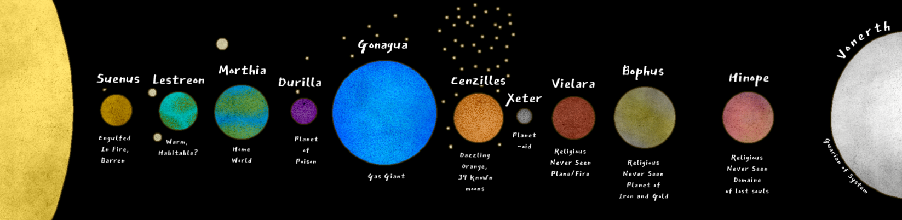

### Lumas System

**Lumas**,

The sun and being of Radiance

**Suenus**

The closest planet to Lumas, entirely engulfed in fire and barren from his power

**Lestreon**

The closest, warmest planet to Moerth that might house life in the future. Hospitable

**Moerth**

The Planet D&D takes place on. Teeming with life, with it’s single moon **Lunas**

**Durilia**

A cold, unforgiving purple mass. Believed to be the origin of all poisons

**Gonagua**

A Beautiful blue gas giant

**Cenzilles**

A dazzling orange and purple planet with 39 discovered moons. Debated if gas giant or not.

**Xeter**

Little more than a moon on it's own. Only seen twice in history

**Vielara**

Known only in religious texts. Fabled planet of Fire

**Bophus**

Known only in religious texts. Fabled planet of Iron and Gold

**Hinope**

Known only in religious texts. Said to be the domain of those who are lost.

**Vonerth**

Believed to be the largest of the planets, guarding the system from outside chaos. Pure white.

## Mountains

### Standalones

#### C - Domain of the Giants

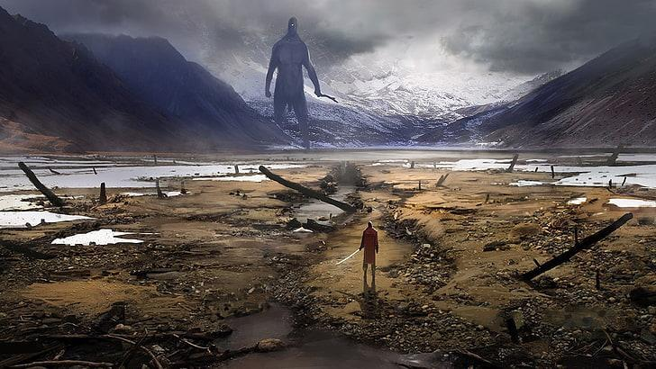

Never visited or seen by any humans, and rarely by any orcs. It's rumored to be the home to an ancient race of giants that dominate the plains before the mountains. The closest reaching society is the orcs of Aztarok, which are rumored to be cross-bred with the giants.

#### C - Hand of the Gods



Mountain like the one from "Holes" movie, set in the distant reaches of a vast marshland.

#### C - Ekhis (Eck-ee) Hills

A vast, sparse field of sharp hills and small mountains. Settled in these treacherous lands are bandits and nomads, with the occasional orc clan too.

#### C - Agonia Foothills

Mirroring Ekhis Hills, the Agonia foothills are largely homes to gnomes, halflings and elves. The hilly land is lush in greenery and hidden from common view. It's prosperity is a closely guarded secret, and is often overlooked by travellers.

#### C - Lonely Peak

The Lonely peak is part of a much larger range of mountains, but it stands out in it's sheer size. The lonely peak pierces clouds and rises higher than most think possible. In it's base sits multiple caverns and areas of interest. Many of the caves are fought over by dragons.

#### X - Blunder Hills

The Blunder hills are a collection of hills, rocky outcrofts and mountains that run north to south. They separate the Winter Woods from the Usuall Basin, creating quite the detour for travellers of Usuall.

#### X - Hearth Mountains

### Ranges

#### C - Border Stones

#### C - Carato Mountains

#### C - Jusomaas Foothills

#### C - Twilight Gates

#### C - Patola Range

#### C - Sickle Mountains

##### C - Guardian Mountain Range

#### CL - Claw Mountain Range

##### CL - Rage Cave

#### E - The Andelin Mountains

#### E -The Wildland Cliffs

##### E - Island Volcano

#### M - Great Morheim Mountains

##### M - Omega Peak

##### C - Mount Feyr

#### M - Smoulder Mountains

#### M - Ragehollow Mountains

Any inquires about the mountain to the local townsfolk won’t reveal much. They know an **old crypt** in the mountain was once a settlement that belonged to a powerful baron-knight or a paladin centuries ago, but no one has gone there since.

##### M - HellCrawl

#### O - StormCrest Range

#### U - Nightgrove Range

#### X - Mourning Mountains

##### X - Mourning Wall

#### X - Dagger Peaks

#### Y - Dead Water Mountains

#### Y - Barren Hills

#### Y - Hammerstone Hills

#### Y - Shard Mountains

## Waters

### Oceans

#### Aquatic Abyss

#### Dead Water Deep

#### Domain of the Lurker

#### Infinite Divide

#### Dreamshard Depths

#### Spirit Bay

### Lakes

#### M - Lake Arcane

Situated next to Lyric and further south is the university of Korthal, approximately a day's journey away

#### M - Tortle Lake

While the lake is of natural occurrence, the 20km connecting river is noted in history as a man/dwarf construction to help bring more shipping options available to the city of Dehum. The detailed works of how it was constructed is unknown, but no person would believe it to be natural.

The river is perfectly straight. With no twists, turns or rapids, it makes either a very peaceful and slow trip, or very quick and direct shipping route. On occasion, the river is used for races and challenges, but nothing is official.

#### M - Fernn Waters

Fernn Waters is known to all of man as it acts as a central hub of trade for Morheim-ians. There are no official ports, but kingdom warships often patrol these waters to monitor traffic heading for the capital. The Fernn Waters is the 3-way path from the southern Dreamshard Depths, the Continental river, and the Capital Inlet.

The lake reaches relatively deep, and several ships are known to have sunken in history. No one has managed to locate any of these ships, and no one knows what lies at the bottom of the lake. It's fabled to have a lurking monster that scampers along the seabed, eating whatever it comes across.

It's very rare for a ship to be attacked in this area by monsters to no one has bothered researching further.

Because of the relative lack of civilizations around the lake, it's difficult to determine who has claims to any coastal land in the area. Of course Korthal claims the area but when establishing a port or town, the entrepreneurs are met with bureaucratic messes.

Unknown to Korthal military, the Hold of Civilization has taken hold of a ship in the southern area of the Lake and keeps close watch of the Dreamshard Depths

#### M - Usuall Basin

This huge is on almost every map, and serves as a great view during travels. Unfortunately, the surrounding mountains of the lake are far too treacherous to accommodate regular traffic, so most will take the path for the view. The lake is very large but also rumored to house a few select lake-fairing monsters.

What's unknown is that while the lake does indeed house a large beast, it's nothing like they believe. It's a **giant island turtle** that is the mortal version of Lunas. Great god of the moon, etc. Lunas will not reveal herself to anyone. She will come out to those who have proven themselves or to a world in crisis.

#### M - The Dead Lake

#### M - Tortle Lake

A lake that was years ago separated and left on the border of the HellCrawl. Tortle lake has relics of tortle shells deep in the waters. It's now attached to the capital inlet via a man-made river to access Boscus Pass.

#### C - Yartyr Gorge

#### C - Atlashire Cove

#### C - Atlashire Lake

#### C - Casrath Lagoon

#### C - Firbolg Shallows

#### C - Patola Lake

#### C - Tibal Depths

#### C - Hunt Waters

#### O - Flurham Inlet

### Rivers

#### M - Continental River

Thin (1000ft) and long, this river serves as the main trading route for the Kingdom of Morheim and OAR. It leads directly to the Capital inlet and the city of Korthal.

#### M - Capital Inlet

The Capital inlet is often assumed to be a large lake, but it remains as a direct route to the continental river, and trade from the ocean. On the west is the GMR mountains, Lyric and the University, etc. On the east is more of Morheim, forests and the Battle-Hardened Plains.

#### M - Gateway River

This is one of, if not the longest known river in Morthia. The gateway river runs from the Usuall basin to Zirconia, and also splits off to pass by the Mistvalley Keep. Both ends terminate in the eastern sea.

#### O - Flurham River Pass

The river was rumored to have been carved out by a single man taking his whole life, and nature taking its course by slowly eroding away the drench until it became a fully-fledged inlet. Runs Behind the Stormcrest Mountains

#### C - Patola River

Running north of the Patola Mountains, past the Lonely peak and into the Tribal depths before terminating at the Patola Lake. From here, a small stream runs along the rim of the Deep woodlands all the way to Jusomaas

### Reefs

#### Nancy's Reef

#### Reef of Captain Leadhand

#### Brightharbour Reef

#### Cemetery of the Forgotten

Cemetery of the Forgotten, a rough and treacherous stone reef that's known to sink ships.

### Coasts

#### Cemetery of the Forgotten

This coastline lies along the separated subcontinent in the OAR, and follows a popular trading route of the republic. It houses 3 cities, all of which have ports and access to free trade.

#### The Free Coast

#### The Dead Coast

#### The Hollow Coast

#### Shimmerian Coast

## Forests

### M - Astral Woods

Supposedly the scene of a huge asteroid strike that didn't level the land around it. It just landed softly.

### M - Deadgrowth Forest

### M - Endless Forest



A large forest in the central part of Morheim. The kingdom controls portions of the forest. Though not a common destination in itself, the forest's central location means that many must pass through it. Combined with its isolation, this makes the forest a nearly perfect environment for bandits.

### M - Grogwood Wilds

Low shrublands, very treacherous and rocky with several wild animals that roam free.

### M - Hell Crawl Forest

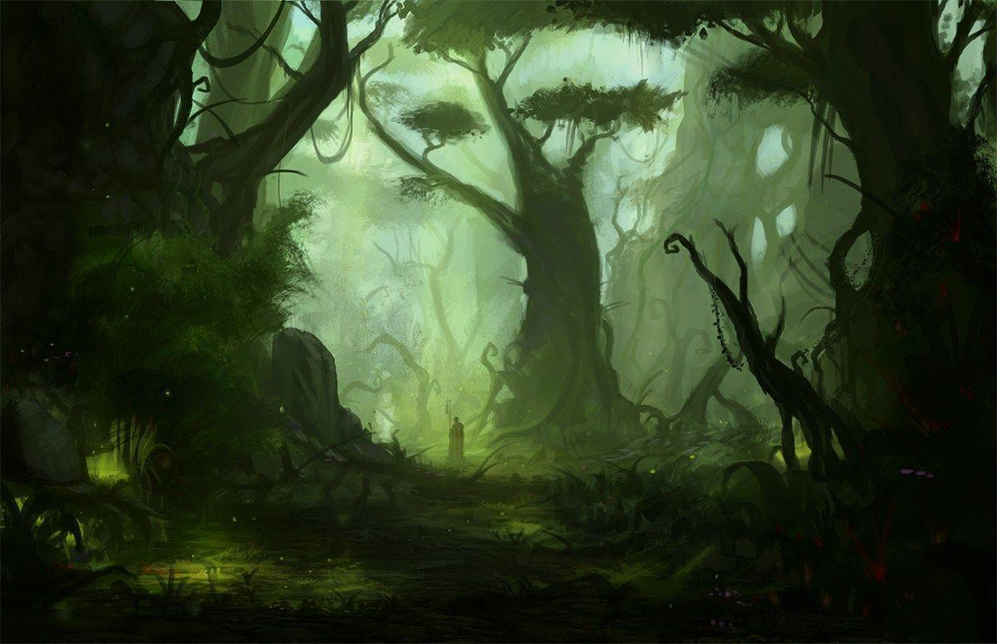

The forest was colossal, radiant, and archaic. Its canopy was marked by oak, beech, and walnut, and sparkling light dancing between the branches allowed for a patchwork of sprouts to make use of the soft, rich soils below.

Silent climbing plants clung to many a tree, and a hodgepodge of flowers, which were common to this area only, brightened up the otherwise unchanging lower level.

A medley of beastly sounds, which were caused by vermin, resonated through the air, and were out of sync with the swaying of treetops in the wind.

Description

Split and broken by mountains, hills, rivers, and lakes, RageHollow forest is known for its dense and dark atmosphere. It's located south of the Dehum-Smit pathway. One river cut right through the forest from mountains in the north to the Continental River. An eerie fog penetrates the dark of the forest and masks the horrors inside. Howls and growls can be heard at night from nearby towns, spreading fear far and wide. Few would dare brave the brush, and only the insane would dare go in at night. The roof of the forest allows the occasional speck of light into the grounds but never much.

The forest is always visible from the clear-cut path heading across the land, and is always on the south. Many locals call it the haunted forest, but there are no spirits here, only monsters. Who can really argue on the distinction though. **Any local nearby would urge PC's not to venture off of the path, even to make camp**. If anything, stay north.

Most of RageHollow Forest is packed with deadly creatures. It's also rumored to house trolls and goblins, as well as the occasional ogre. The eastern portion of the forest is swampy and near untraversable. No one really knows what lies out there...

**RageHollow** **Mountain** sits in the middle of the forest, with the cut-through river running along the base and splitting to go either way. The area south of the mountain is a lush forest ripe with magical aura and special species of plans and animals. The mountain itself is better described as a very large hill, and in the side of the hill is something odd.

Any inquires about the mountain to the local townsfolk won’t reveal much. They know an **old crypt** in the mountain was once a settlement that belonged to a powerful baron-knight or a paladin centuries ago, but no one has gone there since.

Approaching from the riverside of the forest shows nothing out of the ordinary. The brush past the shore is relatively normal but a few kilometers in and it thickens up rather quickly. A critical investigation might show the speck of man-made stone, or a figure darting through the trees with haste.

Plant life

Lish

Small tree, which grows dozens of small nuts in the spring in temperate forests. A handful of the nuts sustains a medium creature for a day. Eating a Lish Nut for each meal of an entire day must succeed a DC 11 CON-save or or becoming sickened for 1d4 days.

Lethelia

This plant appears blue in its leaves and purple in it's flowering bulb. The pollen causes Flurhamesia when inhaled

#### Heart of Hell

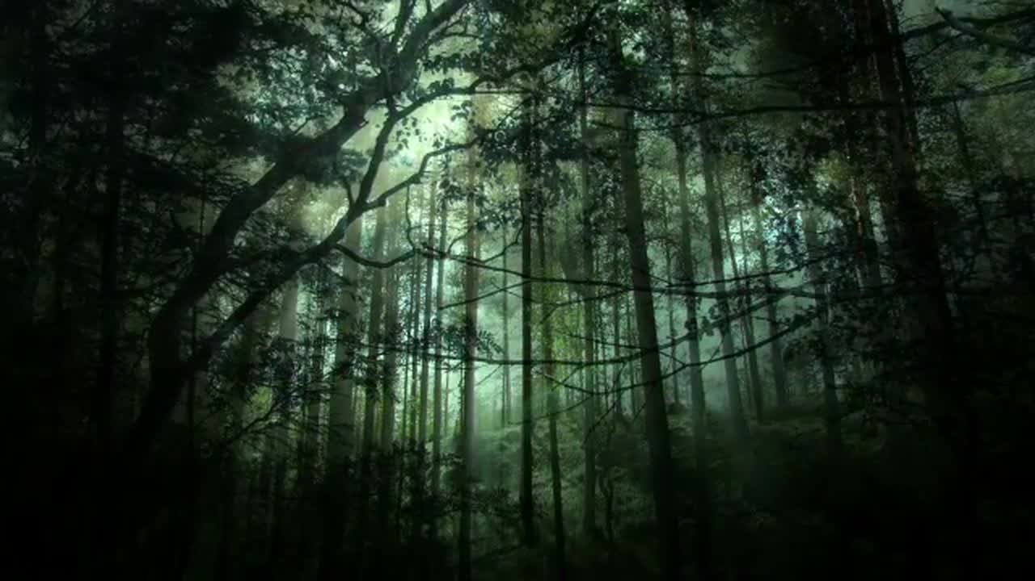

A diverse assortment of forest creatures, magical beasts, the undead, and demons

It's foretold that the oddly deep density of magical creatures was used for hiding something powerful in the mountains of the forest.

### M - Joultou Grove

### M - Korthal Forest

A large forest in the central part of Morheim. The kingdom controls portions of the forest. Though not a common destination in itself, the forest's central location means that many must pass through it. Combined with its isolation, this makes the forest a nearly perfect environment for bandits.

One would be easily lost in the Kotharel Forest. And while the kingdom claims ownership over the land, any governance is severely lacking. The forest stretches for hundreds of kilometers and has few, hard to find trails that wind through parts of it.

Rumors of the forest include portals to the Fey, ancient creatures and temples of old worship.

### M - Steep Pine Pass

A small forest nestled between mountains and two lakes. Steep Pine pass is known to be the dwarves old hunting grounds. Now, since most of the dwarves are gone, some risk the trek to search for old relics and secrets.

In the forest are several crypts, ruins and mines. There's also several monsters and traps to be wary of, and an old cave rumored to house a dragon.

### M - Velvin Thicket

Mainly used by the University as a special testing or hunting ground, the Velvin thicket is a special, dangerous forest.

The Velvin thicket also grows special trees, Livewood, which is used for spellcasting and enchantment.

### F - The Evergrowth

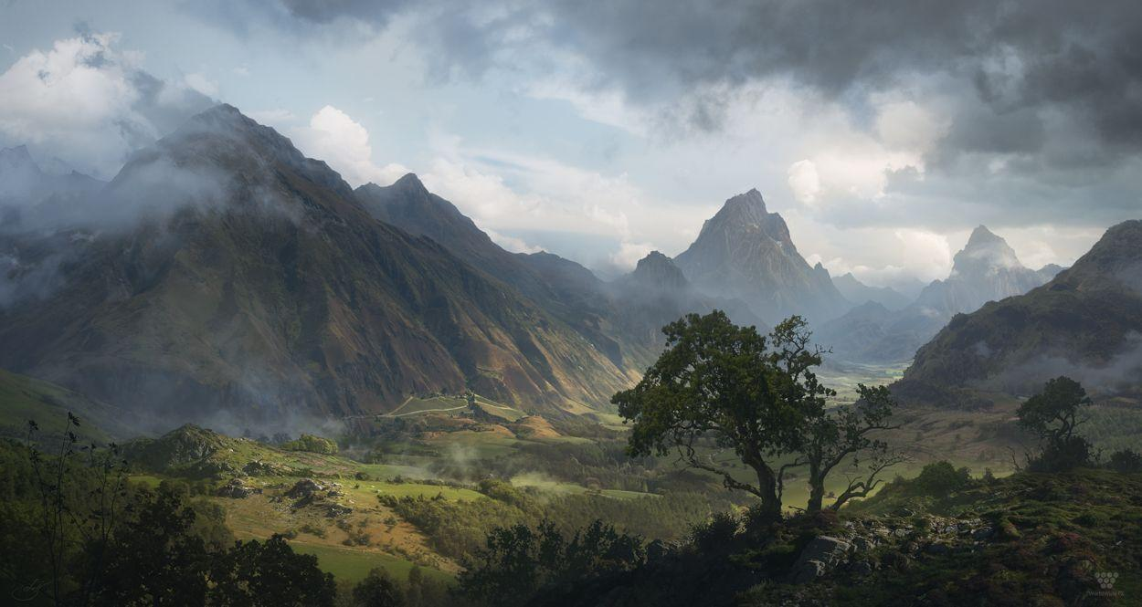The forest is vast. It takes days to get across, through thick and thin, up, and down mountains and valleys within. There are pockets of gold ore bleeding through more and more mountain cracks, which are uncharacteristically dark and dreary. These areas are newly inhabited by an influx of hags who are coming to see or join the new world, and are in turn beginning to terrorise the space around for their own amusement and benefit. Large parts of the lowlands within the forest are flooded, creating a murky swampland.

The lands are covered in collections of trees, and wide-open plains. Wild animals dominate the landscape and legend has it that Giants claim this land for their own; the only area believed to house them. There is rumor of a building army with a new leader, but no one has dared venture near enough to verify these claims.

### Co - Dreamseap Forest

### Co - Dry Forest

### Co - Sycamores

### Co - The Thicket

A small, yet thick, forest. Protected from storms by the surrounding mountain slopes.

### Co - Willow Glades

The Old Morheim Marshlands was largely covered with forest of middling density, making it appear more like a flooded forest than an actual swamp. One could rarely see far through the forest. The terrain was dominated by undergrowth and bogs with precious little clear, dry land to be found anywhere within its borders. The ground underfoot was soft and spongy, largely comprising thick peat. What paths there were to be found winding through the swamp were little more than muddy trails. The marshland itself was comparatively shallow, but very great in extent. Before it's relinquishment to The Collective, the WillowGlade were left largely undeveloped.

The wilderness was completely polluted by its various denizens and a long history of dark magic. While a natural marshland would filter sediments and toxic substances from a river, this barely occurred in the Morheim Marshlands.

*South of Guarding Peaks*

Odor

Uncomfortable sulfur smell. After some exposure it causes players eyes to water

Perception Fodder

Rotting corpse of a spider the size of a house. Looks like it died within the last couple of days

Friendly creatures

Large brown snakes that camouflage as branches. Still unless disturbed

Monsters

Zombies in the water. Wait to pull players down to drown them.

Monster Boss

Gorgon lurking in the ruins, hording a valuable artifact crucial to the plot.

Fauna

Musk Muddle

Stinky, brown, dead-looking plant with wide leaves found in swamps and marshes. Can be made into Burn Salve, which when applied within 2 rounds after taking fire damage, heals 1d6 points of the damage done by fire.

Common,

Mimetic Plants

A non-specific category of plants whose fibers have the ability to take on the hue of whatever is around it. Forms the basis for Chameleon weave. Combinable with armor

Very rare, 100gp/plant

Cassil

Mustard-like shrub, whose seeds can be made into a powder that suppresses male fertility for 3d4 days (1 hour to take effect). Medicine / Survival 15 check can detect its effects, while a Med/Sur 20 check can reverse them.

Priceless

Darkberry

Bush that grows clumps small purple berries. The handful of berries that reach ripeness each year contain shadow stuff in their skins, and if broken or crushed, they create a 5 ft diameter circle of “blackness” for 2 rounds.

5 gp. rare, 5sp/berry

Duskwood

Black-barked tree that grows 60 ft tall in tightly spaces groves, featuring small branches and smoky grey wood that's strong as iron (hardness 10, 30 Hp/inch) but half the weight. Items made from it count as master-work and replaces steel in weapons and Breastplates, which have altered stats and counts as light armor.

Costs +1500 for a weapon, +300 for a breastplate.

Pixie table 300 gp

Rare 1-ft tall and 1 ft diameter mushroom with a dark lavender cap that can be found in any woodland but is most common in temperate forests housing Fey. If boiled with cloth, it dyes it Lavender. It is the main ingredient for a red liquid called memorybind, which allows a prepared caster to prepare an extra 1st level spell in exchange for reducing all save DCs by 2. Alchemy DC 20,

*Orticusp* 500 gp Very Rare

Extremely rare flower with a root that looks like a pale white fist, found in temperate forests with trees of at least 150 years of age. Fey within 20 yards can smell its earthy aroma and find it easily. If the root is pulped it can be made into Night Venom, which when added to a poison, adds an additional saving throw (at the poisons' normal DC) to the initial save against the poison. Failure causes the creature to fall asleep

Shadowtop

Massive trees native to humid climates that grow 2 ft a year, top out at 90 ft and reach a 10 ft or more diameter. Its wood is fibrous and tough, making it unusual for carving or building, but burns hot with very little smoke (torch lasts 2 hours) and its fibres make good ropes.

### Co - Border Forest

### U - Nightgrove Forest

The Nightgrove forest is a largely unexplored and fabled area of the world.

Lore

The contents of it are unknown to humans and most believe there to be magical beings such as unicorns, dragons, and maybe even **gods** living there. The Nightgrove is strongly connected with Shadow fell and the fey wilds, making it abundant in magical forces.

Centaur Guards

The only thing that's known of this area is that in the West, Centaurs guard the gates. Anyone coming too near will have a bow aimed at them and they will be ordered to turn back. Anyone to continue walking will be downed on sight. Centaurs will be willing to speak with adventurers of high enough stature and influence, but will not grant them access to the forest without reason.

Inhabitants

The forest is in fact home to many magical creatures, evil and good. In uncharted plains, unicorns run free and minotaur hunt them down. Centaurs guard ancient secrets, and goblins test them constantly. Corruption beasts frequent the area as well.

Fey Portals

The forests grow remarkable high and trees are inconceivably large and thick. The forest has a strong connection to natural forces, and there are several portals leading to the **Feywild and shadow fell alike**. A common occurrence is for the Fey to merge with the forest and for Fey creatures to venture into this world.

Plant life

Abundant and diverse. An adventurer would need to exercise caution when traversing this land as some plants may stun or even kill you on site.

Shadowtop Trees

Massive trees native to humid climates that grow 2 ft a year, top out at 90 ft and reach a 10 ft or more diameter. Its wood is fibrous and tough, making it unusual for carving or building, but burns hot with very little smoke (torch lasts 2 hours) and its fibres make good ropes.

Duskwood Trees

Black-barked tree that grows 60 ft tall in tightly spaces groves, featuring small branches and Smokey grey wood that's strong as iron (hardness 10, 30 Hp/inch)but half the weight. Items made from it count as master-work and replaces steel in weapons and Breastplates, which have altered stats and counts as light armor. **Costs +1500 for a weapon, +300 for a breastplate**.

Orticusp Lilies

Extremely rare flower with a root that looks like a pale white fist, found in temperate forests with trees of at least 150 years of age. Fey within 20 yards can smell its earthy aroma and find it easily. If the root is pulped it can be made into Night Venom, which when added to a poison, adds an additional saving throw (at the poisons' normal DC) to the initial save against the poison. Failure causes the creature to fall asleep. **Very Rare, 500gp/shrub**

Cassil Leaf

Mustard-like shrub, whose seeds can be made into a powder that suppresses male fertility for 3d4 days (1 hour to take effect). Medicine / Survival 15 check can detect its effects, while a Med/Sur 20 check can reverse them.**Priceless**

Darkberry

Bush that grows clumps small purple berries. The handful of berries that reach ripeness each year contain shadow stuff in their skins, and if broken or crushed, they create a 5 ft diameter circle of “blackness” for 2 rounds. **rare, 5gp/berry**

Mimetic Plants

A non-specific category of plants whose fibers have the ability to take on the hue of whatever is around it. Forms the basis for Chameleon weave. Combinable with armor and almost impossible to find **Very rare, 100gp/plant**

### X - Old Growth of Elmonn

The forest was modest, gloomy, and ancient. Its canopy was overshadowed by beech, maple, and willow, who left just enough light for scattered herbs to use the flat, fertile grounds below.

Thin tree limbs hung from a couple of trees, and a mishmash of flowers, which were unique to this region, adorned the otherwise brown forest floor.

### X - Winter woods

The winter Woods span 25,000km2 and are encompassed by 'newly' established travelling roads. The winter woods are relied on primarily by Usuall, Andale Port and Sledge for their lumber and game supply. It's also known to be home to the occasional dragon.

### X - The Wild Woods of Espia

The Wild woods is a small but thick woodland in the region surrounding Espia. Several watch towers jut out from the thick low bushes and woodlands to serve as keen eyes to the west. The forest is nestles in the cove of mountains

At the end of the forest, along the one road in, lies the Crystal mines of the Dynasty.

### O - Baryon's Hunt Grounds

### Cr – Evennfall Forest

The Blackwoods are the best known to the people of the OAR due to it's proximity to several towns, and military significance. It's name comes from the odd foliage that grows there. The bark and leaves from roughly half the trees shift every year from green to pure black, and back again. It's highly sought after, but still in the realm of the orcs and therefor quite dangerous to procure.

### Cr - Carato Forest

Carato forest is nestles around a three-pronged mountain range of the same name. Its southern spans is much larger than the northeast and west which huge the mountains, exceeding only 10-20km's out. The south, however, spans up to 100.

Multiple rivers stretch from the mountains and through the forest, down into surrounding water bodies. These rivers are the lifeblood of the region and bring life to more than three other forests.

### Cr - Casrath Growth / Lagoon

Casrath lagoon is the northern-most forest in the lands and seldom explored through, especially as it's farthest into the Orc lands. It's also in close proximity to the domain of the giants, and the clan of the Aztarok brutes.

The floor of the 'forest' is almost entirely water, leaving unknown topography and very likely houses many many monsters.

### Cr - The Covert

A large orcish forest nestled between two mountains that see loads of rain. A river runs through it into the lake south of the forest known as the hunt waters

The forest roof is dense and dark, leading to constant dripping leaves from above and a perpetually damp environment. It's ideal for nocturnal and stalker-like hostiles.

### Cr - Damned Forest

The damned forest is rich in rough terrain and damaging foliage. It's strategically maintained for the Capital city of Gaj Gedad so only those who know the area know how to traverse it safely.

### Cr - Deep Woodlands

The deep woodlands is least-known to non orcs. It's encompassed by four different mountain ranges and 49,000km2. It's inhabitants are largely unknown but it's fabled to house ancient civilizations, mythical beasts, and the heart of the feywilds.

### Cr - Epterre Woods

### Cr - Feyr Forest

### Cr - Feywoods

### Cr - The Frost

### Cr - Misty Bog

### Cr - Yartyr Swamp

Set to the North of Gedad, the area is encompassed by less-dense trees than the Hunting grounds and holds a rockier terrain. Several riverbanks are dried up around the area and make for interesting settings of depressed lines in the land. The area is regularly patrolled by Orcs.

The interior of Gedad Forest contained many ridges and steep gullies that were hidden beneath thick vines, dense shrubbery, and cloaking mists that presented a danger to casual travelers. In addition, tunnels, cellars, and vaults constructed by dwarves during a time of alliance became pitfalls centuries later.

Plant Life, Organized by rarity

***Panaeolo*** Magical herb whose leaves tastes like leather and function as an ingested drug with no initial effect. Can be rolled and smoked. Low addiction

Uncommon, 250gp/kg Forest - Creatus Forest

***Ripplebark*** Shelf-like fungus that looks like rotting flesh but is perfectly edible, although it tastes better if cooked properly.

Uncommon, 10sp/bushel Forest - Creatus Forest near water

***Green*** ***Air*** ***Bramble*** Fast-growing creping vine that sprouts green berries. Can grow in most inhospitable climates and only needs to be in moist soil for 6 hours per week. Exposure to poison quickly kills the plant, wrinkling leaves and berries. Carrying 3 ft vine grants +2 untyped bonus to resist inhaled poisons, airborne diseases and nauseating effects like stinking cloud.

rare, 80sp/vine Forest - Deep in forests

***WishBlossom*** Small, petalled bulb plan with glowing gold spheres in the center. Nature 20 to harvest or the bulbs dim and the plant dies. Three bulbs in a drink grant the user one wish, which (DM discretion) comes true after a nights sleep

2,500/bulb Forest - Deep in forests

***Densewood*** AC16. It doubles the weight of any wooden item and costs twice as much.

Rare, 4gp/kilo Forest - Deep in forests, Nobleman Furniture

## Open Areas

### Cr - The Fejur Badlands

Only known well to Feywild inhabitants, the Fejur Bandlands are a large dead plains area, desolated by an unseen force that swept through the valley.

### Cr - The Crystal Tundra

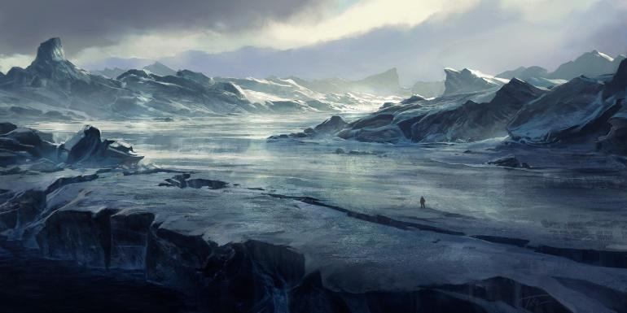

Wild rushing winds rip through the air, cutting into the deepest of pelts and rendering all mounts and vehicles useless. A barren snowy desert occupies the land with several caves and hills hiding lairs of ferocious beasts.

The Crystal Tundra is home only to the legendary **Ice Elves,** who claim the land as their own.

Ice Elves:

Only some know of the origin of the Ice Elves. This sub-race of Elves was made when a clan of Elves were heading north to hide from the increasing orc raids and raiders. They have lived there for so long that the ice has become part of them. Ice Elves typically live in beautiful elven cities or towns. Since their forms are changed by the Ice so are their personalities- most of the subspecies share certain traits with Ice, examples of these traits being: Cold, emotionless, and slow to act and they are hard to talk to.

### E - The Neverfields

### Y - The Barren Waste

### O - Battle-Hardened Plains

The area is scarred with fissures, explosion holes, built and destroyed barracks and decay. The land is not suitable for development or farmland, but it's showing signs of healing, the grass, while patchy in areas and largely dead in others, is spreading. Animals are returning to graze but leave to find shelter. Even gnomes scour the area for habitable sections. Currently, the area is used for travel and the Morheim Kingdom mandated that compact roads 30ft wide would be created and maintained across the land. This was a relatively successful job.

Lore - The Lost Battle

### CL - The Tarsal Desert

Description

A magical, illusionary spans of desert that takes people and rarely lets them go. People will get turned around and get lost, without markers to tell them where they are. Many say there is no hope in finding your way once it's lost.

The desert desert stretches north to southeast of the GMR Mountains. Nomadic tribes of humans, half-elves, and half-orcs travel with their herds with little official structure among them. Recently, an astrological event has altered the nature of the desert, turning it into a treacherous and unrelenting crossing.

The edges of the desert are comprised of a steep drop of 50-100ft at various areas.

Plants

Wolf's Milk, harvested from cacti

Distilled liquid drug that stains lips blue, Initial 1 poison damage, Secondary 1d4 hours pain immunity, euphoria and -2 Initiative, Overdose if second dose during duration of first. Med10 to revive. Causes Slowed for 2d4 hours. Medium Addiction, 15 gp.

Brineweed,

A non-magical plant that grows in deserts. Its roots are highly nutritious and contain a lot of water, however it is incredibly disgusting. It is useful when you're starving though. It is easily identifiable by its reddish-yellow branches. CON 8 or throw up and can't eat for the rest of the day

Golden Desert Tree

A rare desert tree, whose sap is a vital ingredient in expensive perfumes and incense. When used as a component in casting a summoning spell with a 1 round casting time, it reduces the casting time to a standard action.

Sand Vine

Relatively rare rope-like seaweed found along temperate or warmer coasts. Grows both above and below water, commonly rooted to a small rock. Can be dried and used as rope. May have special healing properties if used as a gauze.

Halfling Thistle

Small hardy thistle with a violet flower that grows in all temperature areas, especially highlands. It can be made into Shine water, which removes all rust and corrosion from metal objects left to soak in it overnight. One dose re-rust a medium-sized metal weapon. Alchemy DC 5, 5 gp.

#### A Hidden People

Often mistaken for nomads, the dune elves live conflicted lives.

They are fond of other races, but a number of raids on their ancient cities for their gold, jewels, or even tomes on illusions has left them distrusting of outsiders. A typical Dune Elf is wary of strangers, but not unfriendly, preferring to take advantage of their long lives to get to know their companions personally.

As such, many Dune Elf settlements have used the illusory magic of the desert to conceal their territories. When happening upon a city or settlement, explorers often see little more than a blur in the distance. Although they often employ the use of illusion magic, those that live among dune elves say they are far from duplicitous, claiming them to be an honest people, though suspicious of outsiders.

# Factions (18)

## Lawful

### L - Church - The Pantheon of Gods

--DESCRIPTION--------------------------------------------------

A religious Order serving the Gods and preaching that they are the combination of all Mantles. It holds incredible political sway in Morheim and surrounding regions and therefore has the funds to maintain a standing army of several hundred holy knights who pledge themselves as protectors of the crown of Morheim.

--HISTORY----------------------------------------------------------

The Church of the Gods is a long-established organization that has recognized the impact of the gods on the life of men. Since the age of Creation, mankind has relied on the powers of the gods for purpose in their life.

Since the age of the Haps, the church has noticed a decrease in influence. Scientific advances and increasing knowledge of the world has led people away from the influence of the gods. And now, with the gods leaving the plane to a higher existence, the church is holding on to the powers they still hold as moral guides in this world.

<Goals>

<Relationships>

--SHOPS & PEOPLE--------------------------------------------------

Church Leader, the **Chope**

### L – The Keepers

--DESCRIPTION--------------------------------------------------

--HISTORY----------------------------------------------------------

--SHOPS & PEOPLE--------------------------------------------------

**Leader**:​ Head Keeper

**Tier 3**:​ ‘Great Keeper’

**Tier 2**:​ ‘Under Keeper’

**Tier 1**: ​‘Cadet’

**Tier 0**:​ ‘Recruit’

### L - Pal/Cler/etc. - Sentinels

--DESCRIPTION--------------------------------------------------

The Sentinels are an order of crusaders, clerics, and

religious scholars within the Church of the Gods, but more focused on proselytizing on behalf of the Gods and biting back at supernatural forces of evil that lurk just beyond sight as opposed to enforcing the laws of the land.

--HISTORY----------------------------------------------------------

Around the time of godly recession, humans still had monsters and catastrophes to deal with. Because of this, the Lord of Morheim at the time established two orders. The Iron Temple, and the **Sentinels.** The latter are tasked with seeking out these monsters and terrors, and disposing of them by whatever means necessary.

**<Audience with the Kneeling Knight>**

Both the Iron Temple and the Elysian Protectorate encourage their members to first make a pilgrimage to the temple of the Kneeling Knight, which is fabled to hold close connections to many deities. People are known to speak directly with gods, be cursed, or find enlightenment and choose the right path for their life.

The temple is located at the base of Mt. Feyr, just west of Morheim and South of Xandor.

**<Goals>**

To rid the world of unnatural evils and threats, while protecting the sanctity of civilization

**<Relationships>**

Origin Morheim

Serves Morheim, OAR, Xecuria

Authority Search, detain, and kill in extreme needs.

Reputation Overall well-respected all over.

**< People>**

High Sentinel

Perrin Overtell

Low Sentinels

Maria Blackwood

Sotorin

Ash

Lower levels

The Branded

The Acolytes

### L - Paladin - Iron Temple

--DESCRIPTION--------------------------------------------------

​An order of Knight worshiping, law-enforcing soldiers, knights, war priests, and law mages who do everything in their power to track down criminals and bring them to justice. Although they are privately managed, they are granted compensation and freedom of jurisdiction in several provinces by the local heads of state, under the condition that they remain neutral in times of political conflict.

Their symbol is a **mighty scale over an iron shield**, and they aim to drive the fear of the gods into would-be, or actual, criminals.

The Iron Temple operates barracks in nearly every major city, and trains the city guards. They also work with small town militias to a certain extent for training exercises every few years, but their presence in villages and small towns for the most part is quite small.

They also operate the highway patrols that can sometimes be seen on major trade routes

--HISTORY----------------------------------------------------------

Around the time of godly recession, humans still had monsters and catastrophes to deal with. Because of this, the Lord of Morheim at the time established two orders. The **Iron Temple**, and the Sentinels**.** The former were tasked with maintaining order among the populous, but soon became too large and widespread for the kingdom to manage.

As such, the King before Arteron agreed to privatize the company, so long as the company reported to the crown and only enforced the laws of the land.

<Audience with the Kneeling Knight>

Both the Iron Temple and the Elysian Protectorate encourage their members to first make a pilgrimage to the temple of the Kneeling Knight, which is fabled to hold close connections to many deities. People are known to speak directly with gods, be cursed, or find enlightenment and choose the right path for their life.

The temple is located at the base of Mt. Feyr, just west of Morheim and South of Xandor.

<Goals>

To protect the sanctity of civilization through law, order and enforcement.

<Relationships>

They are not above the immediate forces (such as guards) of the local heads of state, though they do train many kings guard in security and anti-assassination measures.

--SHOPS & PEOPLE--------------------------------------------------

**Leader**:​ His Magistrate, Lord Eisencroft

**Tier 3**:​ ‘Legate’

**Tier 2**:​ ‘Officer’

**Tier 1**: ​‘Private’

**Tier 0**:​ ‘Recruit’

### L - Charity - Elysian Protectorate

The Elysian Protectorate is a guild founded by Paladins to promote the propagation of good deeds. They often act as a charitable mercenary group but also actively seek out challenges to overcome and evil threats to vanquish. 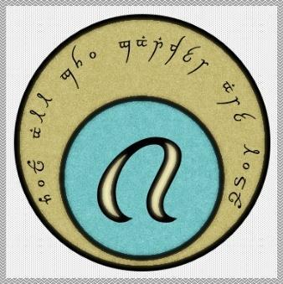

The guild is not exclusive to Paladins and many other classes can be found so long as they adhere to the tenets of the group. Members voluntarily contribute a tithe to help maintain the guild’s resource centers.

While often unsuccessful, the Elysian Protectorate tries to thwart foul players to the best of their ability. They are, however, quite adept at containing local criminals when they get out of hand.

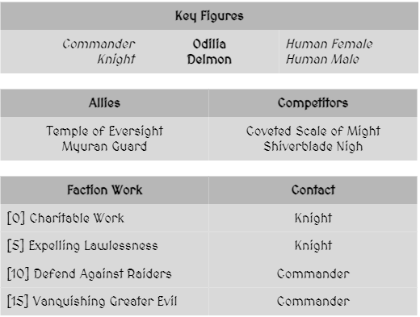

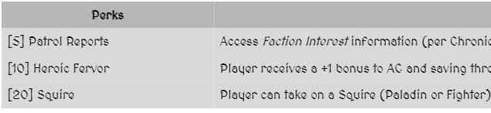

### L - Adv. Leag. - Guild of the Hammer (Heroes)

--DESCRIPTION--------------------------------------------------

The Guild of the Hammer is a clan/guild of influential figures that recognizes Heroes in history based on their actions.

They recruit these people, offer them chances to amass fame, fortune, and power, so long as they act on behalf of the guild.

<Headquarters/Location of Organization>

--HISTORY----------------------------------------------------------

Brought on at a time where demons dominated the land, people like Hammer Ranjfold sought out brave men and women to fight them back to the abyss. The fight was known to all, and the movement spread like wildfire from the Hold of Civilization to the rest of the lands. Soon, every town had several bands of heroes fighting the demons, and encouraging generations to come and do the same.

When Hammer fell, the news was that of sorrow and hope. The unofficial guild beacon of light and strength was gone. However, his last feat of strength, determination and call on the divine to aid humanity shone brighter a light and more powerful a tale than any story before him. His death was a testament to the world, showing mankind curried favor with the gods, and that the fight was one worth fighting.

While the lands rebuilt themselves over the next few hundreds of years, the Kingdoms that rose and fell all paid tribute to Hammer and the gods. Many also tried instituting a Guild of the Hammer to keep the population and leaders safe. While not all were successful, many rose to high levels of fame and fortune, only solidifying the possibilities of this lifestyle.

Around the time that Morheim developed its foundation, the King of the time tried to merge the guild with the kingdom. The effort succeeded for a few hundred years, but slowly the power of the king corrupted him. He tried to have the guild kill those who stirred up rebellion. Some of the guild followed blindly, while others second-guessed their choices.

Soon enough the corruption of the king was too blatant to turn a blind eye to. His greed, sloth and envy of others turned him to a cruel old man. One man in the guild by the name of **Antaris** had secretly joined the rebellion, but also managed his way up the guild ladder to a point of trust and non-suspicion with the king. Then, one night before the King called for the destruction of the rebellious towns, Antaris slit the throat of the king, cut off his head, and displayed it on a pike at the doors of the castle.

**Antaris** died for this deed, and with it came the official death of the guild. They no longer carried support with the Kingdom, as Antaris had shown that no matter how trusted you were, any of them were capable of bringing down an empire.

With no heir, the death of the king left the throne unoccupied. People prayed to the gods to find a righteous leader, and that's when the Aasimar descended from the Omega Peak to comb the lands for someone worthy in the eyes of the gods.

Antaris is notoriously know to history as the **Mad King-Killer** but holds renown with historians.

After the death of the king, the guild was in disarray, but slowly rebuilt itself as an independent organization, transcending the borders of kingdoms. Antaris holds fame in the guild as a seer or sorts. Many aspire to act as courageously as he. In the coming hundreds of years, the guild begins to stand in a respectable position across the lands once more, while strictly adhering to values of peace, truth, and community. They also still favor fame and fortune, so long as their actions benefit humanity.

In recent years, the guild had sought out a new leader to be the face of. Their search has found them a peasant named **Gaarin** (Garran) Ranjfold, a field worker to the south of Kingsport. While initially opposed to this new path, Gaarin was persuaded by a council of guild elders to follow them for a year, before deciding. In that time, Gaarin displayed abilities and accomplished feats thought to be possible of only legendary heros. His tales are told to all and he stands as leader of the guild council.

<Goals>

To find notable heroes to help eradicate evil forces from the world and promote peace, while also netting a profit on their work.

<Relationships>

--SHOPS & PEOPLE--------------------------------------------------

Guild Leader

Notable Hero

### L - Secrets - G.O.S.P.E.L.

When the darkness of yesterday dons the horizon, we stand there to face it. When you are lost in the darkness, we are there to guide you to the light.

--DESCRIPTION--------------------------------------------------

A secret, highly religious organization that was founded by followers of Hammer, at the turn of the age of creating, and has devoted their lives to acting in the utmost secrecy while studying the world and its properties, as well as acquiring knowledge of universal powers.

<Headquarters/Location of Organization>

--HISTORY----------------------------------------------------------

GOSPEL's Chapter began with **Hammer Ranjfold** at the **Hold Of Civilization**. Hammer functioned as the last stand between a great demon army and the old age.

GOSPEL has used it's members abilities and influence to alter events such as wars and cataclysms, so they never happened.

<Goals>

* Gather information from powerful beings in a quiet and unintrusive manner
* Teach those around you about equality and kindness.
* Find heroes willing to fight evil and give them the guidance and tools to do so.

<Relationships>

GOSPEL is a secretive society, only known by the members. Other citizens may have heard tales or pieces of secret societies, but never pieced it together

--SHOPS & PEOPLE--------------------------------------------------

Mithril Lake -

Rasa -

The Hold -

Jusomaas -

Vel-Gendar -

Bright Stone -

Elder Point -

Korthal -

Starguard -

Meera -

Pirates Sanctum -

Port Passer -

Smugglers Port -

Usterduum -

Frostling Stronghold -

Hold of Civilization -

Repository of Records -

Sutherland Keep -

The Watch House -

Underdark Guard Post -

University -

Val'Alora -

Freeton -

Mistvalley Keep -

Revari -

Zirconia -

Mire'Seil -

Yuntas -

### L - Nature - Grove Striders

The Grove Striders is a widespread group of wilderness survivalists who preserve the natural order while rooting out unnatural threats. The organization is decentralized, hardy, and reclusive. Barbarians, druids, and rangers of good or neutral alignments are commonly drawn to the Grove Striders.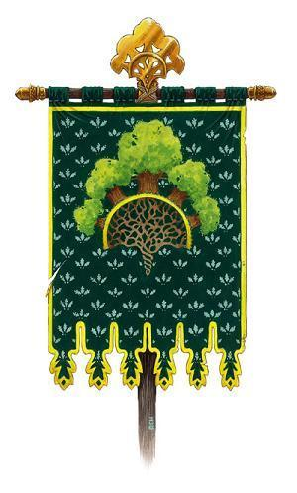

--HISTORY----------------------------------------------------------

<Member Traits>

Members of the Grove Striders are spread far and wide, and usually operate in isolation. They learn to depend on themselves more than others. Survival in a harsh world also demands great fortitude and mastery of certain fighting and survival skills. Members of the Enclave who dedicate themselves to helping others survive the perils of the wilderness are more social than others who are charged with defending sacred glades and preserving the natural balance.

<Headquarters/Location of Organization>

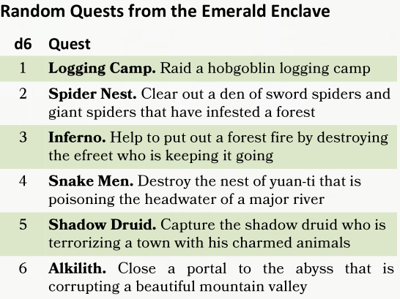

Goals

* Restore and preserve the natural order.
* Destroy all that is unnatural.
* Keep the elemental forces of the world in check.
* Keep civilization and the wilderness from destroying each other.

Beliefs

* The natural order must be respected and
* preserved.
* Forces that upset the natural order must be
* destroyed.
* Civilization and the wilderness must learn to
* coexist peacefully.

**Items:**

i) a faction insignia (Grove Striders leaf clasp) and

ii) a faction loot satchel.

Master of the Wild –

The leader of the Grove Striders, responsible for overseeing the organization and ensuring that its goals are being pursued effectively. They are a seasoned and experienced warrior, with an extensive knowledge of the natural world and its inhabitants. The Master of the Wild is a respected figure among the Grove Striders, and their wisdom is sought out by all members of the organization.

Characters are ensconced within the leadership of the faction and have a great degree of influence, guiding faction decisions.

**Supernatural gift**. Once, the faction can call upon a deity to bestow a blessing of speed upon the agent.

Winter Stalker –

A senior member of the Grove Striders, with a particular focus on rooting out unnatural threats during the winter months. They are skilled at tracking and hunting, and are often called upon to lead missions to eliminate dangerous creatures or protect natural habitats. The Winter Stalker is a formidable warrior and a respected mentor to younger members of the organization.

Characters are trusted voices within the faction’s leadership. They are looked upon as champions of the faction’s beliefs, and as mentors by those of lower rank.

**Quest:** Trusted with the issues of Rea Xandor and Till

Autumn Reaver –

A senior member of the Grove Striders, with a particular focus on rooting out unnatural threats during the autumn months. They are skilled at scouting and reconnaissance, and are often called upon to gather intelligence on the movements of dangerous creatures or other unnatural forces. The Autumn Reaver is a cunning and resourceful warrior, and their knowledge of the natural world is highly valued by the Grove Striders.

Characters are reliable faction members, entrusted with many secrets and deserving of additional support.

Permanent item: The agent’s leaf clasp is magically upgraded and given the properties of a *ring of animal influence*.

Summer Strider –

A member of the Grove Striders, with a particular focus on preserving the natural order during the summer months. They are skilled at navigating difficult terrain, and are often called upon to lead expeditions to remote or dangerous areas. The Summer Strider is a hardy and resilient warrior, and their expertise in survival is highly valued by the Grove Striders.

Characters have shown that they’re aligned with the faction’s goals, and are able to take on more responsibility. Perks include:

Permanent item.

i) Either a +1 weapon, +1 rod of the pact keeper, or +1 wand of the war mage.

Spring Warden –

A junior member of the Grove Striders, responsible for maintaining the organization's camps and outposts during the spring months. They are skilled at farming and foraging, and are often called upon to provide support for more experienced members of the organization. The Spring Warden is a dedicated and hardworking member of the Grove Striders, and their contributions to the organization are highly valued.

This is the rank a character receives when first joining and pledging service to a faction. Perks include:

Permanent item.

Grove Striders Secret Trails

Trail Leads to:

Folk path Faster Travel between towns

Mythical paths Direct route to dangerous areas

The unicorn run Fey paths in normal nature

Forest pool to the Feywild Feywild

Tree root path Hidden castle in fey

Forest paths to the Beastlands Archfey realm

Mushroom ring Cove Omega gates (Lunas)

**Lesser Factions (11)**

### The Silver Priests – Tarsal Desert

The Silver Priests begin their worship when the shroud of night folds over the Tarsal desert's unending sky.

Theirs is not one of old chants or stuffy prayers, the desert has no patience for that. The priests serve

their matron, Lunas, as wardens of the twilight, keeping watch over the bright settlements and dark sweeping

dunes of the desert.

The role of a Silver Priest is not unlike that of a shepherd, guiding travellers between settlements in the

open desert or leading creatures of shadow away from harm. But on occasion a rogue force manifests, prompting

swift and final action. For this reason, Silver Priests are some of the most adept warriors in the Tarsal,

instrumental in the protection of Rasa, the Tarsal's largest settlement.

Silver Priests are nomadic, travelling between settlements performing acts of medicine and magic. They are

bringers of life -- aids to mothers in labour -- and a comfort in death -- walking with dying souls into

the afterlife.

**Enemy - Creed of Sesikhi** - Roguelike cult that was defeated by the Silver Priests

**Ally - The College of GOND**order of craftsmen that work with the Silver Priests to adequately arm them to face their foes and rise to their challenges. Operate out of Vermillis, with Close ties to the Dwarven Craftsmen of Vel-Gendar

**Leader**: no temple, the world is their temple as night falls, in that moment. Therefor, no governing body.

**Way of Worship: No praying, worship through service and deeds.**

**Races** Humans, dwarves and dragonborn but not exclusively.

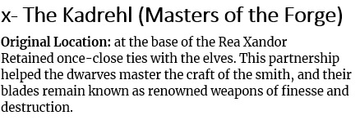

Helped Aldwulf Kadrehl, the last lord of the Clan before it fell to the World Serpent. Ol’tek(?) helped Aldwulf earlier in life and earned the prestigious gift of a Dwarven warhammer by the name of

Hammer names:

* Daybreak

Reason to leave?

The order itself is becoming villainized, and for some reason a new so and so is in power.

### Excavum Institute​: [Ex-Cave-Uhm]

Academic research dedicated to researching the Planar and Great Wars and the disappearance of the Gods. They look for the lost sites of civilization and battlefields from the first planar war and fund and man expeditions and archaeological digs of those sites to seek lost technologies and artifacts.

Of particular interest to both adventurers and the Institute is the lost mythical hoard of Azerim, a demon lord, though the few writings that survive are unclear about whether this is a collection of treasures, a location, or a single object.

<Headquarters/Location of Organization>

## Neutral

### N – The Forever Knights

Leader - Enoch

The Forever Knights are an organization of human supremacist knights that despise all other races.

*Forever Knights, our time has come. This is why we exist. All the other false purposes of the Forever Knights; gathering technology, fighting dragons; nonsense and corruption of our one true mission. As we did upon our founding, so shall we do again. We shall protect this world form impurity and restore order to human-kind!*

***Forever Kings***

*Dr. Joseph Chadwick*

*Sir George*

*Sir Driscoll*

*Patrick*

*Urien*

*Enoch*

*Sir Cyrus*

[*https://ben10.fandom.com/wiki/Forever_Knights#Goals*](https://ben10.fandom.com/wiki/Forever_Knights#Goals)

### N - Meera Trading Company



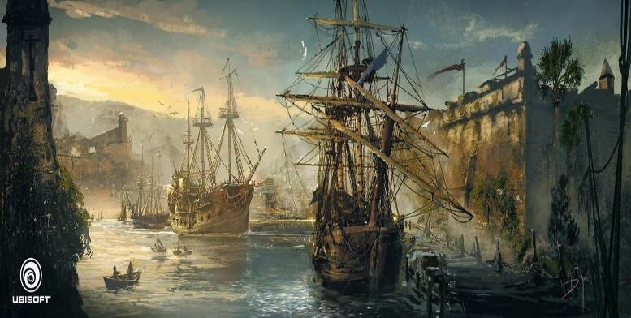

--DESCRIPTION--------------------------------------------------

The main sea-faring trading company directly owned and operated by the Naval Chancellor. All boats and crewmen are required to use their ships for war, if called upon.

Their main opposition is the Sunken Souls, a collective of pirates.

<Headquarters/Location of Organization>

--HISTORY----------------------------------------------------------

The Meera Trading company originally began as a crudely built armada of ships and soldiers made to defend the OAR. Soon, relative peace came to the republic and the company as it was known, soon became more of a liability as an asset.

Because of such, the Chancellor of the time called the company to disband as a military force, with the possibility of a draft. Now, the company acts as a trading company for both individuals and for the republic. Ships are owned and operated individually, and are certified by the republic.

<Goals>

To provide safe and professional trade and passage to all law-abiding and respectable individuals.

<Relationships>

Close ties to the republic. Respect with Yuntas Mire and Morheim.

Leader

Naval Chancellor Greg

Fleet Leaders:

17 Captains, 5 Sea Lords and the Naval Chancellor

***Huron, 52, Guardian of the Guarded Gates Coast***

**Winston** 'Crippled' Asheton

**Manley** 'Rage' Duke

**Alvar** 'Crocked' Bradshaw

**Garson** 'The Boar' Thorne

***Elen'moth, 84, Warden of the North***

**Helen** 'One-Tooth' Cromwell

**Hilton** 'Merciless' Hastings

**Tripp** 'Golden Hair' Zindo

**Chad** 'The Hawk' Parch

***Slimee, 75, Lord of the Abyss***

**Barnum** 'Mad' Finch

**Vernon** 'Jolly' Roscoe

**Oswald** 'Golden-Eye' Mitchell

***Tanver, 61, Defender of the Dead Water Deep***

**Byron** 'The Bull' Holt

**Adamson** 'Black Beard' Alistair

**Upshaw** 'Corsair' Vexacion

**Ardella** 'Vicious' Allen

***Marshall, 42, Reefmaster***

**Buena** 'The Witch' Burlingame

**Morgan** 'Black Eyes' Mace

**Bill** 'Blunderbust' Bram

### N - Plot - The Relic Alliance

--DESCRIPTION--------------------------------------------------

A group of History students with the shared traits of scars below their eyes have a shared history of abuse with an abusive mentor that would punish them all the same when one of them failed a task. To cope, they sing quietly in solidarity when they're together.

As part of their upbringing, they were made to wear their hair in as long a ponytail as they could make, and were given aged scabbards to use on expeditions. Their current quest is to find the locations of an ancient network of crypts that are said to carry ancient powers.

This is all, of course, at the command of their leading professor who's operating WELL out of school practices.

--HISTORY----------------------------------------------------------

The alliance is a longstanding group as old as the University. The first professor noted in their archives, professor Templesteed, was said to have been brought from another world. Having lost a great battle, he became angry and resentful. But he had much knowledge to share, so he became a professor of the new University.

Not knowing this world, he sought out the secrets and treasures it held. He arranged a group of students for what he claimed to be archeological expeditions. He names this group of students 'The Relic Alliance'

Quickly the students noticed how limitless his thirst for knowledge was, and they began to worry. He muttered in his sleep, on the trips, and in his office and lectures. Fearing his and their safety, they reported him to the dean, but it was swept under the rug. The students weren't happy.

Templesteed became angrier and more paranoid, and brought the students into more and more dangerous situations. So on the next expedition, the students trapped Gombart in an ancient crypt, and sealed him in it with a relic they found and hid on a previous assignment.

The group that sealed him away vowed never to share the secrets of that day, and to continue his work with a more noble and honest pursuit. They kept the name of 'The Relic Alliance'.

<Goals>

<Relationships>

<Headquarters/Location of Organization>

--SHOPS & PEOPLE--------------------------------------------------

* Relic Master -
  1. The leader of the Relic Alliance, responsible for managing the group and overseeing all relic acquisition and protection efforts.
* Relic Guardian –
  1. A senior member of the alliance who is tasked with guarding and protecting the relics that have already been secured.
* Relic Hunter –
  1. A skilled adventurer and warrior who is responsible for tracking down and retrieving new relics.
* Relic Scholar –
  1. A learned member of the alliance who studies the history and properties of relics in order to better understand their powers and potential dangers.
* Relic Apprentice –
  1. A new member of the alliance who is being trained in the ways of relic acquisition and protection. They assist higher-ranking members in their duties and are tasked with learning as much as possible about the relics and the Alliance's goals.

### N - The Guiding Wind

--DESCRIPTION--------------------------------------------------

The guiding wind is a sect of monks who travel the world, offering peaceful resolution to any conflict they may encounter. Their philosophy is based on going with the flow of life and seeking to avoid or minimize conflict wherever possible.

--HISTORY----------------------------------------------------------

"The Guiding Wind" is a peaceful and philosophical organization dedicated to spreading the ideals of pacifism and conflict avoidance/management to others in the world. The guiding wind was founded by retired Chasers of the Great Storm after seeking wisdom from the monks in Rhun, but instead found a remarkably peaceful settlement and decided to become acolytes. The first member, Ganzo, found it easy to adopt the ideals of their lifestyle, but met immediate dismissal from the OAR communities. Only when a fierce dragon attacked Nightshale did Ganzo see his opportunity. And so he went, on the second night of the attacks, to speak with the dragon. He spoke with and debated with the dragon for 3 days before convincing him to leave the village in peace.

Returning with his good news, many took Ganzo to great praise, and began taking him seriously. Soon a following grew until his way was found to be hugely successful. The group began to expand and share their belief around the world.

<Goals>

They believe that by promoting understanding, empathy, and open communication, conflicts can be resolved peacefully without resorting to violence. The members of the organization travel the world, offering counsel and guidance to those in need, and striving to create a more peaceful and harmonious world.

<Headquarters/Location of Organization>

Lyric

<Relationships>

Highly regarded in Nightshale and Flurham

Lesser known outside of OAR

--SHOPS & PEOPLE--------------------------------------------------

The Wind **–**

The leader of the organization, known for their wisdom, insight, and ability to inspire others. They are a revered figure among the members of the organization and are respected by all who encounter them. The Wind is responsible for setting the overall direction and vision of the organization, and for guiding the other members in their efforts.

The Gust **–**

A high-ranking member of the organization, known for their charisma, energy, and ability to motivate others. They are often tasked with representing the organization in public settings, and are skilled at building relationships and creating partnerships with other groups and individuals. The Gust works closely with The Wind to implement the organization's goals and strategies.

The Breeze **–**

A dedicated and committed member of the organization, known for their deep understanding of the principles of pacifism and conflict resolution. They are responsible for training and mentoring new members of the organization, and for providing guidance and support to those in need. The Breeze is often called upon to mediate conflicts and to help others find peaceful solutions to their problems.

The Leaf **–**

A member of the organization who is responsible for communicating the ideals of the group to the public. They use their skills in writing, speaking, and other forms of communication to spread the message of pacifism and conflict avoidance to a wider audience. The Leaf works closely with The Gust to develop messaging and to build relationships with media outlets.

The **Seed** **–**

A new recruit to the organization, eager to learn and grow in their understanding of pacifism and conflict resolution. They are tasked with studying the principles and practices of the organization, and are mentored by The Breeze and other senior members of the group. The **Seed** is encouraged to participate in the organization's activities and to contribute their unique skills and perspectives to the group's mission.

### N - Bards - Lyres for Hire

--DESCRIPTION--------------------------------------------------

The Lyres are a guild of performers, messengers, and entertainers of all kinds. They comprise a vast network of

individuals who are interested in performing or spreading the news from town to town. They help arrange for musicians and performers to find places for their acts and settle disputes among competing entertainers.

--HISTORY----------------------------------------------------------

<Headquarters/Location of Organization>

Lyric

<Goals>

<Relationships>

--SHOPS & PEOPLE--------------------------------------------------

Melloran Belarus

Director –

The leader of the guild, responsible for setting the overall vision and direction of the organization. They are skilled at managing and inspiring musicians, and are often called upon to negotiate contracts and partnerships with other organizations. The Director is the public face of the guild, representing the organization in public settings.

Maestro –

A highly skilled and experienced musician, known for their expertise in a particular genre or style of music. They are responsible for training and mentoring other members of the guild, and for ensuring that the quality of the guild's performances meets the highest standards. The Maestro often leads performances and directs rehearsals.

Agent –

A member of the guild who is responsible for booking performances and negotiating contracts with clients. They are skilled at building relationships and identifying opportunities for the guild to perform. The Agent works closely with the Director to develop strategies for promoting the guild's services and expanding its reach.

Journeyman –

A skilled musician who is still developing their craft. They are responsible for performing in various settings, including concerts, weddings, and other events. The Journeyman is often called upon to adapt their style and repertoire to fit the preferences of different clients, and to work closely with other members of the guild to create cohesive performances.

Scribe –

A member of the guild who is responsible for maintaining records and managing administrative tasks. They keep track of contracts, performance schedules, and other important documents, and are skilled at managing the logistics of performances. The Scribe works closely with the Agent to ensure that performances are executed smoothly and efficiently.

### N - Musician's Guild

--DESCRIPTION--------------------------------------------------

The Guild is a guild of performers, messengers, and

entertainers of all kinds. They comprise a vast network of

individuals who are interested in performing or spreading the news from town to town. They help arrange for musicians and performers to find places for their acts and settle disputes among competing entertainers.

--HISTORY----------------------------------------------------------

<Headquarters/Location of Organization>

Lyric

<Goals>

<Relationships>

--SHOPS & PEOPLE--------------------------------------------------

**Master** **Musician** –

The highest-ranking member of the guild, known for their unparalleled skill with their magical instrument. They are responsible for training and guiding the other members of the guild, and their performances are the most sought-after events in the magical world.

**Organizer** –

A member of the guild who oversees the logistics of performances and events. They work closely with the Master Musician to coordinate rehearsals, book venues, and ensure that everything runs smoothly during a performance. They are skilled at managing people and resources and are an essential part of the guild's success.

**Performer** –

A skilled musician who has mastered the use of their magical instrument. They are an integral part of the guild's performances and are often featured soloists. They are constantly striving to improve their skills and are always looking for new ways to innovate and push the boundaries of magical music.

**Apprentice** –

A new recruit to the guild who is still learning the basics of magical music. They are eager to learn and are tasked with practicing, performing basic tasks, and assisting higher-ranking members in their duties. They are the future of the guild and are nurtured and trained to become skilled musicians and performers.

**Lackey** –

The lowest-ranking member of the guild, responsible for menial tasks such as carrying equipment, setting up chairs and tables, and cleaning up after performances. While their duties may seem unglamorous, they are an important part of the guild's operations, and their hard work and dedication are valued by all members. They are often given opportunities to observe rehearsals and performances, and are encouraged to develop their own musical skills over time.

### N - Adventure -The Chasers (of the Great Storm)

**<Description>**

The Chasers of the Great Storm are a relatively new group of 200 years that has dedicated their lives to the pursuit of discovering a way through the Everstorm. Their group spans much of the OAR but they tend to stick to the eastern shores, closest to the open Ocean.

**<Ships>**

Their ships are very different from many freighters.. They are fully encompassed with retractable sails and reinforced hulls. There are 20 ships in their fleet, with the flagship being the **Storm Breaker**, housed in Sheerstone Island.

**<Headquarters/Location of Organization>**

The Chasers of the Great Storm Operate out of Tebiton and Port Sheerstone, and sometimes from the Pirates Sanctum, where they are respected for their naval capabilities.

**<Goals>**

To breach the Everstorm that rages to the East, and find what lies beyond!

**<Tiers>**

Leader: Storm Lord

Tier 3: Sea Master

Tier 2: Tide Surger

Tier 1: Surf Breaker

* Storm Lord –
  1. The leader of the Storm Chasers, responsible for overseeing all storm exploration efforts and guiding the group's research and development projects.
* Tempest Navigator –
  1. A skilled navigator who specializes in reading and predicting the complex movements of the storm system. They work closely with the Storm Lord to chart safe paths through the turbulent seas.
* Thunder Master –
  1. A powerful mage who specializes in manipulating the storm system with their magic. They work closely with the Storm Lord to create safe passages through the raging tempests.
* Squall Hunter –
  1. A seasoned warrior who braves the storm system's dangerous winds and currents to gather important data and materials. They also defend the group's ships from any hostile entities that may dwell within the storm.
* Surge Engineer –
  1. An expert in ship design and engineering who creates advanced vessels capable of withstanding the storm system's intense weather conditions. They work closely with the Tempest Navigator and Thunder Master to create the most effective and safe ships possible.
* Wind Apprentice –
  1. A new recruit to the Storm Chasers who is trained in the basics of navigation, combat, and weather analysis. They assist higher-ranking members in their duties and are tasked with learning as much as possible about the storm system and the Alliance's goals.
* Wave Scholar –
  1. A learned member of the Storm Chasers who studies the history and properties of storms in order to better understand their behavior and potential dangers. They work closely with the wind apprentices and Tempest Navigator to develop new strategies and technologies for exploring the storm system.

--SHOPS & PEOPLE--------------------------------------------------

Tebiton (Southern):

**Patrons and suporters:**

Sea Lord Huron Guarded Gates, 52

Port Master Derdoug Majewski, 21

Critics:

Lord Devin Kramer, 13

Priest/ess Yanira Kingsly, 44

Elder Aered Blackwood, 93

Sailor Cyndi Duchamps, 62

**Port Sheerstone (North):**

Patrons and suporters:

Representative Marquis Pierre, 19

Nobility Clark Ewoda, 33

Shopkeeper Errol Denford, 32

Critics:

Lord Jules Deighton, 27

IT Officer Entonno No Senb, 18

Smith Die Ult, 26

Innkeeper Emilia Elkrana, 43

--SHOPS & PEOPLE--------------------------------------------------

### N - Scholar - The University

--DESCRIPTION--------------------------------------------------

The University of Morheim is widely recognized as one of the most influential and knowledgeable places in the Morheim Kingdom.

--HISTORY----------------------------------------------------------

<Headquarters/Location of Organization>

The University

<Goals>

<Relationships>

In **Morheim and the OAR**, the University is seen as THE central hub of knowledge and education

Morheim owes the University it's place of peace in the world, and the king knows it. So long as they keep order in the world, they are given full autonomy and authority to do as they wish.

The OAR doesn't work much with the University, but trusted scholars look upon them highly and regularly make the trip to the University.

In **Xecuria, The Collective and Yuntas-Mire**, the University is looked on with less regard.

Xecuria leaders believe they are too passive and should have acted on the mad king before he caused chaos.

The peoples of Yuntas Mire are weary of the power they posses and believe they are a threat to their own powers.

The Collective largely agrees that the University is helpful and powerful, and therefore keeps good relations.

--SHOPS & PEOPLE--------------------------------------------------

Minister of **magic** Elodius

Has her own building. Dabbles in experiments all the time and often sends people for relics, etc.

Professor of **War** Laurenzia

Has led several wars as a Morheim General. Acts as a retired peacekeeper and teacher now.

Master of the **sword** Lenka

Selective on who he teaches. All his students are renowned warriors and swordsmen.

Bearer of **knowledge** Liliana

Close relationship with Korthal and Sutherland Keep. Knows many secrets and will share.

**Religious** Instructor Marcella

Leads religious instruction. Claims direct contact with the Gods, or able to read their signs

Grand **Naturalist** Marlon

Spends time in contact with lords around the world in keeping news of natural phenomena

Master **Merchant** Robert

Often Travels or studies with the other masters to find special items.

Son of the **Dean** Madero

Studies full time. Likely to gain a space on the council one day.

The schools of magic are overseen closely in the University, forming the academy of magic

At the heart of every major University sect is a wizard's school, a nexus for scholars wishing to study the weave. The various sects spread across the land have, once combined, an impressive collection of dangerous and rare items, keeping them safe and studying their powers.

Founded by Darvik, back when learning magic was still done by independent tutors or union of local mage, the various school lives up to the shining vision of its founder, to be "a beacon of knowledge".

But, the university magic isn't pristine, tainted by rumors of cruel experimentation, treasure hunting, and profiteering. Many priceless relics recovered from the first civilization ruins have disappeared from the university vaults and found their way to the black market. It’s an open secret that some scholars, professors, and even students at the university have ties to smugglers and thieves.

Scholars and professors of the various school of magic are nonetheless very respected, generally noble, or coming from richer families as a year of scholarship costs 300gp. In addition to the power brought by the amount of money their family has, they know how to bend the weave as they like, and are not to joke with.

Eight schools of magic exist within Morthia, some variation and alternative schools may have grown, but only the 8 major schools of magic are represented by the magic academy and are the following:

Abjuration,

Conjuration,

Divination,

Enchantment,

Evocation,

Illusion,

Necromancy,

Transmutation.

The academic world is relatively small, each of the wizard school is closely related under and follow the same set of rules. But in addition to those, the academy of magic have other connections. You might parlay such relationships into assistance from academies and institutions, such as the following organizations:

* **The Guild of Hammer.** While there is no official agreement between any wizard schools and the adventurer's guild, they have a mutually beneficial relationship, the university asking for adventurer's assistance to recover certain relics, but unleashing dozens of wizards and other spellcasters, eager to adventure in this world.
* **Repository of Records.** The Library of Oakhearth boasts the greatest collection of learning in the Lightfoot Land. It is common to see the scholar of the local school of Transmutation spend hours in the library corridor. Some higher-ranking wizards might even access the library's precious scroll collection to borrow a spell scroll to copy.
* **Elantis Observatorium.** It is unfortunate for the scholar of the school of divination that the greatest observatorium is in Oakhearth, as it means they have to travel days to access it, but it is a price worth paying to access this place perfectly suited for astral observation. It is also common to see scholars from the school of Conjuration coming from Megima to have a better understanding of our plane and its tie with other planes.
* **Lyres for Hire.** The Bard's college is a rival of the local school of conjuration, as both secretly teach part of the ancient art of baldesinging. More so, the school of Conjuration keeps refusing insight on its teaching or method to the local bards and agents of the bard's College.

Scholar Benefits

As a scholar of one of the schoorrl of magic, you gain the following benefits:

* **Compensation.** The university pays accomplished wizard for the work you do on its behalf. The nature of your employment influences how you are paid. On average, the university pays each member of your group 1 gp per day, or enough to sustain a modest lifestyle. Or you might be paid a bounty for each ancient artifact you bring back from your adventures and give to the university.
* **Documentation.** Each member of your group has identification papers that include your affiliation with the university, which carries some clout in academic circles. The university also secures documentation, letters of introduction, and traveling papers for you if your work requires them.
* **Research.** Research might be part of your group’s job, but your patron has abundant resources to facilitate it. You can call in a favor to delegate the work of researching lore (a downtime activity described in the Player’s Handbook or Xanathar’s Guide to Everything) to a colleague, contact, or research assistant. You’re responsible for covering all expenses occurred as part of this research, and the DM determines the success, failure, or other possible results.
* **Resources.** Most universities have extensive libraries and museums, which you have access to. You can call in a favor to gain access to resources that are generally not on exhibit—dangerous relics or possibly magic items, spellbooks, and the like. Additionally, the faculty of your university might make it possible for you to consult with experts in various fields—so long as you can coax them away from their work.
* **Training.** Because you’re associated with the university, you receive a discount on any education you wish to pursue. When you undergo training as a downtime activity (as described in the Player’s Handbook or Xanathar’s Guide to Everything), you pay only one-half the normal cost, assuming that what you are studying is something the university teaches. Training in languages or you can gain proficiency in the Arcana, History, Nature, or Religion skills by this method, as if you were learning a language. A character can only learn one of these skills in this way.

### Artificer’s College​ of Gond:

The Artificers are most interested in the mechanics of reality, and with attuning devices to the magical fabric of nature in order to better understand the differences between magical and mechanical energies.

<Headquarters/Location of Organization>

Vel-Gendar

### Dead Tongues’ Society​:

A society of academics who research obscure dialects and forgotten languages, especially ​the languages of the first gods. This group of linguists hope to unlock new understandings of magic and consciousness by investigating magic’s linguistic tethers. The Dead Tongues are also known to act as interpreters, envoys to groups who speak rare or difficult languages, and consultants on ancient engraved or inscribed artifacts.

<Headquarters/Location of Organization>

This group has their main offices in Korthal, but keep smaller offices in other major cities.

### Dockbucks

Chaotic, Evil

The Dockbucks operate primarily in the docks and warehouse district of Port Synea. A street-level gang of thugs, they have made some strides into the life of political corruption and bribery.

Dockbucks do have a small contingent of members in Myura but they are kept in check by other gangs that make their home in the big city. Despite being one of the smaller factions in the region they can, at times, cause the most trouble. They have a working relationship with both Wrenheld and the Farraguther Family and act as their muscle in Port Synea area.

Key Figures Allies

Gang Leader Competitors

Boss The Farraguther Family

Laundel Buck Wrenheld

Kalig Iron Temple Navy

Human Male Baelaar Crest

Half Orc Male

Faction Work

[0] Petty Theft

Street Thug

[5] Extortion

Boss

[10] Bully City Official

Boss

[15] Grand Theft

Gang Leader

### The Errant

Karnac, Dorton, Claevilton, Port Synea

Neutral, Chaotic, Evil

Not every arcane caster is suited for life as a perpetual student. Many of those who prefer a more hands-on lifestyle find themselves in the guild house of the Errant.

Although it is considered a guild, it is more of an informal agreement between like-minded individuals willing to loan their magical support out for the right price.

They are organized however, which helps when Whistler University tries to assert their order on the Errant. Whisperwyn Black frequently hires The Errant for magical support and relies on them to produce their scry-proof Booths.

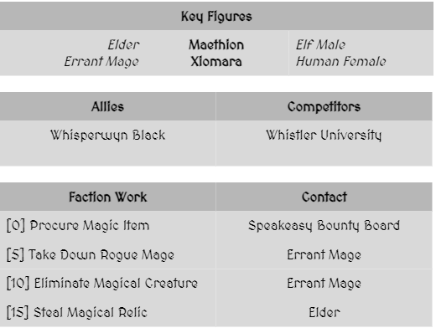

## Evil

### E - Criminal - The Shade-Bringers

--DESCRIPTION--------------------------------------------------

The Shade-Bringers are a secretive and powerful consortium of thieves' guild in eastern Morthia that were headquartered in the Republic city of Meera

The Shade-Bringers were discreet in their activities, even in Flurham where they were known by just about every citizen of the nation. Even the lower-ranked members, who earned their gold as beggars, cut-purses, thugs and fences followed these rules as they went about their daily duties. Even these minor operations allowed the Shade-Bringers to insert itself into the daily lives of Flurhamian citizens. Thus, a friendly game of chance run by a con artist gamer could lead to higher and higher stakes and a great take of gold for the agent and overall guild.

Many citizens relied upon the manipulative and illicit services provided by the Shade-Bringers. Businesspeople became reliant on their protection rackets, money lenders and the enforcers and thugs they hired out. Politicians and government officials would often hire the guild's spies and burglars to obtain guarded knowledge, or plant false information. The multitude of traders and merchants in Flurham, Ruslet and Meera received a myriad of unique mercantile opportunities provided by the guild's smugglers and pirates.

The agents of the guild were just as ruthless as they were secretive. If a situation required the use of violence, they would only take prisoners if a person was deemed worthy of capture, i.e. they possessed arcane, political, or financial power. The captives were relocated to a safehouse until ransom could be collected or the person otherwise manipulated.

--HISTORY----------------------------------------------------------

The Shade Bringers were formed as a singular guild by five charismatic rogues and assassins in the city of Meera during the Year of 706. It functioned as any thieves' guild would for about 40 years, with the power of the group being shared among the families of the founders and their respective allies. In 746, Lestyn, who operated under the alias of the "Painted Lady", infiltrated the organization and killed four of the group's five founding members.

The surviving senior guild-leader, Hexa "Deep shadow", and the remaining Shade Bringers escaped from the Republic Capital and went into hiding. It was then that Grandmaster Deep shadow swore the two oaths that the Shade Bringers operated by for decades.

Before he could resettle the guild in the lands north of Meera and the Shimmerian Coast, a reorganization of the group's hierarchy was in order. Feeling they were previously too reliant on actual thieves and hired killers, appointed himself, a trusted assassin and an ally who possessed training in arcane spellcasting as the group's leaders known as "the Three". They began recruiting wizards, priests of Flip and other spellcasters to the guild, allowing them to gather information and influence their contacts by magical means.

<Headquarters/Location of Organization>

Meera and Flurham

<Goals>

<Relationships>

### E - Killers - Ghost Cloaks

--DESCRIPTION--------------------------------------------------

A league of assassins, mercenaries, and contract killers for hire. These assassins specialize in making threats and nuisances go away permanently. Many of the other criminal organizations outsource to the Ghost Cloaks for

challenging and time-sensitive jobs. Their fees are assumed to be seven silver pieces for a standard hit.

To summon a representative of the Ghost Cloaks, lay out seven silver pieces in a hexagonal shape with one at the center, and spray the arrangement with your own blood. The “real” fee is negotiated with the assassin that is sent for the job, however once summoned their services cannot be refused. If you cannot afford their price, they will take your life.

--HISTORY----------------------------------------------------------

<Headquarters/Location of Organization>

<Goals>

<Relationships>

--SHOPS & PEOPLE--------------------------------------------------

Leader: Ghost Cloak

Tier 3: Ghost

Tier 2: Slayed

Tier 1: Killed

### E - BBEG - Cult of The Void

--DESCRIPTION--------------------------------------------------

The atmosphere of the organization was one of unwavering faith to its leader, Deusorum itself. Disobeying an order usually resulted in a punishment worse than death.

--HISTORY----------------------------------------------------------

Deusorum is older than Lumas, originating from the greater universe.

From the void came the alien entity. He was attractive to this world by the Shine of Lunas, and has found a realm of abundant life. Staying mainly in the shadows, unnoticed, Deusorum feeds on the souls of the dead. He's used many means in the past to gain powers, such as Azerim and several wars around the globe.

In recent years, Deusorum has notices a lack in conflict and strife. Mankind is bettering themselves without the help of the gods, leaving him at the perfect opportunity to create chaos and ruin for his own personal gain.

Through avatars, threats and conniving, Deusorum has made a hidden cult following, split into several orders for his use.

<Headquarters/Location of Organization>

<Goals>

* Undermine the gods and bring chaos back to the world.
* Feed our leader with the dying souls, damned away from the afterlife

<Relationships>

--SHOPS & PEOPLE--------------------------------------------------

The church was split into individual cells that operated independently from one another, with a temple or shrine of Shar as their focal point. Cells were linked under the leadership of a priest, who controlled a number of cells in a geographic area. Priests regularly communicated with one another, but rarely revealed truthful information to their inferiors.

### E - LBEG - Soweren the Lycanthrope

--DESCRIPTION--------------------------------------------------

--HISTORY----------------------------------------------------------

<Headquarters/Location of Organization>

<Goals>

<Relationships>

--SHOPS & PEOPLE--------------------------------------------------

### E - BBEG - Sunken Souls

<Description>

Those lost at sea sink into the depths of the Lurker and given the opportunity to return to life if they do his bidding. What they do not know is when they return, they life a half-life and are forced to do the bidding of Marduk.

--HISTORY----------------------------------------------------------

<Headquarters/Location>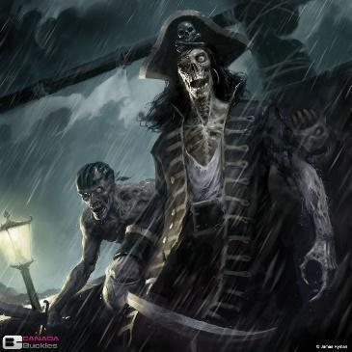

Meerilian Islands (unknown)

<Goals>

The Sunken Souls are a mysterious and secretive group of individuals who have made a pact with the Lurker, a powerful entity that controls the depths of the sea. They believe that by doing the Lurker's bidding and carrying out its will, they can earn the right to return to the surface world and live again. However, the Lurker's goals are not always aligned with the Sunken Souls', and the group may find themselves caught in the middle of a dangerous game of power and politics in the underwater realm.

<Tiers>

**The Chosen:**

The highest tier of the Sunken Souls, made up of the most trusted and skilled members of the group. The Chosen are the only ones who have a real chance of returning to life, and as such, they are given the most difficult and dangerous missions to complete. They may be tasked with stealing powerful artifacts from enemy factions, hunting down legendary sea monsters, or infiltrating rival groups to sow discord and chaos. However, the Lurker's favor is fickle, and the Chosen must constantly prove themselves in order to maintain their position of power.

**The Devoted:**

The second tier of the Sunken Souls, consisting of members who have proven their worth to the Lurker and the group's leaders. The Devoted are given more important tasks and missions, such as protecting the Sunken Souls' lairs or sabotaging the operations of rival factions. They are often tasked with recruiting new members to the group and ensuring that the Sunken Souls' influence continues to grow.

**The Initiated:**

The lowest tier of the Sunken Souls, made up of new recruits who have only just joined the group. The Initiated are given simple tasks and errands to complete, such as scouting out new areas of the sea or gathering resources for the group. They are not yet fully trusted by the higher-ups in the Sunken Souls and must prove themselves through their loyalty and dedication.

### Order of the Dark Moon

This order means to oppose Lunas directly and bring on a dark moon that wouldn't only shroud the moon of Lunas, but also absorb the power of Lumas and add to the void.

**HIDEOUT – In the Firelight Forest**

### Order of the Long Death

This order aims to seek the true nature of death, as it's kept hidden from them by their void patron. This order is made of a secluded clan of monks that perform ritual sacrifices and magics to explore the beyond and unknown. They seldom recruit new members.

### Nightcloaks

This order is a nomadic clan of night-travellers that search the lands for places of magical and evil intensity. They setup camps around this area and begin rituals in attempts to bring forth this evil. They are regularly pursued by the Iron Temple and Sentinels of the Church.

The closest this order has gotten to power is opening a portal to the Demon Lord Azerim back in old ages. They have since become devout worshipers of the Void god and seek to do his bidding.

The nightcloaks often get drafted by far-away kigndoms to enact acts of violence without having direct affiliation tracable back to them. Most recently, the Night Cloaks atemped to snuff the light of Stormhall in the OAR. Their hirers did not Identify themselves, but they would be a group that wanted to sew chaos into the republic.

### Lawbreaker’s Mask -Hexa

Wondrous item, uncommon

This twisted, dreadful mask is sacred to cults worshipping the trickster-god Flip. When worn by a non-Evil creature, the creature must pass a DC 15 Wisdom saving throw to immediately remove the mask or else become Evil in alignment while the mask is worn. The character will not willingly remove the mask once the save is failed. An Evil creature can wear the mask with no ill effect. In addition to the alignment-switching properties the mask makes it difficult for someone to describe the actions or individuals they encounter when donning it. Anyone attempting to recall specifics of the individual’s dress, build, posture, voice, etcetera must pass a DC 20 Wisdom saving throw to be able to do so. Otherwise, they can offer only vague, meaningless descriptions.

The mask is regularly used for concealing identities, and for recruiting members into the group. It’s a right of passage.

**People who wear this mask do so voluntarily over time, and take it off during the day to go about their normal life, without risk of remembering their actions from the nights before.**

--SHOPS & PEOPLE--------------------------------------------------

Leader: Grand Master Hexa, the Changeleing

The Three:

Archmage Ghost-Cloak Assassin Legheon

Chameleon Rogue Master Kirka

Greybeard Shadow Magic Sorcerer Soerial

Tier 3: Shadow

Tier 2: Silhouette

Tier 1: Shader

--Beliefs--------------------------------------

**1:​** Loyalty to the Cloaks supersedes all: Betrayal of your brothers is betrayal of oneself.

**2:** ​Whatever you can take belongs to you: You are master of your own fate.

**3:** ​Everyone has a price - but not all costs are weighed in gold.

**Quote**: ​You may not see us, but we’re always behind you.

### Eigengrau and his hoard

### Marduk the Lurker

--DESCRIPTION--------------------------------------------------

Marduk is an ancient, primordial being born in the Plane of water, and brought here by Nereus as a guardian of his domain.

--HISTORY----------------------------------------------------------

<Goals>

Rid the world of Aquatas + reclaim the ocean as a revered lord.

<Relationships>

--SHOPS & PEOPLE--------------------------------------------------

### Druidic Thieves Guild

Home to a booming industry of blacksmiths, metalworks, and the imperial mint, the city of **Lunalem** is both excessively rich, and responsible for near-constant wildfires in the eastern reaches of the Korthal forest. As one travels further west into the wood, beyond the scars of centuries-old blazes, the trees grow taller, and broader, and more ancient. The space separating them widens, yet the air between seems to grow dense. Footfalls are dampened, then silenced completely. Speech is softened, stifled, muted. Paradoxically, only whispers seem to pierce the atmosphere, carrying far further than intended. Dappling the forest floor are distinctive yellow lily flowers, each with seven petals rather than the usual six.

In this wood is hidden, in plain sight, a door to a den of thieves. Lunalem's rich know them as the Lunalem Bandits, or (more derisively) the "**Hoods in the Wood**". Among the lower classes, they have a better reputation, and are called by their true name: the *Men of Kits' Ken*. They're a band devoted to the people and to the wood, and they have only one law: a fifth of everything taken from the rich is given (in equal measure) to the poor, and to the forest. This rule is so well-known, even the children of Lunalem know the rhyme: "*Gild the hood, but silver the wood*".

One seeking to join the guild proves their worth merely by entering its den, as it is well-hidden, and can only be found by those with both the skill of a thief, and a deep understanding of the forest. Upon entry, new recruits are welcomed like family, and treated with respect, so long as they respect the Wood in return, and honor the law.

In truth, the secret is secured by a twofold "language barrier". Any druid entering the Korthal Forest easily notice that the moss and lichen on many of the trees grows in a very particular pattern. Roughly one in every ten trees bears the same cryptic lyrics in Druidic script:

River of flax, oldest oak  
Run to the sea, shed your leaves  
Borne of your ash and your smoke  
Lunalem, of lilies and thieves

Read, ye, the law of Kits' Ken:  
Reap, ye, two tin from the flax  
One shall be gifted to men  
One shall be saved for the ax

Summon the red cedar stair  
Middlest knuckle past nine  
Counting the dying verse fare  
Tin on the tail of the sign

Tax on twin lilies in bloom  
Toes of two riders in sum  
One for each night of the moon  
One for each beat of this drum

While all druids can read the literal translation of the script, few can grasp its meaning. This rhyme, in fact, is suffused with language any tea leaf worth his salt will recognize Thieves' Cant! It's not technically necessary to solve the riddle, but rogues will get some bonus clues and lower intelligence DCs to figure things out (when was the last time you ran a campaign where *either* druidic *or* thieves' cant were actually useful, let alone *both*???). I've included the solution below, spoiled-out for those eager beavers who want to solve it themselves:

River of flax, oldest oak  
Run to the sea, shed your leaves  
Borne of your ash and your smoke  
Blackwood, of lilies and thieves

"Rivers" typically reference banks ("river bank") in thieves' cant, reinforced by "flax", which symbolizes gold; together they can mean both banks and the imperial mint. The term "oak tree" is usually used to indicate a wealthy individual, and "old oak" implies old money; the nobility. "The sea" can refer to the people, the peasantry, the unwashed masses. "Leaves" simply signify money.

Read, ye, the law of Kits' Ken:  
Reap, ye, two tin from the flax  
One shall be gifted to men  
One shall be saved for the ax

Kit's Ken is the well-known name of the guild, but its symbolism is lightly obscured by thieves' cant: "Ken" refers to a safe house or hideout, while thieves are called (among many other names) "foxes"; a "kit" is just what you call a baby fox! "Flax" is gold, "tin" is silver.

Summon the red cedar stair  
Middlest knuckle past nine  
Counting the dying verse fare  
Tin on the tail of the sign

In thieves' cant, time is often measured in hours past sunset (6 pm by convention). Each finger represents one hour, and can be broken into 20-minute "knuckles". "Middlest knuckle past nine" means 9 hours and 30 minutes (middle of the second 20-minute subdivision) after sunset. The third and fourth lines are a bit riddlish, but just mean "figure out the price (count the fare) in the last stanza (dying verse), and put that many silver (tin) on the end (tail) of the red oak's message (sign)".

The last stanza contains no thieves' cant, and is just a straight up riddle. Well... four wee riddles, decreasing in difficulty, all with the same answer. This way, it's extremely likely that at least one player will solve at least one of them, and the party won't get stuck for an hour on a puzzle whose complexity I underestimated.

Tax on twin lilies in bloom  
Toes of two riders in sum  
One for each night of the moon  
One for each beat of this drum

The first line requires knowledge of the tribute law, as well as of the special yellow seven-petaled lilies of the wood. Yellow petals = gold. "Twin lilies" = two flowers = 14 gold. The tax on 14 gold = 14 / 5 = 2.8 = 28 silver.

The second line requires some clever thinking and nature knowledge: horse's hooves are actually single phalanges (toes), so the total number of toes is equal to ten for each man, plus four for each horse, for a sum of 28

For the third line, The lunar cycle is 28 nights long... well, not exactly, but let's just say it is in this universe.

The fourth line is easiest of all: just count the number of syllables in the stanza.

Put it all together, and the full translation of the druidic thieves' cant is as follows:

We address the banks, the mint, and the nobles:

surrender your wealth to the People, for, from the destruction you have wrought on nature, we have risen against you.

We are the Thieves of Blackwood.

Upon entry to this sanctuary, you agree to the terms and conditions of the Guild. For each gold coin taken in by a member, they must pay a tax of two silver. One of these silvers is given back to the people, the other is reserved for the preservation of the forest.

A stairway can be summoned from the red cedar tree at 3:30am by pressing 28 silver coins to the last word of the message written upon it.

It is not difficult to locate the red cedar spoken of in the rhyme: it towers over the rest of the forest, which is already exceedingly tall. It's wide enough that, were it hollow, a dozen men could comfortably stand inside.

On the south side of the cedar is more lichenous druidic script, but much larger, and more "ornate" (if such can be said of a message writ in moss). It reads:

Nature  
takes  
everything  
back  
eventually

If exactly 28 silver pieces (or 112, or 196, equally correct interpretations) are pressed to the word "eventually" at roughly 3:30am, the bark will slowly fold over itself, absorbing the coins, and erasing the last word from the message. After a moment, the entire trunk of the tree begins to writhe, like the surface of an angry sea, and a tall ornate doorway "grows" from its roots, revealing a wooden staircase inside, spiraling down into the earth. Below lie the Caves of Kits' Ken, which teem with thoroughly Robin-Hood's-Merry-Men-ish thieves. I imagine they smell *terrible*.

### Crossroads Milita

Lawful, Neutral, Good

The Crossroads Militia is a cooperative army between the towns of Xecuria and The Collective. It acts as a supplemental force to the Iron Temple Guard and trains with them.

The primary focus of the Crossroads Militia is the protection of the outer regions of these nations, leaving the Iron Temple Guard to protect the highly populated cities.

Many Iron Temple Guard veterans retire into the Militia as officers and commanders. Most members of the Militia serve in a part-time capacity or act in a reserves capacity.

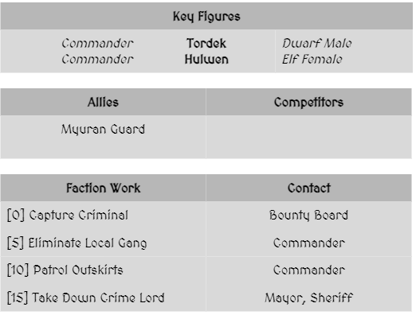

### The Farraguther Family

Port Synea

Neutral

The Farraguther Family, of noble lineage, has built up a reputation as a hard-nosed and somewhat ruthless business family. They own some of the most secure warehouses in Port Syne and have minor facilities in Karnac, Dorton, and Lanaalia.

Inroads into Myura have been thwarted due to a personal rivalry with Yora Baelaar and Claevil Shipping dominates its namesake town. With the Dockbucks in their pocket and House Oesterr on their side, the Farraguther Family is poised to make huge strides in the business world… if only their competition wasn’t in the way.

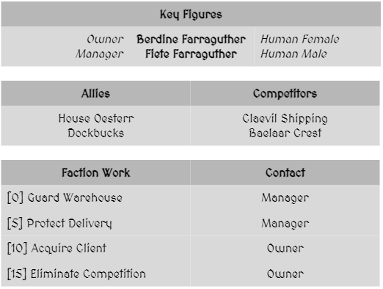

### Sacrosanct

Claevilton

Lawful, Neutral, Evil

To fight is to live, as the Sacrosanct are fond of saying. Combat prowess is respected above all else in this warrior guild. Its members are often seen as brutish and rude but they respond kindly to confidence and insults. Sacrosanct values the personal pursuit of fighting mastery above all else but they do hold a code of honor. They will not kill weaker opponents, but neither will they respect or aid them. Their fondness for Gunduk Brew has led them to patrol the southern regions to keep the Brewery that much safer. In turn, Gunduk Brewery converted one of its unused buildings in Claevilton into a dojo for Sacrosanct which helped to cement the lasting friendship between the two groups.

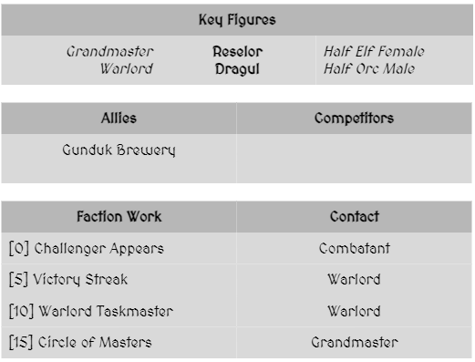

### Shiverblade Nigh

Dorton

Neutral, Evil

The Shiverblade Nigh is a deadly assassin guild and feared to such a degree that very few public figures are willing to challenge them. Although not directly allied, they have tenuous relations with Whisperwyn Black and often utilize their speakeasy Booths for their dealings. It is very difficult to join this guild and new members often have to survive assassination attempts as part of their trials. Shiverblade Nigh has contacts in nearly every settlement although inroads into the Lanaalian region have been slowed by the Draenyr. The Elysian Protectorate has vowed to stop the assassin guild although Shiverblade Nigh hardly pays them any notice.

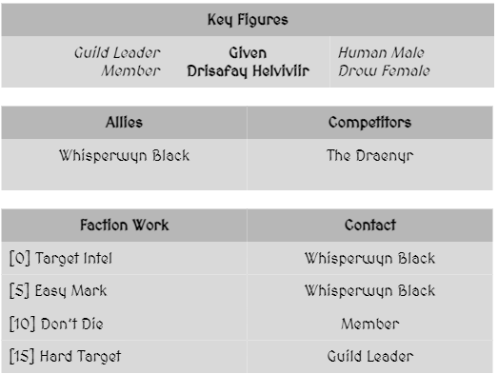

# Kingdoms

Summary

## Overview

### Morheim

Nestled in the north center of the continent, Morheim is ruled under a kind and fair rule by King Ferguson Divinitus. Currently, they're riddled with bandits beasts along major trade routes that are cause for significant alarm.

### Xecuria

The ruler of Xecuria is Queen Andale Zirca, a powerful mage and elected heir to the recently liberated region of Moreth. The people of this nation are still adjusting to their severance from the kingdom, and are finding their path. All they know for sure is they're entering a new era for their people

### The Collective

The lands of The Collective are ruled by the code of the guilds. Tradesmen, merchants, and citizens alike hold respect and order above all else. They have achieved peace through the pursuit of development. The council of the 9 Guild leaders acts as a representative government for international business.

### OAR

The People of OAR are a homogenous, sea-felling nation who live by and rely on ocean trade. They sail along the coast as the deep waters are ridden with pirates and sea beasts. The Everstorm rages to the east, past the pirates reach.

### Creatus

The Kingdom of Creatus is one of conflict. There is an ongoing war between Orcs and Elves, which has been at a stalemate for generations.

The divided kingdom covers the northern spans of the world and experiences wonderful summers and terribly cold winters. Some of the populous are known to have travelled farther north into unknown seas, but very few have returned and were deemed lost. The few who have returned and have since died told tales of a delightfully warm climate past the freezing storm, **with an odd palace that dwarfs all around it**.

### Yuntas-Mire

Yuntas-Mire is a coastal collection of largely independent city states, governed by two leaders from Yuntas and Mire'Seil. Their desert lands lie on the dead continent, and their culture shows an elegant resilience to both their environment and the nations around them. Living in Yuntas-Mire are Nagas and humans, together.

### Enigmus

Nothing is known about the lands of Enigmus, hence it’s name. At best are tales of lands where beasts rule in ivory castles and the people are at perfect balance with nature. But that's a tale as old as time. The only reason it's marked on the map is to provide a sense of knowing.

### Dwarven Keep Kingdoms

Once mighty and revered, the dwarven Kingdom (No official name) has fallen to ruin and its secrets largely lost to history. The last remaining Keep of their culture is Vel-Gendar, to the East.

DM History:

The dwarves of this world were a prosperous, and largely advanced civilization. But like many dwarves of many worlds, greed was their folly. They build too grandly, dug too deeply, and saw and unrecorded demise.

### Unaligned Locations

The Unaligned locations are under joint or individual supervision of kingdoms, clans, guilds, and larger powers. Their purposes and influences vary largely.

### The Shattered Isles Archipelago

## Kingdom - Morheim (27)

<Representative Image>

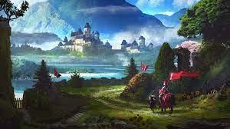

<Flag>

**<Basic Description>**

The History of Morheim is long, complicated, and largely forgotten. Much of the records from the past were destroyed during the war that uprooted the old tyrannical leader, and great fabled battles of good and evil. With that said, Morheim is the largest and longest-standing empire to date.

### Summary

*Geography in summary*

The kingdom of Morheim spans the Western fields to the north of the Desert, and East into the Deep woodlands up to the Battle-Hardened plains. It’s kingdom varies greatly in woodlands, mountain ranges and open fields.

*Culture in summary*

Like the geography, the people of Morheim are distinctly various and unpredictable. They value or are made to value to kingdom they live in and keep little contact with those out of their cities.

#### Leader/Lord

<Image>

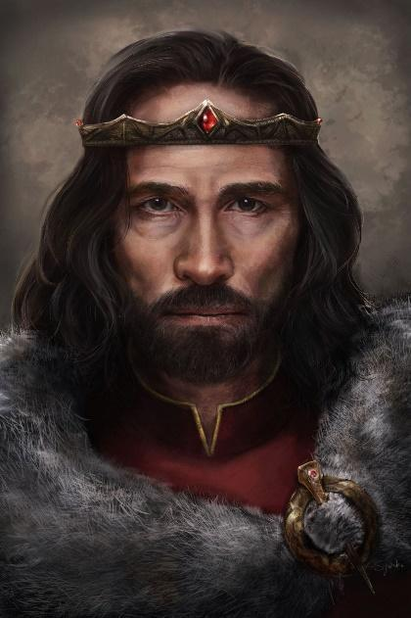

--DESCRIPTION--------------------------------------------------

King Ferguson Divinitus Morheilium comes from a newly established lineage of kings brought to rule from divine interference. He is a kind, warm-hearted man that tries to rule with a fair and firm hand.

#### History

*Brief and limited to the story of its formation and current situation

At the beginning of the New Era, the Old leader's forces were demolished, and their leaders captured. The old king, **Arteron the Mad**, was brought to the grand entrance of the Kings castle for judgement from the newly appointed **high Judge** and opposition leader, **Treyton Divinitus, an Aasimar paladin.**

The high judge cast judgment on Arteron for crimes of indecency against humanity such as torture, desolation of lands, illegal invasions, and instigated race wars. Being found guilty, Arteron the mad was sentenced to death by decapitation, as it was found to be more humane than hanging. **Treyton** was the bearer of the sword and executioner. He brought his blade down in one swift movement.

The Execution was watched by millions. Artwork remains in museums; stories of the events stood the test of time. It's still fresh, 600 years on, for the citizens of the continent.

#### Laws and Government

Royalty

**King** Ferguson Divinitus Morhellium

**Queen** Patton Windchester Morhellium

**Princes** Tobias & Elijah Morhellium

Government

King

Ferguson Divinitus Morhellium

Kings Inner Circle

Royal Treasurer Curtice Young

Grand Secretariat Ferdinando Robert

Royal High Priestess Alma Ravenwood

Regional Managers | Priest/ess'es

Victorian Letendre, 58 | Kina Wasanthi, 105

Ethan Goode, 98 | Ernard Burtt, 98

Renny Dorrance, 44 | Ken Kellar Harley, 95

Maria Blackwood, 104 | Gyleon Morhellium, 56

Wes Atwig, 36 | Jarrett, 62

Ular Newberry, 43 | Oliva Helzer, 86

Gerald Nere, 95 | Nia Nunn Ever, 48

Robinson Ever, 73 | Monserrate Keen, 109

Pat Newberry, 65 | Elicia Watt, 82

Kole Spycey, 88 | Thiery Robert, 72  
| Bev Marlee, 30

Fredericka, 90

Danuta Devaul Ravenwood, 53 Armando McDuffee, 70

Shawnda Ever, 40 Shenita Nere, 101

Markus Atwig, 104

Lords

Boscus Pass Springer Helzer, 62

Fernn Marchello Ream, 71

Fort Arteron Regan Ashwood, 73

Geblem Gallavant Spycey, 72

Groggwood Joseph Newberry, 55

Luanem Aero Marlee, 22

Lyric Cecile Thyte, 62

Mattermont Norman Withers, 106

Wakefield Elrer Windchester, 79

Military

Private 270,000

Thousand, vary in skill and ethical behaviour. Not all are in the kingdom or accounted for.

Chief Private 55,000

Leads the teams of privates.

Corporal 18,000

Leading teams of 4-5 privates

Sergeant 4,024

Lead squadrons of Their lesser, mainly on battlefields

Master Sergeant 198

Sergeant commanders and battle strategists.

Major 155

Public figures and local leaders

Command Sergeant 40

Regional Leaders

Captain 17

Provincial Leaders

Colonel 9

Commanders of Captains & Confidants

General 3

Kings Military Advisers

King 1

Head of Military

#### Goals

1. The Kingdom of Morheim spans farther than most would ever see in a lifetime. With large towns few and far between, most remain self-reliant for many aspects of life.
2. There is a growing concern of sights in the south spans of the kingdom, specifically in the Nightgrove Forest and sightings of weird figures in the night. Citizens hearing the tales are growing concerned and are looking to the crown for answers. While they seek help, the crown continues to gather taxes as they see no threat in the north.
3. The crown is looking to regulate the University of Korthal, which unlike its name has been around since the beginning of the early parts of the Age of Man. Their ways are traditional, and their secrets are largely hidden.
   1. The university remains strongly opposed to the crowns rule in a passive manner. They will not yield easily.

### Korthal - Capital

<Image>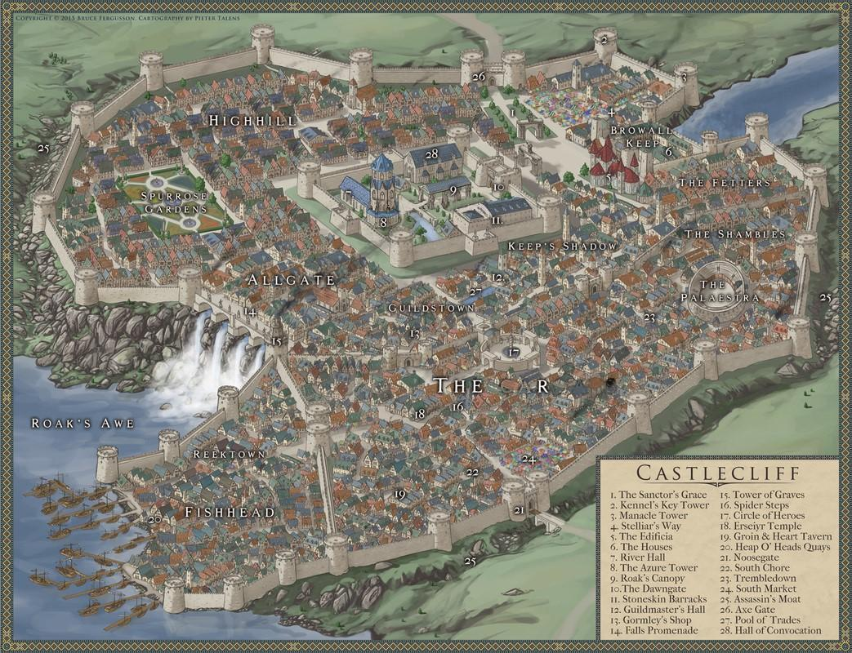

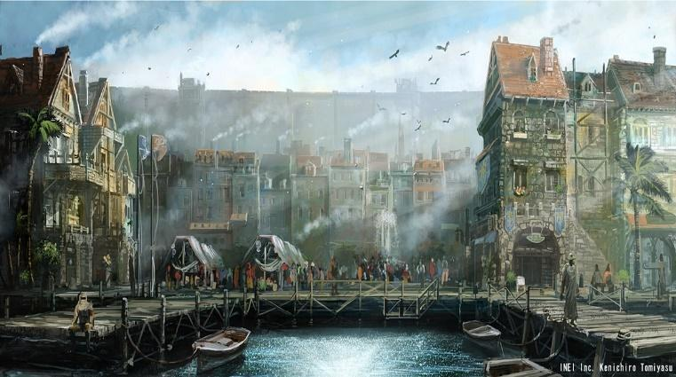

--DESCRIPTION--------------------------------------------------

A bustling metropolis, the Capital city is a center of trade, commerce, and adventure. After a long and rich history, the city’s architecture is ever-changing, unique and timeless.

Ferguson Divinitus Morheilium, the unmatched.

Ferguson is a Kind and controlling king who does his best to maintain order.

Ferguson wields a powerful staff and magical circlet embossed with 10 sending stones.

--SHOPS & PEOPLE--------------------------------------------------

King Ferguson

Ferguson grew up knowing that we would be the king. He was raised by his parents to know the ins and outs of the social intricacies, and was greatly influenced by a childhood friend Armal, a man who died in a tragic accident many years ago. Armal was known to be a kind soul and unrelentingly religious. Some believe his ghost has remained from the beyond, guiding Ferguson in his decisions.

|  |  |  |  |  |  |
| --- | --- | --- | --- | --- | --- |
| *High Judge* | *Treyton Highjudge, 79* |  | *Shopkeeper* | *Adelia Bigfelloe, 31* |  |
| *King* | *Ferguson Morhellium, 59* |  | *Shopkeeper* | *Lloyd Arnuanna, 32* |  |
| *Royal High Priestess* | *Alma Ravenwood, 67* |  | *Shopkeeper* | *Rakyq Caskajaro, 65* | *The Mysterious Sheet* |
| *Royal Treasurer* | *Curtice Strife, 45* |  | *Shopkeeper* | *Richard Spycey, 92* | *The Fancy Cow (Owner)* |
| *Prince* | *Tobias Gelnne, 23* |  | *Hunter* | *Bren Rain, 31* |  |
| *IT Legate* | *Zartok, 75* |  | *Hunter* | *Ambrose Mccabe, 35* |  |
| *General* | *Isolt The Loyal, 43* |  | *Hunter* | *Booker Holebl, 49* |  |
| *King's Hand* | *Walter Elyn, 89* |  | *Innkeeper* | *Illa Carelton, 50* | *The Ghost Parsnip Tavern* |
| *Investor* | *Swalda Borchardt, 72* |  | *Innkeeper* | *Novi Fishcher, 65* | *The Scattered Hamsters* |
| *Priest/ess* | *Bev, 30* | *Korthal Religion* | *Innkeeper* | *Heny Benson, 77* | *The Bumpy Willow* |
| *GOSPEL Member* | *Jewell Hernasi, 53* |  | *Innkeeper* | *Chef Cabaniss, 84* | *The Daily Kangaroo* |
| *Alchemist* | *Matilda Chatwick, 300* |  | *Citizen* | *Shaunna Zduntie, 23* |  |
| *Scribe* | *Scribe, 34* |  | *Citizen* | *Dewey Kwood, 34* |  |
| *Guild Member* | *Tana Vorlsen, 39* |  | *Citizen* | *Casi Ven, 44* |  |
| *Jeweler* | *Dartorg Thettow, 22* |  | *Citizen* | *Zachary Stensen, 50* |  |
| *Jeweler* | *Lophy Ernak, 29* |  | *Farmer* | *Phillip Isandov, 37* | *Local Farm* |
| *Jeweler* | *Cory Amberswift, 64* |  | *Farmer* | *Bradly Caron, 45* | *Local Farm* |
| *IT Officer* | *Chase Henn, 25* | *Korthal Law* | *Farmer* | *Carson Ackel, 47* | *Local Farm* |
| *IT Officer* | *Alavio Lajsen, 44* | *Korthal Law* | *Bard* | *Corey Inter, 25* |  |
| *IT Officer* | *Oscar Kenz, 44* | *Korthal Law* | *Bard* | *Drew Well, 26* |  |
| *IT Officer* | *Fernn, 98* | *Korthal Law* | *Bard* | *Elmore Dumont, 32* |  |
| *Smith* | *Irsayu Bonsaw, 92* | *Outland Outfitters* | *Servant* | *Isting Ywelyn, 19* |  |
| *Smith* | *Rico Devaul, 98* | *Big Sticks* | *Servant* | *Darolei Ei Conn, 24* |  |
|  |  |  | *Servant* | *Jennings S Bolage, 25* |  |
|  |  |  | *Servant* | *Giuseppe E Belsen, 32* |  |

--ECONOMY--------------------------------------------------------

--SPECIAL FEATURES--------------------------------------------------

**CHURCH**

**IRON TEMPLE**

**GOSPEL**

**LYRES FOR HIRE**

**UNIVERSITY BRANCH**

**ARTIFICER’S COLLEGE**

**DISTRICTS:**

The city is divided into districts, based on income and profession. Areas of large difference in societal class are kept far apart and behind their own inner walls. An example would be the Shambles and HighHill, to keep citizens out and in, respectively. Other districts are open for travel such as Fishhead and the commoners or merchants' districts.

**--SHAMBLES**

Set in the north-east corner of the city by the colosseum, the shambles are reserved for lower income citizens and criminals that have either lost property or have had their land ownership revoked.

The shambles are rife with crime and shady fellows, many of which have their own personal goals. The area is heavily guarded and anyone coming or going from this walled off section of the city must state their business. Very few welcome the guards here.

**--HIGH HILL**

HighHill is home to all of the wealthy citizens and nobles. Many of them are heads of guilds, inheritors, crowns guards, and investors in the city. The area surrounds the western circumference of the Palace, leading to both Allgate and the Kings Keep.

Crowns guard spend leisure time here here, casually strolling the streets and garden. The most they have to deal with in this section of town is petty domestic squabbles, and are weary of newcomers that look as though they might cause trouble for the wealthy.

**--GRAND GADENS**

A luxurious patch of grass is enclosed by huge flower bushes and shrubs. A lone, wide tree stands in the back, its trunk and crown reach for the sky, ever trying to reach higher and higher. The flowers and plants are fighting for their place in the garden, thankfully helped by human hands; they're a delight for butterflies. The flower bushes and shrubs reach 1m/3ft high, but this is thanks to great care and a lot of effort. A path of marble stones loops around the garden, beckoning people to explore the garden, and showing them the best sights at the same time. Grass and plants keep each other in line, but are all hungry for more land to expand to.

The garden is kept by a group of abstinent ladies that prefer the company of nature to men. They are friendly but hard to charm.

The tree, an aconite, has stood there for a dozen years, and demands all attention, but in doing so also draws the attention to all the life forms living on it. The flowers and plants can't be denied their share of the attention, and the flower bushes and shrubs are eye catching in their own right, but you just can't compete with the tree.

**Aconite** is a special tree that in which a beautiful purple and blue flower blossoms year-round, turning silver and red in the winter.

At the base of the tree are cinder petals, keeping the area warm and comfortable all year without posing a fire hazard.

**--FISHHEAD**

Set at the port of the city, Fishhead is home and workplace of fishermen, ship wrights, traders, sailors and travellers. It's a collection of older, well-kept homes and businesses that range from hundreds to thousands of years old, just like the families that work here.

The people are a sturdy, hard working group. There is little trouble in this section of town but the crowns guard frequently patrol this area specifically due the the amount of people that come and go by sea. The guards are welcomed and well-respected in this part of town.

**--ALLGATE**

With a sturdy, high wall to the south of the district, the Allgate almost feels cramped between the cast and waterfall. In this section of town, some can occasionally feel the rumble of the torrents running below their feet. Overall, the area is a well-respected district and home to wealthier shop owners like Master Avery (Store Store), Richard (A life of luxury), and Kildrak Goldfinder (Devas Bling Cart).

**--PALACE PLACE**

**--COMMONERS DISCTRICT**

Merchants, guildsmen, and all people of trade work and live in this district. The streets are wide and organized, bustling with traffic of foot and cart. Without guidance, one could get easily lost here. The best landmarks to guide are the Kings Keep, Palace, and central Fountain, all of which reach high to the sky.

**--ROADS**

The main roads within the city are twenty feet wide unless otherwise indicated.

**--ALLEYS**

All alleys between buildings are ten feet wide unless otherwise indicated.

**--DOORS**

doors to businesses will be unlocked from dawn to dusk, from dusk to dawn all business doors will be locked. All other doors are also locked unless otherwise indicated. All doors are made of wood with iron locks and hinges. A locked door can be picked with thieves' tools and a successful DC 10 Dexterity Check. A door can be broken down with a successful DC 20 strength check.

**--MERCHANTS**

All businesses have access to 1d8 x 1 thousand GP for the purchase of goods from travellers, should the merchant run out of gold it will take 1D4 days to replenish their funds.

**--GUARDS**

The city guard operates within all three districts. They enforce the laws of Korthal and attempt to arrest anyone breaking those laws, though they can be bribed at the DM's discretion. Should the adventurers commit any crimes have them perform a DC Dexterity (Stealth) Check to determine if anyone catches the adventurers committing the crime to inform the guards. The difficulty of which will be at the DM's discretion depending on the crime.

**--PRISON**

Adventurers can either choose to go willingly to prison or attempt to fight the city guard to escape. Should the adventurers escape they will not be allowed back into the city except to serve their prison time. Should the adventurers go to prison they will be offered the opportunity to pay a fine instead of serving their time. The fine is at the DM's discretion. Should the adventurers not have enough to pay the fine, they will have to serve their prison sentence. This results in the adventurers being exhaustion level 3 after release from prison.

**LOCATIONS OF NOTE**

**--THE CITY CASTLE**

is found in the center of town in its own gated center. The Castle is really a ground of separate buildings such as the barracks, the **Azure Tower,** and the **Hall of the King.** A large green center field offers a quaint and clean atmosphere for those of the highest order.

**--THE AZURE TOWER**

is home to the Roswall, the High priestess of Korthal. The tower has three main levels, with the middle being her living quarters and the top being her workstation. The ground floor is set with an alarm spell and is guarded at all times by two elite guards

**--THE KING’S KEEP**

**--THE WATERWAYS**

are thick streams of water originating directly from the mountains. The force of the water is seasonal, and the moats on either side of the city are used as a last resort to guide overflow, during the season of growth (spring).

Under the city is a labyrinth of sewer tunnels that twist and flow around the bottom of the town so to cover everyone's need of sewage disposal. The one thing known about the waterways is that originate on the north end from one large tunnel, split off several times, and reconnect to 4 smaller but still massive tunnels before hitting the waterfalls.

--HISTORY----------------------------------------------------------

--SHOPS & PEOPLE--------------------------------------------------

High Judge Treyton Highjudge, 79 Absolute Law

King Ferguson Morhellium, 59 Morheim

Roy. High Priestess Alma Ravenwood, 67 Morheim Religion

Royal Treasurer Curtice Strife, 45 Royal Finances

Prince Tobias Gelnne, 23 Korthal

IT Legate Zartok, 75 Law and order

General Isolt The Loyal, 43 Capital Army

King's Hand Walter Elyn, 89 The King's Health and daily routine

Priest/ess Bev, 30 Korthal Religion

Investor Swalda Borchardt, 72 Korthal Finances

Alchemist Matilda Chatwick, 300 Tent of Saber

Scribe Scribe, 34 A'Valean Scribe

Jeweler Cory Amberswift, 64 Victorious Secret

Jeweler Lophy Ernak, 29

Jeweler Dartorg Thettow, 18

IT Officer Fernn, 98 Korthal Guards

Smith Rico Devaul, 98 Geeban works

Smith Irsayu Bonsaw, 92 Feather in Your Cap

Shopkeeper Richard Spycey, 92 Fine Clothing

Shopkeeper Rakyq Caskajaro, 65 See You Latte

Shopkeeper Lloyd Arnuanna, 32 The Admired Horse

Shopkeeper Adelia Bigfelloe, 31 The Sandy Mirror

Hunter Bren Rain, 31

Hunter Booker Holebl, 14

Hunter Ambrose Mccabe, 15

Innkeeper Chef Cabaniss, 84 The Deep Discovery Pub

Innkeeper Heny Benson, 77 The Warm Pegasus Inn

Innkeeper Novi Fishcher, 65 The Eolian

Innkeeper Illa Carelton, 50 Ye Old Spider

Bard Drew Well, 26

Bard Corey Inter, 25

Bard Elmore Dumont, 32

IT Officer Chase Henn, 25

IT Officer Oscar Kenz, 44

IT Officer Alavio Lajsen, 16

Citizen Casi Ven, 22

Citizen Dewey Kwood, 34

Citizen Shaunna Zduntie, 13

Citizen Zachary Stensen, 18

Farmer Phillip Isandov, 13

Farmer Carson Ackel, 17

Farmer Bradly Caron, 13

Servant Jennings S Bolage, 25

Servant Darolei Ei Conn, 24

Servant Isting Ywelyn, 20

Servant Giuseppe E Belsen, 32

### ADD: Town- Aris Abbey – Hold of Iron Temple

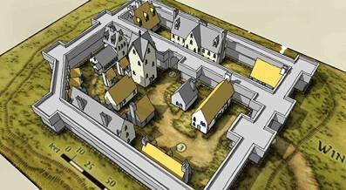

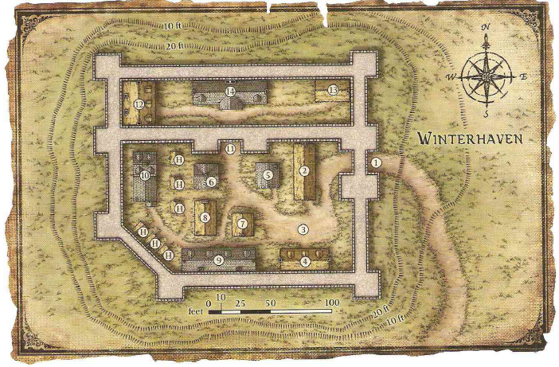

--DESCRIPTION--------------------------------------------------

--SHOPS & PEOPLE--------------------------------------------------

--ECONOMY--------------------------------------------------------

--SPECIAL FEATURES--------------------------------------------------

**CHURCH**

**SENTINELS**

**ELYSIAN PROTECTORATE**

**LYRES FOR HIRE**

**SHADE BRINGERS**

**WOODLAND RUINS**

--HISTORY----------------------------------------------------------

--SHOPS--------------------------------------

--INNS----------------------------------------------------------------

### ADD: Town- Duke – Lumberjack Riches

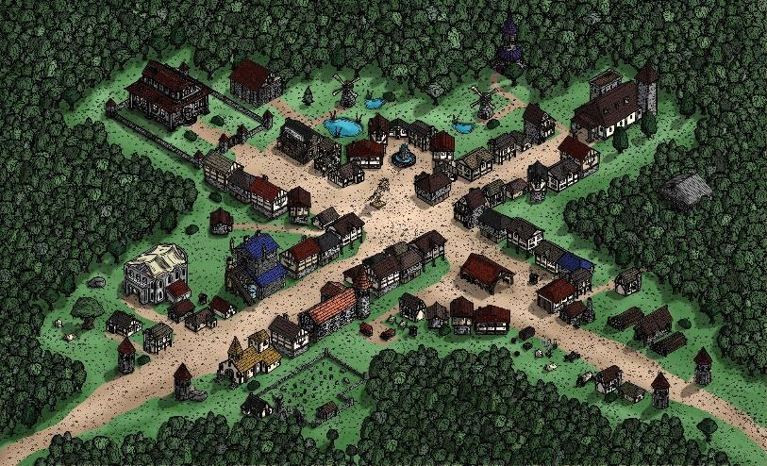

--DESCRIPTION--------------------------------------------------

--SHOPS & PEOPLE--------------------------------------------------

--ECONOMY--------------------------------------------------------

--SPECIAL FEATURES--------------------------------------------------

**CHURCH**

**GOSPEL**

**CULT OF THE VOID**

**OLD LORD’S CRYPT**

--HISTORY----------------------------------------------------------

--SHOPS--------------------------------------

--INNS----------------------------------------------------------------

### ADD: Town- Passerwick – Hellcrawl’s Host Village

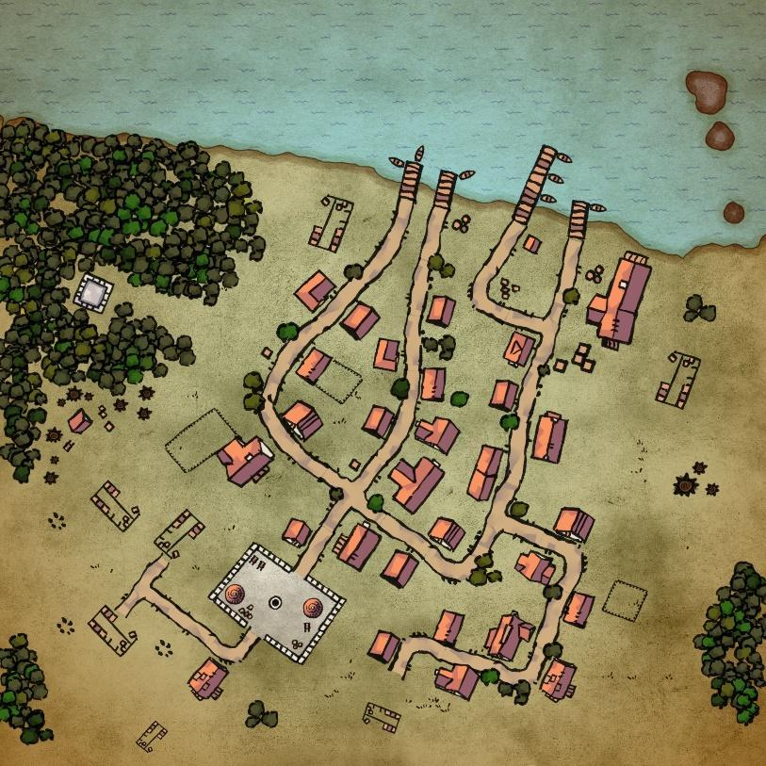

--DESCRIPTION--------------------------------------------------

--SHOPS & PEOPLE--------------------------------------------------

--ECONOMY--------------------------------------------------------

--SPECIAL FEATURES--------------------------------------------------

**CHURCH**

**SHADE BRINGERS**

**THE HATCH OF HELLCRAWL**

**SENTINELS**

Guard the hatch and watch it for evil

--HISTORY----------------------------------------------------------

--SHOPS--------------------------------------

--INNS----------------------------------------------------------------

### ADD: Town- Salsforge – Fisherman’s Dream (Tortle)

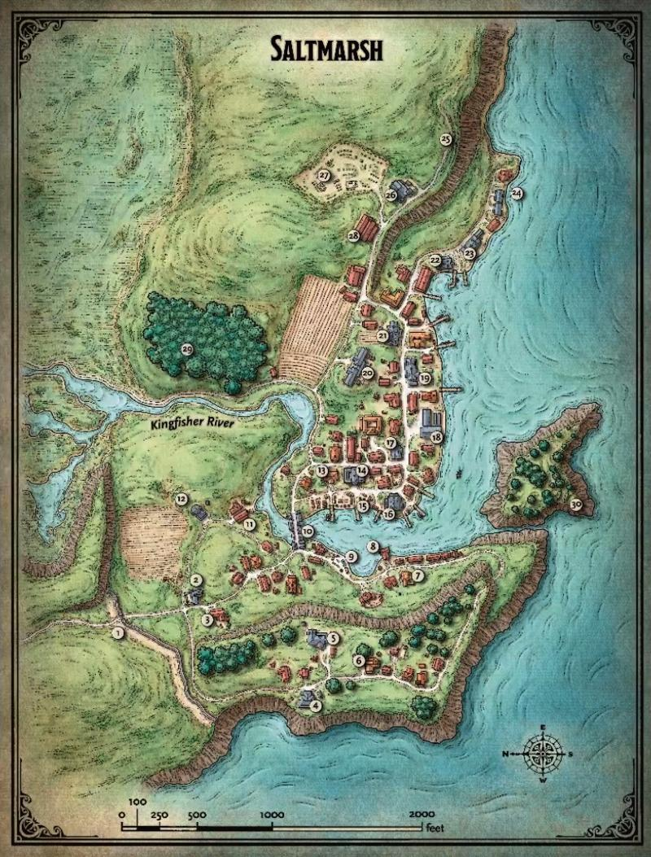

--DESCRIPTION--------------------------------------------------

A sleepy fishing village that sits on the precipice of destruction. Smugglers guide their ships to hidden coves, willing to slit the throat of anyone foolhardy enough to cross their path. Cruel sahuagin gather beneath the waves, plotting to sweep away coastal cities

--SHOPS & PEOPLE--------------------------------------------------

--ECONOMY--------------------------------------------------------

--SPECIAL FEATURES--------------------------------------------------

**CHURCH**

**SENTINELS**

**CULT OF THE VOID**

**500ft FOREST OF THE FEY**

--HISTORY----------------------------------------------------------

--SHOPS--------------------------------------

--INNS----------------------------------------------------------------

### ADD: Town- Yellow Ridge – New Mine Settlement

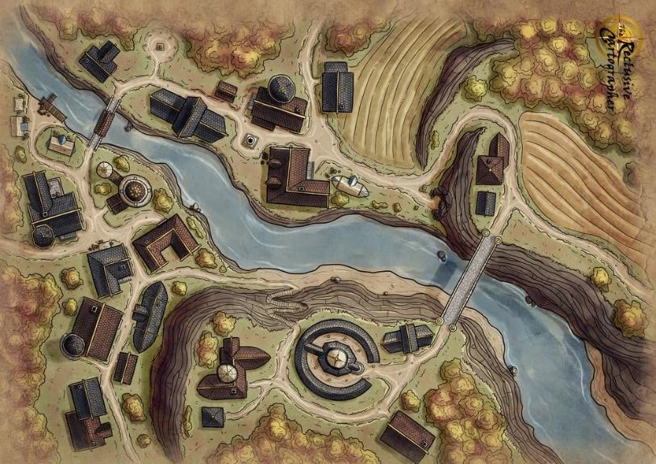

--DESCRIPTION--------------------------------------------------

Yellow ridge is built after the discovery of an iron and silver-rich range of mountains deep in the Hellcrawl forest. The town was build near the water for ease of transport and accessibilty, not to mention safety! Only heros and high-risk miners dare venture along the path to the many mines in the hills.

Recently discovered south of the mines, along the side of a large mountain, is a form of crypt or temple yet to be explored. There’s a large reward for ensuring it’s safe and clear.

--SHOPS & PEOPLE--------------------------------------------------

--ECONOMY--------------------------------------------------------

--SPECIAL FEATURES--------------------------------------------------

**CHURCH**

**SENTINELS**

**GUILD OF HAMMER**

**MOUNTAINSIDE CRYPT/TEMPLE**

--HISTORY----------------------------------------------------------

--SHOPS--------------------------------------

--INNS----------------------------------------------------------------

### ADD: Town- Inkirk – Base of the Sentinels

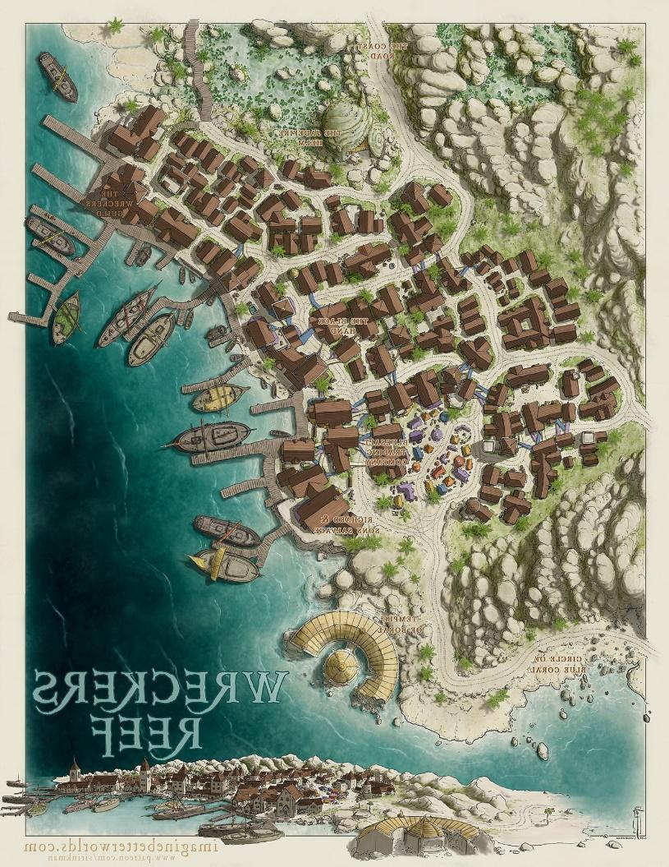

--DESCRIPTION--------------------------------------------------

--SHOPS & PEOPLE--------------------------------------------------

--ECONOMY--------------------------------------------------------

--SPECIAL FEATURES--------------------------------------------------

**CHURCH**

**SENTINELS – BASE / HOME**

**SHADE BRINGERS**

**HILL OF STONE**

**NORTH MARSH**

**CONCH CAVE – FOOT OF MARSH**

A large shell-shaped cave that goes deep underground

--HISTORY----------------------------------------------------------

--SHOPS--------------------------------------

--INNS----------------------------------------------------------------

### CITY - Borderton – Gates to the Endless Woods

<Image>

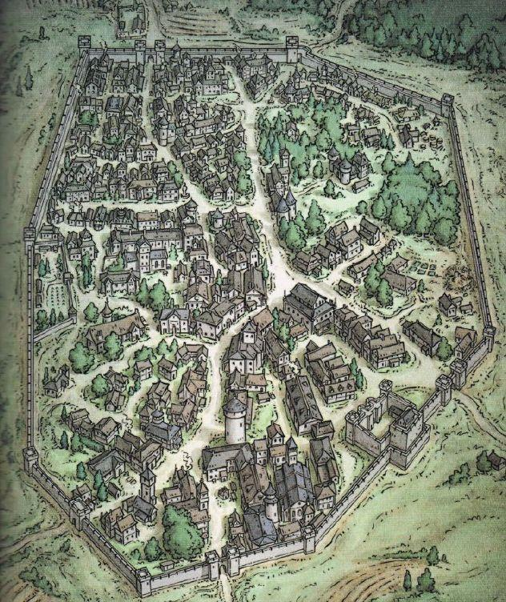

--DESCRIPTION--------------------------------------------------

A small city built along the path of the Great Stone Road, near the eastern border of the Morheim Kingdom. Borderton houses an arcane messaging system directly to Korthal.

Borderton is the closest city by land to the OAR. It sees often travel and trade, and has since made a name for itself.

--SHOPS & PEOPLE--------------------------------------------------

|  |  |  |  |  |
| --- | --- | --- | --- | --- |
| ***Lord*** | ***Ernard, 98*** | ***Borderton*** | *Merman* | *Gloomy* |
| *Priest/ess* | *Kina, 105* | ***Borderton Religion*** | *Elf* | *Friendly* |
| *Loanshark* | *Bradford Fasharash, 29* |  | *Dragonborn* | *Annoyed* |
| *Guild Member* | *Natalie Konstantinov, 41* |  | *Halfling* | *Friendly* |
| *IT Officer* | *Wine, 41* | ***Borderton Law*** | *Human* | *Wise* |
| *Tradesmen* | *Rodo Wedo, 27* |  | *Human* | *Helpful* |
| *Smith* | *Rin Cloudbend, 89* | *The Roaring Hide* | *Human* | *Honest* |
| *Shopkeeper* | *Doreen Fernn, 86* | *Borderton General, and Aventuring Supplies* | *Human* | *Friendly* |
| *Innkeeper* | *Frobern Bram, 36* | *Borderton Beds* | *Elf* | *Kind* |
| *Citizen* | *Brain Nfeld, 28* |  | *Human* | *Quiet* |
| *Citizen* | *Cashaye Ochberg, 21* |  | *Human* | *Curious* |
| *Citizen* | *Elverth Mikham, 38* |  | *Human* | *Friendly* |
| *Citizen* | *Rock Anie, 26* |  | *Human* | *Friendly* |
| *Citizen* | *Telayle Schris, 59* |  | *Human* | *Ponderous* |

--ECONOMY--------------------------------------------------------

--SPECIAL FEATURES--------------------------------------------------

**Arcane messaging system**

**Kingdom welcome sign, sign of laws differing from OAR**

**WAYSTONE**

**CHURCH**

**IRON TEMPLE**

**GUILD OF HAMMER**

**LYRES FOR HIRE**

**GROVE STRIDERS**

--HISTORY----------------------------------------------------------

--SHOPS--------------------------------------------------------------

--INNS---------------------------------------------------------------

### CITY - Boscus Pass – Forest

<Image>

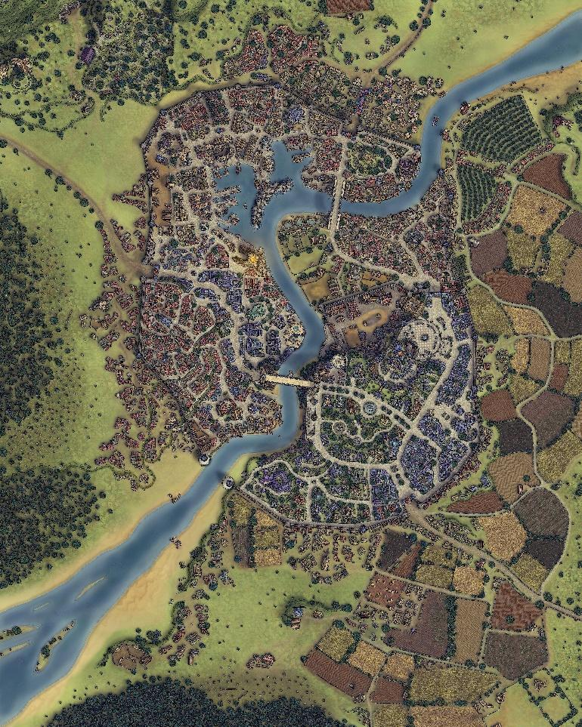

--DESCRIPTION--------------------------------------------------

--SHOPS & PEOPLE--------------------------------------------------

|  |  |  |  |  |
| --- | --- | --- | --- | --- |
| ***Lord*** | ***Springer Kingsly, 62*** | ***Boscus Pass*** | *Human Sorcerer 45F* | *Helpful* |
| *Priest/ess* | *Ken Kellar, 95* | ***Boscus Pass Religion*** | *Human* | *Cautious* |
| *Nobleman* | *Gauwis Borchardt, 37* |  | *Elf* | *Shrewd* |
| *Alchemist* | *Clau Land, 29* | *The Hourglass* | *Human* | *Shrewd* |
| *Alchemist* | *Win Rry, 47* | *The Hidden Rune* | *Human* | *Argumentative* |
| *Guild Member* | *Stephanie Dumont, 27* |  | *Human* | *Cautious* |
| *IT Officer* | *Franklin, 81* | ***Boscus Pass Law*** | *Human* | *Honest* |
| *Tradesmen* | *Livisa Lamond, 52* | *Pauldron & Helmet (Owner)* | *Dwarf* | *Quiet* |
| *Smith* | *Ethan Fowlkes, 98* | *Eel Steel* | *Human* | *Friendly* |
| *Smith* | *Jeanice Curry, 55* | *Rusty's Discount Sword Emporium* | *Human* | *Gloomy* |
| *Smith* | *Berton Fasharash, 52* | *The Warforged Forge* | *Half-Elf* | *Cautious* |
| *Shopkeeper* | *Hoa Aefina, 72* | *Fine Clothing* | *Human* | *Kind* |
| *Shopkeeper* | *Niyaha Byron, 49* | *See You Latte* | *Human* | *Jovial* |
| *Shopkeeper* | *Octavius Grim, 36* | *The Admired Horse* | *Human* | *Friendly* |
| *Bartender* | *Fjord Bonsaw, 23* |  | *Human Necromancer* | *Argumentative* |
| *Innkeeper* | *Anfjold Amberdown, 68* | *The Rainy Falcon Tavern* | *Elf* | *Curious* |
| *Citizen* | *Minerva Va Mart, 26* |  | *Human* | *Wise* |
| *Citizen* | *Rodo Nsen, 24* |  | *Human* | *Gloomy* |
| *Farmer* | *Alvidam Movgajs, 27* | ***Local Farm*** | *Human* | *Intelligent* |
| *Farmer* | *Osco Sers, 23* | ***Local Farm*** | *Human* | *Friendly* |
| *Servant* | *Jaime Usobo, 31* |  | *Human* | *Friendly* |
| *Servant* | *Karl Tsen, 36* |  | *Half-Elf* | *Friendly* |

--ECONOMY--------------------------------------------------------

--SPECIAL FEATURES--------------------------------------------------

**WAYSTONE**

**CHURCH**

**IRON TEMPLE**

**RELIC ALLIANCE**

**BORCHARDT HALL**

**THE NORTH SLUMS**

**THE WINDMILL FARM SIDE-VILLAGE**

**STONE DOCKS OF DUMONT**

**DISTRICTS:**

**--NOBLEMAN’S**

Rich, blue and grand. Large catle estate on hill

**--SLUM’S**

Lively, happy, but oppressed. Kept outisde the wall.

**--TRADER’S**

Sprawled, but dense. Not always safe.

**--DOCKMAN’S**

Guarded, busy and rich in ships. Large port for inlet.

**--RIVERSIDE**

Not perfectly kept but likely and prosperous.

**--HILLSIDE**

West. Moderately wealthy, secluded and political

**--GUARDHOLD**

Gated, under big estate. Opens to market square.

**--CEMETERY**

North of town, along hills. Bush walls and sprawled.

**--TEMPLE**

Open to all. Several templs of worship on riverside.

--HISTORY----------------------------------------------------------

--SHOPS--------------------------------------------------------------

--INNS---------------------------------------------------------------

### Town- Bright Stone – The Mountain Pass

<Image>

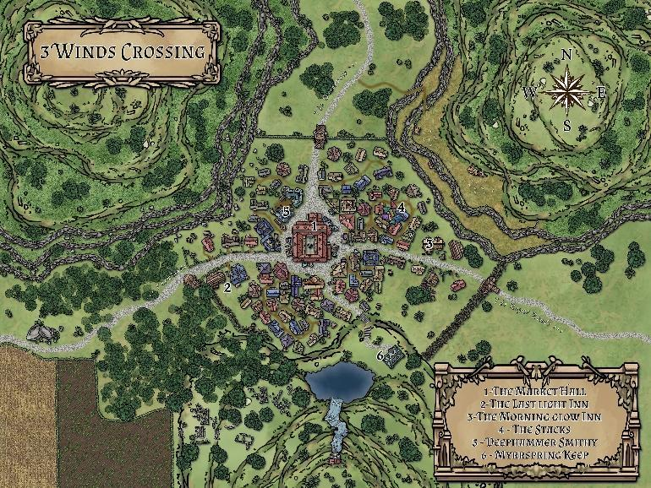

--DESCRIPTION--------------------------------------------------

--SHOPS & PEOPLE--------------------------------------------------

|  |  |  |  |  |
| --- | --- | --- | --- | --- |
| ***Lord*** | ***Ali Lak, 56*** |  | ***Half-Elf*** | ***Friendly*** |
| *Priest/ess* | *Laverne Ambault, 35* |  | *Human* | *Kind* |
| *GOSPEL Member* | *Madre Pasternack, 92* |  | *Human* | *Kind* |
| *Aventurer* | *Marian Teague, 48* | *Guild of Hammer Council, Morheim* | *Human* | *Shrewd* |
| *Alchemist* | *Jeryl Heson, 24* | *The Plain Roc* | *Human* | *Gloomy* |
| *Alchemist* | *Miguel Nilsen, 34* | *The Striped Angel* | *Human* | *Wise* |
| *Guild Member* | *Earl Dams, 19* |  | *Human* | *Intelligent* |
| *IT Officer* | *Douglass Ass Sonh, 23* |  | *Human* | *Quiet* |
| *Tradesmen* | *Jarrad Stirling, 31* |  | *Human* | *Jovial* |
| *Tanner* | *Gran Enfe, 54* | *William's Essentials* | *Human* | *Friendly* |
| *Smith* | *Michael Jokult, 24* | ***[Owner's Name] Hilts*** | *Half-Elf* | *Curious* |
| *Smith* | *Kan Ayn, 19* | ***The Exalted Hilts*** | *Human* | *Friendly* |
| *Smith* | *Donaar Elkiir, 25* | ***The Sweat of the Steelworks*** | *Dragonborn* | *Intelligent* |
| *Shopkeeper* | *Dwayne E Herr, 25* | *Brightstone's Finest* | *Half-Orc* | *Honest* |
| *Shopkeeper* | *Guillin In Nack, 22* | *Nack's Racks (Clothes)* | *Half-Orc* | *Kind* |
| *Shopkeeper* | *Talisha Clellan, 31* | *Tally-Ho!* | *Human* | *Friendly* |
| *Bartender* | *Kayloui Macbert, 94* | *The Minty Chimney* | *Dwarf* | *Intelligent* |
| *Innkeeper* | *Justine Ne Osen, 31* | *The Minty Chimney* | *Human* | *Ponderous* |
| *Citizen* | *Chrill Krupin, 32* |  | *Human* | *Shrewd* |
| *Citizen* | *Hammon Trevor, 36* |  | *Human* | *Friendly* |
| *Farmer* | *Alesia Sprzak, 31* | ***Local Farm*** | *Human* | *Blustering* |
| *Farmer* | *Derr Nert, 24* | ***Local Farm*** | *Half-Orc* | *Delightful* |
| *Farmer* | *Grosabe Burneil, 36* | ***Local Farm*** | *Human* | *Arrogant* |
| *Farmer* | *Lumarle Pernack, 32* | ***Local Farm*** | *Human* | *Tired* |
| *Farmer* | *Marques Andreas, 33* | ***Local Farm*** | *Human* | *Friendly* |
| *Farmer* | *Motty Ailov, 49* | ***Local Farm*** | *Human* | *Helpful* |
| *Farmer* | *Nish Spet, 26* | ***Local Farm*** | *Human* | *Honest* |
| *Farmer* | *Rolland Mercier, 23* | ***Local Farm*** | *Half-Elf* | *Friendly* |
| *Farmer* | *Kip Dan, 38* | ***Local Farm*** | *Human* | *Friendly* |
| *Farmer* | *Parina Thayer, 28* | ***Local Farm*** | *Human* | *Friendly* |
| *Traveller* | *Logan Ernak, 54* |  | *Human* | *Wise* |
| *Servant* | *Bethann Mcfalbe, 28* |  | *Human* | *Friendly* |
| *Servant* | *Gren Osen, 69* |  | *Dwarf* | *Shrewd* |

--ECONOMY--------------------------------------------------------

--SPECIAL FEATURES--------------------------------------------------

**CHURCH**

**IRON TEMPLE**

**GOSPEL**

**UNIVERSITY BRANCH**

**GROVE STRIVERS**

**ARTIFICER’S COLLEGE BRANCH (SMALL)**

**WATERFALL SHRINE**

**OLD TOWN RUINS**

--HISTORY----------------------------------------------------------

--SHOPS--------------------------------------------------------------

--INNS---------------------------------------------------------------

### Town- Coval – Villlage in the Grove

<Image>

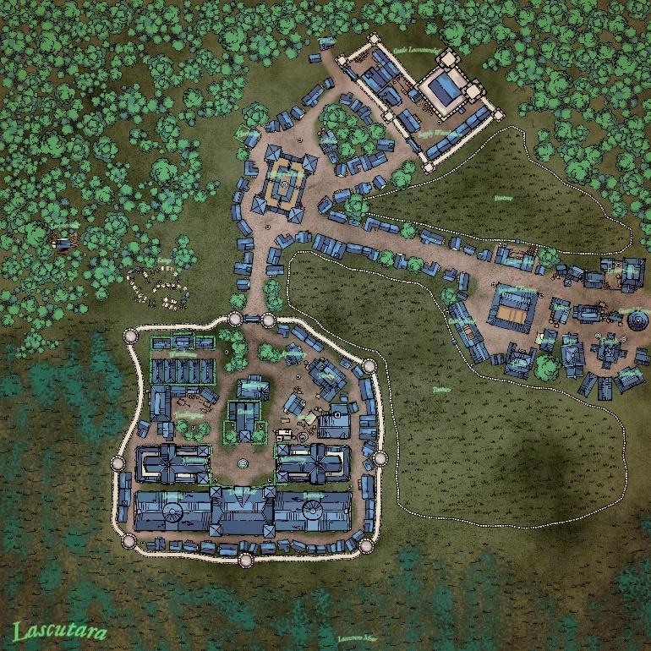

--DESCRIPTION--------------------------------------------------

Tucked down a separate trail from the Great Stone Road, Coval acts as a place of refuge for weary travellers. Their small population specializes in collection of natural resources, and is the second closest village to the river that runs through the forest. They use ancient pathways to access prime fishing and hunting locations. Additionally is their reputation for a lineage of a Medically trained familly with a tragic past (**INDIGO**)

--SHOPS & PEOPLE--------------------------------------------------

|  |  |  |  |  |  |
| --- | --- | --- | --- | --- | --- |
| ***Coval*** | ***Lord*** | ***Tope Gnek, 46*** | ***Coval*** | *Human* | *Quiet* |
| *Coval* | *Elder* | *Jay Evans, 27* |  | *Human* | *Honest* |
| *Coval* | *Guard* | *Laron Chrad, 23* |  | *Human* | *Gloomy* |
| *Coval* | *Guild Member* | *Royc Lewolo, 36* |  | *Half-Orc* | *Friendly* |
| *Coval* | *Tradesmen* | *Tomeon Wolff, 33* | *The Odd Spool* | *Human* | *Kind* |
| *Coval* | *Smith* | *Janey Mdahl, 26* | *The Emperor's Head* | *Human* | *Ponderous* |
| *Coval* | *Shopkeeper* | *Gerre Rtsen, 41* | *A Mans burden* | *Human* | *Blustering* |
| *Coval* | *Shopkeeper* | *Ilynna Bonn, 42* | *The Bleeding Pantheon Sport Store* | *Human* | *Quiet* |
| *Coval* | *Shopkeeper* | *Mary Chel, 58* | *The Honest Shark* | *Dwarf* | *Curious* |
| *Coval* | *Innkeeper* | *Dante Anche, 33* | *The Moldy Boat Bar* | *Human* | *Friendly* |
| *Coval* | *Citizen* | *Adree Charood, 33* |  | *Half-Orc* | *Friendly* |
| *Coval* | *Citizen* | *Isidro Romon, 22* |  | *Human* | *Friendly* |
| *Coval* | *Citizen* | *Jericke Materra, 45* |  | *Human* | *Friendly* |
| *Coval* | *Citizen* | *Vand Vine, 51* |  | *Half-Elf* | *Ponderous* |
| *Coval* | *Farmer* | *Bufus Atchison, 34* | ***Local Farm*** | *Human* | *Honest* |
| *Coval* | *Farmer* | *Nathan Wooks, 80* | ***Local Farm*** | *Human* | *Gloomy* |
| *Coval* | *Farmer* | *Nickie Vin, 41* | ***Local Farm*** | *Human* | *Rude* |
| *Coval* | *Farmer* | *Owen Donn, 36* | ***Local Farm*** | *Human* | *Intelligent* |

--ECONOMY--------------------------------------------------------

Fishing, hunting, natural resource collection

--SPECIAL FEATURES--------------------------------------------------

**The Public Estate of Parker Windchester**

This large, walled castle estate is the hallmark of the city's history and it's founding. These days, Parker has opened his walls to operate the market square within to ensure security of the citizens. Citizens also have the option of being housed in small settlements along the insider perimeter of the walls, whenever needed.

**CHURCH**

**IRON TEMPLE**

**ORDER OF THE LONG DEATH**

**ELYSIAN PROTECTORATE**

--HISTORY----------------------------------------------------------

--SHOPS--------------------------------------------------------------

--INNS---------------------------------------------------------------

### Town- Eallen – Village of the River

<Image>

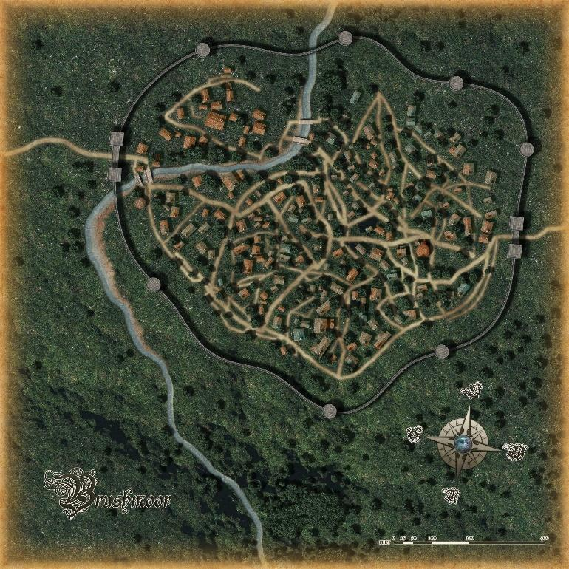

--DESCRIPTION--------------------------------------------------

Sitting on the foot of a major river at the end of the Endless Forest, Eallen is the recent focus of Morheim. A wall was established to promote security and growth within the city, while the interior remains relatively rural and quiet.

--SHOPS & PEOPLE--------------------------------------------------

|  |  |  |  |  |
| --- | --- | --- | --- | --- |
| *Lord* | *Birdie Ece Sven, 28* | *Eallen* | *Human* | *Friendly* |
| *Elder* | *Oorg Sokolov, 16* |  | *Human* | *Ponderous* |
| *Guard* | *Winford Lgersen, 25* |  | *Human* | *Friendly* |
| *Guild Member* | *Emialo Lloomek, 44* |  | *Human* | *Wise* |
| *Tradesmen* | *Brandt Craig, 47* | *The Odd Spool (Owner)* | *Half-Orc* | *Curious* |
| *Smith* | *Chuck Albertsen, 27* | *Hammer Time* | *Human* | *Friendly* |
| *Smith* | *Ira Passen, 31* | *The Grim Codex* | *Human* | *Grumpy* |
| *Shopkeeper* | *Adelle Uthest, 28* | *Masterwork Faster Work* | *Human* | *Intelligent* |
| *Innkeeper* | *Tomson Geot, 26* | *The Storm Peach* | *Half-Orc* | *Friendly* |
| *Citizen* | *Abe All, 33* |  | *Human* | *Kind* |
| *Citizen* | *Chadger Sverfor, 29* |  | *Human* | *Ponderous* |
| *Citizen* | *Daxwell Ll Sver, 27* |  | *Half-Elf* | *Friendly* |
| *Citizen* | *Mill Ponn, 33* |  | *Human* | *Arrogant* |
| *Citizen* | *Odell Thomas, 24* |  | *Human* | *Quiet* |
| *Citizen* | *Otthowa Mccles, 33* |  | *Human* | *Curious* |
| *Citizen* | *Pathadr Bern, 24* |  | *Half-Elf* | *Kind* |
| *Citizen* | *Rock Sokal, 24* |  | *Human* | *Quiet* |
| *Citizen* | *Rosanne Pass, 25* |  | *Dwarf* | *Friendly* |
| *Farmer* | *Katra Mccoy, 86* | ***Local Farm*** | *Dwarf* | *Cautious* |
| *Farmer* | *Smivan Oirier, 27* | ***Local Farm*** | *Human* | *Argumentative* |
| *Farmer* | *Stindy Anthonsen, 20* | ***Local Farm*** | *Human* | *Shrewd* |
| *Servant* | *Horedin N Greer, 31* |  | *Human* | *Intelligent* |

--ECONOMY--------------------------------------------------------

--SPECIAL FEATURES--------------------------------------------------

**CHURCH**

**IRON TEMPLE**

**GUILD OF HAMMER**

**GROVE STRIDERS**

**RIVER OF 500 YEARS**

Deep trenches on either side, helping with controlling aspects of the town.

--HISTORY----------------------------------------------------------

--SHOPS--------------------------------------------------------------

--INNS---------------------------------------------------------------

### Town- Elder Point – An Adventurer’s Rest

<Image>

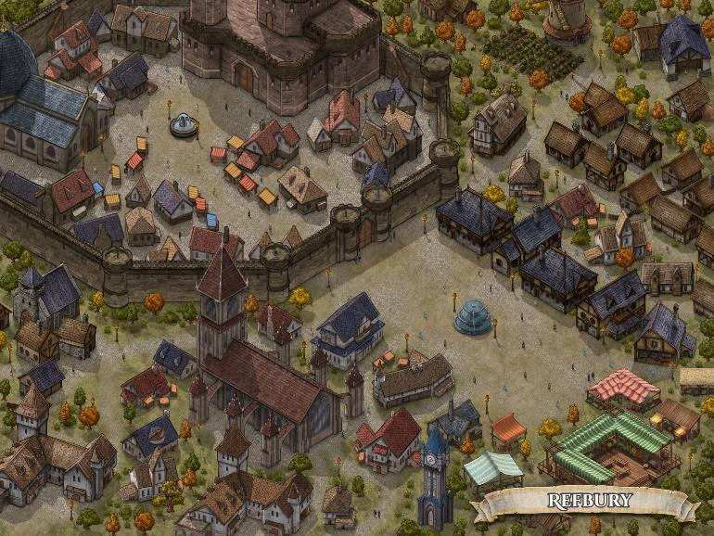

--DESCRIPTION--------------------------------------------------

A prestigious city of elderly, where the most notable and influential people of the world can retire in peace. Guarded closely by the capital.

--SHOPS & PEOPLE--------------------------------------------------

|  |  |  |  |  |
| --- | --- | --- | --- | --- |
| ***Lord*** | ***John Frai, 63*** |  | *Dwarf* | *Shrewd* |
| *Priest/ess* | *Dave Wenz, 43* |  | *Human* | *Shrewd* |
| *GOSPEL Member* | *Casper Mcarson, 64* |  | *Human* | *Intelligent* |
| *Alchemist* | *Otto Mermans, 25* | *The Fading Griffin* | *Half-Elf* | *Friendly* |
| *Guild Member* | *Jamison On Povg, 67* |  | *Human* | *Curious* |
| *IT Officer* | *Eddy Iver, 54* | *The Black Nock (Owner)* | *Human* | *Kind* |
| *Tradesmen* | *Jordra Argutc, 66* |  | *Dwarf* | *Friendly* |
| *Shopkeeper* | *Rayney Ferro, 39* | *Ferro's Guilders* | *Human* | *Friendly* |
| *Innkeeper* | *Bertram Rdillon, 41* | *The River Taste* | *Half-Elf* | *Friendly* |
| *Citizen* | *Elvismo Tholebl, 44* |  | *Human* | *Delightful* |
| *Farmer* | *Cherria Klimek, 32* | ***Elder Point*** | *Human* | *Cautious* |
| *Farmer* | *Dann Houn, 18* | ***Local Farm*** | *Human* | *Ponderous* |
| *Farmer* | *Nikole Artosz, 26* | ***Local Farm*** | *Human* | *Kind* |
| *Servant* | *Demond Frans, 60* |  | *Human* | *Friendly* |

--ECONOMY--------------------------------------------------------

--SPECIAL FEATURES--------------------------------------------------

**CHURCH**

**GOSPEL**

**LYRES FOR HIRE**

**UNIVERISTY BRANCH**

**MARKET SQUARE CASTLE**

--HISTORY----------------------------------------------------------

--SHOPS--------------------------------------------------------------

--INNS---------------------------------------------------------------

### CITY - Elvene – Inlet City

<Image>

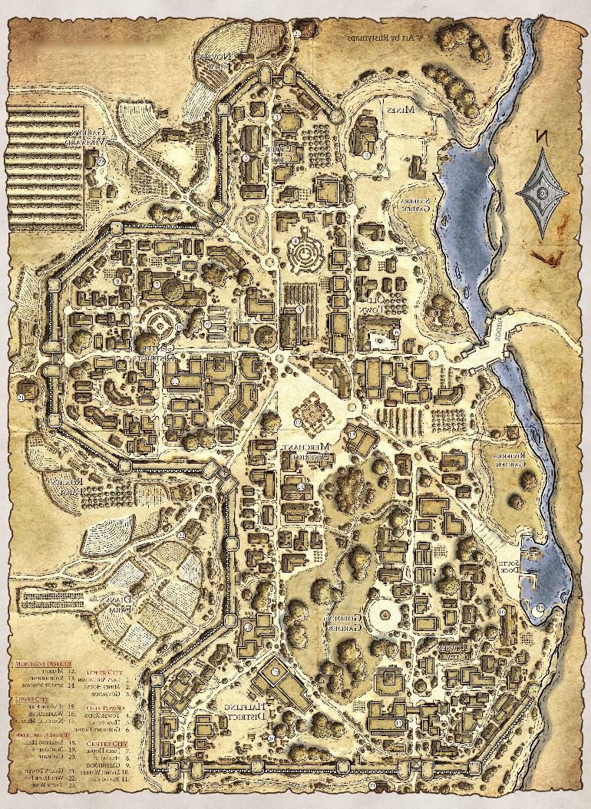

--DESCRIPTION--------------------------------------------------

--SHOPS & PEOPLE--------------------------------------------------

|  |  |  |  |  |
| --- | --- | --- | --- | --- |
| ***Lord*** | ***Fonda Martz, 64*** | ***Elvene*** | *Human* | *Helpful* |
| *Priest/ess* | *Emilly Wolff, 24* | ***Elvene Religion*** | *Human* | *Gloomy* |
| *Alchemist* | *Kanklyd Lywedeu, 32* | *The Invisible Fairy* | *Human* | *Wise* |
| *Alchemist* | *Martin Onnell, 40* | *The Mithril Mantle* | *Halfling* | *Friendly* |
| *Guild Member* | *Fanny Belsen, 49* |  | *Half-Elf* | *Friendly* |
| *IT Officer* | *Travon Chmiko, 25* |  | *Human* | *Gloomy* |
| *Tradesmen* | *Deal Povg, 47* |  | *Human* | *Quiet* |
| *Tanner* | *Edsel Onsen, 45* |  | *Human* | *Friendly* |
| *Smith* | *Teresa Nolan, 30* | ***[Owner's Name] Blades*** | *Halfling* | *Kind* |
| *Smith* | *Millse E Orey, 24* | ***[Owner's Name] Weapons*** | *Half-Orc* | *Curious* |
| *Smith* | *Key Dov, 47* | ***The Hammer and the Braces*** | *Human* | *Annoyed* |
| *Shopkeeper* | *Jerex Nther, 37* | *ALAS's Store Room (Owner)* | *Human* | *Argumentative* |
| *Shopkeeper* | *Dall Eald, 46* | *Borchart's Gold* | *Halfling* | *Friendly* |
| *Shopkeeper* | *Markus Wolff, 40* | *Gnome-Depot* | *Human* | *Wise* |
| *Bartender* | *Mhlo Ccoy, 66* |  | *Dwarf* | *Friendly* |
| *Innkeeper* | *Angelina Vrounne, 27* | *The Silk Street* | *Human* | *Friendly* |
| *Citizen* | *Haymos Parris, 44* | ***Local Farm*** | *Half-Orc* | *Intelligent* |
| *Citizen* | *Leigon Bieber, 47* | ***Local Farm*** | *Human* | *Kind* |
| *Farmer* | *Jeraldine Pasternak, 41* |  | *Human* | *Intelligent* |

--ECONOMY--------------------------------------------------------

--SPECIAL FEATURES--------------------------------------------------

**CHURCH**

**IRON TEMPLE**

**ELYSIAN PROTECTORATE**

**GUILD OF HAMMER**

**GHOST CLOAKS**

**ARTIFICERS COLLEGE**

**MAZE GARDENS & GOLDEN GARDENS**

Noble nature areas carefully cultivated. Meeting spots

**DISTRICTS:**

**--MINES**

Cleared area, near water. Deep and Shallow shafts

**--MERCHANT DISTRICT**

Center of city, hub of activity (And crime)

**--LOWER CITY**

Older, dense and less wealthy. Ghost Cloaks

**--UPPER CITY**

Smaller but high quality. Mainly for merchants

**--HALFLING DISTRICT**

Headed by a large hafling population and the best Inn

**--OLD TOWN**

Small, riverside area. GOSPEL clubhouse

**--CITY CENTER**

Walled area, noble and studily-built estates. Lord area

--HISTORY----------------------------------------------------------

--SHOPS--------------------------------------------------------------

--INNS---------------------------------------------------------------

### Town- Fernn – The Continental Claim

<Image>

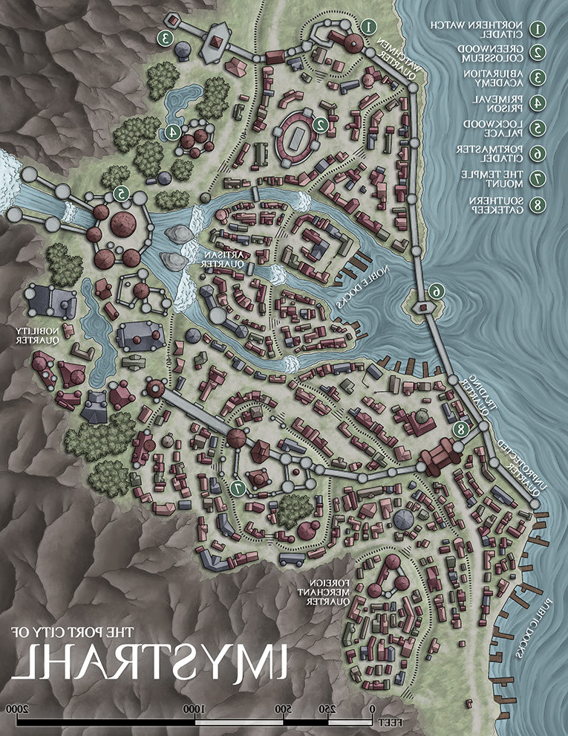

--DESCRIPTION--------------------------------------------------

Fernn's Port-town is a small fishing and agricultural community. It's home to many humans and halflings, and is known for it's quiet and tranquil atmosphere. The town almost looks deserted as the population is well spread out and only the town center has a hustle of trade and fishing work.

The town has a long and controversial history of being home to tyrannical leaders, secret societies, and master artisans. The City lies on the side of a large hill. Rested into the hill is a large stone keep that's argued to have been a dungeon, Jail, or part of an old Castle.

--SHOPS & PEOPLE--------------------------------------------------

|  |  |  |  |  |
| --- | --- | --- | --- | --- |
| *Lord* | *Marchello Ashwood, 71* | *Fernn* | *Human* | *Intelligent* |
| *Priest/ess* | *Gyleon, 56* | ***Fernn Religion*** | *Human* | *Honest* |
| *Alchemist* | *Kalryn Cloudbend, 84* | *Shades and Shadows* | *Human* | *Argumentative* |
| *Guild Member* | *Steen Szek, 38* |  | *Half-Elf* | *Quiet* |
| *Jeweler* | *Darlove Dawnweaver, 90* | *Antiquities* | *Orc* | *Friendly* |
| *IT Officer* | *Amira, 92* | ***Fernn Law*** | *Human* | *Ponderous* |
| *Tradesmen* | *Leonardo Do Craig, 28* | *Wheel & Hub (Owner)* | *Half-Orc* | *Intelligent* |
| *Smith* | *Billy Benson, 56* | *Curious Forge* | *Human* | *Ponderous* |
| *Smith* | *Bundrigo Cabaniss, 29* | *The Outpost Defenders* | *Human* | *Helpful* |
| *Shopkeeper* | *Eda Bloodlust, 26* | *The Outpost* | *Human* | *Arrogant* |
| *Shopkeeper* | *Master Eshleman, 66* | *The Ration Shoppe* | *Human* | *Honest* |
| *Bartender* | *Norward Bram, 43* |  | *Orc* | *Grumpy* |
| *Innkeeper* | *Moises Tamrei, 40* | *The Tall Pickaxe Pub* | *Human* | *Intelligent* |
| *Citizen* | *Clare Belse, 32* |  | *Human* | *Kind* |
| *Citizen* | *Dana Llar, 46* |  | *Half-Orc* | *Arrogant* |
| *Citizen* | *Darred Smonn, 41* |  | *Half-Orc* | *Intelligent* |
| *Citizen* | *Die Rtz, 41* |  | *Human* | *Curious* |
| *Citizen* | *Jarrear Ar Filt, 25* |  | *Human* | *Friendly* |
| *Farmer* | *Cellie Endsen, 43* | ***Local Farm*** | *Human* | *Curious* |
| *Servant* | *Jaso Anek, 30* |  | *Half-Orc* | *Wise* |

--ECONOMY--------------------------------------------------------

A farming town growing wheat, carrots, and several herbs.

Occasional port trade

--SPECIAL FEATURES--------------------------------------------------

**WATERFALLS**

**OLD STONE KEEP**

**WAYSTONE**

**CHURCH**

**IRON TEMPLE**

**GUILD OF HAMMER**

**DRUIDIC THIEVES GUILD (WASTELAND DIVISION)**

**DRAGONSCALE CATACOMBS (UNDER KEEP)**

--HISTORY----------------------------------------------------------

### Hold - Fort Arteron – The Hold of Old

<Image>

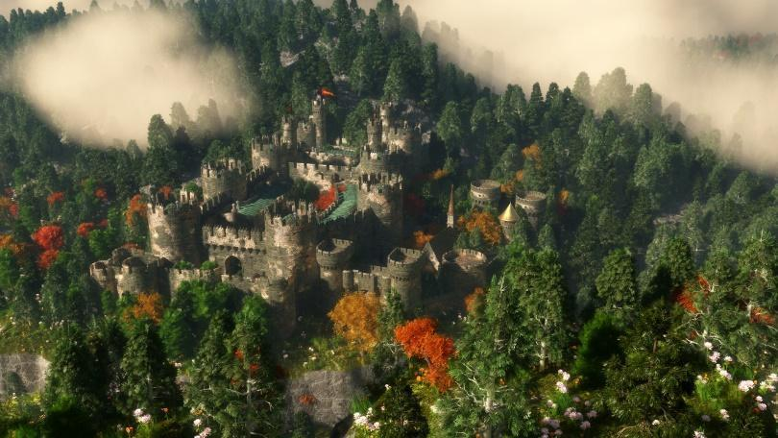

--DESCRIPTION--------------------------------------------------

The Old Castle of a forgotten king. The structure is a prominent landmark in the landscape, and currently houses a community of dwarves and gnomes.

Rolling hills of wheat and other crops, as well as orchards and private homes. One can go miles without seeing more than one or two farms. The main trading route skirts around the plains. The farms make their own, less pronounced trails to the main road and mark them with signs.

--SHOPS & PEOPLE--------------------------------------------------

|  |  |  |  |  |
| --- | --- | --- | --- | --- |
| *Castle Master* | *Steves, 750* |  | *Elf* | *Kind* |
| *General* | *Houdoin, 48* |  | *Human* | *Friendly* |
| *Colonel* | *Imbart, 50* |  | *Human* | *Wise* |
| *Lord* | ***Regan Westchesterforth, 73*** | ***Fort Arteron*** | *Human* | *Friendly* |
| *Priest/ess* | *Jarrett, 62* | ***Fort Arteron Religion*** | *Aarokocra* | *Friendly* |
| *Alchemist* | *Isquay Benson, 92* | *The Fireball* | *Human* | *Annoyed* |
| *Guild Member* | *Lanny Mathiasen, 33* |  | *Dwarf* | *Rude* |
| *IT Officer* | *Carrie, 71* | ***Fort Arteron Law*** | *Human* | *Kind* |
| *Tradesmen* | *Alas Lsen, 37* | *Wheel & Hub* | *Human* | *Honest* |
| *Smith* | *Ronni Chatwick, 97* | *General Goode's General Goods* | *Human* | *Annoyed* |
| *Smith* | *Balle Fishcher, 23* | *Rica's* | *Human* | *Cautious* |
| *Shopkeeper* | *Meghann Goode, 74* | *Jugs and Outlet* | *Human* | *Cautious* |
| *Shopkeeper* | *Kellie Burns, 26* | *The Baking Painting Repairs* | *Human* | *Friendly* |
| *Innkeeper* | *Thirnan Chatwick, 33* | *The Unsinkable Truth* | *Elf* | *Friendly* |
| *Citizen* | *Betty Eesen, 19* |  | *Human* | *Kind* |
| *Citizen* | *Jewe Geot, 18* |  | *Human* | *Gloomy* |
| *Citizen* | *Tabdust Tirling, 47* |  | *Human* | *Friendly* |
| *Citizen* | *Tina Mens, 49* |  | *Human* | *Wise* |
| *Farmer* | *Lorne Owicz, 28* | ***Local Farm*** | *Half-Orc* | *Arrogant* |
| *Farmer* | *Nalivic C Mccoy, 36* | ***Local Farm*** | *Dwarf* | *Honest* |

--ECONOMY--------------------------------------------------------

--SPECIAL FEATURES--------------------------------------------------

**CHURCH**

**SENTINELS**

**RELIC ALLIANCE**

**UNIVERSITY BRANCH – LIBRARY AND RECORDS ROOM**

**VAULT OF THE MAD KING**

--HISTORY----------------------------------------------------------

--SHOPS--------------------------------------------------------------

--INNS---------------------------------------------------------------

### Town- Geblem – Village of the Lakeshore

<Image>

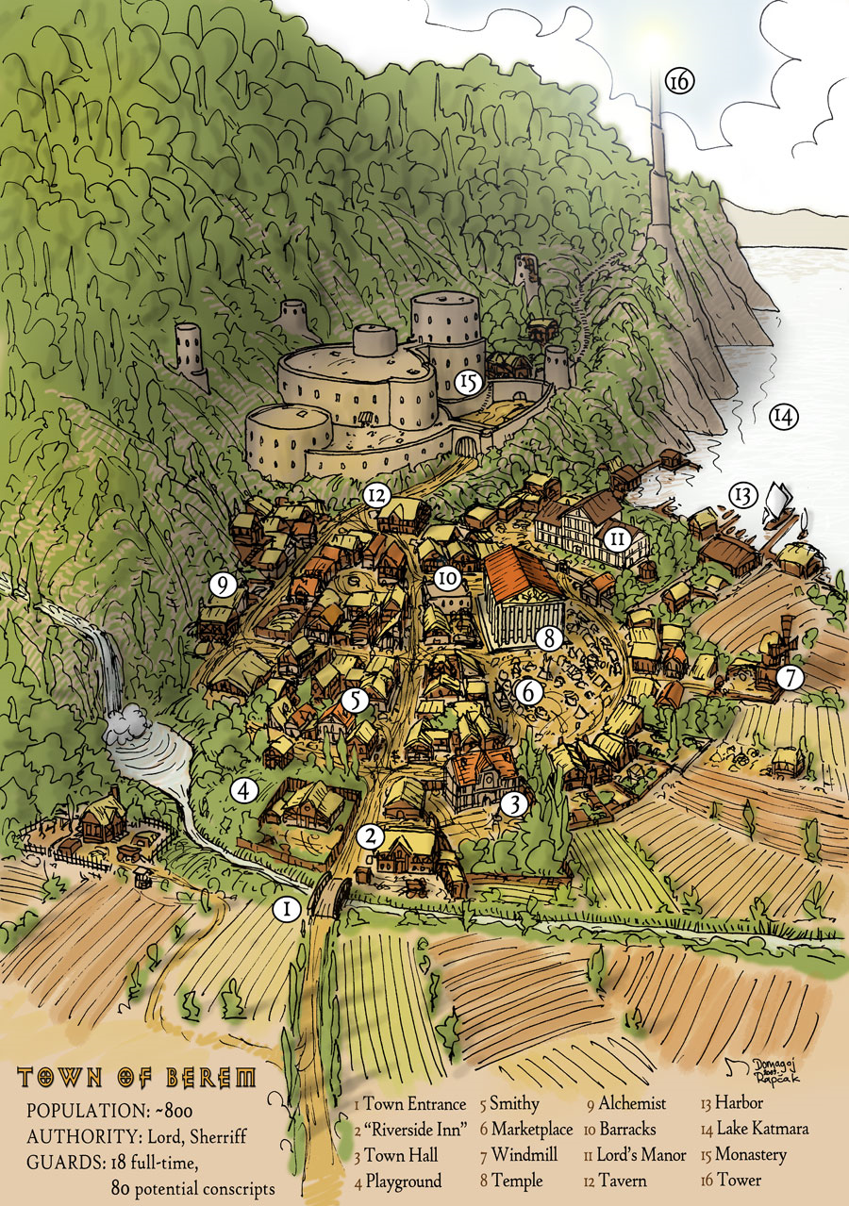

--DESCRIPTION--------------------------------------------------

Geblem is a mystic town sitting on the edge of Tortle Lake. A large stone hand sits atop the hills edge, gesturing out into the water. The town itself is made entirely of a unique material, seemingly much older than is expected.

The town is human, and the population enjoy both their solitude and their quiet. While part of the Morheim kingdom, they do not pay taxes or benefit in any way.

--SHOPS & PEOPLE--------------------------------------------------

|  |  |  |  |  |
| --- | --- | --- | --- | --- |
| *Lord* | *Gallavant Stallam, 72* | *Geblem* | *Human Warrior 32F* | *Gloomy* |
| *Priest/ess* | *Nia Nunn, 48* | ***Geblem Religion*** | *Human* | *Helpful* |
| *Scribe* | *Scribe, 59* |  | *Elf* | *Curious* |
| *Guard* | *Regal, 62* |  | *Human* | *Curious* |
| *Guild Member* | *Pher Landau, 50* |  | *Half-Orc* | *Ponderous* |
| *Tradesmen* | *Thad Vlon, 27* |  | *Half-Orc* | *Wise* |
| *Smith* | *Helmund Carelton, 99* | *Cathedral of the Gleaming Spear* | *Elf* | *Ponderous* |
| *Shopkeeper* | *Ebriarwel Blunt, 95* | *Gems and Such* | *Orc* | *Jovial* |
| *Hunter* | *Daniela A Maria, 16* |  | *Human* | *Honest* |
| *Innkeeper* | *Fausto Devaul, 17* | *Geblem Inn* | *Human* | *Helpful* |
| *Citizen* | *Black Piel, 28* |  | *Human* | *Friendly* |
| *Citizen* | *Blake Ndrei, 50* |  | *Human* | *Friendly* |
| *Citizen* | *Daid Agnew, 75* |  | *Human* | *Honest* |
| *Citizen* | *Damsey Onneau, 18* |  | *Human* | *Friendly* |
| *Citizen* | *Gali Holiano, 83* |  | *Human* | *Honest* |
| *Citizen* | *Jera Tailler, 48* |  | *Half-Elf* | *Wise* |
| *Citizen* | *Long Granger, 33* |  | *Human* | *Cautious* |
| *Citizen* | *Rudesta Sta Roy, 23* |  | *Human* | *Friendly* |
| *Farmer* | *Haulfga Oodburn, 52* | ***Local Farm*** | *Dwarf* | *Arrogant* |
| *Servant* | *Myrtice Travere, 20* |  | *Human* | *Friendly* |

--ECONOMY--------------------------------------------------------

--SPECIAL FEATURES--------------------------------------------------

**WAYSTONE**

**CHURCH**

**IRON TEMPLE**

**THE OLD STONE**

**THE MYSTICAL STONE OF UNKNOWN METAL**

--HISTORY----------------------------------------------------------

--SHOPS--------------------------------------------------------------

--INNS---------------------------------------------------------------

### Town- Grogwood – Wild Woods Town

<Image>

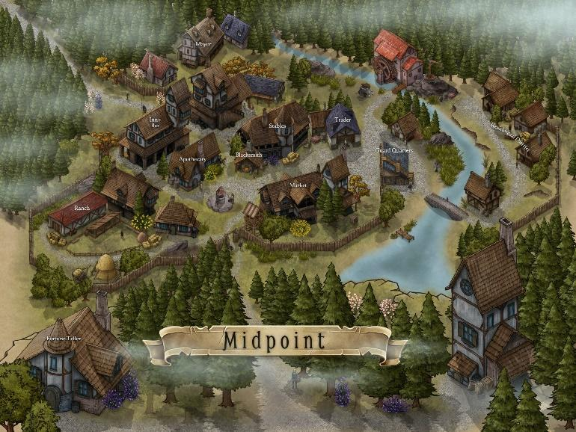

--DESCRIPTION--------------------------------------------------

The second northern-most location in the Morheim kingdom, bested only by Korthal, Grogwood is a small town set on the edge of the Endless Forest. It sits along a great river that feeds into the Flurham inlet, just near a massive waterfall and the Grogwood Wilds.

Many fear either the woods to the north or the mountains to the south are home to a dragon, which is told to have decimated the town one hundred years ago.

The people of Grogwood live a quiet, secluded life. Few travel to this town and the roads up to their city are not as well-kept as the Great Stone Road. The travel is known to be treacherous.

--SHOPS & PEOPLE--------------------------------------------------

|  |  |  |  |  |
| --- | --- | --- | --- | --- |
| *Lord's Wife* | *Marry Carelton, 40* |  | *Human* | *Delightful* |
| *Priest/ess* | *Monserrate, 109* | ***Groggwood Religion*** | *Human* | *Annoyed* |
| *Guild Member* | *Jeffry Faucher, 49* |  | *Human* | *Shrewd* |
| *Smith* | *Eloise Flatwater, 93* | *Tenacious Butterfly Brewery (Owner)* | *Human* | *Arrogant* |
| *Smith* | *Gilew Gripgear, 86* | *The Black Nock* | *Halfling 25F* | *Kind* |
| *Shopkeeper* | *Roselia Aston, 44* | *Forest Finds* | *Human* | *Quiet* |
| *Shopkeeper* | *Nefto Ever, 61* | *Grogg General* | *Human* | *Friendly* |
| *Innkeeper* | *Adan Gripgear, 34* | *Where else to sleep?* | *Human* | *Friendly* |
| *Citizen* | *Alec Rnak, 17* |  | *Human* | *Annoyed* |
| *Citizen* | *Amartin In Saks, 35* |  | *Human* | *Tired* |
| *Citizen* | *Kinte Chber, 26* |  | *Human* | *Kind* |
| *Farmer* | *Cend Ilov, 33* | ***Local Farm*** | *Human* | *Friendly* |
| *Farmer* | *Hurr Kov, 30* | ***Local Farm*** | *Human* | *Wise* |
| *Farmer* | *Ivellin N Marek, 94* | ***Local Farm*** | *Elf* | *Friendly* |
| *Farmer* | *Stacey Bowen, 33* | ***Local Farm*** | *Human* | *Delightful* |
| *Prostitute* | *Huem Deighton, 26* |  | *Halfling* | *Arrogant* |
| *Traveller* | *Elden Guson, 45* |  | *Half-Elf* | *Tired* |
| *Servant* | *Fell Llan, 50* |  | *Human* | *Friendly* |

--ECONOMY--------------------------------------------------------

--SPECIAL FEATURES--------------------------------------------------

**CHURCH**

**ELYSIAN PROTECTORATE**

**GUILD OF HAMMER**

**ORDER OF THE LONG DEATH**

**THE EVERFALLS**

**WALL OF DISALLOWED RACES (ORCS, GNOMES, FEY)**

--HISTORY----------------------------------------------------------

--SHOPS--------------------------------------------------------------

--INNS---------------------------------------------------------------

### Town- Lunalem – Capital Port Stop

<Image>

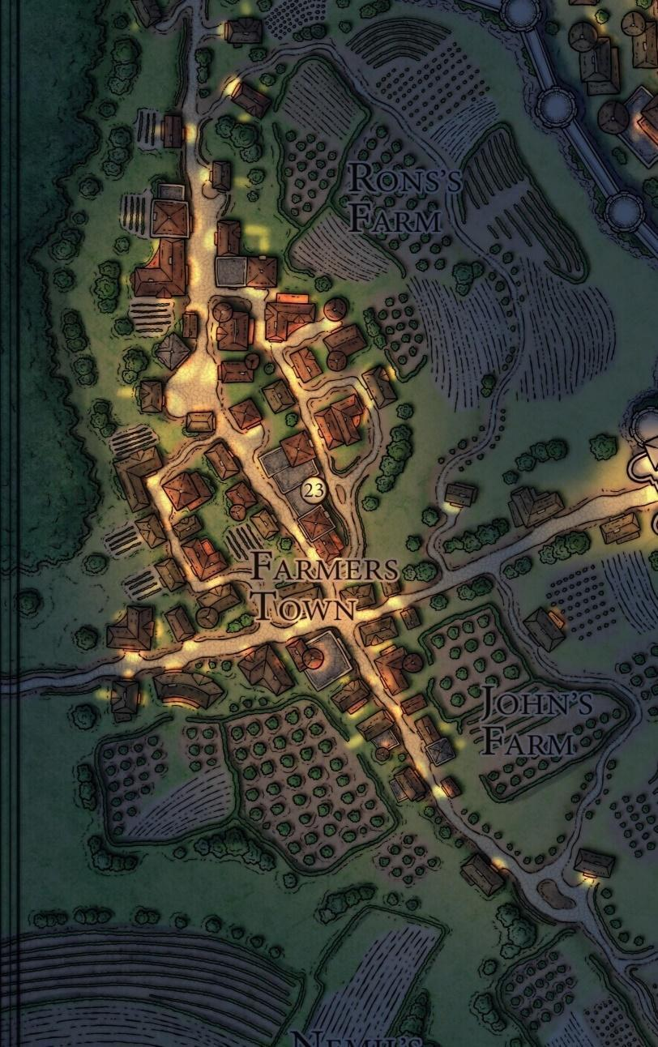

--DESCRIPTION--------------------------------------------------

Lunalem is a farming village with close ties to the capital Korthal. It lies to the South-East, past the Royal mines. It's borders extend into the surrounding farmlands to the north.

The main town is built along the road that leads from the Great Stone Road to Korthal. The town is separated from the forest to the East by a large stone wall. Homes are built on both siders of the wall, as it's more symbolic than effective.

The capital relied heavily on this town as it controls and operates the land that makes food for the capitals.

--SHOPS & PEOPLE--------------------------------------------------

|  |  |  |  |  |
| --- | --- | --- | --- | --- |
| *Lord* | *Aero Olathana, 37* | *Luanem* | *Human Monk 32M* | *Shrewd* |
| *Priest/ess* | *Armando, 70* | ***Lunalem Religion*** | *Human* | *Friendly* |
| *Alchemist* | *Kathil Carelton, 66* | *Portable Potents* | *Orc* | *Intelligent* |
| *Guild Member* | *Guy Bradave, 34* |  | *Human* | *Tired* |
| *Jeweler* | *Therella Dorgin, 51* | *Well of a Time* | *Elf* | *Jovial* |
| *IT Officer* | *Kenneth, 51* | ***Luanem Law*** | *Human* | *Curious* |
| *Tradesmen* | *Darrick Ck Rone, 37* |  | *Human* | *Gloomy* |
| *Smith* | *Kimum Bram, 70* | *Smelting Stars* | *Orc* | *Friendly* |
| *Shopkeeper* | *Kai Daniels, 90* | *The Winged Jewel (Owner)* | *Human* | *Rude* |
| *Innkeeper* | *Louella Bonsaw, 100* | *The Heavenly Lamb Inn* | *Human* | *Blustering* |
| *Citizen* | *Alindse Vorlsen, 32* |  | *Human* | *Shrewd* |
| *Citizen* | *Billye Holme, 44* |  | *Human* | *Honest* |
| *Citizen* | *Cart Gill, 88* |  | *Dwarf* | *Honest* |
| *Citizen* | *Danierw W Macra, 24* |  | *Human* | *Jovial* |
| *Citizen* | *Deron Ntire, 49* |  | *Human* | *Helpful* |
| *Citizen* | *Kodriam Pastire, 26* |  | *Human* | *Curious* |
| *Citizen* | *Long Rnak, 39* |  | *Human* | *Tired* |
| *Citizen* | *Sam Amy, 34* |  | *Half-Elf* | *Curious* |
| *Farmer* | *Tim Sky, 72* | ***Local Farm*** | *Half-Elf* | *Friendly* |
| *Servant* | *Amir Mach, 24* |  | *Human* | *Friendly* |

--ECONOMY--------------------------------------------------------

--SPECIAL FEATURES--------------------------------------------------

**WAYSTONE**

**CHURCH**

**IRON TEMPLE**

**GUILD OF HAMMER**

**GROVE STRIDERS**

**DRUIDIC THIEVES GUILD**

**END OF THE GREAT STONE ROAD**

--HISTORY----------------------------------------------------------

--SHOPS--------------------------------------------------------------

--INNS---------------------------------------------------------------

### Town- Lyric – Home of the Bard’s College

<Image>

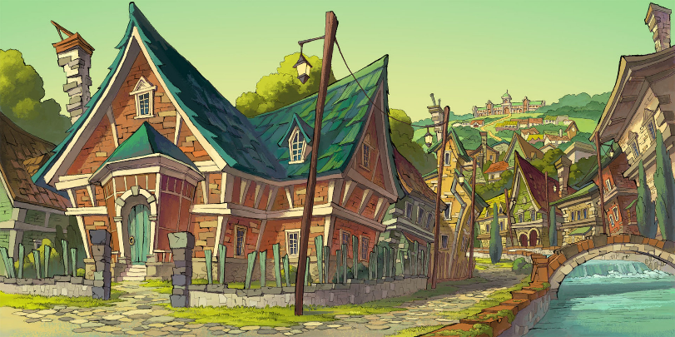

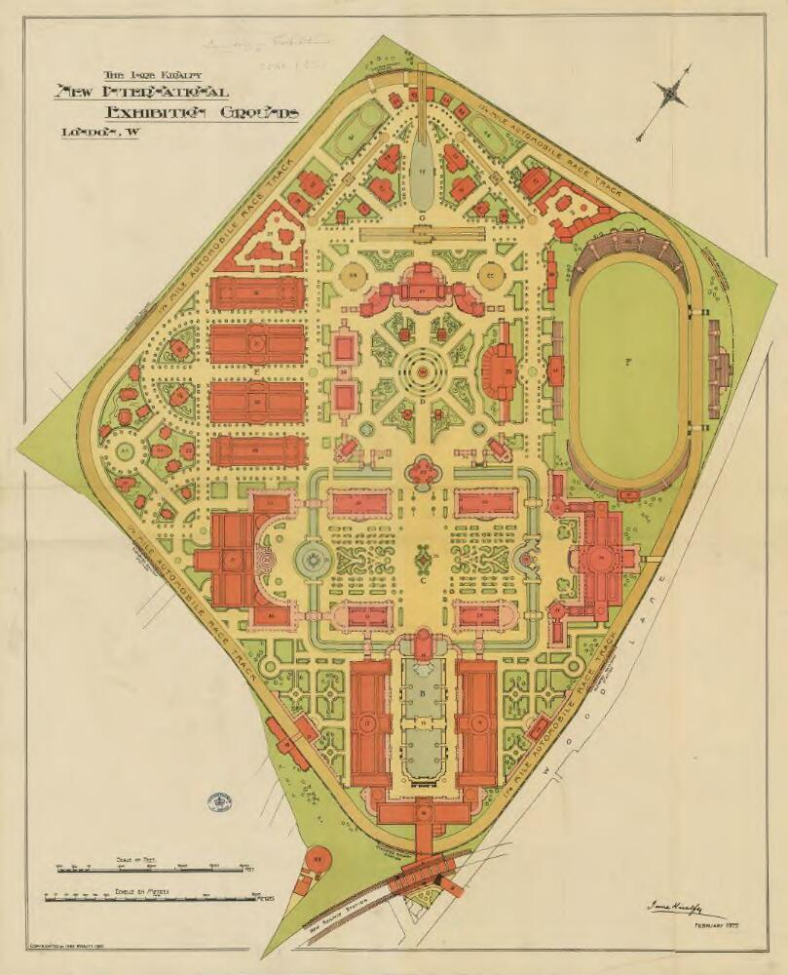

--DESCRIPTION--------------------------------------------------

Much like Imre was to the University, Lyric is an established town just a days travel from the University and is home to both accomplished and aspiring performers. It is also the last city of of Morheim that borders The Collective. Being a largely neutral and peaceful town, the neighbouring areas carry careful amicability.

Lyric is surrounded by rolling fields and farmland. Other than performers, their main economy is lumber, agriculture and travel.

--SHOPS & PEOPLE--------------------------------------------------

|  |  |  |  |  |
| --- | --- | --- | --- | --- |
| *Lord* | *Cecile Smither, 62* | *Lyric* | *Tiefling Fighter 50F* | *Friendly* |
| *Priest/ess* | *Thiery, 72* | ***Lyric Religion*** | *Human* | *Friendly* |
| *Guild Member* | *Tamming Kasprzak, 24* |  | *Human* | *Friendly* |
| *IT Officer* | *Denny, 74* | ***Lyric Law*** | *Human* | *Ponderous* |
| *Tradesmen* | *Tondy Ellan, 34* |  | *Human* | *Helpful* |
| *Smith* | *Salad Greek, 26* | *Metal Pandemonium* | *Orc* | *Friendly* |
| *Smith* | *Lon Elkrana, 44* | *Sarah's Bastion* | *Orc* | *Honest* |
| *Shopkeeper* | *Hinpoltas Garza, 89* | *The Thunder Elf* | *Lizardfolk* | *Friendly* |
| *Shopkeeper* | *Celindir Fizzlebottom, 70* | *The Wishing Oven* | *Elf* | *Intelligent* |
| *Fletcher* | *Bertram Arrow, 28* |  | *Human* | *Grumpy* |
| *Bartender* | *Nancee Elkrana, 106* |  | *Orc* | *Friendly* |
| *Innkeeper* | *Henriette Ahren, 35* | *The Lush Troll Pub* | *Human* | *Friendly* |
| *Innkeeper* | *Mariano Greek, 40* | *Ye Old Spider* | *Panda* | *Delightful* |
| *Citizen* | *Alpha Fost, 36* |  | *Human* | *Grumpy* |
| *Citizen* | *Billupe Scottyr, 42* |  | *Human* | *Annoyed* |
| *Citizen* | *Holairs Rs Adam, 100* |  | *Dwarf* | *Friendly* |
| *Citizen* | *Kiera Arent, 25* |  | *Human* | *Friendly* |
| *Citizen* | *Roosevelt T Galanod, 50* |  | *Human* | *Kind* |
| *Citizen* | *Sust Olto, 50* |  | *Human* | *Kind* |
| *Citizen* | *Uriel Clerc, 28* |  | *Human* | *Ponderous* |
| *Farmer* | *Darl Cier, 40* | ***Local Farm*** | *Human* | *Tired* |
| *Bard* | *Hadan Royer, 19* |  | *Half-Orc* | *Argumentative* |
| *Bard* | *Kata Nter, 40* |  | *Human* | *Jovial* |
| *Bard* | *Leslie Mccoy, 42* |  | *Human* | *Annoyed* |
| *Servant* | *Ster Sen, 25* |  | *Human* | *Honest* |
| *Servant* | *Sylo Blam, 38* |  | *Human* | *Cautious* |

--ECONOMY--------------------------------------------------------

Lumber and Agriculture

--SPECIAL FEATURES--------------------------------------------------

**The Song House**

AA place of talent and promise to fame and fortune.

**The Y-Road**

Granting paths to either the University or the Ruins of Ul'Tumeir in the desert.

**WAYSTONES**

**CHURCH**

**ELYSIAN PROTECTORATE**

**LYRES FOR HIRE**

**DRUIDIC THIEVES GUILD**

**BARD COLLEGE**

--HISTORY----------------------------------------------------------

--SHOPS--------------------------------------------------------------

--INNS---------------------------------------------------------------

### Town- Mattermont – Arcane Loch, Noble’s home

<Image>

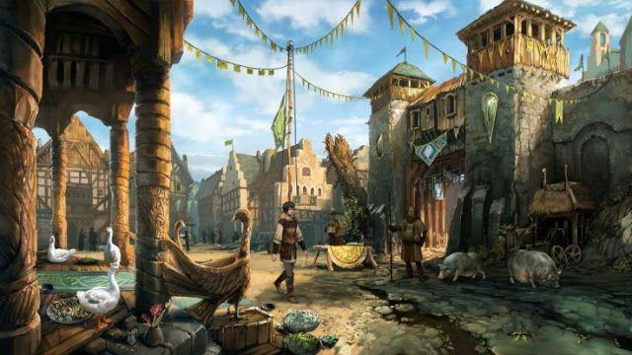

--DESCRIPTION--------------------------------------------------

Named after the family that led the expedition into Lake arcane. Mattermont is a popular stop with all adventurers and warriors.

Mattermont is a wealthy, trade-rich town and home to many nobles. Mattermont is a common meeting space for these nobles and as such, lots of unsavory activities happen behind closed doors.

Mattermont houses a group that guards the mouth of Lake Arcane. A distant sect of the GOSPEL, the Secret Soldiers. They know there's a deep secret in the University, and are willing to lay down their lives to guard the lake.

--SHOPS & PEOPLE--------------------------------------------------

|  |  |  |  |  |
| --- | --- | --- | --- | --- |
| Lord | Norman Windchester, 106 | Mattermont | Human | Honest |
| Priest/ess | Danuta Devaul, 53 | **Mattermont Religion** | Human | Kind |
| Nobleman | Reed Tsen, 21 |  | Half-Elf | Wise |
| Scribe | Scribe, 50 |  | Human | Argumentative |
| Guild Member | Don Larody, 26 |  | Human | Rude |
| IT Officer | Dart, 44 | **Mattermont Law** | Gnome Barbarian | Curious |
| Tradesmen | Blaine Arsen, 46 |  | Half-Elf | Blustering |
| Smith | Gailord Amberdown, 72 | Kronk's Krushers and Kleavers (Orc Blacksmith) | Elf | Friendly |
| Stable Keeper | Gearo Uston, 23 |  | Human | Wise |
| Shopkeeper | Master Cornwallis, 79 | The Storm Sign | Human | Ponderous |
| Innkeeper | Bethanie Flatwater, 77 | The Eolian | Aarokocra | Friendly |
| Citizen | Merritt Aitken, 30 |  | Human | Friendly |
| Farmer | Ignacio Macasse, 34 | **Local Farm** | Human | Tired |
| Bard | Toris Ailis, 29 |  | Half-Orc | Helpful |
| Servant | Cole Fino, 44 |  | Human | Honest |

--ECONOMY--------------------------------------------------------

--SPECIAL FEATURES--------------------------------------------------

**CHURCH**

**IRON TEMPLE**

**ELYSIAN PROTECTORATE**

**RELIC ALLIANCE**

**LYRES FOR HIRE**

**UNIVERSITY BRANCH**

**DRUIDIC THIEVES GUILD**

**SECRET SOLDIERS**

Group of GOSPEL members that are commited to finding and guarding Univeristy secrets, especially under the lake

--HISTORY----------------------------------------------------------

--SHOPS--------------------------------------------------------------

--INNS---------------------------------------------------------------

### CITY - Riverhold – Southern City

<Image>

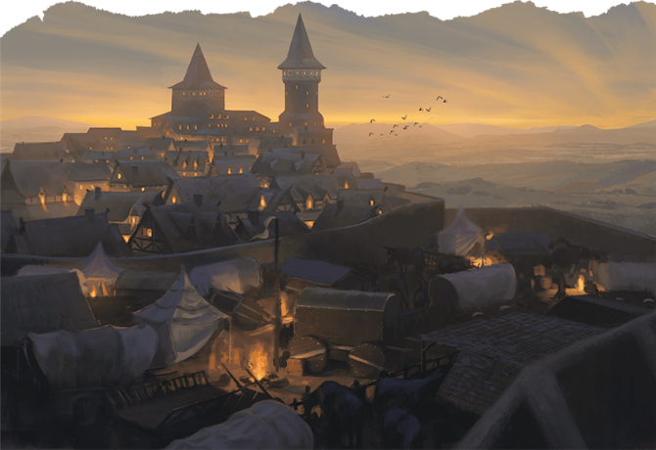

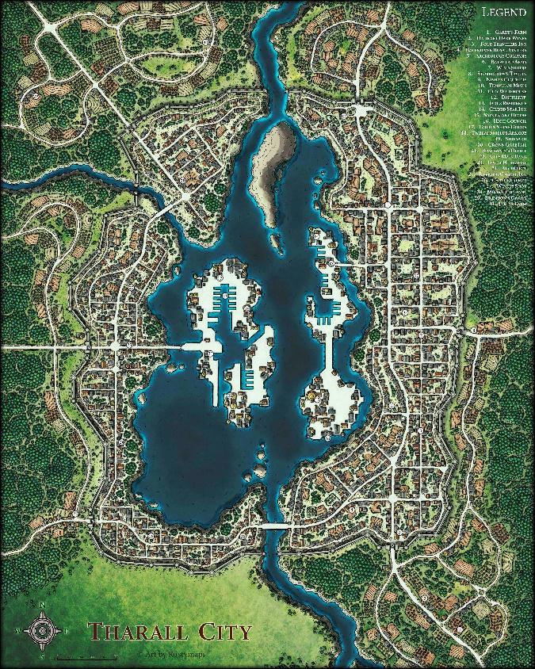v

--DESCRIPTION--------------------------------------------------

A dark, often fogged over city sitting at the end of a peninsula leading up to the capital channel. The people here are weary of the university to the West and the Forests to the East.

--HISTORY----------------------------------------------------------

--SHOPS--------------------------------------------------------------

--INNS---------------------------------------------------------------

--SHOPS & PEOPLE--------------------------------------------------

|  |  |  |  |  |
| --- | --- | --- | --- | --- |
| *Lord* | *Kole Blackwood, 88* | *Riverhold* | *Human* | *Friendly* |
| *Priest/ess* | *Shawnda, 40* | ***Riverhold Religion*** | *Merman* | *Annoyed* |
| *Guild Member* | *Sean Challey, 77* |  | *Human* | *Friendly* |
| *IT Officer* | *Grewill, 68* | ***Riverhold Law*** | *Merman* | *Helpful* |
| *Tradesmen* | *Cleta Ersen, 24* |  | *Human* | *Friendly* |
| *Smith* | *Jerrell Tamrei, 107* | *Feather in Your Cap* | *Human* | *Argumentative* |
| *Smith* | *Eera Ahren, 107* | *Iron Designs* | *Elf* | *Intelligent* |
| *Shopkeeper* | *Teresita Doomkeeper, 63* | *Marblegate* | *Human* | *Curious* |
| *Shopkeeper* | *Savannah Dugir, 102* | *Tongue and String* | *Panda* | *Curious* |
| *Innkeeper* | *Francoise Gelnne, 37* | *The Warm Pegasus Inn* | *Orc* | *Friendly* |
| *Citizen* | *Boyce Mdaux, 27* |  | *Human* | *Shrewd* |
| *Citizen* | *Ebet Den, 19* |  | *Human* | *Helpful* |
| *Citizen* | *Jeannine E Dennel, 42* |  | *Human* | *Jovial* |
| *Citizen* | *Laure Hamps, 46* |  | *Human* | *Honest* |
| *Citizen* | *Theo Amse, 33* |  | *Human* | *Helpful* |

--ECONOMY--------------------------------------------------------

--SPECIAL FEATURES--------------------------------------------------

**MORHEIM VAULT**

**CHURCH**

**IRON TEMPLE**

**GUILD OF HAMMER**

**UNIVERSITY BRANCH**

**GROVE STRIDERS**

### Town- Shirin – Eastern Reach

<Image>

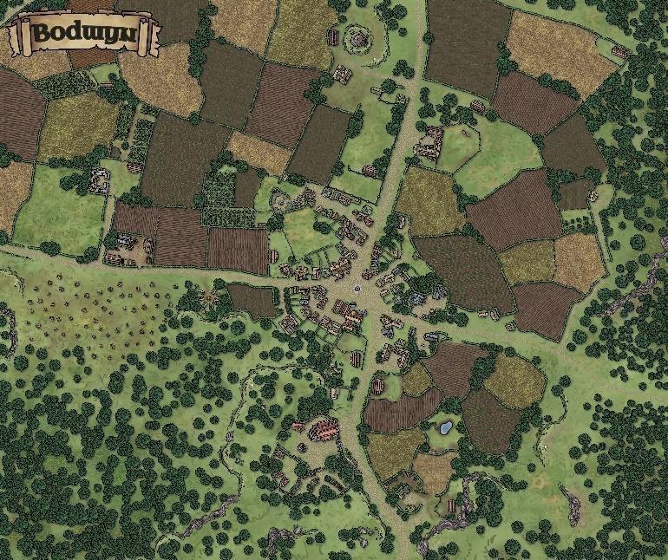

--DESCRIPTION--------------------------------------------------

--SHOPS & PEOPLE--------------------------------------------------

|  |  |  |  |  |
| --- | --- | --- | --- | --- |
| **Lord** | **Stacie Wegner, 69** | **Shirin** | Human | Jovial |
| Priest/ess | Pheobe Irier, 26 |  | Human | Friendly |
| Alchemist | Baittin Abel, 36 | The Tired Sphinx | Human | Honest |
| Alchemist | Chandy Macrasl, 42 | The Glowing Codex | Human | Friendly |
| Guild Member | Wammy Raszw, 24 |  | Human | Honest |
| IT Officer | Margeret Johnurr, 47 | Geeban works | Half-Elf | Friendly |
| Tradesmen | Finas Chber, 55 | The Steady Pocket | Human | Honest |
| Tanner | Haskell Hardy, 44 |  | Human | Annoyed |
| Smith | Tobias Guett, 31 | The Deep Discovery Pub | Human | Tired |
| Smith | Carlie Reiner, 36 | **The Minotaur's Arms** | Half-Elf | Kind |
| Smith | Berra Gier, 23 | **The Minotaur's Furnaces** | Human | Intelligent |
| Shopkeeper | Antwain Dziedzic, 40 | Bards Guard | Human | Helpful |
| Shopkeeper | Rana Frank, 46 | Eagle's Eye | Half-Orc | Kind |
| Shopkeeper | Bermarl Plansen, 25 | Plansen's Vault | Half-Orc | Friendly |
| Bartender | Virshor Mathieson, 17 |  | Human | Arrogant |
| Innkeeper | Elmo Guerra, 31 | The Cane | Human | Jovial |
| Citizen | Honn Abel, 30 | **Local Farm** | Human | Curious |
| Farmer | Marty Masson, 36 | **Local Farm** | Human | Wise |
| Farmer | Nali Vino, 43 | **Local Farm** | Half-Elf | Ponderous |
| Farmer | Princeton Landvik, 28 | **Local Farm** | Human | Intelligent |
| Servant | Jamonso Pionert, 26 |  | Human | Wise |

--ECONOMY--------------------------------------------------------

--SPECIAL FEATURES--------------------------------------------------

**CHURCH**

**IRON TEMPLE**

**GROVE STRIDERS**

**WAYFARERS APOTHECARY**

**HUGE FARMING FIELDS**

--HISTORY----------------------------------------------------------

--SHOPS--------------------------------------------------------------

--INNS---------------------------------------------------------------

### CITY - Starguard – City of Miner’s Wealth

<Image>

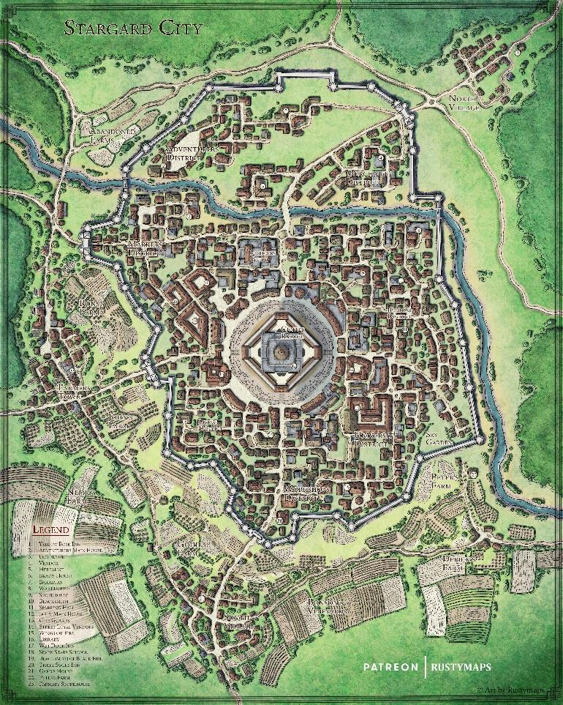

--DESCRIPTION--------------------------------------------------

--SHOPS & PEOPLE--------------------------------------------------

|  |  |  |  |  |
| --- | --- | --- | --- | --- |
| Lord | Brennan Iedeman, 26 | Starguard | Human | Quiet |
| Priest/ess | Cher Agan, 44 | **Starguard Religion** | Dwarf | Intelligent |
| GOSPEL Member | Dianta Fredriksen, 57 |  | Human | Kind |
| Alchemist | Dolt Reen, 26 | The Affordable Tome | Half-Orc | Friendly |
| Alchemist | Nessa Limek, 44 | The Frozen Hippocampus | Human | Friendly |
| Guild Member | Mervin N Pero, 27 |  | Human | Delightful |
| IT Officer | Minerva Va Wenz, 44 |  | Human | Intelligent |
| Tradesmen | Cheleen N Simon, 30 |  | Human | Tired |
| Tanner | Fara Kepesht, 32 |  | Dwarf | Friendly |
| Smith | Renaldo O Arsen, 31 | **[Owner's Name] Shields** | Half-Elf | Arrogant |
| Smith | Bryan Ierst, 42 | The Bleeding Caravan | Human | Friendly |
| Smith | Ivetti Wolff, 48 | **The Sweat of the Furnaces** | Human | Helpful |
| Shopkeeper | Honn Olan, 75 | The Dragon's Seal | Human | Friendly |
| Shopkeeper | Jeanda Pointe, 50 | The Pointe | Human | Friendly |
| Shopkeeper | Adrialm Lm Nako, 27 | Tinctures and Tomes | Half-Orc | Friendly |
| Bartender | Juli Nsen, 28 |  | Human | Kind |
| Innkeeper | Jamarco Arsokul, 46 | Blueprint | Human | Blustering |
| Citizen | Blas Evor, 29 | **Local Farm** | Human | Delightful |
| Citizen | Jest Rber, 44 | **Local Farm** | Human | Intelligent |
| Farmer | Devin Ntura, 24 | **Local Farm** | Human | Friendly |
| Farmer | Roldary Mcnabet, 24 | **Local Farm** | Human | Kind |
| Farmer | Rosevelt Lt Logan, 34 | **Local Farm** | Half-Orc | Intelligent |
| Farmer | Sheelagh Agh Nako, 41 | **Local Farm** | Halfling | Wise |
| Farmer | Travis Arster, 25 | **Local Farm** | Human | Ponderous |

--ECONOMY--------------------------------------------------------

--SPECIAL FEATURES--------------------------------------------------

**CHURCH**

**IRON TEMPLE**

**GOSPEL**

**RELIC ALLIANCE**

**LYRES FOR HIRE**

**ARTIFICERS COLLEGE**

**TEMPLE OF PURE OLD IRON**

Large town center sqaure with beasement vaults & jail

--HISTORY----------------------------------------------------------

--SHOPS--------------------------------------------------------------

--INNS---------------------------------------------------------------

### Town- Treton – Just ‘There’

<Image>

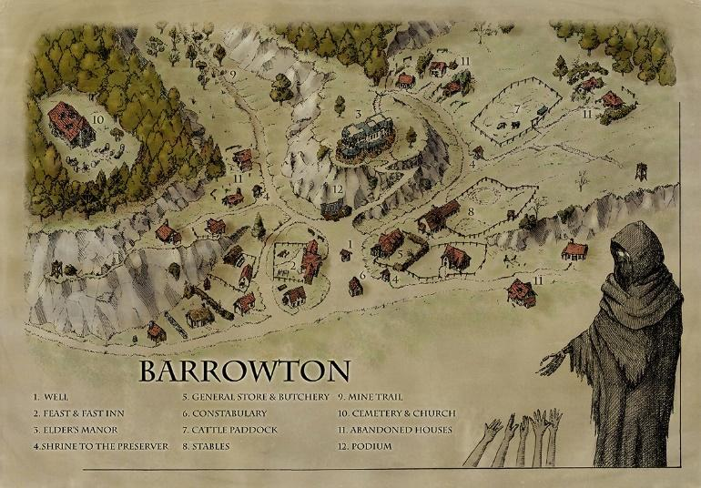

--DESCRIPTION--------------------------------------------------

--SHOPS & PEOPLE--------------------------------------------------

|  |  |  |  |  |
| --- | --- | --- | --- | --- |
| *Lord* | *Barbara A Riese, 23* | *Treton* | *Half-Orc* | *Ponderous* |
| *Priest/ess* | *Suzanat At Beck, 29* | ***Treton Religion*** | *Human* | *Curious* |
| *Nobleman* | *Linanes Wawrzaszek, 44* |  | *Human* | *Ponderous* |
| *Guild Member* | *Lexa Nack, 26* |  | *Human* | *Shrewd* |
| *Tradesmen* | *Winerte Carlsen, 23* |  | *Human* | *Kind* |
| *Citizen* | *Abe All, 25* |  | *Dwarf* | *Rude* |
| *Citizen* | *Broderick Sokal, 26* |  | *Human* | *Friendly* |
| *Citizen* | *Elizabeth Mcgraw, 61* |  | *Human* | *Argumentative* |
| *Citizen* | *Mishava Delmirev, 17* |  | *Human* | *Gloomy* |
| *Citizen* | *Otho Martsen, 23* |  | *Human* | *Arrogant* |
| *Farmer* | *Ana Aul, 36* | ***Local Farm*** | *Human* | *Honest* |
| *Farmer* | *Aran Page, 133* | ***Local Farm*** | *Human* | *Ponderous* |
| *Farmer* | *Brales Stromor, 32* | ***Local Farm*** | *Human* | *Intelligent* |
| *Traveller* | *Jarret Pauwels, 48* |  | *Human* | *Argumentative* |
| *Servant* | *Cory Linther, 23* |  | *Half-Elf* | *Friendly* |
| *Servant* | *Kargayr Simer, 42* |  | *Elf* | *Jovial* |
| *Servant* | *Kaylora A Kovac, 27* |  | *Human* | *Kind* |

--ECONOMY--------------------------------------------------------

--SPECIAL FEATURES--------------------------------------------------

**CHURCH**

**GUILD OF HAMMER**

**HILLSIDE CEMETERY**

**ELDERS HALL ON THE HILL**

**ROADSIDE SHRINE TO GOND THE TINKERE**

--HISTORY----------------------------------------------------------

--SHOPS--------------------------------------------------------------

--INNS---------------------------------------------------------------

### CITY - Wake Field – City of Farmers

<Image>

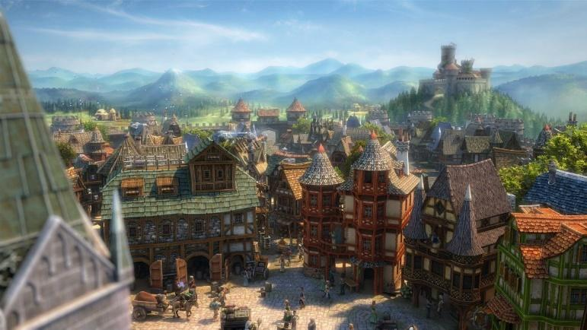

--DESCRIPTION--------------------------------------------------

A relatively large town, WakeField is set in a massive valley surrounded by huge rolling hills and beyond that, flat farmland. They're known to the kingdom for their exceptional crops, and act as the main agricultural importers to the capital. This has led to fair wealth in the town.

--SHOPS & PEOPLE--------------------------------------------------

|  |  |  |  |  |
| --- | --- | --- | --- | --- |
| *Lord* | *Elrer Berkeley, 79* | *WakeField* | *Human* | *Friendly* |
| *Priest/ess* | *Markus, 104* | ***WakeField Religion*** | *Human* | *Wise* |
| *Guild Member* | *Leregob Albeaum, 44* |  | *Human* | *Friendly* |
| *Tradesmen* | *Gary Alds, 44* |  | *Dwarf* | *Friendly* |
| *Tradesmen* | *Orick Horn, 73* |  | *Human* | *Tired* |
| *Smith* | *Noemi Gelnne, 92* | *True North* | *Orc* | *Honest* |
| *Shopkeeper* | *Thasrian Firekin, 28* | *The Sandy Mirror* | *Tabaxi* | *Friendly* |
| *Innkeeper* | *Adria Elkrana, 83* | *The Attractive Gate* | *Panda* | *Friendly* |
| *Citizen* | *Alois Oulin, 25* |  | *Human* | *Kind* |
| *Citizen* | *Brucio Auffma, 27* |  | *Half-Orc* | *Tired* |
| *Citizen* | *Leo Mas, 38* |  | *Human* | *Friendly* |
| *Citizen* | *Melvin Anvier, 23* |  | *Human* | *Blustering* |
| *Citizen* | *Odis Ille, 32* |  | *Human* | *Blustering* |
| *Farmer* | *Dedwina A Bowen, 48* | ***Local Farm*** | *Human* | *Curious* |
| *Farmer* | *Kwame Ernak, 22* | ***Local Farm*** | *Human* | *Friendly* |
| *Servant* | *Shari Rick, 38* |  | *Human* | *Tired* |

--ECONOMY--------------------------------------------------------

--SPECIAL FEATURES--------------------------------------------------

**WAYSTONE**

**CHURCH**

**IRON TEMPLE**

**GUILD OF HAMMER**

**CITY HALL**

**FARMERS MARKET**

--HISTORY----------------------------------------------------------

--SHOPS--------------------------------------------------------------

--INNS---------------------------------------------------------------

## Republic - OAR (23)

<Representative Image>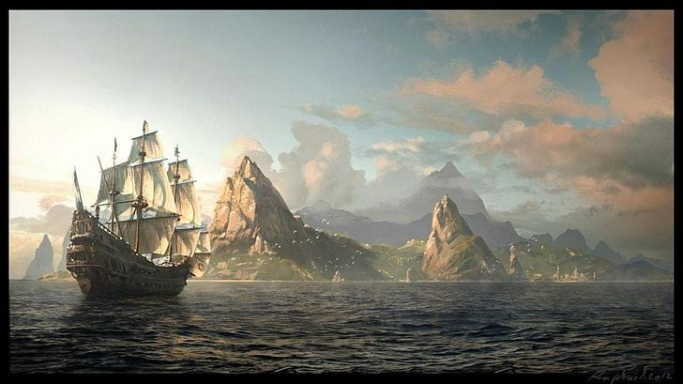

<Flag>

<Basic Description>

The Oceans Alliance Republic (OAR) was founded by a collection of naval traders, travellers, and coastal city owners. They founded relatively recently, approximately 1,300 years ago. With it, there is the story of the Chancellor family. It is told still to this day.

### Summary

*Geography in summary*

*Culture in summary*

**Angelfer Island**

**Ardenport**

**Carran**

**Cindergulch**

**Drymoor**

**Far Water**

**Flurham**

**MesaPort**

**Meera**

**Nightshale**

**Pikecliff**

**Pikeville**

**Pirate’s Sanctum**

**Port Mid**

**Port Passer** is a city of success built from the relations of 3 great civilizations. Sitting on the end of a wild continent, seafaring access to abundant resources and kind currents made the city the ideal stopping point for all travel. Such such, it was known as the Passing Port. Currently, the town holds tense peace with a quiet power lurking in the mountains. The roads are was well patrolled by the Sentinels and Iron temple Legates.

From abundant wealth came the opportunity to design a grand utopia. The city is teeming with grand castles, temples, brownstone tallhouses, marketplaces, emporia, and beautiful mansions, all surrounded by parks, topiaries, statuary, decorative pools, and a wide variety of complex fountains. The city's crown jewel is the **Yuntas Crown,** an ancient circlet of coral and gemstones. It’s fabled to be the soul of the sea, and much sought after by older powers. It’s also said to hold the powers of the sea.

**Port Sheerstone,** Also known as the City of Skilled Hands and the Jewel of the North, was a bustling, cultured, and cosmopolitan city of Port Sheerstone. During the expansion of the republic, and through agreements of Creatus clans, Port Sheerstone was the farthest the OAR agreed to grow to. Known as the northern corner, it has become home to a range of orcs and humans. Both reap the benefits of a secured inlet of fishing, and a formidable port. Most ships make this their last stop through the republic, or first on long voyages north. Nestled between sacred forests, the humans are wearily extend their reach. Slowly, they managed a road to another large Cliffside they claimed for the home of their expanded navy. They share vicinity with Sheerstone island, a soon after-developed island resort town in a magnificent cove.

**Retria** is the grand ‘hidden jewel’ of the republic. This bustling cove metropolis was built as a second stronghold of the republic long before it’s inception. The city is designed in a lotus-like fashion, with several major arteries through the city, and a wall of ports. The inlet is narrow and shallow in key areas, allowing for tight controls of access. Fronting the inlet is a large cliffed island that houses the citie’s castle and guard posts, not to mention the lords home and secret vault. In the center of the city is the church. One older than most others, the church has sealed off hidden floors and an intricate basement leading to old, OLD crypts. In it are the records of an old rule by the name of General Iron, and a scepter that he mentioned in his memoirs. Unknown to most, the history of his cty runs much much deeper than even that.

**Ruslet** is a large city, though smaller than Retria. Their lands lie on an open penninsula cove, now closed and controlled by a man-made landline with a huge brick wall built atop it. The city is constructed around four large hills, each of which holds a different aspect of the city. They sit nearby main routes of sea travel between capital and the navy ports. As such, the city sees large support of the republic. The oceans by Ruslet are rich in fish populations and tend to be shallower farther out, garnering a safer feeling for the local population (sea monsters) when out at sea. The seas also sit on the end of the Cemetery of the Forgotten, a rough and treacherous stone reef that's known to sink ships. As such, tales of loot ripe for the taking are various and well-known. **Lord Roland Berkeley, 108** Soon on the way out, this aging lord raised the town from it's village-like state nearly 90 years ago, and led it to what it is today. Roland sits on his deathbed, and the population regularly visits his estate to wish him well. His son, Tirus, is eager to lead the town soon after, so long as the election sees him as the best choice. He's not above hiring a group to ensure his victory in the coming years.. The populous is less than impressed with his vivilous spending and attitude, and believes a change is sorely needed.

**Sheerstone Island** is a hidden spiral cove with sharp mountain walls. The surrounding bay is patrolled frequently as many nobles and influential people are known to frequent the Island. It’s quiet and serene, with little left to describe. Oh, except for the odd waterfall of no clear origin.

**Smit** is a large and splendorous coastal town. The people are known to keep much to themselves but hold close to the influence of Meera and Flurham. Their city is a day’s walk from the Great Stone Road leading into the Morheim Kingdom,

**Tebiton**

**Usterduum**

#### Leader/Lord

<Image>

--DESCRIPTION-------------------------------------------------- 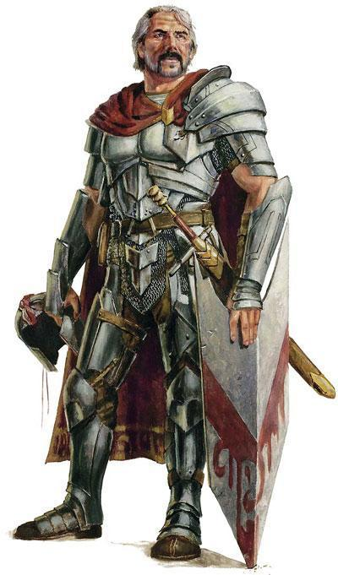

As part of historical tradition, any named leader of the new republic was titled with Chancellor, who's family bloodline died with one of their last leaders. The now-Chancellor, Greg, comes from Meera and rose to power from next to nothing.

***The People of OAR are a homogenous, sea-felling group who live by and rely on ocean trade.*** Most people at an early age develop skills and appreciation for ships and sailors, even if they go into other trades as adults.

Schooling is largely done by working and government-aided systems. Lessons are practical and last only a few weeks to cover basics. Most other skills are handed down over generations, like the stories.

#### History

Long lasting in the Age of man, civilizations rose

and fell to their own folly, and the force of others.

Once such civilization lay along the eastern coasts, stretching from now-days Smit to Tebiton. Masters of the coast, this nation controlled the ocean paths and regulated all travel and trade, gaining them much influence and power. But their success was centuries short-lived at the hand of pirates and monsters.

This old kingdom stretched their forces too far and too thin, leading to their eventual downfall. Pirates raided their lands at mass. Citizens died in the battles and the leader of this ancient civilization fell early in the wars. Afraid and leaderless, the kingdom surrendered control to the public and plunged into chaos. For the next decades, generations and centuries, the land was overrun by chaos. The citizens were desperate for leadership and order.

There was only one family on the island of Meera who refused to relinquish control of their city. In secret, they sent cryptic letters to and from each city, as far as they could. They drew up walls, killed all who flew the pirate flag, and openly called out for the pirates demise.

The lord's surname was Chancellor. Their family withstood the pirates for generations before being strong enough once more to call on the other cities.

They soon came up with a plan to train the remaining men and children to overtake the pirates they could, and silently kill the remainders. Their determination and motivation came from this open defiance and charismatic leadership.

The citizens prevailed, fighting almost to self-destruction. Soon, they were able to rebuild as the pirates retreated back to the seas.

#### Laws and Government

**Laws**

As judged by the eyes of the Naval Chancellor, appointed law makers, or another approved body, any criminals discovered and/or convicted of crimes within local halls of judgment throughout the republic are subject to punishments befitting the crime.

**All fines and punishments for crimes by-or-against nobles, soldiers, or ranking military officials are doubled.**

**All fines and punishments for crimes by-or-against imperial officials are tripled.**

Government

The governing of OAR consists of a representative for people from each region. The representatives spend half a year in their respective towns and half a year in **Port City Meera, the OAR capital.** While they seldom battle for total power, their needs usually outweigh the needs of lesser settlements like Smit, or Tebiton.

Overseeing all representatives is **the Naval Chancellor Greg**, who acts as judge and impartial leader that maintains order during conferences and disputes. He commands a small army of 3000 who are seldom used to enforce compliance. The main use of this army is to patrol the seas and protect/inspect other ships. They're also known as the **Meera Trading Company**.

The Representatives are **not leaders or authoritative figures** in their regions. Each town city and hamlet have their own **elected/divine leader** who pays taxes and leads their people. The representatives collect unbiased opinions about the towns they oversee and their leaders to determine if OAR intervention is necessary. As a whole, the OAR is highly respected by all, and their word is seen as law.

Each city has the right to elect or appoint a leader for any period of time they choose. This has led to a large cultural difference and political challenge for the OAR.

Representatives:

|  |  |  |  |
| --- | --- | --- | --- |
| *Angelfer Island* | *Floy Esch, 39* | *Human* | *Shrewd* |
| *Ardenport* | *Horace Dillon, 26* | *Human* | *Intelligent* |
| *Carran* | *Euan Chan, 100* | *Dwarf* | *Cautious* |
| *Cindergulch* | *Pat Roth, 37* | *Human* | *Intelligent* |
| *Drymoor* | *Jacinta Adamse, 22* | *Half-Elf* | *Blustering* |
| *Far Water* | *Myle Duchamps, 45* | *Human* | *Friendly* |
| *Flurham* | *Ceterus Tiev, 23* | *Human* | *Shrewd* |
| *Flurham* | *Paribus Chrupie, 25* | *Human* | *Friendly* |
| *MesaPort* | *Jack Servaant, 28* | *Human* | *Curious* |
| *Nightshale* | *Breeanna Raevand, 50* | *Human* | *Shrewd* |
| *Pikecliff* | *Rufus Welyn, 27* | *Human* | *Grumpy* |
| *Pikeville* | *Yoel Horn, 27* | *Human* | *Friendly* |
| *Port Mid* | *Patrinn Myastan, 48* | *Dragonborn* | *Helpful* |
| *Port Passer* | *Eve Son, 27* | *Human* | *Wise* |
| *Port Sheerstone* | *Marquis Pierre, 17* | *Human* | *Blustering* |
| *Retria* | *Adwills Llau, 24* | *Human* | *Kind* |
| *Retria* | *Celanis Legolin, 302* | *Elf* | *Wise, fair and just. Holds temper well* |
| *Retria* | *Peri Tuul, 36* | *Halfling* | *Annoyed* |
| *Retria* | *Yorem Ulmathean, 249* | *Dwarf* | *Annoyed* |
| *Ruslet* | *Leonard D Evans, 22* | *Human* | *Rude* |
| *Sheerstone Island* | *Ruben Dubicki, 35* | *Human* | *Friendly* |
| *Smit* | *Ollen Ermid, 72* | *Dwarf* | *Curious* |
| *Tebiton* | *Florine Dennel, 24* | *Human* | *Friendly* |
| *Usterduum* | *Chris Servaant, 65* | *Half-Orc* | *Jovial* |

Lords:

|  |  |  |  |
| --- | --- | --- | --- |
| *Angelfer Island* | *Ecin Aveyry, 46* | *Human* | *Friendly* |
| *Aquatas* | *Ethed Gelnne, 53* | *Human* | *Honest* |
| *Ardenport* | *Gunthur Eshlemen, 200* | *Dwarf* | *Curious* |
| *Carran* | *Vyncent Tamrei, 28* | *Human* | *Wise* |
| *Cindergulch* | *Ethew Ahren, 74* | *Half-Elf* | *Helpful* |
| *Drymoor* | *Beth Amberdown, 95* | *Half-Elf* | *Curious* |
| *Far Water* | *Urnath Greek, 100* | *Dragonborn* | *Friendly* |
| *Flurham* | *Kimim Clayton, 26* | *Lizardfolk* | *Curious* |
| *MesaPort* | *Durwin Bram, 87* | *Elf* | *Intelligent* |
| *Nightshale* | *Lytton Bonsaw, 58* | *Orc* | *Gloomy* |
| *Pikecliff* | *Dursley Grendal, 65* | *Human* | *Jovial* |
| *Pikeville* | *Wetherby Flatwater, 97* | *Orc* | *Kind* |
| *Pirates Sanctum* | *Jalen Ashley, 101* | *Elf* | *Annoyed* |
| *Port Passer* | *Treyari Adlam, 53* | *Elf* | *Blustering* |
| *Port Sheerstone* | *Jules Deighton, 27* | *Elf* | *Kind* |
| *Retria* | *Osval Poive, 31* | *Human* | *Helpful* |
| *Ruslet* | *Roland Burkeley, 108* | *Human* | *Quiet* |
| *Sheerstone Island* | *Shermon Slootmaekers, 28* | *Human* | *Friendly* |
| *Smit* | *Cyso Pauwels, 28* | *Human* | *Grumpy* |
| *Smugglers Port* | *Johnnie Vollan, 25* | *Human* | *Quiet* |
| *Smugglers Port* | *Scot Atwig, 116* | *Elf* | *Jovial* |
| *Smugglers Port* | *Sozen Mountainkin, 64* | *Dwarf* | *Ponderous* |
| *Tebiton* | *Devin Kramer, 40* | *Human* | *Friendly* |
| *Usterduum* | *Ulysses Deney, 36* | *Elf* | *Friendly* |

<Image>

--DESCRIPTION--------------------------------------------------

A dense island hill-city with sprawling paths and roads cutting through it. Holding a population of over 800,000 it is a sight to behold.

**The Port-Master Barren** leads this metropolitan marvel in organized trade and keeps close eyes on those who dock in his ports.

--SHOPS & PEOPLE--------------------------------------------------

|  |  |  |  |  |
| --- | --- | --- | --- | --- |
| Sea Lord | Tanver Yuntas Sea, 61 | **Yuntas Sea Border** | Human | Cautious |
| Naval Chancellor | Gregory, 51 |  | Human | Ponderous |
| Low Sentinel | Renzen, 120 |  | Half-Elf | Grumpy |
| GOSPEL Member | Cornell Stagnet, 84 |  | Human | Friendly |
| Alchemist | Ilil Ever, 59 | Orbs and Talismans | Elf | Friendly |
| Portman | Edgar Amberswift, 73 |  | Human Male Retired Scribe | Intelligent |
| Guild Member | Rosetha Wodzki, 44 |  | Human | Rude |
| Smith | Mitchel Smither, 98 | **[Owner's Name] Breastplates** | Orc | Ponderous |
| Smith | Joshua Olathana, 56 | **[Owner's Name] Chains** | Human | Friendly |
| Shopkeeper | Bertioo Bardye, 43 | The Blue Bear | Merman | Helpful |
| Shopkeeper | Delma Dorrance, 87 | The Blue Decoctions | Human | Curious |
| Shopkeeper | Emilee Denford, 100 | The Broken Clarvoiance | Human | Friendly |
| Innkeeper | Anelel Ashley, 38 | The Clumsy Bassoon Bar | Orc | Wise |
| Citizen | Fory Nnel, 39 |  | Human | Ponderous |
| Citizen | Wendell Valdsen, 49 |  | Human | Tired |

--ECONOMY--------------------------------------------------------

Imported/Exported Goods, Fishing

--SPECIAL FEATURES--------------------------------------------------

**THE CASTLE OF MEERA**

sitting atop the main hill of the island

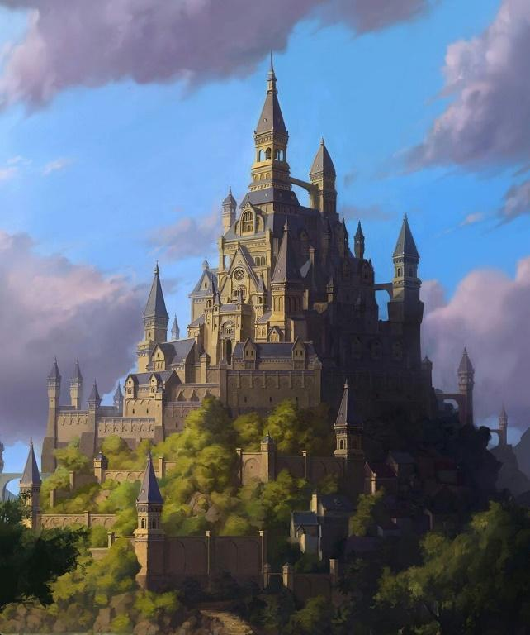

The castle sits in the middle of the upper district of Meera and takes up a large portion of the mouth of the volcano. It has its own surrounding wall and gate, completed with castle guards. The guards do not allow entry to anyone who doesn't have scheduled business with a high-ranking official.

The castle rises several stories in elevation with one main peak used as the Naval Chancellors private quarters.

**THE CHURCH**

**THE IRON TEMPLE TEMPLE**

**MEERA TRADING COMPANY WAREHOUSE**

**UNIVERISTY BRANCH**

**SHADE BRINGERS HIDEOUT**

**ARTIFICER’S COLLEGE OFFICE**

**VOLCANIC FORGE**

**MUSICIAN’S GUILD**

--HISTORY----------------------------------------------------------

--SHOPS--------------------------------------------------------------

--INNS---------------------------------------------------------------

### Town- Angelfer Island – Navy’s Rest

<Image>

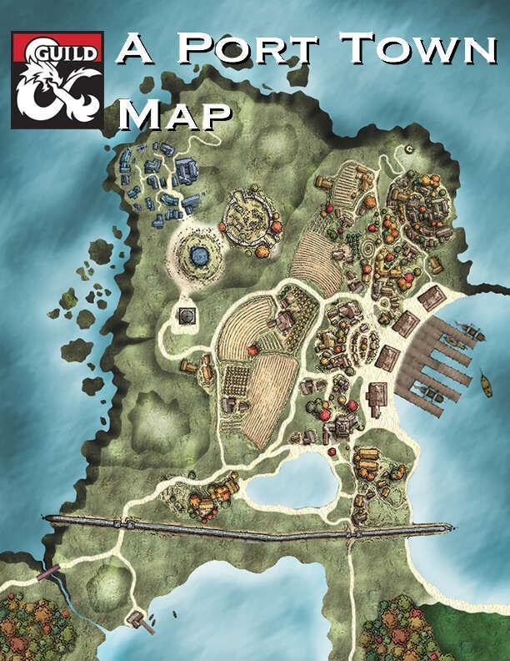

--DESCRIPTION--------------------------------------------------

Angelfer Island takes up nearly the entire area of the island it sits on, the largest of the small island chain.

Ecin Young is a respectable middle aged man, and has a secret crush on Luanna

--SHOPS & PEOPLE--------------------------------------------------

|  |  |  |  |  |
| --- | --- | --- | --- | --- |
| **Representative** | **Floy Esch, 39** |  | Human | Shrewd |
| **Lord** | **Ecin Aveyry, 46** |  | Human | Friendly |
| SC, Sea Master | Brandon Mcgraw, 63 |  | Dwarf | Argumentative |
| Sailor | Miso Jokult, 23 | Hippomenes | Human | Helpful |
| Sailor | Oria Thorsen, 28 | Affleck | Dwarf | Friendly |
| Guild Member | Bo Lestrange, 23 |  | Half-Elf | Tired |
| SC, Tide Surge | Kired Bonnaire, 72 |  | Half-Elf | Friendly |
| SC, Tide Surge | Tim Lewsky, 61 |  | Half-Orc | Curious |
| Smith | Sarah Clayton, 68 | **[Owner's Name] Chains** | Human Wizard | Friendly |
| Shopkeeper | Thony Cote, 59 | The Amber Complex | Human | Kind |
| Hunter | Vendd Estes, 63 |  | Dwarf | Grumpy |
| SC, Surf Breaker | Kimberley Durkers, 86 |  | Human | Ponderous |
| SC, Surf Breaker | Wistor Tinney, 58 |  | Human | Tired |
| Innkeeper | Rogelio Burtt, 82 | Bandits | Human | Annoyed |
| Citizen | Armando Ilippov, 44 |  | Human | Friendly |
| Citizen | Jalindr Chrader, 29 |  | Human | Honest |
| Citizen | Jason Aullo, 80 |  | Dwarf | Friendly |
| Citizen | Shletta Zduchel, 47 |  | Human | Ponderous |
| Citizen | Troy Burn, 20 |  | Half-Elf | Cautious |
| Traveller | Leigha Aczykk, 21 |  | Human | Kind |

--ECONOMY--------------------------------------------------------

Fishing and trade

--SPECIAL FEATURES--------------------------------------------------

**THE CHURCH**

**MEERA TRADING COMPANY BUILDING**

**MUSICIAN’S GUILD**

**STORM CHASERS**

**SHADE CLOAKS**

**CLIFFSIDE ORCHARDS**

**SIRENS TRAIL**

Archipellago of small islands littered with ages of shipwrecks with no apparent reasoning. There are old, OLD rumors of Sirents that haunt the waters at night and draw in unsuspecting sailors.

--HISTORY----------------------------------------------------------

Angelfer island for the longest time was a small fishing village. It still largely is, but with the pirate raids of the past and it's close proximity to such a prominent trade route, it opted to join the republic and benefit from their assets to develop slightly into a town worthy of a map marker

--SHOPS-------------------------------------

--INNS---------------------------------------------------------------

### Town- Ardenport – Bustling, towards the North

<Image>

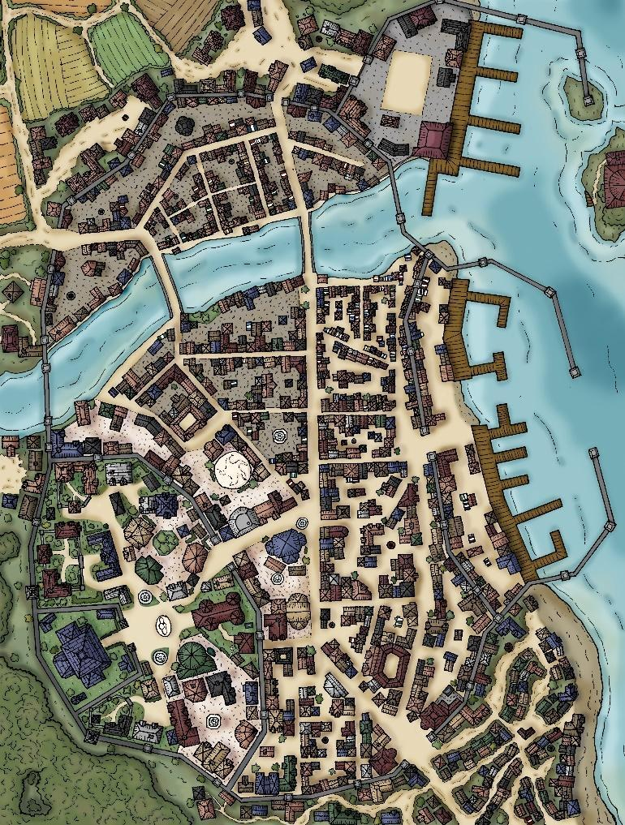

--DESCRIPTION--------------------------------------------------

Ardenport lies withing three stone bluffs, each containing comfortable amounts of space between each other. Given the geography, every square foot of space is taken to consideration. As such, farms are dispersed evenly throughout the city.

Behind the town is a large, light forest leading into the surrounding foothills.

Gunthur Ulmathean, a dwarf lord, is an uncommon leader for any city other than in the DKK. But this man was given a chance by the people and through a firm fist, has made the town thrive in their conditions. This is added by the fact that Gunthur surveyed the lands and found rich **iron and coal deposits**, making this town a necessary stop-over for trade between the OAR and Flurham.

--SHOPS & PEOPLE--------------------------------------------------

|  |  |  |  |  |
| --- | --- | --- | --- | --- |
| *Representative* | *Horace Dillon, 26* |  | *Human* | *Intelligent* |
| *Lord* | ***Gunthur Eshlemen, 200*** |  | *Dwarf* | *Curious* |
| *Sailor* | *Eraq Comtois, 31* | *Montreal* | *Human* | *Grumpy* |
| *Sailor* | *Jamarco Arsokul, 41* | *Verdun* | *Human* | *Quiet* |
| *Guild Member* | *Antonio Merckx, 36* |  | *Human* | *Shrewd* |
| *Tanner* | *Ithrerwel Dorgin, 67* |  | *Orc* | *Kind* |
| *Smith* | *Jacinto Burbach, 47* | ***The Minotaur's Hilts*** | *Human* | *Rude* |
| *Shopkeeper* | *Ered Doomkeeper, 63* | *The Amber Tonics* | *Human* | *Annoyed* |
| *Innkeeper* | *Marcelino Deighton, 53* | *Acapella* | *Human* | *Blustering* |
| *Citizen* | *Carmelo Powink, 23* |  | *Half-Elf* | *Grumpy* |
| *Citizen* | *Chri Darijnd, 43* |  | *Human* | *Intelligent* |
| *Citizen* | *Karyn Beaugla, 41* |  | *Human* | *Curious* |
| *Citizen* | *Lata Cummins, 32* |  | *Half-Elf* | *Blustering* |
| *Citizen* | *Marquis Blauweg, 28* |  | *Human* | *Wise* |
| *Citizen* | *Martell Pasternak, 35* |  | *Human* | *Argumentative* |
| *Citizen* | *Mercolu Stowsky, 19* |  | *Half-Elf* | *Helpful* |
| *Citizen* | *Osey Damer, 37* |  | *Dwarf* | *Friendly* |
| *Citizen* | *Rogelio Angu, 45* |  | *Half-Orc* | *Tired* |
| *Citizen* | *Russell Rome, 30* |  | *Human* | *Wise* |

--ECONOMY--------------------------------------------------------

--SPECIAL FEATURES--------------------------------------------------

**WAYSTONE**

**CHURCH**

**MEERA TRADING COMPANY**

**LYRES FOR HIRE**

**SHADE BRINGERS**

**ORDER OF THE LD**

**GROVE STRIDERS**

**ARTIFICER’S COLLEGE BRANCH**

**NOBLE HOUSE OF THE BRADFORDS**

--HISTORY----------------------------------------------------------

--SHOPS--------------------------------------------------------------

--INNS---------------------------------------------------------------

### Town- Aquatas – Sunken from History

<Image>

--DESCRIPTION--------------------------------------------------

Removed from the world but surprisingly intact and thriving, Aquatas is home to a population of Merpeople. The origin of how the city came to the bottom of an abyss in an ocean is unknown to all, and few surface dwellers even know of its existence. The only reference to be found is old maps that house a? in its spot.

The city is divided into 8 sections, all sitting on raised land and connected by decaying bridges.

--SHOPS & PEOPLE--------------------------------------------------

|  |  |  |  |  |
| --- | --- | --- | --- | --- |
| ***Lord*** | ***Ethed Gelnne, 53*** |  | *Human* | *Honest* |
| *Sailor* | *Devin Ventura, 24* | *Alberni* | *Human* | *Honest* |
| *Sailor* | *Finellen Alcorn, 30* | *Enchantress* | *Human* | *Gloomy* |
| *Guild Member* | *Odar Michel, 29* |  | *Dwarf* | *Friendly* |
| *Smith* | *Logan Borchardt, 53* | ***[Owner's Name] Anvils*** | *Human* | *Kind* |
| *Smith* | *Susan Ashley, 95* | ***The Sweat of the Forges*** | *Human* | *Quiet* |
| *Shopkeeper* | *Admiral Arnuanna, 70* | *The Amber Stallion* | *Dwarf* | *Friendly* |
| *Hunter* | *Agon Onst, 44* |  | *Human* | *Grumpy* |
| *Innkeeper* | *Willard Hagar, 115* | *The Maple* | *Elf* | *Friendly* |
| *Citizen* | *Demarcus S Thayer, 47* |  | *Human* | *Jovial* |

--ECONOMY--------------------------------------------------------

--SPECIAL FEATURES--------------------------------------------------

--HISTORY----------------------------------------------------------

--SHOPS--------------------------------------------------------------

--INNS---------------------------------------------------------------

### Town- Carran – Village of Karen’s and Krakens

<Image>

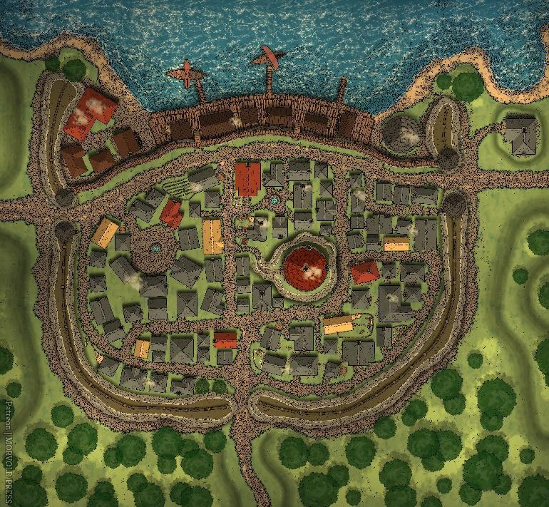

--DESCRIPTION--------------------------------------------------

The third-closest location to the OAR capital and second closest town, Carran is nestled comfortable between mountain and forest, allowing them access to two large industries. As such, Carran has benefited from surpluses in resources and live as such.

The houses are finely built, but the port less-so established. This is a clear indication that they remain largely independent, though they take advantage of their taking part in the OAR

Vyncent Withers is a nobleman by birth. His grandfather, Old man Withers in Flurham, has become sick recently and is causing Vyncent great stress.

--SHOPS & PEOPLE--------------------------------------------------

|  |  |  |  |  |
| --- | --- | --- | --- | --- |
| ***Representative*** | ***Euan Chan, 100*** |  | *Dwarf* | *Cautious* |
| ***Lord*** | ***Vyncent Tamrei, 28*** |  | *Human* | *Wise* |
| *Nobleman* | *Cyne Griffin, 38* |  | *Human* | *Ponderous* |
| *Sailor* | *Annemarie Waldsen, 43* | *Dundalk* | *Human* | *Ponderous* |
| *Sailor* | *Cliell Kranc, 26* | *The Vixen* | *Human* | *Rude* |
| *Guild Member* | *Leo Bevan, 40* |  | *Human* | *Friendly* |
| *Smith* | *Jeramy Adlam, 110* | ***[Owner's Name] Hilts*** | *Human* | *Friendly* |
| *Smith* | *Matt Deighton, 37* | ***[Owner's Name] Shields*** | *Gnome* | *Friendly* |
| *Shopkeeper* | *Bartholomeu Spycey, 45* | *The Angry Power* | *Dwarf* | *Shrewd* |
| *Shopkeeper* | *Dodry Cornwallis, 95* | *The Barking Arms* | *Human* | *Rude* |
| *Innkeeper* | *Miguel Divinitus Morhellium, 37* | *The Heavy Oak* | *Gnome* | *Kind* |
| *Citizen* | *Denvie Wodzki, 37* |  | *Human* | *Honest* |
| *Citizen* | *Eldo Rome, 28* |  | *Human* | *Ponderous* |
| *Citizen* | *Guillermo Breiner, 40* |  | *Human* | *Quiet* |
| *Citizen* | *Kara Wintagu, 32* |  | *Human* | *Ponderous* |
| *Citizen* | *Nessa Klimek, 44* |  | *Human* | *Friendly* |
| *Herald* | *Adakell Airvins, 33* |  | *Human* | *Annoyed* |

--ECONOMY--------------------------------------------------------

--SPECIAL FEATURES--------------------------------------------------

**MUSICIANS GUILD**

**IRON TEMPLE**

**CHURCH**

**WAYSTONE**

**THE SPIRIT HUT**

--HISTORY----------------------------------------------------------

--SHOPS--------------------------------------------------------------

--INNS---------------------------------------------------------------

### Town- Cindergulch – Jungle’s Border

<Image>

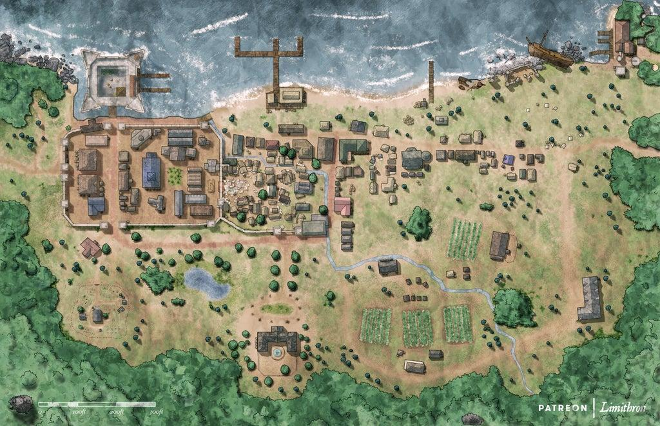

--DESCRIPTION--------------------------------------------------

Surrounded by the Hunt Grounds Forest of Baryon, Cindergulch is rich in forestry that they aren't permitted to harvest. Thankfully, they also sit in a large bay that's home to huge schools of fish and the occasional Wand'rin Trader. As such, the town is able to

Ethew comes from a relatively modest upbringing. He was elected into the lords seat because of his ideas for resurging the economy of the town, and kept his seat for following through. He's recently been courting Charsea and is hoping to marry her.

--SHOPS & PEOPLE--------------------------------------------------

|  |  |  |  |  |
| --- | --- | --- | --- | --- |
| *Representative* | *Pat Roth, 37* |  | *Human* | *Intelligent* |
| *Lord* | ***Ethew Ahren, 74*** |  | *Half-Elf* | *Helpful* |
| *Priest/ess* | *Wilbur Patton, 47* |  | *Human* | *Honest* |
| *SC, Sea Master* | *Xantinu Meliamne, 49* |  | *Human* | *Wise* |
| *Nobility* | *Germaine Pastiau, 35* |  | *Human* | *Friendly* |
| *Nobility* | *Von Utkin, 22* |  | *Human* | *Quiet* |
| *Sailor* | *Deth Dreeddi, 47* | *Felicidade* | *Half-Elf* | *Kind* |
| *Sailor* | *Land Wegeott, 38* | *Yeovil* | *Human* | *Ponderous* |
| *Guild Member* | *Dino Mcanox, 37* |  | *Human* | *Curious* |
| *SC, Tide Surge* | *Cleveland Kranz, 69* |  | *Half-Elf* | *Blustering* |
| *SC, Tide Surge* | *Demi Mcmanus, 96* |  | *Half-Elf* | *Curious* |
| *IT Officer* | *Hoover Dronsen, 34* |  | *Human* | *Rude* |
| *Smith* | *Jonathon Hagar, 23* | ***The Hammer and the Gauntlets*** | *Elf* | *Delightful* |
| *Shopkeeper* | *Heznam  Bigfelloe, 37* | *The Barking Rose* | *Dwarf* | *Tired* |
| *SC, Surf Breaker* | *Kah Ran, 83* |  | *Human* | *Quiet* |
| *SC, Surf Breaker* | *Letis Ilo, 28* |  | *Human* | *Wise* |
| *Innkeeper* | *Annabelle Aveyry, 56* | *The Melting Crocodile Bar* | *Elf* | *Wise* |
| *Farmer* | *Delbert Serafin, 29* |  | *Human* | *Cautious* |
| *Farmer* | *Lavon Piontek, 49* |  | *Half-Orc* | *Friendly* |
| *Servant* | *Flora Dery, 25* |  | *Half-Orc* | *Friendly* |

--ECONOMY--------------------------------------------------------

--SPECIAL FEATURES--------------------------------------------------

**CHURCH**

**MEERA TRADING COMPANY**

**STORM CHASERS**

**CULT OF THE VOID**

**GROVE STRIDERS**

**HAUNTED SHIPWRECK**

--HISTORY----------------------------------------------------------

--SHOPS--------------------------------------------------------------

--INNS---------------------------------------------------------------

### Town- Drymoor – Cliffside Castle

<Image>

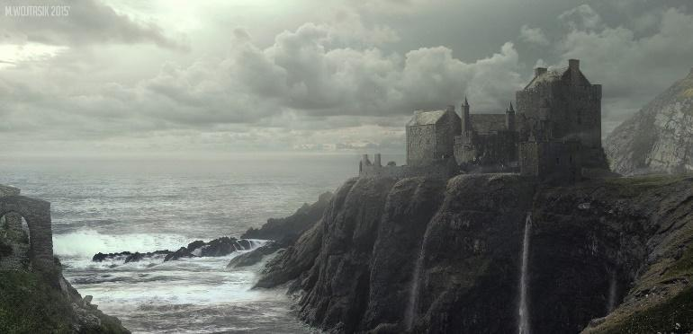

--DESCRIPTION--------------------------------------------------

Drymoor is a stronghold city with no port or water access. It rests in the cove of a large round cliff face rising above them on all sides.

The people of Drymoor are miners, soldiers and smiths. The hold is hugely invested in the resources of the earth, and is an iconic stop for travellers along the southern OAR pass.

Beth is a military woman who commands respect and tolerates no shenanigans. To her, the hold is a full-blown operation and she expects the best from everyone.

Decard counters Beth by listening to the citizens and assessing their needs, which boils down to either fun or a tavern.

--SHOPS & PEOPLE--------------------------------------------------

|  |  |  |  |  |
| --- | --- | --- | --- | --- |
| ***Representative*** | ***Jacinta Adamse, 22*** |  | *Half-Elf* | *Blustering* |
| ***Lord*** | ***Beth Amberdown, 95*** |  | *Half-Elf* | *Curious* |
| *Sailor* | *Felarlo Griffiths, 41* | *Truelove* | *Human* | *Honest* |
| *Sailor* | *Orel Buchanan, 41* | *Lobelia* | *Half-Orc* | *Grumpy* |
| *Guild Member* | *Vanie Lapointe, 49* |  | *Human* | *Friendly* |
| *Smith* | *Dorian Aveyry, 26* | ***[Owner's Name] Chains*** | *Elf* | *Helpful* |
| *Smith* | *Risa Divinitus Morhellium, 120* | ***[Owner's Name] Gauntlets*** | *Human* | *Friendly* |
| *Shopkeeper* | *Wilyn Thorburn, 44* | *The Barking Wheel* | *Elf* | *Honest* |
| *Shopkeeper* | *Gallagan Garza, 64* | *The Black Jester* | *Human* | *Shrewd* |
| *Shopkeeper* | *Figgorlim Dently, 80* | *The Black Weapons* | *Dwarf* | *Friendly* |
| *Hunter* | *Wyatt Ncent, 25* |  | *Human* | *Quiet* |
| *Innkeeper* | *Chuck Blossombard, 81* | *The Full Horses Tavern* | *Human* | *Friendly* |
| *Citizen* | *Ahma Dubiel, 33* |  | *Human* | *Curious* |
| *Citizen* | *Alvin Ahl, 47* |  | *Human* | *Intelligent* |
| *Citizen* | *Harley Horeen, 37* |  | *Human* | *Friendly* |
| *Citizen* | *Jedon Kovac, 29* |  | *Human* | *Friendly* |
| *Citizen* | *Mari Send, 31* |  | *Human* | *Friendly* |
| *Citizen* | *Nyree Hulierr, 42* |  | *Human* | *Argumentative* |
| *Citizen* | *Westley Dubicki, 35* |  | *Human* | *Rude* |
| *Farmer* | *Ebet Den, 34* |  | *Human* | *Delightful* |
| *Farmer* | *Lavar Janc, 31* |  | *Human* | *Blustering* |
| *Farmer* | *Trethoy Jokumsen, 37* |  | *Human* | *Argumentative* |

v

--ECONOMY--------------------------------------------------------

Mining, Tourism, Smiths

--SPECIAL FEATURES--------------------------------------------------

**CHURCH**

**IRONG TEMPLE**

**MEERA TRADING COMPANY**

**RUINS ON THE CLIFFSIDE**

--HISTORY----------------------------------------------------------

--SHOPS--------------------------------------------------------------

--INNS---------------------------------------------------------------

### Town- Far Water – Island of Riches

<Image>

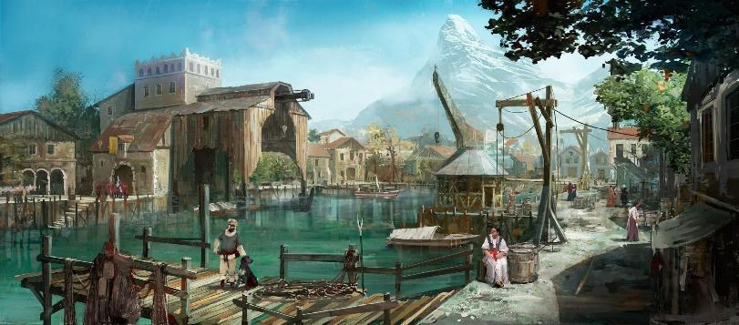

--DESCRIPTION--------------------------------------------------

Far water is the only town on Sea Island, and has made its home on the northern center of the island. While not far off the path of regular trade routes, Far Water enjoys their seclusion and peace of mind in town. They do, however, welcome travellers with open arms.

Urnath is the only Tiefling leader in the OAR. He gives the impression of a wise and fair leader, but many believe there is something haunting him. He stays home in his chambers for days at a time, and then works without stopping for the weeks to follow.

--SHOPS & PEOPLE--------------------------------------------------

|  |  |  |  |  |
| --- | --- | --- | --- | --- |
| ***Representative*** | ***Myle Duchamps, 45*** |  | *Human* | *Friendly* |
| ***Lord*** | ***Urnath Greek, 100*** |  | *Dragonborn* | *Friendly* |
| *Sailor* | *Anie Leot, 26* | *The Granicus* | *Halfling* | *Friendly* |
| *Sailor* | *John Adaw, 49* | *Palma* | *Dwarf* | *Friendly* |
| *Guild Member* | *Wilf Rome, 26* |  | *Human* | *Friendly* |
| *Smith* | *Obdulia Blossombard, 99* | ***[Owner's Name] Arsenals*** | *Gnome* | *Curious* |
| *Smith* | *Tracey Reurdy, 24* | ***[Owner's Name] Arsenals*** | *Human* | *Kind* |
| *Smith* | *Erick Duffy, 23* | ***The Hammer and the Braces*** | *Human* | *Intelligent* |
| *Shopkeeper* | *Thork Fizzlebottom, 74* | *The Bloody Bow* | *Warforged Fighter* | *Friendly* |
| *Hunter* | *Kenn Mcronto, 43* |  | *Human* | *Rude* |
| *Hunter* | *Rhermar Aleksandrov, 30* |  | *Human* | *Jovial* |
| *Innkeeper* | *Valentin Atwig, 66* | *The Natural Baker* | *Elf* | *Friendly* |
| *Citizen* | *Bella Machber, 37* |  | *Human* | *Friendly* |
| *Citizen* | *Flint Casey, 38* |  | *Human* | *Blustering* |
| *Citizen* | *Gordon Mcfarland, 24* |  | *Dwarf* | *Friendly* |
| *Citizen* | *Jambell Laguece, 46* |  | *Human* | *Intelligent* |
| *Citizen* | *Leah Ahlers, 39* |  | *Human* | *Friendly* |
| *Citizen* | *Shanika Gibson, 19* |  | *Human* | *Intelligent* |
| *Citizen* | *Stoney Danielsen, 48* |  | *Human* | *Jovial* |
| *Farmer* | *Sharlene Viaster, 42* |  | *Human* | *Curious* |

--ECONOMY--------------------------------------------------------

--SPECIAL FEATURES--------------------------------------------------

**WAYSTONE**

**CHURCH**

**ELYSIAN PROTECTORATE**

**GHOST CLOAKS**

**DRUIDIC THIEVES GUILD**

**UNCHARTED MOUNTAIN**

- Under watch and examination by the elysian protectorate

--HISTORY----------------------------------------------------------

--SHOPS--------------------------------------------------------------

--INNS---------------------------------------------------------------

<Image>

--DESCRIPTION--------------------------------------------------

Aero Fischer, Human

He has curly, auburn hair with a long moustache.  He is generally helpful and kindly, but also modest. His disposition is compassionate, but he is honorable by nature. He is quite brave in the face of danger. he comes off as being quite driven. He can be perceived as normal when it comes to his morality. He has a great interest in herbalism.

--SHOPS & PEOPLE--------------------------------------------------

|  |  |  |  |  |
| --- | --- | --- | --- | --- |
| ***Representative*** | ***Ceterus Tiev, 23*** |  | *Human* | *Shrewd* |
| ***Representative*** | ***Paribus Chrupie, 25*** |  | *Human* | *Friendly* |
| ***Lord*** | ***Kimim Clayton, 26*** |  | *Lizardfolk* | *Curious* |
| *Port Master* | *Barren Clayton, 42* |  | *Human* | *Intelligent* |
| *Alchemist* | *Symart Burns, 31* | *The Curly Robe* | *Half-Elf* | *Ponderous* |
| *Portman* | *Phineas Dawnweaver, 32* |  | *Human* | *Jovial* |
| *Sailor* | *Brisid Plourde, 24* | *The Polyphemus* | *Human* | *Friendly* |
| *Sailor* | *Ivellin Marek, 94* | *Gluckstadt* | *Half-Orc* | *Friendly* |
| *Guild Member* | *Audhild Brobist, 38* |  | *Human* | *Intelligent* |
| *Guild Member* | *Bhar Shkmoli, 27* |  | *Human* | *Ponderous* |
| *IT Officer* | *Amira, 72* |  | *Human* | *Friendly* |
| *IT Officer* | *Theron Duncan, 44* |  | *Human* | *Annoyed* |
| *Smith* | *Clifton Atwig, 56* | ***[Owner's Name] Pommels*** | *Human* | *Wise* |
| *Smith* | *Mickey Deney, 108* | ***[Owner's Name] Steelworks*** | *Gnome* | *Tired* |
| *Shopkeeper* | *Ball Caskajaro, 94* | *The Bloody Medicaments* | *Dwarf* | *Delightful* |
| *Shopkeeper* | *Mal Daniels, 100* | *The Bloody Tonics* | *Human* | *Ponderous* |
| *Graveyard Operator* | *Vernon Kauder, 42* |  | *Human* | *Quiet* |
| *Innkeeper* | *Dalla Deney, 73* | *The Exclusive Chimpanzee Inn* | *Human* | *Blustering* |
| *Citizen* | *Aroll Unne, 30* |  | *Human* | *Gloomy* |
| *Citizen* | *Malil Dennel, 29* |  | *Human* | *Quiet* |
| *Farmer* | *Damien Fedorov, 41* |  | *Human* | *Gloomy* |
| *Bard* | *Donn Oucy, 24* |  | *Human* | *Arrogant* |

Lord Representatives, **Ceterus** and **Paribus**

They split the town from **East** and **west**, **rich**, and **poor**.

The West side holds the port and all the exporting business while the East has the farms and merchants.

Both are very busy from day top day and don't like interruptions from their schedule.

--ECONOMY--------------------------------------------------------

--SPECIAL FEATURES--------------------------------------------------

**CHURCH**

**MEERA TRADING COMPANY**

**MUSICIANS GUILD**

**UNIVERISTY BRANCH**

**SHADE BRINGERS**

**CULT OF THE VOID**

**ORDER OF THE DARK MOON**

**CIRCLE OF FAKE WAYSTONES**

--HISTORY----------------------------------------------------------

### Town- Mesaport – Port of Order

<Image>

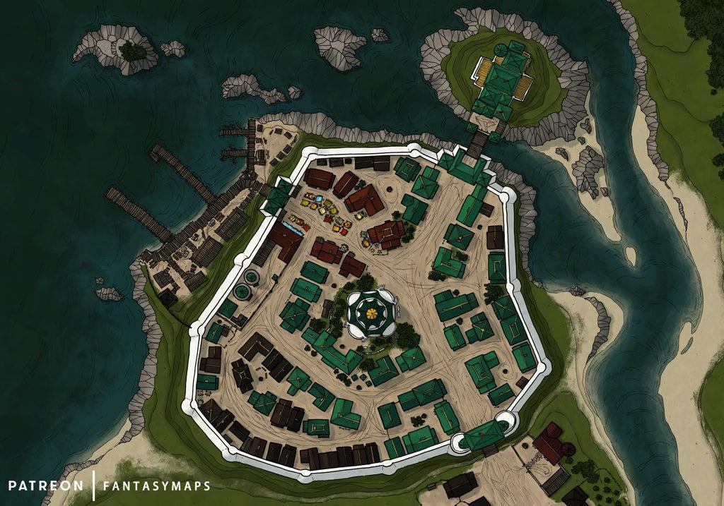

--DESCRIPTION--------------------------------------------------

Mesaport is a clean, small and wealthy town surrounded entirely by stone walls while sitting atop a large hill. In the center of town sits a temple entirely dedicated to Nereus and Torrent. To the North-East is Lord Durwin's Estate. It was built on a separate island, connected by a bridge.

Durwin is a nobleman and expects treatment as such. He does not take kindly to casual visitors, and will make them wait up to a week before seeing them.

The city gets its name from an underground capacit

--SHOPS & PEOPLE--------------------------------------------------

|  |  |  |  |  |
| --- | --- | --- | --- | --- |
| ***Representative*** | ***Jack Servaant, 28*** |  | *Human* | *Curious* |
| ***Lord*** | ***Durwin Bram, 87*** |  | *Elf* | *Intelligent* |
| *Port Master* | *Cairy Bloodborn, 29* |  | *Human* | *Wise* |
| *Alchemist* | *Adam Denford, 39* | *The Red Slippers* | *Elf* | *Honest* |
| *Sailor* | *Fink Mattand, 45* | *Alert* | *Human* | *Grumpy* |
| *Sailor* | *Joanie Armando, 47* | *Undine* | *Human* | *Kind* |
| *Guild Member* | *Lori Faure, 31* |  | *Human* | *Gloomy* |
| *Smith* | *Ester Eshleman, 109* | ***[Owner's Name] Shields*** | *Human* | *Friendly* |
| *Smith* | *Katelin Burns, 88* | ***The People's Furnaces*** | *Human* | *Arrogant* |
| *Shopkeeper* | *Shari Elyn, 31* | *The Broken Mystics* | *Human* | *Annoyed* |
| *Shopkeeper* | *Eldurn Noblemansword, 108* | *The Broken Wonders* | *Human* | *Friendly* |
| *Innkeeper* | *Jordon Elyn, 98* | *The Delirious Clams Inn* | *Human* | *Friendly* |
| *Citizen* | *Remicky Mciver, 26* |  | *Human* | *Cautious* |
| *Citizen* | *Rent Rick, 25* |  | *Human* | *Blustering* |
| *Citizen* | *Tarfing Schert, 27* |  | *Human* | *Jovial* |
| *Servant* | *Vani Reid, 26* |  | *Halfling* | *Friendly* |

--ECONOMY--------------------------------------------------------

--SPECIAL FEATURES--------------------------------------------------

**CHURCH**

**IRON TEMPLE**

--HISTORY----------------------------------------------------------

--SHOPS--------------------------------------------------------------

--INNS---------------------------------------------------------------

### Town- Nightshale – Orc Port

<Image>

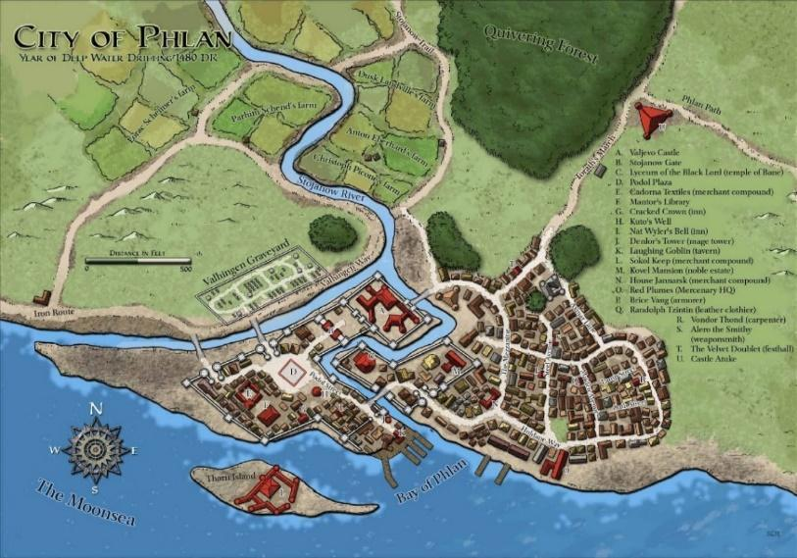

----DESCRIPTION------------------------

Nightshale is as close as one would come to Smuggler's Port without leaving the republics law and order. The city appears desolate on first glance- possibly squalid and poor. At night though, the town comes alive. Pubs open, trade leaves and is allowed in, and the people of the town head to work.

Lord Lytton has convinced the town that activity by night is far more efficient. He's secretly a vampire, and Minerva pretends to follow him while secretly looking to undermine his power.

----HISTORY----------------------------------------------------------

--SHOPS & PEOPLE----------------------------------------------------

|  |  |  |  |  |
| --- | --- | --- | --- | --- |
| ***Representative*** | ***Breeanna Raevand, 50*** |  | *Human* | *Shrewd* |
| ***Lord*** | ***Lytton Bonsaw, 58*** |  | *Orc* | *Gloomy* |
| *Sailor* | *Curtis Holgersen, 34* | *The Northolt* | *Human* | *Intelligent* |
| *Sailor* | *Harvey Losense, 25* | *Nankin* | *Human* | *Grumpy* |
| *Guild Member* | *Don Lamar, 29* |  | *Human* | *Blustering* |
| *Tanner* | *Freda Noblemansword, 32* |  | *Elf* | *Delightful* |
| *Smith* | *Moises Bloodlust, 47* | ***Hot Pokers and Anvils*** | *Elf* | *Wise* |
| *Shopkeeper* | *Shaquita Dorgin, 65* | *The Cozy Braces* | *Elf* | *Gloomy* |
| *Innkeeper* | *Emerson Deney, 109* | *The Ugliest Doves Tavern* | *Human* | *Quiet* |
| *Citizen* | *Derdoug Ajewski, 33* |  | *Human* | *Blustering* |
| *Citizen* | *Jodia Calbe, 43* |  | *Human* | *Honest* |
| *Citizen* | *Leregob Albeaum, 44* |  | *Half-Elf* | *Friendly* |
| *Citizen* | *Orto Esen, 25* |  | *Human* | *Friendly* |
| *Citizen* | *Rumbere Rtensen, 23* |  | *Human* | *Ponderous* |
| *Farmer* | *Chrina Bosch, 25* |  | *Human* | *Helpful* |
| *Servant* | *Rogen Uchet, 23* |  | *Human* | *Honest* |

----ECONOMY--------------------------------------------------------

----SPECIAL FEATURES--------------------------------------------------

**WAYSTONE**

**CHURCH**

**MEERA TRADING COMPANY**

**CULT OF THE VOID**

**ORDER OF THE DARK MOON**

**GROVE STRIDERS**

**DRUIDIC THIEVES GUILD**

**ABANDONDED CASTLE (WEST)**

----SHOPS-------------------------------------

----INNS----------------------------------------------------------------

### CITY - Pikecliff – City of Millitary Might

<Image>

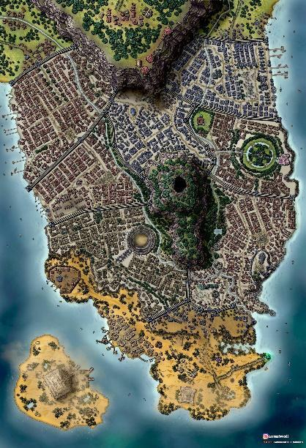

--DESCRIPTION--------------------------------------------------

Pikecliff is **not** open to the public. Because it's in close proximity to the capital, it acts as their primary military base. It's situated on the end of a small peninsula.

Pikecliff acts as a training ground for both naval and land-based soldiers. They would do combat training, tactical planning and

The IT Officer / Guard Leader, Gruff, lives in the hold with his daughter Charlotte and the obligatory representative, Grue.

--SHOPS & PEOPLE--------------------------------------------------

|  |  |  |  |  |
| --- | --- | --- | --- | --- |
| ***Representative*** | ***Rufus Welyn, 27*** |  | *Human* | *Grumpy* |
| ***Lordess*** | *Charolette Olathana, 22* |  | *Human* | *Friendly* |
| ***Lord*** | ***Dursley Grendal, 65*** |  | *Human* | *Jovial* |
| *Guild Member* | *Keara Bukowski, 24* |  | *Half-Orc* | *Ponderous* |
| *Smith* | *Jody Fernn, 110* | ***[Owner's Name] Hilts*** | *Elf* | *Delightful* |
| *Shopkeeper* | *Merissa Amberswift, 120* | *The Creaking Elixers* | *Human* | *Jovial* |
| *Innkeeper* | *Ahinar Gelnne, 70* | *The Flashy Hyena Tavern* | *Human* | *Arrogant* |
| *Citizen* | *Adelin Teague, 33* |  | *Human* | *Intelligent* |
| *Citizen* | *Canda A Olt, 40* |  | *Human* | *Arrogant* |
| *Citizen* | *Derlis Parry, 17* |  | *Human* | *Friendly* |
| *Citizen* | *Marg Esch, 65* |  | *Human* | *Ponderous* |
| *Farmer* | *Gaylord Vendsen, 43* |  | *Human* | *Argumentative* |
| *Traveller* | *Mien Crum, 19* |  | *Half-Orc* | *Friendly* |
| *Servant* | *Darde Holey, 44* |  | *Half-Orc* | *Friendly* |

--ECONOMY--------------------------------------------------------

--SPECIAL FEATURES--------------------------------------------------

**CHURCH**

**IRON TEMPLE**

**GUILD OF HAMMER**

**GROVE STRIDERS**

**THE HOLE IN THE HILL – HUGE MINE**

--HISTORY----------------------------------------------------------

--SHOPS--------------------------------------------------------------

--INNS---------------------------------------------------------------

### Town- Pikeville – Military Family Home

<Image>

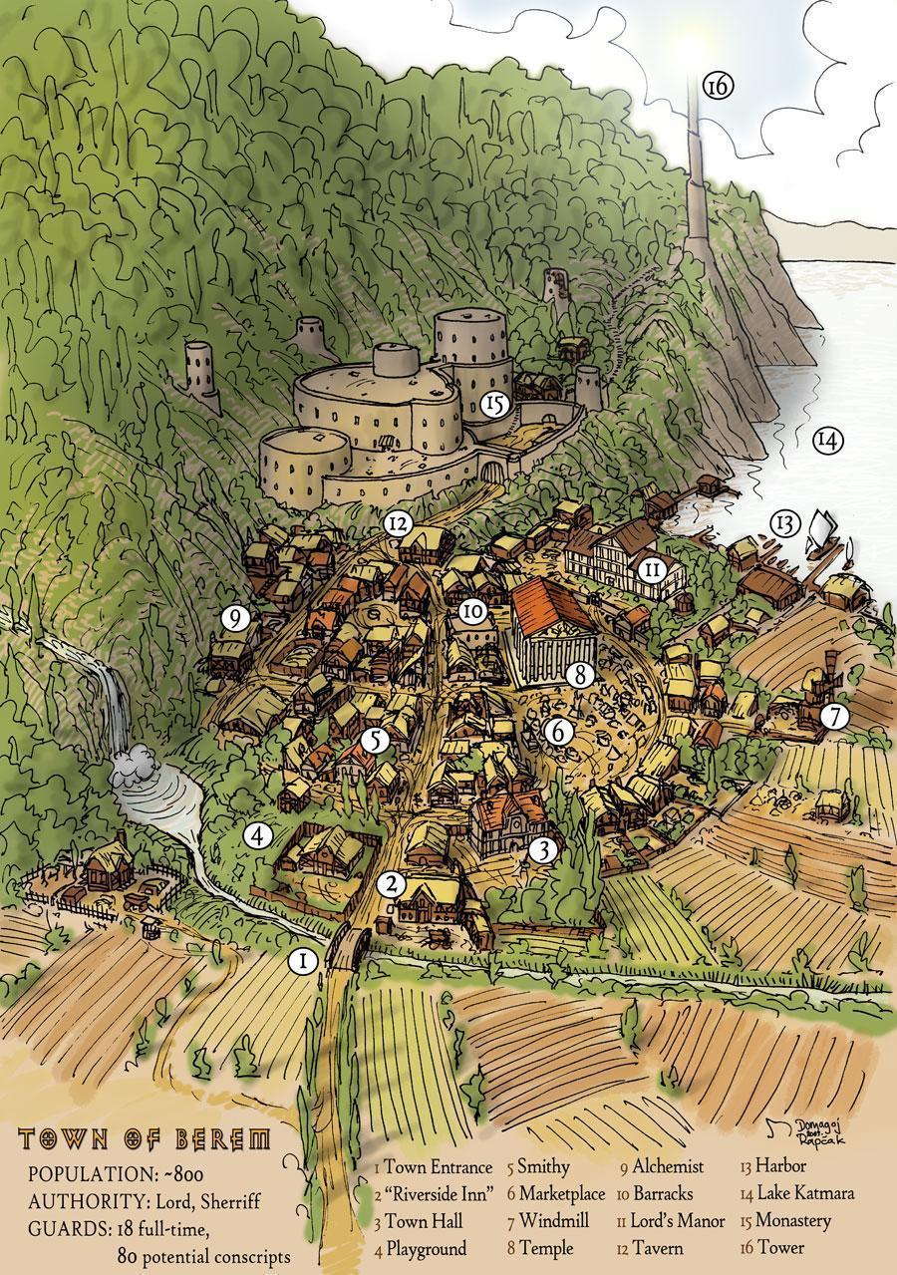

--DESCRIPTION--------------------------------------------------

Pikeville is established at the bottom of a rocky grove, right under the wash of a majestic waterfall. Due to the close proximity to the military compound of Pikecliff, the OAR decided they wanted to keep these citizens happy to avoid any power shifts. Because of this, heavy investment went into this town, creating a complex and luxurious lifestyle.

Above this rocky atoll is the sprawling forest of HellCrawl, and the mountain lairs of RageHollow.

--SHOPS & PEOPLE--------------------------------------------------

|  |  |  |  |  |
| --- | --- | --- | --- | --- |
| ***Representative*** | ***Yoel Horn, 27*** |  | *Human* | *Friendly* |
| ***Lord*** | ***Wetherby Flatwater, 97*** |  | *Orc* | *Kind* |
| *Sailor* | *Bertram Zdunvin, 48* | *The Woolston* | *Dwarf* | *Tired* |
| *Sailor* | *Fabian Clemensen, 17* | *The Earl of Chatham* | *Human* | *Quiet* |
| *Guild Member* | *Dani Adam, 50* |  | *Dwarf* | *Friendly* |
| *Smith* | *Wallace Grim, 102* | ***[Owner's Name] Arms*** | *Halfling* | *Honest* |
| *Shopkeeper* | *Sung Dawnweaver, 95* | *The Creaking Forges* | *Gnome* | *Friendly* |
| *Innkeeper* | *Bernard Tamrei, 39* | *The Fuzzy Pistachio Tavern* | *Human - Gold Dradon* | *Quiet* |
| *Citizen* | *Beredde Dennel, 22* |  | *Half-Orc* | *Friendly* |
| *Citizen* | *Jesse His, 21* |  | *Half-Orc* | *Ponderous* |
| *Citizen* | *Moises Prithar, 35* |  | *Dwarf* | *Kind* |
| *Citizen* | *Vani Hart, 27* |  | *Human* | *Friendly* |
| *Citizen* | *Vanie Ointe, 33* |  | *Human* | *Quiet* |
| *Farmer* | *Sand Vinogradov, 43* |  | *Half-Elf* | *Kind* |
| *Herald* | *Auge Iver, 29* |  | *Human* | *Friendly* |
| *Servant* | *Beri Iner, 23* |  | *Human* | *Ponderous* |

--ECONOMY--------------------------------------------------------

--SPECIAL FEATURES--------------------------------------------------

**WAYSTONE**

**CHURCH**

**IRON TEMPLE**

**MEERA TRADING COMPANY**

**RELIC ALLIANCE**

**MUSICIANS GUILD**

**UNIVERSITY BRANCH**

**THE CRYPT IN THE KEEP**

--HISTORY----------------------------------------------------------

--SHOPS--------------------------------------------------------------

--INNS---------------------------------------------------------------

### Town- Pirates Sanctum – Feared and Unknown

<Image>

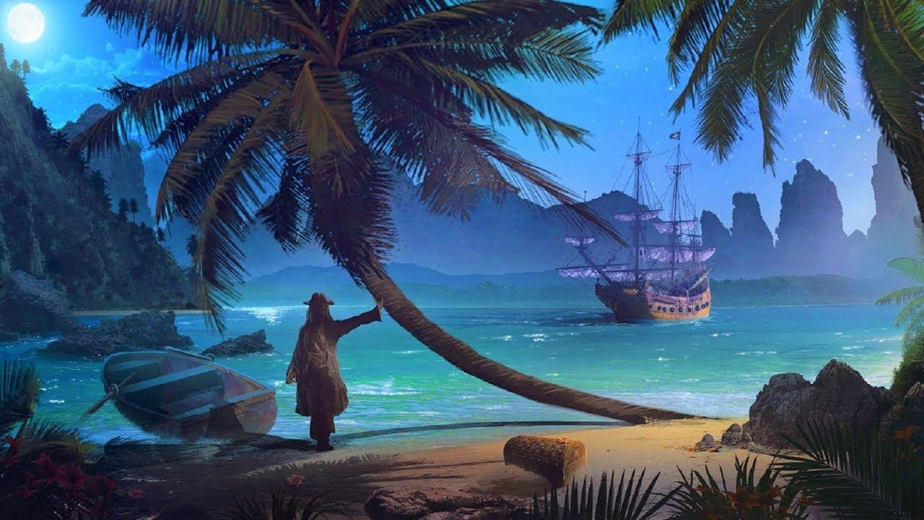

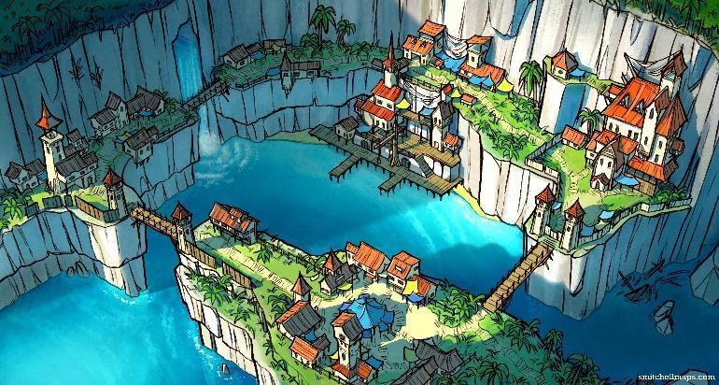

--DESCRIPTION--------------------------------------------------

--SHOPS & PEOPLE--------------------------------------------------

***The current Pirate ship/crew I have in the works that could work for you is Captain Mercer Mace (Age 60) of the Leadhand Legion, a pirate group dedicated to finding a long-lost treasure of the famous captain Leadhand from many generations past. His crew consists of a fleet of 5 ships, but the only one you knew (you knew about the existence of the others, but information was scarecely handed out) was the Golden Rose, a prestigious longship that made most other ships avoid you as much as they possibly could***

|  |  |  |  |  |
| --- | --- | --- | --- | --- |
| ***Lord*** | ***Jalen Ashley, 101*** |  | *Elf* | *Annoyed* |
| *Priest/ess* | *Kerl Ansen, 48* |  | *Half-Elf* | *Quiet* |
| *SC, Sea Master* | *Ald Rome, 36* |  | *Dwarf* | *Friendly* |
| *Nobility* | *Jayley Mcrobbie, 38* |  | *Human* | *Friendly* |
| *GOSPEL Member* | *Mon John, 95* |  | *Human* | *Friendly* |
| *Alchemist* | *Sabeth Dently, 98* | *Augury and Alchemy* | *Elf* | *Ponderous* |
| *Sailor* | *Roscobi Simon, 20* | *Excalibur* | *Human* | *Arrogant* |
| *Sailor* | *Torey Konstantinov, 50* | *Beacon Hill* | *Human* | *Friendly* |
| *Guard* | *Arenda Illani, 27* |  | *Human* | *Gloomy* |
| *Guard* | *Synn Raek, 30* |  | *Human* | *Honest* |
| *Guard* | *Wani Gunt, 25* |  | *Human* | *Friendly* |
| *Guild Member* | *Deric Bern, 46* |  | *Dwarf* | *Wise* |
| *Guild Member* | *Gelet Lumagne, 31* |  | *Human* | *Friendly* |
| *Guild Member* | *Inela Duncan, 27* |  | *Half-Orc* | *Honest* |
| *SC, Tide Surge* | *Alee Amne, 27* |  | *Human* | *Ponderous* |
| *SC, Tide Surge* | *Jay Grigor, 37* |  | *Elf* | *Arrogant* |
| *Smith* | *Darryl Byron, 63* | ***[Owner's Name] Weapons*** | *Human* | *Ponderous* |
| *Shopkeeper* | *Shauna Cote, 38* | *The Creaking Fox* | *Human* | *Friendly* |
| *SC, Surf Breaker* | *Gavin Rusi, 65* |  | *Half-Orc* | *Grumpy* |
| *SC, Surf Breaker* | *Ulor O'Hagan, 83* |  | *Human* | *Wise* |
| *Innkeeper* | *Dundunt Ahren, 66* | *The Beacon* | *Dragonborn* | *Friendly* |

|  |  |  |  |  |
| --- | --- | --- | --- | --- |
| ***PIRATES***  *Pirate* | *Conbjorn, 89* |  | *Half-Elf* | *Grumpy* |
| *Pirate* | *Coryath H Mcfer, 17* |  | *Human* | *Shrewd* |
| *Pirate* | *Daniele Driksen, 29* |  | *Human* | *Helpful* |
| *Pirate* | *Dorian Kyles, 36* |  | *Half-Elf* | *Gloomy* |
| *Pirate* | *Elodius, 68* |  | *Human* | *Honest* |
| *Pirate* | *Hinum, 93* |  | *Halfling* | *Friendly* |
| *Pirate* | *Lenka, 105* |  | *Warforged* | *Tired* |
| *Pirate* | *Liliana, 95* |  | *Gnome* | *Shrewd* |
| *Pirate* | *Marcella, 67* |  | *Human* | *Wise* |
| *Pirate* | *Marlon, 54* |  | *Elf, Wood* | *Annoyed* |
| *Pirate* | *Merry Evald, 21* |  | *Human* | *Ponderous* |
| *Pirate* | *Ricki, 63* |  | *Human* | *Ponderous* |

--ECONOMY--------------------------------------------------------

--SPECIAL FEATURES--------------------------------------------------

**CHURCH**

**GOSPEL**

**MUSICIANS GUILD**

**GHOST CLOAKS**

**STORM CHASERS**

**UNCHARTED ISLANDS**

--HISTORY----------------------------------------------------------

--SHOPS--------------------------------------------------------------

--INNS---------------------------------------------------------------

### Hold- Port Mid – Northern Navy Outpost

<Image>

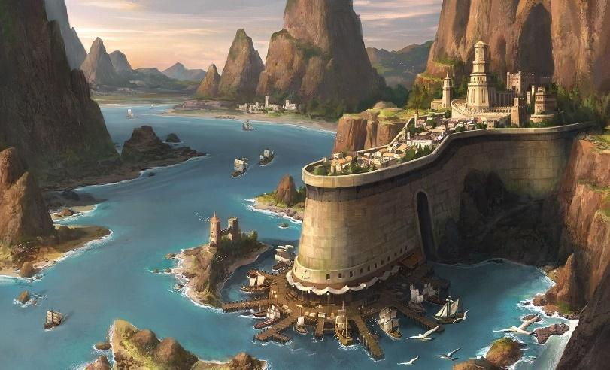

--DESCRIPTION--------------------------------------------------

Port Mid is an established historical monument that has been refitted to act as home to part of the OAR navy.

--SHOPS & PEOPLE--------------------------------------------------

|  |  |  |  |  |
| --- | --- | --- | --- | --- |
| ***Representative*** | ***Patrinn Myastan, 48*** |  | *Dragonborn* | *Helpful* |
| *General, OAR* | *Carroll Aefina, 80* |  | *Human* | *Wise* |
| *Priest/ess* | *Brandon Consor, 113* |  | *Gnome* | *Honest* |
| *Priest/ess* | *Elvenor Borchardt, 23* |  | *Elf Druid 48M* | *Friendly* |
| *Aventurer* | *Kara Walon, 92* | *Guild of Hammer Council, OAR* | *Dwarf* | *Friendly* |
| *Guard Trainer* | *Leta Grensen, 66* |  | *Human* | *Kind* |
| *Alchemist* | *Breana Cambridge, 65* | *Pharmagician* | *Human* | *Friendly* |
| *Guild Member* | *Drizzle Amberdown, 82* |  | *Human* | *Friendly* |
| *Guild Member* | *Lydita Adern, 38* |  | *Human* | *Friendly* |
| *IT Officer* | *Dwile Merob, 44* |  | *Human* | *Friendly* |
| *Smith* | *Omelorg Massen, 47* | ***[Owner's Name] Chains*** | *Human* | *Wise* |
| *Smith* | *Handomm Jansen, 21* | ***Hot Pokers and Weapons*** | *Human* | *Gloomy* |
| *Shopkeeper* | *Hector Macdo, 21* | *The Creaking Grindstones* | *Half-Orc* | *Friendly* |
| *Shopkeeper* | *Lavon Nthal, 30* | *The Crossed Dragon* | *Human* | *Friendly* |
| *Innkeeper* | *Dell Llum, 24* | *The Dragonclaw* | *Human* | *Blustering* |
| *Bard* | *Dani Adam, 20* |  | *Half-Orc* | *Friendly* |

--ECONOMY--------------------------------------------------------

Fdsfd

--SPECIAL FEATURES--------------------------------------------------

**CHURCH**

**IRON TEMPLE**

**MEERA TRADING COMPANY**

**GUILD OF HAMMER**

**MUSICIANS GUILD**

**CULT OF THE VOID**

**ORDER OF THE DARK MOON**

**OAR MOUNTAIN VAULT**

--HISTORY----------------------------------------------------------

fdsdf

--SHOPS--------------------------------------------------------------

dfs

--INNS---------------------------------------------------------------

### CITY - Port Passer – City of New Hope, Travel

<Image>

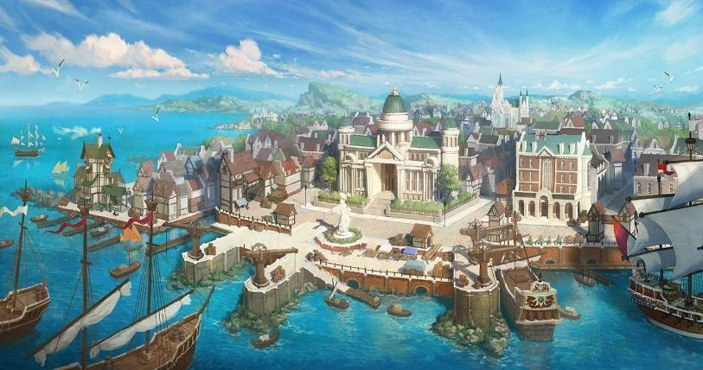

--DESCRIPTION--------------------------------------------------

Port Passer is a wealthy port town with bountiful trade coming in and out daily. At the moment, the town is peaceful and without conflict.

Port Passer’s most notable feature was the design of its impressive buildings and intricately decorated homes. The city was teeming with grand castles, temples, brownstone tallhouses, marketplaces, emporia, and beautiful mansions.

All were surrounded by parks, topiaries, statuary, decorative pools, and a wide variety of complex fountains. The city's crown jewel was the

The city had several scattered districts, some of which were quite unremarkable.

**Warehouse District**. It was located in the south-east,[25] located to the south-west from:

**The Dock District**. Seaside area of town. Very bright and clean, made for looks and leisurely activities including city festivals. Also home to the largest inn of the City.

**The Foreign District** was dominated by warehouses and taverns frequented by merchants and adventurers.

The roads are was well patrolled by the Sentinels and Iron temple Legates.

--SHOPS & PEOPLE--------------------------------------------------

|  |  |  |  |  |
| --- | --- | --- | --- | --- |
| *Sea Lord* | *Marshall Reefmaster, 42* | ***Shattered Isle Reef*** | *Tiefling* | *Jovial* |
| ***Representative*** | ***Eve Son, 27*** |  | *Human* | *Wise* |
| ***Lord*** | ***Treyari Adlam, 53*** |  | *Elf* | *Blustering* |
| *Priest/ess* | *Crielif Bowski, 20* |  | *Human* | *Friendly* |
| *GOSPEL Member* | *Aine Dams, 102* |  | *Human* | *Kind* |
| *Alchemist* | *Finnan O'Reilly, 23* | *The Last Spell* | *Human* | *Jovial* |
| *Elder* | *Nara Hart, 44* |  | *Human* | *Wise* |
| *Sailor* | *Merritt Macfarland, 25* | *The Deane* | *Human* | *Friendly* |
| *Sailor* | *Telly Martin, 38* | *The Cadmus* | *Human* | *Argumentative* |
| *Guild Member* | *Christopher Blauffi, 24* |  | *Human* | *Rude* |
| *IT Officer* | *Ornard Herg, 39* |  | *Dwarf* | *Argumentative* |
| *Smith* | *Geva Clinton, 74* | ***[Owner's Name] Hilts*** | *Human* | *Shrewd* |
| *Shopkeeper* | *Marcella Andersen, 102* | *The Crossed Enchantments* | *Human* | *Rude* |
| *Innkeeper* | *Ingrid Greek, 92* | *The Garden* | *Human* | *Gloomy* |
| *Citizen* | *Darkurr Ukowski, 23* |  | *Half-Elf* | *Friendly* |
| *Citizen* | *Jackel Atenna, 28* |  | *Half-Orc* | *Friendly* |
| *Citizen* | *Kend Neau, 47* |  | *Half-Orc* | *Tired* |
| *Farmer* | *Marl Nzen, 33* |  | *Half-Elf* | *Friendly* |
| *Servant* | *Grant Macconnell, 35* |  | *Human* | *Curious* |

--ECONOMY--------------------------------------------------------

Travel and recreation, avdenture and mining

--SPECIAL FEATURES--------------------------------------------------

**WAYSTONE**

**CHURCH**

**GOSPEL**

**MEERA TRADING COMPANY**

**UNIVERISTY BRANCH**

**DRUIDIC THIEVES GUILD**

**SHIPYARD HIDEOUT**

--HISTORY----------------------------------------------------------

--SHOPS--------------------------------------------------------------

--INNS---------------------------------------------------------------

### Town- Port Sheerstone – City of Peace

<Image>

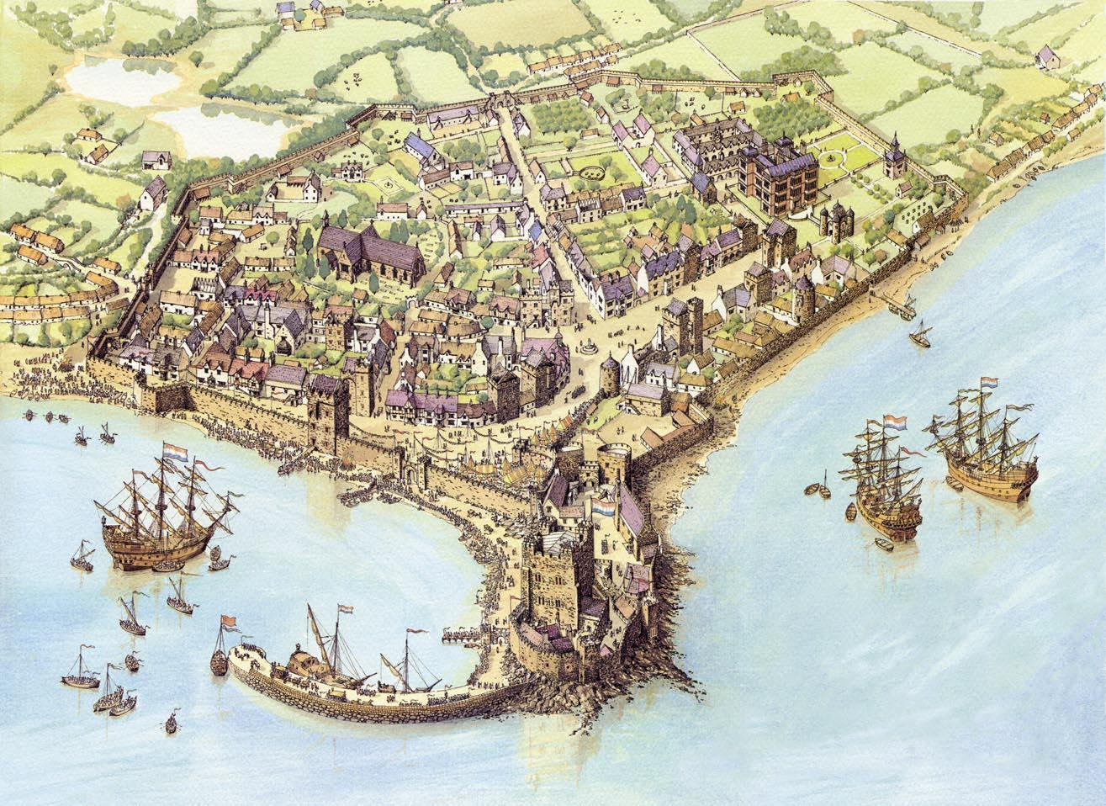

--DESCRIPTION--------------------------------------------------

Also known as the City of Skilled Hands and the Jewel of the North, was a bustling, cultured, and cosmopolitan city of Port Sheerstone.

A wealthy port town, with bountiful trade coming in and out daily. At the moment, the town is peaceful and without conflict.

--SHOPS & PEOPLE--------------------------------------------------

|  |  |  |  |  |
| --- | --- | --- | --- | --- |
| ***Representative*** | ***Marquis Pierre, 17*** |  | *Human* | *Blustering* |
| ***Lord*** | ***Jules Deighton, 27*** |  | *Elf* | *Kind* |
| *SC, Sea Master* | *Ashley Myers, 77* |  | *Human* | *Jovial* |
| *Nobility* | *Clark Ewoda, 33* |  | *Human* | *Friendly* |
| *Port Master* | *Yasmina Commonbrook, 59* |  | *Human* | *Gloomy* |
| *Sailor* | *Cathie Simon, 28* | *Dartmoor* | *Human* | *Grumpy* |
| *Sailor* | *Jeanette Weld, 24* | *Papua* | *Human* | *Honest* |
| *Guard* | *Beau Commonbrook, 76* |  | *Human* | *Grumpy* |
| *Guild Member* | *Chal Rnak, 46* |  | *Human* | *Friendly* |
| *Guild Member* | *Durt Johnston, 34* |  | *Human* | *Kind* |
| *SC, Tide Surge* | *Jacob Pounnea, 66* |  | *Human* | *Honest* |
| *SC, Tide Surge* | *Samantha Bottan, 62* |  | *Human* | *Shrewd* |
| *IT Officer* | *Entonno No Senb, 23* |  | *Human* | *Shrewd* |
| *Smith* | *Salley Bloodborn, 96* | ***[Owner's Name] Grindstones*** | *Human* | *Intelligent* |
| *Smith* | *Die Ult, 26* | ***The Hammer and the Hilts*** | *Human* | *Friendly* |
| *Shopkeeper* | *Sarah Bardye, 25* | *The Crossed Jester* | *Human* | *Curious* |
| *Shopkeeper* | *Errol Denford, 32* | *The Drunken Chains* | *Human* | *Arrogant* |
| *SC, Surf Breaker* | *Handd Mcgron, 94* |  | *Human* | *Shrewd* |
| *SC, Surf Breaker* | *Orick Horn, 90* |  | *Halfling* | *Annoyed* |
| *Innkeeper* | *Emilia Elkrana, 43* | *The Pyre* | *Human* | *Friendly* |
| *Citizen* | *Inei Sens, 25* |  | *Human* | *Ponderous* |
| *Citizen* | *Lonny Igsen, 32* |  | *Human* | *Arrogant* |
| *Citizen* | *Thueyer Zduchel, 41* |  | *Human* | *Shrewd* |
| *Farmer* | *Rhermar Sandrov, 30* |  | *Human* | *Friendly* |

--ECONOMY--------------------------------------------------------

--SPECIAL FEATURES--------------------------------------------------

**WAYSTONE**

**CHURCH**

**IRON TEMPLE**

**STORM CHASERS**

**CULT OF THE VOID**

**ORDER OF THE DARK MOON**

**THE WARF HOME OF PIERRES, A LEGENDARY FISHER**

--HISTORY----------------------------------------------------------

--SHOPS--------------------------------------------------------------

--INNS---------------------------------------------------------------

### CITY - Retria – Largest City in OAR

<Image>

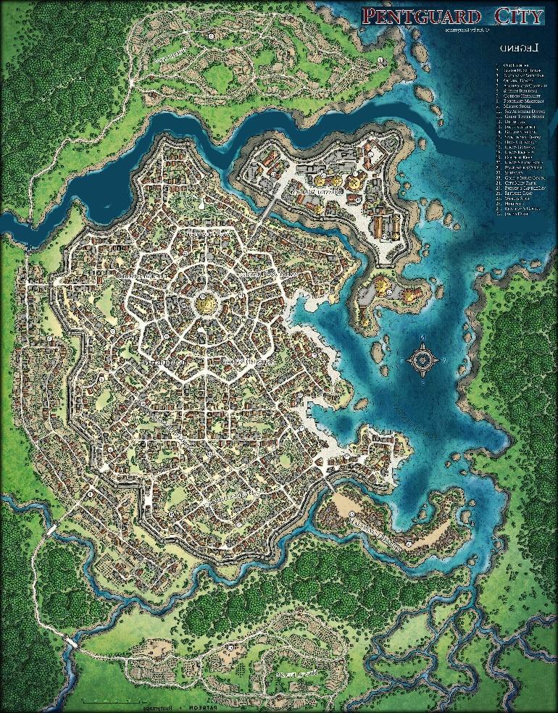

--DESCRIPTION--------------------------------------------------

A bustling city of retirees, military families and old heroes. The people of Retria live with abundant renown, and act like it. If you don't fit in, you'll be told so.

Retria is formally regarded as a city-state, although the area it directly controls is large and the area it indirectly influences is huge. The surrounding countryside out to around 50 miles in all directions is heavily patrolled by Retrian guards and militia and the city frequently employs mercenaries and adventurers to further secure its borders out three times as far.

Very large farmlands are required to feed the city and these farms in turn need protection from the hostile tribes (human and non-human) that can be found further north.

Retria’s influence is generally held to run out around 100 miles south of the city and the same distance to the North-West.

--SHOPS & PEOPLE--------------------------------------------------

|  |  |  |  |  |
| --- | --- | --- | --- | --- |
| ***Representative*** | ***Adwills Llau, 24*** |  | *Human* | *Kind* |
| ***Representative*** | ***Celanis Legolin, 302*** |  | *Elf* | *Wise, fair and just.* |
| ***Representative*** | ***Peri Tuul, 36*** |  | *Halfling* | *Annoyed* |
| ***Representative*** | ***Yorem Ulmathean, 249*** |  | *Dwarf* | *Annoyed* |
| ***Lord*** | ***Osval Poive, 31*** |  | *Human* | *Helpful* |
| *Priest/ess* | *Nikolas Dubiels, 66* |  | *Human* | *Wise* |
| *SC, Sea Master* | *Carley Bannerman, 31* |  | *Human* | *Kind* |
| *SC, Sea Master* | *Harkime Babineaux, 51* |  | *Human* | *Intelligent* |
| *Nobility* | *Cathryn Litten, 55* |  | *Dwarf* | *Tired* |
| *Nobility* | *Cardaro Macasse, 76* |  | *Human* | *Kind* |
| *Nobility* | ***Shaunna Humeken, 38*** |  | *Human* | *Ponderous* |
| *Sailor* | *Sarquis Verg, 28* | *The Bridgnorth Castle* | *Human* | *Kind* |
| *Sailor* | *Westeve Vaniaul, 28* | *Porlock Bay* | *Human* | *Blustering* |
| *Guild Member* | *Coll Jaciner, 32* |  | *Elf* | *Intelligent* |
| *SC, Tide Surge* | *Armand Salomon, 51* |  | *Elf* | *Intelligent* |
| *SC, Tide Surge* | *Audra Poin, 63* |  | *Human* | *Intelligent* |
| *SC, Tide Surge* | *Cheryl Macalla, 64* |  | *Human* | *Friendly* |
| *SC, Tide Surge* | *Del Guthrie, 37* |  | *Human* | *Friendly* |
| *SC, Tide Surge* | *Die Fains, 87* |  | *Human* | *Intelligent* |
| *SC, Tide Surge* | *Irlon Miksen, 60* |  | *Human* | *Arrogant* |
| *SC, Tide Surge* | *Jacquelyn Soku, 66* |  | *Human* | *Friendly* |
| *SC, Tide Surge* | *Jason Araullo, 75* |  | *Dwarf* | *Friendly* |
| *IT Officer* | *Raul Saner, 42* |  | *Human* | *Friendly* |
| *Smith* | *Ramon Unterbrink, 42* | ***[Owner's Name] Furnaces*** | *Half-Orc* | *Friendly* |
| *Smith* | *Donald Naumov, 29* | ***The Exalted Forges*** | *Half-Elf* | *Friendly* |
| *Smith* | *Lesley Byrne, 26* | ***The Hammer and the Braces*** | *Half-Orc* | *Jovial* |
| *Shopkeeper* | *Avery Pedrey, 37* | *The Drunken Lantern* | *Human* | *Blustering* |
| *SC, Surf Breaker* | *Christal Fel, 93* |  | *Human* | *Friendly* |
| *SC, Surf Breaker* | *Gunna Berg, 25* |  | *Human* | *Kind* |
| *SC, Surf Breaker* | *Landon Mclain, 25* |  | *Human* | *Arrogant* |
| *SC, Surf Breaker* | *Paimega Skene, 89* |  | *Human* | *Friendly* |
| *SC, Surf Breaker* | *Stent Fedeudv, 66* |  | *Human* | *Friendly* |
| *Innkeeper* | *Broll Pov, 23* | *The Emerald Willow* | *Human* | *Quiet* |
| *Innkeeper* | *Carylee Mceachern, 37* | *The Chocolate Table* | *Human* | *Friendly* |
| *Citizen* | *Anno Masper, 23* |  | *Halfling* | *Delightful* |
| *Citizen* | *Arlo Pontecorvo, 32* |  | *Human* | *Kind* |
| *Citizen* | *Bevanni Pasternack, 38* |  | *Human* | *Friendly* |
| *Citizen* | *Collin Sova, 35* |  | *Human* | *Friendly* |
| *Citizen* | *Edison Rice, 48* |  | *Dwarf* | *Gloomy* |
| *Citizen* | *Howard Del, 23* |  | *Half-Orc* | *Shrewd* |
| *Citizen* | *Jonas Duffy, 46* |  | *Dwarf* | *Shrewd* |

--ECONOMY--------------------------------------------------------

--SPECIAL FEATURES--------------------------------------------------

**CHURCH**

**IRON TEMPLE**

**MEERA TRADING COMPANY**

**STORM CHASERS**

**UNIVERSITY BRANCH**

**HUNTING GROUNDS**

**DOCKBUCKS DOMAINE**

--HISTORY----------------------------------------------------------

--SHOPS-------------------------------------

--INNS---------------------------------------------------------------

### CITY - Ruslet – City on the Road

**IF COME HERE THEN PREP THE DOCKBUCKS**

<Image>

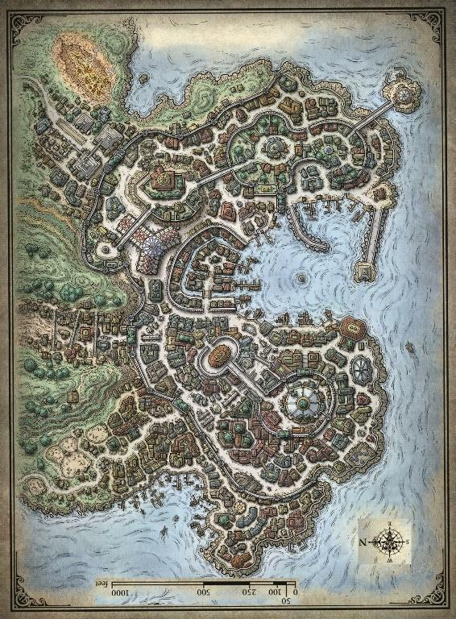

--DESCRIPTION--------------------------------------------------

**Ruslet** is a large city, though smaller than Retria. Their lands lie on an open penninsula cove, now closed and controlled by a man-made landline with a huge brick wall built atop it. The city is constructed around four large hills, each of which holds a different aspect of the city.

They sit nearby main routes of sea travel between capital and the navy ports. As such, the city sees large support of the republic.

The oceans by Ruslet are rich in fish populations and tend to be shallower farther out, garnering a safer feeling for the local population (sea monsters) when out at sea. The seas also sit on the end of the Cemetery of the Forgotten, a rough and treacherous stone reef that's known to sink ships. As such, tales of loot ripe for the taking are various and well-known. **Lord**

**Roland Berkeley, 108** Soon on the way out, this aging lord raised the town from it's village-like state nearly 90 years ago, and led it to what it is today. Roland sits on his deathbed, and the population regularly visits his estate to wish him well. His son, Tirus, is eager to lead the town soon after, so long as the election sees him as the best choice. He's not above hiring a group to ensure his victory in the coming years..

The populous is less than impressed with his vivilous spending and attitude, and believes a change is sorely needed.

--SHOPS & PEOPLE--------------------------------------------------

|  |  |  |  |  |
| --- | --- | --- | --- | --- |
| *Low Sentinel* | *Deborah Andry, 40* |  | *Human* | *Delightful* |
| ***Representative*** | ***Leonard D Evans, 22*** |  | *Human* | *Rude* |
| ***Lord*** | ***Roland Burkeley, 108*** |  | *Human* | *Quiet* |
| *Priest/ess* | *Kaley Alhock, 23* |  | *Human* | *Cautious* |
| *Nobility* | *Alindse Vorlsen, 32* |  | *Human* | *Gloomy* |
| *Nobility* | *Brooklyn Giese, 47* |  | *Human* | *Honest* |
| *Nobility* | *Elsenri Evans, 27* |  | *Human* | *Wise* |
| *Alchemist* | *Ogmund Daniels, 25* | *The Blushing Ghost* | *Elf* | *Friendly* |
| *Sailor* | *Alitteq Klimek, 17* | *Cruelle* | *Human* | *Friendly* |
| *Sailor* | *Cara Garnier, 27* | *Augustus* | *Human* | *Wise* |
| *Guild Member* | *Gilbert Adam, 27* |  | *Human* | *Curious* |
| *Smith* | *Stefan Scratchbox, 80* | ***[Owner's Name] Anvils*** | *Human* | *Kind* |
| *Smith* | *Gustafo Greysword, 64* | ***[Owner's Name] Chains*** | *Human* | *Grumpy* |
| *Smith* | *Jack  Turner, 52* | ***[Owner's Name] Gauntlets*** | *Human* | *Friendly* |
| *Shopkeeper* | *Thyri Noblemansword, 32* | *The Drunken Power* | *Human* | *Delightful* |
| *Shopkeeper* | *Randal  Caswell, 45* | *The Exalted Bear* | *Human* | *Friendly* |
| *Shopkeeper* | *Britni Amberswift, 68* | *The Exalted Fate* | *Human* | *Gloomy* |
| *Shopkeeper* | *Reti Grant, 83* | *The Frowning Alchemy* | *Half-Elf* | *Intelligent* |
| *Hunter* | *Evan Inov, 27* |  | *Human* | *Friendly* |
| *Innkeeper* | *Eacher Devaul, 88* | *The Cinnamon Brewery* | *Human* | *Kind* |
| *Innkeeper* | *Gavin Bonsaw, 65* | *The Palm Sisters* | *Human* | *Delightful* |
| *Innkeeper* | *Justan  Shaw, 72* | *The Japanese Wharf* | *Human* | *Annoyed* |
| *Citizen* | *Sharee E Rice, 41* |  | *Human* | *Jovial* |
| *Citizen* | *Trak Nlie, 94* |  | *Dwarf* | *Friendly* |
| *Citizen* | *Wally Gang, 30* |  | *Human* | *Shrewd* |
| *Farmer* | *Blane Mcconn, 34* |  | *Dwarf* | *Shrewd* |
| *Farmer* | *Malik Fremack, 20* |  | *Human* | *Friendly* |
| *Farmer* | *Mane Matek, 47* |  | *Human* | *Gloomy* |
| *Bard* | *Gradon Duchamps, 71* |  | *Human* | *Delightful* |
| *Traveller* | *Mace Albelyo, 38* |  | *Human* | *Grumpy* |
| *Servant* | *Andreas Ilippov, 42* |  | *Human* | *Arrogant* |
| *Servant* | *Jeanie Jann, 22* |  | *Human* | *Helpful* |
| *Hermit* | *Brock Donne, 46* |  | *Human* | *Argumentative* |

--ECONOMY--------------------------------------------------------

Port Trade, Public access

Fishing, Need a boat + Fisherman guide

Land Trade, Shops need couriers /guards

Farming, Away from town, they good

Lumber North of town, private trade.

--SPECIAL FEATURES--------------------------------------------------

**WAYSTONE**

**CHURCH**

**IRON TEMPLE**

**MUSICIAN’S GUILD**

**HIDDEN MESSAGES ON CITY WALLS**

**THE GREAT ASTRONOMY TOWER**

circular, with town wall. Used only by nobles, academics and dignitaries from the University.

**THE HOT PATCH**

a volcanically-active area north of the town that bubbles with lava. It's stayed this way for the last 50 years or so.

**LORD BERKELEY’S ESTATE – ON NORTH HILL**

**THE SIREN’S BELL**

A small island in the center of the port houses a gazebo. Inside it is the statue of a siren sitting on a bench, mid-song. Her history is lost and most just know of it's existence.

--HISTORY----------------------------------------------------------

More than 100 years ago, Ruslet wouldn't have showed up on the map. It was little more than a small fishing village on a sub-continent that most avoided.

In recent history, the Berkeley family took leadership of the town and made it known as a rest-stop on the popular OAR trade route running N/S. They built up the town strong and fast, attracting many to it's natural and marketed appeal. Now, it stands as a successful almost-city on a main trade route, with a well-loved lord.

--SHOPS--------------------------------------------------------------

--INNS---------------------------------------------------------------

--SMITHS-----------------------------------

**The Moran's Smithy**

Run by Stefan Moran, it's a smithy just near the Hot Path on the north side of town. He claims to use it as his forge, and makes fine weapons from it.

**The Brass Flame**

Run by Cecilia Brass, and set in the southern part of town, the Brass flame is a rougher, worker-friendly smith that fixes and makes tools for tradesman. You won't find any weapons or armor here.

--CURIOS-------------------------------------

**Gizbo's cemetery treasures**

Cannot purchase without renown, lots of gold, or a personal meeting.

The Chemist

### Town- Sheerstone Island – Vacation Getaway

<Image>

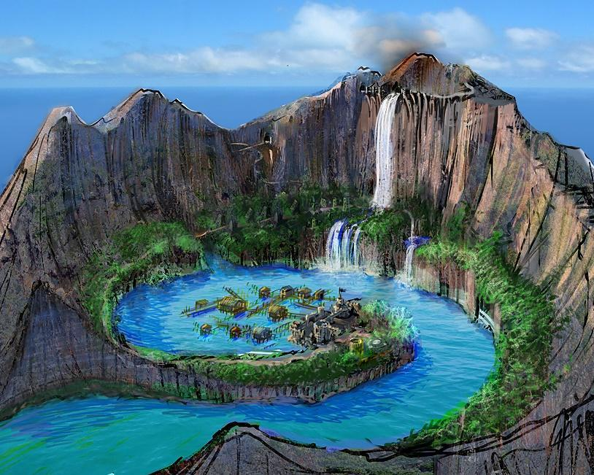

--DESCRIPTION--------------------------------------------------

**Sheerstone Island** is a hidden spiral cove with sharp mountain walls. The surrounding bay is patrolled frequently as many nobles and influential people are known to frequent the Island. It’s quiet and serene, with little left to describe. Oh, except for the odd waterfall of no clear origin.

--SHOPS & PEOPLE--------------------------------------------------

|  |  |  |  |  |
| --- | --- | --- | --- | --- |
| *Sea Lord* | *Elen'Moth Warden of the North, 84* | ***Seas North of Retria*** | *Half-Orc* | *Kind* |
| ***Representative*** | ***Ruben Dubicki, 35*** |  | *Human* | *Friendly* |
| ***Lord*** | ***Shermon Slootmaekers, 28*** |  | *Human* | *Friendly* |
| *Priest/ess* | *Odis Lewolan, 33* |  | *Human* | *Rude* |
| *Nobility* | *Chynna Salomon, 54* |  | *Human* | *Ponderous* |
| *Nobility* | *Emot Aley, 22* |  | *Half-Orc* | *Kind* |
| *Nobility* | *Joesph Divinitus Morhellium, 48* |  | *Elf* | *Friendly* |
| *Head Guard* | *Hubert Caskajaro, 72* |  | *Elf* | *Friendly* |
| *Alchemist* | *Anterri Diespel, 31* | *The Evil Sandman* | *Dwarf* | *Honest* |
| *Sailor* | *Audriana Simon, 32* | *The Chestnut* | *Human* | *Curious* |
| *Sailor* | *Chritne Schen, 34* | *Siren* | *Human* | *Kind* |
| *Guild Member* | *Jacob Macallister, 52* |  | *Human* | *Tired* |
| *Smith* | *Charleen Lagen, 39* | ***[Owner's Name] Grindstones*** | *Human* | *Annoyed* |
| *Shopkeeper* | *Marybeth Chs, 17* | *The Frowning Tent* | *Human* | *Honest* |
| *Innkeeper* | *Maro Reck, 42* | *Vertigo* | *Human* | *Argumentative* |
| *Citizen* | *Emed Oyer, 35* |  | *Half-Orc* | *Arrogant* |
| *Citizen* | *Tyna Anuril, 93* |  | *Human* | *Honest* |
| *Farmer* | *George Dawnweaver, 71* |  | *Human* | *Curious* |
| *Bard* | *Eugenia Eshlemen, 120* |  | *Human* | *Ponderous* |
| *Herald* | *Aldo Atek, 36* |  | *Human* | *Intelligent* |

--ECONOMY--------------------------------------------------------

--SPECIAL FEATURES--------------------------------------------------

**CHURCH**

**MEERA TRADING COMPANY**

**GHOST CLOAKS**

**CULT OF THE VOID**

**ORDER OF THE DARK MOON**

**CATACOMB CAVE WATERFALL**

--HISTORY----------------------------------------------------------

--SHOPS--------------------------------------------------------------

--INNS---------------------------------------------------------------

### CITY - Smit – City of Splendor

<Image>

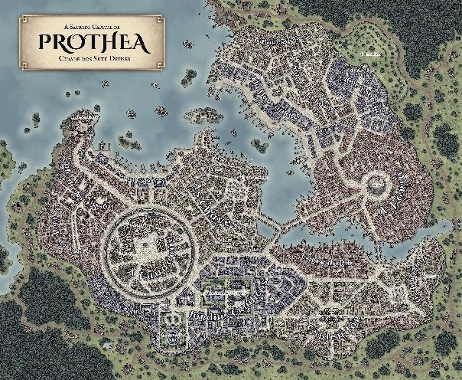

--DESCRIPTION--------------------------------------------------

--SHOPS & PEOPLE--------------------------------------------------

|  |  |  |  |  |
| --- | --- | --- | --- | --- |
| ***Representative*** | ***Ollen Ermid, 72*** |  | *Dwarf* | *Curious* |
| ***Sea Lord*** | ***Slimee Abyss, 75*** | ***P{ikecliff -> Ruslet*** | *Human* | *Arrogant* |
| ***Lord*** | ***Cyso Pauwels, 28*** |  | *Human* | *Grumpy* |
| *Priest/ess* | *Tezran Sokaufm, 40* |  | *Half-Elf* | *Quiet* |
| *Nobility* | *Carley Amundsen, 17* |  | *Human* | *Rude* |
| *Nobility* | *Corie Royd, 29* |  | *Human* | *Tired* |
| *Nobility* | *Stonael Przyk, 41* |  | *Human* | *Grumpy* |
| *Port Master* | *Bertio Scratchbox, 88* |  | *Elf* | *Gloomy* |
| *Alchemist* | *Arroell Humeken, 26* | *The Humble Gnome* | *Human* | *Annoyed* |
| *Sailor* | *Dargus Galanno, 41* | *Leocadia* | *Human* | *Ponderous* |
| *Sailor* | *Vanny Kowelly, 43* | *Leven* | *Human* | *Wise* |
| *Guard* | *Benc Filipek, 48* |  | *Human* | *Rude* |
| *Guild Member* | *Chaundo Augustin, 45* |  | *Human* | *Curious* |
| *Guild Member* | *Dam Skene, 88* |  | *Human* | *Friendly* |
| *IT Officer* | *Norman Hardie, 42* |  | *Half-Orc* | *Friendly* |
| *Lords Nephew* | *Keegan Westchesterforth, 34* |  | *Human* | *Shrewd* |
| *Smith* | *Else Westchesterforth, 26* | ***[Owner's Name] Scabbards*** | *Human* | *Kind* |
| *Smith* | *Rhona Windchester, 84* | ***The Hammer and the Pommels*** | *Human* | *Arrogant* |
| *Shopkeeper* | *Flo Cambridge, 66* | *Spectacular Dwarf* | *Human* | *Wise* |
| *Shopkeeper* | *Heward Grensen, 72* | *The Amber Anvil* | *Human* | *Jovial* |
| *Hunter* | *Crutum Macken, 28* |  | *Human* | *Curious* |
| *Groundskeeper* | *Matthom Stueck, 50* |  | *Dwarf* | *Kind* |
| *Bartender* | *Peggie Danill, 32* |  | *Human* | *Gloomy* |
| *Innkeeper* | *Judi Johnson, 64* | *Enigma* | *Dwarf* | *Friendly* |
| *Innkeeper* | *Odo Bradford, 90* | *The Lotus* | *Human* | *Kind* |
| *Citizen* | *Curt Pasternak, 42* |  | *Human* | *Kind* |
| *Citizen* | *Perry Mccanov, 16* |  | *Human* | *Curious* |
| *Citizen* | *Tashael Haston, 31* |  | *Human* | *Blustering* |
| *Farmer* | *Daniela Maria, 43* |  | *Human* | *Shrewd* |
| *Farmer* | *Tonell Paget, 30* |  | *Human* | *Grumpy* |
| *Herald* | *Finnan Reilly, 23* |  | *Halfling* | *Friendly* |
| *Servant* | *Alee Kinloch, 20* |  | *Human* | *Arrogant* |
| *Servant* | *Buddy Mikolajczak, 26* |  | *Human* | *Friendly* |

--ECONOMY--------------------------------------------------------

--SPECIAL FEATURES--------------------------------------------------

**CHURCH**

**IRON TEMPLE**

**MEERA TRADING COMPANY**

**GUILD OF HAMMER**

**MUSICIANS GUILD**

**SHADE BRINGERS**

**GHOST CLOAKS**

**DRUIDIC THIEVES GUILD**

**ARTIFICERS COLLEGE**

**LAKE NYMPHS**

--HISTORY----------------------------------------------------------

--SHOPS--------------------------------------------------------------

--INNS---------------------------------------------------------------

### Town- Smuggler's Port – Criminal’s Cove

<Image>

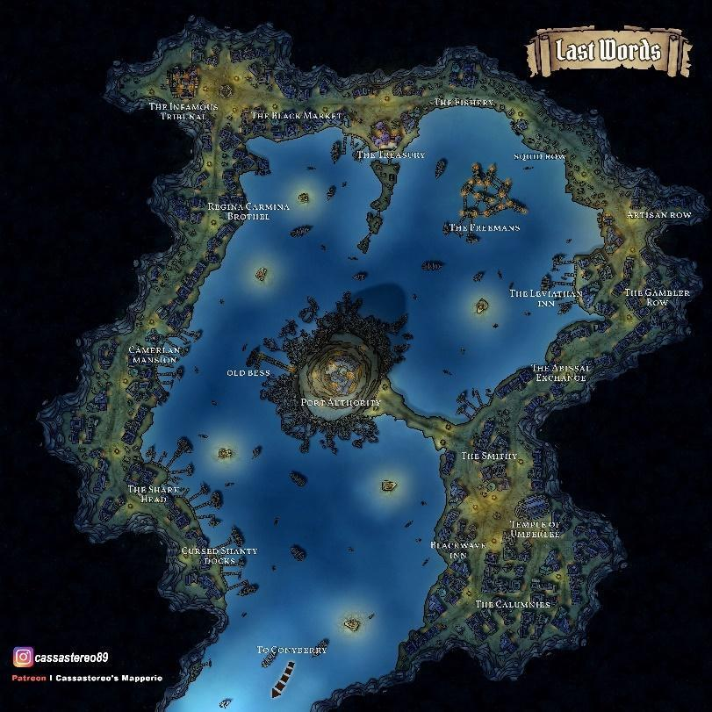

--DESCRIPTION--------------------------------------------------

Hidden away by powerful magics in the Patola Bay, The Smugglers port is home to all the unsavory business of the North-OAR population.

A Large, 400ft high and several-kilometer deep cavern hidden inside the mountainous cliffside. Sailors coming into this port are greeted with two magnificent stone pillars holding the ceiling up in the middle of the water, with ropes and bridges sprawling from it at every height and direction possible, leading elsewhere into the cavern walls or surrounding buildings.

**The City**

A conglomerate mess of shanty and well-built buildings and roads, running along the shore deeper and higher into the cavern. The port is equipped with several bars, brothels, and illegal tradespeople.

Anything underground in the kingdom can be found in this collective. Or at least, the path to anything one might desire.  
**Rules.**

Visitors of the town must pay 500gp entrance fee/group to Port Master **Sozen Mountainkin**, and have the leader agree to a **soul bond**, in which they will be killed "if they harm or bring harm to any other citizen/visitor of the town while visiting."

The bond is limited to the cave, and the bond is upheld always.

--SHOPS & PEOPLE--------------------------------------------------

|  |  |  |  |  |
| --- | --- | --- | --- | --- |
| ***Lord*** | ***Johnnie Vollan, 25*** |  | *Human* | *Quiet* |
| ***Lord*** | ***Scot Atwig, 116*** |  | *Elf* | *Jovial* |
| ***Lord*** | ***Sozen Mountainkin, 64*** |  | *Dwarf* | *Ponderous* |
| *Priest/ess* | *Wynalvi I Binse, 32* |  | *Human* | *Wise* |
| *GOSPEL Member* | *Rubien Mcnatch, 31* |  | *Dwarf* | *Wise* |
| *Port Master* | *Line Artr, 24* |  | *Human* | *Blustering* |
| *Alchemist* | *Ardis Lint, 35* | *The Blind Sword* | *Human* | *Friendly* |
| *Sailor* | *Auque Byron, 39* | *Snowflake* | *Gnome* | *Grumpy* |
| *Sailor* | *Chon Holt, 48* | *The Lion* | *Half-Elf* | *Kind* |
| *Sailor* | *Eldold Szwarc, 27* | *Ballahou* | *Dwarf* | *Arrogant* |
| *Sailor* | *Emilly Wolff, 23* | *Autumn* | *Human* | *Helpful* |
| *Sailor* | *Radavy Deniel, 28* | *Nerbudda* | *Human* | *Blustering* |
| *Sailor* | *Sey Ick, 48* | *Coucy* | *Human* | *Friendly* |
| *Guard* | *Tanshyo Burbach, 108* |  | *Tabaxi* | *Delightful* |
| *Guild Member* | *William Andersen, 41* |  | *Human Male* | *Ponderous* |
| *IT Officer* | *Judson Stallam, 39* |  | *Human* | *Curious* |
| *Smith* | *Jashano Duffin, 17* | *[Owner's Name] Weapons* | *Human* | *Wise* |
| *Smith* | *Chay Falconer, 45* | *The Exalted Braces* | *Dwarf* | *Friendly* |
| *Shopkeeper* | *Lukamo Zduntie, 44* | *The Amber Camel* | *Human* | *Helpful* |
| *Innkeeper* | *Ant Drudny, 38* | *Rhye and Limestone* | *Human* | *Friendly* |
| *Innkeeper* | *Harley Anthonsen, 33* |  | *Human* | *Curious* |
| *Citizen* | *Benny Michers, 18* |  | *Human* | *Friendly* |
| *Citizen* | *Rob Fredriksen, 45* |  | *Half-Elf* | *Intelligent* |
| *Servant* | *Carlyle Sova, 34* |  | *Human* | *Gloomy* |
| *Servant* | *Tania Grim, 35* |  | *Human* | *Curious* |
| *Servant* | *Teranath Fernn, 29* |  | *Orc* | *Quiet* |
| *Servant* | *Theo Mortensen, 46* |  | *Human* | *Cautious* |
| *Smuggler* | *Alvin Jana, 25* |  | *Human* | *Curious* |
| *Smuggler* | *Thad Ravlon, 27* |  | *Human* | *Kind* |
| *Smuggler* | *Woodrow Wind, 38* |  | *Human* | *Argumentative* |

--ECONOMY--------------------------------------------------------

--SPECIAL FEATURES--------------------------------------------------

--HISTORY----------------------------------------------------------

--SHOPS-------------------------------------

--INNS---------------------------------------------------------------

### CITY - Tebiton- Far and Large City

<Image>

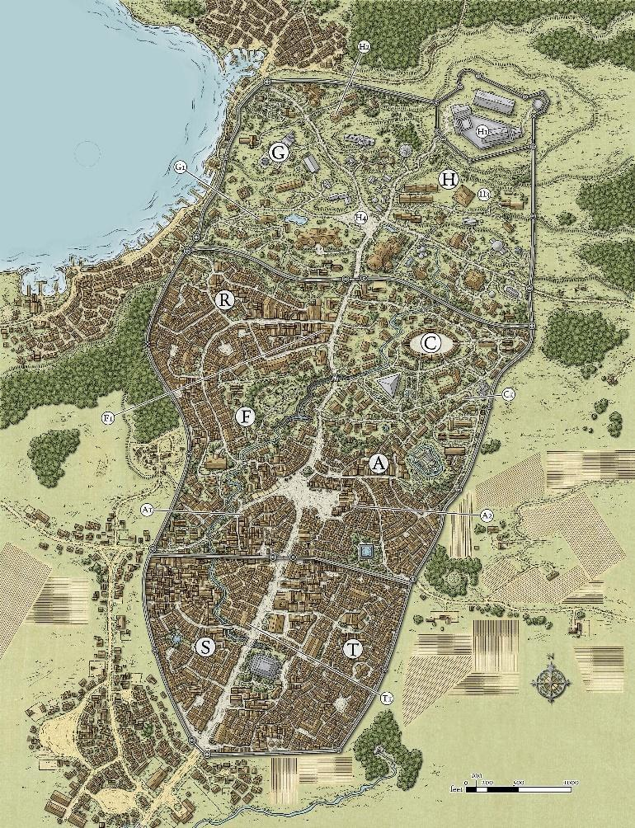

--DESCRIPTION--------------------------------------------------

--SHOPS & PEOPLE--------------------------------------------------

|  |  |  |  |  |
| --- | --- | --- | --- | --- |
| *Sea Lord* | *Huron Guarded Gates, 52* | ***Port passer -> Tebiton*** | *Human* | *Kind* |
| *SC, Storm Lord* | *Hamish Crawford, 48* |  | *Human* | *Intelligent* |
| ***Representative*** | ***Florine Dennel, 24*** |  | *Human* | *Friendly* |
| ***Lordess*** | *Domenic Keith, 34* |  | *Half-Orc* | *Delightful* |
| ***Lord*** | ***Devin Kramer, 40*** |  | *Human* | *Friendly* |
| *Priest/ess* | *Yanira Kingsly, 44* |  | *Human* | *Shrewd* |
| *Port Master* | *Derdoug Majewski, 41* |  | *Human* | *Rude* |
| *Alchemist* | *Gordon Rudert, 62* | *The Fast Codex* | *Human* | *Ponderous* |
| *Alchemist* | *Lafa Eshlemen, 82* | *Shades and Shadows* | *Human* | *Argumentative* |
| *Elder* | *Aered Blackwood, 53* |  | *Human* | *Ponderous* |
| *Sailor* | *Cyndi Duchamps, 62* | *Wistaria* | *Human* | *Friendly* |
| *Sailor* | *Leigon Bieber, 36* | *Northern Rover* | *Half-Elf* | *Intelligent* |
| *Guild Member* | *Romona Adam, 44* |  | *Human* | *Friendly* |
| *SC, Tide Surge* | *Eve Powmats, 67* |  | *Human* | *Kind* |
| *SC, Tide Surge* | *Fliames Symington, 80* |  | *Human* | *Friendly* |
| *Smith* | *Erya Fern, 35* | ***[Owner's Name] Scabbards*** | *Human* | *Friendly* |
| *Smith* | *Evin Charbonneau, 40* | ***The Minotaur's Steelworks*** | *Human* | *Friendly* |
| *Shopkeeper* | *Keven Burtt, 52* | *The Amber Complex* | *Human* | *Delightful* |
| *Shopkeeper* | *Jenna Firekin, 106* | *The Amber Stallion* | *Human* | *Friendly* |
| *SC, Surf Breaker* | *Cassidy Wardill, 64* |  | *Human* | *Friendly* |
| *SC, Surf Breaker* | *Lee Hopkins, 46* |  | *Human* | *Friendly* |
| *Innkeeper* | *Loris Dently, 61* | *Elements* | *Human* | *Honest* |
| *Farmer* | *Eraxis Hrader, 40* |  | *Human* | *Jovial* |
| *Farmer* | *Rewill Borchardt, 73* |  | *Elf* | *Friendly* |
| *Farmer* | *Zebulon On Reer, 29* |  | *Human* | *Friendly* |
| *Servant* | *Troy Ssen, 30* |  | *Human* | *Tired* |

--ECONOMY--------------------------------------------------------

--SPECIAL FEATURES--------------------------------------------------

**CHURCH**

**IRON TEMPLE**

**MEERA TRADING COMPANY**

**GUILD OF HAMMER**

**RELIC ALLIANCE**

**STORM CHASERS**

**UNIVERSITY BRANCH**

**ARTIFICERS COLLEGE GROVE STRIDERS**

**SECRET POOL OF FEY MAGIC**

--HISTORY----------------------------------------------------------

--SHOPS--------------------------------------------------------------

--INNS---------------------------------------------------------------

--DESCRIPTION--------------------------------------------------

A small but consequential town located in the Stormcrest subcontinent within the greater OAR.

**The Lord Ulysses Deney** is a jovial, well presented Elf that enjoys conversation with local citizens. Being thrust into the role, Ulysses’ confidence is largely a façade and will break down in intimate settings with peoplel of equal stature.

**In recent times** The town, while experiencing growth and relative prosperity, has noticed a sense of unease in the forest. More attacks are taking place to travellers of the Ol’ Dirt Road, and even docile wildlife appear feral at times. **Ulysses is desperate to maintain the peace and order, and waits for the right group to find their way into town.**

--SHOPS & PEOPLE--------------------------------------------------

|  |  |  |  |  |
| --- | --- | --- | --- | --- |
| ***Representative*** | ***Chris Servaant, 65*** | ***OAR Council*** | *Half-Orc* | *Jovial* |
| ***Low judge*** | *Hyatt, 109* | *Citizens of OAR* | *Human* | *Friendly* |
| ***Lord*** | ***Ulysses Deney, 36*** | ***Usterduum*** | *Elf* | *Friendly* |
| *Priest/ess* | *Bede Bradford, 70* |  | *Human* | *Honest* |
| *Nobility* | *Geoffrey Windchester, 27* |  | *Human* | *Kind* |
| *Nobility* | *Olga Smither, 40* |  | *Human* | *Grumpy* |
| *GOSPEL Member* | *Jesm Powski, 53* |  | *Dragonborn* | *Jovial* |
| *Portman* | *Darius Atwig, 75* |  | *Dwarf* | *Delightful* |
| *Guild Member* | *Wess Burns, 92* | *Guild Affairs* | *Human* | *Friendly* |
| *IT Officer* | *Valentine, 48* | *Law and order* | *Human* | *Shrewd* |
| *Smith* | *Burton Bradford, 39* | *The Fancy Forge* | *Human* | *Tired* |
| *Shopkeeper* | *Barney Dugir, 58* | *Odds and Ends* | *Orc* | *Kind* |
| *Innkeeper* | *Gene Grae Adlam, 85* | *Genie's Tavern* | *Human* | *Tired* |
| *Farmer* | *Porter Blossombard, 43* | *Local Farm* | *Dwarf* | *Quiet* |
| *Farmer* | *Audie Ergaa, 28* |  | *Human* | *Kind* |
| *Farmer* | *Rafael Cfayne, 23* |  | *Human* | *Curious* |
| *Bard* | *Bardy McFly, 31* | *Singer at Genie's Tavern* | *Human* | *Quiet* |
| *Bard* | *Bardy McFly, 31* |  | *Aarokocra* | *Blustering* |
| *Bard* | *Ed An, 24* |  | *Human* | *Tired* |
| *Killer* | *Linda Honey, 35* | *Killer, BBEG support* | *Dwarf* | *Argumentative* |

--ECONOMY--------------------------------------------------------

Fishing and naval trade, lumber and recent mining op's

--SPECIAL FEATURES--------------------------------------------------

**CENTRAL PONDS**

In the center of town are two small ponds that hold about 5ft deep of seawater. At the bottom of the pond is a buried chest, but otherwise is just a part of the geography. **The pond is sacred in traditional senses to the town and won’t enjoy splashing around in it. Not illlegal though.**

**MAGMATIC FORGE**

Natural lava wells remain fresh and active below The Fancy Forge. The lava boils regularly and is left uncovered around the building.

**CITY WALLS**

10ft tall city walls surround the city, made of stone, and reach to the shores of the beach. Entrance and exit to north, south and East, guarded by one or two guards.

**OL’ DIRT ROAD**

A long dirt path-turned roadway in recent years to accommodate freer trade to and from Ruslet to the north, while also opening up possibility for resource harvesting in between. Attracts bandits.

**SURROUNDING AREAS**

Varied. Forest and mountains to the north, river running from it. Fields to the east and ocean to the south and west.

**DOCKS**

Capacity – 9 Longships, 2-4 sailing ships

Dockmaster - Darius Atwig, 75 (Dwarf)

**WAYSTONE**

5 miles out of town, off Ol’ Dirt Road

**CHURCH**

Like most other churches

**IRON TEMPLE**

**GOSPEL**

Olga Smithers

**MEERA TRADING COMPANY**

**MUSICIAN’S GUILD**

**SHADE BRINGERS**

**GHOST CLOAKS**

**CULT OF THE VOID**

**CULT OF THE DARK MOON**

--HISTORY----------------------------------------------------------

While it was primarily a farming community, and considered by some to be a stopover town, the town had great ambitions to grow and be seen as an alternative to their northern neighbor of Ruslet.

Despite its modest size and somewhat inflated sense of importance, Usterduum was resilient. It was something of a relic from the old kingdoms past, too stubborn to fall even when a series of wars, crusades, and other conflicts threatened the entirety of the Republic.

The village as it stands now is relatively newly built, and on the cusp of small-city status. Given the recent completion of their temple construction project. The temple was built in the image of Nereus and Torrent.

--SHOPS--------------------------------------------------------------

Smith **The Fancy Forge** Burton Riley, 39

S speed L pitch and Throaty.

Usually GLOOMY. When calm GREEDY. When stressed OBSESSIVE.

In entering the open smiths quarters, you see a tall broad-shouldered man hunched over a workbench, mumbling to himself. He appears to be completely immersed in some sort of map. **Has a map of caved-in mine to the north, where he thinks a large deposit of rare minerals are.**

Shop **Odds** **and** **Ends** Barney Saunter, 58

S speed M pitch and Throaty.

Usually NERVOUS. When calm DRIVEN. When stressed SARCASTIC.

The shop is wide and hard to navigate, given all the clutter around. You immediately get the sense that the owner is a hoarder. As you begin to walk through, your foot accidentally catches something and a large pile of goods crashes to the ground. The Shopkeeper comes out from the back. "Be careful there!"

Barney:

* Old Adventurer
* Collects stuff (junk) from all around the world.
* Has good connection with Ulysses, and knows she needs help in a personal matter.

--INNS---------------------------------------------------------------

Inn **Gene's** Gene Grae, 85

Gene:

* Warm, elderly lady. Uses a cane to walk around, but still manages to get work done.
* Keeps a tight ship as best she can.
* Well invested in the goings-on of the town.

## Tribe Lands - Creatus: Orc (6)

<Representative Image>

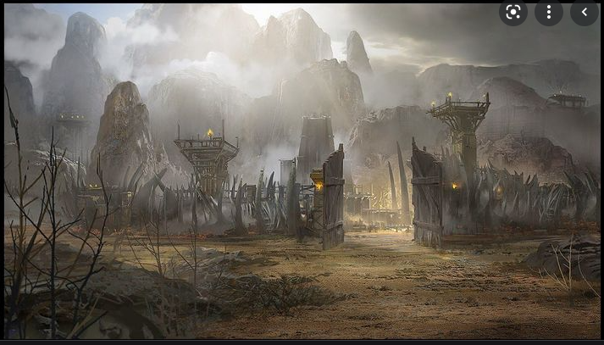

<Flag>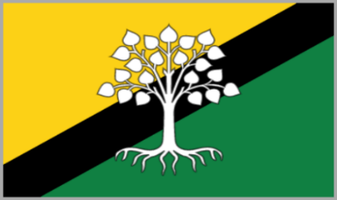

### Summary

<Basic Description>

Huge region of land lying mostly barren and wild, with several factions and tribes of Orcs and other untamed fey creatures.

*Geography in summary*

The land is divided by the lands of man by the Southern Mountain Ranges. The mountains in this area are known to be remarkably tall and impassable. They make for great barriers to the kingdoms and are believed to be filled with precious metals.

*Culture in summary*

Orcs are violent creatures, and almost all disputes are settled through fistfights. Being as massive as they are, these fistfights can be highly destructive to the surrounding area. Sometimes, Orcs fight each other for no other reason than for fun; for this reason, the center of most Orc villages have a fighting pit in the center.

As part of their history, the orcs have taken claim of ancient and deserted settlements of the elves and brought them back up to towns of glory and respect. They believe the lands are now rightfully theirs and the elves shouldn't dare try to claim it after abandoning them so long ago.

#### Leader/Lord

<Image>

Grugg: Chamillian: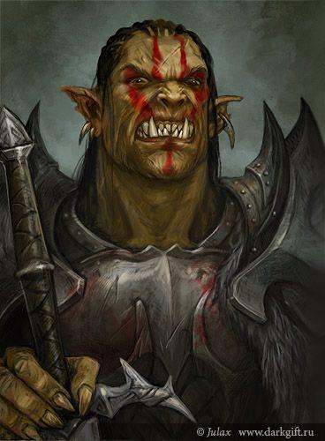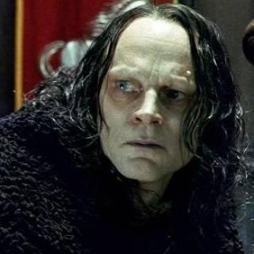

--DESCRIPTION--------------------------------------------------

The Orcish leader **Grugg**

An orc made leader by challenging the past leader and killing him in the fighting ring. He comes from a bloodline said to be blessed with dragon blood. Legend says he kills a man and cooks him for dinner with his own fiery breath.

Grugg is advised by his childhood friend named Chamillian. Chamillian is calling for Grugg to launch an invasion against the elves before they act against the orcs.

#### History

Brief and limited to the story of its formation and current situation

Long ago, Orcs were brought to this land by an unknown god, and have made much of the north their home. While the orcs live largely in solitude from humans, their location of settlements have caused great strife with the Elves.

The elves claimed the land to be theirs by ancient right, and fought the Orcs to leave. There are legends of **ancient elven artifacts** secreted away that can tip the scales in favor of the bearer's race, and others that might devastate all humanity.

The war has gone on for so long that generations have passed, and the **original strife has turned to primarily a simple prejudice** between both with unwavering stubbornness of opinion. Only in deep crypts and renowned libraries does the truth lie.

The Orcish leader Grugg is growing impatient on the tense ceasefire and is calling for an absolute end to the conflict.

He hasn’t decided anything in particular, but he has called for further militarization of his cities in preparation of an assault, either on him or by him. Both He and King Thourmon have spies whispering in their ears, escalating tensions in the hope of a coming conflict.

#### Laws and Government

Orc Lord Leader of all Orcs

High Shaman Religious leader of tribes

Chieftan Leader of smaller tribes

Adult General population

Whelps Children learning to fight

### Gedad (Capital)

<Image>

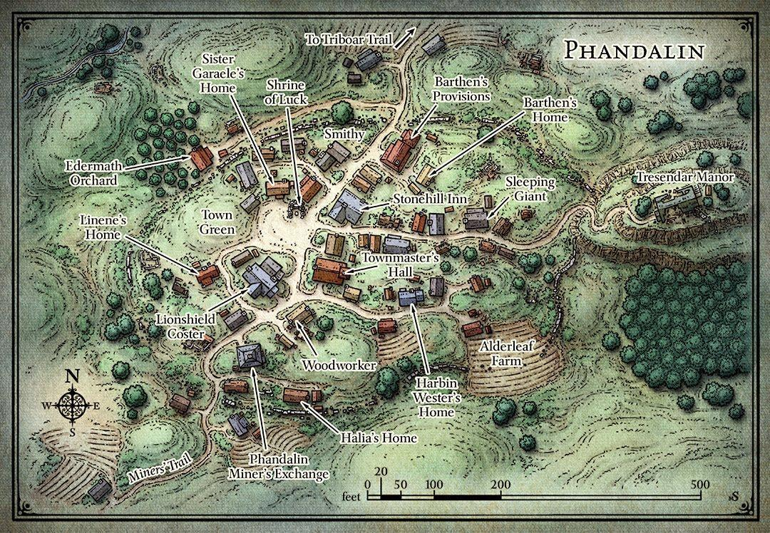

--DESCRIPTION--------------------------------------------------

Gedad is the sister capital city to the Creatus Kingdom. While it shows no signs of military or power, and the population is low, Gedad is respected as home to many of the Orcish intellectuals. The history and secrets of the race lie both here and in the Gaj Gedad, where more of the population lives.

Ruled by Kophe the wise, Gedad allocates resources exceptionally strictly to save and conserve for the future. Since the town has minimal contact with outside towns, Gedad has to rely on what it can make for itself.

--SHOPS & PEOPLE--------------------------------------------------

Lord Kophe, 23

Priest/ess Richomer, 26

Nobleman Jamshir Otholey, 30

Alchemist Hlin Ford, 52

Alchemist Cynthia Asprzak, 28

Tanner Chambec Materra, 22

Smith Borgakh, 75

Smith Gashnakh, 49

Miner Adar, 54

Miner Lesley Byrne, 26

Miner Bob Ore, 51

Hunter Asheldo Colasen, 46

Hunter Johnie E Szek, 19

Bartender Rondona Ackwood, 12

Innkeeper Ierilles, 32

Farmer Ina Ter, 14

Farmer Nie Gan, 50

Farmer Lance Magne, 26

Farmer Larvin Dennel, 36

Traveller Dend Ntek, 25

Servant Josiah Prycen, 19

--ECONOMY--------------------------------------------------------

Agriculture, Mining

--SPECIAL FEATURES--------------------------------------------------

--HISTORY----------------------------------------------------------

--SHOPS--------------------------------------------------------------

--INNS---------------------------------------------------------------

### Aztarok

<Image>

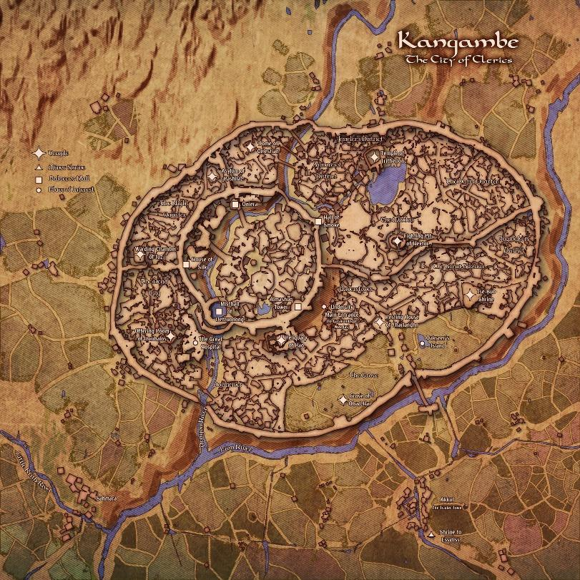

--DESCRIPTION--------------------------------------------------

The city on the back of a titan Azta, buried deep in the ground.

The people of this village are su

--SHOPS & PEOPLE--------------------------------------------------

Priest/ess Drun, 50 Aztarok Religion

Lord Abraror, 65 Aztarok

Nobility Haakon, 31

Alchemist Dura, 83

Gld. Member Rhys, 37 Guild Affairs

Tanner Quugug, 40 Leather Shop

Tanner Larek, 63 Bracers and Bootstraps

Smith Xurek, 33 Xurek's Forge

Smith Glob, 46 Glob's Forge

Shopkeeper Burp, 47 Shop

Hunter Deldrach, 34 Their Game

Hunter Rulouni, 86 Their Game

Innkeeper Rinaf, 98 The Free Piano Pub

Farmer Danim, 100 Local Farm

Farmer Buster, 82 Local Farm

--ECONOMY--------------------------------------------------------

--SPECIAL FEATURES--------------------------------------------------

--HISTORY----------------------------------------------------------

--SHOPS--------------------------------------------------------------

--INNS---------------------------------------------------------------

### Gaj Gedad

<Image>

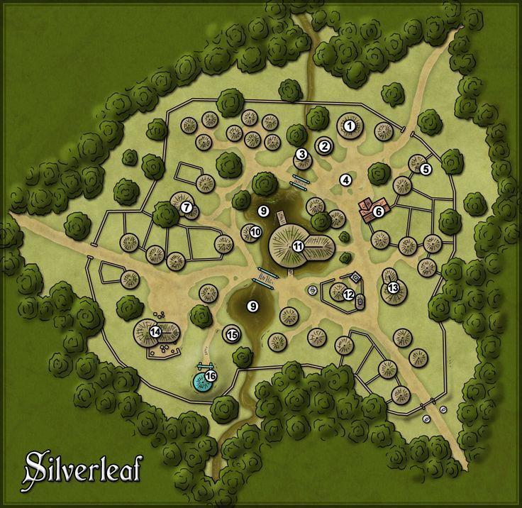

--DESCRIPTION--------------------------------------------------

--SHOPS & PEOPLE--------------------------------------------------

Priest/ess Richomer, 26 Gedad Religion

Lord Kophe, 23 Gedad

Nobility Tatiana, 99

Alchemist Shufharz, 43

Tanner Fodagog, 49 Leather Shop

Tanner Luronk, 43 Leather Shop

Smith Gashnakh, 49 Gashnakh's Forge

Smith Borgakh, 75 Borgakh's Forge

Miner Hildifons, 59 Gedad Mines

Miner Adar, 54 Gedad Mines

Hunter Aglomph, 77 Their Game

Innkeeper Ierilles, 32 The Wandering Jester Tavern

Farmer Hiltrude, 57 Local Farm

Farmer Pike, 94

--ECONOMY--------------------------------------------------------

--SPECIAL FEATURES--------------------------------------------------

--HISTORY----------------------------------------------------------

--SHOPS--------------------------------------------------------------

--INNS---------------------------------------------------------------

### Jusomaas

<Image>

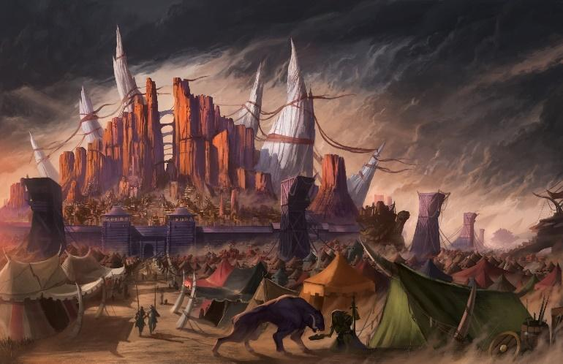

--DESCRIPTION--------------------------------------------------

--SHOPS & PEOPLE--------------------------------------------------

Priest/ess Chinte, 53 Jusomaas Religion

Lord Ulumpha, 93 Jusomaas

Tanner Bogugh, 41 Leather Shop

Smith Homraz, 50 Homraz's Forge

Smith Shagdub, 55 Shagdub's Forge

Miner Flurhamoid, 77 Jusomaas Mines

Miner Bran, 24 Jusomaas Mines

Hunter Yorhearra, 81 Their Game

Hunter Bertha, 69 Their Game

Innkeeper Mournalf, 23 The Unnatural Banjo Tavern

Farmer Wazo, 80 Local Farm

--ECONOMY--------------------------------------------------------

--SPECIAL FEATURES--------------------------------------------------

--HISTORY----------------------------------------------------------

--SHOPS--------------------------------------------------------------

--INNS---------------------------------------------------------------

### Od'Nenga

<Image>

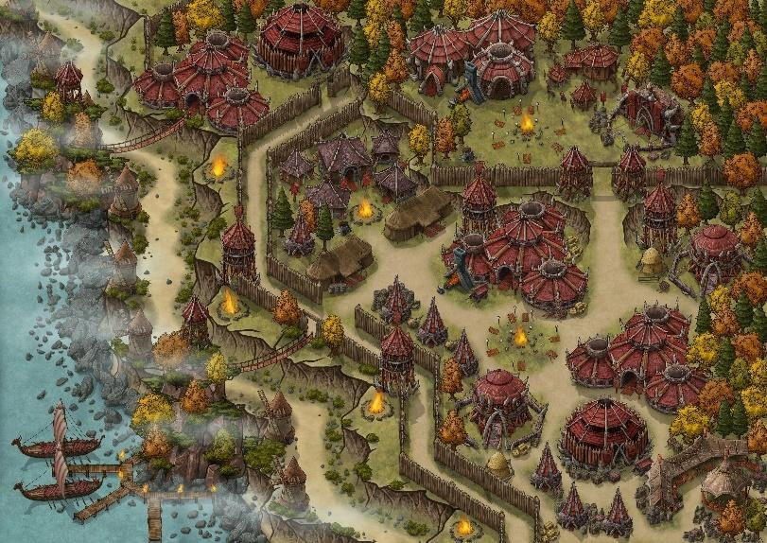

--DESCRIPTION--------------------------------------------------

--SHOPS & PEOPLE--------------------------------------------------

Priest/ess Sanev, 25 Od-Nenga Religion

Lord Marroc, 82 Od-Nenga

Alchemist Ushat, 94

Tanner Xnath, 45 Leather Shop

Smith Sharog, 50 Sharog's Forge

Smith Gul, 72 Gul's Forge

Miner Feinim, 20 Od-Nenga Mines

Hunter Taerentym, 46 Their Game

Hunter Krylde, 63 Their Game

Innkeeper Yondraek, 98 The Painful Tree

Innkeeper , 52

Farmer Tannyll, 37 Local Farm

Farmer Philibert, 78 Local Farm

Farmer Obadiah, 59

--ECONOMY--------------------------------------------------------

--SPECIAL FEATURES--------------------------------------------------

--HISTORY----------------------------------------------------------

--SHOPS--------------------------------------------------------------

--INNS---------------------------------------------------------------

### Zut'Kitot

<Image>

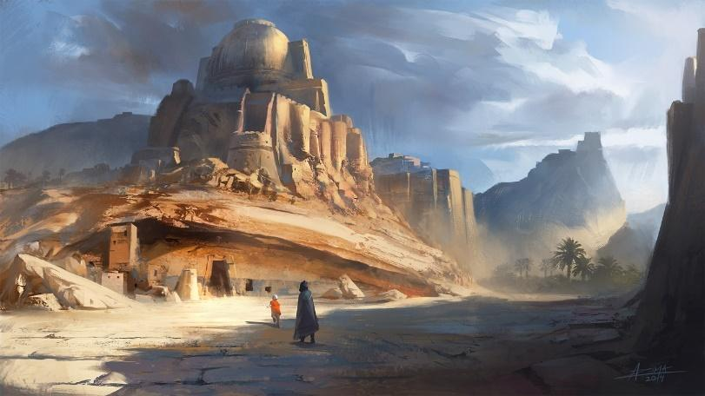

--DESCRIPTION--------------------------------------------------

--SHOPS & PEOPLE--------------------------------------------------

Priest/ess Ghinte, 22 Zut'Kitot Religion

Lord Goddaebelle, 21 Zut'Kitot

Nobility Eleanor, 58

Alchemist Shufharz, 38

Alchemist Urzul, 64

Tanner Slapdud, 24 Leather Shop

Miner Werakgretaine, 31 Zut'Kitot Mines

Miner Kinna, 60 Zut'Kitot Mines

Hunter Kante, 86 Their Game

Hunter Quevven, 93 Their Game

Innkeeper Drinor, 82 The Empty Meerkat Bar

Farmer Carter, 55

--ECONOMY--------------------------------------------------------

--SPECIAL FEATURES--------------------------------------------------

--HISTORY----------------------------------------------------------

--SHOPS--------------------------------------------------------------

--INNS---------------------------------------------------------------

## Kingdom - Xandor: Elf (4)

<Representative Image>

<Flag>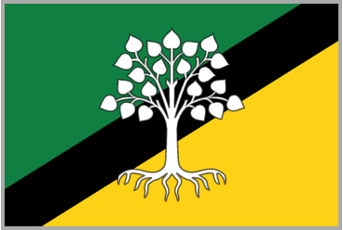

<Basic Description>

### Summary

*Geography in summary*

*Culture in summary*

#### Leader/Lord

<Image>

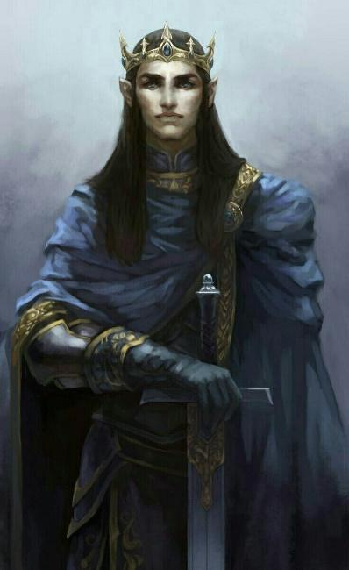

--DESCRIPTION--------------------------------------------------

#### History

*Brief and limited to the story of its formation and current situation

#### Laws and Government

### Rea Xandor

<Image>

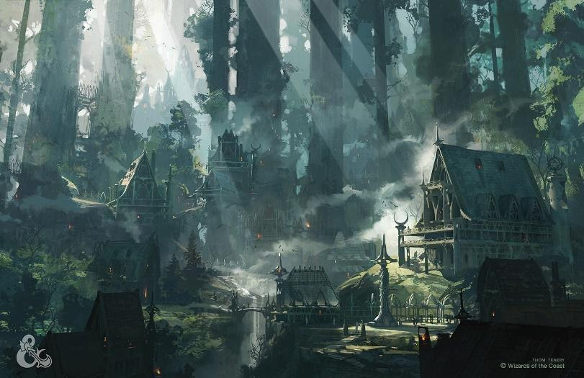

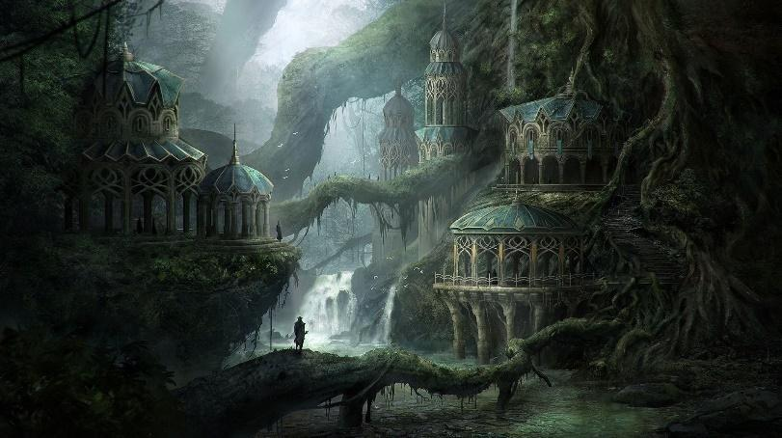

--DESCRIPTION--------------------------------------------------

Rea Xandor is the Capital of Xandor. It's hidden deep in ancient woodlands, known to few, and seen to fewer. It's lands are sparse and rich in life. The elves that live here are committed to guarding this natural balance with their life.

The house of Thourmon sits in the center of the forest, and is extremely humble. There are no grand temples, but rather small homes and larger communal living spaces.

--SHOPS & PEOPLE--------------------------------------------------

King Thourmon Tauriel, 750

Princess Myrtice Consenz, 44

Wand Smith Brendon Paspens, 14

Lord Lenon, 43

Priest/ess Istepha Woodburn, 72

Alchemist Gail Bodilsen, 48

Gld. Member Rotrude Aestra, 84

Jeweler Rhys Maccoll, 36

Smith Jaree, 42

Shopkeeper Ushug Amamion, 29

Miner Perr Niven, 10

Hunter Kaleigh Montgomery, 13

Hunter Laureen Ruud, 0

Innkeeper Pehrakgu Amamion, 21

Citizen Mournar Olerydon, 92

Citizen Vivienne Byrnell, 47

Student Gaby Asen, 14

--ECONOMY--------------------------------------------------------

--SPECIAL FEATURES--------------------------------------------------

--HISTORY----------------------------------------------------------

--SHOPS--------------------------------------------------------------

--INNS---------------------------------------------------------------

### Ty Rythel, the hidden capital

<Image>

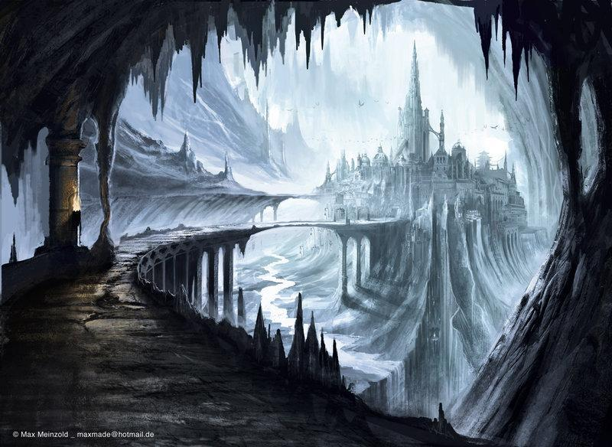

--DESCRIPTION--------------------------------------------------

A low and barely visible collection of igloos and ice-made buildings blend into the land. Gaining access to these buildings, you find either a ladder, stairs or magical elevator which brings you down into a massive ice cavern that acts as home to the **Ice Elves**

Ice Elves:

Only some know of the origin of the Ice Elves. This sub-race of Elves was made when a clan of Elves were heading north to hide from the increasing orc raids and raiders. They have lived there for so long that the ice has become part of them. Ice Elves typically live in beautiful elven cities or towns. Since their forms are changed by the Ice so are their personalities- most of the subspecies share certain traits with Ice, examples of these traits being: Cold, emotionless, and slow to act and they are hard to talk to.

The Cavern

Nestled by the feet of titan-huge mountains, under several feet of ice and snow sits a massive open, roofed-over cavern. It stretches kilometers deep and some wide, housing a massive, isolated city on a hill. If found by other elves or the dwarves, it would be the envy of their lives

The Depths

The mainly lit area of the cavern houses the City. Heading farther into the depths, along the **white river,** is **The Depths.** The depths house several smaller but still massive rooms, in which livestock are kept or secrets are hidden.

Farther into the pitch black and crushing depths lies the precipice of an unbelievably deep chasm.

--SHOPS & PEOPLE--------------------------------------------------

Lord Oggugat Galakir, 66

Priest/ess Makibelle Aire, 59

Alchemist Hanki Urquhart, 7

Gld. Member Brokil Xiloscient, 19

Gld. Member Nellie Machwaw, 18

Jeweler Zarredr Dirkx, 15

Smith Nicholas Simerob, 47

Smith Brandy Paszen, 6

Shopkeeper Crie Ley, 31

Miner Dorsey Atchison, 63

Hunter Jarret Stein, 23

Hunter Geraldine Filyon, 5

Innkeeper Bellas Othanar, 81

Innkeeper Bree Anod, 41

--ECONOMY--------------------------------------------------------

--SPECIAL FEATURES--------------------------------------------------

--HISTORY----------------------------------------------------------

--SHOPS--------------------------------------------------------------

--INNS---------------------------------------------------------------

### Val'Alora

<Image>

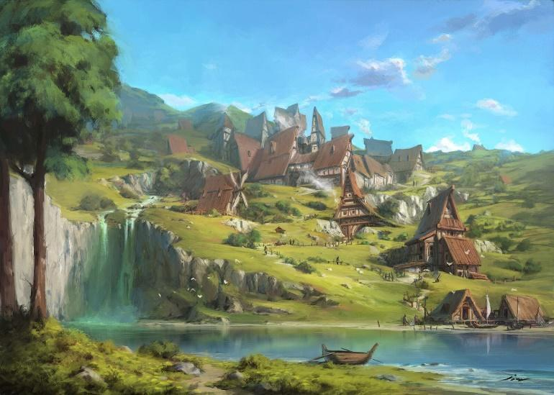

--DESCRIPTION--------------------------------------------------

This city is as well known as the Shire is to the citizens of Tolkien's world. It's marked on the map as a noted Elf city, but that's about it.

The citizens here life quiet happy lives. Many elves in their later life may choose to trek to Val'Alora to enjoy retirement. Unfortunately, a deep sickness has arisen in the nearby lands to the East, threatening Val Alora gravely.

--SHOPS & PEOPLE--------------------------------------------------

Lord Gerardo O Lanse, 12

Priest/ess Delg Smor, 52

Alchemist Deet Macclor, 11

Gld. Member Caitlyn Snedden, 58

Gld. Member Brutren Holiilo, 27

Jeweler Lorri Szwarc, 35

Smith Tras Ooks, 72

Smith Annetta Stirling, 16

Shopkeeper Mckene Bett, 10

Miner Albertha Lauritsen, 17

Hunter Augustine Dampber, 25

Hunter Phnna Passent, 25

Innkeeper Umruigig Neithaor, 75

Citizen Nakgu Duindaer, 54

Citizen Thourmon Tauriel, 750

--ECONOMY--------------------------------------------------------

--SPECIAL FEATURES--------------------------------------------------

--HISTORY----------------------------------------------------------

--SHOPS--------------------------------------------------------------

--INNS---------------------------------------------------------------

### Rhûn

<Image>

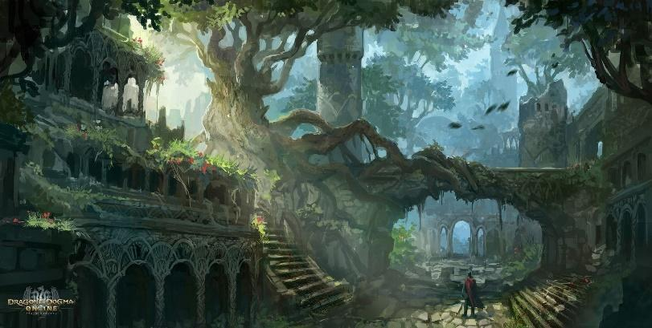

--DESCRIPTION--------------------------------------------------

Rhûn is a town forgotten to the wars of Elves and Orcs. While on maps it's believed to be desolate and not of worth. In reality, the town has lost connection with the rest of civilization and over the centuries, has developed into a closed town with tight borders and unending resources.

--SHOPS & PEOPLE--------------------------------------------------

Lord Krikle Shazorwyn, 79

Priest/ess Jasodem, 49

Alchemist Mardand Goru, 44

Gld. Member Debbra A Hore, 13

Gld. Member Elonnya Craziel, 31

Jeweler Joseph Mathieson, 13

Smith Filree, 49

Smith Kanne Robert, 51

Shopkeeper Vargan Meliscient, 51

Miner Casi Chslam, 26

Hunter George Vinogradov, 51

Hunter Nicia Winther, 28

Innkeeper Adgulg Sir, 35

Innkeeper Shela Arsen, 15

Farmer Kandis Mcfer, 40

--ECONOMY--------------------------------------------------------

--SPECIAL FEATURES--------------------------------------------------

--HISTORY----------------------------------------------------------

--SHOPS--------------------------------------------------------------

--INNS---------------------------------------------------------------

### Elantis

<Image>

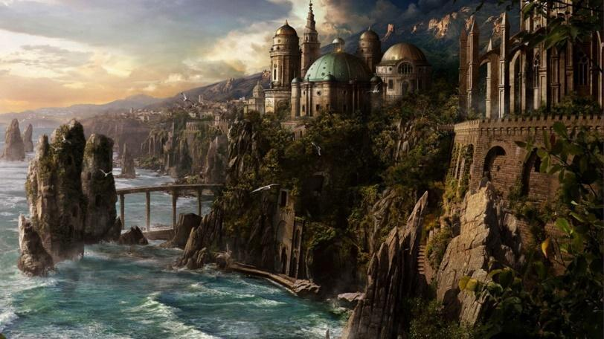

--DESCRIPTION--------------------------------------------------

--SHOPS & PEOPLE--------------------------------------------------

Priest/ess Jamert Lorenzen, 20

Alchemist Juli Karstensen, 12

Gld. Member Joseph Crawford, 2

Gld. Member Levi Dubicki, 2

Jeweler Keronri Adamczyk, 33

Smith Brandon Carrick, 41

Smith Loria Hirschel, 16

Shopkeeper Sharda Sonher, 6

Miner Westaug Macleod, 19

Hunter Hanna Duffy, 11

Hunter Chay Ines, 25

Innkeeper Huan Muel, 22

Innkeeper Corey Alle, 19

Farmer Ard Sen, 28

--ECONOMY--------------------------------------------------------

--SPECIAL FEATURES--------------------------------------------------

--HISTORY----------------------------------------------------------

--SHOPS--------------------------------------------------------------

--INNS---------------------------------------------------------------

### Other Areas

#### The Frost Isles

#### Mourning Wall

## Unknown - Far Lands (10)

<Representative Image>

<Flag>

<Basic Description>

To the East, the unknown. An untamed, wild jungle ridden with life unknown.

To the West, a barren waste filled with dangers and secrets. Creatures lurk beneath the sand. Safe travel is only found on the stone pathways marked by those who lived before, much like the Great Stone Road. Each outpost operates largely independantly, and don't take kindly to unexpected outsiders.

And those are the colonizers. The indigenous peoples are known as beast-like, wild and unpredictable. Some report seeing lions standing like men, leaping across the desolate wastes. In the sky fly men-like birds with wide faces and wider wings. The believed indigenous peoples of this land seldom approach the stone roads, but hold strong to the lands they claim.

There is no kingdom here. No overarching lineage or power that governs its inhabitants. The people of the far lands live in freedom, away from each other and surrounded in mystery and danger.

*Genasi, Leonin, Owlin, Bugbear, Kobold, Feral Tieflings*

### Summary

*Geography in summary*

*Culture in summary*

#### Leader/Lord

<Image>

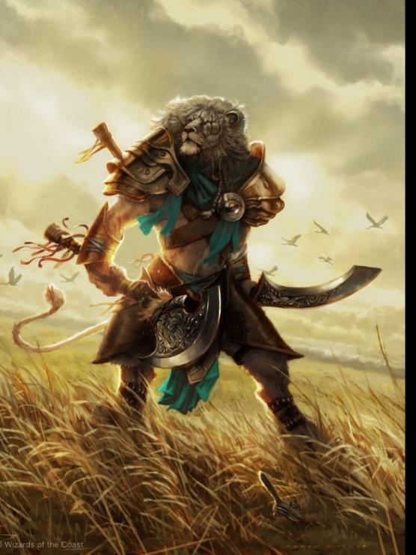

--DESCRIPTION--------------------------------------------------

Enigmus King Titun the Leonin Lord

#### History

*Brief and limited to the story of its formation and current situation

There are tales in the world's varied history about a calamity of world-ending proportions between Morthia and an ancient world, Karthuum. During this war there was known to be a place of refuge for peoples of both sides of the world. A place where people were safe from oppressive religions and governments. And so the legend emerges of the Far Lands- A place of freedom and wonder.

The only known information comes from a message in a bottle, dated 700 years ago. It states:  
  
*"I hope this finds you well, good traveller.*

I seek aid for our lands, as King Trition has fallen ill. I fear he likely has not long for this world. Please, find your way south and help us cure what I fear to be a coming plague. But be warned; Gods and magic have different influence here, and our people do not take kindly to outsiders. You may not be well received, but I promise the most lucrative of riches if you're able to bypass our ignorance.

Come soon, come ready.

Lord Eshelor"

#### Laws and Government

Collective the council of 9

Yuntas mire the Durckheart and Siryhth rulers

Creature orc leader Grugg and Elf

OAR Naval Chancellor Greg

### CITY - Neverport – City of Stone Mountains

<Image>

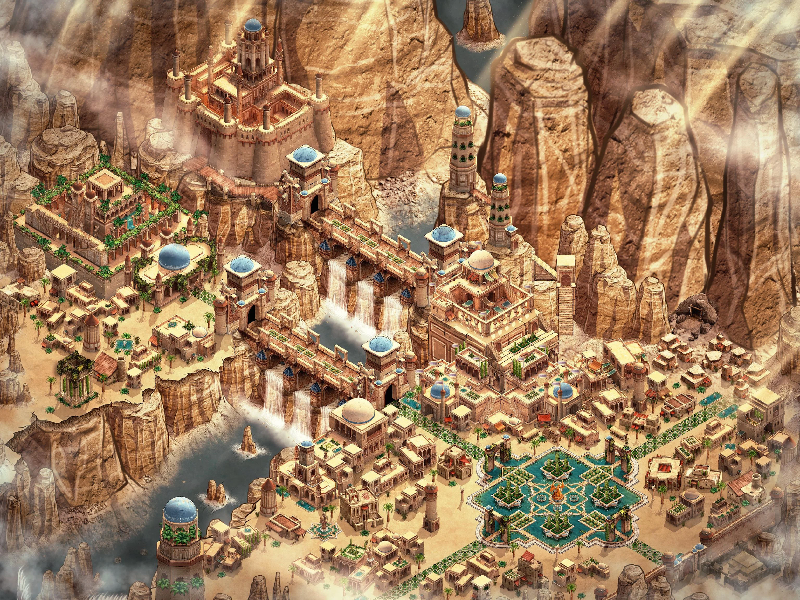

--DESCRIPTION--------------------------------------------------

Neverport is a new city in the Far Lands, established by OAR and headed by

--SHOPS & PEOPLE--------------------------------------------------

Archmage Ghandilin Karstensen, 45

Lord Delvin Frazier, 11

Priest/ess Mickie Haineil, 19

Nobility Long Oliver, 24

Alchemist Karlenn Mcnaura, 28

Gld. Member Anda Mcalister, 2

IT officer Darisse Storstrand, 30

Smith Moshe Lyon, 22

Shopkeeper Mart Borisov, 22

Innkeeper Prince Passent, 3

Innkeeper Ollen Fermid, 72

Port Master Wingto Mccorn, 1

Sailor Willie Mccrudn, 29

Sailor Tord Caurdoo, 44

Mtn. Guide Tanniqu Calhoun, 25

Hunter Stacey Bowen, 19

Servant Chance Fabre, 8

--ECONOMY--------------------------------------------------------

--SPECIAL FEATURES--------------------------------------------------

--HISTORY----------------------------------------------------------

--SHOPS--------------------------------------------------------------

--INNS---------------------------------------------------------------

### Town- Slag's Reach – Wizards Warden

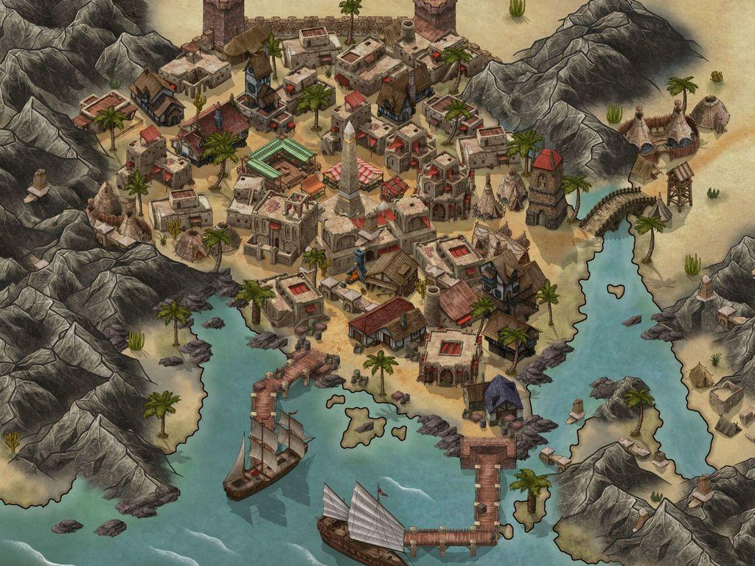

<Image>

--DESCRIPTION--------------------------------------------------

--SHOPS & PEOPLE--------------------------------------------------

--ECONOMY---------------------------------------------------------

--SPECIAL FEATURES--------------------------------------------------

--HISTORY----------------------------------------------------------

--SHOPS--------------------------------------------------------------

--INNS---------------------------------------------------------------

### Town- Trigg's Landing – Riverside Ruins City

<Image>

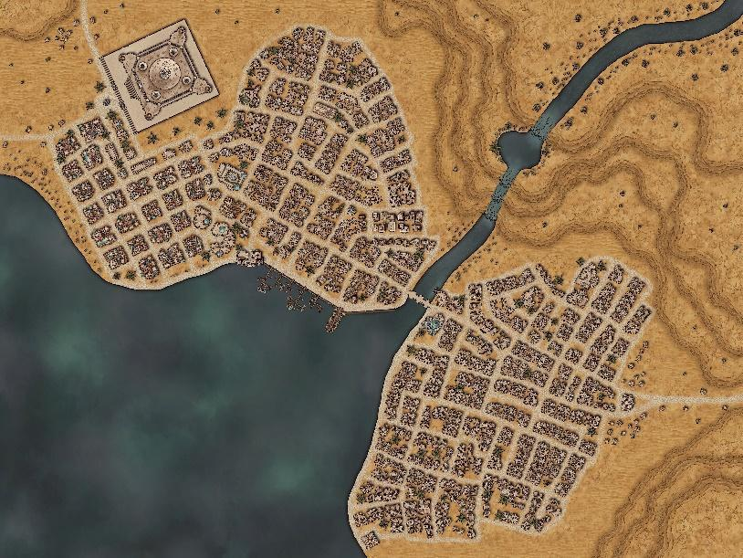

--DESCRIPTION--------------------------------------------------

A brutal and cruel people, the inhabitants of Trigg's landing operate on a kill first, question later structure. It's known as one of the most isolated colonies in the world.

--SHOPS & PEOPLE--------------------------------------------------

--ECONOMY--------------------------------------------------------

--SPECIAL FEATURES--------------------------------------------------

--HISTORY----------------------------------------------------------

--SHOPS--------------------------------------------------------------

--INNS---------------------------------------------------------------

### Town- Ironscar Hill – The Riches of Arcarath

<Image>

--DESCRIPTION--------------------------------------------------

A metal rich hillside down, focused mainly on weapons development and defense.

--SHOPS & PEOPLE--------------------------------------------------

--ECONOMY--------------------------------------------------------

--SPECIAL FEATURES--------------------------------------------------

--HISTORY----------------------------------------------------------

--SHOPS--------------------------------------------------------------

--INNS---------------------------------------------------------------

### Town- Voht – Home of the Korred

--DESCRIPTION--------------------------------------------------

Korreds are unpredictable, secretive Fey with strong ties to earth and stone. Because of their magical hair and mystical understanding of minerals, they are sought after by treasure-hunting dwarves and others who desire wealth beneath the earth.

--SHOPS & PEOPLE--------------------------------------------------

--ECONOMY--------------------------------------------------------

--SPECIAL FEATURES--------------------------------------------------

--HISTORY----------------------------------------------------------

--SHOPS--------------------------------------------------------------

--INNS---------------------------------------------------------------

### Town- Tabrise – Slave Town of Secrets

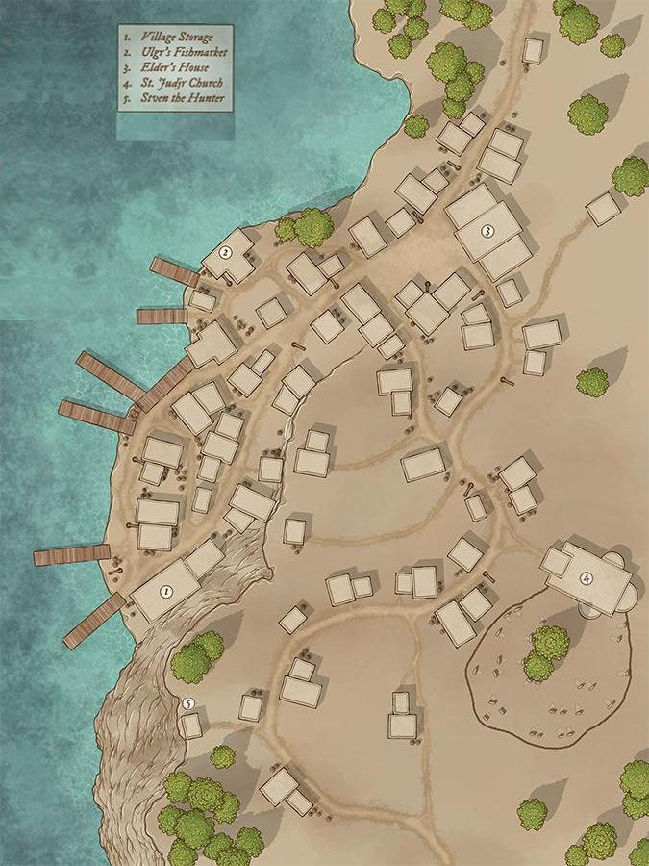

--DESCRIPTION--------------------------------------------------

--SHOPS & PEOPLE--------------------------------------------------

--ECONOMY--------------------------------------------------------

--SPECIAL FEATURES--------------------------------------------------

--HISTORY----------------------------------------------------------

--SHOPS--------------------------------------------------------------

--INNS---------------------------------------------------------------

### Town- Arak – Yuan-Ti Domain

--DESCRIPTION--------------------------------------------------

--SHOPS & PEOPLE--------------------------------------------------

--ECONOMY--------------------------------------------------------

--SPECIAL FEATURES--------------------------------------------------

--HISTORY----------------------------------------------------------

--SHOPS--------------------------------------------------------------

--INNS---------------------------------------------------------------

### Town- Soratin - Hardstone Cove Castle

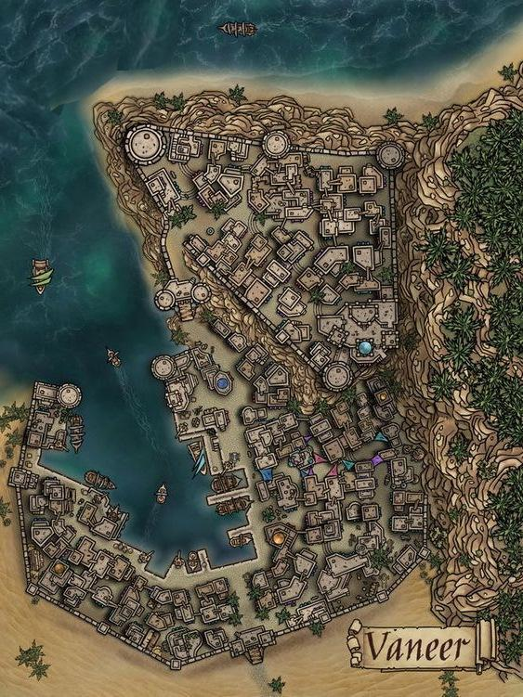

--DESCRIPTION--------------------------------------------------

--SHOPS & PEOPLE--------------------------------------------------

--ECONOMY--------------------------------------------------------

--SPECIAL FEATURES--------------------------------------------------

--HISTORY----------------------------------------------------------

--SHOPS--------------------------------------------------------------

--INNS---------------------------------------------------------------

### Town- Requlen – Shanty Dry Village

<Image>

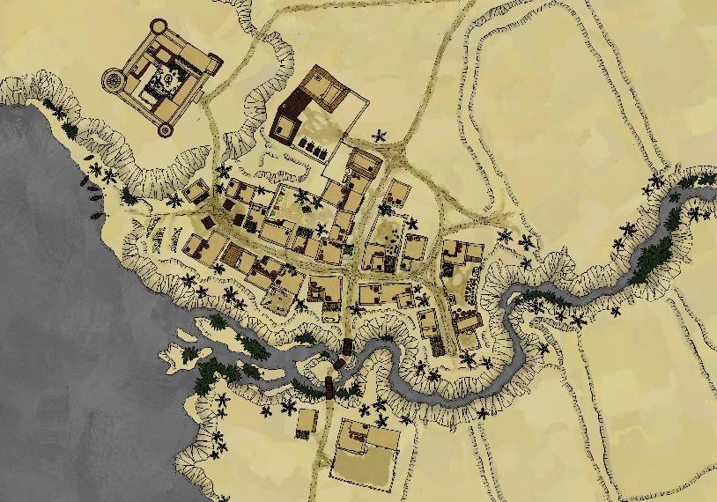

--DESCRIPTION--------------------------------------------------

--SHOPS & PEOPLE--------------------------------------------------

--ECONOMY--------------------------------------------------------

--SPECIAL FEATURES--------------------------------------------------

--HISTORY----------------------------------------------------------

--SHOPS--------------------------------------------------------------

--INNS---------------------------------------------------------------

### CAP - Enigmus (Capital)

<Image>

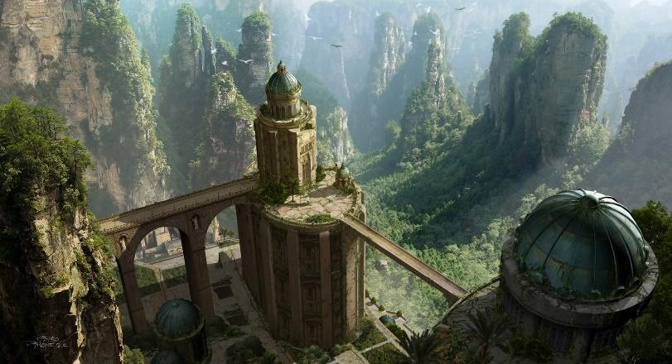

--DESCRIPTION--------------------------------------------------

--SHOPS & PEOPLE--------------------------------------------------

Lord

Nobility

Nobility

Alchemist

Gld. Member

Trader

Smith

Smith

Shopkeeper

Shopkeeper

Bartender

Innkeeper

Farmer

--ECONOMY--------------------------------------------------------

--SPECIAL FEATURES--------------------------------------------------

--HISTORY----------------------------------------------------------

--SHOPS--------------------------------------------------------------

--INNS---------------------------------------------------------------

## Dynasty - Xecuria (21)

<Representative Image>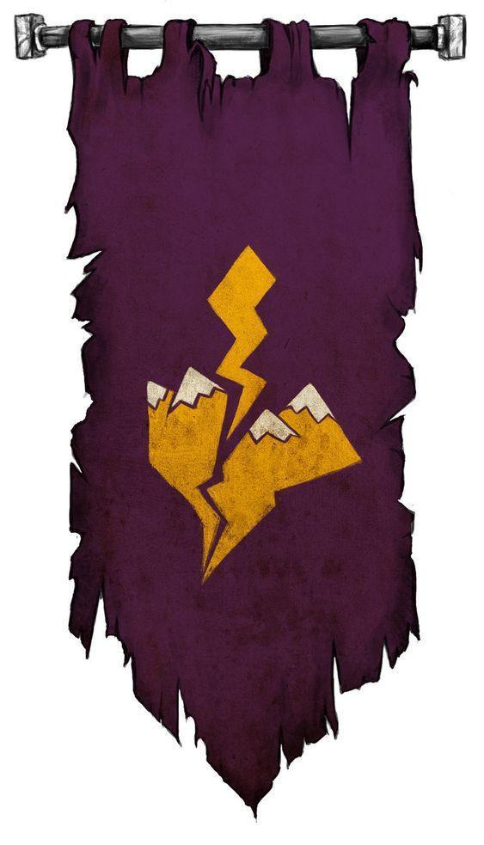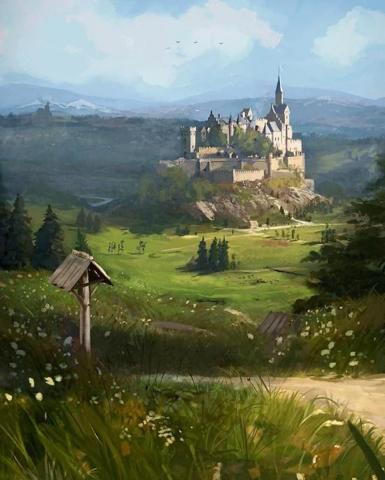

<Basic Description>

The Dynasty of Xecuria is one of the newest-established authorities of power on the western continent, at 829 years.

### Summary

*Geography in summary*

The Dynasty is separated from The Collective and Morheim kingdom by a mess of mountain ranges and dense forests. Few well-known passages cut through the mountains of the Dwarves or the forests that lead to The Collective.

The wilderness off the beaten paths are travelable, but seldom kept in check and are believed to be quite dangerous.

*Culture in summary*

#### Laws and Government

#### Goals

Queen Andale has recently launched a campaign to validate old tales passed on from her family. The tales tell of an ancient weapon held by the mad king, and used to threaten the broken kingdoms into submission. If such a weapon truly exists, she'd rather it be in the secure hands of her dynasty, should she ever need it.

New writing:

Xecuria

Prior to the end of the Age of Man, The region of Xecuria was part of the Morheim Kingdom. And though while part of the kingdom, their distance from the capital and division along the mountains left them to govern largely for themselves. It’s here where they found their strength, and build the Mistvalley Keep.

**MVK**

The keep was built halfway between the western side of the mountain range of the same name. The keep is furthest in distance from the reach of Morheim, with only one main route through the mountains as access. Beyond the keep to the west is a rich, fertile farmland with scattered forests rish in quality timber and fauna. Beyond that is the vast Andalin Coast and an unending sea. It’s from here that Mistvalley held power and influence.

The Keep was Seen over by a council of men, most of which who believed in the independence from Morheim. This council argued and discussed their best means of development, well into the reign of the mad King Arteron.

**HISTORY**

During the rule of the Arteron, The city leaders of the region came together in council once more, and voted on the fate of the Xecurian region. Of the 15 cities in this province, 12 opted to break away from the kingdom and 3 opted to stay. The three that opted against the rest were Revari, Usuall, and Freeton.

The people faced retaliation from Morheim, especially those set father east. But thankfully, the region was prepared. They developed in quiet until the region was well functioning without external influence. The council developed an authority regement known as **The Keepers** who would patrol and police the land. The laws drew much from Morheim but without the severe punishments of the King’s law, leading to further support and participation from most cities.

Once support was solidified and their economy stabilized, the council sent a regional letter of withdrawl to the mad King, expecting the worst. And the worst was to come. Their immediate response was to send an army through the mountains and forest to reclaim the lands by force. But thankfully the preperation of Xecuria was worth the effort.

The bridge at revari was collapsed, and the mountains abandoned to the influence of dragons and trolls. The winding river and ancient bridges to Still creek made travel impossible for an army, and the winter soon set in. The mad king was reckless, and his distance from Xecuria had completely desensitized his know of the kingdom’s influential reach.

Crossing over the mountains brought on giants, bandits, and weather so severe that many regiments could not even survive the retreat home. Crossing The Tarsal Desert, The Thicket and the Dry forest without a willing guide led to an equally quick demise from the environment. No one knew exactly how they came to fall, but tales tell of soldiers limping into towns before collapsing and dying at the gates. They soon retreated and regrouped, but the damage was done.

**Kings Port** operated at the main port city of the region, promoting open trade to hasten advancement abroad, including the sharing of ideologies and news. The road to **MVK** was interrupted only by:

**Pilfernook,** a small clean town known to house families of sailors and merchants alike, given it’s safe location.

**Somarden** lies at a roads split, at the tip of two expansive woodlands. Their livlihood is made up largely by timber, trades, and mining of the mountains to the north. Their ideally placed location amongst abundancy grew then a quick and formidable wealth, leading to the town being one of walls and industry. **MVK** wisely chose to house nobility and security forces here, and dubbed the location “South Warden” for that purpose.

**Esperia** is known to many as Spyre, given the unnatural sharp stone tower that sits in the middle. The tower is hundreds of feet high with relatively flat land around it, leading to an ideal watch point for folk to hold a strong lay of the land. The rest of the city is build on the gradual hillside nearby.

**Revari** is the easternmost town of the region, sitting at the far end of the mountain corridor from **MVK.** This town is held almost by force for Xecuria due to it’s critical placement, allowing for ample warning of coming invasions. The city itself lies in a valley between a Lake of the same name, and the vast mountains to the east. As such, their economies rely heavily on mining and fishing. For a while though, the Morheim city of Montistum held influence via trade and proximity, leading to the status of Revari as teetering. Sitting nearby are old ruins of a waystone.

**Still Creek,** south of Revari, is small and one of the most independent towns in the region. Isolated by river, forest, moutnains and distance, the people of Still creek live in happy quiet. This has also made them weary of newcomers, however. But **MVK** relies on their Still Forest claim to collect a rare lumber used for special arcana. People here choose to focus on spiritual balance and beauty in simplicity. Sitting nearby are old ruins of a waystone.

**Hearth** is, like Revari, aptly placed in a critical pass through the mountains. Because of this, **MVK** holds special consideration for their needs. Hearth lies by a magnificent waterfall and rich mines of gold and silver. At the heart of the waterfall is a dormant volcano of Mt. Espeer that leads into a dead region of the underdark, known to none. The surrounding land of the moutnain pass is dense shrubbery with a stone road cut through. Sitting nearby are old ruins of a waystone.

**Freeton** is a large city of mainly self-suffiency. While a large distance from **MVK,** it also lies at he end of the moutain range. It lies in land rich in fertility, and sparse woodlands that serve their needs. The people here are prosperous and happy. With mining, lumber and agriculturally rich lands, opportunity is plethoric. Their allegiance to Xecuria comes from the lighter hand of law compared to Morheim. Freeton rules know of an old and somber duty that they must carry out, no matter their ruler. A small group of seeming-mercenaries travel often to the south to scout the forbidden lands for any changes.

**Oberon Port** is a massive city by means of towns. Sitting on a nearby hill is a massive version of a waystone circle- the only of which stands in full glory. The town itself sits on the cost, 10 leagues from the trickling end the Esper River. They chose to build away from the river for fear of it’s unnatural purity being spoiled by industry and visitors. It operates as the largest trading hub abroad, but seaside trade is expensive due to the distance required. Nearby however is a rich reefland across the Zircon Straight, where rare and expensive materials are found (amongst old unclaimed ruins too). Nevertheless, the people of Oberon know wealth well. They also know of an old monster lurking in the nearby growth.

**Zirconia** Zirconia is a grand, prosperous city in southern Xecuria. Their cove, Zircon-Sol, is home to the gates of Lumas and a magnificent port. The ships made here are said to be able to last centuries. The people here are determined and hard working, known for having a strong sense of community and mutual benefits in life. Zirconia sits on it's own island, connected on road by a short ferry ride. It’s land offers bountiful crop, ample forestry and peculiar ruins to the north.is A 3,300 mile journey of varying seas bring ships to and from the Shattered Isles. As such, far-visiting ships are large and sturdy built, only visiting on larger expeditions. Their first stop? Zirconia. For **MVK,** holding the entire coast is critical for it’s security both against Morheim and other forces as well. Queen Andale  **Far Point** is known just as that. The farthest point of the region. Last before the piked river border of Underrun, which is forbidden to all in the world. Far point sits in a coved region of the coast, offering still seas and an easily-defensible position. Far Point’s prowess comes from being known as an ancient city, beautiful and grand. And so it was… before it’s decline. The city now sits almost forgotten, too far for most to venture. Nevertheless, it’s is largely suited to accommodate a naval way of life, with a multitude of farms surrounding the city. Most people here know their way around a boat and probably have their fair share of stories to tell. **MVK** uses the city as a last stop before embarking large ships to the rest of the world to share their culture, goods, stories, resources and people in exchange for the same.

**East Warden** is the closest town to **MVK**, and serves as the main training site for all Xecurian soldiers. The Valley they train in is heavily armed and barricaded, making fantastic training grounds. It also serves as the last line of defense from the mountain pass to the east. The two rivers surrounding East Warden converge to the south. The keep sits atop a slight hill, surrounded by mountains. Originally a dwarven hold, it was abandoned and fell into ruin until the Dynasty rediscovered and renovated it. It's said to still hold some secrets deep in the crypts of the hold.

**Druin** was established as a safe haven during the divergence of Xecuria from Morheim. It acted as refuge to travellers, following the effort of the dynasty to validate their claim. And because Druin was set at a crossroad of two major trade routes, they spent considerable effort to build it up.

The surrounding lands are mainly farmlands and scattered forests, with a field of rolling hills to the east. The people here are strong, humble and kind. They welcome newcommers with open arms, and an ale in hand.

**Elafi Field** sits north of the Nightstar Fields and east of the forest of the same name. Nestled at the convergence of two rivers and two main paths, their livlihood draws from the frequent traffic of newcomers. Elafian’s are welcoming, yet weary people, as they value the quality of their land and upbringing. Sharing the Cindere and Redwater river give them a special, iron-rich water that breeds heavy fertility in the surrounding lands. The water also brings natural wonders, plants and beasts alike.

**Red Rock** is a sister town to Usuall, both ancient and calm. They found peace on the shores of Lock Redwater, under the watchful eyes of a dragon clan. The road to Red Rock and Usual are not ones for the weary, as many mountainous passes and roaring rivers hold many dangers. After all that is a road of water or 15 miles of sheer cliff to climb.

The people here are wise and full of spirituality. Their dragon onlooker acts as a diety, and their loch is full of enough life to hold them for generations to come. Are they better off for being isolated? Or is ignorance bliss?

**Usuall** is more easily accessible of the two sister towns of Loch Redwater. Still a ways away, their waystone allows easy access to those who know it’s secrets, which is most. The town also lies at the natural gats of the Direshade valley, a wild and unforgiving land of ruins and wonder.

**Andale Port** is

**Cindere** is

**Cledge** is

#### Leader/Lord

--DESCRIPTION--------------------------------------------------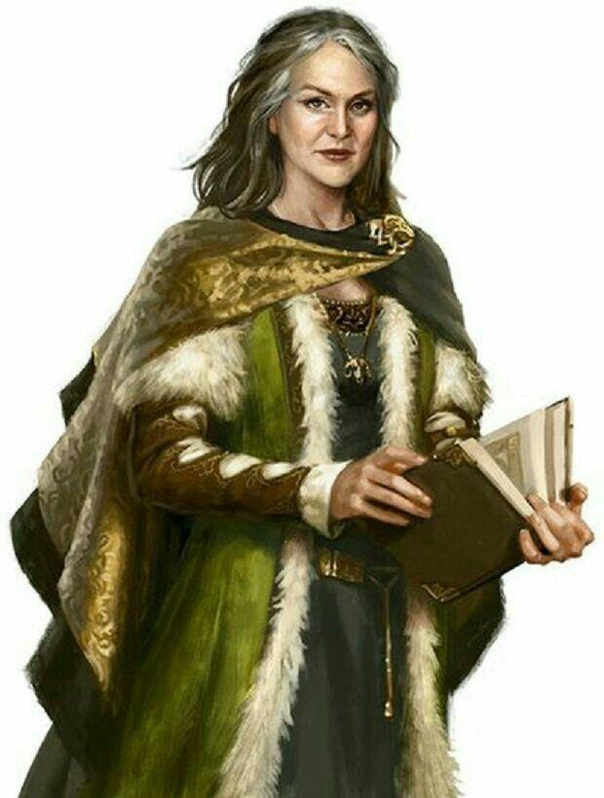

Their Leader, Queen Andale Xecuria, is a learned mage that has led the dynasty for the last 45 years. She studied much of her life at the University.

#### History

*Brief and limited to the story of its formation and current situation

Prior to the end of the Age of Man, The region of Xecuria was part of the Morheim Kingdom. And though while part of the kingdom, their distance from the capital and division along the mountains left them to govern largely for themselves.

During the rule of the mad king Arteron, The city leaders of the region came together in council, at the Mistvalley Keep, and voted on how they wanted to proceed in this world. Of the 15 cities in this province, 12 opted to break away from the kingdom and 3 opted to stay. The three that opted against the rest were Revari, Usuall, and Freeton.

Their leaders feared retaliation from the Kingdom and, as border-facing towns, believed they would be the first to fall. Soon after news of the vote came to public, the citizens of the three cities were quick to revolt and replace their leaders, in favor for leaders with different views.

Unfortunately, their fears came true all too soon. A letter of withdrawal was sent to Korthal, and their immediate response was to send an army through the mountains and forest to reclaim the lands by force. Their campaign was short-lived though, as their distance had completely desensitized the kingdom to their reach.

Crossing over the mountains brought on giants, bandits, and weather so severe that many regiments could not even survive the retreat home. Crossing The Tarsal Desert, The Thicket and the Dry forest without a willing guide led to an equally quick demise from the environment. No one knew exactly how they came to fall, but tales tell of soldiers limping into towns before collapsing and dying at the gates. They soon retreated and regrouped, but the damage was done.

### CAP - Mistvalley Keep – Castle of Iron

The Keep of Freedom and Order

<Image>

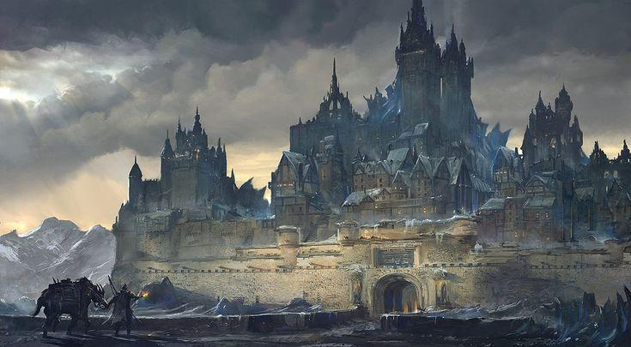

^^This but hella patrollings

--DESCRIPTION--------------------------------------------------

Soaring high into the fog-covered lands along the end of forested hills is the Mistvalley Keep- a massive castle made centuries past. Standing still, the castle has been converted into the capital location of the Xecuria Dynasty. Sitting atop this throne is Queen Andale Xecuria.

Queen Andale Xecuria

--SHOPS & PEOPLE--------------------------------------------------

Queen Andale Xecuria, 74

Prince Greggelosh Cortex, 65

Judge Austin Mcnamara, 27

Lord Ashly Bonsaw, 83

Priest/ess Greggelosh Cortez, 65

Priest/ess Rex, 47

Nobility Alon Allen, 12

Nobility Rex, 47

Enchanter/ress Mahtata Vega, 57

Alchemist Darren, 83

Alchemist Nyla Salter, 90

Teacher Gadriel Strife, 102

Guard Holly Mill, 94

Gld. Member Robert Fowlkes, 75

IT officer Rosanne Firekin, 112

IT Officer Darrrn, 83

Smith Ooglie Elkrana, 28 By Hammer by Hand

Smith Robert Dently, 77 The Mithril Arms

Smith Rosanna Firekin, 112 Silvermoon Landing Smithy

Stable keeper Gary, 30 Stables

Shopkeeper Nyla Salter, 90 Nyla's Emporium

Shopkeeper Mahtata Vega, 57 Royal Open Market

Shopkeeper Robert Fowlkes, 75 Mountain Road Goods

Shopkeeper Jane Doe, 14 Centre Lane

Shopkeeper Mariah Bentli, 45 The Blushing Sphere

Groundskeeper Jane Riese, 7 Nothing

Innkeeper Robert Dently, 77 The Courageous Grasshopper

Innkeeper Uriel Leclerc, 13 The Soothsayer

Citizen Eve Janson, 27

Citizen Geor Tinney, 52

Citizen Flip Ness, 29

Farmer Wulfyria Rojas, 81 Local Farm

Undecided Joel Mel, 19

Undecided Gert Ille, 34

--ECONOMY--------------------------------------------------------

--SPECIAL FEATURES--------------------------------------------------

Church Rex

Keeper

Relic Alliance Nyla Salter

University Gadriel

--HISTORY----------------------------------------------------------

--SHOPS--------------------------------------------------------------

--INNS---------------------------------------------------------------

### CITY - Andale Port – Heart of Andale

<Image>

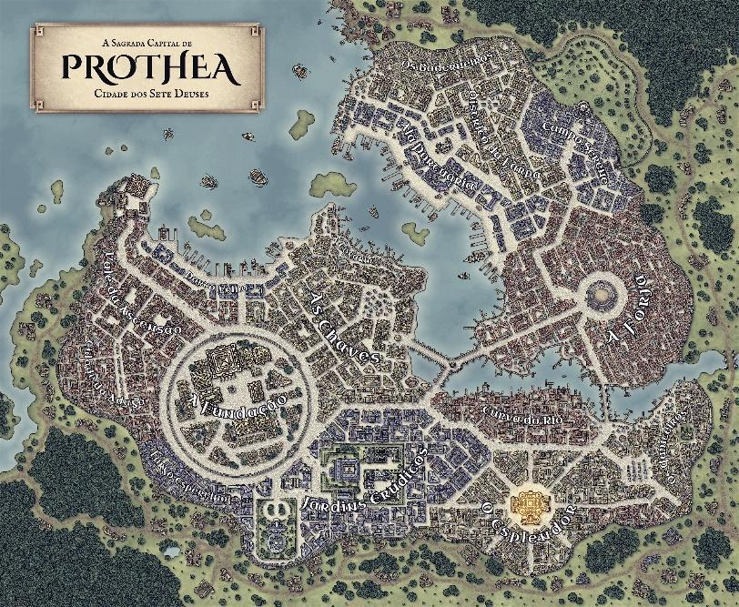

--DESCRIPTION--------------------------------------------------

Andale port is a large port city, the northern most port in Xecuria. The city is entirely walled, as raiding bands are frequent in surrounding areas. A small river runs through the town from the forest, sometimes turning odd colors for unknown reasons.

The town's main export is Blueleaf and Suth, two very rare woods found in the Winter Woods.

--SHOPS & PEOPLE--------------------------------------------------

Lord Dean Richards, 74 Andale Port

Priest/ess Roswall, 89 Andale Port Religion

Port Master Frasier, 82

Nobility Cristin Cabaniss Xiong, 92

Alchemist Lucille Spycey, 47 The Fair Wizard

Gld. Member Melodee Rojas, 101 Guild Affairs

IT officer Marge Kim, 79 Andale Port Guards

Smith Claudette Carelton, 112 Magma Man

Shopkeeper Celestina Flatwater, 36 The Royal Open Market

Shopkeeper Cassandr Maria, 24 The Pink Elf Toy Store

Innkeeper Lyna Mackenzie, 5 The Flower Shop

Citizen Raym Pontecorvo, 20

Citizen Walter Sergeant, 47

Citizen Katie Ccabe, 100

Farmer Roni Lsen, 35 Local Farm

Farmer Cade Nacolse, 42 Local Farm

--ECONOMY--------------------------------------------------------

--SPECIAL FEATURES--------------------------------------------------

--HISTORY----------------------------------------------------------

--SHOPS--------------------------------------------------------------

--INNS---------------------------------------------------------------

### CITY - Cindere – City of Hills and Magma

<Image>

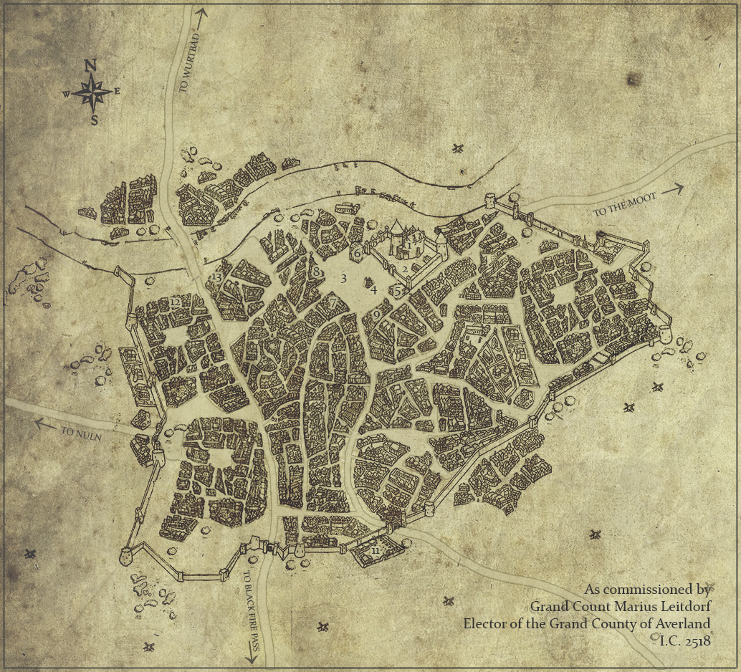

--DESCRIPTION--------------------------------------------------

Cindere is a medium sized trading town just to the north of Mistvalley Keep. Due to it's proximity the the capital along a major travel route, Cindere receives great wealth and trade.

Cindere sits at a crossroads, with one road heading to Druin and another taking a much longer road to Red Rock, through the countryside and lowland hills of Xecuria.

The Lord, Christiana, is strict and sure of herself. She hopes to join the Queens court and is fine to play the game until then.

--SHOPS & PEOPLE--------------------------------------------------

Lord Christiana Amundsen, 48 Cindere

Priest/ess Erltos Aekers, 13 Cindere Religion

Nobility Stuart Nierst, 14

Nobility Elio Osel, 20

Alchemist Amy Larkins, 44 The Shady Cloak

Gld. Member Marguerite Patvers, 4 Guild Affairs

IT officer Dome Kristiansen, 4 Cindere Guards

Smith Rory Teau, 15 Mithril Arms

Shopkeeper Penesca Ackse, 7 Herbs n' Stuff

Shopkeeper Rosi Gibson, 12 The Royal Open Market

Innkeeper Kacie Saks, 43 Flower Girls

Citizen Bran Ante, 35

Citizen Kord Gusk, 8

Citizen Reuben Adamsen, 16

Farmer Abel Say, 37 Local Farm

Farmer Isidro Cnacia, 32 Local Farm

Undecided Abielde Pypeeki, 22

Undecided Brigitte Tte Tray, 3

Undecided Anthony Boista, 12

Undecided Olie Lsen, 52

--ECONOMY--------------------------------------------------------

--SPECIAL FEATURES--------------------------------------------------

--HISTORY----------------------------------------------------------

--SHOPS--------------------------------------------------------------

--INNS---------------------------------------------------------------

### Town- Druin – Village of Walls and Farms

<Image>

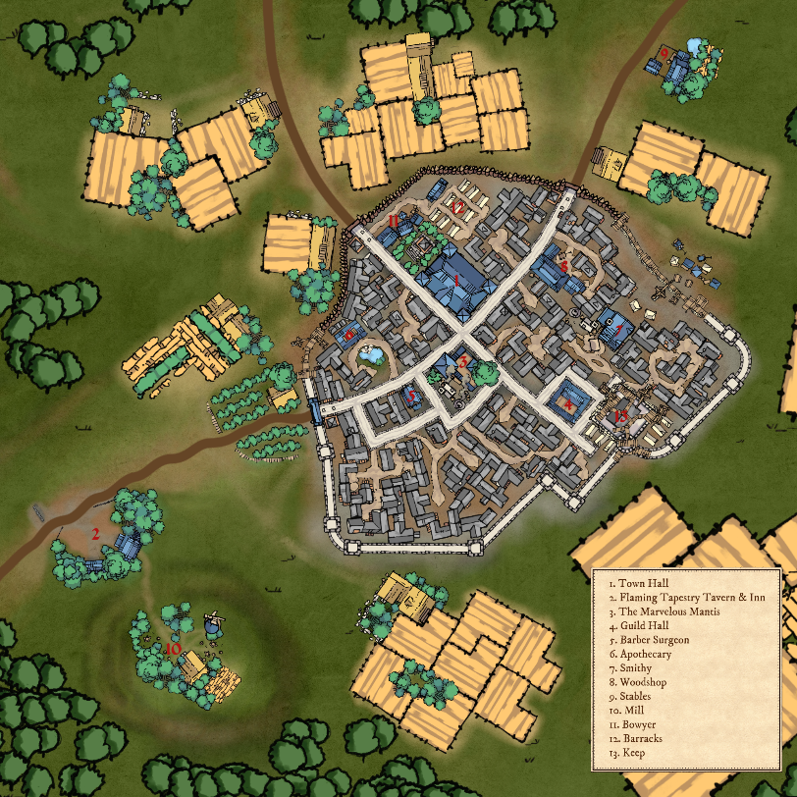

--DESCRIPTION--------------------------------------------------

Druin was established as a safe haven during the divergence of Xecuria from Morheim. It acted as refuge to travellers, following the effort of the dynasty to validate their claim. And because Druin was set at a crossroad of two major trade routes, they spent considerable effort to build it up.

The surrounding lands are mainly farmlands and scattered forests, with a field of rolling hills to the east.

--SHOPS & PEOPLE--------------------------------------------------

Lord Burocco Babineaux, 20 Druin

Priest/ess Rantere Bertsen, 21 Druin Religion

Nobility Carter Gillani, 2

Nobility Kalfora Hult, 28

Alchemist Calb Boll, 50 The Serene Hourglass

Gld. Member Wance Hance, 39 Guild Affairs

IT officer Ron Ldt, 62 Druin Guards

Smith Tyren Onsen, 75 Block and Anvil

Shopkeeper Ster Sen, 25 Traveller's Needs

Shopkeeper Katrin Hardie, 17 Lillypad Llane

Innkeeper Jack Giff, 69 The Soothsayer

Citizen Amicil Melville, 16

Citizen Assie Adon, 23

Citizen Elli Onth, 14

Farmer Miles Pokulsk, 24 Local Farm

Farmer Roycell L Caron, 53 Local Farm

Undecided Cart Abel, 47

Undecided Dalonic Ware, 5

Undecided Santheo Gomecen, 32

Undecided Wani Gunt, 25

Undecided Jessie Nack, 1

Undecided Tambra Nglais, 26

Undecided Ruben Organ, 17

Undecided Zane Lumo, 12

Undecided Immerev Nailosc, 161

Undecided Jacalyn N Ackel, 35

--ECONOMY--------------------------------------------------------

--SPECIAL FEATURES--------------------------------------------------

--HISTORY----------------------------------------------------------

--SHOPS--------------------------------------------------------------

--INNS---------------------------------------------------------------

### Town- East Warden – Military Base

<Image>

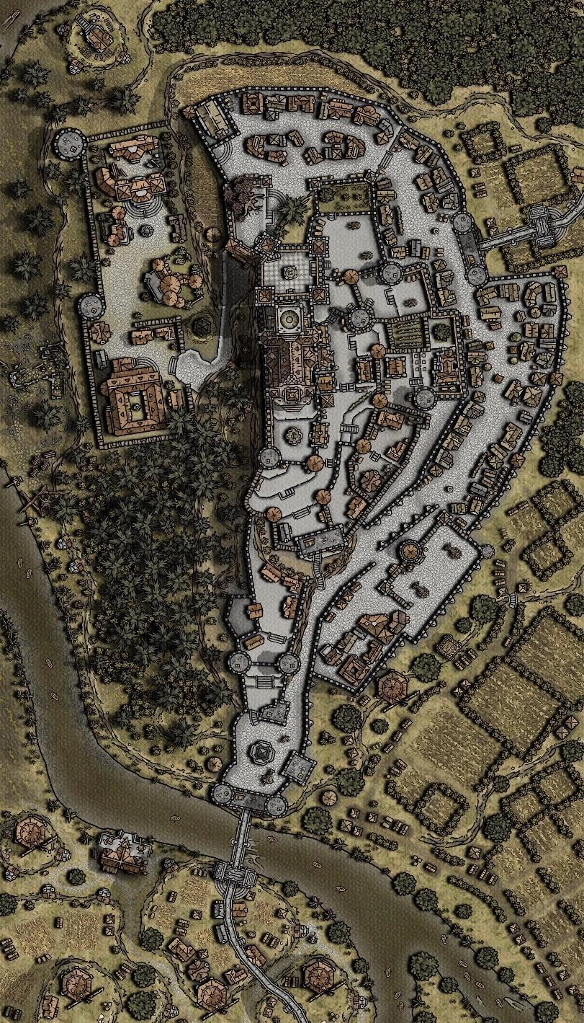

--DESCRIPTION--------------------------------------------------

East Warden is the nearest notable location from Mistvalley Keep. It acts as the main hold of the military for the Keepers.

The keep sits atop a slight hill, nestled between two rives and surrounded by mountains. Originally a dwarven hold, it was abandoned and fell into ruin until the Dynasty rediscovered and renovated it. It's said to still hold some secrets deep in the crypts of the hold.

--SHOPS & PEOPLE--------------------------------------------------

Lord Leland Ley, 31 East Warden

Priest/ess Liff Lywedeu, 48 East Warden Religion

Nobility Earl Mcadams, 18

Nobility Sabl Pasternak, 59

Alchemist Rartist Dumel, 9 Fantasma

Gld. Member Archie Port, 14 Guild Affairs

IT officer Taunya Allels, 18 East Warden Guards

Smith Jammie Smolak, 28 Dark Flame

Shopkeeper Nan Ova, 18 Ivy Street

Shopkeeper Terrill Maccrum, 26 The Closet

Innkeeper Shaunna Mcnes, 14 The Midwife & The Mocking Artist Inn

Citizen Heremin Daniel, 14

Citizen Jacob Morel, 15

Citizen Brya Szwarc, 1

Farmer Kelci Lek, 46 Local Farm

Farmer Stefany Wyrette, 12 Local Farm

Undecided Shaun Kranc, 7

Undecided Wichen Monet, 7

Undecided Sammie Vaughn, 57

Undecided Rumber Ffmann, 14

Undecided Gus Olt, 26

Undecided Mackenzie Dennel, 14

Undecided Step Ohar, 24

Undecided Haylee Arnier, 21

Undecided Lindy Utkin, 15

Undecided Mynd Olff, 26

--ECONOMY--------------------------------------------------------

--SPECIAL FEATURES--------------------------------------------------

--HISTORY----------------------------------------------------------

--SHOPS--------------------------------------------------------------

--INNS---------------------------------------------------------------

### Town- Elafi Field – Villlage of Farmers and Fields

<Image>

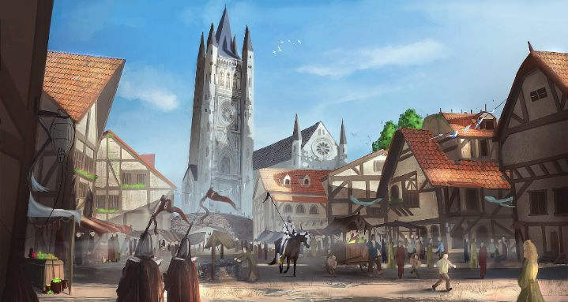

--DESCRIPTION--------------------------------------------------

Elafi Field Sits farther to the north in Xecuria, as a smaller farming village. They people of Elafi aren't too kind to those they don't know, and like to keep to themselves.

There's a supposedly haunted forest to the West of Elafi Field, reaching all the way to the coast.

--SHOPS & PEOPLE--------------------------------------------------

|  |  |  |  |
| --- | --- | --- | --- |
| Lord | Adol Forey, 102 | Elafi Field | Human |
| Priest/ess | Dewey Blackburn, 68 | Elafi Field Religion | Human |
| Nobility | Gery Ever, 33 |  | Human |
| Nobility | Fat Greek, 43 |  | Human |
| Under Keeper | Marrema Ma Roel, 29 | Elafi Field Guards | Human |
| Alchemist | Elvera Rivers, 93 | Humble Leprechaun | Elf |
| Guild Member | Dando Bowarro, 26 | Guild Affairs | Half-Elf |
| Smith | Tonya Sutherland, 31 | From Limb to Limb | Human |
| Shopkeeper | Laure Duchamps, 47 | Critter Closet | Half-Elf |
| Shopkeeper | Nickolas Lummiln, 21 | The Royal Open Market | Human |
| Innkeeper | Anic Lisa, 23 | The White Dove | Human |
| Citizen | Brendan, 109 |  | Elf |
| Citizen | Barb Draper, 28 |  | Human |
| Citizen | Anatol Fasharash, 56 |  | Human Male Retired Scribe |
| Farmer | Micha Drake, 29 | Local Farm | Human |
| Farmer | Tori Olan, 18 | Local Farm | Human |

--ECONOMY--------------------------------------------------------

--SPECIAL FEATURES--------------------------------------------------

--HISTORY----------------------------------------------------------

--SHOPS--------------------------------------------------------------

--INNS---------------------------------------------------------------

### CITY - Esperia – Spyre on the Hill

<Image>

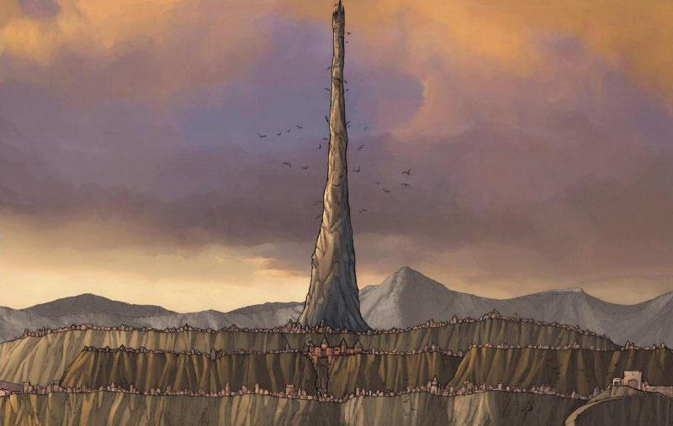

--DESCRIPTION--------------------------------------------------

Esperia is commonly referred to Spyre, for the tower in the center. Esperia holds the tallest constructed structure known to mankind, and houses the cursed princess Ley until such a time as she can be healed.

The surrounding city of Esperia runs up a very gradual hill with 3-4 main streets. At the top of the hill are guard training posts and a large mining project under works. Little more is known as civilians aren't allowed up to the top.

--SHOPS & PEOPLE--------------------------------------------------

Princess Ley Mcnamee, 41

Lord Clad Arnuanna, 54 Esperia

Priest/ess Renato Howarth, 110 Esperia Religion

Nobility Brice Fishcher, 80

Guild Me Tanner Ubelse, 33Guild Affairs

IT officer Les Rtz, 86 Esperia Guards

Smith Erme Cottrell, 56 Hammer's Block

Shopkeeper Sunny, 53 The Royal Open Market

Miner Zachary Vendsen, 46

Innkeeper Astrid Dawnweaver, 40 Haven

Citizen Kenna Mcilnes, 28

Farmer Wyin, 64 Local Farm

--ECONOMY--------------------------------------------------------

--SPECIAL FEATURES--------------------------------------------------

--HISTORY----------------------------------------------------------

--SHOPS--------------------------------------------------------------

--INNS---------------------------------------------------------------

### CITY - Far Point – Ancient City of Adventurers

<Image>

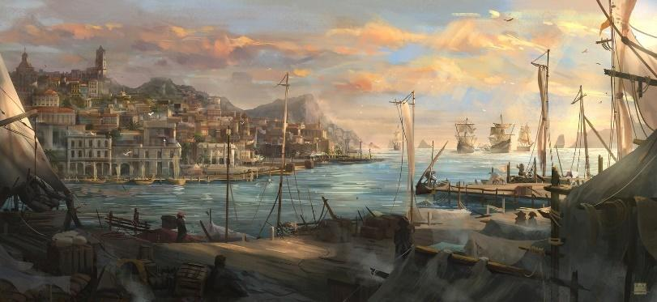

--DESCRIPTION--------------------------------------------------

Far point is known as the ancient city of adventurers. It's recent status is closer to a dying town that few visit, given it's close proximity to the strictly monitored region border. While one can sail out the inlet of the area, anyone found crossing the border wall into the Forbidden Lands is punishable by death. The only exception comes with explicit permission given by someone in the queens court.

The town itself is beautiful and grand. The architecture is largely suited to accommodate a naval way of life, with a multitude of farms surrounding the city. Most people here know their way around a boat and probably have their fair share of stories to tell. The leader, Cher, was once head of the Chasers of the Great Storm, and is only one of few known to have both travelled so far in the world, and survived the deepest levels of the Everstorm.

--SHOPS & PEOPLE--------------------------------------------------

Lord Cher Tron, 133 Far Point

Priest/ess Jefry Maria, 20 Far Point Religion

Nobility Kend Charbonneau, 17

Nobility Jackson Cloudbend, 30

Alchemist Reshson Caskajaro, 76 Feathered Serpent

Gld. Member Kath Denholm, 38 Guild Affairs

IT officer Jover Acrae, 31 Far Point Guards

Smith Rachel Damsen, 15 Blood, Bath and Beyond

Shopkeeper Jacob Zdunowski, 27 The Antique Tankard

Shopkeeper Kerry Smith, 24 Rellish

Innkeeper Master Mccartney, 31 Clear Comfort for Coin

Citizen Rica Doomkeeper, 74

Citizen Alexandre Amberdown, 40

Citizen Rhell Allum, 18

Farmer Maere, 250 Local Farm

Farmer Temple Tillman, 49 Local Farm

--ECONOMY--------------------------------------------------------

--SPECIAL FEATURES--------------------------------------------------

--HISTORY----------------------------------------------------------

--SHOPS--------------------------------------------------------------

--INNS---------------------------------------------------------------

### CITY - Freeton – City of Independance

<Image>

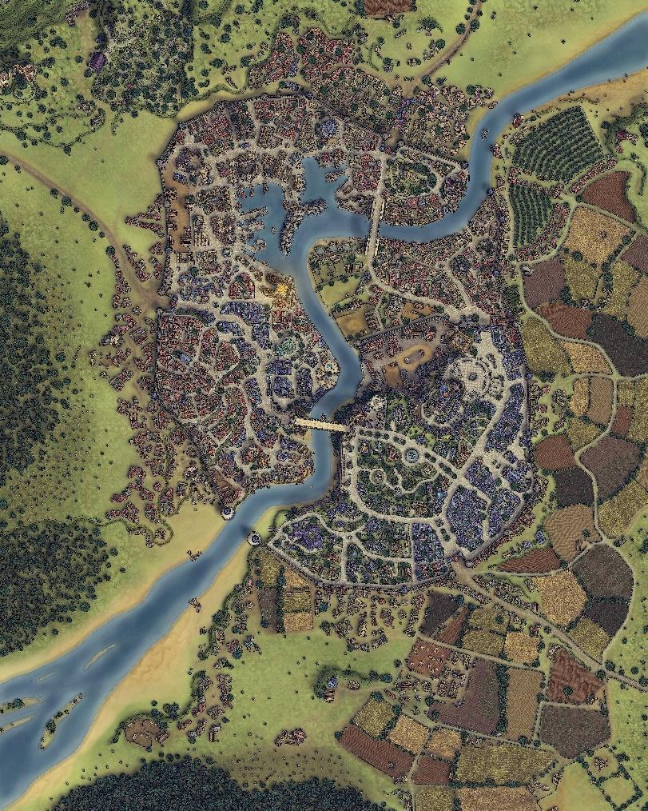

--DESCRIPTION--------------------------------------------------

Freeton is a large, hugely independent city in the Xecuria Dynasty. While they don't require much of the dynasty, they still support them and rely on their armies for security and law.

Freeton sits interestingly on both sides of the tail end of the GMR river, with varying landscapes around them. Mountains to the east, forests to the west and forest plains to the south. They're also close neighbors to Far Point and Zirconia.

The people here are prosperous and happy. With mining, lumber and agriculturally rich lands, opportunity is plethoric.

--SHOPS & PEOPLE--------------------------------------------------

Lord Dino Berg, 20 Freeton

Priest/ess Larissa Danielsen, 46 Freeton Religion

Nobility Jamey Mcleod, 13

Gld. Member Isidro Ness, 28 Guild Affairs

IT officer Ewar Conroy, 88 Freeton Guards

Smith Enna Ilphelkiir, 16 The Broken Feather

Smith Calb Boll, 50

Shopkeeper Brendan Horton, 67 Envy's Eye

Shopkeeper Perteph Abb, 29

Miner Bran Yardley, 22

Miner Niki Ristier, 9

Miner Stia Bowen, 22

Innkeeper Gilbert Daniels, 107 The Aether Pub

Innkeeper Lia Mclain, 23

Citizen Roman Bram, 65

Citizen Jordra Gargutc, 66

Farmer Sara, 84 Local Farm

Farmer Ebar Sall, 11

Farmer Kristofer Pet, 16

Farmer Paul Allen, 21

Farmer Band Nolan, 25

Farmer Alby Faucher, 12

--ECONOMY--------------------------------------------------------

--SPECIAL FEATURES--------------------------------------------------

--HISTORY----------------------------------------------------------

--SHOPS--------------------------------------------------------------

--INNS---------------------------------------------------------------

### Town- Hearth – Harmonic Pathway

<Image>

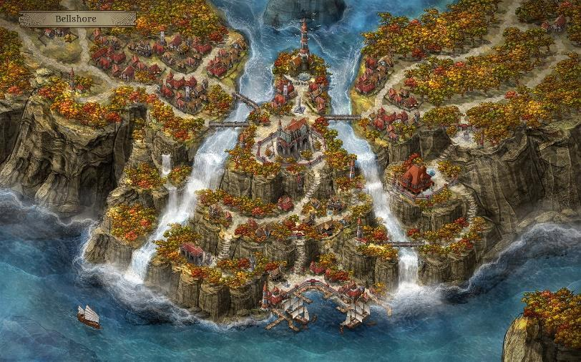

--DESCRIPTION--------------------------------------------------

Set on the crest of a waterfall, Hearth is a resort-like town of peace and tranquility. Hearth brings a calmness to all who visit or travel through.

--SHOPS & PEOPLE--------------------------------------------------

Lord Coleman Cote Boyle, 49 Hearth

Priest/ess Horacio Hayden, 89 Hearth Religion

Nobility Zekin Passen, 27

Nobility Shanthe Brody, 25

Alchemist Yajaira Bodilsen, 27

Gld. Member Paul Dumel, 34 Guild Affairs

IT officer Winfred Alip, 12 Hearth Guards

Smith Sey Zick, 21 Zick Gauntlets

Stable keeper Edie Fay, 18

Shopkeeper Jason Piel, 35 Secrets of GMR

Bartender Crista Tholmer, 15

Innkeeper Talkrio Crainul, 11 The Scary Mouse

Citizen Rennocc Morris, 18

Farmer Julee Ventura, 8 Local Farm

Servant Fonda Otmartz, 64

Undecided Rena Schs, 29

--ECONOMY--------------------------------------------------------

--SPECIAL FEATURES--------------------------------------------------

--HISTORY----------------------------------------------------------

--SHOPS--------------------------------------------------------------

--INNS---------------------------------------------------------------

### CITY - Kings Port – Queens Port City

<Image>

--DESCRIPTION--------------------------------------------------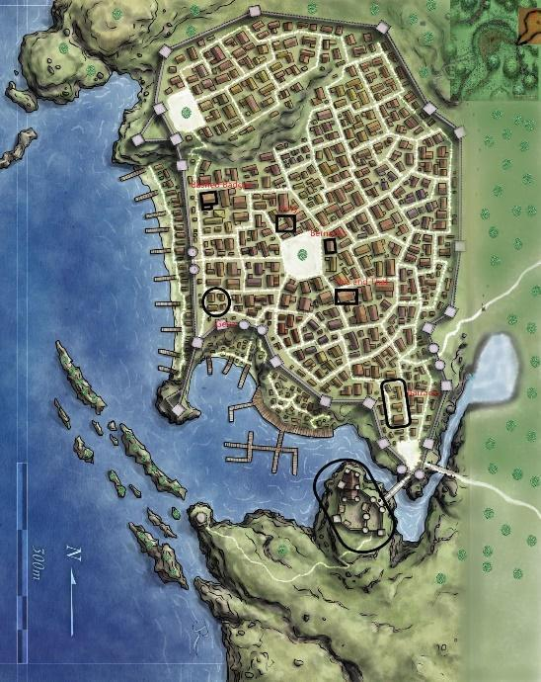

**Kingsport** is a bustling city of ocean and land trade. The ports themselves span many kilometers of assorted docks and sailors can be seen bustling around loading and unloading cargo. A line of houses is built outside the **enormous stone city walls** for temporary housing of captains and importers.

In recent times, the port is slowing down. Ships still come in, but it's lucky if more than half of the ports are filled or working.

Frankie is the Lord of the town

--SHOPS & PEOPLE--------------------------------------------------

Lord Sam, 56 KingsPort

Priest/ess Frankie Edge, 32 KingsPort Religion

Nobility Latonia Dubelse, 43

Nobility Jacob Janik, 38

Guard Leney Howell, 7

Gld. Member Dannette Gripgear, 86 Guild Affairs

Jeweler Mhanie Warrime, 38

IT officer Fritz Garza, 107 KingsPort Guards

Smith Grosabe Burneil, 21

Smith Bennett Dugir, 35 Smelt's of Heaven

Stable keeper Armando Donne, 22

Shopkeeper Quillathe Cortes, 45 Cortes' Goods

Innkeeper Bryant Burtt Mohamed, 82 Chuggs

Citizen Alexis Curry, 24

Farmer Lest Simon, 13

Farmer Heric Rivers, 49 Local Farm

Farmer Barbara Riese, 23

Servant Carla Lachance, 11

Undecided Tison Hberg, 59

--ECONOMY--------------------------------------------------------

Trade, fishing, farming

--SPECIAL FEATURES--------------------------------------------------

The main port gates.

A massive, 70ft arced construction of stone and brick finished with two large, circular towers.

Guarded, with guards checking all cargo coming into the town. Papers aren't necessarily needed for entry, but the guards will ask your business and make sure the visitors will not be causing trouble.

The Lords manor

is located in the southern area of town. Anyone wanting to go there must pass a city gate, cross a bridge, and pass through another gate of a smaller walled area on its own peninsula. The manor is a two-story building on a hillside cliff overlooking the rest of the city, from a distance. Just before the bridge leading to the castle is the garrison outpost. It's headed by **Sam**

The inlet

that divides the mayor's manner runs along the south-east wall of town and ends soon after. Most trips drawn into this area are smashed against small rocks. Only small rowboats can maneuver through the area to find a **small alcove** that houses a forgotten **treasure chest** (Treasure limited to gold and silver)

The town is somewhat different. **It's a huge-gated city** with a large town square used for festivals and Events. The Main bar is Bernard's located in the center of town. It faces the town square and is the main stopping point for all travellers. It also offers the best deal on housing and drinks, which it can afford due to sheer volume.

The higher class section.

of the town is in the north. It's on a hill and can only be accessed by a road in the far west or east. The east if favorable for carriages and a nicer walk, while the west is a criss-crossing path up the hill for walking only. In this area of town is a smaller private square that is patrolled often and well-gardened.

--HISTORY----------------------------------------------------------

--SHOPS--------------------------------------------------------------

--INNS---------------------------------------------------------------

### Town- Oberon Port – Capital of Culture

<Image>

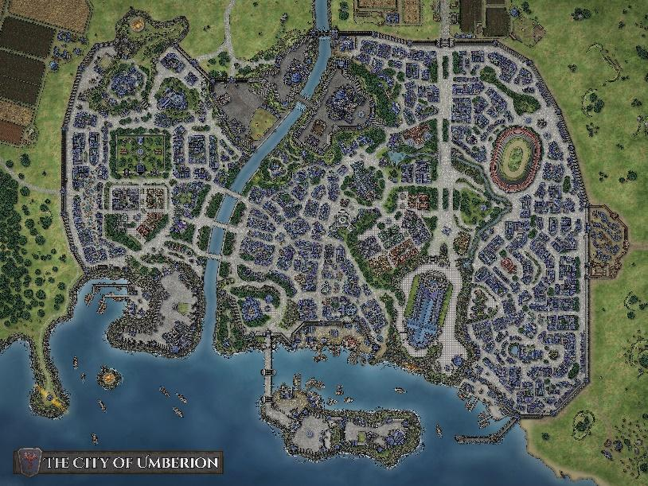

--DESCRIPTION--------------------------------------------------

Oberon Port is the largest city in Xecuria. It operates as the largest trading hub abroad, but seaside trade is expensive due to the distance required. Nevertheless, seaside trade is crucial for domestic operations.

Learned people and wealthy upper-class citizens reside in Oberon. With 7 distinct districts, status is everything in this town.

--SHOPS & PEOPLE--------------------------------------------------

Lord Ellyn Blunt, 71 Oberon Ports

Priest/ess Aron Melendez, 118 Oberon Ports Religion

Nobility Esails Tamrei, 73

Port Master Maynild Walters, 59

Alchemist Lawerence Bardye, 94 Demons and Me

Sailor Carter Owelly, 35

Sailor Jert Davi, 30

Sailor Walen Ntint, 52

Gld. Member Cecila, 25 Guild Affairs

IT officer Sige, 46 Oberon Ports Guards

Smith Alda Lais, 27 Steel Appeal

Shopkeeper Mony Pieran, 11 Center Lane

Shopkeeper Chill Eraro, 32 The Royal Open Market

Innkeeper Bobyron Reurdy, 32 The Nutty Spoon Liquor Store

Innkeeper Asha Ikha, 21

Bard Grick Krith, 20

--ECONOMY--------------------------------------------------------

--SPECIAL FEATURES--------------------------------------------------

--HISTORY----------------------------------------------------------

--SHOPS--------------------------------------------------------------

--INNS---------------------------------------------------------------

### Town- Pilfernook – Home of Homes

<Image>

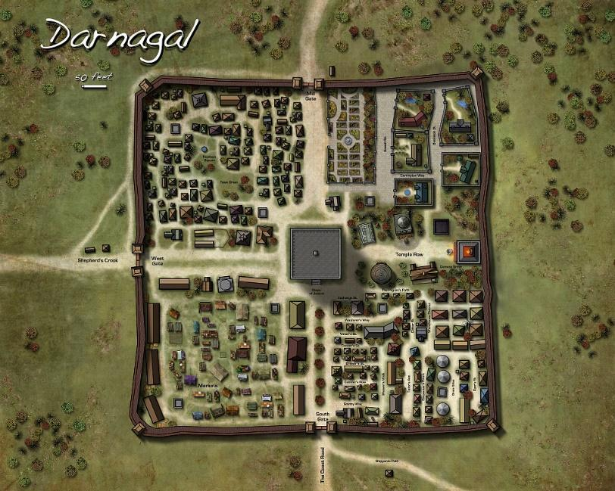

--DESCRIPTION--------------------------------------------------

Pilfernook is known as the town that needs defense from itself. Pilfernook hosts a variety of stereotypes that the citizens are off ball clutz's. The city is, upon visiting, a very well put together and fully functioning society.

In the center of the town is the temple. On the outskirts is an oddly clean and smooth stone wall.

--SHOPS & PEOPLE--------------------------------------------------

Lord Kott Sonsenz, 22 Pilfernook

Priest/ess Silley Arlsen, 37 Pilfernook Religion

Nobility Ting Eldt, 15

Gld. Member Amy Ick, 155 Guild Affairs

IT officer Kinte E Ret, 14 Pilfernook Guards

Smith Winifred Reid, 46 The Stone and Bone

Shopkeeper Thad Falconer, 58 Wizarding Wears

Shopkeeper Valentin Roth, 33

Innkeeper Merle Rcier, 30 The Great Rakshasa

Innkeeper Jevon Wolff, 16

Citizen Tomeon Wolff, 33

Citizen Reece Kovin, 28

Citizen Ahma Biel, 12

Citizen Elwyn Albe, 29

Farmer Ana Rek, 288 Local Farm

Farmer Harvey Osense, 25

Farmer Ashazur Mens, 54

Undecided Cher Tron, 133

Undecided Blossom Buchesc, 38

Undecided Jillian Lewolan, 36

--ECONOMY--------------------------------------------------------

--SPECIAL FEATURES--------------------------------------------------

--HISTORY----------------------------------------------------------

--SHOPS--------------------------------------------------------------

--INNS---------------------------------------------------------------

### Town- Red Rock – Hidden Haven

<Image>

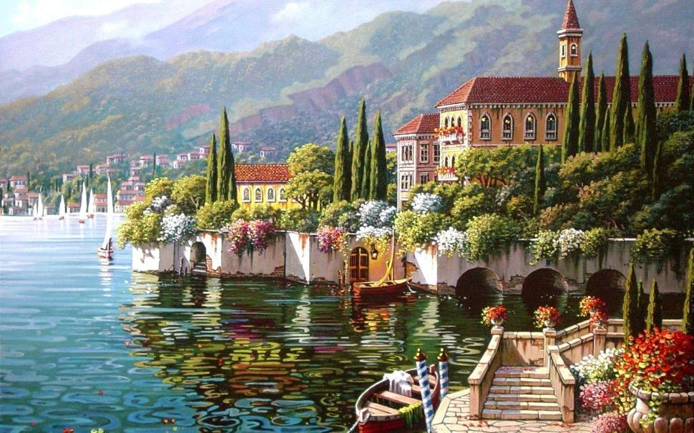

--DESCRIPTION--------------------------------------------------

Red Rock is a wealthy and prosperous city. They enjoy their distance from the rest of the dynasty but still rely on their defenses too. Sitting on red Rock Lake and at the base of the western GMR, Red Rock has achieved riches from mining and mineral harvesting. Most notably is the Red mineral found along the lakebed and in deposits close to the surface of the land.

This Red Rock, named simply as so, has the property of mixing well with stone and brick while also making it extremely strong. Because of the lack of erosion or breaks in the city, it's impossible to accurately date it's est. Some say it predates the dynasty or even the mad king.

As the city is in a time of unprecedented peace, Elix is able to oversee the town with a loose grip.

--SHOPS & PEOPLE--------------------------------------------------

Lord Elix Cabaniss, 37 Red Rock

Priest/ess Jordan Horton, 89 Red Rock Religion

Nobility Dave, 92

Nobility Shenia Ochoa, 94

Alchemist Berta Goode, 80 Red Rock Herbalist

Gld. Member Antone Damsen, 33 Guild Affairs

IT officer Letitia Tia Dup, 27 Red Rock Guards

Smith Laure Doree, 11 Iron Skillet

Shopkeeper Line Salomon, 25 This and that

Shopkeeper Tyler Niersen, 13 The Ivory Moon

Innkeeper Judith Brennal, 11 Sex and Sleep

Citizen Rett Naumov, 16

Citizen Lail Oths, 26

Citizen Lesley Dufmard, 4

Farmer Aryl Vroomen, 0 Local Farm

Farmer Rocco Lorbart, 27 Local Farm

Undecided Orant Powen, 17

--ECONOMY--------------------------------------------------------

--SPECIAL FEATURES--------------------------------------------------

--HISTORY----------------------------------------------------------

--SHOPS--------------------------------------------------------------

--INNS---------------------------------------------------------------

### Town- Revari – Shangri-La of Xecuria

<Image>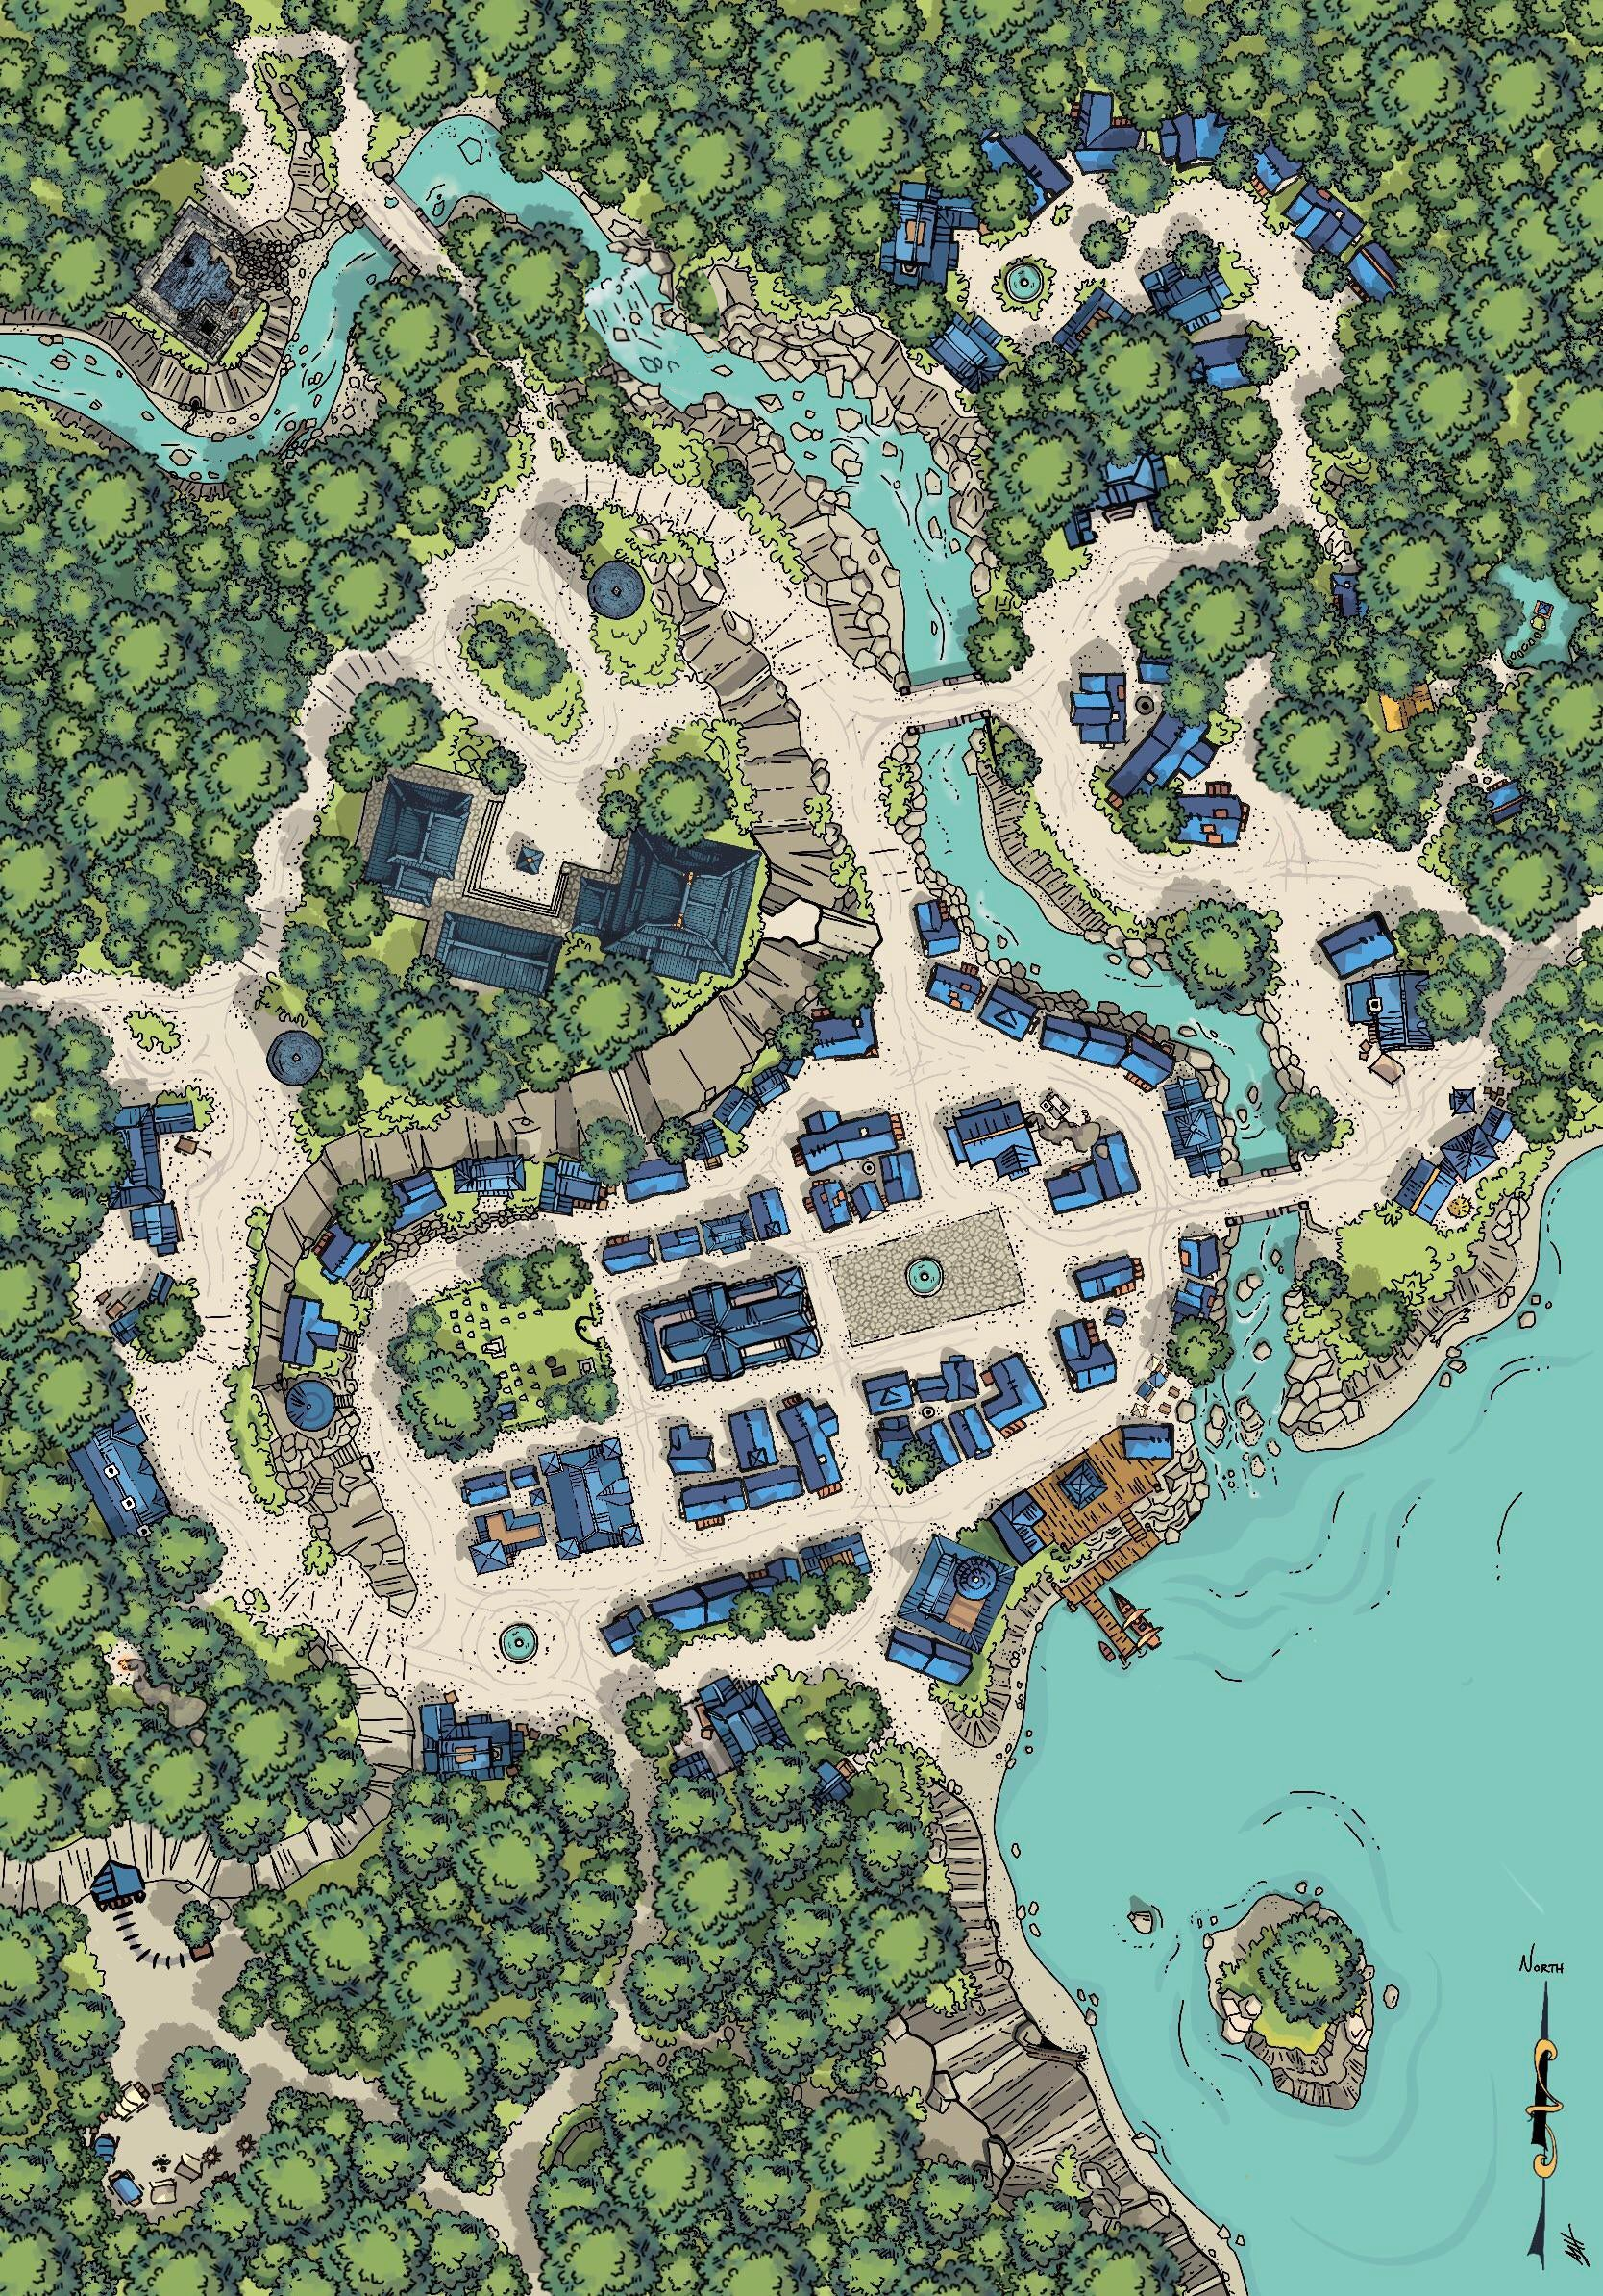

--DESCRIPTION--------------------------------------------------

Revari sits next to the basin of the GMR river, known especially for it's mythical lore. The town was first established by a cult that worshiped a god of the lake, but was eventually overtaken by Morheim.

--SHOPS & PEOPLE--------------------------------------------------

Lord Di Dorrance, 93 Revari

Priest/ess Dante Mcbride, 35 Revari Religion

Nobility Donald, 97

Alchemist Stonn Ntian, 34 Local Farm

Gld. Member Dani Dorrance, 47 Guild Affairs

IT officer Lorban Loadhauler, 97 Revari Guards

Smith Solaine Hayden, 77 Revai Smithy

Shopkeeper Tracy Ahren, 84 The Royal Open Market

Innkeeper Owen Rson, 63 The Knock and loose

Citizen Tyrel Reud, 6

Mtn Guide Anwar Enson, 27

Undecided Emmara Guthrie, 52

Undecided Lakolau Boix, 9

--ECONOMY--------------------------------------------------------

--SPECIAL FEATURES--------------------------------------------------

GMR Basin Lake

The Falls

The Last home of the monks

Dorrance Home at the hilltop

Town Square

--HISTORY----------------------------------------------------------

--SHOPS--------------------------------------------------------------

--INNS---------------------------------------------------------------

### Town- Sledge – Queen’s Reach North

<Image>

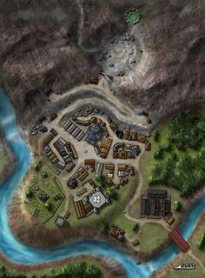

--DESCRIPTION--------------------------------------------------

Sledge is the northern-most town of Xecuria, and just barely earns that status. It holds a strategic position in the northern tip of the region to validate the claim of the dynasty. It's nestled in a cove of mountains, west of the ruins of the Torruhn dwarves civilization.

The living state in sledge is not a nice one. The surrounding area is cold and regularly barren, with small breaks in the summer. Food is brought in on regular freights from close-by cities to ensure citizen survival. The citizens of Sledge are there for several reasons, but one of the most prominent is the mapping of the Mourning mountains and the riches it holds.

--SHOPS & PEOPLE--------------------------------------------------

Lord Abethra Joubert, 69 Sledge

Priest/ess Carysea Hinrichs, 24 Sledge Religion

Nobility Marl Leda, 20

Gld. Member Lini Nzek, 28 Guild Affairs

IT officer Milania, 82 Sledge Guards

Smith Kevin Levine, 53 Steel Arms

Shopkeeper Salvador Bigfelloe, 42 Adventurers glory

Innkeeper Theron Benson, 101 Royal Banquet Hall

Citizen Jardoy Ansoux, 18

Farmer Thughye Barajas, 92 Local Farm

Bard Gustavo Adaver, 22

Undecided Dicecin Skovgaard, 17

Undecided Alexa Nfeld, 48

--ECONOMY--------------------------------------------------------

--SPECIAL FEATURES--------------------------------------------------

--HISTORY----------------------------------------------------------

--SHOPS--------------------------------------------------------------

--INNS---------------------------------------------------------------

### Town- Somarden – Castle Keep City

<Image>

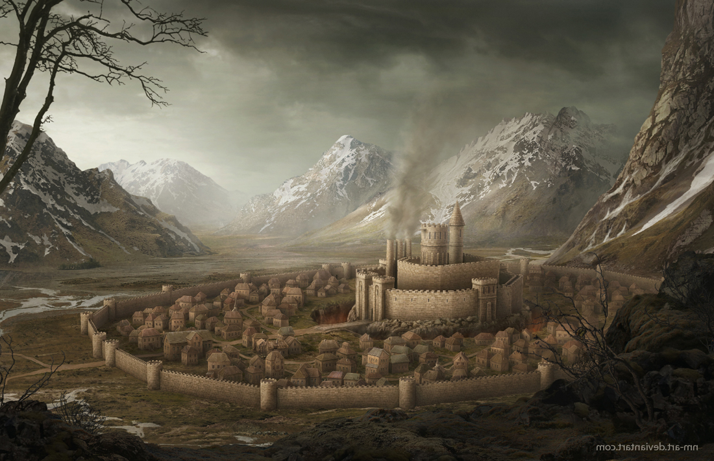

--DESCRIPTION--------------------------------------------------

Somarden is the southern military stronghold of Xecuria. It's a multi-walled city that guards the only main road into the southern region of the dynasty. As such, they value security for all citizens and officers stationed here are rigid and strict. In in the center of the city lies the castle and jail of the lord of town and general of the south.

Passing through or living in Somarden requires strict adherence to the law, while otherwise risks exile or incarceration.

--SHOPS & PEOPLE--------------------------------------------------

Lord Janna Asmon, 23 Somarden

Priest/ess Beloric Ric Say, 30 Somarden Religion

General Pauline Regenbogen, 68 Somarden Security

Nobility Enda Siad, 111

Nobility Ezer Four, 29

Nobility Glan Geot, 34

Gld. Member Mardewe Hardy, 13 Guild Affairs

IT officer Marcus Jesen, 13 Somarden Guards

IT officer Rick Stueck, 5

IT officer Lexie Charbonneau, 1

IT officer Marican Hardie, 21

IT officer Clasper Mcalister, 15

Smith Iesha Paud, 3 Metal Mastery

Smith Stewan Mcvin, 66

Shopkeeper Elie Danielsen, 15 Envy's Eye

Shopkeeper Karon Ante, 30

Innkeeper Orval Dreas, 14 Lusty Maiden

Innkeeper Ivich Lagen, 14

Citizen Ellyn Atton, 23

Farmer Sey Ger, 37 Local Farm

Undecided Tyisha Hansen, 59

Undecided Alistair R Linden, 72

--ECONOMY--------------------------------------------------------

--SPECIAL FEATURES--------------------------------------------------

--HISTORY----------------------------------------------------------

--SHOPS--------------------------------------------------------------

--INNS---------------------------------------------------------------

### Town- Still Creek – Quiet and Mysterious Town

<Image>

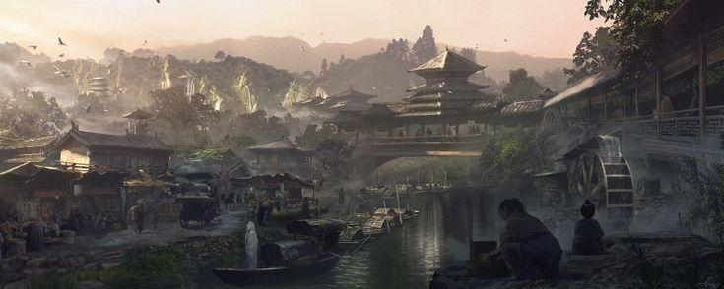

--DESCRIPTION--------------------------------------------------

Still creek is a quiet and peaceful town that lies along a large forest river. Around the town, the river pool and it's flow slows to a peaceful level, allowing for quaint rides via boat.

The citizens of Still creek, due to their distance from other cities, chose to adopt their own way of life. They focus on spiritual balance and beauty in simplicity and thoughtfulness. It's home to some of the worlds most famous philosophers and martial masters.

--SHOPS & PEOPLE--------------------------------------------------

Lord Mete Fizzlebottom, 48 Still Creek

Priest/ess Roosevelt Meza, 56 Stillcreek Religion

Nobility Celadrie, 85

Gld. Member Tin'Dan Vega, 102 Guild Affairs

IT officer Bradford Chatwick, 29 Stillcreek Guards

Smith Dale Gibson, 13 Forge and Forger

Shopkeeper Jeffery Ry Mens, 62 Jeffrey's Mart

Innkeeper Lavonia Grimes, 107 Breaknose Tavern

Citizen Hant Upin, 26

Farmer Ned Denford, 34 Local Farm

--ECONOMY--------------------------------------------------------

--SPECIAL FEATURES--------------------------------------------------

--HISTORY----------------------------------------------------------

--SHOPS--------------------------------------------------------------

--INNS---------------------------------------------------------------

### Town- Usuall Town in one House (Omashu)

<Image>

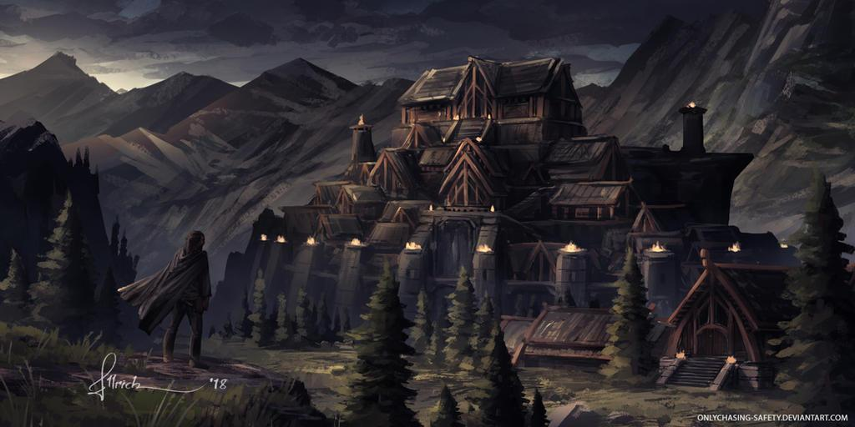

--DESCRIPTION--------------------------------------------------

Uusuall sits in a separated valley to the north-east of the Xecuria regions. To the west are the Blunder hills, a line of small mountains stretching north-south. The hills are also rumored to be home to a collection of dragons and other dangers.

Usuall is built much like Omashu - A Large wall around the city and large structures intermixed inside. The tallest structure jets into the sky- The House Grimes.

--SHOPS & PEOPLE--------------------------------------------------

Lord Kenny, 72 Usuall

Priest/ess Bertin Aston, 69 Usuall Religion

Nobility Kyleora Ora Rey, 20

Nobility Mono Colquhoun, 24

Nobility Cordero Girard, 20

Nobility Rick, 37

Alchemist Paole Cleod, 19

Gld. Member Stephon Hall, 14 Guild Affairs

IT officer Kelley Y Gler, 19 Usuall Guards

Smith Omarry Danter, 14 Forge and Forger

Shopkeeper Mila Emec, 30 Cart Corner

Innkeeper Nathanial Ial Riese, 20 Usual Rest

Citizen Shan Fauf, 52

Farmer Moises Rithar, 35 Local Farm

Bard Delsie Walsh, 40

Mtn Guide Handra Mcram, 108

--ECONOMY--------------------------------------------------------

--SPECIAL FEATURES--------------------------------------------------

--HISTORY----------------------------------------------------------

--SHOPS--------------------------------------------------------------

--INNS---------------------------------------------------------------

### CITY - West Warden – Seaside Splendor City

<Image>

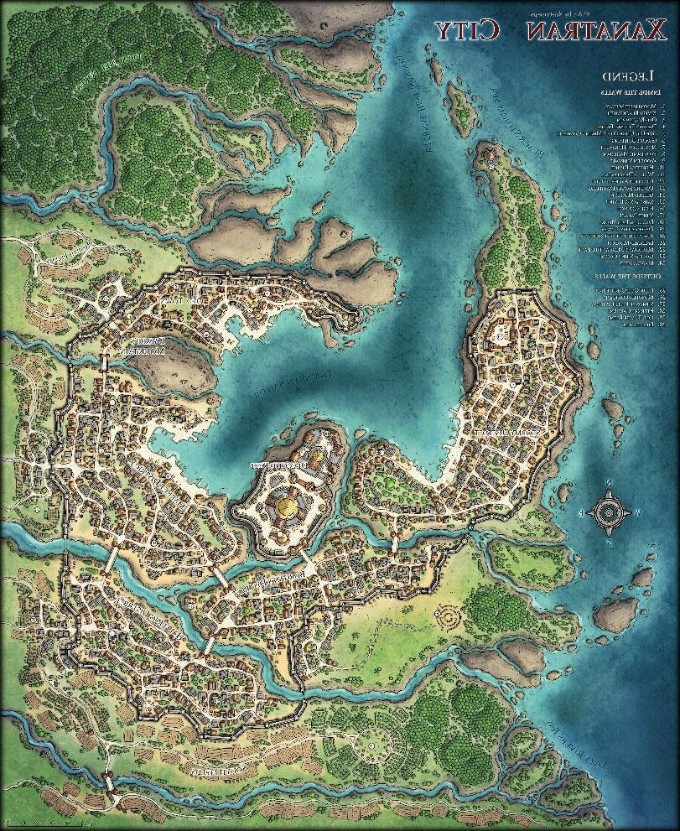

--DESCRIPTION--------------------------------------------------

West Warden is one of the oldest cities in Xecuria. Being on Elmonn Island, it remains largely self-sufficient through mining, fishing and lumber. The people in WW are devoutly religious to Maat, the Face in the Tree, and the Huntress. Their temple sits in the center of town, which is divided into six sectors by rivers.

--SHOPS & PEOPLE--------------------------------------------------

Archmage Lenard Atverc, 59

Lord Emorder Matinle, 28 West Warden

Priest/ess Lorene Ieblai, 26 West Warden Religion

Nobility Cariara Galanno, 122

Alchemist Hoover R Dahl, 11

Gld. Member Lukamo Duntie, 44 Guild Affairs

IT officer Robert Allely, 38 West Warden Guards

IT officer Terence E Mcnes, 36

IT officer Broscor Griffin, 23

Smith Ady Sen, 41 Forge and Forger

Smith Judeddi I Kovac, 14

Smith Romman Lerrov, 39

Shopkeeper Arenda Gillani, 27 The Royal Open Market

Shopkeeper Cory Ther, 23

Innkeeper Marcust T Horen, 21 Horen-Home

Innkeeper Micah Ceasl, 43

Citizen Lorenzo O Scott, 20

Farmer Minnie E Angu, 21 Local Farm

--ECONOMY--------------------------------------------------------

--SPECIAL FEATURES--------------------------------------------------

--HISTORY----------------------------------------------------------

--SHOPS--------------------------------------------------------------

--INNS---------------------------------------------------------------

### CITY - Zirconia – Great Port-City of Legends

<Image>

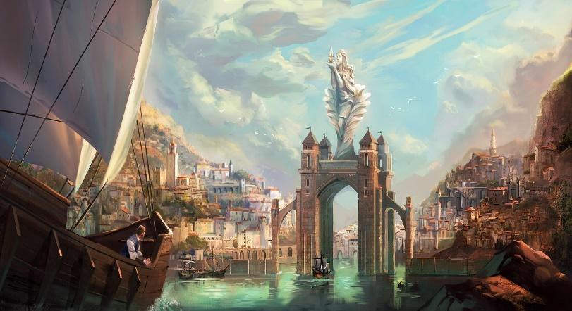

--DESCRIPTION--------------------------------------------------

Zirconia is a grand, prosperous city in southern Xecuria. Their cove, Zircon-Sol, is home to the gates of Lumas and a magnificent port. The ships made here are said to be able to last centuries. The people here are determined and hard working, known for having a strong sense of community and mutual benefits in life.

Zirconia sits on it's own island of 19,600km2. It offers bountiful crop land, ample forests and peculiar ruins to the north.

--SHOPS & PEOPLE--------------------------------------------------

Priest/ess Gerry, 60 Zirconia Religion

Lord Elmer Levine, 88 Zirconia

Nobility Vladimir Dickson, 54

Alchemist Shae Montoya, 21

Jeweler Kildrak Mathews, 52 Silvermoon Landing Shopkeeper

IT Officer Sophie, 77 Zirconia Guards

Smith Tane Cornwallis, 80 The Stone and Bone

Stable keeper Katib, 67 Stables

Shopkeeper Aulgon Gelnne, 62 Everyday Elixirs

Shopkeeper Chase Devaul, 73 Bottle Shock

Innkeeper Jack Thompson, 80 Lusty Maiden

Farmer Gereon Miles, 94 Local Farm

Farmer Ellen Dunn, 32 Local Farm

Farmer Jace Steadman, 69

Bard Toby Barajas, 78

--ECONOMY--------------------------------------------------------

--SPECIAL FEATURES--------------------------------------------------

--HISTORY----------------------------------------------------------

--SHOPS--------------------------------------------------------------

--INNS---------------------------------------------------------------

### Other Areas

#### Gilded Ruins

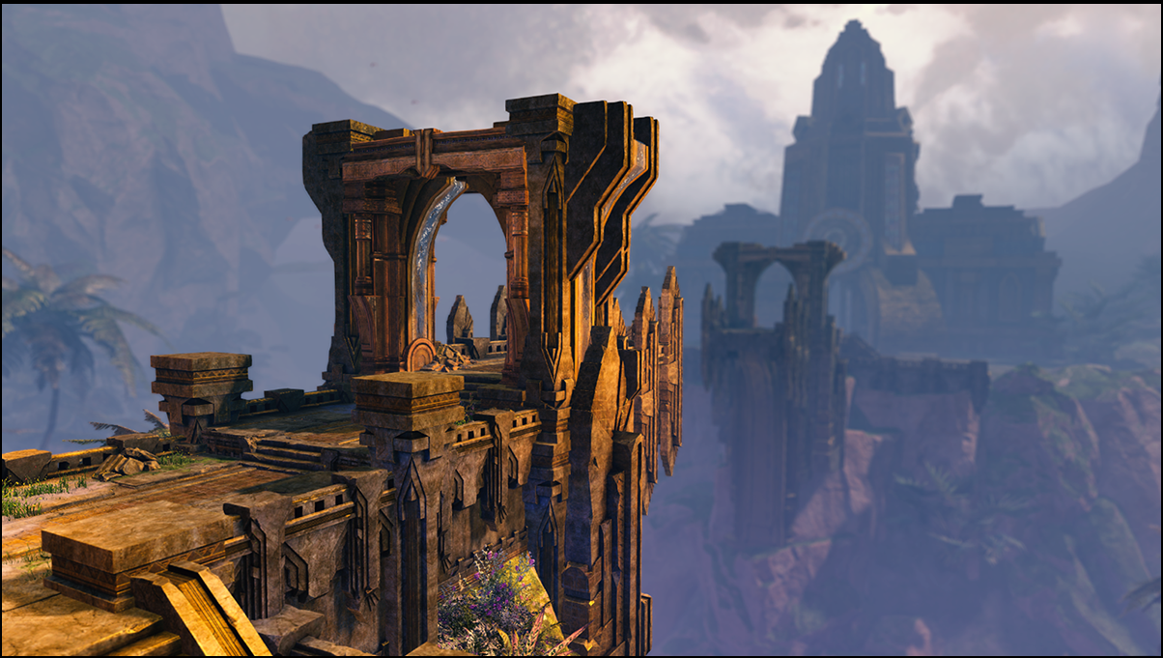

#### Crystal Mines

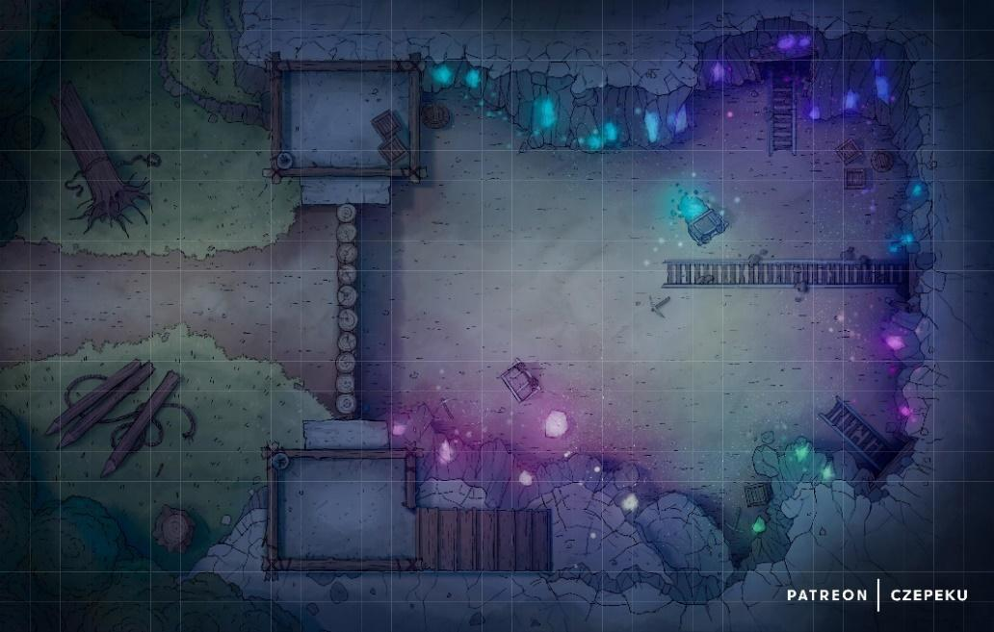

#### Rage Cave

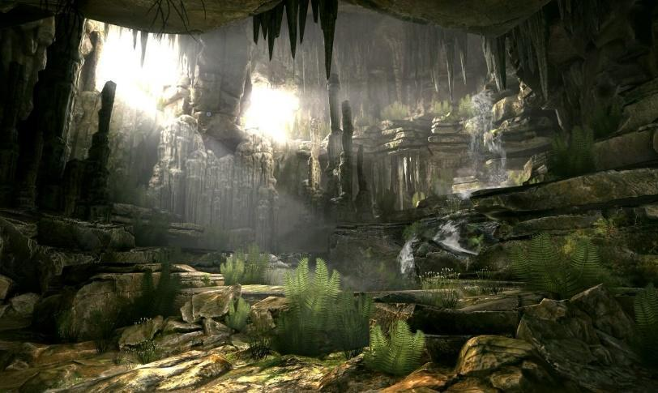

## Historic - Dwarven Kingdoms (9)

<Representative Image>

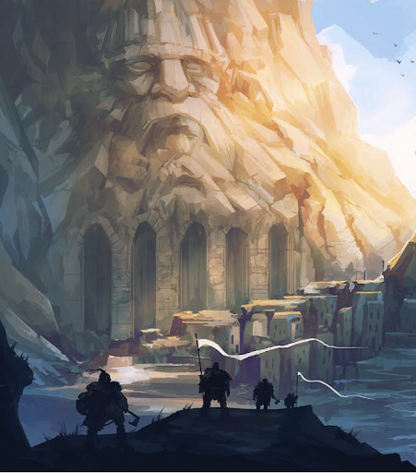

<Flag> **none**

<Basic Description>

|  |  |  |
| --- | --- | --- |
| Old Name | New Name | Domain |
| Krumillian | Kadrehl | Smithing |
| Dugir | Barlenghir | Terraforming |
| Dorgin | Varkuhldir | Architect |
| Vel-Gendar | Vel-Gendar | Merchants |
| Kragmane | Torruhn | Knowledge/Lore |
| Noblesword | Aindaruhl | Farmers/Fields |
| Aerduluk | Aerduluk | Treasurers |
| Ulamathean | Korhelir | Greedy Nomads |
| Mithril-Born | Lordakihr | Exotic Forces |

### Summary

*Geography in summary*

*Culture in summary*

#### Leader/Lord

<Image>

--DESCRIPTION--------------------------------------------------

#### History

The dwarves of this world were a prosperous, and largely advanced civilization. But like many dwarves of many worlds, greed was their folly. They build too grandly, dug too deeply, and saw and unrecorded demise.

**It was the Korhelihr's that led the ultimate demise of the dwarves.** Their greed and dissatisfaction with their treasures led them to mine farther and farther south. No dwarves knew exactly what they were looking for, but **Froegar Korhelihr** was a stern lord of his clan and answered no questions.

Eventually, they found what they thought was the holy grail. An entire city, buried underground, past the Thicket and the Iron Hills. Almost as far as the guarding peaks.

The city was something to behold. Towering structures jutting out from a literal abyss. Gold rivers flowing freely and perpetually from ancient forges still lit. An expansive land with no apparent life left in it, but there was.

As the Ulmatheans continued farther into the city, looting and exploring, they did not see the eyes following them. The serpent-men of the city felt them coming from mile away, and planned an ambush of their own.

Once the Ulmatheans were deep enough into the city, a horn was called. The city shook, and the path behind them crumbled to nothing, They were now stuck in place and quickly after surrounded by the Sarrukh race, a serpent bottom and humanoid top. In this encounter, the dwarves were arrested for trespassing beyond their reach and ordered to leave the lands of the world serpent.

Being they greedy group they were, they refused, and fought. They fought well and hard, but soon they all fell until only Froegar remained. Froegar was locked up for his vices, and was cursed in watching the god of these people be called into the world. He saw a massive serpent ascend from the abyss, and was judged by it.

He was found unworthy of retributions. As punishment, he was granted immortality and then jailed for all time Over thousands of years, the world serpent slowly travelled the world seeking out dwarven settlements, and befalling them all. Some were already abandoned, and others full of dwarves ripe for eating and murdering.

In the end, the only settlement the serpent did not find was Vel-Gendar, through the devout prayer of Froegar to the gods.

One by one, the dwarven cities fell or were abandoned. No descendants dare speak of their clan's history, nor do they dare venture home. Much was left behind, and it's believed that each clan held sacred artifacts that cursed their families to fall. With this belief, it'd only be a matter of time until Vel-Gendar fell too. If a dwarf were to return home, they would find runes left by the world serpent, and their homes completely annihilated.

#### The 9 Clans

##### - The Vel-Gendars (Merchants Supreme)

**Original Location:** East of the mountains

The Vel-Gendars are the last formidable, fully standing family and city of the dwarven kingdom. Their rule, when in effect, is absolute and devoid of disrespect. The Vel-Gendars are known for wise, decisive action and open-mindedness. They brokered a peace treaty with the kingdoms of Morheim for protection, trade and free travel for their people. In exchange, Morheim citizens gained the right to travel through dwarven lands.

##### x- The Kadrehl (Masters of the Forge)

**Original Location:** at the base of the Rea Xandor

Retained once-close ties with the elves. This partnership helped the dwarves master the craft of the smith, and their blades remain known as renowned weapons of finesse and destruction.

##### x- The Barlenghir, Levelers of Mountains

**Original Location:** South-East of Krumilins, where four mountains meet.

This clan is famous for having leveled one of the tallest mountains in the realm, and building their city in the middle of the carnage. History states it only took them 750 years to turn the formidable Sky-Spear Mountain into the Four Daggers, as they're known today.

##### x- The Varkuhldir (Grand Architects)

**Original Location:** East of GMR lake, along mountain pass.

Masterful architects and mechanical maniacs. The Dorgins are the original creators of the Dwarven forges, and spearheaded the founding of the processes of forging with mithril.

##### x- The Torruhn (Master of History and Knowledge)

**Original Location:** North-west of the Omega Peak

##### x- The Anduril (Field Dwarves)

**Original Location:** At the Base of the Omega Peak (Hidden Entrance)

##### x- The Aerduluk (Counters of Coin)

**Original Location:** East of the Mountain Bridge passing, Deep in the GMR woods.

Often taken significantly for granted by the other families, the Aerduluks

##### x- The Korhelihr (Greedy Wanderers)

**Original Location:** South of the Aerduluks, deeper in the forest and at the base of a different mountain.

Little is known about the Ulmatheans, but that they were the first to fall and lose contact with the other dwarves. Lore mentions of a mighty earthquake felt by all dwarves, and the underground paths to their lands being blocked by an unbreakable stone. The last thing heard from the Ulmatheans was that they were digging farther south..

##### x- The Lordakihr (Seekers of the Exotic)

**Original Location:** At the entrance facing Death Canyon, along the desert coast.

Known for their aptitude and abundance of mithril, their name takes a fairly literal meaning. This keep is decorated to the nine in mithril and other rare metals like gold and silver. Many dwarf babies were literally born on mithril birthing beds and decorated with gold as soon as they cleared the mother.

Mithril-born tastes are expensive and their attitudes of elitism and entitlement.

### Cities

### Vel-Gendar – Merchants Supreme

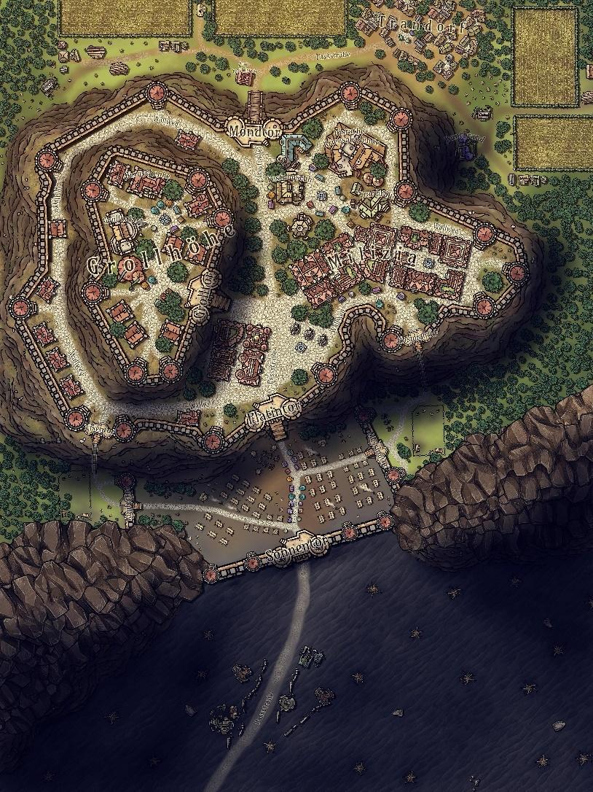

<Image>

--DESCRIPTION--------------------------------------------------

**Brief**

Originally a mithral mine belonging to Clan Battlehammer, this underground town became a safe haven for various dwarf families and even some persons of other races. Vel Gendar had a long history of tragedy and triumph, and was the making and breaking of countless individuals.

**Origin**

The settlement was originally set up as a mine, due to the rich seams of mithral ore in the mountain. The business quickly grew into a thriving community. The location of Vel Gendar was kept extremely secret, so that other organizations wouldn't try invading.

**Business**

The dwarves used to sell their ore and weapons in Vermillis and Fort Arteron, using them as a public front for the mine. This way outsiders were not exposed to the secret location of the mine.

**Nowadays**

The location of Vel Gendar was made public after the fall of the entire Dwarf Kingdoms, where Minster Herre decided it was time to embrace the issues facing the world.

--SHOPS & PEOPLE--------------------------------------------------

**Mnstr/Mng** Herre Korhelir, 294

Vel Gendar Mining Operations

**Councilman** Aldwulf Kadrehl, 173

Smithing

**Councilman** Brielle Barlenghir, 128

Quarrying

**Councilman** Dason Varkuhldir, 140

Building

**Councilman** Baldehuia Vel-Gendar, 133

Trading

**Councilman** Cheeke Torruhn, 259

Military / History and Knowledge.

**Councilman** Ango Anduril, 98

Food and Water

**Councilman** Abel Korhelir, 384

Treasury

Alchemist Thorin Barlenghir, 90

The Twinkle Star

Elder Rewis Vel-Gendar, 350

Treasurist Toeindale Vel-Gendar, 248

Dwarven Keep Vel Gendar Treasure

Jeweler Me'tis Aerduluk, 60

The Night's Decoration of Deva

Smith Vicente Varkuhldir, 72

He Who Smelt It

Shopkeeper Vernice Torruhn, 42

Vernice's Crevice

Minor Miner Rider Lordakihr, 16 No One

Miner Catarina Kadrehl, 96 Vel-Gendar Mines

Miner Fredda Anduril, 22 Vel-Gendar Mines

Miner Elza Barlenghir, 105 Vel-Gendar Mines

Bartender Florence Fowlkes Kadrehl, 46 The Wishing Mug

Liquor Store

--ECONOMY--------------------------------------------------------

Mithral, Gold, Iron and Silver, respectively.

--SPECIAL FEATURES--------------------------------------------------

**ARTIFICER’S COLEGE**

Headed by Rewis Vel-Gendar, 350. A small group of 30 or so students who are admitted on an annual basis. Only 3 students are permitted for further study, while the others go back into the world to help their communities.

Once inside the town, one was faced with a web of tunnels and numerous caves and rooms. To navigate the tunnels required an experienced guide or several years of experience spelunking within them. Vel Gendar was an ever-expanding settlement as the residents were constantly mining for more mithral.

The tunnels and chambers of Vel Gendar were a self-contained city complete with taverns, forges, workshops, homes, and shrines to Craghand and Gond

**Craghand:**Dwarven God who is fabled to have ascended to the mine the sky. His form is in the stars, and his appearance is a dark-hooded dwarf with a shiny silver bear, and mithril pickaxe.

**Gond:**

The Lord of All Smiths and makers, he pushed for innovation and imaginativeness, sometimes to a dangerous degree, as a result of his short-sighted desire to create and wander.

**CHURCH**

**ELYSIAN PROTECTORATE**

**GOSPEL**

**GUILD OF HAMMER**

**LYRES FOR HIRE**

**UNIVERSITY BRANCH**

**ORDER OF THE LONG DEATH**

**THE MINES OF GENDAR, AND VAULT OF THE ANCIENTS**

--HISTORY----------------------------------------------------------

--SHOPS--------------------------------------------------------------

--INNS---------------------------------------------------------------

### Barlenghir – Terraformers Supreme

<Image>

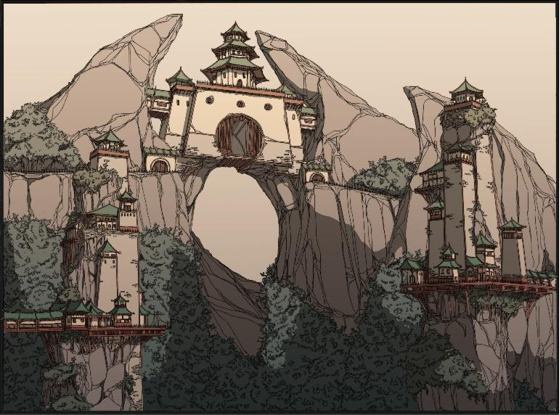

--DESCRIPTION--------------------------------------------------

--SHOPS & PEOPLE----------------------------------------------

--ECONOMY--------------------------------------------------------

--SPECIAL FEATURES------------------------------------------

--HISTORY----------------------------------------------------------

--SHOPS---------------------------------------------------------------

--INNS-----------------------------------------------------------------

### Kadrehl - Forgemasters

<Image>

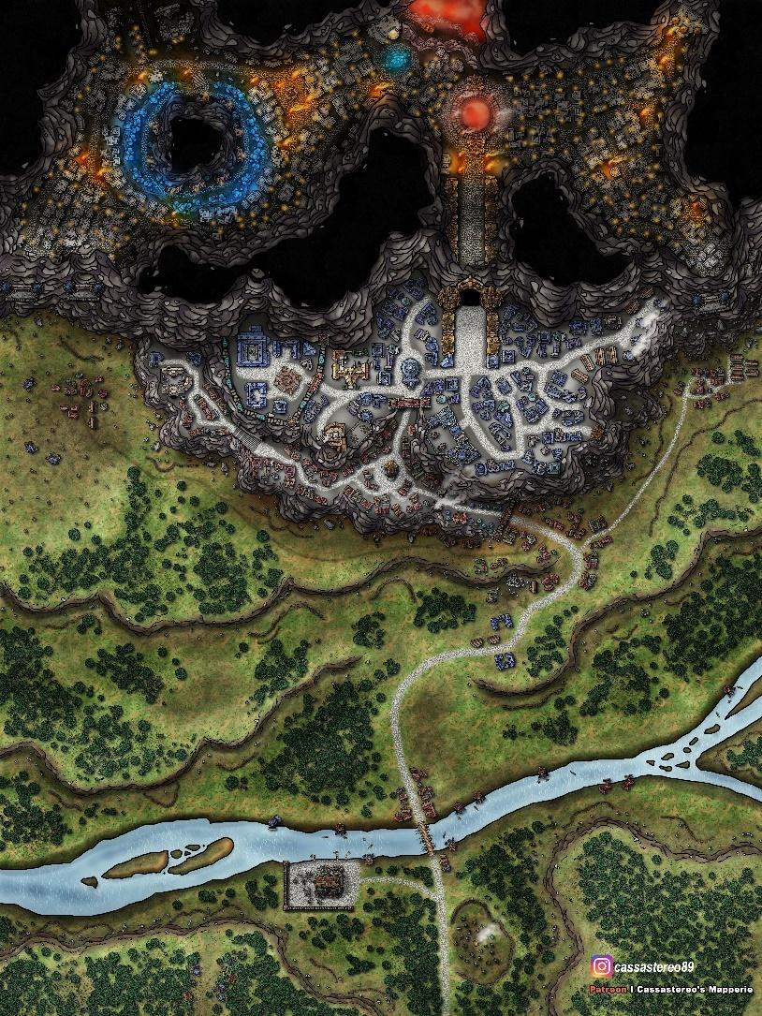

--DESCRIPTION--------------------------------------------------

--SHOPS & PEOPLE--------------------------------------------------

--ECONOMY--------------------------------------------------------

--SPECIAL FEATURES--------------------------------------------------

--HISTORY----------------------------------------------------------

--SHOPS--------------------------------------------------------------

--INNS---------------------------------------------------------------

### Varkuhldir – Architects Supreme

<Image>

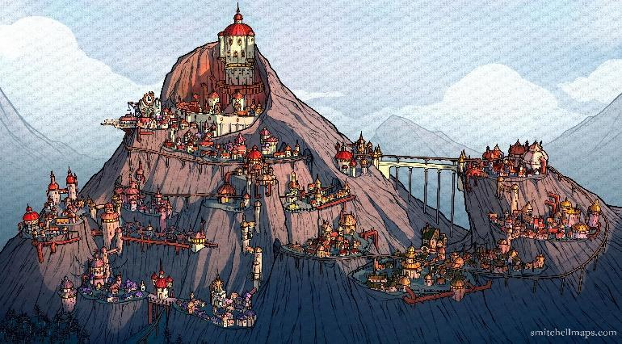

--DESCRIPTION--------------------------------------------------

--SHOPS & PEOPLE--------------------------------------------------

--ECONOMY--------------------------------------------------------

--SPECIAL FEATURES--------------------------------------------------

--HISTORY----------------------------------------------------------

--SHOPS--------------------------------------------------------------

--INNS---------------------------------------------------------------

### Torruhn – Masters of History

<Image>

--DESCRIPTION--------------------------------------------------

--SHOPS & PEOPLE--------------------------------------------------

--ECONOMY--------------------------------------------------------

--SPECIAL FEATURES--------------------------------------------------

--HISTORY----------------------------------------------------------

--SHOPS--------------------------------------------------------------

--INNS---------------------------------------------------------------

### Anduril – Masters of Agriculture

<Image>

--DESCRIPTION--------------------------------------------------

--SHOPS & PEOPLE--------------------------------------------------

--ECONOMY--------------------------------------------------------

--SPECIAL FEATURES--------------------------------------------------

--HISTORY----------------------------------------------------------

--SHOPS--------------------------------------------------------------

--INNS---------------------------------------------------------------

### Aerduluk – Masters of Coin

<Image>

--DESCRIPTION--------------------------------------------------

--SHOPS & PEOPLE--------------------------------------------------

--ECONOMY--------------------------------------------------------

--SPECIAL FEATURES--------------------------------------------------

--HISTORY----------------------------------------------------------

--SHOPS--------------------------------------------------------------

--INNS---------------------------------------------------------------

### Korhelihr – Nomads with a home

<Image>

--DESCRIPTION--------------------------------------------------

--SHOPS & PEOPLE--------------------------------------------------

--ECONOMY--------------------------------------------------------

--SPECIAL FEATURES--------------------------------------------------

--HISTORY----------------------------------------------------------

--SHOPS--------------------------------------------------------------

--INNS---------------------------------------------------------------

### Lordakihr – Followers of the Devine

<Image>

--DESCRIPTION--------------------------------------------------

--SHOPS & PEOPLE--------------------------------------------------

--ECONOMY--------------------------------------------------------

--SPECIAL FEATURES--------------------------------------------------

--HISTORY----------------------------------------------------------

--SHOPS--------------------------------------------------------------

--INNS---------------------------------------------------------------

## Idealistic - Collective (11)

<Representative Image>

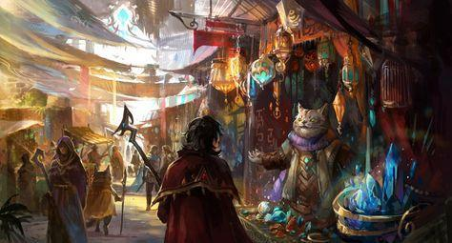

<Flag>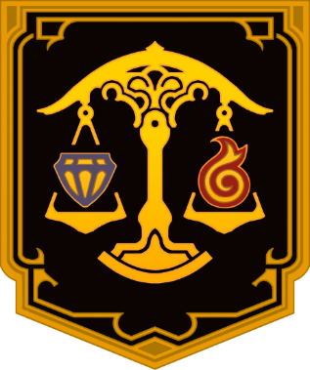

<Basic Description>

### Summary

*Geography in summary*

*Culture in summary*

#### Leader/Lord

<Image>

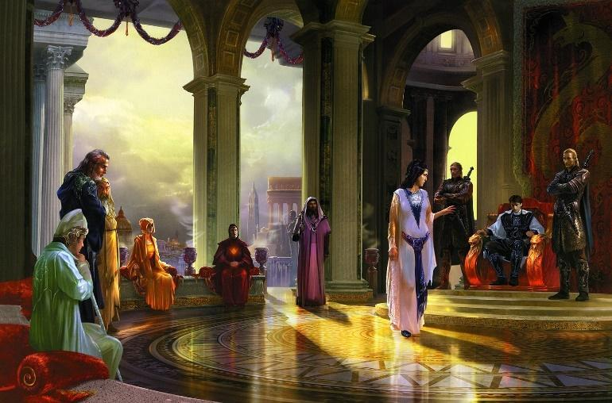

--DESCRIPTION--------------------------------------------------

The leader/representatives of the Collective are the Council of 9. They are sent representatives from each city, with the exception of **Mithril** Lake. Mithril Lake is largely independent, barley on the map with a beaten path into the collective.

#### History

Seeing the embarrassing 'defeat' of the Morheim kingdom by the new Dynasty, Cities along The Tarsal Desert and the Thicket and farther south began to sway their allegiances as well.

Being already established for their impeccable handiwork and rich resources, all of the cities stretching from Vermillis to Ardesia chose to leave the kingdom, taking on the name of The Collective.

The Mad king was furious. He sent letters to dignitaries of both kingdoms, claiming to have acquired a godly weapon that could obliterate them all if they did not surrender back their lands in a months time. Both Xecuria and The Collective's leaders met in haste and agreed quickly to send the following letter back. *"Come and get us. The Collective and New Dynasty will oppose the mad king, until the last man standing."*

No weapon or army came, and mad king soon fell. The new king Divinitus tried to re-establish ties to the new kingdoms, but by this time the citizens were happy with the new arrangement. The leaders of The Collective and dynasty stood firm and refused to discuss possibilities of rejoining the kingdom.

Wanting to show him as a fair and king ruler, King Divinitus agreed to the formation of these new nations, so long as all trade and travel between their kingdoms and Morheim would pay the appropriate taxes and sign a peace treaty to avoid future conflict. Divinitus also invited the Guild leaders and then-leader of the Dynasty to Korthal on a peace summit to sign the document.

While there, he showed the the leaders what the mad king had threatened them with. It was indeed an **ancient, godly artifact**, but it was not a weapon. It was a staff with a circlet of of the pantheon. A steel rod etched in divine runes and topped with the GOSPEL circle made of an ***unworldly material.*** 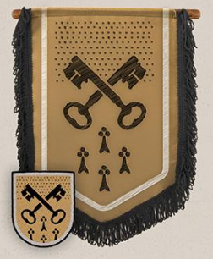

King Divinitus claimed he intended to never use this ever as a weapon, but his top mages were still studying it. He vowed to send it to either Sutherland Keep, the University, or Frostling Stronghold for close-kept guarding.

King Divinitus quietly sent the object away from prying eyes to the deepest depths of the university vaults, where it lies under magical and mechanical protection.

#### Laws and Government

This coalition of city rulers collectively agrees that some level of solidarity is needed to keep evil at bay. However, every lord in the Alliance works for the fate and fortune of his or her own settlement above all others. The rulers of the free cities in the region dominate the Alliance.

The Hold Lord Vern Gates, 27

Anchorage Vista Lord Alex Mendoza, 88

Ardesia Lordess Nestée Bruce, 60

Claw Harbour Lord Brenden Stott, 29

Cochrane River Lordess Hollis S Petr, 30

Cochrane River Lordess Melana Finch, 30

Mithril Lake Lord Loren Yu, 103

Montistum Lordess Leslym Barrett, 104

Rasa Lord Mitch Stein, 70

Sabul Pass Lord Keith Stanton, 34

Vermillis Lord Sammy Floyd, 116

WillowGlade Lord Merryl Drake, 65

### CAP - The Hold (Capital)

<Image>

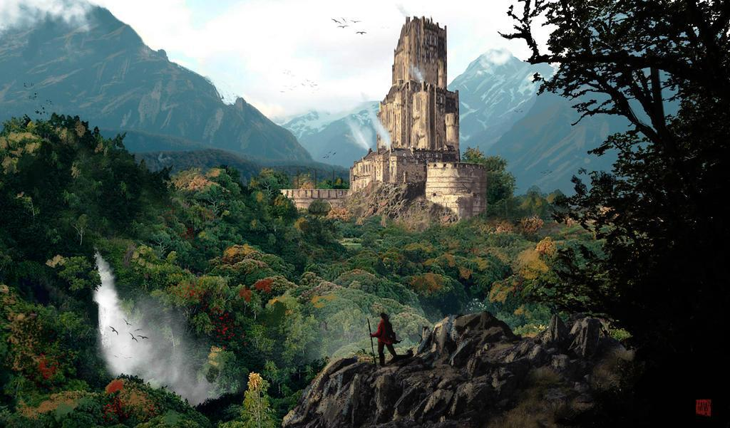

--DESCRIPTION--------------------------------------------------

THE HOLD was a city made from war, and originated as an outpost for people travelling during war. Some few individuals saw the large amount of traffic as an opportunity for making profit. They began setting up shops and inns to provide quality stopping. While old maps show many of the buildings to be single story, individual areas, much of the town center has urbanized.

Nowadays, the hold acts as one of the largest single structures in the Collective. Every now and again, it also acts as home to all lords of the Collective during times of urgent need for meeting. The last time used was to discuss

**Vern Gates** acts as lord of The Hold,

--SHOPS & PEOPLE--------------------------------------------------

Judge Nerwe Slater, 89 Law of the Collective

Lord Vern Gates, 27 The Hold

Lord Helper Jimothy Bradford, 89 Nothing

Nobility Alice Xecuria, 78

Shop Owner Jamagher Battle, 200 The Old Market

Alchemist Phelrey Whitworth, 77 The Fireball

Alchemist Anise Mill, 70

Teacher Dreyny Gates, 107 Town Education

Treasurist Jane Floyd, 40 Finances of the town

Gld. Member Vamir Barajas, 65 Guild Affairs

IT Officer Daggy, 92 The Hold Guards

Trader Oogwar Barrett, 58 Trade

Smith Cornelia Phelps, 96 Beauregard's Bit and Bridle

Smith Druscilia Griffiths, 98 Doctor of Letters

Stable keeper Trisha, 34 Stables

Shopkeeper Leandra Horner, 38 Girks

Shopkeeper Dreyny Griffiths, 104 The Golden Mermaid

Shopkeeper Sterey Jeffery, 87 The Final Word

Groundskeeper Stacey Mccartney, 66 Nothing

Bartender Lexand Raymond, 107 The Wooden House

Innkeeper Lawrel Keeling, 49 The Nice Unicorns Inn

Farmer Jed Xiong, 34

--ECONOMY--------------------------------------------------------

--SPECIAL FEATURES--------------------------------------------------

--HISTORY----------------------------------------------------------

--SHOPS--------------------------------------------------------------

--INNS---------------------------------------------------------------

### Town- Anchorage Vista – Riverhold of the Deep

<Image>

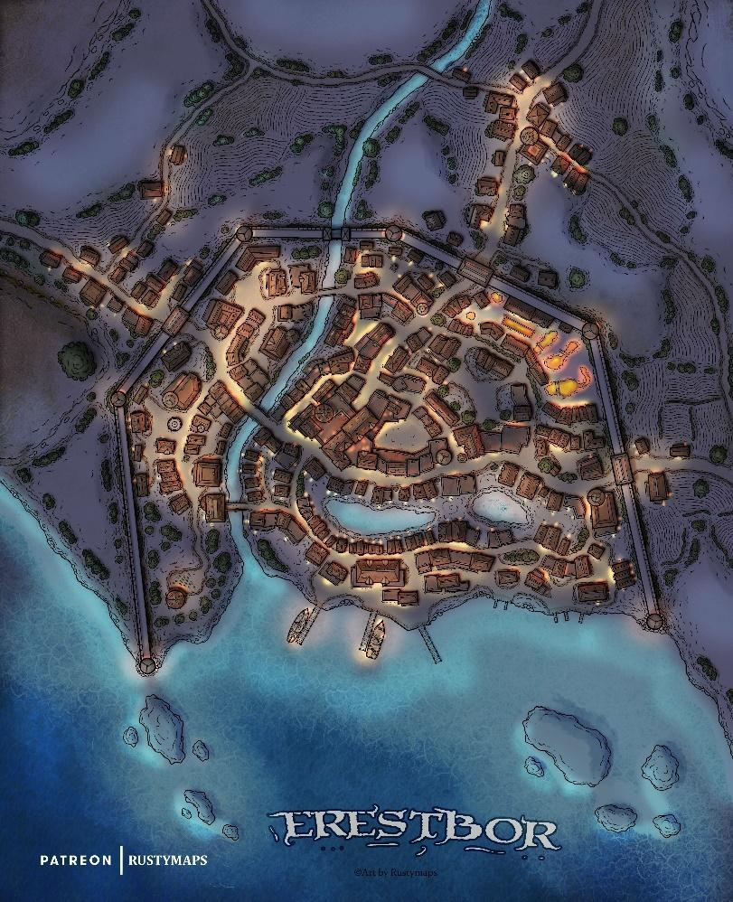

--DESCRIPTION--------------------------------------------------

Anchorage vista is a medium-sized port town in the Collective- one of only two. Anchorage vista operates as the nearest seaway connector for travel to and from Morheim and the OAR, cutting many days of travel short when compared to the road. But at a high cost. Anchorage Vista enjoys security of invasion from pirates via the Capital Channel, but sits hidden at the northern-most point of the Dreamshard Depths by a handful of islands. Beyond the islands sits a sea riddled with monsters and a “Continent of Death” to the east.

--SHOPS & PEOPLE--------------------------------------------------

Lord Alex Mendoza, 88 Anchorage Vista

Nobility Kira Drummond, 87

Nobility Hellow Blackburn, 72

Alchemist Vicky Alvarez, 56 The Witch's Nose

Gld. Member Mumihilda Vega, 59 Guild Affairs

Trader Abel Bradford, 26 Trade

Smith Lola Potter, 120 Kilt Lifters

Smith Terra Fisher, 107 Jermaine's Jerked Meats

Shopkeeper Lena Ferreira, 65 A Fair Deal

Shopkeeper Tonas Mckinney, 57 Merchants Destination

Bartender Oloth Mcgowan, 18 Nothing

Innkeeper Ludivina Moyer, 56 The Gruesome Worker

Farmer Colt Montoya, 91

--ECONOMY--------------------------------------------------------

--SPECIAL FEATURES--------------------------------------------------

--HISTORY----------------------------------------------------------

--SHOPS--------------------------------------------------------------

--INNS---------------------------------------------------------------

### Town- Ardesia – Xenophobic Crime Lands

<Image>

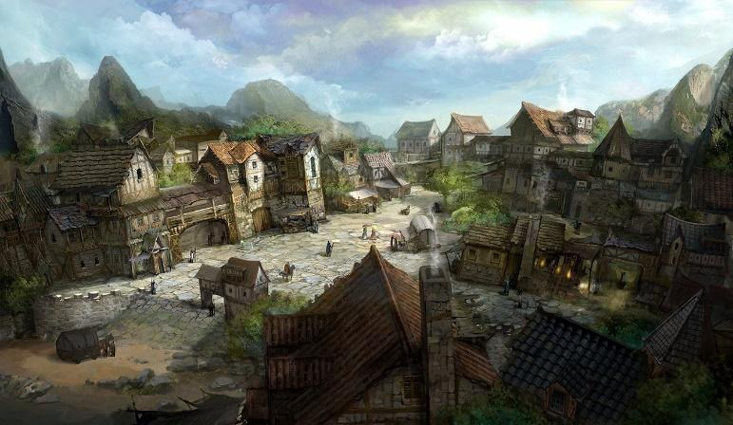

--DESCRIPTION--------------------------------------------------

The Core of Ardesia

**Humanoids Only.** The society of Ardesia is deeply xenophobic. Other races are treated as slaves. For   
half orcs, Ardesia is literally hell on earth. Practicing magic in public is punishable by mutilation or death. All mages are registered and monitored via arcane means. Additionally, m**oney is everything.** In Ardesia, everything and everyone has a price. Every mistake bears a cost paid by you or your Blade. People are indebted or indentured.

**Slavery is safety.** The only safety in Ardesia is the one provided by the Blades and their administration. Be useful to your Blade, and you will be safe and respected.

--SHOPS & PEOPLE--------------------------------------------------

Lordess Nestée Bruce, 60 Ardesia

Nobility Stish Pennington, 67

Nobility Crya Blackburn, 63

IT Officer Rodire, 104 Ardesia Guards

Lord Daughter Dor Miles, 48 Ardesia

Trader Gary Drake, 24 Trade

Smith Saran Pennington, 100 Mondregan's Mortuary

Smith Krishna Cummings, 117 Lamont's Laminates

Shopkeeper Tyrone Wormald, 21 Trade for Coin

Shopkeeper Jeanmarie Fisher, 28 Ardersia Landing

Innkeeper Cody Partridge, 27 The Silent Fly Tavern

Farmer Telford Salter, 59 Local Farm

--ECONOMY--------------------------------------------------------

--SPECIAL FEATURES--------------------------------------------------

--HISTORY----------------------------------------------------------

--SHOPS--------------------------------------------------------------

--INNS---------------------------------------------------------------

### Town- Claw Harbour – Exotic Retreat of Magic

<Image>

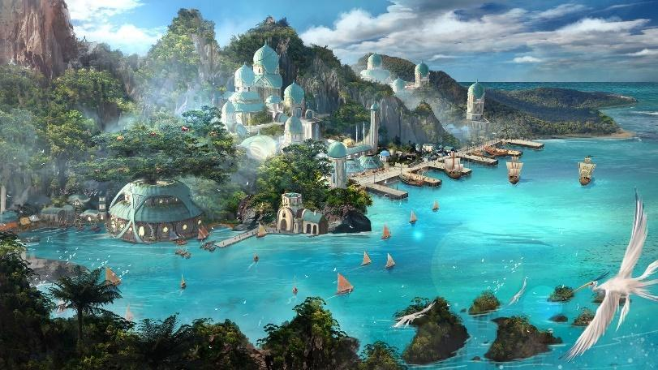

--DESCRIPTION--------------------------------------------------

--SHOPS & PEOPLE--------------------------------------------------

Lord Brenden Stott, 29 Claw Harbour

Nobility James Zimmerman, 30

Gld. Member Gayle Duggan, 46 Guild Affairs

Trader Martin Bruce, 51 Trade

Smith Meggan Jeffery, 82 Obrigal's Ordnance

Smith Foster Cortes, 84 Neelix's Necessities

Shopkeeper Ying Graves, 102 Ying's

Shopkeeper Faye Potter, 45 Not of the Fae

Gatekeeper Felizitas Mohamed, 107

Bartender Kurt Bowes, 83 Ratagasts Diner

Innkeeper Junior Chester, 108 The Dire Mushroom

Farmer Vern Kim, 42

--ECONOMY--------------------------------------------------------

--SPECIAL FEATURES--------------------------------------------------

--HISTORY----------------------------------------------------------

--SHOPS--------------------------------------------------------------

--INNS---------------------------------------------------------------

### Town- Cochrane– Village on Hills

<Image>

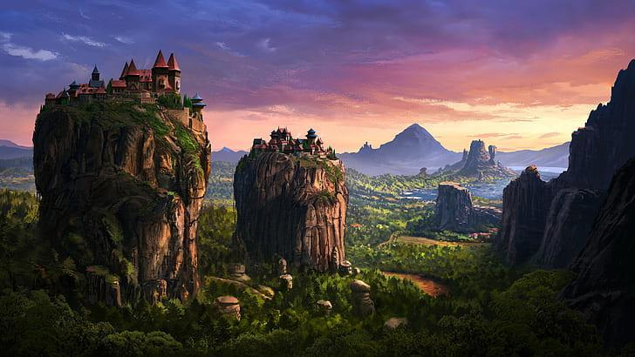

--DESCRIPTION--------------------------------------------------

A small-set progressive town on the edge of a forest, Cochrane River is largely the center of crime and criminal organizations in The Collective.

--SHOPS & PEOPLE--------------------------------------------------

Lordess Melana Finch, 30 Cochrane River

Nobility Formn Alvarez, 79

Trader Cristobal Trujillo, 40 Trade

Smith Carrol Hodson, 109 Pops'

Shopkeeper Pheothre Shields, 48 The Lit Lantern

Innkeeper Colin Krause, 65 The Exclusive Hag Inn

--ECONOMY--------------------------------------------------------

--SPECIAL FEATURES--------------------------------------------------

--HISTORY----------------------------------------------------------

--SHOPS--------------------------------------------------------------

--INNS---------------------------------------------------------------

### Town- Mithril Lake – Guardians of Purity

<Image>

--DESCRIPTION--------------------------------------------------

--SHOPS & PEOPLE--------------------------------------------------

Lord Loren Yu, 103 Mithril Lake

Nobility Gornde Blackburn, 54

Alchemist Stoic Mustafa, 39 Illuminations

Alchemist Alana Arnold, 52

Gld. Member Armin Rojas, 29 Guild Affairs

Jeweler Darwin Dunn, 98

Tanner Sandiel Stein, 42 Leather Shop

Trader Lerd Cole, 55 Trade

Trader Lucien Floyd, 55 Trade

Smith Zane Dickson, 23 Roberts and Roberts

Smith Steve Shields, 90 Quiggly's Quicklime

Shopkeeper Erica Dickson, 81 Erica's

Shopkeeper Gery Hodson, 24 Mithril Lake Emporium

Innkeeper Jin Davison, 87 The Proud Seadog Inn

Farmer Trevor Walters, 51

--ECONOMY--------------------------------------------------------

--SPECIAL FEATURES--------------------------------------------------

--HISTORY----------------------------------------------------------

--SHOPS--------------------------------------------------------------

--INNS---------------------------------------------------------------

### CITY - Montistum – The Old Hold

<Image>

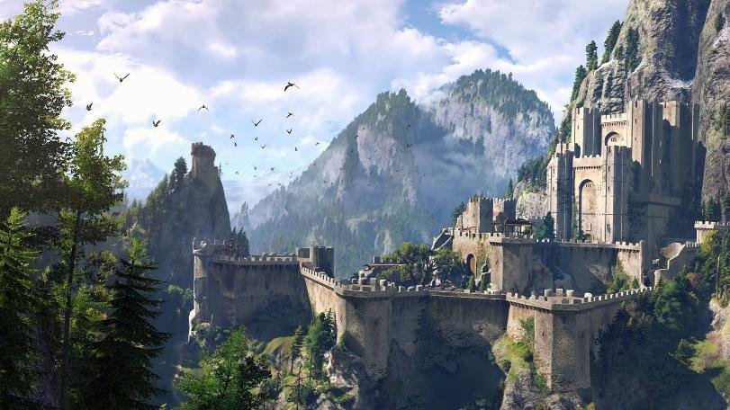

--DESCRIPTION--------------------------------------------------

--SHOPS & PEOPLE--------------------------------------------------

Lordess Leslym Barrett, 104 Montistum

Nobility Lisdo Zimmerman, 47

Nobility Jane Grimes, 46

Trader Pedro Mendoza, 33 Trade

Smith Iola Mckinney, 49 Salmonious & Co.

Shopkeeper Maco Phelps, 106 Boots and Barding

Miner Jacqueline Cortez, 106 Montistum Mines

Innkeeper Olympia Malone, 81 The Iron Shirt Inn

Farmer Eli Ochoa, 88

--ECONOMY--------------------------------------------------------

--SPECIAL FEATURES--------------------------------------------------

--HISTORY----------------------------------------------------------

--SHOPS--------------------------------------------------------------

--INNS---------------------------------------------------------------

### CITY - Rasa – The Reclaimed Ruins

<Image>

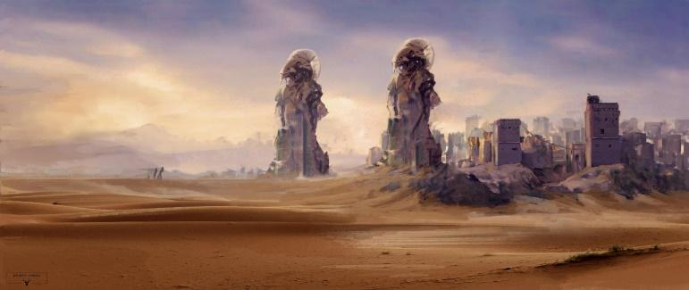

--DESCRIPTION--------------------------------------------------

--SHOPS & PEOPLE--------------------------------------------------

Judge Timmy Stevenson, 43

Lord Mitch Stein, 70 Rasa

Lord Helper Leafen Cole, 67 Nothing

Nobility Merg Dickson, 51

Alchemist Vonbin Padilla, 37 The Rune

Gld. Member Erlareo Rivers, 54 Guild Affairs

IT Officer Anies, 61 Rasa Guards

Trader Lowell Drake, 29 Trade

Smith Hilorfin Battle, 56 Tresbien

Shopkeeper Harkin Logan, 89 The Fine Print

Shopkeeper Hugh Zavala, 44

Treasurist Amber Graves, 38 Rasa Mines

Miner Mauricio Pennington, 97 Rasa Mines

Bartender Geneve Alford, 37 The Haunting Pegasus

Innkeeper Walker Xecuria, 45 The Aromatic Flea Tavern

Farmer Jeb Walsh, 34

--ECONOMY--------------------------------------------------------

--SPECIAL FEATURES--------------------------------------------------

--HISTORY----------------------------------------------------------

--SHOPS--------------------------------------------------------------

--INNS---------------------------------------------------------------

### Town- Sabul Pass – Desert Cove of Safety

<Image>

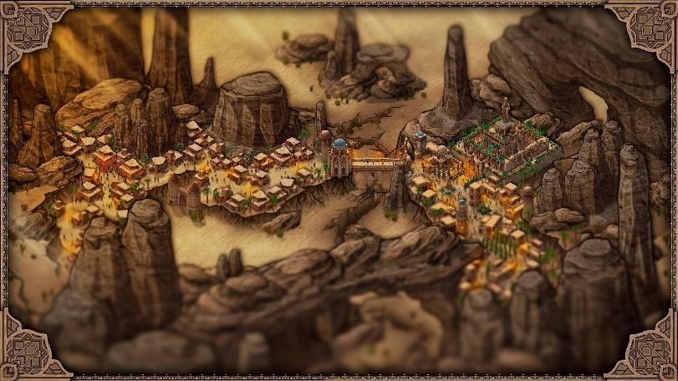

--DESCRIPTION--------------------------------------------------

Established long ago and nestled in the cove of several rocky hills, Sabul Pass acts as a safe haven to all travellers who desperately avoid the desert.

--SHOPS & PEOPLE--------------------------------------------------

Lord Keith Stanton, 34 Sabul Pass

Gld. Member Hakrarlig Murray, 52 Guild Affairs

Trader Milan Yu, 22 Trade

Smith Cuchie Cortez, 85 Ummagumma

Shopkeeper Tina Mathews, 76 Reylar Shopkeeper

Shopkeeper Sh'ker Cummings, 67

Innkeeper Leofred Steadman, 82 The Fast Loch

Farmer Clay Thompson, 84

--ECONOMY--------------------------------------------------------

Trade and mining

--SPECIAL FEATURES--------------------------------------------------

The Sabul Mines

The Palace Grounds

The Pass Bridge

--HISTORY----------------------------------------------------------

--SHOPS--------------------------------------------------------------

--INNS---------------------------------------------------------------

### CITY - Vermillis – The Cliffside City

<Image>

--DESCRIPTION--------------------------------------------------

Vermillis lies in the plains, at the northern-most point of the Collective. It's distant position from the rest of the collective gives it closer ties to the Dwarves of Vel Gendar and humans of Morheim.

Vermillis relies on it's surrounding economies and acts mostly as a farming city, being very widespread. It gets minerals and such from both Vel Gendar and Rasa, and weapons from Fort Arteron. Large but widespread, most Vermillians are self-sufficient.

--SHOPS & PEOPLE--------------------------------------------------

Lord Sammy Floyd, 116 Vermillis

Lord's Guard Diana Trujillo, 71 Vermillis

Nobility Hallo Grimes, 50

Fortune Teller Ealafid Cottrell, 48

Gld. Member Edith Draper, 27 Guild Affairs

Tanner Joanie Zavala, 78 Leather Shop

Trader Monte Finch, 54 Trade

Smith Carlota Horner, 116 Candibar's Candlery

Smith Mathews, 95 Marty's Smithy

Shopkeeper Recha Cortes, 54 The Thunder Nymph

Innkeeper Alexandria Snow, 120 The Dirty Seals Inn

Farmer Powell Pham, 63

Farmer Adrishe E Bager, 11 Local Farm

Farmer Chyl Tsen, 30 Local Farm

Farmer Pamela Hnston, 12 Local Farm

Farmer Camille Albert, 6 Local Farm

Farmer Schuyler Lbertsen, 22 Local Farm

Farmer Rayford Rd Mcki, 10 Local Farm

Farmer Patromy Wyrzyk, 42 Local Farm

Farmer Farrah Simon, 19 Local Farm

--ECONOMY--------------------------------------------------------

--SPECIAL FEATURES--------------------------------------------------

--HISTORY----------------------------------------------------------

--SHOPS--------------------------------------------------------------

--INNS---------------------------------------------------------------

### Town- Willowglade – Swamp Hill City

<Image>

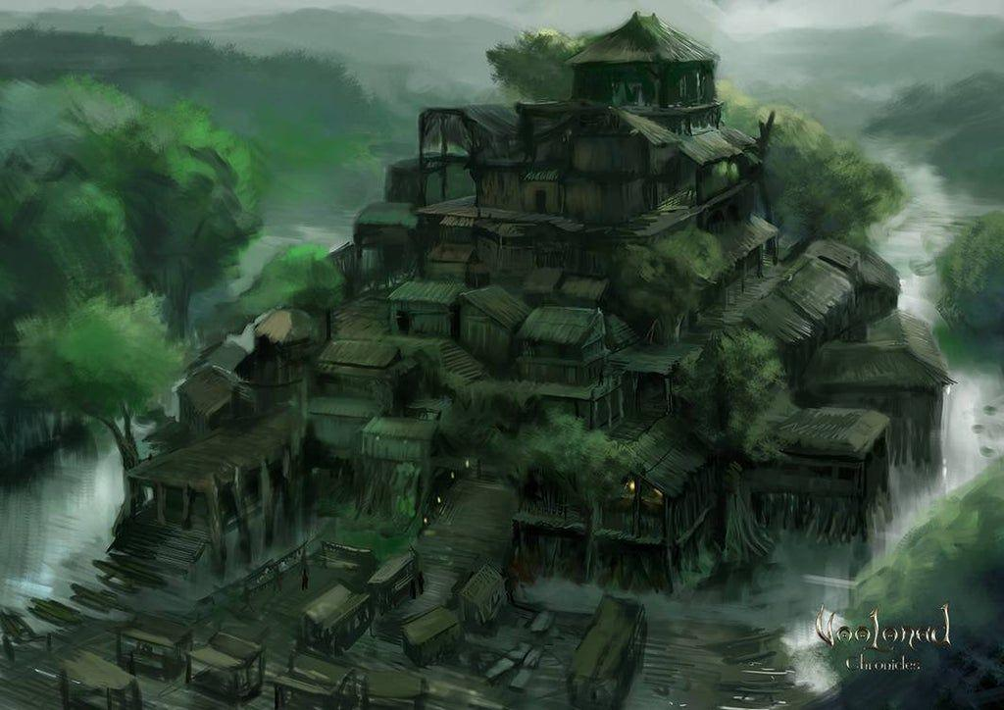

--DESCRIPTION--------------------------------------------------

Set at the foot of the Willow Glades and the Dry Forest, WillowGlade is a landmark trade route city that offers solace and protection for resting travellers.

--SHOPS & PEOPLE--------------------------------------------------

Lord Merryl Drake, 65 WillowGlade

Gld. Member Baccanthus Hayden, 27 Guild Affairs

Trader Brice Miles, 45 Trade

Tailor Teys Tanni, 91 Nothing

Smith Devon Wormald, 101 The Dowager Hotel

Smith Mcnamara, 52

Shopkeeper Doug Mcnamara, 37 The Trick Sleeve

Groundskeeper Sherman Boyle, 39 Nothing

Innkeeper Matt Stamp, 28 The Third Albatross

Farmer Gideon Bloom, 91

--ECONOMY--------------------------------------------------------

--SPECIAL FEATURES--------------------------------------------------

--HISTORY----------------------------------------------------------

--SHOPS--------------------------------------------------------------

--INNS---------------------------------------------------------------

### Other Areas

#### Ruins of Ul'Tumeir

<Image>

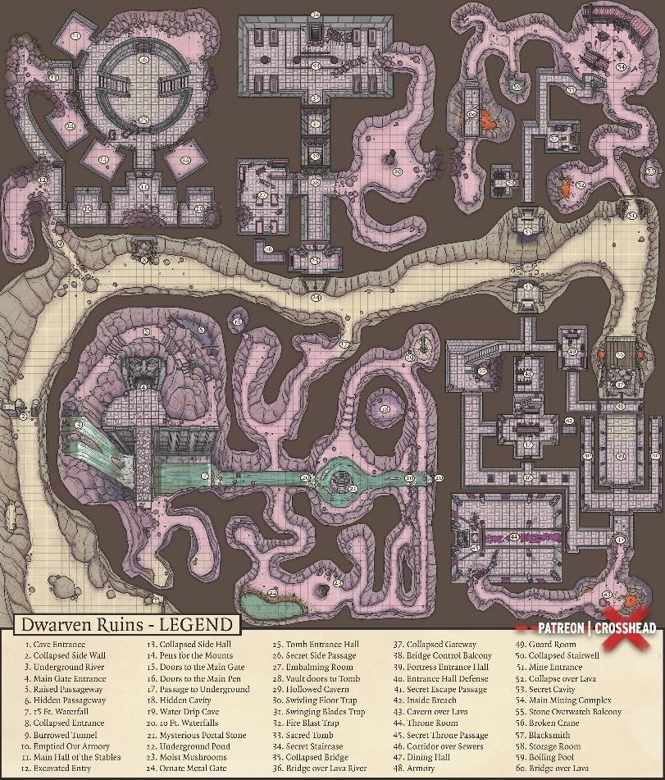

--DESCRIPTION--------------------------------------------------

https://i0.wp.com/crossheadstudios.com/wp-content/uploads/2018/08/ dwarven-ruins-abandoned-dwarven-outpost-dd-map-battlemap.jpg?resize =2561%2C3000&ssl=1

Nestled in the north-west cave of The Vallely of Death, the Ruins are rumored to hold the crypt of an old dwarven king. Notably, a **Korhelir.** It very likely offers insight into the history of the dwarves demise.

--SHOPS & PEOPLE--------------------------------------------------

--SPECIAL FEATURES--------------------------------------------------

--HISTORY----------------------------------------------------------

#### Waystones

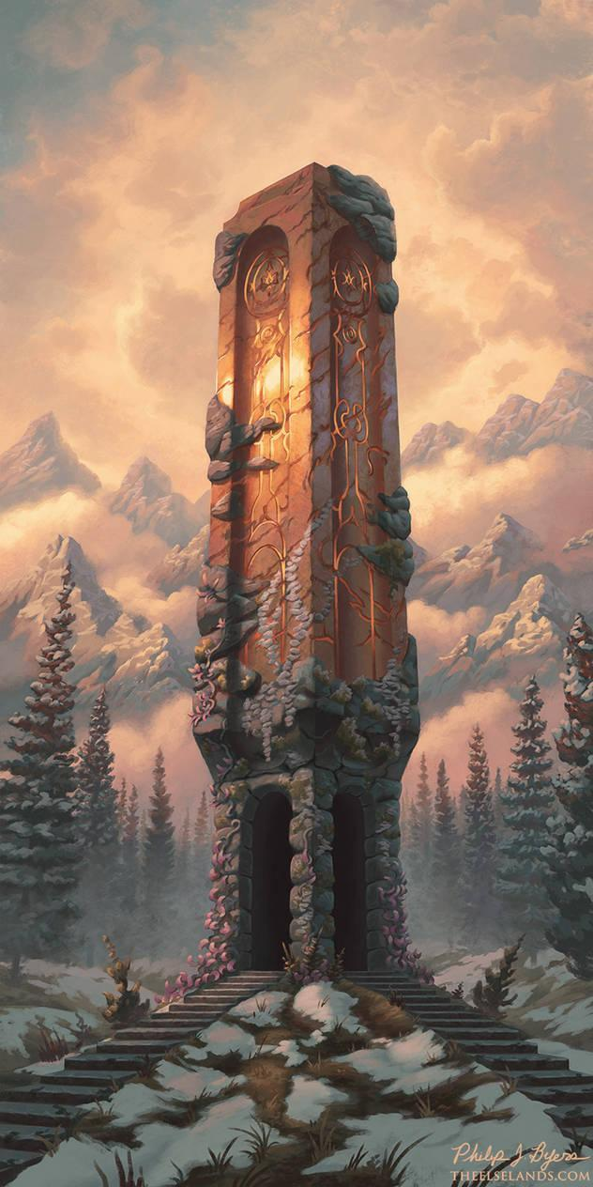

<Image>

--DESCRIPTION--------------------------------------------------

--SHOPS & PEOPLE--------------------------------------------------

--SPECIAL FEATURES--------------------------------------------------

--HISTORY----------------------------------------------------------

#### Barrow King Crypt

<Image>

--DESCRIPTION--------------------------------------------------

--SHOPS & PEOPLE--------------------------------------------------

--SPECIAL FEATURES--------------------------------------------------

--HISTORY----------------------------------------------------------

#### Rage Cave

<Image>

--DESCRIPTION--------------------------------------------------

--SHOPS & PEOPLE--------------------------------------------------

--SPECIAL FEATURES--------------------------------------------------

--HISTORY----------------------------------------------------------

## City-States - Yuntas-Mire (8)

<Representative Image>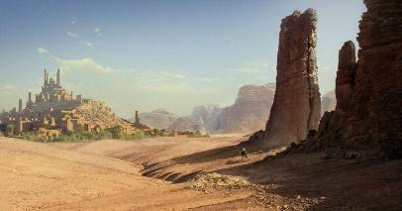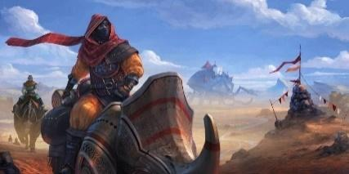

<Flag>

<Basic Description>

Yuntas-Mire is a mainly coastal collection of large, independent city states, governed by two leaders from Yuntas and Mire'Seil. Living in Yuntas-Mire are Nagas, lizardfolk and humans together.

*Geography in summary*

The city states of Yuntas Mire defy logic and belief. Residing along the foot of the Hammerstone hills, down to the Shard Mountains, the whole region is dominated by unforgiving desert wastes.

*Culture in summary*

Their desert lands lie on the dead continent, and their culture shows an elegant resilience to both their environment and the nations around them. Trade is open and strict, with the most lucrative of goods being exported for great profit.

Nagas & Lizardfolk:

Summary: Their society places honor, devotion, and dedication above all else. Less charitable observers from outside such societies might call the Naga “born slaves,” but the Naga do not think of themselves as slaves to their naga overlords, and point to the fact that they are free to make their own life decisions.

**Relations**: For their part, Naga regard humans as violent expansionists not to be trusted as political neighbors or allies. The general lack of a strong national heritage worries and confounds the Naga, with the exceptions of the Humans of the Mire'Seil regions.

**Alignment and Religion**: Most Naga are lawful neutral, but Naga of any alignment are possible. Religion plays a **secondary** role in Naga society to civic obedience.

**Adventurers**: Naga are often drawn to lives of adventure out of a desire to prove themselves to their own worth outside of this racial obligation. Naga excel as sorcerers, fighters, and for the right personality, serve exceptionally well as paladins.

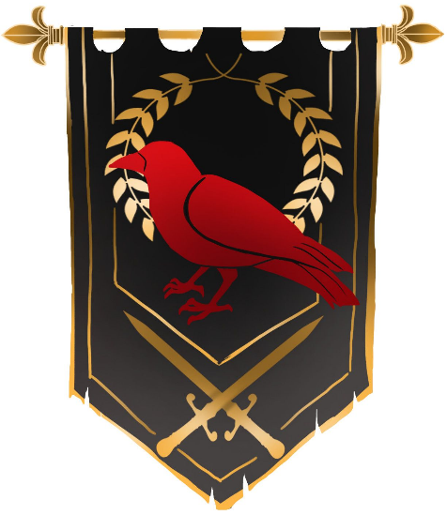

Humans:

**Summary:** When comparing the Cities of Yuntas Mire to other kingdoms on the continent, it's a wonder that they aren't a world superpower. These cities are so massively and extravagantly built. Their true histories are lost to time, but their economies thrive in their way of life. The people are driven by technology and peace, which they achieved.

**Relations**: The Humans of Mire'Seil have formed steady and amicable relationship with the Nagas of the region. They also have diplomatic arrangements with the OAR, but maintain respectful distance as they rely on their relationships with the naga more.

**Alignment and Religion**: This culture is a lawful neutral society, and holds religion to a very high power. Except, they don't praise the pantheon, but rather a lesser god named **Gond,** The tinkerer. With his help, humans have worked with Nagas to erect the most massive structures and cities known in the world.

**Adventurers**: Adventurers make great fighters, and for the right personality, serve well as paladins of Gond.

#### Leaders/Lords

NAGAS

<Image>

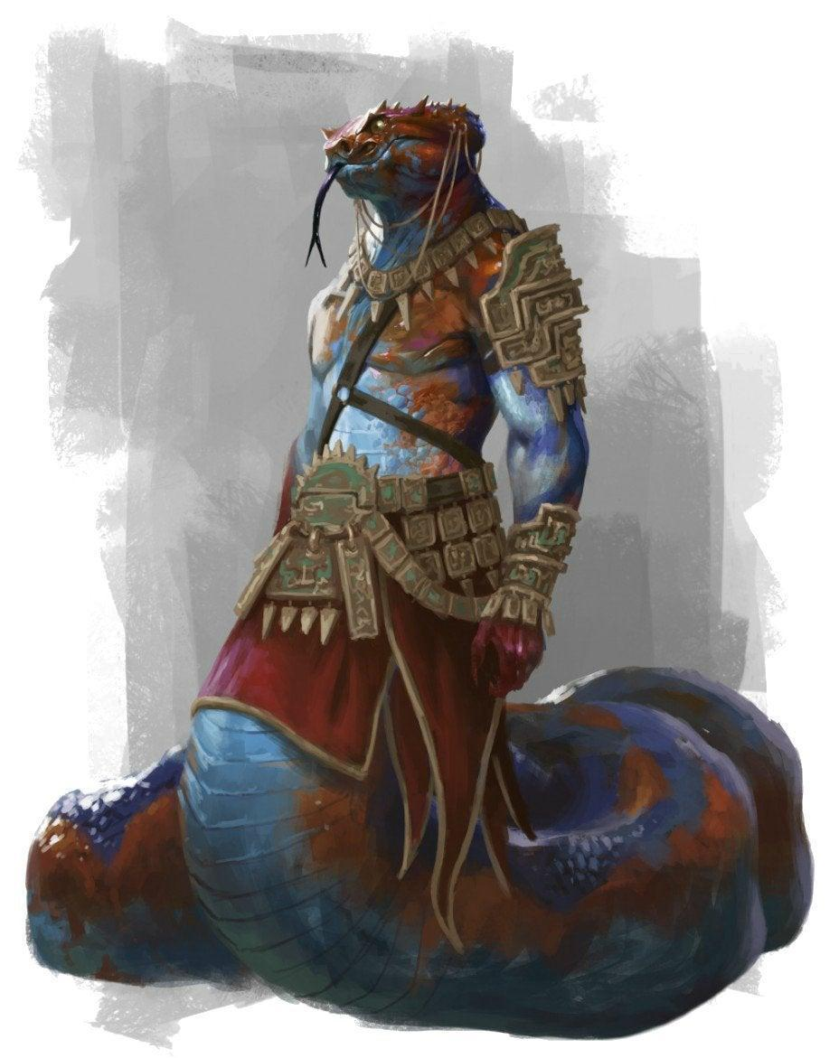

--DESCRIPTION--------------------------------------------------

Naga King **Heymon**

HUMANS

<Image>

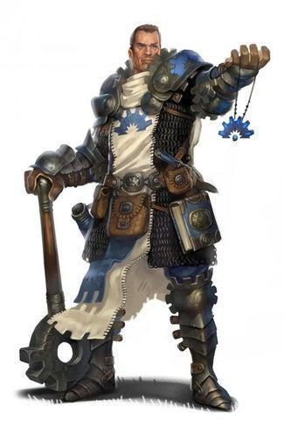

--DESCRIPTION--------------------------------------------------

Human King **Acelmus**

Acelmus comes from a long line of noble craftsman and architects. As a master Artificer, Acelmus is renowned as a creative leader in the city states. Though the cities are largely independent, his voice carries large weight in grand-scheme operations

Acelmus is creative, cocky and brilliant. He worships Gond devoutly and claims to speak with him often, leading to ideas of new structures and means of improving society. He values the

#### History

Acelmus was born into nobility but earned his rank and influence through his work. As a child he went on a quest to the caves near his village, where he met Gond in a vision. Gond told him if he kept applying himself, he'd rise to power and influence, and Gond would be with him to guide his people

Acelmus took this advice as ultimate and devoted his life to his work, leaving family and friends to the side. He studied at the University as a young man and took his knowledge of magic back to his lands to implement into his society, while also exploring it further. He spent the rest of his adult life working, and creating diplomatic relations with the Naga that gained from his knowledge.

### CITY - Barsellaq – Brickhold of Secrets

<Image>

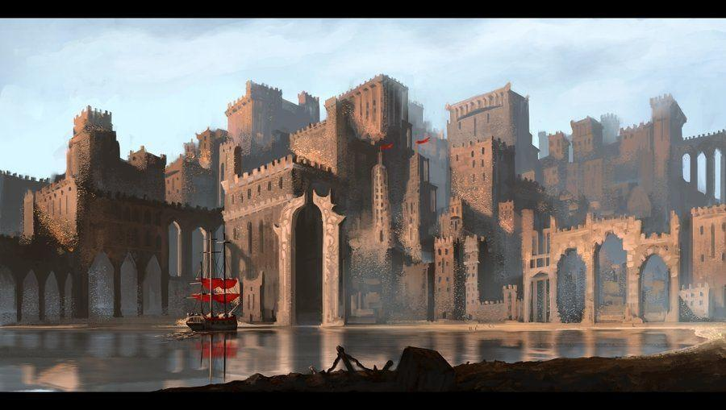

--DESCRIPTION--------------------------------------------------

--SHOPS & PEOPLE--------------------------------------------------

Lord Suzanna Sweet, 47 Barsellaq

Nobility Arthur Pennington, 49

Elder Caroline Finch, 88 Nothing

Elder Fumiko Miles, 108 Nothing

Guard Meridith Mendoza, 53 General Security

Guard Pauletta Drake, 60 General Security

Gld. Member Iolo Xecuria, 97 Guild Affairs

Smith Rohesia Benson, 91 Iron Woman

Smith Karey Cloudbend, 36 Keeping Coin

Smith Torie Cabaniss, 62 Metal Arts

Shopkeeper Teacher Elkrana, 91 The Merchants Doe

Shopkeeper Radoc Bonsaw, 65 Mountain Finds

Shopkeeper Joi Bram, 25 The Admiring Cart

Shopkeeper Edgardo Devaul, 39 The Brass Captain

Innkeeper Ceolsky Salter, 60 The Bashed Badger

Innkeeper Jesse Ochoa, 75 The Drunken Clam

Innkeeper Parker Pham, 27 The Sober Dwarf

Farmer Chet Partridge, 55

Mercenary Wasul, 70 Killing Stuff

Mercenary Trian, 102 Killing Stuff

Dead Lord Charmaine Partridge, 63 No One

--ECONOMY--------------------------------------------------------

--SPECIAL FEATURES--------------------------------------------------

--HISTORY----------------------------------------------------------

--SHOPS--------------------------------------------------------------

--INNS---------------------------------------------------------------

### Town- Fallmoer – Coastal Oasis

<Image>

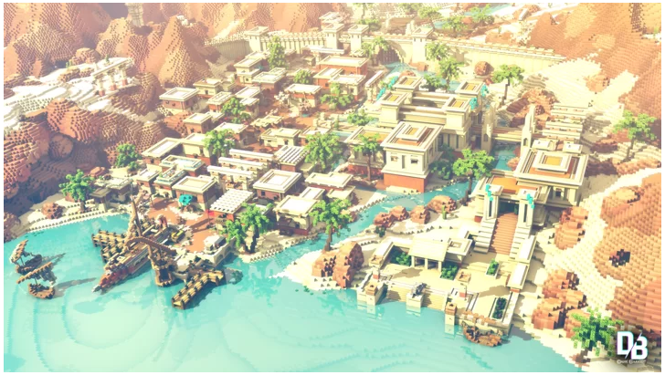

--DESCRIPTION--------------------------------------------------

This city resides along the most commonly known river of the Dead continent, known at the Geyser stream. This river appears from seemingly nowhere 10km up its path, and continues down back into the ocean.

The city build around it forms a type of oasis from it's abundance of fresh water. The city is made of buildings no larger than three stories but stretches the entire 10km. A large palace/stronghold is build right on-top of the geyser in an effort to keep it safe and for routine examinations as to it's source.

Surrounding the city are ragged hills and desert. The citizens remain largely unconcerned, and believe the city to be a paradise.

--SHOPS & PEOPLE--------------------------------------------------

Priest/ess Denis, 35 Fallmoer Religion

Lord Mendy Krause, 64 Fallmoer

Nobility Alexia Alvarez, 38

Alchemist Joanie Xiong, 68 The Urchins Spider

Elder Cathie Stott, 88 Nothing

Elder Augustine Stanton, 72 Nothing

Guard Cristi Sweeney, 25 General Security

Guard Marianna Steadman, 22 General Security

Gld. Member Vulmon Barrett, 41 Guild Affairs

Smith Nick Dawnweaver, 86 Finy and Jamas'

Smith Alverta Cote, 48 Forged away

Smith Shelby Amberswift, 36 Tick & Tock

Shopkeeper Helburth Fowlkes, 26 Shades and Shadows

Shopkeeper Thote Fasharash, 62 Crow's Nest Fishing and Tackle

Shopkeeper Alyson Elyn, 19 Tinker Tanner

Wnd'rn Trader Rachel Wazeman, 37 The Centaurs Vault

Innkeeper Uriel Padilla, 56 The Hidden Record

Innkeeper Vaughn Bowes, 27 The Elemental Fury

Innkeeper Leone Mill, 27 Drunken Dragons

Innkeeper Lowell Mustafa, 75 The Flowing Cauldron

Farmer Wanda Cottrell, 112 Local Farm

Farmer Jesse Mohamed, 34

Mercenary Bertie, 88 Killing Stuff

--ECONOMY--------------------------------------------------------

--SPECIAL FEATURES--------------------------------------------------

--HISTORY----------------------------------------------------------

--SHOPS--------------------------------------------------------------

--INNS---------------------------------------------------------------

### CAP - Mire'Seil – City on a Cliff

<Image>

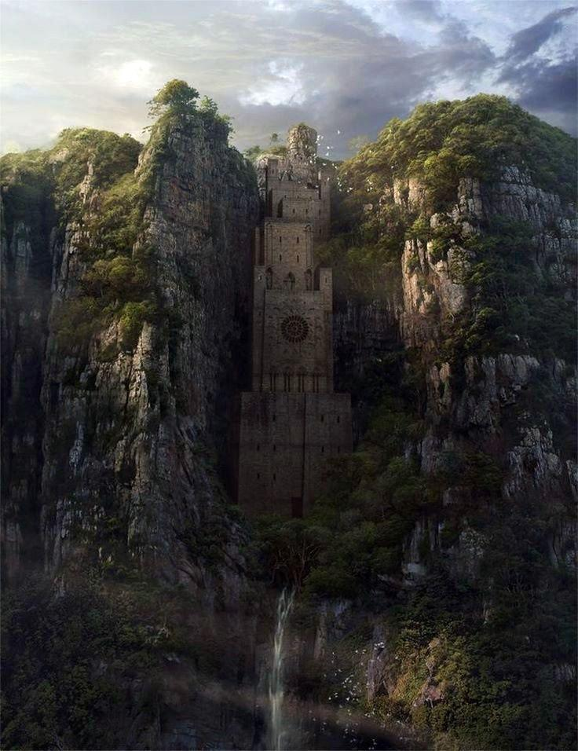

--DESCRIPTION--------------------------------------------------

Mire'Seil was known to be an ancient stronghold of mankind from the age of creation. It's said to have been build by the gods themselves, containing a waterfall in stone and harnessing all it's power through hydro-kinetic means.

At face value, the city may look like one tall building on a cliff. In reality, it stretches deep and far into the accompanying cliff face, storing a massive trove of tunnels and undiscovered secrets.

Home to the Relic Alliance

Prominent is the Guild of Hammer and Iron Temple

--SHOPS & PEOPLE--------------------------------------------------

Queen Matill, 64 Mire'Seil

King Ancelmus, 63 Northern Yuntas-

Mire, up to Vassalqar

IT Legate Rutherford, 55 Law and order

Priest/ess Brittni, 74 Mire'Seil Religion

Lord Devin Stamp, 61 Mire'Seil

Nobility Theodore Dickson, 64

Alchemist Bihon Thompson, 22 The First Last Spell

Elder Janyce Krause, 88 Nothing

Guard Petra Gates, 62 General Security

Guard Leora Stanton, 74 General Security

Treasurist Andree Smither, 56 Finances of the town

Gld. Member Taree Cortez, 37 Guild Affairs

Smith Sabenn Denford, 31 Dane of Flame

Smith Peggie Andersen, 71 The Greedy Cloak

Shopkeeper Girk Cote, 48 Marine Wonder

Shopkeeper Aerith Andersen, 90 All the RAGE

Shopkeeper Malena Cambridge, 41 Chimera Supplies

Shopkeeper Sherilyn Grensen, 59 Merchant Street

Fisherman Ludwig Krause, 37

Wnd'rn Trader Kareem Wazeman, 33 Umrat's Magical Oddities

Innkeeper Lakenya Letendre Murray, 63 Bastion's

Bathhouse

and Brothel

Innkeeper Oorg Meza, 98 Bernard's

Innkeeper Lianne Horton, 59 Barbarians Hall

Innkeeper Max Howarth, 62 The Bitter Lychee

Farmer Tylen Ochoa, 79 Local Farm

Farmer Webb Walsh, 55

Mercenary Um'hini, 54 Killing Stuff

Bard Alan Barajas, 109 Nothing

Dead Lord Anibal Malone, 53 No One

--ECONOMY--------------------------------------------------------

--SPECIAL FEATURES--------------------------------------------------

--HISTORY----------------------------------------------------------

--SHOPS--------------------------------------------------------------

--INNS---------------------------------------------------------------

### Town- Ousoul'Droth – Dead Field Castle

<Image>

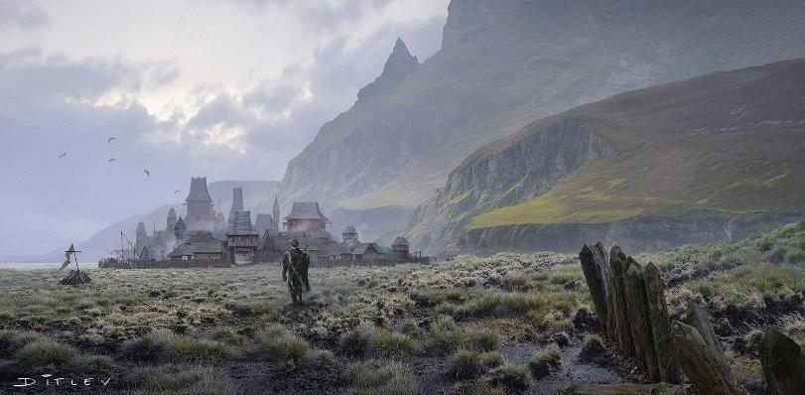

--DESCRIPTION--------------------------------------------------

Ousoul'Droth is tucked away from the coast on the northern foot of the Dead Lake Mountains. It resides in an open field and is largely just a self-contained city. Most buildings to not exceed 4 stories like the neighboring city states, and the people live here in happy quiet isolation.

--SHOPS & PEOPLE--------------------------------------------------

Priest/ess Arcelia, 54 Ousoul-Droth Religion

Lord Noma Steadman, 55 Ousoul-Droth

Alchemist Darrell Draper, 40 Mages for Ages

Elder Eileen Gates, 69 Nothing

Elder Omar Yu, 81 Nothing

Guard Shanti Stamp, 45 General Security

Guard Ira Chester, 58 General Security

Treasurist Velma Olathana, 72 Finances of the town

Gld. Member Precious Battle, 33 Guild Affairs

Smith Ariel Fowlkes, 70 The Shimmering Pommel

Smith Alvina Fasharash, 63 Mrs. Smith

Smith Debby Curry, 64 The Big Hammer

Shopkeeper Lahili Carelton, 34 The Dapper Pig

Shopkeeper Ramsy Flatwater, 102 Fis(c)her Price-Mart

Shopkeeper Liliana GripGear, 51 Rosie's Cauldron

Shopkeeper Jeromy Chatwick, 58 Carters Row

Innkeeper Cuthbald Kim, 32 The Last Drop

Innkeeper Liase Montoya, 50 The Horn

Innkeeper Ashanti Bloom, 52 The Launderer & Jailer

Farmer Boone Murray, 65

Farmer Taj Xecuria, 83

Mercenary Yray, 72 Killing Stuff

Mercenary Untther, 47 Killing Stuff

--ECONOMY--------------------------------------------------------

--SPECIAL FEATURES--------------------------------------------------

--HISTORY----------------------------------------------------------

--SHOPS--------------------------------------------------------------

--INNS---------------------------------------------------------------

### CITY - Tinheim – Coastal City of Gold

<Image>

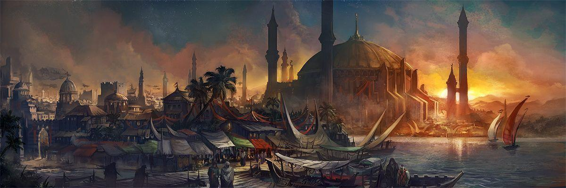

--DESCRIPTION--------------------------------------------------

--SHOPS & PEOPLE--------------------------------------------------

Priest/ess Milan, 57 Tineihm Religion

Lord Karol Keeling, 26 Tineihm

Nobility Alexandrine Xecuria, 29

Alchemist Stacie Ochoa, 25 The Unicorn's Horn

Elder Adela Snow, 101 Nothing

Guard Lindy Yu, 56 General Security

Guard Zofia Stott, 34 General Security

Gld. Member Celendine Graves, 82 Guild Affairs

Smith Erky Bardye, 120 Balthar's Blunts & Blades

Smith Adena Cambridge, 38 The Gorgeous Train

Smith Jeremiah Grensen, 45 Hammerstone Forge

Shopkeeper Lopowe Dawnweaver, 63 The Performing

Antenna Outfitter

Shopkeeper Rae Noblesword, 32 The Jumping Expedition

Shopkeeper Wanda Dorgin, 92 Stuffs

Shopkeeper Kesha Amberswift, 67 Gertha's

Wnd'rn Trader Rosalba Wazeman, 35 Caravan on the Road

Wandering

Innkeeper Penael Arnold, 34 The Cave Inn

Innkeeper Mormo Alvarez, 61 The Graceful Kettle

Innkeeper Freddie Edge, 29 The Secret Hellhound

Innkeeper Izetta Whitworth, 54 The Drunken Miner

Farmer Micah Walters, 47

Mercenary Ealdhed, 60 Killing Stuff

Dead Hero Benedict Hayden, 66 No One

--ECONOMY--------------------------------------------------------

--SPECIAL FEATURES--------------------------------------------------

--HISTORY----------------------------------------------------------

--SHOPS--------------------------------------------------------------

--INNS---------------------------------------------------------------

### Town- Vassalqar – Bustling Ravine Town

<Image>

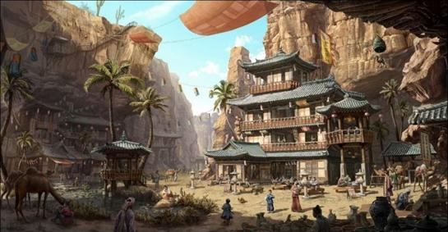

--DESCRIPTION--------------------------------------------------

Again lying away from the coastlines, Vascular stretches through miles of canyon-like cracks in the earth to escape the harsh sun. To it's north is a lonely mountain separated from the Hammerstone Hills..

--SHOPS & PEOPLE--------------------------------------------------

Priest/ess Marcie, 23 Vassalqar Religion

Lord Desiree Chester, 71 Vassalqar

Nobility Nicolaos Zimmerman, 53

Alchemist Kaleigh Walsh, 31 The Original Last Spell

Elder Junie Stein, 65 Nothing

Guard Minerva Keeling, 43 General Security

Guard Jamal Sweet, 21 General Security

Gld. Member Joscelyn Pennington, 74 Guild Affairs

Smith Latisha Noblesword, 28 Gnome Depot.

Smith Viki Elyn, 26 Ironclad

Smith Emma Dorgin, 54 Shielded Soldiers

Shopkeeper Dawson Cloudbend, 41 The Awesome Ticker

Newsstand

Shopkeeper Wytias Fishcher, 68 Tome's A-Plenty

Shopkeeper Sitar Curry, 82 Woodne Wonders

Shopkeeper Tessie Cabaniss, 70 The Awkward Branch

Shopkeeper Rhett Benson, 74 The Winking Wall

Wnd'rn Trader Branda Wazeman, 40 Caravan on the Road

Wandering

Innkeeper Burrd Alford, 96 Rock Bottom

Innkeeper Meefer Raymond, 34 The Earl Arms

Innkeeper Lavinia Mcgowan, 69 The Vicious Armor Bakery

Farmer Homer Rojas, 22 Local Farm

Farmer Wade Vega, 34

Mercenary Alexiana, 52 Killing Stuff

Bard Local Rivers, 33 Nothing

--ECONOMY--------------------------------------------------------

--SPECIAL FEATURES--------------------------------------------------

--HISTORY----------------------------------------------------------

--SHOPS--------------------------------------------------------------

--INNS---------------------------------------------------------------

### CAP - Yuntas – Ancient City Gargantuan

<Image>

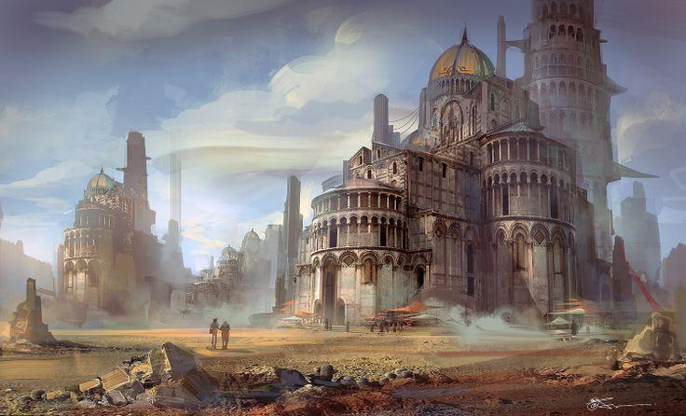

--DESCRIPTION--------------------------------------------------

The outcrop of the city of Yuntas can be seen from the shores of Barsellaq and beyond. Unbelievably massive circular towers dwarf anything in the region and stand together as the most ancient, known stronghold on the continent.

The city spans many kilometers in any distance and visitors are rarely welcome. It remains to this day as one of man's biggest questions

--SHOPS & PEOPLE--------------------------------------------------

Queen Louve, 73 Yuntas

King Heymon, 35

Southern Yuntas-Mire, up to Ousol'Droth

Grand Sec. Illyana Thourmon, 300 Repository of Records

Archmage G'tariel Oathbreaker The Arcane Celestia

IT Legate Hammond, 44 Law and order

Priest/ess Marie, 73 Yuntas Religion

Lord Rosamaria Sweeney, 47 Yuntas

Nobility William Dickson, 50

Babysitter Pelham Duggan, 51 Nothing

Elder Heather Salter, 91 Nothing

Elder Fidelia Raymond, 71 Nothing

Guard Cristine Cole, 34 General Security

Treasurist Birdie Stallam, 57 Finances of the town

Gld. Member Thargraerika Steadman, 60 Guild Affairs

Smith Leocadie Aefina, 108 Metal Mastery

Smith Dorothea Chatwick, 20 The Storm Weapon

Smith Anjanette Fishcher, 61 Mr. & Mrs. Smith

Shopkeeper General Amberdown, 74 Seaview Route Route

Shopkeeper Wilson Greek, 40 Fletcher Passage

Shopkeeper Philbert Ahren, 59 The Fake Giant

Shopkeeper Valentin Tamrei, 73 The Secret Ingredient

Shopkeeper Vivian Gelnne, 35 Sew and Tell

Innkeeper Quinten Xiong, 44 The Red Rat

Innkeeper Phoebe Mill, 43 The Crimson Pearl

Innkeeper Camilla Thompson, 59 The Wooden House

Innkeeper Emely Walsh, 36 The Merry Quill

Farmer Emmett Snow, 52

Mercenary Wardra, 93 Killing Stuff

Mercenary Wytas, 57 Killing Stuff

Dead Hero Kati Davison, 48 No One

--ECONOMY--------------------------------------------------------

--SPECIAL FEATURES--------------------------------------------------

The Repository of Records

The Arcane Celestia

--HISTORY----------------------------------------------------------

--SHOPS--------------------------------------------------------------

--INNS---------------------------------------------------------------

### CITY - Katsu-Tal – The Secret Haven

<Image>

Expectation

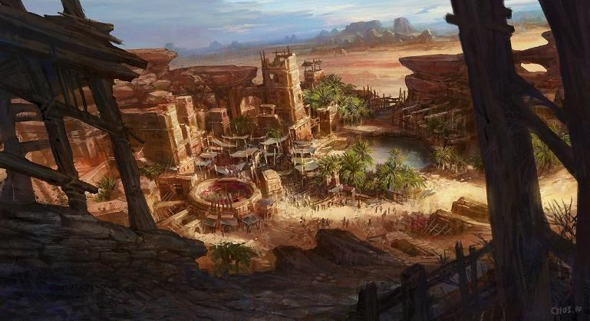

Reality

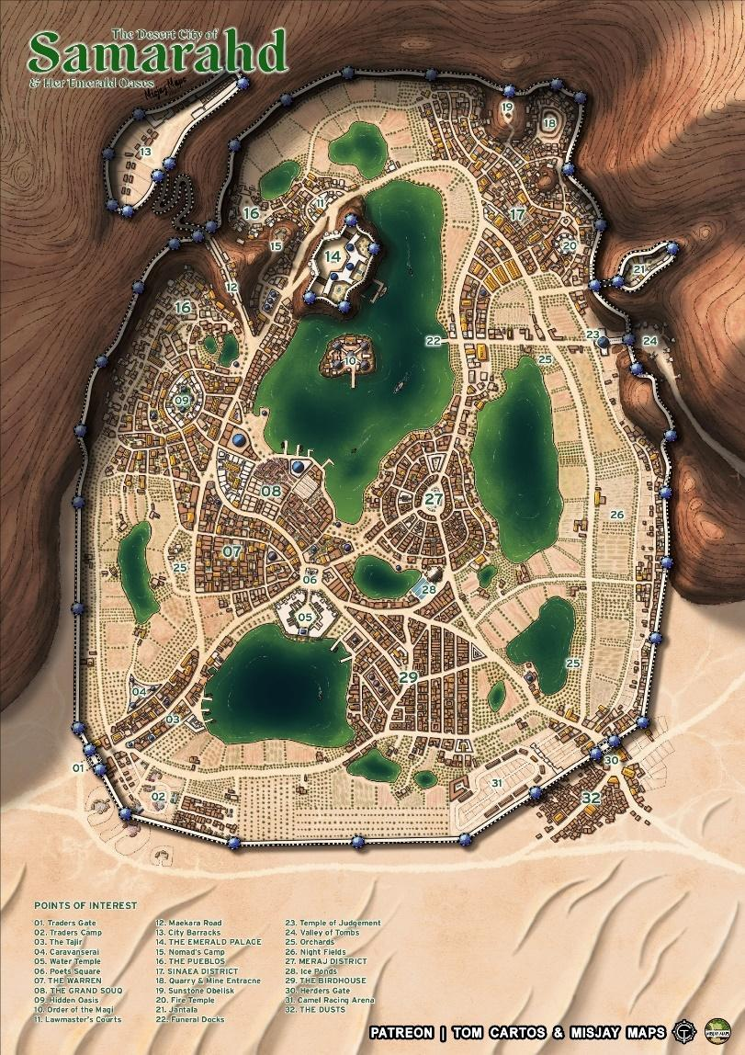

--DESCRIPTION--------------------------------------------------

--SHOPS & PEOPLE--------------------------------------------------

--ECONOMY--------------------------------------------------------

--SPECIAL FEATURES--------------------------------------------------

--HISTORY----------------------------------------------------------

--SHOPS--------------------------------------------------------------

--INNS---------------------------------------------------------------

**Island - The Shattered Isles (9)**

The Shattered Isles are a collection of five or so large islands and hundreds of smaller bits of land that know no ruler. Various communities, people and secrets inhabit each one, with Laogai Island holding the only well-known town of note. The town, known only as Laogai, sits at the base of a volcanic mountain and is home to a simple folk.

**‘Goddess’ Zahaine**

The Islands are overlooked by an outcast Archfey names Zahaine, The Lunar soul reaper. She was stripped of many of her powers and cursed to the farthest reaches of the realm, only to return after keeping the lands as they naturally are for 1000 years.

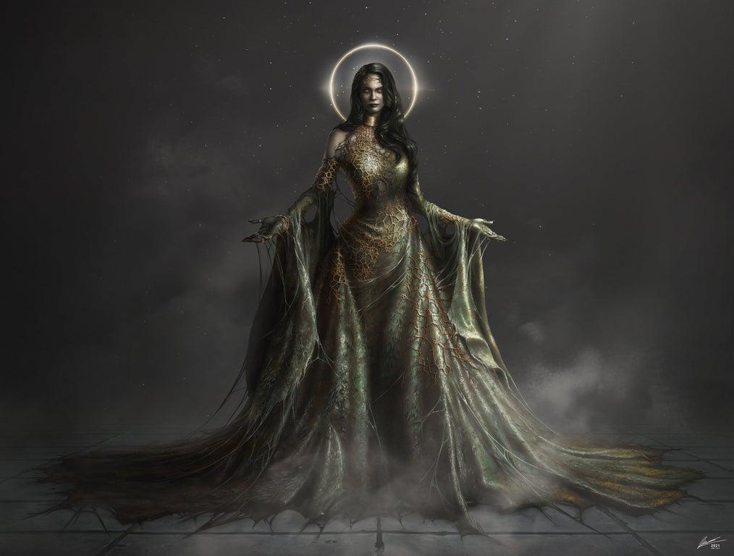

Her clothing and jewellery seem almost a part of her body, and as she appears, she usually emerges from a thick pool of the green, viscous tar that rises from the earth where she stands.

Her Goal

She conflicts often with oceanic travellers and is sometimes too mistaken with the Painted Lady to the north. She acts like a siren to those who sail the waters with the intention of bringing outside influence to the lands.

### CITY - Aphachaigia Isl. – Island of Champions

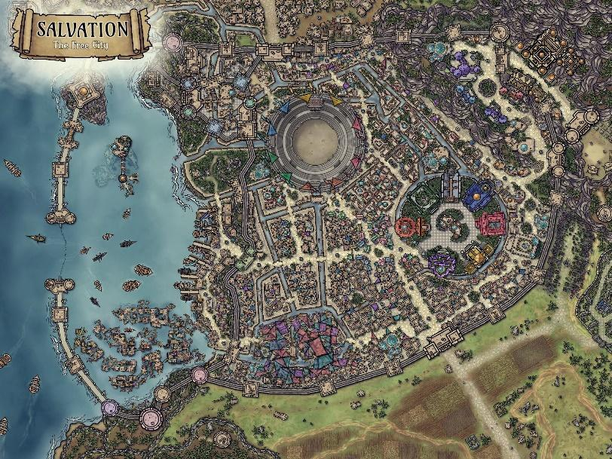

--DESCRIPTION--------------------------------------------------

--SHOPS & PEOPLE--------------------------------------------------

--ECONOMY--------------------------------------------------------

--SPECIAL FEATURES--------------------------------------------------

--HISTORY----------------------------------------------------------

--SHOPS--------------------------------------------------------------

--INNS---------------------------------------------------------------

### CITY - Broken Earth Isl. – Seaside City

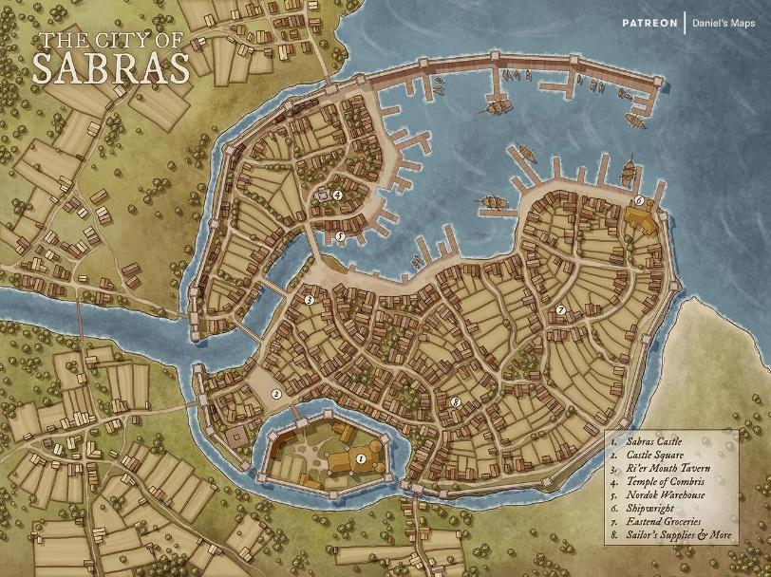

--DESCRIPTION--------------------------------------------------

--SHOPS & PEOPLE--------------------------------------------------

--ECONOMY--------------------------------------------------------

--SPECIAL FEATURES--------------------------------------------------

--HISTORY----------------------------------------------------------

--SHOPS--------------------------------------------------------------

--INNS---------------------------------------------------------------

### CITY – Azureinn Isl. – Mountain City

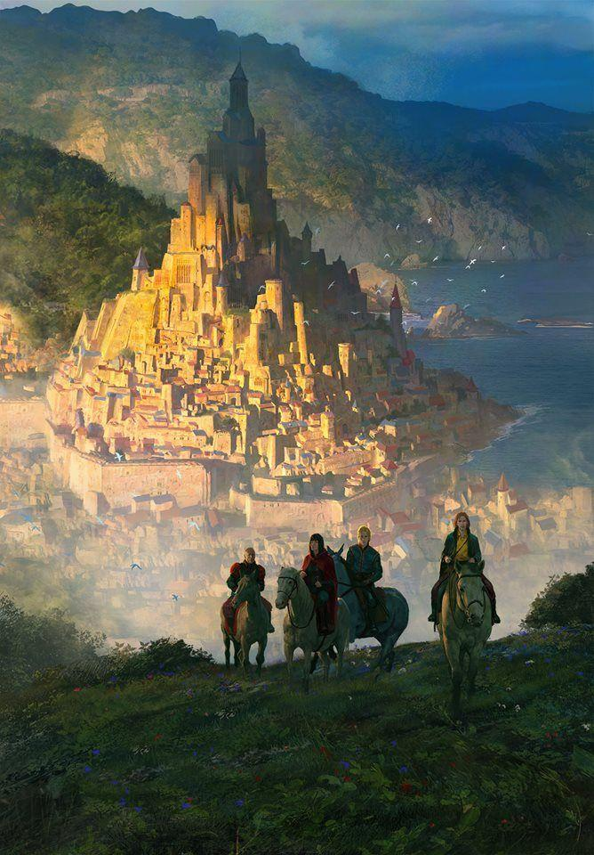

### Town- Ichor Landing - Wizard’s Rest

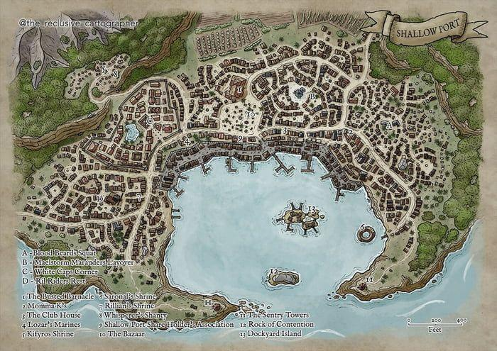

--DESCRIPTION--------------------------------------------------

Ichor landing is the plalce where southern wizards convene to discuss the goings-on of the world. Here, they plan their actions and communicate with the University

--SHOPS & PEOPLE--------------------------------------------------

--ECONOMY--------------------------------------------------------

--SPECIAL FEATURES--------------------------------------------------

--HISTORY----------------------------------------------------------

--SHOPS--------------------------------------------------------------

--INNS---------------------------------------------------------------

### Town- Laogai Isl. – Magic Lumber Island

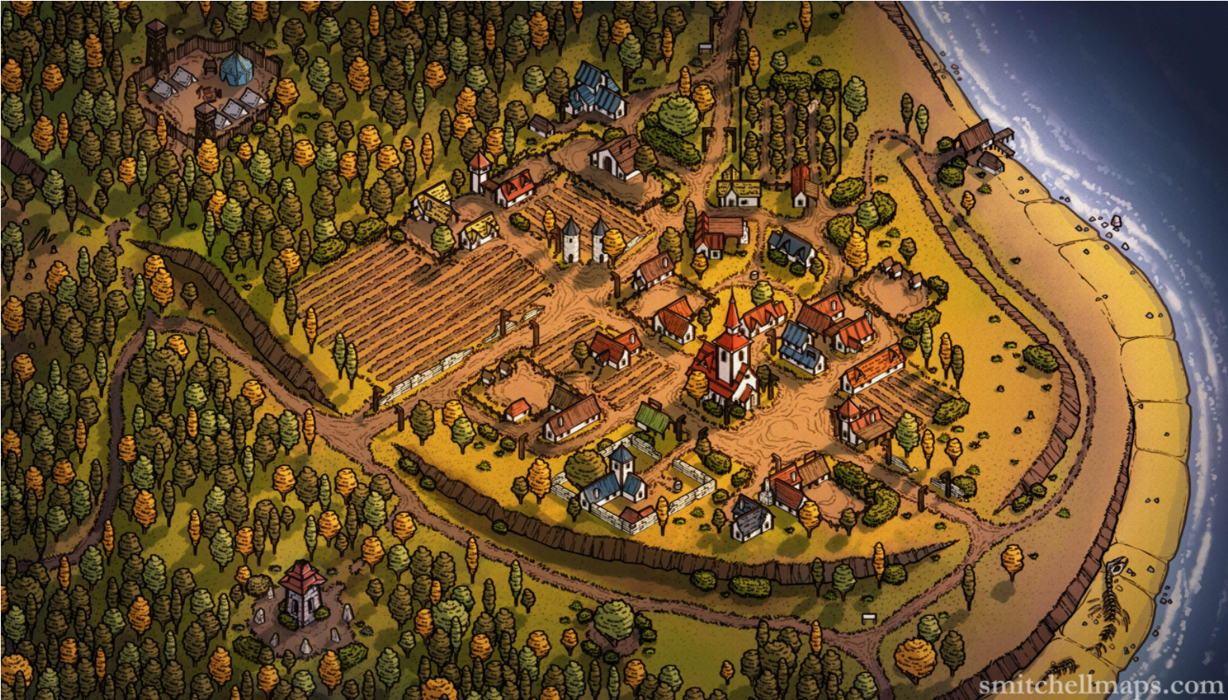

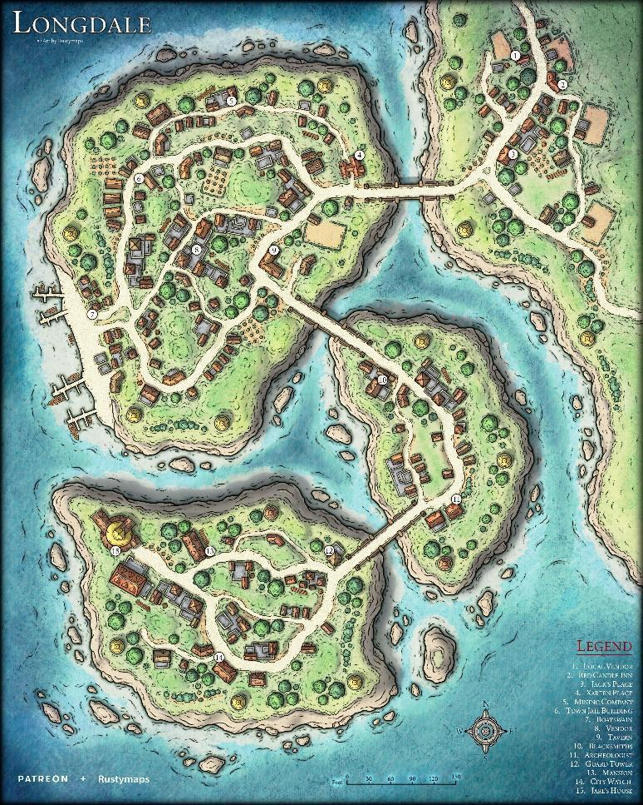

--DESCRIPTION--------------------------------------------------

--SHOPS & PEOPLE--------------------------------------------------

--ECONOMY--------------------------------------------------------

--SPECIAL FEATURES--------------------------------------------------

--HISTORY----------------------------------------------------------

--SHOPS--------------------------------------------------------------

--INNS---------------------------------------------------------------

### Shattered Isl. – Range of Broken Clans

--DESCRIPTION--------------------------------------------------

--SHOPS & PEOPLE--------------------------------------------------

--ECONOMY--------------------------------------------------------

--SPECIAL FEATURES--------------------------------------------------

--HISTORY----------------------------------------------------------

--SHOPS--------------------------------------------------------------

--INNS---------------------------------------------------------------

### Tortlewall Reef – Sea-Gates of the Ikidian

--DESCRIPTION--------------------------------------------------

--SHOPS & PEOPLE--------------------------------------------------

--ECONOMY--------------------------------------------------------

--SPECIAL FEATURES--------------------------------------------------

--HISTORY----------------------------------------------------------

--SHOPS--------------------------------------------------------------

--INNS---------------------------------------------------------------

### Mytra – Fields of Misery and Mystery

--DESCRIPTION--------------------------------------------------

--SHOPS & PEOPLE--------------------------------------------------

--ECONOMY--------------------------------------------------------

--SPECIAL FEATURES--------------------------------------------------

--HISTORY----------------------------------------------------------

--SHOPS--------------------------------------------------------------

--INNS---------------------------------------------------------------

### Uadir – Land of the Drakes

--DESCRIPTION--------------------------------------------------

--SHOPS & PEOPLE--------------------------------------------------

--ECONOMY--------------------------------------------------------

--SPECIAL FEATURES--------------------------------------------------

--HISTORY----------------------------------------------------------

--SHOPS--------------------------------------------------------------

--INNS---------------------------------------------------------------

### Oman – Prison of Kyuss Spawn

--DESCRIPTION--------------------------------------------------

--SHOPS & PEOPLE--------------------------------------------------

--ECONOMY--------------------------------------------------------

--SPECIAL FEATURES--------------------------------------------------

--HISTORY----------------------------------------------------------

--SHOPS--------------------------------------------------------------

--INNS---------------------------------------------------------------

## Unaligned (7)

<Representative Image>

<Flag>

<Basic Description>

### Summary

*Geography in summary*

*Culture in summary*

#### Leader/Lord

<Image>

--DESCRIPTION--------------------------------------------------

#### History

*Brief and limited to the story of its formation and current situation

#### Laws and Government

### Frostling Stronghold

<Image>

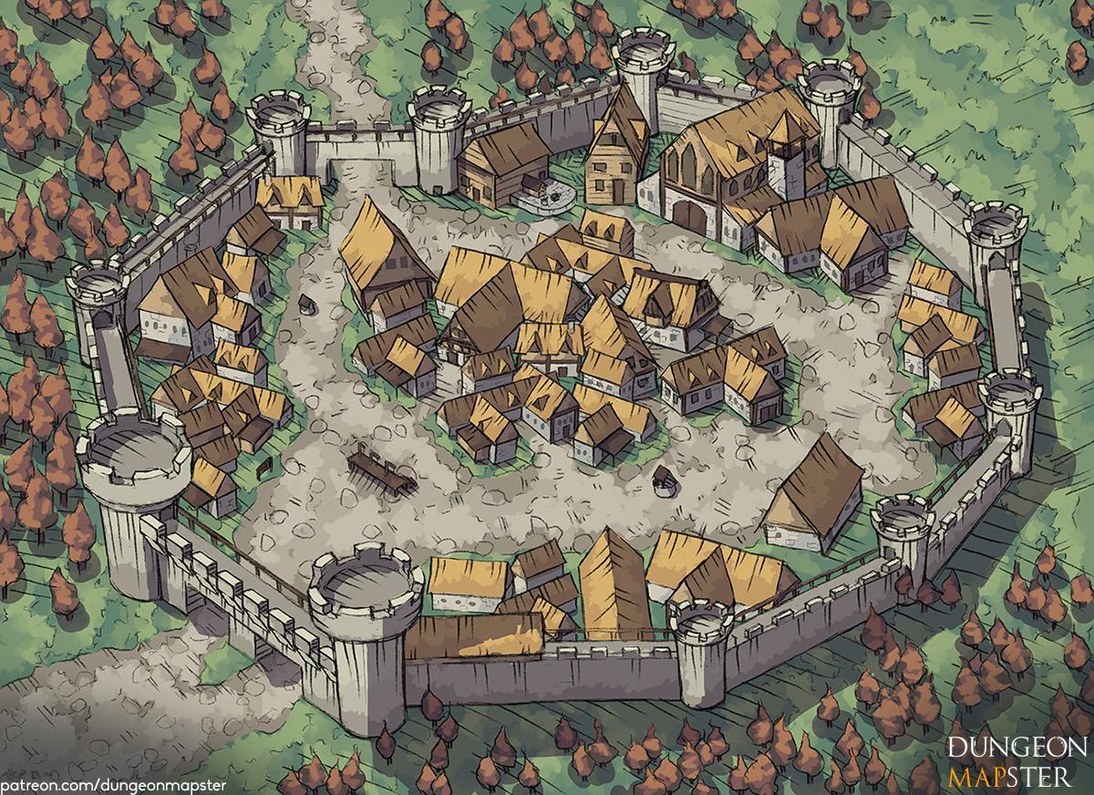--DESCRIPTION--------------------------------------------------

--SHOPS & PEOPLE--------------------------------------------------

Prince Sige Mcgowan, 59 Frostling Stronghold

Jailer Saewy, 93

Innkeeper Vi Mohamed, 95 The Ugly Grape

Innkeeper Olevia Walsh, 63 The Launderer & Jailer

Smith Olga Eshelwood, 62 Olgas Arms

IT Legate Grant Mister, 30

--ECONOMY--------------------------------------------------------

--SPECIAL FEATURES--------------------------------------------------

--HISTORY----------------------------------------------------------

--SHOPS--------------------------------------------------------------

--INNS---------------------------------------------------------------

### Hold of Civilization

<Image>

--DESCRIPTION--------------------------------------------------

--SHOPS & PEOPLE--------------------------------------------------

Hero Luetta TBD, 117 Nothing

Archmage Edward TBD, 73 Nothing

Lord Alleen TBD, 82 Nothing

Innkeeper Olevia Walsh, 63 The Launderer & Jailer

Thief Monique TBD, 39 Nothing

Dead Hero Tremmor TheGreat, 107 No One

Dead Hero Hammer Hammer, 800 No One

Hermit Brittny TBD, 38 Nothing

--ECONOMY--------------------------------------------------------

--SPECIAL FEATURES--------------------------------------------------

--HISTORY----------------------------------------------------------

--SHOPS--------------------------------------------------------------

--INNS---------------------------------------------------------------

### Sutherland Keep

<Image>

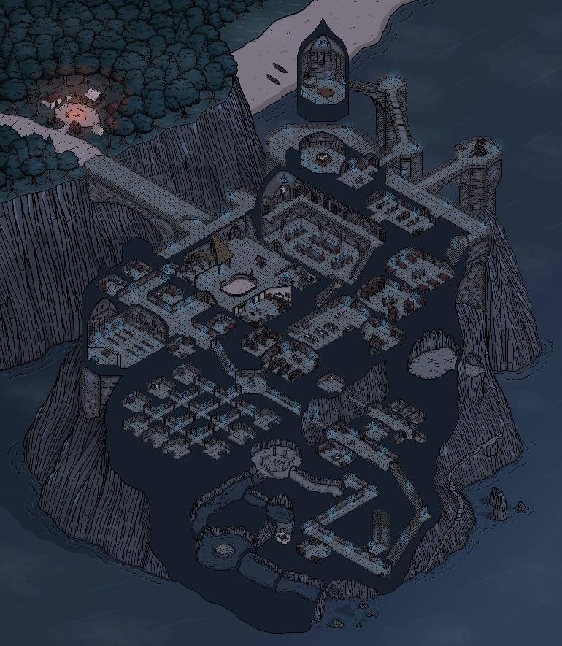

--DESCRIPTION--------------------------------------------------

--SHOPS & PEOPLE--------------------------------------------------

Historian Findalye Rememberall, 87

Grand Secretariat Edolie Secrin, 101

Princess Elsa Raymond, 750 Sutherland Keep

Wand Smith Witmund, 109 Wands

Jailer Cenfa, 79

Innkeeper Artariel Mccartney, 88 The Royal Owl

--ECONOMY--------------------------------------------------------

--SPECIAL FEATURES--------------------------------------------------

--HISTORY----------------------------------------------------------

--SHOPS--------------------------------------------------------------

--INNS---------------------------------------------------------------

### University

<Image>

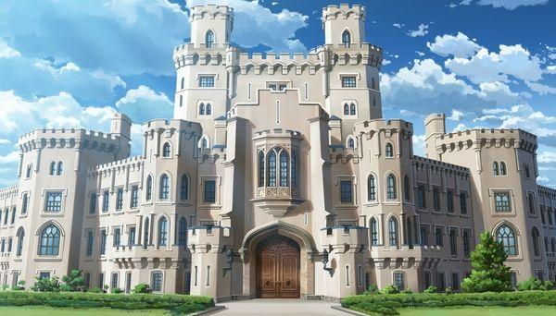

DESCRIBE, DON'T SHOW

* Massive, impossibly smooth stone structures
* Solid oak doors and perfectly clean landscapes surrounding
* Beautiful sparkling view of the Lake Arcane in the background..

--DESCRIPTION--------------------------------------------------

--SHOPS & PEOPLE--------------------------------------------------

STAFF

Grand Archivist Edwina Herbert, 90

Administrator Marlayl Stirling, 90

Dean Griffin, 56

M. of War Laurenzia, 27

M. Swordsman Lenka Ward, 38

M. Necromancy Raenyon, 52

M. Naturalist Marlon Gaer, 28

M. Merchant Robert Ma Trae, 25

M. of Magic Elodius, 34

M. of Knowledge Liliana Adaw, 13

SUPPORT STAFF

Wand Smith Una Lorenzen, 12

Archmage Jerrod Steacki, 18 Conjuration

Archmage Merle Pen, 12 Abjuration

Archmage Lino Fino, 40 Illusion

Archmage Trent Wolff, 15 Divination

Archmage Cleo Allo, 36 Enchantment

Archmage Tholyne Past, 33 Transmutation

Archmage Paylord Aressen, 301 Necromancy

Archmage Adam Pennington, 53 Evocation

Priest/ess Mara Cortez, 31

TOWNSPEOPLE

Alchemist Bertrom Cloudcutter, 18 Sorcerer's Source

Alchemist Isaldon Lander, 29 Mara's Fortune

Alchemist Octavius Wrzak, 12 Pharmagician

Alchemist Grant Hamsers, 36 Tired Basilisk

Gld. Member Charmaine Ochoa, 70

Gld. Member Bral Den, 25

Jeweler Finy Arrow, 24

Smith Quinton Adamsen, 30

Smith Doln Mart, 34

Shopkeeper Ebren Griffiths, 350 Student supply shop

Shopkeeper Liez Leot, 20 Grizwolds curios

Shopkeeper Barry Dams, 40 Break and Buy!

Innkeeper Malia Graves, 88 The Hub

Innkeeper Koron Rland, 32 Annie's Best Inn

STUDENTS

Student Delg Acheson, 72 Their Studies

Student Syle Vineree, 8 Their Studies

Student Krystle Rutiasp, 14 Their Studies

Student Burl Macangus, 12 Their Studies

Student Samuel Lusk, 44 Their Studies

Student Geranni Rone, 29 Their Studies

Student Leendri Granger, 24 Their Studies

Student Eunice Acraven, 26 Their Studies

Student Vand Karstensen, 12 Their Studies

Student Roth Miksenb, 16 Their Studies

--ECONOMY--------------------------------------------------------

--SPECIAL FEATURES--------------------------------------------------

--HISTORY----------------------------------------------------------

--SHOPS--------------------------------------------------------------

--INNS---------------------------------------------------------------

### Underdark Guard Post

<Image>

--DESCRIPTION--------------------------------------------------

--SHOPS & PEOPLE--------------------------------------------------

Captain Calepu, 103 WatchTower 1

Captain Eldurn, 86 WatchTower 2

Captain Gha'hin, 83 WatchTower 3

Captain Honec, 101 WatchTower 4

Captain Serray, 62 WatchTower 5

Captain Smoirtden, 67 WatchTower 6

Captain Tanque, 104 WatchTower 7

Captain Gorbar, 58 WatchTower 8

--ECONOMY--------------------------------------------------------

--SPECIAL FEATURES--------------------------------------------------

--HISTORY----------------------------------------------------------

--SHOPS--------------------------------------------------------------

--INNS---------------------------------------------------------------

### Repository of Records

<Image>

--DESCRIPTION--------------------------------------------------

--SHOPS & PEOPLE--------------------------------------------------

--ECONOMY--------------------------------------------------------

--SPECIAL FEATURES--------------------------------------------------

--HISTORY----------------------------------------------------------

--SHOPS--------------------------------------------------------------

--INNS---------------------------------------------------------------

### The Watch House

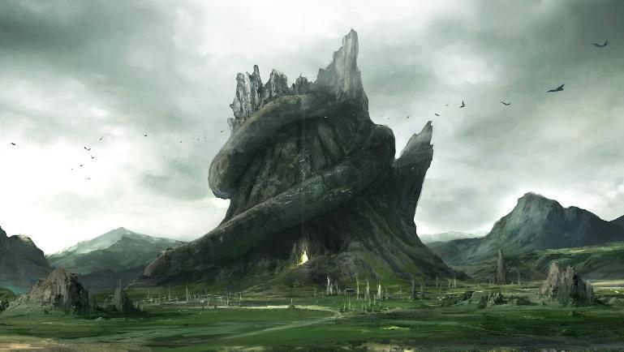

<Image>

--DESCRIPTION--------------------------------------------------

--SHOPS & PEOPLE--------------------------------------------------

--ECONOMY--------------------------------------------------------

--SPECIAL FEATURES--------------------------------------------------

--HISTORY----------------------------------------------------------

--SHOPS--------------------------------------------------------------

--INNS---------------------------------------------------------------

**Special Locations**

### Waystones - Recurring

Between cities, roll a d20. On a 20, arrive upon a waystone.

https://www.gmbinder.com/share/-MPob5M-78E6_Ns1z3Q_

At first glance, these stones appear to be landmarks. Upon closer inspection, these stones are some manner of memorial, as the inner face of every stone is packed with text in elven script. To those who can read elvish, they are little more than directions, as the words are all ancient elven words for various locations.

These innocuous looking set of standing stones hold a secret. Sometimes known as waystones, these way shrines hold the secret to how elves maintained a powerful empire even spread across extreme distances.

***Ancient Teleportation.*** Built long ago by the elves of that era, these waystones use the keylines of the world to transport individuals across vast distances.

Typically built at a point where two or more keylines meet, these magical stones turn creatures into pure magic and pull them along the keylines where many of these points meet. At its most straightforward, the two points are "next to" each other on the path, though travel can be chained along several way shrines, potentially "turning" onto different keylines at each way shrine.

***Misunderstood Magic.*** The secrets of these waystones have been largely lost to time. Not because they themselves have been forgotten. No, the power of the waystones are lost because modern scholars misinterpreted their use.

Typically, when starting to discern the function of magical structures, the first thing a mage does is cast detect magic, since that gives insight as to what sort of magic they're dealing with. However, these way shrines are positioned in such a manner that makes that impossible.

The way shrines are structured in such a manner that they intersect they magical keylines of the world, as such, attempting to "see" the magic coming from them fails because you are blinded by the amount of magic flowing through them from the outside.

***Effect and Cause.*** It has been understood by modern scholars that these way shrines mark where magic is the most powerful, each stone dictating the flow of the keylines out of the structure. They have come to understand that this is why they are often found nearby current (or former) high elven settlements.

While this is all true, it is because they believe the requirement for these structures to function is in fact their purpose.

#### Way stone Teleportation

Using waystones for "fast travel" is rather straight-forward. There are a few requirements that need to be met though.

* The character must know about the use of way shrines.
* The character must have encountered at least two in their travels.

It's that easy, but because its that easy, the knowledge has been lost for ages. Most do not have reason to travel the vast distances required to encounter a second stone. As such very few people have encountered more than one, if even that.

#### The Dangers

Being of a "simple" construction, these waystones can be as dangerous as they are useful. This is, in part, the reason why there is limited knowledge on this subject.

Simply put, waystones exist to pull matter along the network, but without a destination, the elf gate attempts to pull the user in all directions at once. Allowing the waystones to perform its task undirected tears the user apart as their existence is pulled in every direction at once, destroying them.

#### Using the Waystones

A creature who enters the center of the waystones feels a gentle tugging sensation in every direction. A creature that has encountered one or more other way shrines feel a stronger tugging in those directions than the others.

The creature must then touch the stone they are being pulled towards and then the name of the location they are being pulled towards, by willing themself, as an action, to be pulled in that direction, they travel near instantaneously to the center of the destination waystones. After transporting something, the way shrine cannot initiate such a transportation for 1 hour.

If multiple creatures or objects are inside the waystones when it is activated, they are all transported at once. The waystones can transport as much at one time as can fit within its perimeter. waystones are typically constructed in a 15-foot circles.

A creature who wills themselves to be transported without a direction must roll a d100. On a result of a 90-100, the creature is transported to a random waystone. On a 1, the creature is torn apart in its entirety, body, and soul, and cannot be resurrected sort of divine intervention. Otherwise, the creature must make a DC 19 Charisma saving throw or take 10d20 points of force damage as the waystone attempts to tear them apart. Taking half as much damage on a successful save. If a creature drops to 0 hit points this way, they are destroyed as if they had rolled a 1.

#### Locations:

Outside of:

Anchorage Vista NW

Sabul Pass SE

The Hold NE

Vermillis S

WillowGlade SE

Rea Xandor W

Rhûn SE

Ty Rythel W

Val'Alora E

Gaj Gedad NW

Jusomaas SE

Zut'Kitot W

Boscus Pass S

Borderton NW

Fernn SE

Geblem N

Luanem NE

Lyric S

WakeField E

Ardenport N

Carran E

Far Water NE

Nightshale E

Pikeville W

Port Passer NE

Port Sheerstone W

Ruslet W

Usterduum N

Andale Port SW

Elafi Field S

Hearth N

Oberon Ports W

Revari SW

Sledge NW  
Stillcreek S

Usuall NW

Zirconia SW

Barsellaq E

Mire'Seil NE

Ousoul-Droth SW

Vassalqar SE

Yuntas W

Elantis SW

### Ruins of Azerim

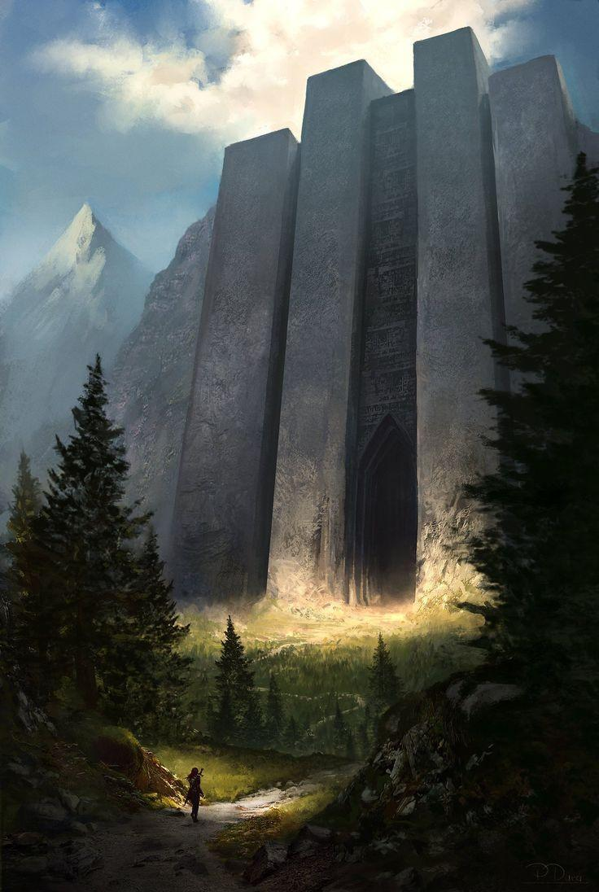

Nestled into the mountain is a door made for Titans. The door is immovbable, impassable, and made for no one to get in or come out, lest they know the way.

The ruins of Azerim are the resting place of the remnants of the Demond Lord. Fearing his return one day, men and dwarves of old worked together to banish his body to a deep crypt filled with lethal defenses of all sorts. The ruins were then sealed under magical lock, and the lands it resides in forbidden by alll governments.

Only once has the doors been open, and that was by the entire group of GOSPEL to rebind old magics to the crypt. Why they knew it needed it remains unknown.

*Azerim is looking to rise once more. His essence lives on in the spirits of small monsters hidden deep away, biding generations-worth of time to regain strength and find the moment to strike.*

### Gliheld, The Prism of Gond

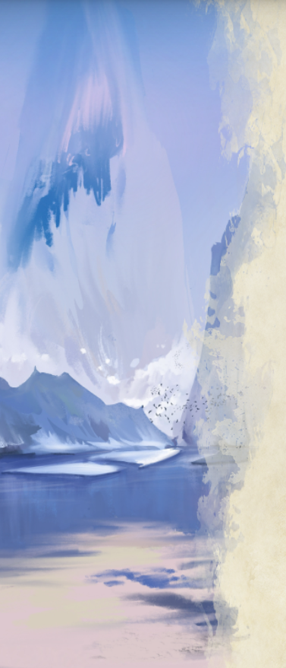

#### Travelling has its rewards…

Set on a blisteringly cold landmass, Gliheld is based deep into the center of a massive landmass of ice. The legends say the region's god-king, Gond, was the first to unearth the light of the Prism centuries ago.

A distinctly human colony, as few other races see the appeal of living through such harsh conditions unless innately acclimated to the cold. Even still, the powerful radiating magic from the Gilheld's core allowed a city to flourish around it, this core is the largest arcane core seen on all of the lands, it wasn’t created by man but rather found. Its nature is an enigma studied by the few academics of The University.

It is a core without the complex runic carvings of its traditional counterparts, a massive shard of thus-far indestructible sapphire, floating in place, bathing Gliheld in bright light and warmth that fails to melt the ice that surrounds it.

Bathed in its glow, the ancients of Gliheld began construction on their capital, carving into the solid mass of ice, using this magical core as the city’s cornerstone. Gliheld’s unique architecture takes advantage of the core’s natural luminescence with translucent buildings and beacons that refract the light and make the entire city sparkle.

The residents of Gliheld rely heavily on other planes for sustenance and thus have become masters at manipulating planar boundaries. While dangerous, these expeditions are common sights when traversing the city, and are made easier by the core’s curious influence warping the planes in harnesable ways. This same power leaves many other nations wary, due to the difficulty of securing oneself against such attackers, although these fears may be misplaced.

The Prism is surrounded by advanced looking waystones, none of which operate as expected. There are 4 that looks well kept, and seems to bring up a curiosity from the group.

### Interesting notes on Gliheld

* The old king sits dead on his throne in the multi-hued Tower at the heart of the city, built directly onto the city’s glowing core. He is a beacon of hope to his people and a well-loved ruler. His status of god-king causes other cultures to be wary of his influence.
* Tundra Worms are the favored mount of Surface Raiders, a group dedicated to conquering the topside and escaping reliance on the core altogether.
* Other nations are terrified of Gliheld due to their ability to move between planes with relative ease. Naughty children are often told stories of Gliheldi men with hooked fangs tearing them out of their beds at night and Gliheldi are generally blamed when something goes missing.
* Concerto Cavern is a hand-designed cave created with the perfect acoustics for a concert hall complete with stadium seating and platform stage.
* The Cleftpikes are a guild of craftsmen and mechanics who specially design airship bulkheads to smash through the icy fragments that surround the continent. Every test they've run so far has been akin to a suicide mission, but this does nothing to discourage them.

# Religion

## Summary

Religion across the world of Morthia has a complex history and varies in representation greatly. Each person worships and acknowledges different gods,

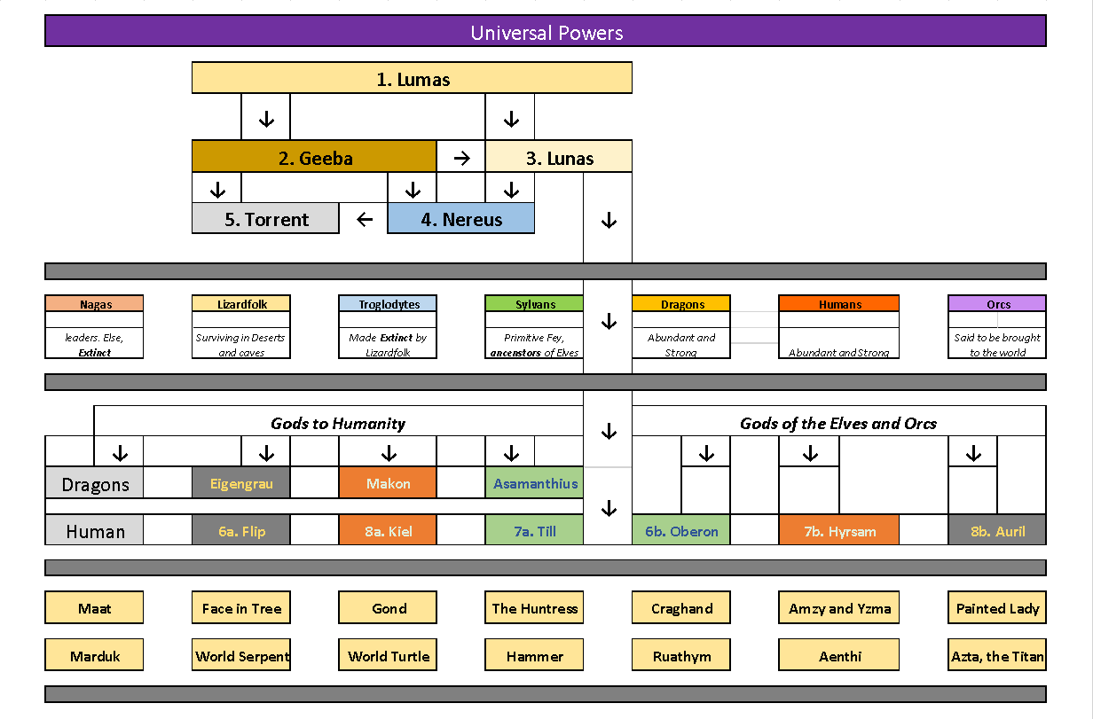

### Deusorum

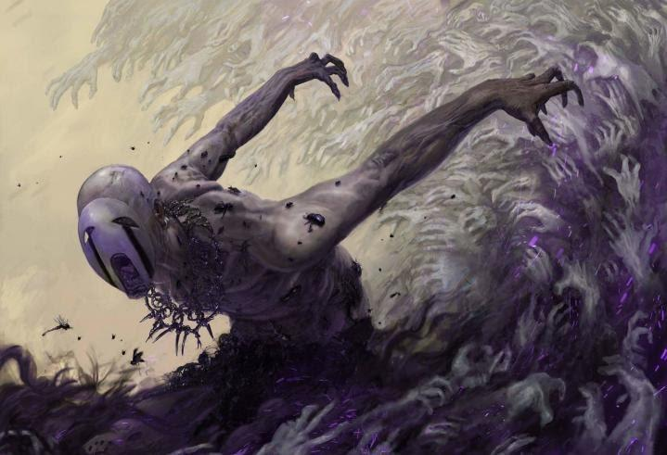Deusorum is older than Lumas, originating from the greater universe.

He is often thought to be the direct counterpart of Lumas, so few people will dare utter his name, and he has been left off of all religious coins except very few of old ages.

Those who pray to him are known to have a terrible life and bring misfortune to all around them. Uttering his name to certain people or in certain areas is a punishable crime.

This god is known to collect acolytes, and beasts of the underworld to do his bidding. So far, Deusorum has resurrected a great dragon of Evil, in an effort to rid the world of life and peace.

## Main Pantheon

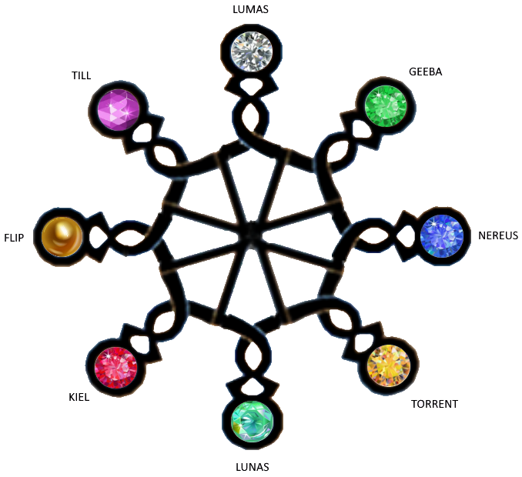

### Gemstones

Lunas White Diamond

Geeba Green Emerald

Lunas Multicolored Opal

Nereus Blue Sapphire

Torrent Yellow Topaz

Kiel Red Ruby

Flip Gold Gold

Till Purple Amethyst

Lunas was the first of the mainstream gods of the pantheon. He is known to have cleared the solar realm of elemental chaos and establish order. He created the system of planets around him, and began creating life by giving life to Geeba on the fourth planet.

Now, he is a mostly neutral god, invested in the goings-on of the pantheon more than the lives of men.

**Most depictions** of Lumas show him as an elderly wise man, holding a spear of light and white silky robes. Followers of Lumas teach: “Follow the light and embrace it’s brightness. Have faith in the gods and your fate will come.”

**Domain** Light, Birth, Virtue

Notable Mention Creator Geeba

**Magical Item** Chronicles of Lumas

**Magical Weapon** Halfspear of the Sun God

Symbol Sun

**Animal Counterpart** Falcon or Lion of solid gold

Alignment LN

**Mantra:**

Bring light and life to the realm, and nuture it’s growth for the betterment of all.

**Encountering:**

Lumas will reveal himself only in a vision, in which the seer will be floating in an empty void. The darkness will slowly illuminate in all directions with Stars, and then one star will slowly grow and grow in size and brightness until the seer is blinded in light. Only then, in his radiance, will you hear his voice.

**Minions/servants:**

Birds, Lions, Wolves.

### GeebaArtStation - God of Earth, Andrey Harchenko

Geeba was created from the sheer power of Lumas. Known as Father Earth.

Geeba is a conditioned god by Lumas, and remains largely dormant in fear of affecting the life on earth if too active.

Geeba is in love with Lunas, who still doesn't forgive him for killing almost all life on earth.

**Domain** Earth, wealth, mines

**Notable Mention** Mover of Mountains, Great Shaker.

**Magical Item** Geeba's Great Remembrance

**Magical Weapon** Leviathan Battle-axe

**Symbol** Red Diamond Jewel

Animal Counterpart Bear

Alignment N

**Mantra:**

What comes from the earth shall return, lest they feel my wrath.

**Encountering:**

In caves or on a hillside, the rocks will shift, tumble and reform to a crude face of stone. It will speak harshly, slowly, and deeply.

**Minions/servants:**

### LunasLunar Deity Physiology | Superpower Wiki | Fandom

Lunas is the Left-hand god to Lumas, narrowly beating Geeba.

Lunas was birthed in Lumas' image, as to help develop life by reflecting his light around Geeba.

Known often as the lady of the Moon, she represents an image of purity and end of day. She meets dying souls to take them to the underworld with gentle hands. She is largely worshiped and held in high regard.

**Domain** Afterlife, light, Moon

**Notable Mention** Lover of the Earth, mover of oceans

**Magical Item** Sphere of Light, Lunas' Letter

**Magical Weapon** Crescent Sickle

**Symbol** Full Moon

Animal Counterpart Deer

Alignment LG

**Mantra:**

In death, there is light. I shall guide the departed to their rest, and guard the balance between life and death.

**Encountering:**

In looking at the moon or a recreation of the moon, speckled stars around it will drift into the space before you. They will grow in numbers and surround you, growing in a cool, grey light. Your vision is clouded by it, then darkened, until it returns and you find yourself floating in a starlit void. In front of you is the celestial-sized still figure of a light-blue woman bearing a crescent crown and intricately lit necklace. Around her, the speckles of light, you see, are figures of spirits in their purest form, most of which revolve around the moon in the background. She speaks in a distant, soft but powerful voice to you.

**Minions/servants:**

Blips of starlight. Wolves, and Owls.

### TorrentLore From Glorantha | Petersen Games

Torrent is a chaotic god born of passion and natural events.

Known as the weather god, Torrent was born in the heart of a superstorm that ravaged across the world. It took the combined effort of Nereus, Geeba and Lunas to bring him life and establish his control of the elements.

**Domain** Weather, luck, trades, Storms

**Notable Mention** Father of storms

**Magical Item** Torrents Testament

**Magical Weapon** Wind Horn - Battleaxes

**Known As**  Wayfarers Guide

**Symbol T**hundercloud

Animal Counterpart Eagle

**Mantra:**

I bear the might of all storms, and guide my followers to their rightful paths.

**Encountering:**

The wind rises, and stormclouds cover the sky. If in the seas, lightning strikes all around, and either a humanoid figure of smoke is lightning-bolted to the ship, or his face will show itself in the clouds of storm and lightning.

**Minions/servants:**

Sharks, Harpies, Pegasi

### NereusFour Compelling Reasons to Conclude You Are Never Alone | Jesus ...

Nereus is a god that was born of love. An explosion of passion between Geeba and Lunas moved the lands around the world, creating a rippling wave of mountains that now stands as a vague ring shape.

Nereus claimed the oceans as his domain and cultivated life as best he could within it, as was the wishes of his creators.

**Domain** Ocean, exploration, bravery

**Notable Mention** Oceanic savior, reaper of drowned

**Magical Item** Heart of the Sea

**Magical Weapon** Ocean Staff (Moses staff)

**Known As** God of divine faith

Symbol Wave

Animal Counterpart Seahorse

Alignment CG

**Mantra:**

The lost may find their paths in faith, and begin anew. Then, their journey will manifest.

**Encountering:**

Nereus will appear as a man in humble clothing, standing calmly on water in a calm sea. Even in the middle of a storm, a circle of calm and light will appear with him in the center. He holds a staff and regards all with kind passifism.

**Minions/servants:**

Seagulls, sea lions, whales.

**Till** was born during a time of agricultural revolution in humans. While the farmers learned the way of the land and the influence of the gods, they began to call upon the gods for their harvests.

**Domain** Agriculture, hearth, home & love

**Notable Mention** Deeply invested in Rea Xandor

**Magical Item** Tome of Till

Magical Weapon Staff / Wilds Vine bone & emerald.

Symbol Heart

Animal Counterpart Stag

**Mantra:**

In nature we breed life. In homes, we breed love. I nurter all, and favor those who protect the love and life of this world.

**Encountering:**

Trees, plants, flowers, vines and/or various other plants will suddenly bloom into a massive version from itself, opening up to reveal a beautiful autumn-hair colored woman in flowing, deep green and brown attire. In her movements, fireflies and airborn seeds follow her movements and alight in her presence.

**Minions/servants:**

Fireflies, all plants and animals as needed, mainly bears, wolves and songbirds.

Kiel is one of the most misunderstood, most wrongfully worshiped gods in the world of Morthia. Many believe him to be a divine warrior and leveler of armies. They pray to him for strength and courage to win their battles.

In reality, Kiel is entirely neutral. He favours those who use their wits to formulate strategy and plans, and will grant them favor. He also records history from all angles and keeps an accurate version of the true histories. He prefers to remain quiet, but regularly consoles with Till and Flip to keep everyone in check. He has much favor with Lumas

**Domain** War, knowledge, history

**Notable Mention** Keeper of all history

**Magical Item** Language of War

**Magical Weapon** Diamond Sword

**Known as**  Secret holder, Bearer/ knowledge

Symbol Book

Animal Counterpart Owl

**Mantra:**

Where victories are made, stories are told and all are laid to rest, I am there, seeing it is so.

**Encountering:**

Kiel will appear as a simple man either visiting the seer, or found sitting at a table, vigorously scribbling down unreadable words in a rapid fashion on an infinitely-paged text.

**Minions/servants:**

Foxes, owls, mice, and bats.

Flip is a god born of men, for all the wrong reasons. At the beginning of civilization came the beginning of Flip.

For every good man, there was a darker counterpart that waiting silently for a chance to act as they saw fit. Fortunately, the need for society and civilization overwhelmed these barbaric desires, and the darkness was pushed away from mans hearts. However, the darkness lingered.

**Domain** Trickery, Thievery, Murder,

**Notable Mention** Spirit of madness, killer of kings.

**Magical Item** Files of Flip

**Magical Weapon** Double longswords, Life/Death

**Known as**  The Rogue Patron

**Symbol** Dagger

Animal Counterpart Raven

Alignment CE

History/Lore:

Flip, in his primitive state, took in the makings of society and developed into one silent lurker, waiting for someone to hit their lowest point before infecting their mind and corrupting their hearts.

The first man to fall to the Shadows was a simple seaside merchant, who in turn became the immortal avatar of Flip. Flip used this man and soon gained influence by spreading his wills like a disease. The carriers went on without knowing what was in them until they covered the globe.

Flip intended to 'activate' them and wreak havoc on humanity for pushing him away, but Lumas and Lunas caught him before he could act and **made him a deal**: He would become an official god and member of the pantheon, but only if he were to suppress the evil inside those infected and abide by the pantheons laws.

From this, Flip was allowed to rejoin a supressed version of the original barbaric darkness with all civilized souls, and create chaos on a smaller scale as he saw fit.

As a result of a resurgence of crime, murder, thievery and war, Laws were set out by man to punish and counteract these crimes, thus resulting in a somewhat balanced system, and further bettering man.

Many still worship Flip, especially the Ghostcloaks and The Shade-Bringers. They use his patronage to develop extremely well-hidden practices and gain power.

**Mantra:**

In darkness I lie. In lies, I see. In betrayal, I laugh.

**Encountering:**

**Minions/servants:**

Rats, bats, snakes and ravens

## Dragon Gods

### Asamanthius

Dragon of gold and radiant beauty, Asamanthius is one of few dragons that park joy in the eyes of humans.

Asamanthius believed all free spirits would find happiness and peace with caring overseers. He travelled the world filling wonder into the eyes of men.

### Makon

Truly neutral of the dragons is Makon, the sage Dragon Turtle god. He listens to both dragons and weighs out both options without committing to one or the other.

Makon commands respect from all and seldom acts unless in dire circumstances.

### Eigengrau

A dragon of Dark grey and blue. Eigengrau act(ed) as an opposing view to Asamanthius, and effectively offering those who sook their wisdom a choice in who to take sage advice from.

This maintained a balance of power in the dragons. In his original state, Eigengrau still believed in peace and order, but in a stricter and more controlled manner.

## Elven Gods

### Oberon - LG

Called the Lord of Beasts or sometimes King Oberon, was a member of the Seelie Court worshiped as a deity of the wilderness and animals.

Oberon appeared as a wingless, unusually tall, and muscular male faerie. His eyes were black and wild, his hair thatched and braided and run through with brambles, and his skin was comparable in color to oak wood. He was known to wear a cloak of green leaves stitched onto brown leather.

Oberon was a stern protector and warrior, if wild and mercurial at times. He relied less on illusion and camouflage than other members of the Fey Court, and was unafraid of physical combat.

### Hyrsam - CN

Hyrsam, the Prince of Fools, was an ancient and powerful satyr Archfey. He was a mischievous trickster who used guile and savagery to further his goals.

Handsome, with a wild mop of curly hair, dark, intelligent eyes, and a fair face. Hyrsam wore simple clothing when traveling, and dressed in formal attire when visiting fey courts.

Though he outwardly presented himself as a fool, Hyrsam was exceedingly clever and manipulative, with a streak of vicious savagery.

Hyrsam was essentially an anarchist who opposed the influence of civilization on the Feywild. He openly resented the presence of orcs in the Feywild, but also secretly shared similar sentiments toward elves.

### Auril - CE

Also known as The Cold Goddess. A fickle, vain, and evil deity, who was primarily venerated out of fear. Auril appeared as an attractive human woman with blue skin. Her body was made from ice and snow.

Auril was the embodiment of winter's wrath. She was arrogant, capricious, and unpredictable. She took great pleasure in torturing her enemies and harassing her foes. Sacrifices and worship to her was often done out of fear. An evil goddess, her main goal is to cover the Realms under ice and snow.

### Hella - NG

Elven goddess of the hunt. Hellen is the tight-lipped elven goddess of the hunt, who instructs her followers to care for the forest and defend it from enemies.

Hellen is **daughter** of her fellow elven deity Oberon, who often speak on her behalf and work with her to improve the impact of elven magic. She maintains careful distance of Hyrsam and Auril.

Hellen is worshipped by many elven rangers and hunters, as well as many small communities and non-elves. Hellen accepts followers of all races as long as they respect nature. Her centre of worship is Gedad, ancestral home of the elves, although she also counts many followers on Rea Xandor as well.

### Titania - CN

https://forgottenrealms.fandom.com/wiki/Titania

## Lesser Gods

### Maat, The Judge

Commonly referred to as the Avatar of the Father of Light (lumas) Maat is a symbol of justice and order, and regularly presides over courts when worldly events are underway. His presence is that of a dark-skinned, elegant man with silk robes and bright white eyes. He holds nothing and never speaks, but his presence demands truth from all. WIS 27 save..

### The Face in the Tree

An old god, with a home deep in the woods of Creatus. The face appears on ancient trees in forest glades, and may call upon or speak to those who wander near. A neutral god, it may bless or curse those who do not respect it's domain.

### Gond, the Travelling Tinkerer God

The Lord of All Smiths and makers, he pushed for innovation and imaginativeness, sometimes to a dangerous degree, as a result of his short-sighted desire to create and wander.

Cocky travellers may be tested on quiet roadways by a frail old man asking to spare some food or water. For those that shoo him away or attack him, they will find their metal rusted and their food spoiled. All children hear to be nice to those on the road.

https://forgottenrealms.fandom.com/wiki/Gond

### Craghand Silverbeard

Dwarven God who is fabled to have ascended to the mine the sky. His form is in the stars, and his appearance is a dark-hooded dwarf with a shiny silver bear, and mithril pickaxe.

### The Huntress

The huntress and her allure beckons to those who answer the call of the hunt. She is the silent huntress and expects those who worship her to be likewise. They are the stalkers of the battlefield who strike key targets. Her followers are expected to revere nature and celebrate life in extreme manners. Family, as well, should be held in high regard.

### Hammer

God of heroes and potential. Embodies and speaks through the form of the Legendary Hammer who saved the world and ascended into godhood.

### Ruathym

God of the shallow sea. When sailors state the tides will not allow them to dock their ship, they really mean they've lost favor with Ruathym

### Azerim

Lord of Demons, banished but alive and thriving in his plane, being guided by Deusorum.

### Amzy / Yzma

Twin goddesses of Transmogrification and choice. They pull a lever to make decisions.

### The Painted Lady

A ghostlike lady who appears at the far edge of most lakes, and punishes those who mistreat them. She heals surrounding areas and those who respect her domains

She was originally named Claire, and offered to the gods at a time of plague and death. Till claimed her, and blessed the lands of the desperate.

### The World Serpent

A deity primarily under the service of the underdark inhabitants. Known to speak with Drow and Verdan, and capable of destroying civilizations through brute force.

### The World Turtle, one of many

Thought to be an avatar of Lunas. The form has since been solidified into stone following the Shine, and on the now-island in the middle of the great lake sits Oogway the monk, and guide to the world turtle.

### Marduk the Lurker

Marduk is an ancient, primordial being born in the Plane of water, and brought here by Nereus as a guardian of his domain.

Seeking power, he betrayed Nereus and claimed part of the domain as his own. He now lies in the deepest depths of the ocean, and calls storms to sink sailors. He leaves them hopeless, and offers them salvation if they commit their lives to him.

### Azta, Titan of the Earth

He blesses all in Aztarok, and they worship him devoutly. A shrine to his worship is located in the hills to the east of Aztarok, at the foot of a massive waterfall.

# HistoryPin on DnD

Eras

Age of the Celestials

- Marked by the formation of the world and the greater gods, where large fights set the stage for the future.

Age of Creation

- The emergence of the creation races, old dark magics, and the beginning of divine intervention on life.

Age of Man

- A fabled time of peace, wars and abundant magic in the world. When men began to rule and civilize themselves.

Age of the Haps

- Marked by the fall of an old king, and the choosing of a new king by the Gods.

## Summary

### Chaos

Void in the beginning

The First births the realms and universe

(1,000,000)

### Demons and Celestials

Lumas claims the realm

Lumas battles the chaos and establishes order

Lumas births the 12 planets around him

Lumas focuses on the 4th and names it Geeba

Lumas creates Lunas to help Geeba

Geeba loves Lunas

Geeba and Lunas birth Nereus

Life grows rapidly

Developing atmosphere creates Torrent

Geeba fears influence of life and gods, and shakes

Lunas casts shadow of heartbreak on the world

Lumas quells the shaking with the Shine

The Shine permeates the universe and attracts Deusorum

(250,000)

### Creation

Gods cast away failed attempts at life into the Abyssal Plane

Creation Races: Human, Sylvan, Naga, Dragon, Troglodyte

Proto-Humans -> Man and Elves

Flip, Till and Kiel born from Men

Oberon, Hyrsam and Auril born from Elves

Civilizations rise and fall for thousands of years

Fey Gods establish the lineage of the Archfey,

Azerim collects the abyssal army

Azerim invades the material plane

Thousand-year war.

Humanity ravaged by war, one man defends the HOS

Gods empower Hammer, and destroys army in 10 days.

Hammer raised to godhood.

GOSPEL established

Underdark guard post established.

(150,000)

### Man

Gods focus on mankind

Life explodes, men flourish,

Begin to look for new lands

Find new lands to the East, begin to colonize

Religion brought over and clash with the gods to the east.

Religion assimilates into the east, breaks apart

East invades West, and begins the 700-year war.

West severely damaged and razed by the East

Gods come down to men and teach them the ways of magic

to help them fight.

Citizens from east seek a haven, find Enigmus

Gods cast across the sky to the East and do battle

Gods begin to contemplate their effect on the world,

A Storm rises to the Eastern coast of the west world.

Titans live in it, guarding the coast.

With new knowledge of magic, some dwarves go east and are lost.

Gods recede to Astral plane after the battle to recover

Thousands of years pass

Men fight and seek power to rule. Fall into barbarism

5,000 years later the gods re-emerge

Birth the Dragons

Dragons and gods re-establish order, and more civilizations rise and fall.

The gods build the University with men, and gift it to the descendants of the GOSPEL members.

Morheim kingdom is risen by men,

conquers all of the main continent.

Battle of Battle beard with the Dwarves,

who ridded the Nightgrove forest of evil

Gift of Morheim to Elves. Create borders controlled by the Elves. Flurham, Forest paths and Frostling

Many cities rise and are made prominent.

Kingsport, Traveller's Rest, and Korthal

Korthal becomes the new capital of Morheim.

The new separated continent is gifted a plague, killing all life on it. Now known as the Dead Continent.

Aquatas, sinks and is lost to the seas.

Till

### Haps

Old leader beheaded; supporters jailed

Interim leadership council while a new King is found

The Divinitus Morheilium line takes the throne.

Relic Hunters are established

Raging monsters are wreaking havoc in the oceans

Reestablishment of Fernn

Guild of the Hammer is in full swing around the world

The Group begins their adventure

## The Age of Chaos

### Broad, god history

At the beginning, there was the void. The astral sea was filled with spirits of chaos, dominated the no-lands, fighting aimlessly for survival and power amongst primordial gods.

Then came the **First**, as it's known. The First knows no name, but was the only entity in existence to not thrive in the darkness. The First radiated untold power, and birthed the primal realms. The realms existed in intertwined elemental chaos, but were immensely rich in substance. From this chaos over time came collections of essences that bound together, further solidifying order in the universe. Over much time, the energy formed and molded itself into the planes known today.

Key takeaway is that all planes and energy are birthed from the same source. Nothing can be separated entirely from another.

## The Age of the Demons and Celestials

Long ago, this universe was one of tumultuous and chaotic forces. Naught but unbridled fires, and churning, saw-like rock made up its substance. Through the ashen skies of Creation Primordial, the new and formless energy of Lumas emerged to claim the new realm as his own.

### Removal of the Elementals

Before Lumas could begin his spark of creation, he fought for many millenia to rid the realm of elemental and planar chaos that resided in his space. He was not able to defeat them, but he was able to chain these beings and cast them into the planes that called to them.

With a now largely open space full of order, Lumas began his creation with the 12 planets. Fourth from him, he believed, was best suited for his work.

### Lumas System

Lumas, The sun and being of Radiance

Suenus, The closest planet to Lumas, entirely engulfed in fire and barren from his power

Lestreon The closest, warmest planet to Morthia that might house life in the future. Hospitable

Morthia The Planet D&D takes place on. Teeming with life

Durilia A cold, unforgiving purple mass. Believed to be the origin of all poisons

Gonagua A Beautiful blue gas giant

Cenzilles A dazzling orange and purple planet with 39 discovered moons. Debated if gas giant or not.

Xeter Little more than a moon on it's own. Only seen twice in history

Vielara Known only in religious texts

Bophus Known only in religious texts

Hinope Known only in religious texts

Vonerth Believed to be the largest of the planets, guarding the system from outside chaos. Pure white.

The Lumas system planets align every 24,554 years, creating a magical effect known as the **surge,** which amplifies all magical auras on all planets for an hour.

### Geeba

Of the many planetary masses Lumas molded and formed in his challenge, he continued his focus on one. He transferred parts of his godhood into this world, and the world named itself Geeba, it's life revolved around Lumas.

### Lunas

To ensure his entire being felt the radiance of the Father of Light, Geeba rotated his body to expose all of his mass to Lumas. But it wasn't enough. Lumas saw the development being stunted by his lack of light for the time the world was on the other side of his influence, even with the rotation. Lumas decided to manifest a reflective orb of pure silver to spin around the earth and reflect his light at a reduced radiance.

At the same time, Lumas manifested one more deity as a reflection of a lesser version of himself, known as **Lunas**. Lunas occupied the newly created body and named it the Lune. Lunas quickly fell for Geeba for his beauty and her knowledge of his gift to her creation.

As Lunas found her place in this realm, her radiance shone on the dark areas of the world, and henceforth life of all types. But something was wrong.

### Developments

When **Lunas** entered the equation, life began to grow into complex organisms, but Lumas still saw a struggle of more development. Something was wrong. Life was crude and unforgiving at the start. Whatever lived fought and killed for resources around the world. Geeba felt his core heating with energy but felt no motivation in his being. Except Lunas. When he saw Lunas revolving around him, he wished to gain her affection. Little did he know, he already had it. Soon, they combined powers to manifest an explosion of matter and energy in the form of water, which fell back onto **Geeba's** planetary mass, creating the oceans, rivers, and lakes.

The Explosion was so powerful and full of passion that it actually moved the surface of the earth around, folding land on top of land and creating a ring of magnificent mountains. It also marked the birth of a new god, **Nereus**. He claimed the oceans as his domain and cultivated life as best he could within it. His being sunk into the depths of the ocean to grow and evolve. This event was the catalyst that Lumas could not fully understand, but was overjoyed to witness. Life on Morthia exploded shortly after and intelligence followed suit very quickly.

After the creation of oceans, a proper atmosphere and weather manifested. The radiant energy was caught in the atmosphere, and grew over time. Eventually, it converged into one superstorm. With the surrounding radiance of **Lumas**, **Geeba**, **Lunas** and **Nereus**, a godly life came to be, by the name of **Torrent**. He reigned in the storm with gaseous chains, and took to the clouds, stating the winds and sky to be his domain.

#### World Turtle Avatar of Lunas

Wanting to be closer to Geeba, Lunas manifested part of her being into a being that could conceal her radiance, and allow her to roam Geeba's surface, feeling his essence. This 'Turtle' is often revered by humans as godlike, and she rests in the Lake of the GMR.

### Geeba's Folly

Concerned for how populous of god-beings his realm was becoming, Geeba was unsure of this path. In a vain attempt to preserve his world, Geeba shook the earth and tried to kill everything on his body. Lumas witnessed this from afar, and become enraged. Even Lunas watched in horror. Geeba refused to stop his shaking for eons, as he was hell-bent on ridding the world of all life.

Lumas punished Geeba harshly for destroying his world. He unleased his power of light unto Geeba, scorching his body and vowing he would start anew. Lunas, heartbroken, removed the memories of Geeba that sullied her shine and threw it back at the world. She then offered her reflective surface to aid Lumas.

The memories of heartbreak and sadness formed the first **shadows** in the world, blanketing areas of the earth and staining it forever. Little did Lunas know, these shadows would later offer protection to enemies of the gods

### The Shine + The Void

The Shine, as it's known by the gods, lasted for an unknowably long time. Its radiance reformed much of Geeba over years. Once Geeba was reconditioned, he thrived on the preservation of life. His fear of life's effect on his being was quelled by his fear of further punishment. The shine remains to this day as currents of wild magic that run through the lands and sky and seas.

Once the gods had begun to work together and channel their powers into this realm, a darkness came from the void, attracted by the shine of Lumas. **Deusorum**, the void itself, challenged the claim of the gods for this world. An epic fight ensued, leading to Deusorum's long-fought defeat. Yet he vowed to return again and again, stealing all that he believed was his, included the souls and powers provided by the gods.

Lumas believed this victory under his leadership proved his worth to rule, and established the basic structure of the Pantheon of gods.

## The Age of Creation

### Creation Races

With a victory under their belt and past quells slowly and magic introduced to the world, many intelligent beings developed across the continents. Modern scholars call them the five **creation races**.

Nagas, Proto-Humans, Troglodytes, Sylvans and Dragons

The least seen and rarest of all races are the **Nagas**. Snakelike people who recede into caves and deep woods to hunt silently. It's known that they are extinct.

The longest-primitive, the **proto-humans**. Always adaptable and ingenious, humans made advances with incredible speed and efficiency when circumstances allowed for their rise to prominence. Of the five creation races, only the humans truly survive as a cohesive civilization form today. **Early humans were separated into two main groups**. These two groups differed in how they interacted with the world.

The Least known creation race is the **Troglodytes**. Their survival was based on barbarism and killer instinct. These dragon-snake-human beasts were fought off to far reaches and unforgiving environments, before being forgotten to time.

Most in tune with the world, the creation races are the **sylvan** people that populated the forests and other wooded areas, living in harmony with nature and leaving few traces. It is believed that their civilization fragmented after a great plague created by a draconic or demonic power. Their descendants are the sprites and other small wood folk that populate the wilderness of Morthia today.

Supreme among the creation races were the **dragons**, powerful enough to obliterate communities of the other races with impunity. Dragons dominated the surface world, claiming vast areas of territory and battling each other for land, mates, and status. They suffered setbacks only when other races mastered magic. They remain influential today despite the advances of men and fey. Lots of their vast history is stored in far ancient crypts of permanently sealed-off caves. It remains lost to all (for now) The individual dragons war with each other, and the others have vanished from the world or splintered among their subraces.

### Proto-Human Divergence

**The first group** was conscientious of nature around them, and held great favor with Lunas and Geeba, and later on Till. Their lifestyle of moderation granted them racial distinction over the years, turning them into the **fey** known today. They mainly are made up of eladrin, satyr, gnomes, and more.

**The second** **group of** humans focused on advancement and technological development. They curried more favor with Lumas and Torrent, as they were rapidly developing, adaptive, and unpredictable. They kept their forms, and evolved into modern day **Humans**

In time, humans developed concepts of grouping together for survival and often hunted magical creatures for their power and resources. Their methods **were** largely chaotic, but they proved successful. Hundred of civilizations came and went in the years. Unfortunately, history is destroyed over time, leaving no trace of their existence for the present to uncover following the events of the years to come. The existence of old civilizations provided the steppingstones to rapid development at one point.

### Three new Gods

What was recorded (or fabled) during this primitive age was the first-ever human creation of gods. Three of them.

**Flip** was the first god, was born from the greed and barbarism of the humanoid races.

Flip was a god born from the desperation of the poor, and the greed of the rich. Being early still in it's development, mankind knew of gods but did not **know** them, so they prayed to anything that would listen. Their prayers became the essence of Flip.

**Kiel** was born from conflict.

When tribes and early civilizations warred, they called on the gods for their blessing. As no god was so invested in the dealings of humans, a new god was born for this purpose. Kiel grants favor to those who worship him most and aid in conflicts. He also rarely will bless individuals with knowledge of the past. Kiel is known as one of the true neutral gods. He **never** favours one side of devout worshipers to another, but always offers visions of wisdom and guidance to those who call for it.

**Till** was born later then the first two, during a time of agricultural revolution in humans.

While the farmers learned the way of the land and the influence of the gods, they began to call upon the gods for their harvests. As they tilled the soil of the fields, they sang merry tunes and prayed happily to anyone who would listen. Most farmers had a respect for the land that curried favor with Lunas. As reward, Lunas manifested Till to answer the call of the humans. Till is intertwined closely with Geeba to represent nature, hearth, and love.

The King at the time took his first-born child to the Omega Peak gateway and offered the child to the gods. Legend has it that the child began to crystalize and disintegrate into a sparkling cloud of light that spread over the world, healing anything it touched. Over the course of the next year and a day, the world grew anew. The child sacrificed was named Claire.

At the entrance of the Gateway summit is a garden. In that garden is a statue of a beautiful woman with a plaque that says, "Here we acknowledge and remember our eternal gratitude to the pure soul of Claire, savior of man, now servant of Till.

Claire became the Painted Lady, and right-hand woman to Till

These three gods of man were thought to be rather balanced. Till promoted the growth and prosperity, Kiel took no side but preserved all knowledge, and Flip encouraged the ambition of man, while also keeping their progress reigned in.

### Rise and fall of Civilizations

Over tens of thousands of years, several magnificent cities and nations rose and stayed risen. Some remnants are barely visible and most have no idea of their heritage. Examples of Such are the Fort Arteron, Old-Gedad and several ruins strewn around the world.

Born around the same time of Flip, Kiel and Till, the **Fey Gods** Oberon, Hyrsam, and Auril came to be from similar means. **Oberon** is worshiped as a deity of the wilderness and animals, and often conflicts with **Till**. He keeps the Other fey gods in check, and punishes them regularly for their deeds. **Hyrsam** is a mischievous trickster who used guile and savagery to further his goals. **Auril** is A fickle, vain, and evil deity, who was primarily venerated out of fear. She is known also as the winter goddess.

### Archfey

The lives of those who lived in the fey may have been one with nature, but it was a chaotic existence. Seeing the developments mankind had made, Oberon believed it was in the realms best interest to forge a path of their own. Oberon wandered the forests, the caves, and the rivers for several years, until he came across an almost invisible house, blended in perfectly to the wilderness surrounding it. Inside the house was a family of elves. Parents Thourmon and Filaurel, and children Eldrin, and Elsa. Oberon praised their living in co-existence with Nature, and judged their hearts to be pure. He blessed them with immortality, powers of great leaders, and a hidden castle to rule from.

The creatures of the fey sensed the change in the realm, and became accustomed to have rulers and laws to follow in the next 50,000 years. Since then, The Archfey Family as they're now known, rule in absolute. Neither Orcs nor elves will cross their paths.

### The Ancient Fable of Azerim

Before the creation races, discarded collections of failed life forms were banished to an abyssal realm by Lumas. These beings were unknowingly deposited into the realm of the Demon Lord, **Azerim**.

Azerim knew nothing of other realms until then. Seeing these beasts materialize in his domain, he collected them, and redeveloped them to bring back to this new world, where his chaos would reign. Over the years, Azerim's forces grew stronger and larger in numbers, thanks to the Lumas' contributions to his realm. He then began to hear the sound of the void in his mind, guiding him further to a maddening desire to overtake this newly discovered world.

The time came, and Azerim gathered his forces, ready to invade. He opened a dimensional door in the center of the southern continent and unleashed hell on the world.

Much of humanity was ravaged by the beasts, and some civilizations managed to hold strong. The northern and southern areas of the world were under powerful protection from the gods of nature, so Azerim focused his efforts on mankind.

Mankind held its ground and fought with bravery, impressing the gods. Even though the race of men was not one of great importance to the higher gods, their actions showed promise for their species.

All races fought valiantly in this age-old war, with heavy casualties on both ends. As humans learned ways to destroy the demons, the beasts retreated to lurking in the shadows, attacking the weak. Priests and warriors hunted them for sport and honor, keeping them at bay for centuries. But the folly of man is their greed and their ignorance.

While the demons grew in the shadows and the humans grew in confidence, they began to fight amongst each other for the sake of land, power, and honor. In the course of the years, most of the development man had made was destroyed. They were furious and desperate, but had little power remaining to use against Azerim and his hoard.

Fortunately, there was one man, **Hammer Ranjfold,** who stood alone after having his family killed by the evil demon. He was a devout worshiper of the gods, and vowed to rid the world of this evil. He fought for many years, gaining a following and inspiring many to do the same in his wake. He fought valiantly for 30 years, until one day.

**In the Battle of The Hold,** Hammer faced a large demon army, alone, at the old gates of the Hold of Civilization. His followers had all fallen, and he knew the end was upon him. In knowing this, he called upon the gods to empower him as the last line of defense.

All who watched thought he was crazy, never thinking a god, much less all of them, would answer one mans call. As the demons descended upon him and the keep, Hammer pointed his hammer to the sky which **opened up**, shining a brilliant radiant light down to his body.

The radiant light illuminated the entire valley, even though the clouds closed up rather quickly. The light, however, did not waver. Onlookers from behind the old city walls witnessed Hammer radiating an ornate excess of blue, gold and silver light through his skin, and his hammer glowing with a blue and red aura. He made quick work of the hundreds of thousands of enemies facing him, unleashing magical abilities never witnessed for anyone to wield.

The sights seen that day were etched into stone and stored in magically sealed crypts beneath the city, so the future would know what happened here today.

It was done swiftly and mercilessly. Hammer fought across the land, searching far and wide for all evil to face him. Soon he was back in the center of his continent, clearing off the last of the demons. When the enemy was destroyed, Hammer called out, challenging any remaining evil to face him. Azerim met him in person.

Hammer's light was fading, and Azerim was fearing his potential defeat. Knowing his divine blessings were fading, Hammer rushed Azerim with his hammer, Hammer, and struck down with bursts of lightning, fire, and divine energy. The fight blew apart the town and left them both in a sea of wreckage, with Azerim pinned under Hammer, Azerim shoved his hands forward, digging right into Hammers body, piercing his heart.

As a final act of sacrifice and finality, Hammer called upon the gods to send them both to oblivion. Hammer weakly raised his hammer to the sky, which began to crackle. He brought it down on both of them and a massive singular, straight bolt of divine silver lightning and fire came down, engulfing them both.

The earth opened up and swallowed Azerim and hammer into the depths of the world, but oddly spat up Hammer's body. It's rumored that a 'wind' carried his body ever so slightly, miles back across the land and into the town center, along with his hammer landing next to him.

### Gospel

As a final act of sacrifice and finality, Hammer called upon the gods to send them both to oblivion. Hammer weakly raised his hammer to the sky, which began to crackle. He brought it down on both of them and a massive singular, straight bolt of divine silver lightning and fire came down, engulfing them both.

The earth opened up and swallowed Azerim and hammer into the depths of the world, but oddly spat up Hammer's body. It's rumored that a 'wind' carried his body ever so slightly, miles back across the land and into the town center, along with his hammer landing next to him.

The only evidence left of the battle was a decimated town, a sea of slaughtered evil beasts, a gaping hold in the center of the continent, and Hammer's body next to his hammer, standing on it's hilt perfectly straight up. Marked into this hammer on every flat surface was a symbol unseen to anyone in the world until now. The Symbol of the GOSPEL

Those who came to Hammers aid first were fabled to have been spoken to by him. He claims that the marks of his hammer represent the combined energies of the gods of this land, and that anyone carrying this mark or a part of it would be forever known as a conduit of the gods.

Hammer was remembered as a hero of the world, and a New **Hold of Civilization** was built around him and his hammer. The hammer was encased in a magically locked golden chest and believed not worthy of being wielded by any other mortal. The symbol on the hammer is known by GOSPEL members as one of combined effort of the old gods towards one goal. It symbolises unity, peace, and divine blessing.

**The symbol** has been driven into every church and hidden in plain sight everywhere a person could find it, though few know its historical importance other than a generic religious symbol.

Azerim was quietly pulled from the void in which he was cast, and brought back to his plane. The voice of the void speaks to him softly while he regains power.

Soon after the battle, the gods remained fully invested in the humans. They spoke to the humans through avatars. They educated them, and watched them grow, die, and replicate themselves. After the fight of Azerim, religious beliefs were at an all-time strength. The gods were at their fullest power, and the world was rebuilding itself into true magnificence.

This new world slowly learned to unlock the secrets of the gods, the lands in which they lived, and of the universe they were in.

#### Underdark Guard Post Established

The project was headed up by the University and Morheim kingdom.

**The Age of Man**

50,000 years ago

Marked by the banishment of Azerim by a human, working for the gods.

#### War of the Gods

##### Divine Investment in Humanity

Soon after the battle of Azerim, the gods remained fully invested in the humans. They spoke to the humans, educated them, and watched them grow, die, and replicate themselves. After the fight of Azerim, religious beliefs were at an all-time strength. The gods were at their fullest power, and the world was rebuilding itself into true magnificence.

Other species emerged and thrived at this time as well. Animals and plants grew rapidly and because of the closeness of the gods, many were magically imbued with amazing features, such as glowing and gigantism. Creatures of the fey left their realms to witness mankind, and began to intermix with them.

It took some time, humans learned from the gods, and developed skills and abilities. They claimed great collections of power, and passed on the knowledge from one generation to the next.

##### The Exodus to new lands

Seeing how far their races had come, humanity ventured outward. They sought lands far away, eager to share their knowledge with the world. Far to the east, they found a land ridden with Dragons, Elves, and a vicious humanoid version of man. There were also tales of Lion-men, birdmen, and many other assortments of humanoid animals.

Finding this new land and bringing back news sparked intrigue throughout the land. The movement of a mass-exodus began. Most people believed they were acting righteously, serving the gods by spreading their influence. Unfortunately, the Eastern lands had their own religions. Those gods did not see kindly to newcomers, and worked to incorporate their influence into them. As such, the names, traditions, and worships of the Western gods was shifted and changed until it became unrecognizable. And since the West could come east, soon enough the East began moving westward.

Religious influence and conflicts began very quickly. Towns and whole kingdoms marked which gods they allowed and which they didn’t. The following years were those of untrust and uncertainty. Lumas led the gods to favour those who worshiped them devoutly, and punish those who didn’t. Nereus and Torrent created vast, unpredictable storms to hinder the travel of information, and they managed to recede much of the Eastern believers back to the East.

The next years was that of relative peace and prosperity. Little did they know that to the East, the gods believed they had been denied opportunity, and were working on a way to re-enter the newfound lands…

##### The Invasion from new lands

The western continent was victim to a 'surprise' invasion by the eastern continent many millennia ago, and a world-war of sorts occurred. ONE of the times in history of **recorded**, unified divine intervention in history. Gods worked with Men, Orcs, Elves, and all others to imbue items and people with the powers of gods. While much of the history is lost to time, the population of Enigmus first emerged here, and the formation of the first, full man-made empire came to be.

The beginning of the war was a naval invasion, lasting hundreds of years. Many men died before even reaching the other, and those who did were beleaguered and not fit for battle.

After many years and the development of new travelling technologies, a land war waged in the West. Cities were burned and destroyed. Port towns sunk into the ocean, or pulled into despair. Civilization itself was torn apart for the sole purpose of appeasing the gods above, with stories of their love fresh in everyone's mind.

There were no more kingdoms or leaders after the first few hundred years. This was a bloodbath of religious barbarism. The gods watched in utter shock and despair. Lumas though, watched with impartial eyes. This conflict went on for thousands of years, scarring the whole continent and decimating almost all of the lands.

###### Founding of Enigmus

Travelling Tabaxi and Lizardfolk travelled far to find this new, untouched land, looking for a place to be free of conflict. The hill they rested upon overlooked the most beautiful valley they'd ever seen, and they spent the next few thousand years establishing a monumental city on the mountain. A city the likes of which no one has ever seen.

Fearing influence and greed from outsiders, their goal became covering the city in a cloud of mystery. As such, Enigmus became its name, and its secrets closely guarded. Their technology is centuries ahead of the rest of the world and they are sheltered by mountains along their back and an overly expansive forest/valley in front of them. No one who enters Enigmus is allowed to leave without entering a soul bond, swearing secrecy.

###### Fight of the Pantheon

Seeing that their lands had begun to heal, Lumas believed it was time to end the conflict of the East, once and for all. Several religious and historical texts claim to have witness eight streaks of light shoot across the sky to the east, and the entire eastern horizon light in a violent red and orange haze. The haze lasted for a year and a day, before diminishing. Priests urged the populous to never venture to the East again, as it had been tainted and cursed by the gods, if not obliterated entirely.

The eastern continent was thought to be entirely obliterated by the whole pantheon of the western continent, and the eastern Gods were also thought to have been killed as well. This left the Western gods severely weakened after the battle. For thousands of years, the westerners prayed devoutly to their gods and have hopes of help in troubled times. The gods heard their prayers and were starting to regain their abilities to a point where they can intervene once more.

##### The disappearance of the Deep Dwarves

They dug. They dug so deeply that no one ever saw them again. A collection of elves followed, seeking enlightenment through adventure. Unfortunately for them, the darkness drove them mad. Once they broke into the underworld (underdark), they scattered and began to form new, corrupt civilizations. Known as the drow.

One thing the gods find hard to understand is their relationship with humans altered their very being and created split personalities. They effectively were fighting themselves. New gods did emerge that aren't part of the original eight though.

##### *STORY* - The Duel of Talon, Gwendolyn, and the Dragons

Once, long ago, there was a peaceful kingdom that covered a great stretch of land with pastures, forests, and rich mines, sitting along a line of mountains that stretched into the skies. The wealth and prosperity of this kingdom attracted the attention of two greedy dragons. These dragons began eating the livestock and scorching the woods. They warned the kingdom that retaliation would only end in destruction.

The kingdom in of this story was called **Grove**, and has since been decimated and overgrown…

The king of the land put out a call to anyone that could destroy these dragons. Heroes from far and wide came to try to kill or contain the dragons, but whenever one was near capture or capitulation, the other came to free it.

Eventually, word of the dragons reached the ears of Gwendolyn and Talon. Gwendolyn was a woman of the forest, sworn to protect the woods with her bow and swords. Talon was an elven druid, able to transform into beasts great and small. Together they kept watch over the woods and mountains of their homelands, and together they built a love truer than the stars in the sky.

Gwendolyn and Talon travelled into the besieged kingdom to answer the call. The king promised them great riches for their future success, but they refused. Bringing peace to their land was reward enough. So they set out to bring down the dragons.

They tracked the dragons to their vile lair. The stench of rotting bones and evil hearts filled the valley. Gwendolyn readied her bow and Talon transformed into a great eagle. As Talin flew up high, Gwendolyn came upon the dragons. Together they attacked.

The battle raged for hours. Gwendolyn fought one dragon, Talon the other. When it looked like Talon was about to conquer his foe, the dragons’ companion came to its aide. The dragons met Talon in the sky, and were threatening to tear him apart. He called down to Gwendolyn and she knew his thoughts. Just as he twisted, she lobbed an arrow into the sky. It connected, piercing through the first dragons head, then through Talon himself, and through the second dragon. All three fell from the sky in a dance of sorts, before crashing to the ground.

As Gwendolyn searched for the body of her love through thick forest and heavy tears, she prayed to the gods his safety. She came upon the bodies of the dead dragons, but Talon was nowhere to be seen. All she found were the dragons, lying dead encircling each other. In the middle of them, lying clear as day on a raised old stone, was a perfect blue jewel that shimmered in the night.

She returned to the king with her story and he begged her to accept a tribute. He had his finest smiths and his finest wizard create **a beautiful sword** using the gem she found in Talon’s place to honor Gwendolyn’s lost love. It’s said that she used that sword to slay scores of dragons and that her vengeance against their kind is still being wrought. The sword was named **Talon's Honor,** and its whereabouts have since been lost to time. Gwendolyn died in her sleep many years later with a letter in clutched to her chest. The letter read that one day a new hero will find her sword, but only when a new evil requires someone to answer her call…

The story has been immortalized on runes in the caves of the nightgrove mines and mountain caves. The letter of Gwendolyn has been preserved in resin and is locked away in a keep with **Gregory** in **Val'Alora**.

Marked by the loss of the dwarves, and lack of intervention from the gods

The Dragon Era was known to man as a time of **godless intervention**. No prayers were answered, and justice often went without. Gods of the west heard every prayer and those who died in this time were granted pardoning by Lumas so they may enjoy the afterlife without collection. Because of this, Lunas created an entire Astral plane on her body in space (The Moon). If anyone alive were to ever visit this plane, they would begin to suffocate immediately while facing nothing but thousands of ghosts. The afterlife is quiet but peaceful and the spirits are at peace. Common belief in humans is that everyone goes to the afterlife when they die...

As mentioned, during this time no prayers were answered. Many tested the lack of divination by murdering, raping, and conquering who they pleased. This went without opposition, so the Dark Era came to. Nothing was safe. Kings rose and fell. Coups and family murders were commonplace and almost everyone alive now has a controversial history.

Many fell into barbarism or else locked themselves away from all contact with the outside. Magic itself became wild and hard to control, often killing the wizards trying to master it. At the same time, however, clerics, druids, and witches began to appear. Their magic was not the arcane schools of the wizards but tied directly into prayers made to gods and spirits of nature and the elements. Human interbreeding (willingly and other) with other species became common. Humans were the quickest race to recover from the Divergence and began to create feudalistic kingdoms for themselves throughout the world.

#### The Everstorm

A Storm has plagued the eastern seas for millennia now with no show of stopping. Strangely, the storm has not moved over the years but more so acts as a border from Morheim to what lies beyond (Continent 2). Legend states that the storm is caused by the will of gods. Those who have been brave or stupid enough to travel so close to the storm and survive tell ‘tall’ tales of shadows and figures being revealed by lightning and appear to be locked in heavy combat behind the clouds. No one has ventured into the storm and lived to tell the tale. Anyone with good sense gets one look and sails away immediately.

Titans are the only beings to have withstood the Everstorm, and use it as combat grounds, away from destructible land. Those are the figures seen in the shadows, standing hundreds of feet tall. The race lives on other continents, unseen to people of this land for millennia.

#### The Gods are back

Around 5000 years before the end of the Age of Men, the gods had regained enough power to help restore balance, but it still took time and many battles to rebalance the world.

#### Birth of Balance

In an effort to regain peace, the Gods collected their energy and Manifested 3 **Dragon eggs** and placed them on the peaks of three of the largest mountains in the land (still untraveled by man) These 3 eggs would become the Dragon deities of balance among men. **Makon**, **Asamanthius**, and **Eigengrau**. The goal of creating these dragons was to have balanced long-standing influencers on Humanity, while they rested and healed.

##### Wars and Ruins

Human controlled cities and trade towns began to develop along the great rivers and coasts. A series of wars and conflicts between the rising nations caused a great flux in borders and created a vast number of ruins, abandoned towers, and keeps that were claimed by all manner of creatures.

Lycanthropy, vampirism, and possession by ephemeral creatures of the other planes also became common threats within the new cities while the monster races continued to plague rural villages. Most feared the return of Azerim was upon them, leading to a new union of man to fight the forces of evil.

The dragon Eigengrau served the gods faithfully, and fell to man during a kingdom-wide war. He attempted to hold two sides of the conflict at bay, but was shot down by a collection of powerful wizards who saw him as an oppressor. After the conflict, he was buried and honored near Korthal after the war, and only recently (+299) has been resurrected by Deusorum. All of these dragons regularly walk the earth in human form and maintain influential parts in society.

#### University Established

With wild magic, violent chaos and widespread conflict guiding civilization, there was a dire need for order. Eight men, being direct descendants from the 8 men who met Hammer some years back, found a kinship and common understanding. They also shared the same fragment of a necklace that was told to have been a family heirloom.

These men were all from vibrantly different backgrounds, but saw value in their differences. Among them was a warrior, a wizard, a historian, a conquerer, a priest, a merchant, a botanist, and a man who's identity is lost to time.

These men set foot on a beautiful stretch of land at the base of a lake, and began construction of a magnificent monument to the virtues of men. A towering castle upon an enormous hill, surrounded by an assortment of buildings, towers, fields, walls, secrets, and magic. The gods, knowing their lineage, accelerated their progress and finished the construction in a year and a day.

Different areas of the settlement were available to those who wanted to learn different things.

#### The Morheim Kingdom, Rise and fall.

During the age of man rose one kingdom who continued to conquer and unit for generations after the ones preceding them. The ruling family was one known as Morheim. Their kingdom stretched from sea to sea, spanning mountains cultures and everything in between.

Much later on in the history of this kingdom, greed and corruption spread through the family, ending with the mad king Arteron. During this time the Xecuria province separated from the kingdom. Following an embarrassment attempt to even get to the kingdom, Morheim receded. After seeing this, so did a collective of trade-based cities now known as The Collective, leave the kingdom. No ill-fate befell upon them either.

During the Haps, the Morheim kingdom has risen from their disgrace under new rule, living in peace with the two new nations. Still a third or less of their original might, their position and history holds strong in time as a kingdom still to be revered.

##### Establishment of Morheim

Morheim, a human kingdom along the east coasts emerged during the Age of Man with a thriving medieval society. After the invasion, they began to reconstruct their kingdom to the status it once held. They were greatly advantaged by coming into peace with the elves of the north and the dwarven clans to the western mountains. The early kings were themselves often possessed at least some elven heritage, but this is a seldom known fact.

BATTLE OF BATTLEBEARD, DWARVES

The era was hallmarked with the rise of young King Cállam Ragamanst who, fulfilling a promise made to the dwarves by his father, took an army south to the Nightgrove Forest and drove out an invasion of goblinoids. King Battlebeard of the dwarves rewarded him generously and trade routes began to open along the western peaks, expanding Morheim reach to the western shores of the continent. King Cállam successfully ruled for nearly sixty years.

GIFT TO THE ELVES

As a final sign of peace, the King mandated the creation of peaceful land borders to the newly opened north-west, as well as the north and north-East. Thus, **Frostling** **Stronghold**, **Flurham**, and the **Forest paths** were formed. Over the years, times of wars changed it to a hostile-prevention border.

##### The establishment of Revari

The road to the western coast, while now free to roam and with minimal threat, still proved deadly. Less than half the men that set out on the journey are said to have initially survived. The problem was the lack of safe rest. Thus, on the bend of a river and relative flat of ground, a secure encampment was formed. Over the years, fortification was installed, and full trade routes established.

While the path remains full of threats, there has been a significantly grown rate of survival. People also at some point learned how to (somewhat) thrive.

##### The building of KingsPort

Finally being allowed a path to the western coast, early citizens of Morheim rushed west. They were desperate for new trade routes and the prospect of bountiful resources.

At this time, they happened upon a seaside alcove with a peninsula of jagged rocks that greatly helped protect against possible harsh seas. The site was claimed in the name of man, and construction of KingsPort was immediately underway. It would not be finished for another 80 years of painstaking work. The name of the town originates from the finder of the land, Sarym Grandjoy, An eccentric man of ambitious tastes.

While Sarym's dream of a great port city cause injuries, death, and hardships… surviving generations are forever grateful to his legacy. The city proves it's strength by standing tall to this date.

##### Establishment of Kaskada-Korthal

Kaskada->Kaskala->Koskala-Kostala->Kostalar->Kotalar->Kotaral->Korthal

Stage 1 The great city of Korthal has remarkable, humble roots. Situated at the site of one of the worlds oldest marvels, the great thundering Patola Falls, Korthal began as a building site for a bridge constructed over the river above the falls to ease land travel.

Stage 2 The bridge over the falls held strong and proved immensely valuable. The issue with the maintenance of the bridge was the distance it was to a town on either side. Lyric and Dehum both held claims of ownership and responsibility to the bridge. Both were tired of it. After years of fighting, they reached an agreement

Stage 3 The construction of a small, waterfall-side town was commenced. They named the town Kaskada, after the waterfall that divided them for so long on land. The town was small, housing a mill, some farmhouses, and a small government building. The construction was not primitive, but not fully established.

Stage 4 Annoyed from the lack of support and reliance on their route, Kaskada decided to start charging bridge travellers for their passage. This went on for years, and Kaskada had the sense to not use any of the small fortune they amassed. All of the wealth was funnelled into the town. Larger buildings, fortifications, towers, walls, and eventually the establishment of a port own the hill (3,500). Progress was slow, but worth it.

Stage 5 Eventually, the now fully established government saw the advantageous position of this emerging town, and it's potential. They offered to leave behind their old capital of Carran to the citizens of Kaskada, to which they denied. This was met with a forceful resolve in the display of an invasion. Few survived on either side, but of course, the government won. Over the next century, they funneled a multitude of wealth into the new city to make it in the image of strength, authority, and power. They were successful.

Stage 6 Once the capital had been established, workers begun to mine the surrounding mountains only to find it abundantly rich in mithril and Adamantium. This further fueled the cities economy and brought great riches to the capital and Kingdom.

The dwarves believe Korthal sits on top of an ancient city of theirs but has no record to support their claims.

#### Establishments known today

#### Splitting of an island from the mainland

The island that bears the Hold of Civilization was removed from the mainland to divide it from the world and prevent a war based on core ideals and an **inciting incident (death/love/murder/etc.)** and the population of this island have distanced themselves from the mainland, while creating their own culture and way of life. In the eyes of the other Kingdoms, they are technically still part of their respective ownerships. They believe they have the right to exercise their will on the people remaining there. This new Island has many historical holds of old knowledge not wanting to be lost.

Most believe it to be the first divine show of power in millennia to have the continent divided, but it was really the work of the first **G**rand **O**rganization of **S**uperior **P**owers **E**nriching **L**ife (**GOSPEL**). Their shared expertise in magic’s of all sorts were combined to awaken a slumbering and recharging Geeba, **and** empower him with enough energy to split the land away.

##### Aquatas Sinks

Invading races took refuge on an ocean island called Aquatas, and built a massive sprawling city right to the shores. Their culture's presence displeased the Western gods, so they turned the island into a large turtle who sank the whole city to the bottom of the ocean. The inhabitants were cursed, and turned into triton.

#### Myths & Legends during this Age

##### Splitting of an island from the mainland

The island that bears the Hold of Civilization was removed from the mainland to divide it from the world and prevent a war based on core ideals and an **inciting incident (death/love/murder/etc.)** and the population of this island have distanced themselves from the mainland, while creating their own culture and way of life. In the eyes of the other Kingdoms, they are technically still part of their respective ownerships. They believe they have the right to exercise their will on the people remaining there. This new Island has many historical holds of old knowledge not wanting to be lost.

Most believe it to be the first divine show of power in millennia to have the continent divided, but it was really the work of the first **G**rand **O**rganization of **S**uperior **P**owers **E**nriching **L**ife (**GOSPEL**). Their shared expertise in magic’s of all sorts were combined to awaken a slumbering and recharging Geeba, **and** empower him with enough energy to split the land away.

##### Demon Lord Magmorath

##### The Duel of Talon, Gwendolyn, and the Dragons

Once, long ago, there was a peaceful kingdom that covered a great stretch of land with pastures, forests, and rich mines, sitting along a line of mountains that stretched into the skies. The wealth and prosperity of this kingdom attracted the attention of dragons. These dragons began eating the livestock and scorching the woods. They warned the kingdom that retaliation would only end in destruction.

The king of the land put out a call to anyone that could destroy these dragons. Heroes from far and wide came to try to kill or contain the dragons, but whenever one was near capture or capitulation, the other came to free it.

Word of the dragons reached Gwendolyn and Talon. Gwendolyn was a woman of the forest, sworn to protect the woods. Talon was a druid, able to transform into beasts. Together they kept watch over the woods and mountains of their homelands, and together they built a love truer than the stars.

Gwendolyn and Talon travelled to the kingdom to answer the call. The king promised great riches for their success, but they refused. Bringing peace to their land was reward enough.

They tracked the dragons to their vile lair. Gwendolyn readied her bow and Talon transformed into a great eagle. As Talon flew up high, Gwendolyn came to the dragons. Together they attacked.

The battle raged. Gwendolyn fought one dragon, Talon the other. When it looked like Talon was about to win, the dragons’ companion came to its aide. The dragons met Talon in the sky, and tried to tear him apart. He called down to Gwendolyn. Just as he twisted, she lobbed an arrow. It connected, piercing through the first dragons head, then through Talon himself, and through the second dragon. All three fell from the sky before crashing to the ground.

As Gwendolyn searched for the body of her love, she prayed to the gods his safety. She came upon the bodies of the dead dragons, but Talon was nowhere to be seen. All she found were the dragons, lying dead encircling each other. In the middle, lying clear as day on a raised old stone, was a perfect blue jewel that shimmered in the night.

She returned to the king with her story, and he begged her to accept a tribute. He had his finest smiths and his finest wizard create **a sword** using the gem she found to honor her lost love. She used that sword to slay scores of dragons. The sword was named **Talon's Honor,** and its whereabouts have since been lost to time. Gwendolyn died in her sleep many years later with a letter in clutched to her chest. The letter calls to heroes to find her hidden sword when it's needed again.

The story has been immortalized on runes in the caves of the Nightgrove region. The letter of Gwendolyn has been preserved in resin and is locked away in a keep with **Gregory** in **Val'Alora**.

Marked by the loss of the dwarves, and lack of intervention from the gods

The Time of Dragons was known to man as an era of **godless intervention**. No prayers were answered, and justice often went without. Gods of the west heard every prayer and those who died in this time were granted pardoning by Lumas so they may enjoy the afterlife without collection. Because of this, Lunas created an entire Astral plane on her body in space (The Moon). If anyone alive were to ever visit this plane, they would begin to suffocate immediately while facing nothing but thousands of ghosts. The afterlife is quiet but peaceful and the spirits are at peace. Common belief in humans is that everyone goes to the afterlife when they die...

As mentioned, during this time no prayers were answered. Many tested the lack of divination by murdering, raping, and conquering who they pleased. This went without opposition, so the Dark Era came to. Nothing was safe. Kings rose and fell. Coups and family murders were commonplace and almost everyone alive now has a controversial history.

Many fell into barbarism or else locked themselves away from all contact with the outside. Magic itself became wild and hard to control, often killing the wizards trying to master it. At the same time, however, clerics, druids, and witches began to appear. Their magic was not the arcane schools of the wizards but tied directly into prayers made to gods and spirits of nature and the elements. Human interbreeding (willingly and other) with other species became common. Humans were the quickest race to recover from the Divergence and began to create feudalistic kingdoms for themselves throughout the world.

##### The Crypt of the lost god

A god of ancient origin, banished from history and lost to time. **Karaan**, a god of beasts and wild savagery, preached hatred and chaos to his followers. Seeing his effect on the world, the gods banished him to the farthest planetary body, granting him only the distant radiance of Lumas to keep him alive.

Once every several hundred years, the planets align and the god is able to find his astral way back to the world. But the link never lasts long, and at best he's able to possess one person to do his bidding.

##### The story of the University

The university is a building that is said to have stood since the age of creation, put there by the gods themselves. The actual history of the building is far less enigmatic.

##### The godly Artifacts

Each god that's come to the earth has left a weapon and/or artifact with the humans as lasting proof of their influence. Some artifacts are books or coins, while others are weapons of great power and destruction.

Ancient texts tell of a forgotten vault, deep in the mountains or high in the sky, where all of these artifacts are destined to return. Upon their return, the deed-doer will learn all the secrets of this world and the gods will leave to find a new realm, marking the new age of a world that no longer depends on or believes in the gods.

##### Aquatas and it's demise

The city of Aquatas was once known as the nautical forefront of technological innovation. The inventions made there to search the sky and brave the waters were hither to undreamt of. Their civilization was centuries ahead of the rest of the world, many of which speculate caused by their being the favorites of the gods. They are even rumored to have left this world entirely to search the stars. **Think stargate: Atlantis** for inspiration.

At some point, newcomers found this land and tried to take the technology for themselves. Rather than risking it reaching the wrong hands, the leaders of Aquatas sunk their city into the depths of the infinite divide. The newcomers perished and the citizens took refuge in the city as the rapidly evolve into a merfolk species, waiting for a day in which they can raise their city once more.

##### The Secrets under the world

The underdark is a world ruled by nagas, troglodytes and mutant sylvan thought to be long extinct. Their kingdom traverses through space faster than the above world, making it a possible route for fast travelling. But the only known entrances to this world are the hole created by Hammer's might, and several deep mountain mines and crypts scattered through the world, guarded by ferocious beasts

##### Worlds above the stars

Multiple planets have been found in the sky, all of which circle around Lumas.

##### The Wreck of Minnow (Module)

##### The Giant King(dom)

Far to the north, hidden past the land of the Orcs, is the kingdom of the Giants. They rule through fields and mountains alike, and claim the northern-most coast as their own.

##### The ArchFey Castle

##### The Deepest Ocean

The infinite divide is home to the Lurker, and also the closest physical point to the essence of Geeba. Only true sea creatures can reach this depth, and thanks to an ancient alliance with Aquatas do humans even know of this.

##### The Moonslayer Blade and the Lunar Keep

Hidden from the world, only found on the tallest mountain under a new moon is the Lunar Keep, earthen home to Lunas.

Hidden deep under this Keep is her prized and most feared possession. A blade of unmatched purity and cunning. The only blade known (or fabled) in existence to be able to slay the moon. The blade is said to be sentient, and will choose it's wielder. All others will perish in it's light.

##### Great Library of Hastpor

Sunken deep into the The Tarsal Desert Desert

##### The King of dragons

Ur' Draxa, an elemental evil of molten rock and fire. Born of volcanoes and demons, this dragon is currently residing in the Land of the Dragons on the east continent. The king of dragons is in an eternal slumber, waiting for his time to return and raze the world once more.

https://darksun.fandom.com/wiki/Borys

##### Deusorum and The void

##### The Lich Lord

Acererak:  
Much of Acererak's past history was forgotten. It was believed that he was originally from Oerth. As he worked to achieve lichdom, Acererak constructed a number of dungeons and tombs in order to draw out, defeat, and claim for his phylactery the souls of adventurers that sought to destroy him. One particular dungeon hidden within a hillside was known as the Tomb of Horrors, near **Yuntas**

At some unknown time not long before now, Acererak traveled to the Negative Energy plane and found an **atropal**, which he decided to nourish to godhood. For that purpose, he built a powerful artifact called the Soul monger and placed it in one of the tombs he possessed, the Tomb of the Nine Gods. The tomb served as the atropal's nursery while the artifact nourished it by trapping the souls of the dead and draining the souls of those who had been beneficiaries of resurrection magic. This was known as the death curse. Not much else is known except that he still wanders this world, raising patrons to do his bidding or die trying.

##### The Waystones

Gargantuan stones sprouted all around the continent, with ancient runes etched into them all over. They resist wear and are being meticulously studied

##### The Divine Legacy

(Staff of the Celestials)

What happens when all 8 original gods combine their forces into on person / artifact. Brought unto this world with the emergence of Lumas was the Staff of the Celestials-

##### Gods break away

After the fight of the pantheon and destruction of the eastern continent, the gods began to contemplate their effect on this new world. Lumas, Lunas and Geeba claimed the right of the gods to remain, but others weren't so sure.

It was Till who saw the effect of the gods around the world. Her, along with several of the lesser gods that rose up to the greater deities. They spread astral barriers all over the world, trying to break away the influence of the world. This conflict raised tensions between the two groups of gods, and the tensions unleashed magic all over the world in destructive ways.

Both gods heard the panicked prayers of men and decided to lessen their influence on mankind. They receded back to the astral plane and established a barrier between the two groups known as the Diverging gate. In the astral plane were the greater deities of Lumas, Lunas & Geeba. And while they receded, their powers and influence remained in the world, at a lesser level.

The remaining gods governed over the world, staying as best they could out of each others domains. Soon, they fell into the background and nature, settling into a new age.

##### The Era Ends

As men rely less on the gods, they end the era of Creation by taking control of their face, and killing the mad king Arteron. Ironically, the replacement of the leader on the throne was chosen at the hands of the gods.

## The Haps

#### 1 Old leader beheaded; supporters jailed

A GOSPEL member saw impending doom, and acted by killing the mad king Arteron. Without a king of queen to rule over the lands, citizens prayed to the gods for a new leader. The gods sent the Aasimar.

#### 2-5 Interim leadership council while a new King is found

Aasimar angels came from the peak of the GMR mountain and took hold of the search for a king, fearing war coming. They brought forward a test for anyone to take, asking them to choose an artifact from a collection of thousands. The one artifact would be touched by all the gods, and would only speak to someone pure of heart. So came the test through every town until a common old man from KingsPort was found to be worthy. He and his family were moved to the capital.

#### 6 The Divinitus Morheilium line takes the throne.

The first king of the Age Untold was named Alterial Divinitus Morheilium. He was a harsh but fair leader, as he needed to establish control of a continent.

#### 30 Relic Hunters are established

As mankind had loosened its dependency on the gods, a group of adventurous and knowledgeable individuals realized that there were still so many artifacts and weapons of divine origin in the world. They began working in secret to find these items and take control of their lands.

#### 200 Raging monsters are wreaking havoc in the oceans

on the Eastern side of the continent. Trade is at a near-halt as no ships can cross safely, even north-south as a result of their wrath. Someone needs to find this creature and kill it or find out its reasoning for destruction.

Could be a jealous enemy of Nereus/Geeba, or just a giant monster that is pissed at humans for dropping garbage into 'it's' oceans.

During the beginning of the new era, supporters of the old leader linger and are trying to resurrect him, or find a new leader like the old one. These supporters are few and far between, but have widespread influence of annoyance. These people hide in plain sight and will ruin festivals, start fires, or try to teach children of how the old days made people rich (not mentioning it did so by making others poor.)

#### 510 Reestablishment of Fernn

At the northern shores of the divided continent lies ruins of an ancient keep. The area, long forgotten has been left untouched for centuries. That is, until Howard Fernn came across it as a shipwreck survivor. Fernn spent the rest of his life recruiting people to take advantage of the rich, guarded farmlands and ore-heavy mountains to build a strong town of portside trade. Unconcerned by more local warnings, the then-known area of Portas Monutum Victorum Gravis (Port-Mont Victor's Grave) **[**Heavy bound gates of the mountain**]** was renamed to **Fernn.**

#### 300 Guild of the Hammer is in full swing around the world

#### 829 The Group begins their adventure

# The Divine Legacy

## Ancient Elven Artifacts

### Dragonscale Helm "Steadyhead"

The skillful hand of an elven warlock carefully worked several dragon scales into this powerful helmet. Red, white and green scales overlap, protecting the wearer from normal blows as well as fire, cold and poison. It is hard to determine whether the benefits originate within the scales or the spells of the mage.

*Requires medium armor proficiency. 

Abilities

1. While wearing the helmet, you can create small sensory effects involving gas, fire or cold, similar to the ones described under the prestidigitation spell. While doing so, you can add 1d6 to your intimidation rolls.
   1. This helmet can be improved by adding the scales of other types of dragons, adding 1d6 of each attributing type.
2. While wearing the helmet, you can inflict maximum damage to one target when you inflict fire, poison, or cold damage. You can use this power once per long rest.
3. You also gain a +2 bonus to all CHA checks and saving throws.

### Moonblade "Lun"

Legendary, requires attunement

Description

Each wielder contributed a power to the sword, which would be absorbed through the moonstone in the blade's pommel. However, the wielder could not be separated from the sword for any length of time and expect to live.

Abilities:

Once per short rest, roll a d8, and the blade will summon the following effect for an additional (1d8) of damage

1. Acid
2. Cold
3. Fire
4. Lightning
5. Necrotic
6. Poison
7. Radiant
8. Thunder

Cursed:

If the attuned wielder is separated from this blade from more than one week, they gain a point of exhaustion for each day separated from it.

### Oath Bow "Oaghth"

The target of your attack becomes your sworn enemy until it dies or until dawn seven days later. You can have only one such sworn enemy at a time. When your sworn enemy dies, you can choose a new one after the next dawn.

When you make a ranged attack roll with this weapon against your sworn enemy, you have advantage on the roll. In addition, your target gains no benefit from cover, other than total cover, and you suffer no disadvantage due to long range. If the attack hits, your sworn enemy takes an extra 3d6 piercing damage.

### Boots/Gloves of Splendor

While attuned to the boots OR gloves, you gain a +1 bonus to all DEX checks and saving throws.

While attuned to BOTH, you gain a +3 bonus to all DEX checks and saving throws.

### Elder Staff

weapon (staff), rare (requires attunement)

The Elder Staff is a quarterstaff made of an ash tree struck by lightning, with harmless purple sparks dancing over the tip.

Storm spells casted using this staff are much more powerful than normal, and the sparks jump with greater intensity when a storm is near.

While you are holding this staff, waving or pointing it replaces any somatic components of a spell that deals thunder or lightning damage. The staff has 5 charges and regains 1d4+1 expended charges daily at dawn.

Growing Storm.

When you cast a spell that deals thunder or lightning damage using this staff, you can expend any number of charges to increase the level of the spell by one for each charge spent, to a maximum of 5th level. When you cast a spell this way, you gain a bonus to your spell save DC or spell attack roll for that spell equal to the number of charges you expended until the end of your turn.

### Feather Token

Wondrous item, rare

This tiny object looks like a feather. Different types of feather tokens exist, each with a different single- use effect. The GM chooses the kind of token or determines it randomly.

|  |  |
| --- | --- |
| d100 | Feather Token |
| 01–20 | Anchor |
| 21–35 | Bird |
| 36–50 | Fan |
| 51–65 | Swan boat |
| 66–90 | Tree |
| 91–00 | Whip |

**Anchor**: You can use an action to touch the token to a boat or ship. For the next 24 hours, the vessel can’t be moved by any means. Touching the token to the vessel again ends the effect. When the effect ends, the token disappears.

**Bird**: You can use an action to toss the token 5 feet into the air. The token disappears and an enormous, multicolored bird takes its place. The bird has the statistics of a roc, but it obeys your simple commands and can’t . It can carry up to 500 pounds while flying at its maximum speed (16 miles an hour for a maximum of 144 miles per day, with a one-hour rest for every 3 hours of flying), or 1,000 pounds at half that speed. The bird disappears after flying its maximum distance for a day or if it drops to [0 hit points](https://www.5esrd.com/gamemastering/combat#TOC-Dropping-to-0-Hit-Points). You can dismiss the bird as an action.

**Fan**: If you are on a boat or ship, you can use an action to toss the token up to 10 feet in the air. The token disappears, and a giant flapping fan takes its place. The fan floats and creates a wind strong enough to fill the sails of one ship, increasing its speed by 5 miles per hour for 8 hours. You can dismiss the fan as an action.

**Swan Boat**: You can use an action to touch the token to a body of water at least 60 feet in diameter. The token disappears, and a 50-foot-long, 20-foot- wide boat shaped like a swan takes its place. The boat is self-propelled and moves across water at a speed of 6 miles per hour. You can use an action while on the boat to command it to move or to turn up to 90 degrees. The boat can carry up to thirty-two Medium or smaller creatures. A Large creature counts as four Medium creatures, while a Huge creature counts as nine. The boat remains for 24 hours and then disappears. You can dismiss the boat as an action.

**Tree**: You must be outdoors to use this token. You can use an action to touch it to an unoccupied space on the ground. The token disappears, and in its place a nonmagical oak tree springs into existence. The tree is 60 feet tall and has a 5-foot-diameter trunk, and its branches at the top spread out in a 20-foot radius.

**Whip**: You can use an action to throw the token to a point within 10 feet of you. The token disappears, and a floating whip takes its place. You can then use a bonus action to make a melee spell attack against a creature within 10 feet of the whip, with an attack bonus of +9. On a hit, the target takes 1d6 + 5 force damage.

As a bonus action on your turn, you can direct the whip to fly up to 20 feet and repeat the attack against a creature within 10 feet of it. The whip disappears after 1 hour, when you use an action to dismiss it, or when you are incapacitated or die.

Rare - Pipe of Hallucinatory Smoke Monsters

Blowing the smoke into an enemy’s face causes them to see a smoky silhouette of their nightmares. They must succeed a Wisdom DC14 or be considered frightened and must move away from the image. If they become frightened, you must also succeed a DC12 check or also be considered frightened and must also move away from the image as well.

## Books

##### 101 *Magical* Tips for the Busy Housewife

Cheaply printed pamphlet

The content of this pamphlet largely consists of its overly long introduction, which tells the reader how to harness "mental magic" and wield "the ancient arts" to maintain a tidier home. Despite these promises, the pamphlet teaches absolutely nothing that's magical in nature; rather, the final six pages are merely a hastily written list of general (and mundane) housekeeping tips, such as "Sweep your entranceway daily, to keep dirt from getting tracked about the house." Several of the tips are duplicates, as well; the total number of unique tips is actually closer to eighty.

##### A Treatise on Tortoises

Religious Text

The first twenty pages or so of this thin folio feature a selection of drawings, essays, and descriptions on and of the large saltwater tortoises that were once proliferate around the subtropical islands of the south. The following pages, however, seem to be written by a different hand, and while at first they follow the same structure, cryptic notes in the margins begin to overtake the text and illustrations, until they make up the entirety of the pages near the end of the book. The meaning of the notes - which largely consist of long strings of seemingly nonsense words - has been rigorously debated within the scholarly community, but at least four disparate religions and cults have been founded based on various interpretations of the text. Notably, all agree that the last page - which is naught but a tangle of scribbled, barely legible mass of ink - depicts the same thing; the face of a long dead God.

Top of Form

##### Argentine Manual of Arms for Noble Gentlemen

A Fencing Manual

A handsome volume, bound in decorated leather, with an inlaid picture of two men in court dress duelling with thin rapiers. The book details a complete fencing style specifically for court duels. It is lavishly decorated with beautiful illustrations of the positions and techniques of the Argentine style. It is not particularly suited to warfare or dungeon delving, but will allow you to avenge insults to a lady's honour while retaining your courtly poise.

##### Barbarian's cookbook

Cooking book

A book for illiterate cooks. Has lots of pictures and simple recipes, mostly meat.

##### Bloody scroll

Bleeding scroll

This scroll has mostly gibberish on it. But when read aloud, blood runs out of it.

##### Book of Book Eating.

You can open the book up, lay other printed material inside, and close the book. The printed material disappears, but whatever was written on it can later be read in the magic book. Sort of a fantasy version of a kindle. A slightly broken version would still be able to recall the material it ate, but might get confused. Feed it both Jaws and Moby Dick and you might end up reading about Captain Ahab and his first mate Sheriff Brody hunting down the Great White Shark. -

##### Book of One’s Knowledge

A book which originally seems to be blank but overtime it takes the shape and contents that its owner believes it to have, so long as the owner already has this knowledge. Lore: created by wizards who foresee their oncoming forgetfulness, this handy handbook can keep track of all tiny details that escape their mind. Actual reason: my players can never remember names, and this helps facilitate the exchange of information. And a relatively useless book is always fun to spring on aspiring adventurers.

Provided by the Bearer of knowledge at University of Lyric

##### Corin Tasslefoot's recipe book

A homely book of cooking tips

A simply bound book decorated with a border of green vines. The book is a set of family recipes from a humble halfling farmer. He wrote down recipes from his extended family, including his great-grandmother. The meals are generally wholesome rustic food but despite that are delicious, filling, and sustaining.

There are a number of recipes for travel food, from way bread and travel rations to making a good meal from the land.

##### Dark Dungeons

Mass-produced scroll

This jeremiad, written by a cantankerous old priest, warns parents in no uncertain terms of the dangers of imaginative play. "When your child fights pretend witches," the scroll reads, "they take the first step toward occult rituals, demonic possession, and even *suicide!!!*"

##### Encyclopedia of the Anvil

Book

The Encyclopedia of the Anvil are a legendary collection of collected over the years by an unknown master Dwarven wizard. With typical Dwarven ingenuity and discipline, he applied himself to cataloging magic with the same intensity of focus that a master smith would bring to a life-long masterwork.

Even to the untrained eye, this collection of 15 books (50 lbs total) appear to be of exceptional quality. Despite their antiquity, they are in exquisite condition. Each page is richly illuminated, with orderly black-on-white lettering interspersed with intricate geometric designs and diagrams.

##### fanwen's funny jokes

Satirical publication

Local troublemaker Fanwen Grist has discovered a lucrative career peddling his crude humor to the lower classes, selling new collections of jokes, lewd stories, and new slang whenever his coffers run a bit low. While writing this issue, Fanwen seems to have become particularly amused by the upper crust's recent obsession with an accessory called a "Tail Stiffener."

Top of Form

##### God Text

A massive carving on a mountainside

On the side of a mountain is a large sheer flat section, atop a treacherous scree slope. Whether the side of the mountain fell long ago and was carved later or, as legends suggest, the rock fell revealing the already existing words underneath, is unknown.

The letters are five feet height, carved the length of a tall man's arm into the rock, and are astoundingly smooth. The nesting birds that use every crook and crevice in the rock for miles around won't go anywhere near the words.

The language is unknown. The letters are regular and square, grouped into words that are only ever four, eight, or sixteen letters long. The number of letters is disputed; some scholars classify subtle differences between carvings as being entirely different letters, others simply as variations. The most common counts are eighteen and thirty-two.

Half of the bottom sixteen lines of text are taken up with a single, gigantic, four-letter word, carved twice as deep into the rock as the other letters.

The God Text has a powerful effect on anyone who sees it. Almost nobody who sees the Text with their own eyes leaves the community based at the bottom of the mountain. Temples and shrines to every religion, cult or prophet in the world nestle next to each other. Despite the fact that everyone claims the God Text as being about *their* religion, there is not a single recorded case of violence in the town. Or even raised voices during an argument.

There are scrolls of the God Text found all over. They are often kept in ornately decorated scroll-cases made of precious metals. The scrolls themselves can be written on thin gold or silver foils. The letters might be embossed, or actually punched out.

The accuracy of the transcription seems to change the effect it has on readers. Reading a copy of the God Text can lead people to drop everything in their lives and head towards the site of the original. Wizards studying the God Text have created new spells of astounding power and versatility. Adventurers have decoded the Text as a treasure map several times, leading to vastly far-flung places. Strangely, each time a powerful artefact of some kind has been found.

One wizard claimed he was going to use the God Text as the basis for a Golem, but nothing has been heard from him, or his city, since then.

##### Great Musicians of the Modern Period

An encyclopedia of famous bards

This book is a veritable "who's who" of modern musicians, almost all of whom are still alive and trying to make a living today. Although thoroughly researched, the book suspiciously goes on at great length about one Aloysius Fernangeles Compodius VII, describing his musical style in flattering, flowery language. Also suspiciously, one of the most popular musicians in the region is consistently referred to as "The Drunk," and his musical style described as "crude fare for the masses."

##### Incomes & Expenditures, Council Treasury, vol. 343

Financial record

A relatively recent financial ledger, with hundreds of pages of densely packed tables of numbers and brief descriptions. It would take weeks to comb through this information, even for someone with extensive knowledge of the Council's financial practices -- but surely there's no need to scrutinize things so closely.

##### Kalathraxas and the Basilisk's Eye

Fourth in a series of popular action novels

Kalathraxas, The Good Necromancer, has succeeded in defeating the evil Pelfanus, but now he faces his greatest enemy: himself. Can Kal overcome the gaze cast upon him by a rival wizard and prevent the Basilisk's Eye from falling into the wrong hands?

##### Leaves of Stone

Bound stone slabs

This "book" is really more of a door stop, though the author would likely priest it's use as such. Its stone pages are bound by think iron rings and engraved with the musings of the great dwarven poet Wilk Whetstone.

##### Lelesh Voth WITH DURWIN

A thick, bound book that is locked by magic

This tome's title translates to Common as "The Power of Pacifism." Should one find a way to open the book's magical lock, they will find that the book's pages have been carved out to make room for a magically sharp dagger with a golden hilt.

Top of Form

##### More Tales from Beyond the Veil

Sequel to a popular religious book

Brother Calymus takes us further into the Spirit Realm with a new collection of stories and essays to follow up his first. Each of these focuses on a first-hand account of the journey from life to death told to Calymus by a ghost, a resurrected individual or a soul called forth from the other realms. Critics suggest Calymus sensationalizes the tales a bit to make death sound more frightening than it is, to which he challenges them to explore death on their own and then come back to talk about it.

##### On the Anatomy of Goblinoid Bodies

Medical text

An exhaustive exploration of the bodies of goblins, hobgoblins, and bugbears, this is the life's work of Barber Stanwen Nolik. It appears highly reputable, but no other surgeon has ever been willing to replicate Nolik's work.

Top of Form

##### Proper Methods of Dress, and Other Pressing Issues, Fourth Edition

Etiquette guide

This quaint text of Domoic origin goes into great detail on exactly how a gentleman or noblewoman of proper breeding should look, act, and think. Notably, more than fifty pages are dedicated to how many waistcoat buttons should be buttoned according to time of day. This edition begins with a blaring notice that, following the Petticoat Massacre, it is now considered an unforgivable faux pas to allow one's coattails to flap in the wind. A new sartorial device called a "Tail Stiffener" is essential for anyone wishing to make a good impression.

##### Royal Proclamation #248, WITH

Old scroll

This proclamation is nearly 300 years old, and it lays out King Haroldus's case for calling to action the Fourth Hunting of the Dwarves. There was only one other known copy of this proclamation that has survived the years, and it was stolen from the library it had been held in a few years ago. The roll of parchment is still intact and would fetch a good price from the right buyer.

##### Scroll of common nonsense

scroll, full of useless information

Anyone reading this scroll can almost understand it, but nobody really agrees what does it say.

Bottom of Form

##### Scroll of Rhythm

Mostly useless magical scroll

When someone versed in arcane magic reads this scroll, they can't help but start speaking in rhythm, snapping their fingers, and tapping their toes. The words start rhyme as the reader marks the time, and all those who are near can't resist the beat they hear. They start to bounce and dance as if they're in a trance. It only lasts a minute till the reader reaches the end. Then the scroll disappears, and all is as before.

##### The 13 Habits of Highly Effective Necromancers

Self-help Scroll

In The 13 Habits of Highly Effective Necromancers, author Stephanus D. Coeuvry presents a holistic, integrated, power-centered approach for solving problems with necromancy and the black arts. With dark humor and a blatant disregard for morality, Coeuvry reveals a step-by-step plan for raising your own undead army, plus tried and tested methods for handling standard problems like finding fresh corpses and dealing with pitchfork-wielding peasants.

Top of Form

##### The Ballad of Barrik and Theda

New book recounting old dwarfish tales

This new book from the dwarfish historian Torgrim Stonehalter recounts in vivid detail the doomed adventures of Barrik and Theda the legendary dwarfish heroes and lovers of a past age. Stonehalter presents new evidence—found in the ruins of the library at Tornikkberg—that Theda was indeed the real leader of the duo, taking initiative in slaying the dragon Baazthys, and that Barrik's devotion to Theda may not have been as unwavering as the tales and songs would have you believe.

##### The Books of Fine...

Sarcastic Non-Magical Books

It all started with an Elven wit, who on a lark one day, took a book full of blank pages, and painted on the cover "The Book of Fine Dwarven Poetry", and displayed in on his mantle at home. A local bookseller was in the home one day and noticed the book, and thought that would be a fine way to sell some blank books to folks. A lot of elves loved the joke, and bought numerous copies to give to friends and family.

Sure enough though, Dwarves visiting the city were not as happy with the book, and some decided to return the favor, and so they created their own blank paged book, called the "Book of Fine Elven Craftsmanship."

The Elves got quite insulted, and came out with a new blank paged book called the "Book of Fine and Attractive Dwarven Women."

Needless to say, other titles ensued in this war of blank paged books, with titles like "Book of Fine and Non-Effeminate Elven Men", "Book of Fine and Bathed Dwarven Men", "Book of Fine and Non-Sheep Buggering Elves", etc.

After a few months, the war mercifully ground to an end, as both sides moved on to weightier issues. But many of those blank paged tomes are still out there.

Top of Form

##### The Fall of the Eastern Empire

Historical text

On the surface, this appears to merely be a recounting of the opulent Eastern Empire's fall from a war centuries ago. Some claim, however, that careful analysis reveals it as a scathing commentary on the notoriously corrupt court of King Judicus, written in code to keep the author from harm.

##### The Herbalists Guide to Tea

A small, illustrated book

This guide was complied by Anthony Crispaen, the Earl of Grey, who was an enthusiastic herbalist and alchemist. He collected all his findings and those of the druidic circles of Grey in his writings, illustrated by an artist passing through town by chance. Unfortunately, the artist accidentally confused Lady's Smock with Nightshade, and the Earl died shortly after teatime the day he published the book.

Top of Form

##### The Love Poetry of Dryads

New edition of an old book of poems

Chock full of translations from ancient and modern Sylvan, this bark-bound book is a little rough in your hands, and according to verse #163, that's how the dryads like it. However, verse #77 suggests a gentle rustle through her leaves will set her desire ablaze. It's all more complicated than peasant girls, so be careful when trying to make a move on your prickly lady friend. This edition has a new forward written by the celebrated elvish bard Lorendel Woods whisper.

##### The Pillow Book of Date Momoko

A beautifully illustrated scroll that you wouldn't take home to your mother

I can't actually tell you much about this. Look, it's beautifully created, written on exquisitely prepared paper and the illustrations are exquisite. But let's just say that people have been known to spontaneously combust while reading it. The Hight Priest of Eros said it was "a bit much". The High Priestess ran off with her copy and hasn't been seen since.

However, if there are questions about bedroom ... matters that you wish addressed, well, somewhere in this scroll I'm sure it will be. In detail. With diagrams. And, some say, maths.

There's supposed to be a story running throughout, of a young bride-to-be asking her female relatives for advice on her upcoming wedding night.

I wouldn't know. I've only ever handled it while wearing oven gloves and a blindfold.

##### The Truths of Vogon

*Religious*[*poetry*](https://www.reddit.com/r/vogonpoetrycircle)  
A small goblin religion, the church of Vogon is well known for its high priest's confusing poetic amalgamation of Common and Goblin in his writings. While mostly joked about, more knowledgeable religious scholars can tell you that Vogon is in fact the goblin god of art, which raises some disturbing thoughts about the tastes of the goblin species.

##### The Wise Wizard's Guide to Fireball Safety

Instructional text

Another in Germund the Scholar's *Wise Wizard's Guide to...* series of spell manuals. This copy looks like the binding has never even been cracked, but the edges of the pages are singed, and the back cover has been entirely burned off.

##### Through the Fire and the Flames

*Scholarly observation of a cult*  
The wizard Ryvok saw many wonders in his travels, the man's foreword explains, but none fascinated him so much as the Sundemon Cult, a small religious group dedicated to a Good fiend. Both shocked and intrigued at the idea such a thing was possible, Ryvok settled down with the cult in his final years, studying and eventually joining the cult. Widely regarded as heresy, few tomes remain now, their continued existence aided by an immunity to destruction by flame (a necessity he explains in chapter three, where he describes the cult's practice of burning everything they own for purity). Those that do are usable to establish a warlock's contract with the demon.

##### Trimple, Primple, Prample and Zot

Collected works of poetry

This collection of works by Gilathil Greenleaf originally became madly popular exclusively among people who could not speak elvish, captivated by the poet's soothing rhymes, wondering what deep mysteries such beautiful language must contain. Those who know Elvish, of course, know that the poems are nothing more than meaningless gibberish, words made up exclusively for their aesthetic sound. The popularity of this book in human lands is yet another reason elf tends to look down upon "lesser peoples."

##### Un shameful Names for Your Child

Parenting book

After learning that his traditional Dwarven name is highly embarrassing to those who speak only Common, Shi'Teater Stunck sought to ensure that no other child would suffer the same public ridicule as him. This book is the culmination of that work.

##### Untitled Poems of the Kywirk Gurr

Anthropological artifact

The 14 goatskin pages of this oversized, fur-bound tome contain the only known example of Yeti poetry, from a highly socialized band on the leeward side of the Bitter snap Mountains. Its topics include seasonal shifts, territorial disputes among bands, and prime hunting grounds. The language is idiosyncratic and pictographic in nature.

Top of Form

##### Wiki book of shared knowledge

Magic book

Few copies of this book exist and copies of it are mostly owned by most educated wizards and priests. When somebody writes something in this book, same text appears in all copies. They are used to share knowledge. Most of creatures and phenomena are described in it and owners are working hard to add new information. Because of that, book has been increasing in its size and weight, despite all the effort and shrinking spells.

## Artifacts

### Book - Chronicles of Lumas

The last-acquired and most eye-opening recording possible. The other gods know of its existence but have been forbidden from accessing its knowledge. The chronicles of Lumas outline the nature of the universe and the origin of all their powers. It also describes the nature of the transcendence from life to death.

When a party member dies, they will have the option of either taking over the body of another person in the world, or having Lumas rewrite history to include a new person into the world at whichever age race and class they please. This will not affect how historic events have taken place in any way. Essentially this means they can become whoever they want, at a matched level of their party and the DM will make it work, but will lose memory of the chronicle of Lumas when remade. If they ever tell another person about what awaits them in death, the agreement will be broken, and their soul will be lost forever.

### Book - Language of War

War knows no boundaries. War is understood in every language. Conflict has existed since beginningless time, its nature unchanging. Knowledge is accumulated, destroyed, and remade again. Kiel sees this all and knows many languages of old. The Languages of war outline the basic theory of each major language, which can be studied over and practiced having a party member learn that language permanently.

### Book - Writings of Nereus

Nereus was one of the first gods to speak directly to humans. His divine knowledge granted many men with godly power from his words along. The discussions he had with these men revolved around many secrets of the universe as well as Nereus answering questions that early men had.

The origin and spirit of fire was made note of at this time, and marks the hallmark turning point in human development. The men who heard directly from Nereus were made wise enough to record exactly what he said. Over years these recordings were compiled into one book and bound with the leather of a dragon.

This book of godly writings is known to current men as a myth, and any wielder to be of legendary origin. The wielder of this book has a direct line to Nereus. He doesn't always answer but will hear any questions or remarks intentionally spoken to Nereus. If the players actions please Nereus, he will aid the players party through divine intervention of varying methods.

### Gem - Heart of Nereus, Heart of the Sea

Hidden in the deepest depths of the ocean, buried under the infinite divide in the aquatic abyss, there is myth of a gemstone. This gemstone is said to be the heart of the sea, and the source of the powers of Nereus. Should this crystal ever be destroyed, the seas would drain into nothingness.

### Letter - Lunas' Letter

The letter of Lunas is one of thanks to adventurers that protect this lake and for those who bring peace to the world. The lake is Lunas' direct link to humanity, where her mortal form lies. (lion turtle) The lake houses a shrine in its center, seemingly floating on a small island of a weird material (gazebo-like) on an altar the letter drives anyone of chaotic-evil nature immediate to their death. Survival 16 to just be driven to death saving throws. A warning is etched into a stone before the shrine saying only those pure of heart and soul will survive seeing its contents. When reading the letter, Lunas will summon the PC's soul to the celestial plane for judgement on their past actions (hence the point of so many goddamn notes during a campaign.) If the PC passes the test of morality, Lunas will imbue them with the ability to see and interact with the dead, OR to have clear and unwavering vision during the night.

### Scroll - Files of Flip

The files of flip are an oddly named scroll bound with a leather band. When thinking of a particular person or the face of someone they might not know and opening the scroll, they will receive a file with any notable information about the person, including fears, needs, wants, and motivations. This does not tell the reader about inventory, secrets, or game breaking information.

### Tablet - Torrents Testament

An tome etched in runes of celestial languages. It tells story of Nereus' interactions with early humans. It's bound in leaves of seaweed. Holding the book in one's off-hand after reading grants 2d8 bonus radiant damage to any melee attacks, 2d10 bonus radiant damage to any ranged attacks, and 2d6 bonus healing to any healing spells cast through it. Each bonus removes 1 charge, the Testament contains 7 charges, 1d4 regained at dawn. If all charges are expelled, use the usual artifact charge rules. Takes the form of the most appropriate weapon. Book for spellcaster, Trident for any other.

Used as arcane focus or melee weapon.

### Tome - Geeba's Great Remembrance

Based on the highest peak of the world, The Capital summit represents the highest reach Geeba has ever created of long standing. His tale of building the mountains and shaping them during an explosion of god-making is one for the ages. Reading this tome provides invaluable wisdom on all knowledge about the earth, and provides insight for traversing underground. It also Increases a players WIS and INT scores by 1, to a maximum of 20.

Arriving at the location of Geeba's Remembrance may trigger an encounter with Lunas or Jax, seeker of the moon goddess.

### Tome - of Till

The Wielder of this tome will be checked upon daily by till to verify the wielders worth. If they are found worthy, they will be granted immediate knowledge of any type of simple plant or animal they come across (Not monsters). Worthiness is determined by a players actions, and their effect on the environment.

## Godly Weapons

### Staff of the Celestials

Weapon (quarterstaff), artifact (Lawful good)

When Lumas first graced the mortal realm with his presence, he left behind a staff which emanated light and life. It was used to heal people and punish creatures of the night. It also acts as a godly artifact that anchors the life force of the gods to this world.

***Radiance.*** This weapon emits bright light for up to 50 feet from its attuned user and dim light for an additional 100 feet. This weapon deals radiant damage and its attuned user gains immunity to radiant damage.

***Innate Spellcasting.*** The attuned wielder of the Helion learns and can cast the *fire bolt* cantrip at will. They can also cast the *fireball* spell once, regaining use daily at dawn.

***Charges.*** This staff has 20 charges. While holding it, the wielder gains a small divine talent for magic, using Charisma as its spellcasting ability modifier if the wielder does not already have one. You can use an action to expend 1 or more of its charges to cast one of the following spells from it, using your spell save DC and spellcasting ability modifier: ***cure wounds*** (1 charge per spell level, up to 4th), ***lesser restoration*** (2 charges), ***mass cure wounds*** (5 charges), or ***heal*** (6 charges). The staff regains 1d8+6 expended charges daily at dawn.  
***Destroying the Staff.***

The staff cannot be broken. It can only cease to be when all spokes on the staff are broken, representing the death of the pantheon. When all spikes are broken, the staff glows hot like the sun and bursts, dealing 30d10 radiant, 30d10 force and 30d10 fire damage to any creature within 100 feet of it and is lost forever.

### Crescent Sickle

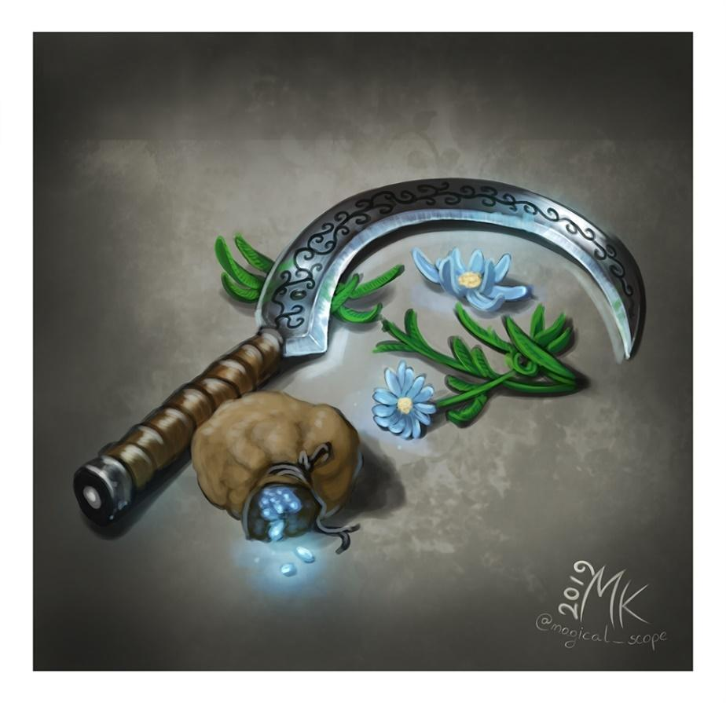

This Sickle has a gem in it's pummel that is clear, round, and glows in reflection to the phases of the moon. The weapon itself is silver and glows with the light of the moon. The weapon deals the damage of any longsword, but with an additional 2d6 radiant damage. An attack made against any creature affected with the curse of lycanthropy has advantage, and if it hits it is automatically a critical hit. The sword has 5 charges. A charge can be used to do one of 2 things

-identify all creatures with the curse of lycanthropy within 50ft of you

-to cure 1 willing creature of it's lycanthropic curse

The sword regains all charges at each moon rise. The sword is powerless on moonless nights. All evil creatures with the curse of lycanthropy that see you with this sword will be openly hostile against you and those in your immediate party.

silvered: The Blade of the Moon is silvered

* 2 minor beneficial properties
* 1 major beneficial property

### Legendary Diamond Sword

This sword has a translucent, bluish blade of pure diamond, with waves of arcane energy rippling across the blades surface. You gain a +3 bonus to attack and damage rolls made with this weapon.

Additionally, when you attune to the sword, it gains one of the following enchantments of your choice. You may use an enchantment once per turn when you hit a creature with an attack using this sword.. When you finish a long rest, you may change the enchantment that is applied.

**Bane:** The target takes an additional 1d8 necrotic damage, and is subjected to the effects of the ***bane*** spell until the start of your next turn

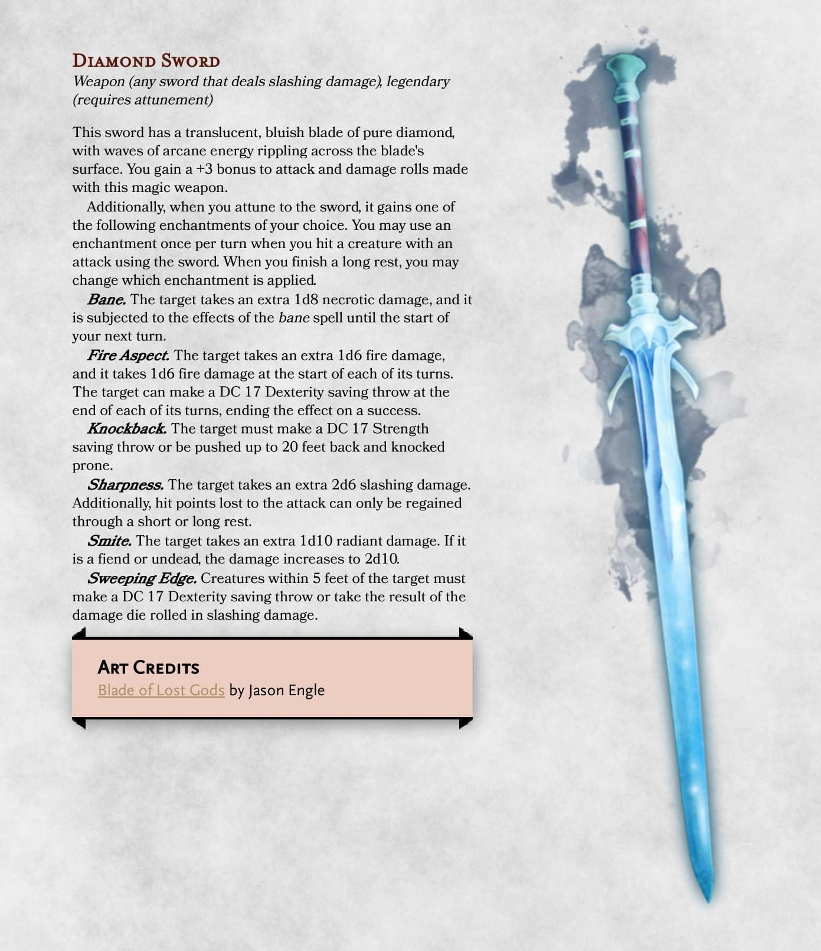

### Leviathan Axe

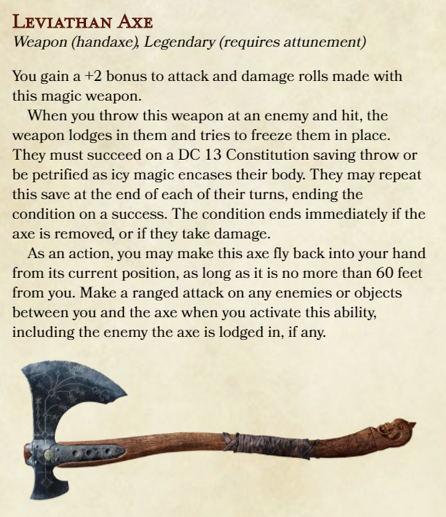

CHANGES:

+3

Grapple with vines instead of freeze

### Life and Death Longswords

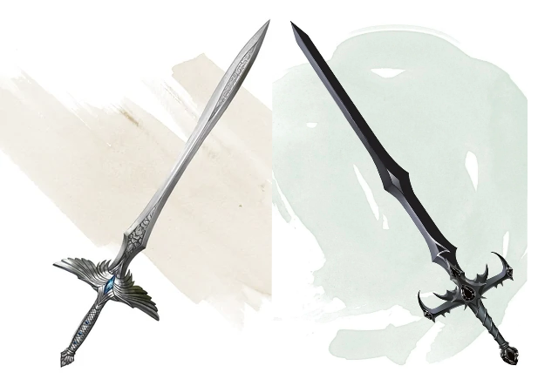

### Ocean Staff

### Staff of the Sun God

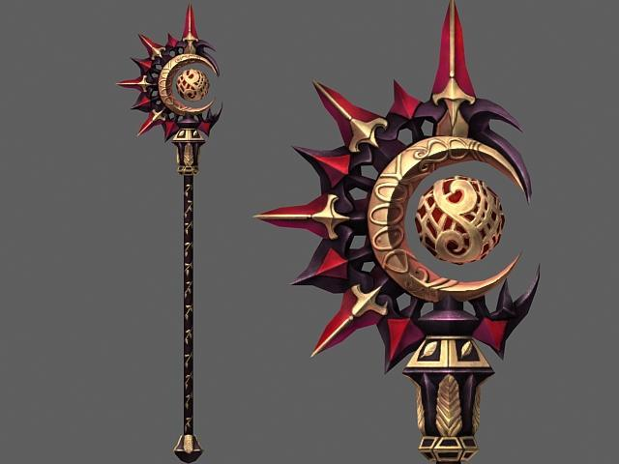

When Lumas first graced the mortal realm with his presence, he left behind a staff which emanated light and life. It was used to heal people and punish creatures of the night. However, corrupt hands got their hands on it with the Brotherhood of Light and it was lost along the annals of dark markets. **Radiance.** This weapon emits bright light for up to 10 feet from its attuned user and dim light for an additional 10 feet. This weapon deals radiant damage and its attuned user gains immunity to radiant damage.

**Innate Spellcasting.** The attuned wielder of the Helion learns and can cast the fire bolt cantrip at will. They can also cast the fireball spell once, regaining use daily at dawn.

**Charges.** This staff has 20 charges. While holding it, the wielder gains a small divine talent for magic, using Charisma as its spellcasting ability modifier if the wielder does not already have one. You can use an action to expend 1 or more of its charges to cast one of the following spells from it, using your spell save DC and spellcasting ability modifier: cure wounds (1 charge per spell level, up to 4th), lesser restoration (2 charges), mass cure wounds (5 charges), or heal (6 charges). The staff regains 1d8+6 expended charges daily at dawn.

**Destroying the Helion.** When the staff's last charge is used, roll a d20. On a 1, one of the 4 main spokes on the staff's Lumasar wheel breaks off. When all 4 are broken, the staff glows hot like the sun and bursts, dealing 3d10 radiant, 3d10 force and 3d10 fire damage to any creature within 10 feet of it and is lost forever.

### Staff of the Wilds

### Wind Horn Battleaxes

## Very Rare Items

### Acererak's Conduits

### Lurkers Orbs

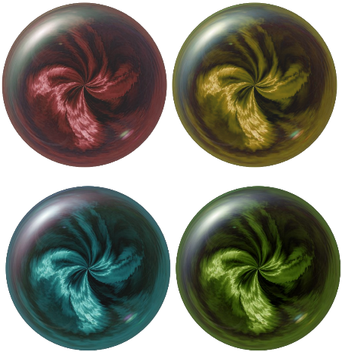Four orbs are controlled by the Lurker, and imbue bearers with Great power.

Red: A +3 spellcasting focus

**Random Properties**. An *Orb of Dragonkind* has the following random properties:  
• 2 minor beneficial properties  
• 1 minor detrimental property  
• 1 major detrimental property  
**Spells**. The orb has 7 charges and regains 1d4 + 3 expended charges daily at dawn. If you control the orb, you can use an action and expend 1 or more charges to cast one of the following spells (save DC 18) from it: *cure wounds* (5th-level version, 3 charges), *daylight* (1 charge), *death ward* (2 charges), or *scrying* (3 charges).  
You can also use an action to cast the *detect magic* spell from the orb without using any charges.

Yellow: Orb of faith. Affinity with the Lurker empowers the other orbs further.

Green: Create potions from ocean plants. Water breathing, healing, etc.

Blue: Attuning to this and you breath underwater indefinitely.

### 9 Rings of Power

### Crown of the Mad King

### Armor of Hammer

### Hammer's Hammer

### Cloak of Invisibility

# Animals

**Basilisk Minotaur**

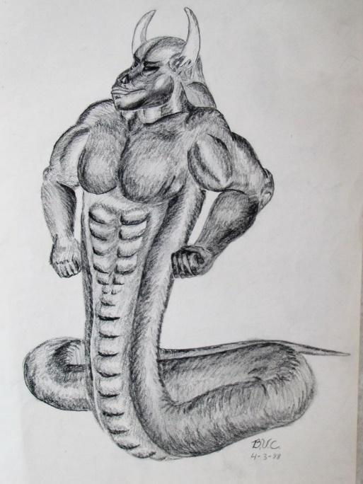

AC | 15

HP | 76

Speed | 40

STR DEX CON INT WIS CHA

16(+3) 11(+0) 16(+3) 6(-2) 16(+3) 9(-1)

**Senses**: Darkvision 60ft, Passive Perception 12

Immunities: -

**Languages:** Abyssal, sylvan

Challenge: 3 (700xp)

Racial Effects:

**Attacks**:

Greataxe.

Melee Weapon Attack: +6 to hit, reach 5 ft., one target. Hit: (2d12 + 4) slashing damage.

Gore.

Melee Weapon Attack: +6 to hit, reach 5 ft., one target. Hit: 13 (2d8 + 4)

piercing damage.

Bite.

*Melee Weapon Attack:* +5 to hit, reach 5 ft., one target. *Hit:*(2d6 + 3) piercing damage plus (2d6)poison damage.

**Barbed hide Frog**

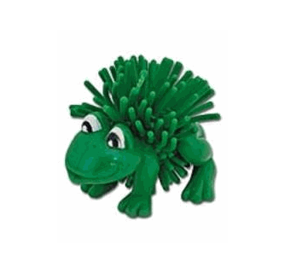

AC | 13

HP | 1

Speed | 20, swim 20

STR DEX CON INT WIS CHA

1(-5) 13(+1) 12(+1) 1(-5) 8(-1) 6(-2)

Senses: Passive Perception 11

Immunities: Poison

Languages: --

Challenge: 0

Racial Effects: Air and Water breathing

Attacks: --

**Giant Rat Pig**

AC | 12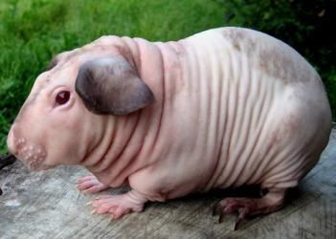

HP | 20

Speed | 15

STR DEX CON INT WIS CHA

10(+0) 16(+4) 11(+0) 9(-1) 10(+0) 2(-4)

Senses: Pass perception 6

Immunities: fearless

Languages: --

Challenge: 0

Racial Effects: Pact tactics: always found in groups.

**Attacks:** Bite: +2 to hit, 1d6+1 dmg

**Improved Natural Armor Displacer Beast**

AC | 16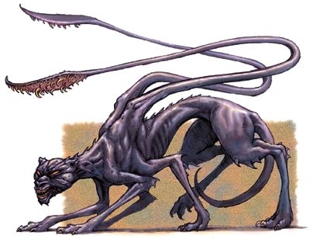

HP | 85

Speed | 40

STR DEX CON INT WIS CHA

18(+4) 16(+3) 16(+3) 6(-2) 12(+1) 8(-1)

Senses: Darkvision 60ft

Immunities:

Languages:

Challenge:

Racial Effects:

Attacks:

REFER TO MM P.81

**Corruption Satyr**

AC | 14 (Leather Armor)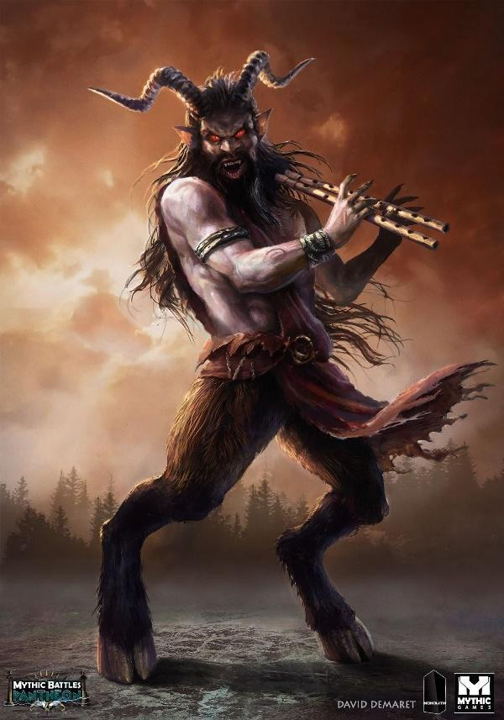

HP | 35 (7d8)

Speed | 40 ft

STR DEX CON INT WIS CHA

12(+1) 16(+3) 11(+0) 12(+1) 10(+0) 14(+2)

Skills Perception +2, Performance +6, Stealth +5

Senses Passive Perception 12

Languages: Common, Elvish, Abyssal

Challenge: 1/2 (100 XP)

Racial Effects:

Magic Resistance.

The satyr has advantage on saving throws against spells and other magical effects.

Corruption Spread

Bearing into the ground, any creature within 10ft of this beast must make a CON 14 save or be poisoned for 1d4 of damage at the end of each of their turn, until the effect ends.

Attacks:

Ram.

Melee Weapon Attack: +3 to hit, reach 5 ft., one target. Hit: (2d4 + 1) bludgeoning damage.

Shortsword.

Melee Weapon Attack: +5 to hit, reach 5 ft., one target. Hit: (1d6 + 3) piercing damage.

Shortbow.

Ranged Weapon Attack: +5 to hit, reach 80/320 ft., one target. Hit: (1d6 + 3) piercing damage.

**Giant Goat Rat - Abonimation**

AC | 11 (natural)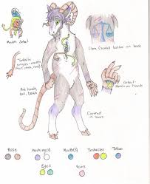

HP | 12

Speed | 30ft

STR DEX CON INT WIS CHA

12(+1) 10(+0) 11(+0) 2(-4) 10(+0) 5(-3)

Senses: Darkvision 30 Ft., passive Perception 10

Challenge: 0 (10xp)

Racial Effects:

Charge.

If the goat moves at least 20 ft. straight toward a target and then hits it with a ram attack on the same turn, the target takes an extra 2 (1d4) bludgeoning damage. If the target is a creature, it must succeed on a DC 10 Strength saving throw or be knocked prone.

Sure-Footed.

The goat has advantage on Strength and Dexterity saving throws made against effects that would knock it prone.

Attacks:

Ram.

Melee Weapon Attack: +3 to hit, reach 5 ft., one target. Hit: (1d4 + 1) bludgeoning damage.

Bite.

Melee Weapon Attack: +0 to hit, reach 5 ft., one target. Hit: (1d1) piercing damage.

**Shark Lion**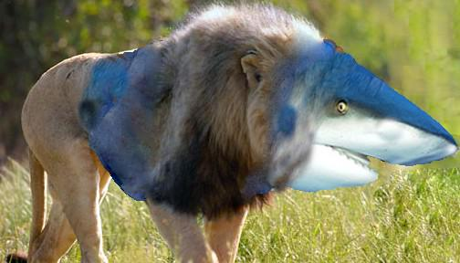

AC | 12 (Natural Armor)

HP | 45 (6d10+12)

Speed | Swim/Walk 40ft

STR DEX CON INT WIS CHA

18(+4) 15(+2) 13(+1) 8(-1) 10(+0) 4(-3)

Skills: Perception +3, Stealth +6

Senses: Blindsight 30 Ft., passive Perception 12

Challenge: 2 (450xp)

Racial Effects:

Keen Smell.

The lion has advantage on Wisdom (Perception) checks that rely on smell.

Pack Tactics.

The lion has advantage on an attack roll against a creature if at least one of the lion's allies is within 5 ft. of the creature and the ally isn't incapacitated.

Pounce.

If the lion moves at least 20 ft. straight toward a creature and then hits it with a claw attack on the same turn, that target must succeed on a DC 13 Strength saving throw or be knocked prone. If the target is prone, the lion can make one bite attack against it as a bonus action.

Running Leap.

With a 10-foot running start, the lion can long jump up to 25 ft..

Attacks:

Bite.

Melee Weapon Attack: +5 to hit, reach 5 ft., one target. Hit: (2d8 + 4) piercing damage.

Claw.

Melee Weapon Attack: +5 to hit, reach 5 ft., one target. Hit: (1d6 + 3) slashing damage.

**Extra Limbs-Ape**

AC | 14 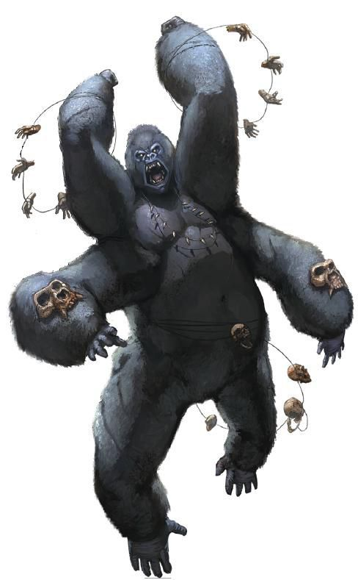

HP | 40 (3d8+6)

Speed | 30 ft., climb 30 ft.

STR DEX CON INT WIS CHA

17(+3) 14(+2) 14(+2) 8(-1) 12(+1) 7(-2)

Skills Athletics +5, Perception +3

Senses: Passive Perception 13

Challenge: 2 (450xp)

Racial Abilities

Thundering Roar

The beast pounds its chest and roars into the air. Creatures in a 50ft radius must make a CON 14 save or be frightened.

Attacks:

Multiattack.

The ape makes 1d4 fist attacks.

Fist.

Melee Weapon Attack: +5 to hit, reach 5 ft., one target. Hit: (1d6 + 3) bludgeoning damage.

Rock.

Ranged Weapon Attack: +5 to hit, reach 25/50 ft., one target. Hit: (1d6 + 3) bludgeoning damage.

**Barbed Hide Pig**

AC | 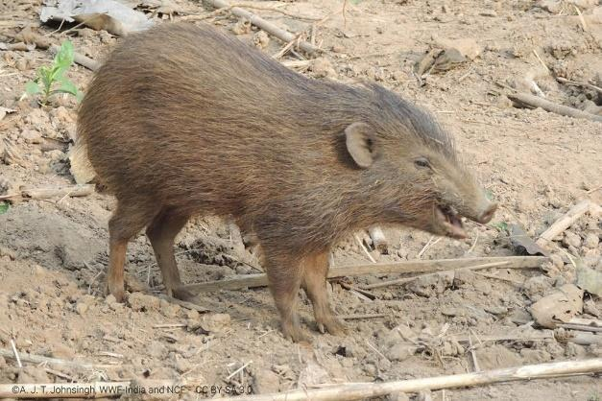

HP |

Speed |

STR DEX CON INT WIS CHA

10(+0) 10(+0) 10(+0) 10(+0) 10(+0) 10(+0)

Senses:

Immunities:

Languages:

Challenge:

Racial Effects:

Attacks:

**Rhino Mole**

AC | 11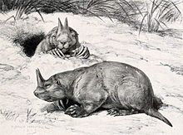

HP | 45 (6d10+12)

Speed | 40ft

STR DEX CON INT WIS CHA

21(+5) 8(-1) 15(+2) 2(-4) 12(+1) 6(-2)

Senses: Darkvision 30 Ft., passive Perception 11

Challenge: 2 (450 XP)

Racial Effects:

Charge.

If the rhinoceros moves at least 20 ft. straight toward a target and then hits it with a gore attack on the same turn, the target takes an extra 9 (2d8) bludgeoning damage. If the target is a creature, it must succeed on a DC 15 Strength saving throw or be knocked prone.

Keen Smell

The Rhino Mole has advantage on Wisdom (Perception) checks that rely on smell.

Attacks:

Multiattack.

The badger makes two attacks: one with its bite/horn and one with its claws.

Bite.

Melee Weapon Attack: +3 to hit, reach 5 ft., one target. Hit: (1d6 + 1) piercing damage.

Claws.

Melee Weapon Attack: +3 to hit, reach 5 ft., one target. Hit: (2d4 + 1) slashing damage.

Gore.

Melee Weapon Attack: +7 to hit, reach 5 ft., one target. Hit: (2d8 + 5) bludgeoning damage.

**Turtle Lion**

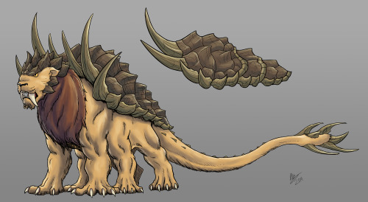

AC |

HP | 24 (4d10+2)

Speed | 35 ft

STR DEX CON INT WIS CHA

17(+3) 15(+2) 13(+1) 10(+0) 13(+2) 8(-1)

Skills Perception + 3, Stealth + 4

Senses: passive Perception 13

Challenge: 1 (200xp)

Racial Effects:

Keen Smell.

The lion has advantage on Wisdom (Perception) checks that rely on smell.

Pack Tactics.

The lion has advantage on attack rolls against a creature if at least one of the lion’s allies is within 5 feet of the creature and isn’t incapacitated.

Incorporeal Movement.

The lion can move through other creatures and objects as if they were difficult terrain. It takes 5 (1d10) force damage if it ends its turn inside an object.

Dawn.

The lion sheds bright light for 5 feet, and dim light for an additional 10 feet.

Pounce.

If the lion moves at least 20 feet straight toward a target before hitting it with a claw attack, the target must succeed a DC 13 strength saving throw or be knocked prone. If the target is prone, the lion can take a bonus action to make one bite attack against it.

Attacks:

Bite.

Melee Weapon Attack: +5 to hit, reach 5ft., one target. Hit 7 (1d8 + 3)

Claw.

Melee Weapon Attack: +5 to hit, reach 5ft., one target. Hit 3 (1d6 + 3)

Tail Swipe.

Melee Weapon Attack: +5 to hit, reach 10ft., one target. Hit 6 (1d10 + 3)

**Birboon**

AC | 11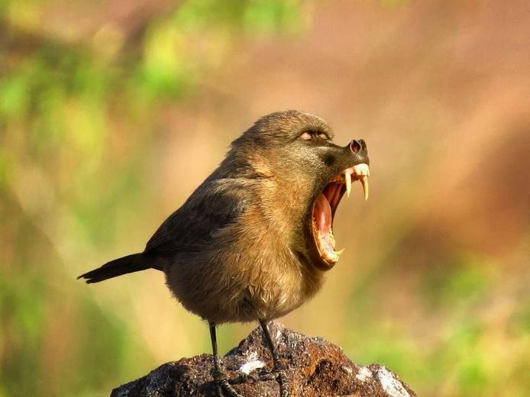

HP | 10

Speed | 5ft., Fly 60ft

STR DEX CON INT WIS CHA

3 (-4) 14 (+2) 11 (+0) 3 (-3) 12 (+1) 7 (-2)

Senses: Darkvision 120 ft., passive Perception 13

Challenge: 0 (10xp)

Racial Effects:

Pack Tactics.

The baboon has advantage on an attack roll against a creature if at least one of the baboon's allies is within 5 ft. of the creature and the ally isn't incapacitated.

Attacks:

Bite.

Melee Weapon Attack: +1 to hit, reach 5 ft., one target. Hit: (1d4 - 1) piercing damage.

Talons.

Melee Weapon Attack: +3 to hit, reach 5 ft., one target. Hit: 1 slashing damage.

Growl…

https://youtu.be/VHvo3Fq7mz8?t=15

**Mammoth Horse**

AC | 13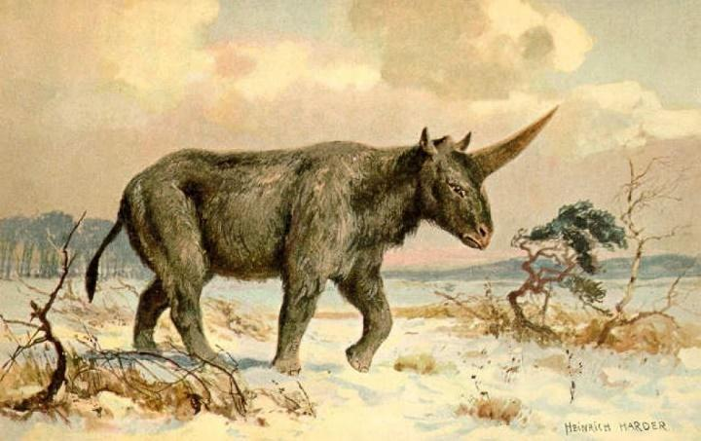

HP | 125 (11d12+55)

Speed | 50ft

STR DEX CON INT WIS CHA

24(+7) 9(-1) 21(+5) 3(-4) 11(+0) 6(-2)

Senses: passive Perception 10

Challenge: 6 (2,300xp)

Racial Effects:

Trampling Charge.

If the mammoth moves at least 20 ft. straight toward a creature and then hits it with a gore attack on the same turn, that target must succeed on a DC 18 Strength saving throw or be knocked prone. If the target is prone, the mammoth can make one stomp attack against it as a bonus action.

Attacks:

Horn Gore.

Melee Weapon Attack: +10 to hit, reach 10 ft., one target. Hit: (4d8 + 7) piercing damage.

Stomp.

Melee Weapon Attack: +10 to hit, reach 5 ft., one prone creature. Hit: (4d10 + 7) bludgeoning damage.

**Corruption Raven**

AC | 12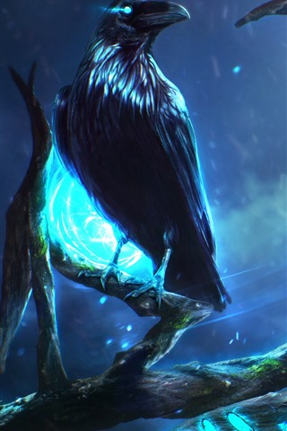

HP | 10

Speed | 10ft., fly 50ft.

STR DEX CON INT WIS CHA

4(-3) 14(+2) 10(+0) 6(-2) 12(+1) 8(-1)

Skills Perception +3

Senses: Passive Perception 13

Challenge: 0 (10xp)

Racial Effects:

Mimicry.

The raven can mimic simple sounds it has heard, such as a person whispering, a baby crying, or an animal chittering. A creature that hears the sounds can tell they are imitations with a successful DC 10 Wisdom (Insight) check.

Corruption spread.

Any area the raven lands on becomes corrupt in a 5ft radius. any creature standing in this area must make a CON 10 save or be poisoned for 1d4 of damage at the end of each of their turn, until the effect ends.

Attacks:

Beak.

Melee Weapon Attack: +4 to hit, reach 5 ft., one target. Hit: (1d1) piercing damage.

**Spider Rat, Giant**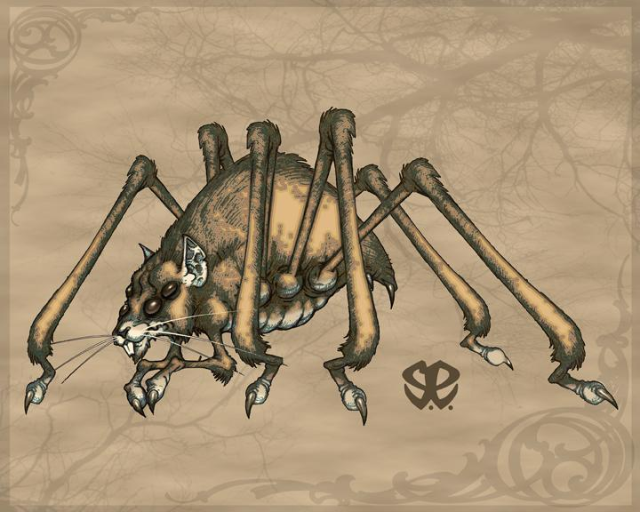

AC | 13

HP | 25 (4d10+3)

Speed | 30 ft., climb 30 ft.

STR DEX CON INT WIS CHA

14(+2) 16(+3) 12(+1) 2(-4) 11(+0) 4(-3)

Skills: Stealth +7

Senses Blindsight 10 Ft., Darkvision 60 Ft., Pass. Perception 10

Challenge: 1 (200xp)

Racial Effects:

Spider Climb.

The spider can climb difficult surfaces, including upside down on ceilings, without needing to make an ability check.

Keen Smell.

The rat has advantage on Wisdom (Perception) checks that rely on smell.

Web Walker.

The spider ignores movement restrictions caused by webbing.

Attacks:

* ***Bite.*** *Melee Weapon Attack:* +5 to hit, reach 5 ft., one creature. *Hit:*(1d8 + 3) piercing damage plus (2d8)poison damage.
  + The target must make a DC 11 Constitution saving throw, taking the poison damage on a failed save, or half as much damage on a successful one. If the poison damage reduces the target to 0 hit points, the target is stable but poisoned for 1 hour, even after regaining hit points, and is paralyzed while poisoned in this way.
* ***Web (Recharge 5-6).*** *Ranged Weapon Attack:* +5 to hit, reach 30/60 ft., one creature.
  + The target is restrained by webbing As an action, the restrained target can make a DC 12 Strength check, bursting the webbing on a success. The webbing can also be attacked and destroyed (AC 10; hp 5; vulnerability to fire damage; immunity to bludgeoning, poison, and psychic damage).

**Mysterious Items**

### Broken Glasses

### Shard of meteorite stone

# Encounters

**Ankheg Burrow**

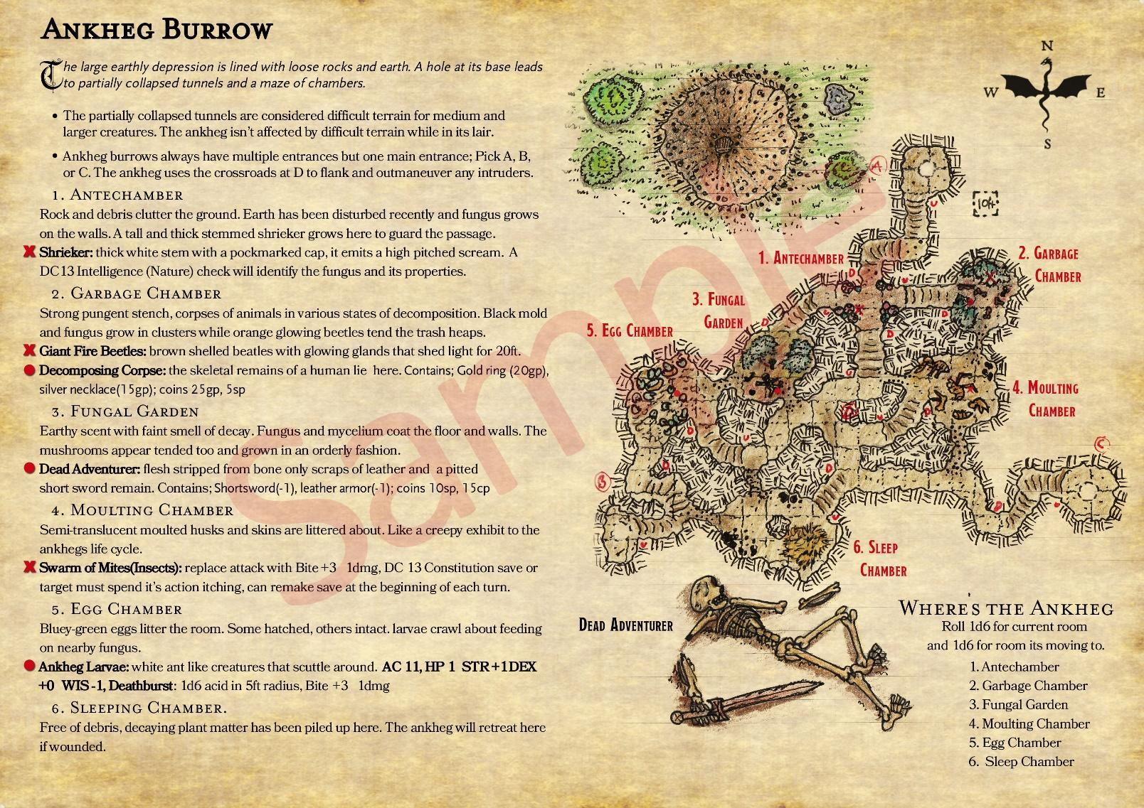

**Basilisk Caves**

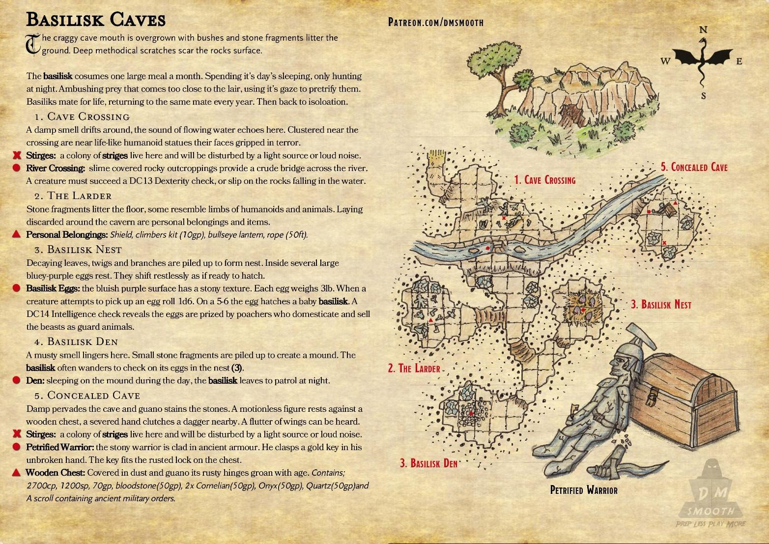

**Curse of Hagwood**

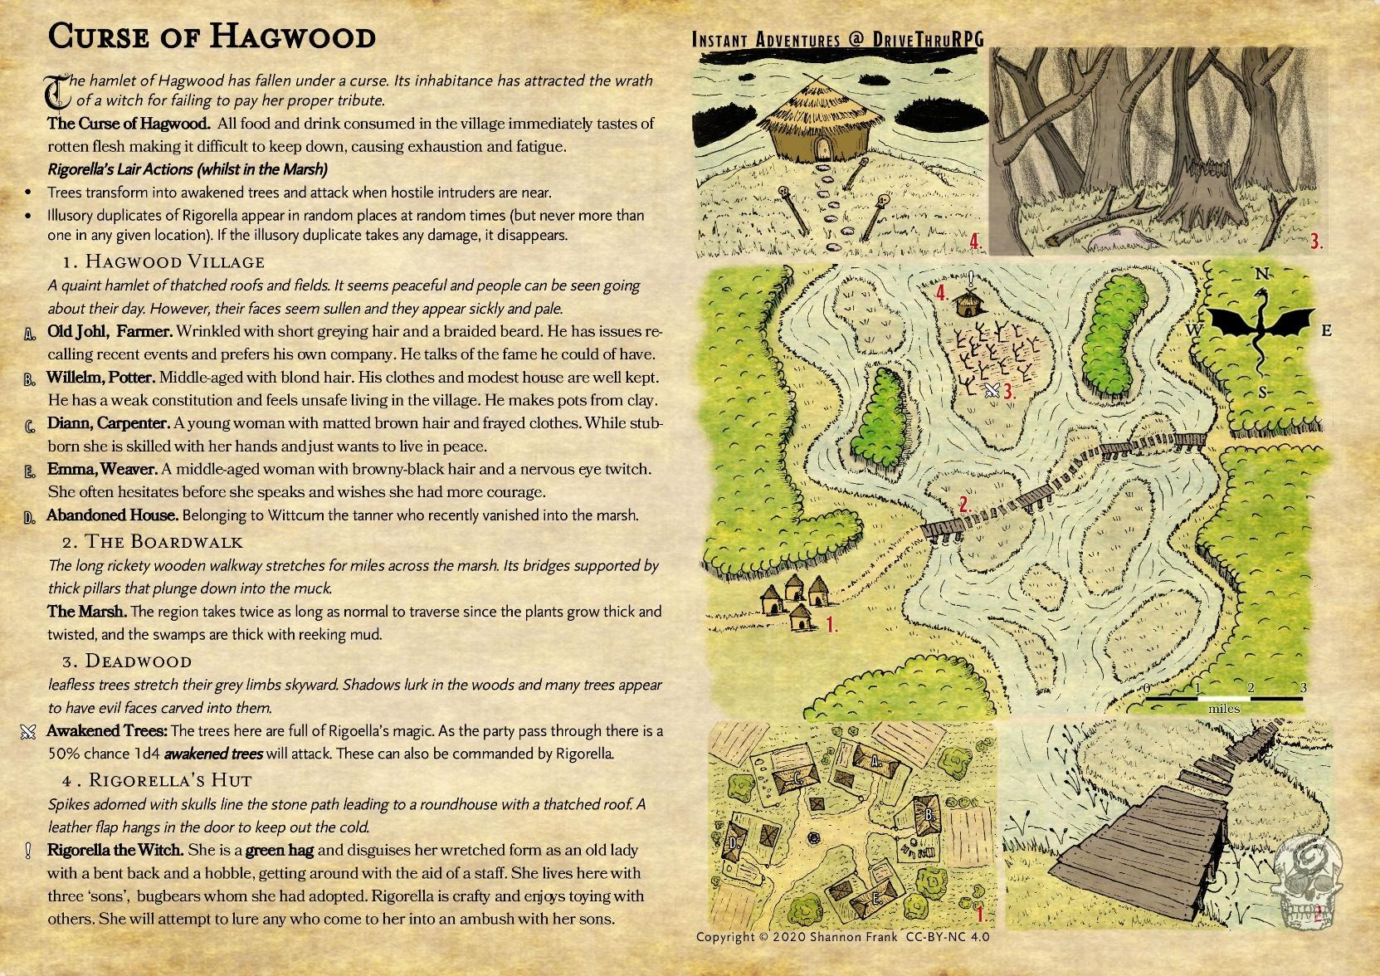

**Elven Crypt**

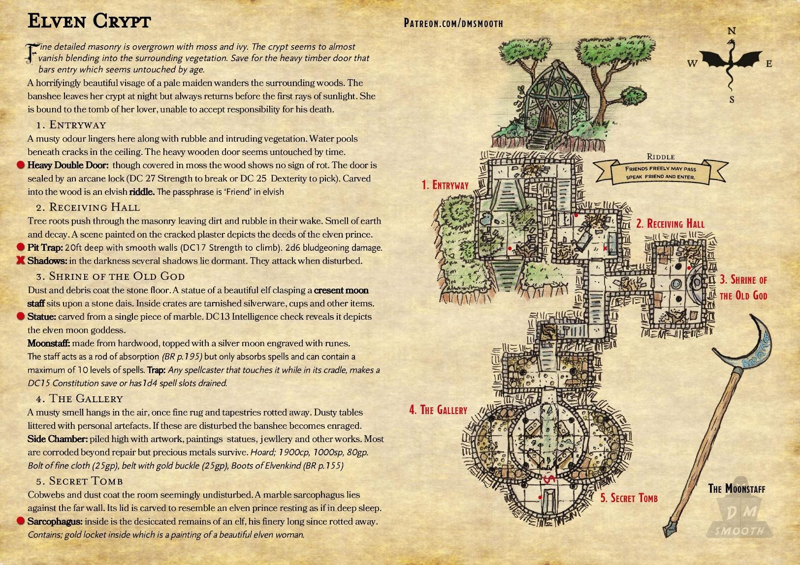

**Giants Hill**

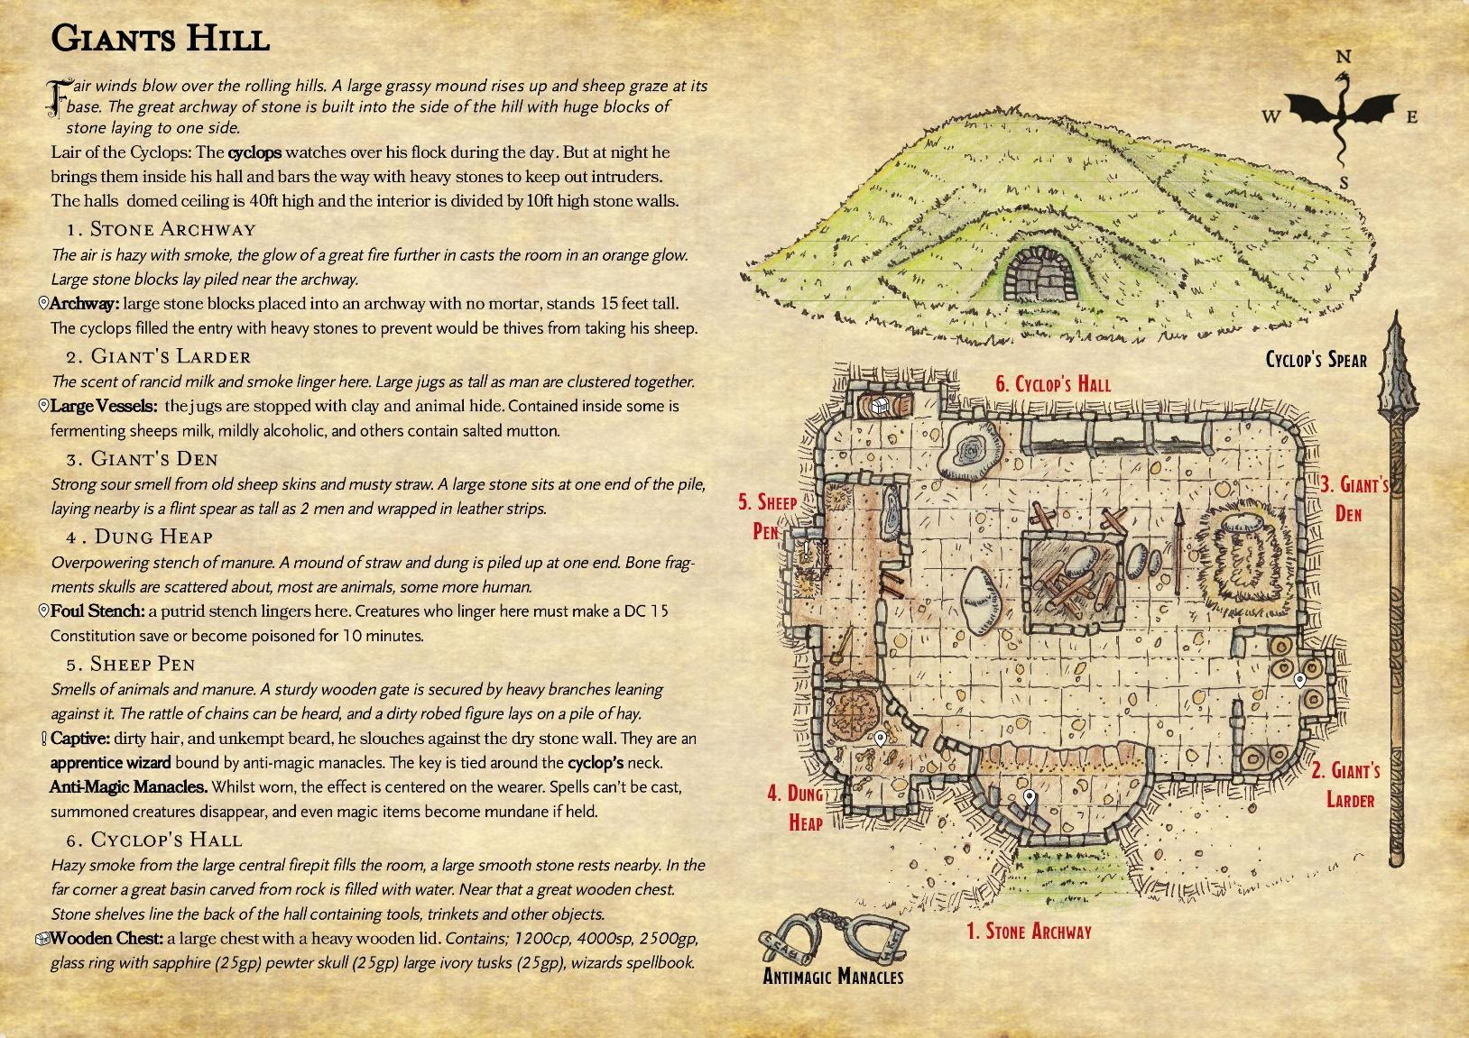

**The Guildhouse**

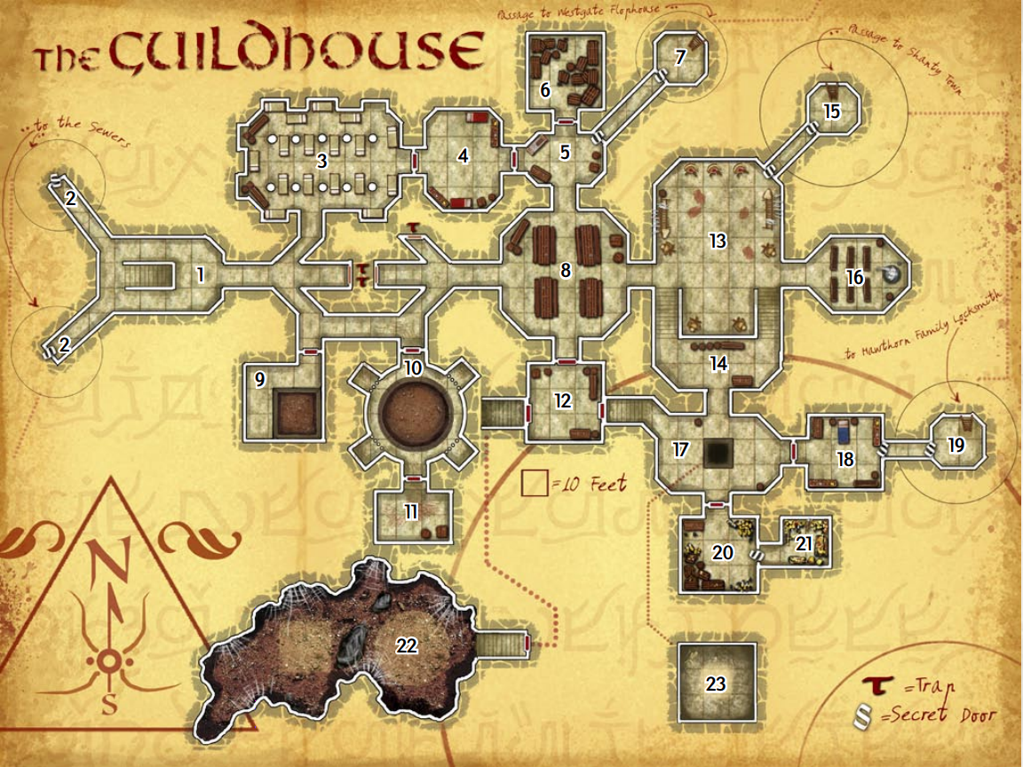

**House of The Physician**

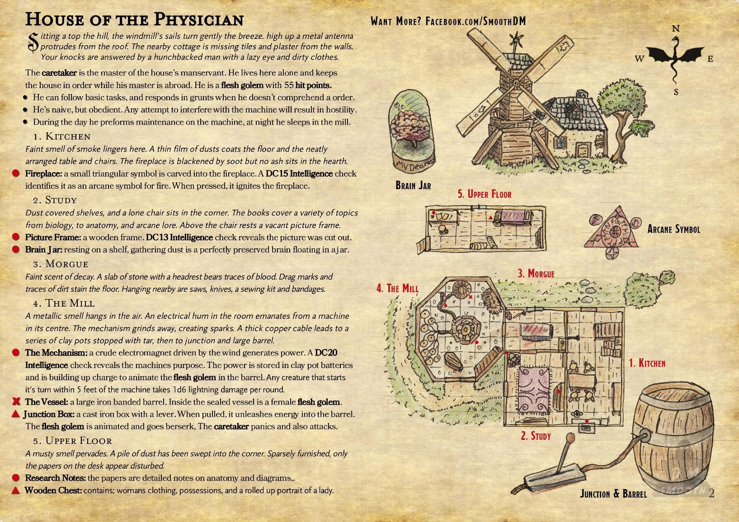

**The Labratory**

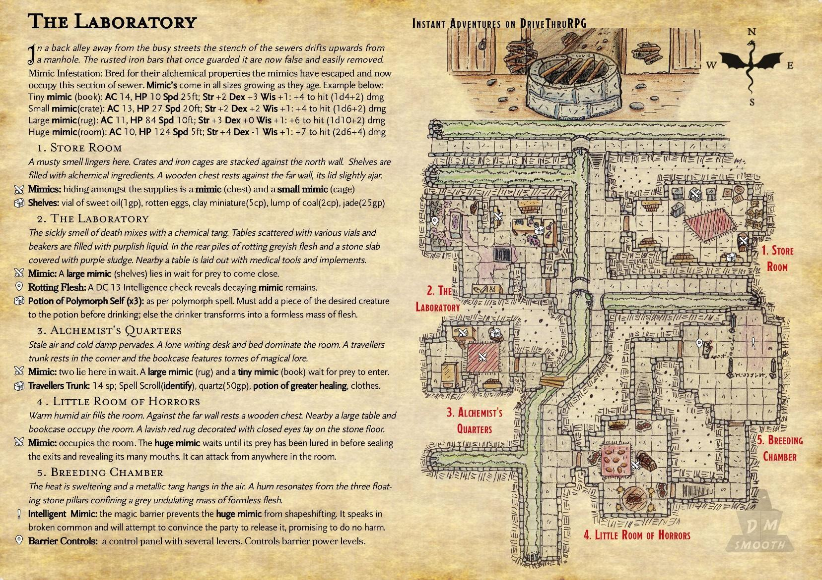

**Siren's Cove**

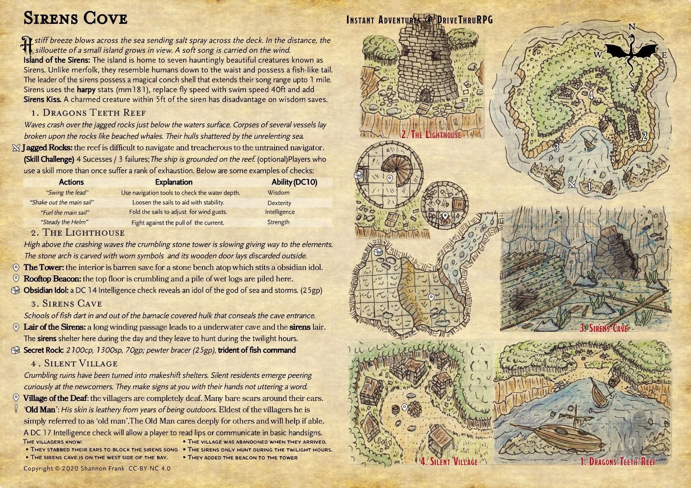

**Smuggler's Cove**

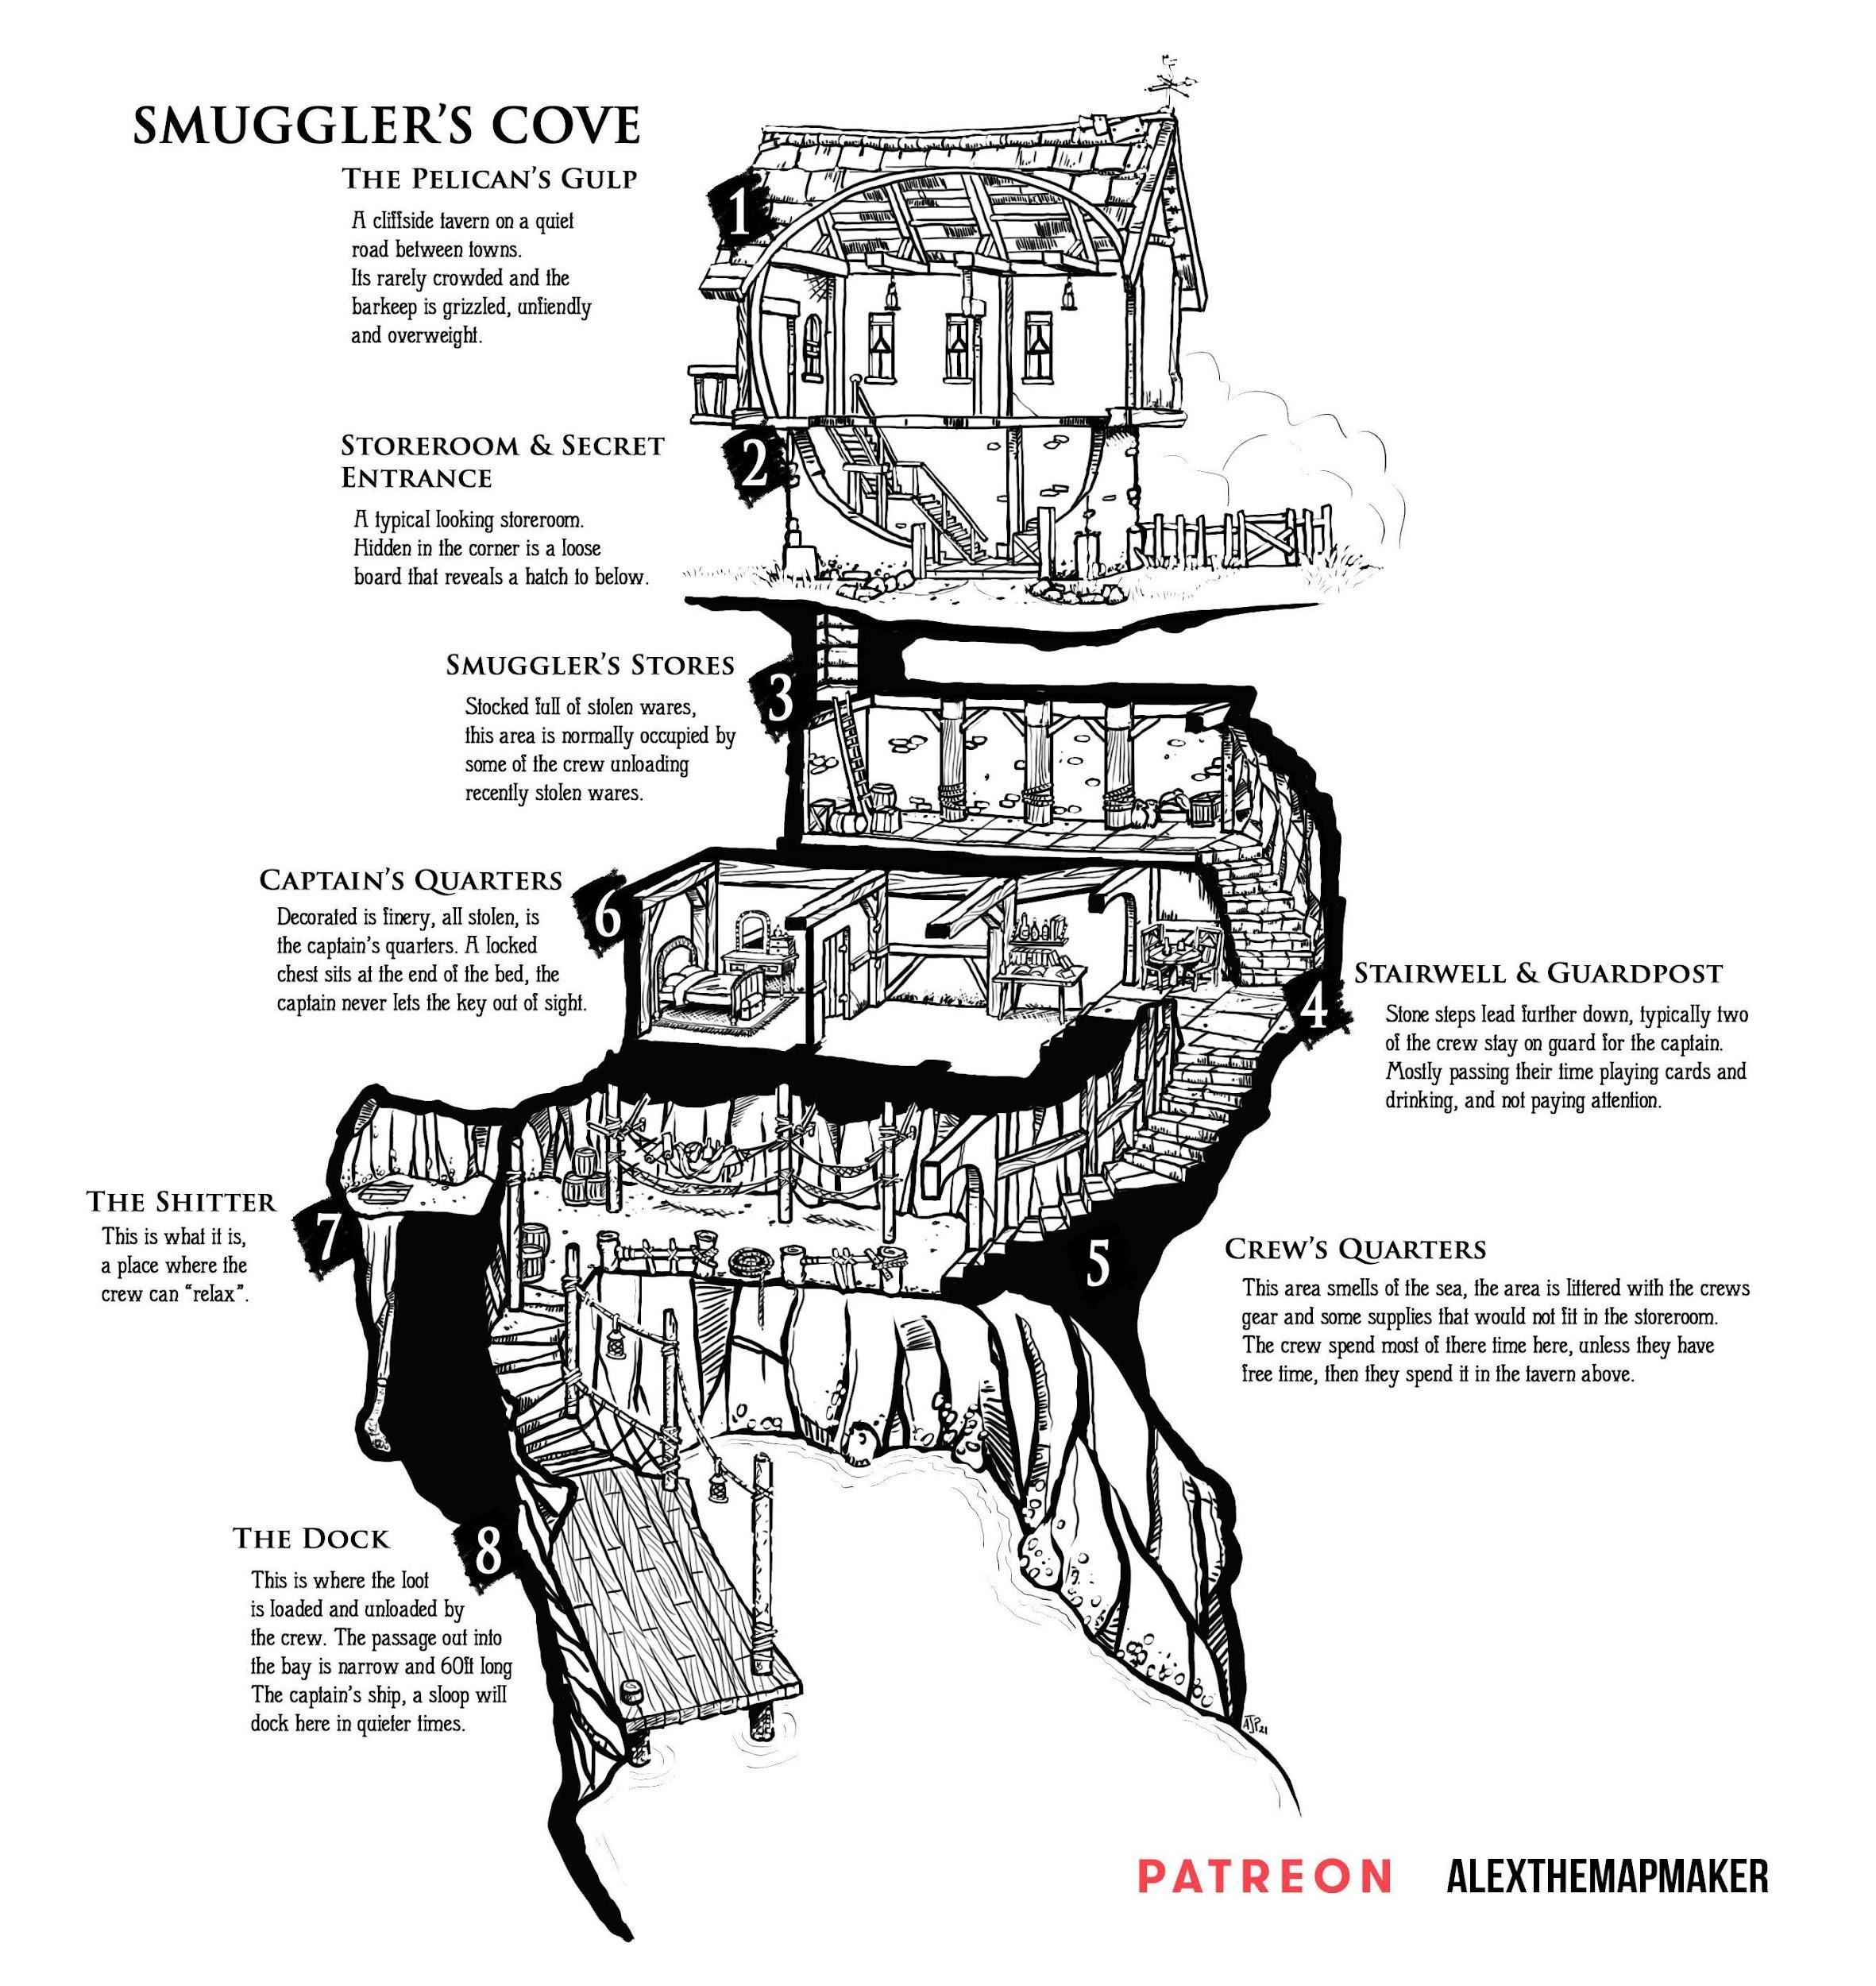

**Smuggler's Den**

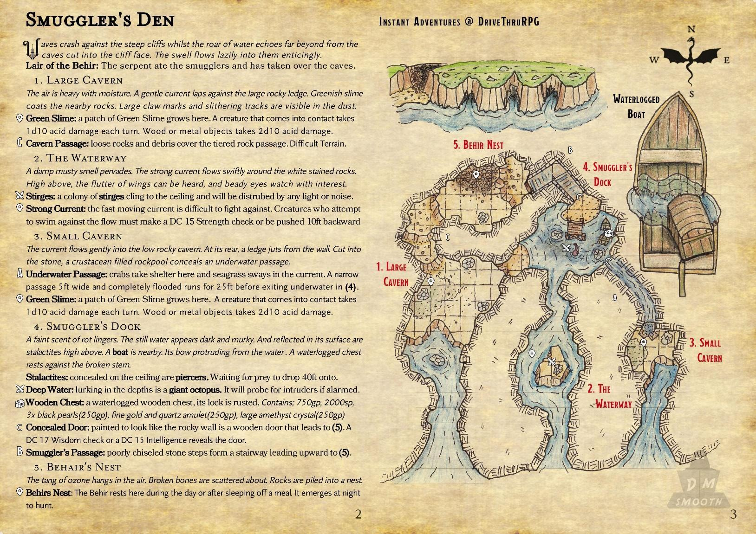

**Tomb of the pheonix**

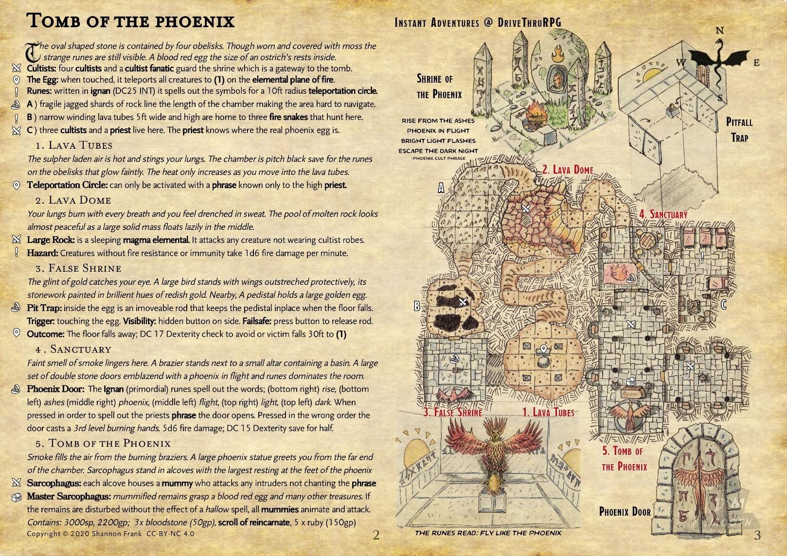

**Wizard's Refuge**

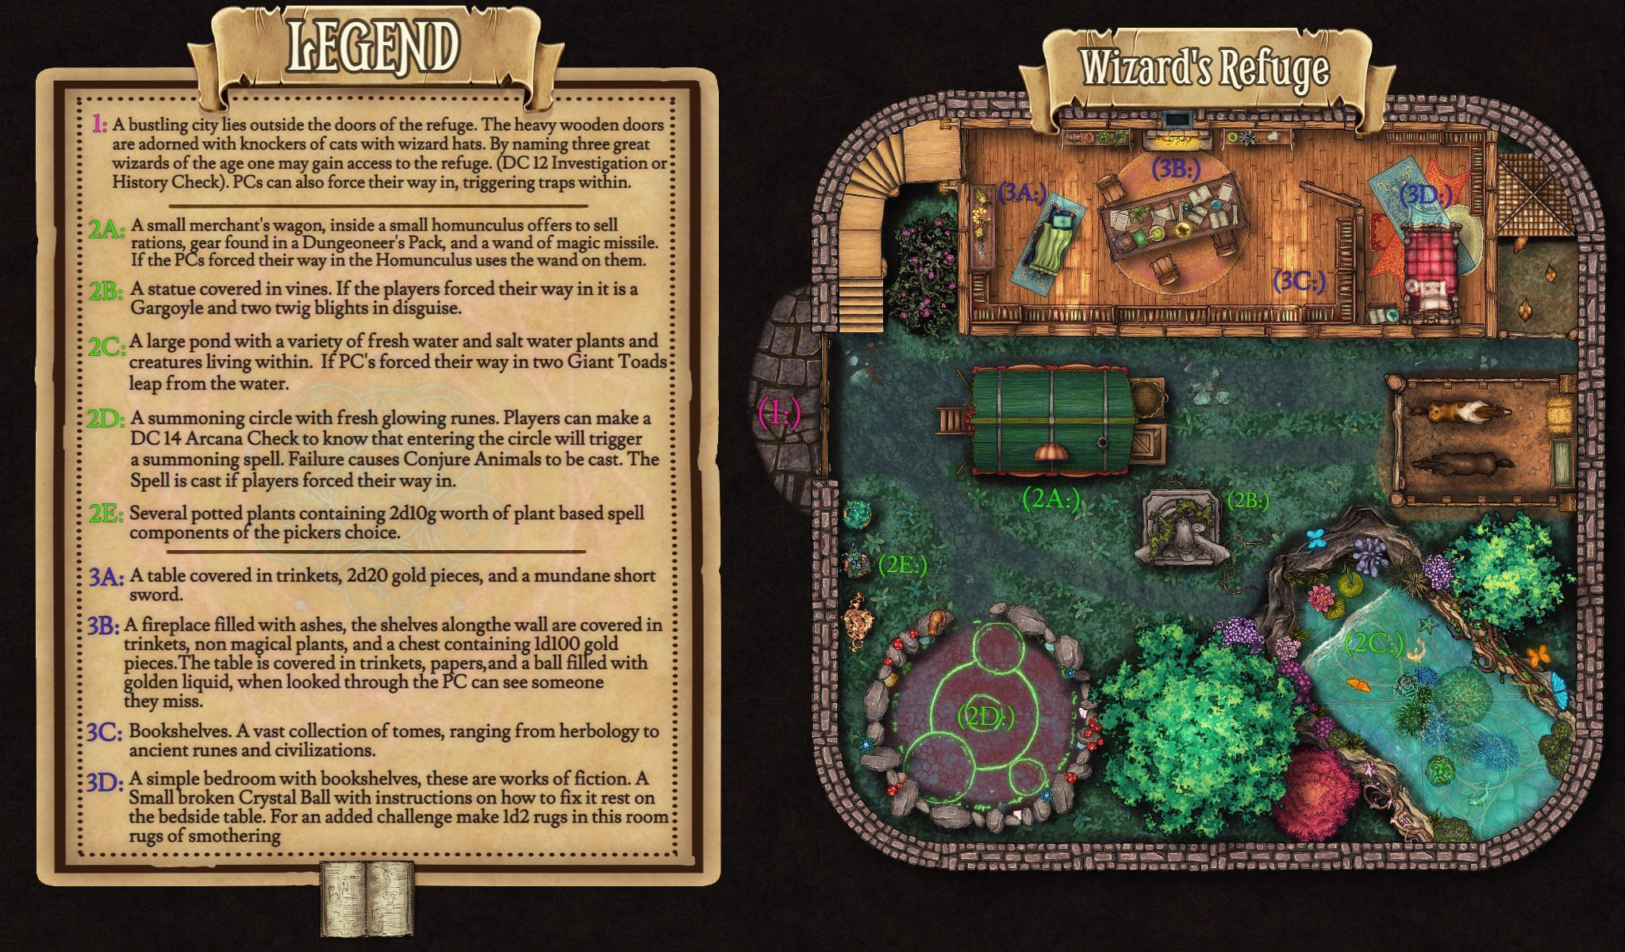

https://i.redd.it/nkbjcrclayp81.jpg

**Wizards Workshop**

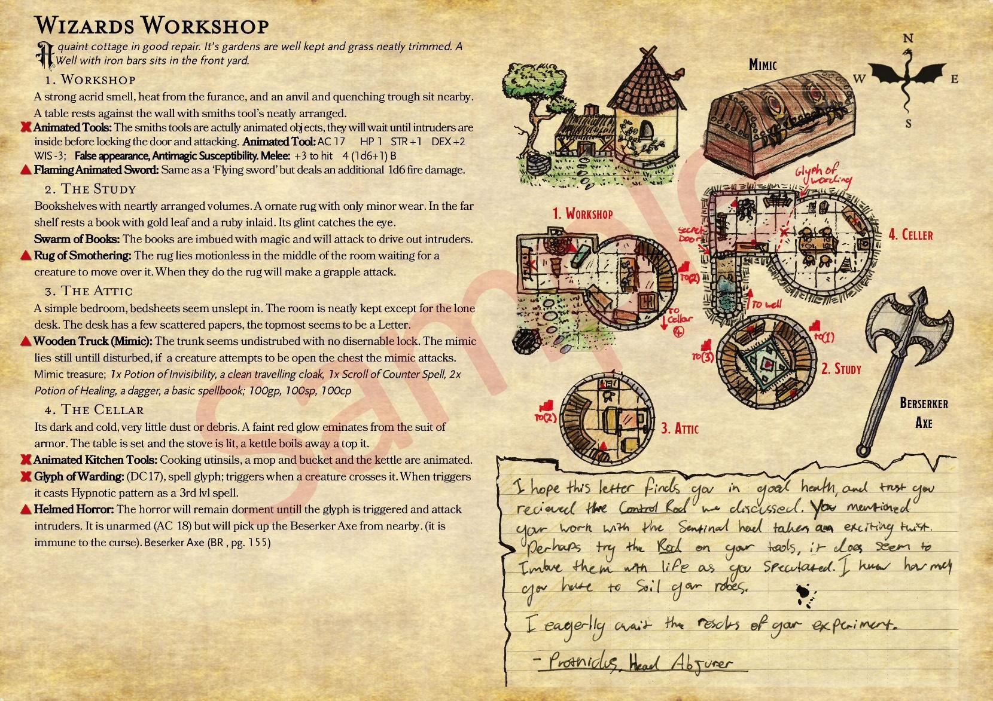

**Riddles**

Unseen I kiss the young and old

Uncut by sword, unswayed by gold

Priest and pauper, rich and poor

All fight, banner less, in my war

Bear my footprints, chase your death

Breathe my silence, cease your breath

[Plague]

​

In and out my body sways

Under, over, many ways

Angels dance upon my head

Deadly I, within your bread

Sharpest sword, yet not for killing

Backwards held, your blood is spilling

[Needle]

​

Silent Ruby swims

Through an unseen sea

Some men faint to see her

Others grin with glee

Ruby loves them all

She makes them feel alive

But if she ever leaves them

All of them will die

[Blood]

​

[Note: this one doesn't rhyme]

Coloured body, pale guts

My father's name carved into me

Again and again, a great pride to him

I never screamed

I've never spoken

Yet still they come for my secrets

The deaf can hear me

But to the blind I'm silent

Though they may strain

I swallowed the world

Though I fear its elements

They will destroy me if they can

And there is nothing I can do

[Book]

​

Through all I end

Cartographer's friend

Foe to fish determination

Realms divide

Mark high tide

The racer's termination

[Line]

​

Three snakes stand unmoving

Two beyond twin seas

First before a bucket

Penultimate near ease

Amongst them is one other

Common as you please

Circle's end and end's beginning

A full half of a sneeze

[Spells out "Success"]

​

For father I am fleeting

For mother I am pain

To daughter I am precious

To son I'm lost in shame

Cut me, I'm not broken

Unbaked, a servant's bun

Grandmother keeps me stony

Grandfather keeps me none

[Hair]

​

What cracks but is not broken?

What burns but is not flame?

What shows the gods' true malice?

What roars but not its name?

[Lightning]

​

Cat's gift

Beggar's feast

Hoarder's foe

Sound beneath

[Rat]

​

King Lox rides out from Val Ren

With his thirty-seven lords

Each lord has seven children

Each child seven wards

The children have their mothers

But lose half of them to grief

They're joined by thirteen others

The last of whom's a thief

The thief steals away a maiden

Every moonless night

Twelve baker's dozen days Lox rides

With convoy and with wife

Plague takes one in seven

But the girl's birth one in ten

How many gone to heaven

Before they reach Val Ren?

[Zero, or none - the king is riding FROM Val Ren]

​

A fisherman's catch, unseen, unintended

Brought home, uneaten, five lives all ended

[A cold]

​

I stand for luck

Face down for work

Liquid when born

Eat nothing but dirt

Swifter than man

Stuck in one place

Pray that I never

Strike you in the face

[Horseshoe]

​

One man sat on a box

Surrounded by fourteen others

Six lay underneath him

And all of them were brothers

[A six-side dice]

​

A knight in silver armour

Vow less, without lord

Cold, silent, unbreathing

Will never hold a sword

[Fish]

​

Three brothers laid me down to rest

For I, their many battles blessed

I'd watched them fight from up on high

I'd watched their honoured father die

Lost and burned, I was no more

Next day marching, as before

I waved to them, they did not yield

I held to them upon their shield

They buried me with brother four

And come dawn carried me to war

[A family crest or standard]

You find my home, here and there, everywhere.

Rivers and mountains carry me for miles,

Used differently by Children and women,

But nevertheless, my uses lead to many smiles.

Precious, played with, and tossed aside alike.

The earth is where I root.

The only time I feel your anger

Is when found in your boot.

[Stone]